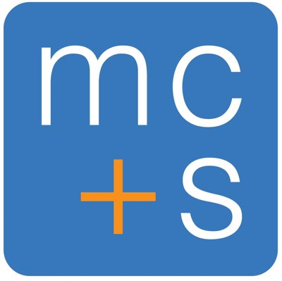 | MC & S PTY LTD | StatementHub Workpaper  Thin Capitalisation Assessment Workpaper  Eva-Triggered Evidence Workpaper
Client: {{entity_name}} ABN: {{abn}} Financial Year: {{financial_year}} Period: {{fy_start_date}} to {{fy_end_date}}

Thin capitalisation rules (Div 820 ITAA 1997) limit debt deductions where an entity's debt exceeds a safe harbour threshold. Applies to entities with foreign interests or cross-border debt. From 1 July 2023, new Fixed Ratio Test (30% of EBITDA) applies for general class investors.

A. APPLICABILITY TEST
B. FIXED RATIO TEST (from 1 July 2023 — General Class Investors)
C. SAFE HARBOUR TEST (Legacy — Prior to 1 July 2023 / Retained if applicable)
D. CONCLUSION

SIGN-OFF
Name: {{preparer}}  Signature:  Date: {{date_prepared}} |  | Name: {{reviewer}}  Signature:  Date: {{date_reviewed}}

