**WORKING WITH LAYOUTS**

Create a new project name it, I name it as **Layout.**

Then click on **res** from left side of Android Studio to add a resource file in given project.

Select on Layout and options will be appeared click on **Layout Resource File,** give it a name.

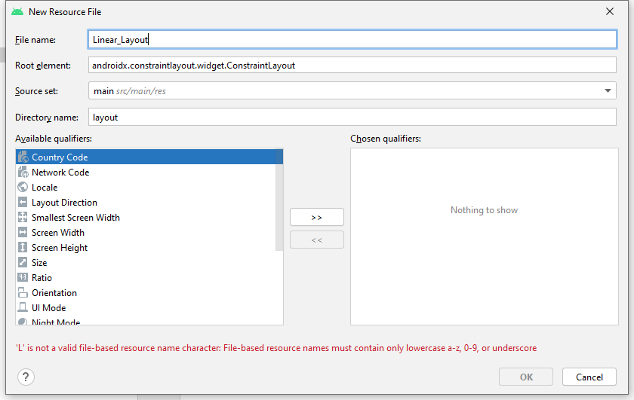

Add some buttons textviews etc on linear_layout xml

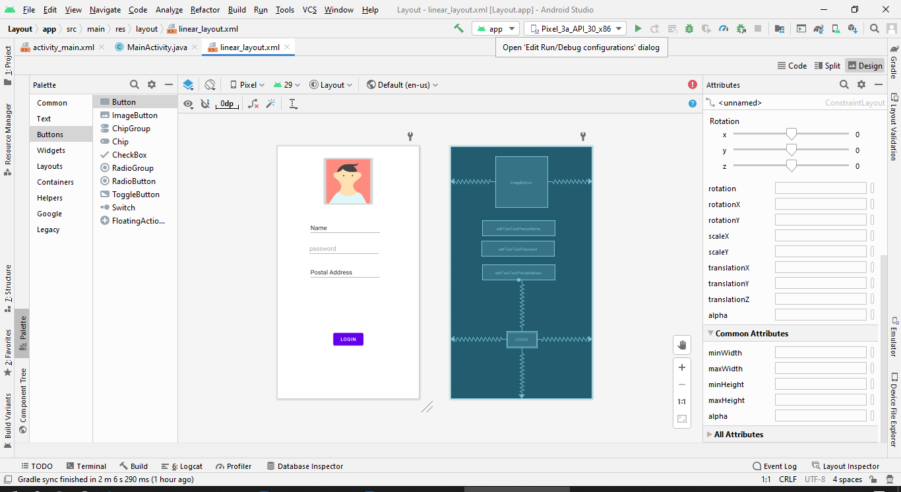

By default we will be displayed the activity main screen do edit activity main by linear_layout

To see linear_layout screen change setContentView(R.layout.***linear_layout***);

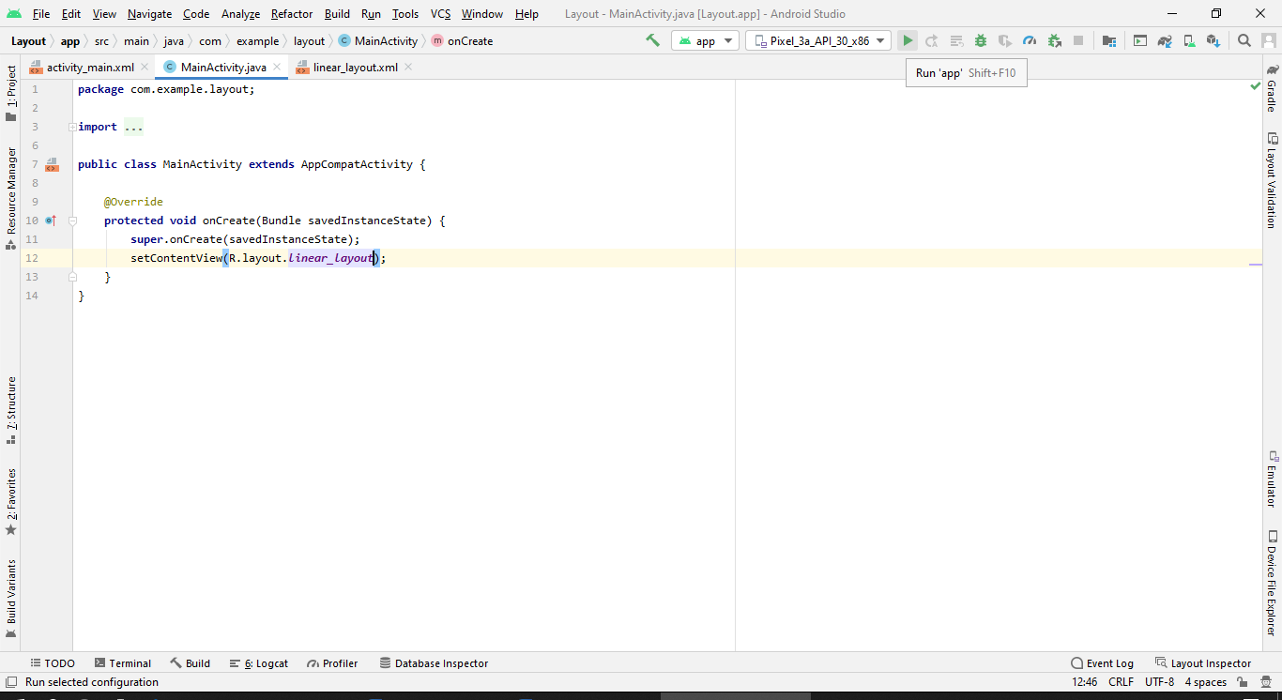

The final screen will be as:

