**Mobile Computing**

**MCSF18M049 (Added with Mcsf19)**

**Task 1**

**At android studio:**

Create a new project on android studio.

Go to the activity_main.xml.

Add button, textview , image view(search image) from palatte.

The screen will be formed like this:

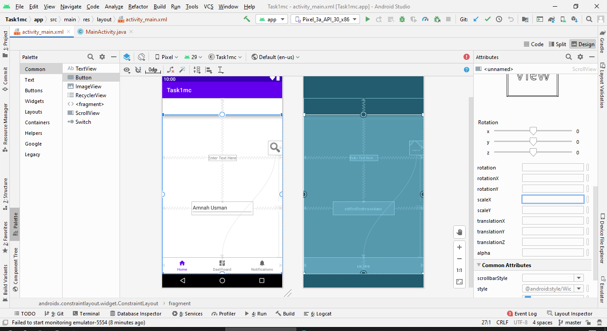

When we run it on Virtual device the output will be like this:

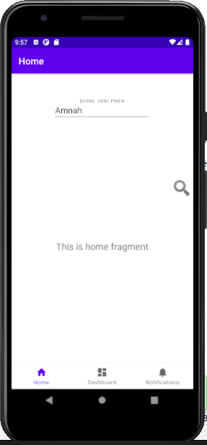

In **MainActivity.java** add a TODO task it will look like:

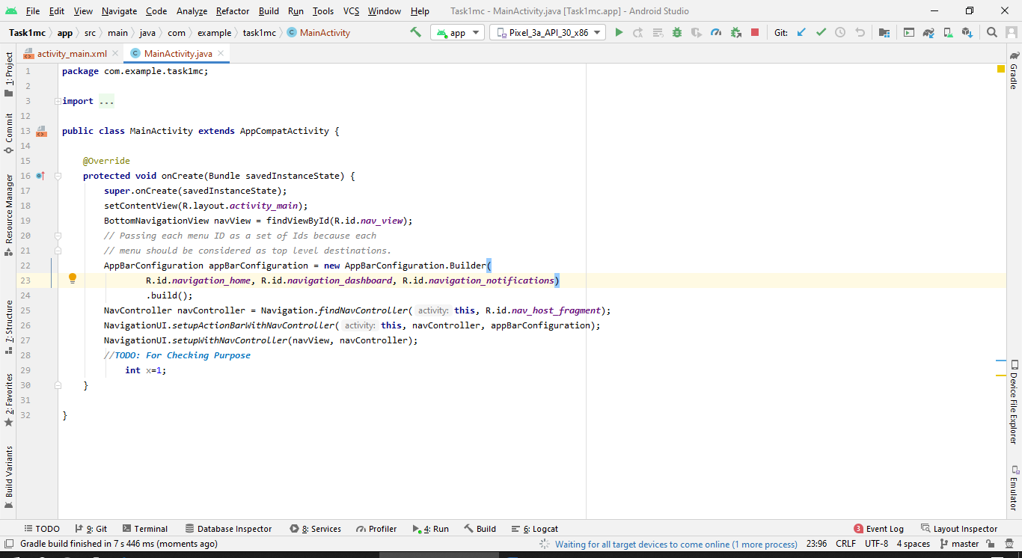

All the code will be written here.