Mobile Computing

Shoaib Raza

MCSF19M052

Introduction to Git& GitHub

Git Installation confimation:

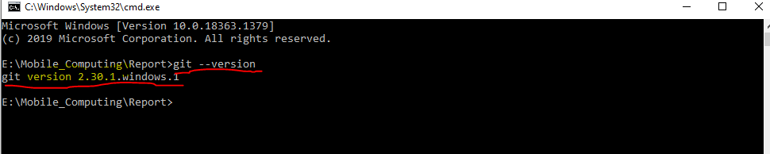

Creating a new repository on GitHub

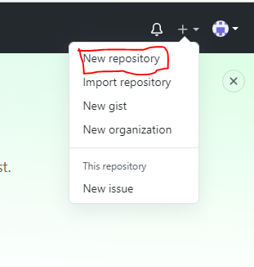

Choosing a suitable name and making it public:

Creating clone :

Coping repository link and execute “git clone url” in command prompt/Git bash

Clone has been created

For uploading a file on Git from local machine, we need to perform following commands:

1:git add filename

It tells Git that you want to include updates to a particular file in the next commit. However, git add doesn't really affect the repository in any significant way—changes are not actually recorded until you run git commit .

2:git commit –m “Any message”

The git commit command captures a snapshot of the project's currently staged changes

The git commit command saves all staged changes

3: git push

The git push command is used to upload local repository content to a remote repository.

File has been uploaded on git, BRAVO!!

Creating/Updating file from Git:

We can create a new file or update an existing file from git.

In order to reflect changes made on Git in local repository, we need

Run git pull command

Creating a new file on remote repository:

Name the file & making some changes:

Giving a message & commit the new file:

File has been uploaded :

Git Pull:

In order to reflect changes made on remote repository ,we run git pullcommand:

File has been pulled from remote:

Merge Conflict:

A merge conflict is an event that takes place when Git is unable to automatically resolve differences in code between two commits. Git can merge the changes automatically only if the commits are on different lines or branches.

Let’s change the Hello.py file remotely and locally in order to understand merge Conflict

Now if we try to push/pull the changes, we will be facing merge conflict:

*WHAT TO DO NOW??*

To resolve this conflict, just taking the best of both worlds.

Commit the changes and push these.

Merge Conflict has gone.