電通二甲微處理器實驗 實驗結報

實驗名稱 | Lab 06 – 音樂教室
組別 | 09 | 組員 | 04050555謝瑜軒  04052422武宏慧

- 實驗目的
* 如何使 Arduino 發出特定旋律的聲音?
Arduino 接喇叭如何接線?
如何使用 tone library?
如何演奏一段音樂?
如何使用 4x4 鍵盤演奏音樂?
如何發報摩斯電碼?
- 實驗步驟
*Arduino 演奏一段特定的音樂, 旋律不得是小蜜蜂
* 使用 4x4 鍵盤演奏音樂
* 發報摩斯電碼
- 程式碼
音階: void playTone(int tone, int duration) { for (long i = 0; i < duration * 1000L; i += tone * 2) { digitalWrite(speakerPin, HIGH); delayMicroseconds(tone); digitalWrite(speakerPin, LOW); delayMicroseconds(tone); } }
節拍: void playNote(char note, int duration) { char names[] = { 'c', 'd', 'e', 'f', 'g', 'a', 'b', 'C' }; int tones[] = { 1915, 1700, 1519, 1432, 1275, 1136, 1014, 956 }; // 利用比對字元的方式來播放某一個音階 for (int i = 0; i < 8; i++) { // 將比對到的音階高電位時間長度傳送給playTone函式播放 if (names[i] == note) playTone(tones[i], duration); } }
摩斯密碼:
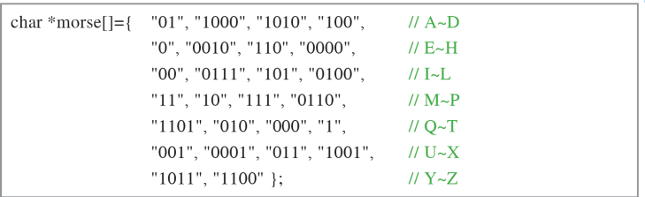
- 實驗結果及分析
實驗出有史以來最慘烈的兩隻老虎,摩斯密碼部份,喇叭跑不出聲音的問題挺嚴重的
- 心得討論
拖了好久的摩斯密碼中於生出來了,但喇叭不太給力,然後這個音頻放出來的音樂,真的只能用殺豬來形容=_=
- 修正電路圖
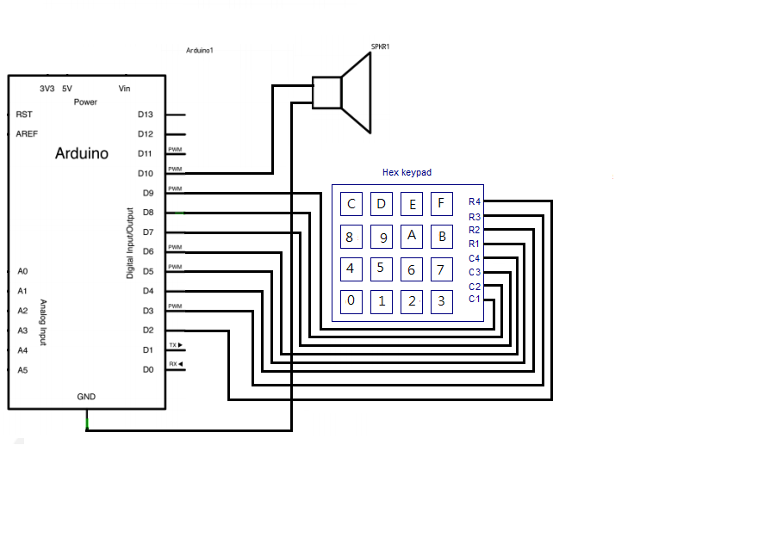
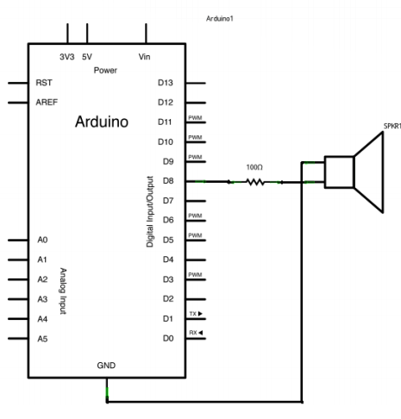
- 修正程式碼
1.
#define NOTE_zero 0
#define NOTE_HDo 1047
#define NOTE_HDoS 1109
#define NOTE_HRe 1175
#define NOTE_HReS 1245
#define NOTE_HMi 1319
#define NOTE_HFa 1397
#define NOTE_HFaS 1480
#define NOTE_HSo 1568
#define NOTE_HSoS 1661
#define NOTE_HLa 1760
#define NOTE_HLaS 1865
#define NOTE_HSi 1976
#define NOTE_HHDo 2094
#define NOTE_Si 988
#define WHOLE 1 //全分符
#define HALF 0.5 //半分符
#define QUARTER 0.25 //4
#define EIGHTH 0.125 //8
#define SIXTEENTH 0.0625 //16
int tune[] = { NOTE_zero, NOTE_Si, NOTE_HDo,
NOTE_HDoS, NOTE_HRe, NOTE_HMi, NOTE_HRe,
NOTE_zero, NOTE_HDoS, NOTE_HRe, NOTE_HMi,
NOTE_HFaS, NOTE_HLa, NOTE_HSo, NOTE_zero,
NOTE_HSi, NOTE_HHDo, NOTE_HLa, NOTE_HSi,
NOTE_HSo, NOTE_HLa, NOTE_HFa, NOTE_HSo,
NOTE_HFa, NOTE_HRe};
float duration[] = {
QUARTER,SIXTEENTH, SIXTEENTH, SIXTEENTH,
SIXTEENTH, SIXTEENTH, SIXTEENTH,EIGHTH,
SIXTEENTH, SIXTEENTH, SIXTEENTH,SIXTEENTH,
SIXTEENTH,SIXTEENTH,EIGHTH,
SIXTEENTH, SIXTEENTH, SIXTEENTH,SIXTEENTH,
SIXTEENTH, SIXTEENTH, SIXTEENTH,SIXTEENTH,
EIGHTH+SIXTEENTH,SIXTEENTH,
};
int length;
void setup() {
pinMode(8, OUTPUT);
length = sizeof(tune) /sizeof(tune[0]);
}
void loop() {
for (int x=0; x<length; x++) {
tone(8, tune[x]);
delay(2500 *duration[x]);
noTone(8);
}
delay(5000);
}
2.
#define LDo 131
#define LRe 139
#define LMi 147
#define LFa 156
#define LSo 165
#define LLa 175
#define LSi 185
#define Do 262
#define Re 294
#define Mi 330
#define Fa 349
#define So 392
#define La 440
#define Si 494
#define HSo 523
#define HLa 587
#define HSi 659
int tune[] = {LDo,LRe,LMi,LFa,LSo,LLa,LSi,Do,Re,Mi,Fa,So,La,Si,HSo,HLa,HSi};
#include <Keypad.h>
const byte ROWS = 4;
const byte COLS = 4;
char keys[ROWS][COLS]={
{'F','E','D','C'},
{'B','3','6','9'},
{'A','2','5','8'},
{'0','1','4','7'}
};
byte rowPins[ROWS]={6,7,8,9};
byte colPins[COLS]={2,3,4,5};
Keypad keypad = Keypad(makeKeymap(keys),rowPins,colPins,ROWS,COLS);
void setup() {
Serial.begin(9600);
pinMode(13, OUTPUT);
}
void loop() {
char key = keypad.getKey();
if (key!=NO_KEY){
if(key>='A' && key<='F')
{
key = key - 'A' + 10;
}
if(key>='0' && key <='9')
{
key = key -'0';
}
Serial.println(key);
tone(13,tune[key]);
delay(200);
noTone(13);
}
}
3.
char *morse[]={
"01","1000","1010","100", //A~D
"0","0010","110","0000", //E~H
"00","0111","101","0100", //I~L
"11","10","111","0110", //M~P
"1101","010","000","1", //Q~T
"001","0001","11","1001", //U~X
"1011","1100" //Y~Z
};
const byte Buzzer=10;
char chr,index;
char *ptr;
void setup() {
pinMode(Buzzer,OUTPUT);
Serial.begin(9600);
}
void loop() {
if( Serial.available() ){
chr=Serial.read();
Serial.println(chr);
if( (chr-'A')>=0 && (chr-'Z')<=0 ){
index=chr-'A';
ptr=morse[index];
while(*ptr!='\0'){
if(*ptr=='0'){
tone(Buzzer,440,100);
delay(100);
}
else{
tone(Buzzer,440,300);
delay(300);
}
ptr++;
delay(100);
}
delay(300);
}
else
delay(700);
}
}

