電通二乙微處理器實驗 實驗結報

實驗名稱 | Arduino circuits 與 github使用
組別 | 09 | 組員 | 謝瑜軒04050555  武宏慧04052422

- 實驗目的
Arduino模擬 與github運用
- 實驗步驟
- 註冊circuits.io
- New element lab
- Components
- 拖入元件
- 連接電路
- 編譯

- 程式碼
before
// _ ___ _______ ___ ___ ___ ___ _ _ ___ _____ ___
// / |_ )__ / \ / __|_ _| _ \/ __| | | |_ _|_ _/ __|
// | |/ / |_ \ |) | | (__ | || / (__| |_| || | | | \__ \
// |_/___|___/___/ \___|___|_|_\\___|\___/|___| |_| |___/
//
// The Unnamed Circuit
//
// Made by Jason Sieh
// License: CC-BY-SA 3.0
// Downloaded from: https://circuits.io/circuits/4059831-the-unnamed-circuit
// Pin 13 has an LED connected on most Arduino boards.
// give it a name:
int led = 13;
// the setup routine runs once when you press reset:
void setup() {
// initialize the digital pin as an output.
pinMode(led, OUTPUT);
}
// the loop routine runs over and over again forever:
void loop() {
digitalWrite(led, HIGH); // turn the LED on (HIGH is the voltage level)
delay(1000); // wait for a second
digitalWrite(led, LOW); // turn the LED off by making the voltage LOW
delay(1000); // wait for a second
}

- 實驗結果及分析
Int lab=13; L燈閃爍;
改成Int lab=9;L燈不閃爍;
Delay由1000改成500;LED燈閃爍頻率變快

- 心得討論
第一次使用github,很難了解,
網頁板arduino很方便模擬

- 修正電路圖
before
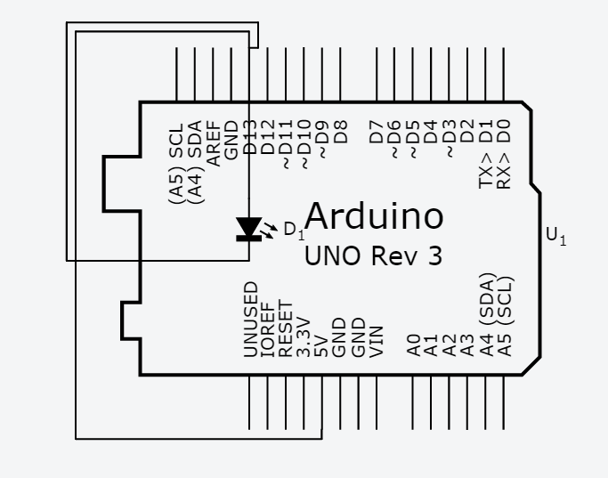
after
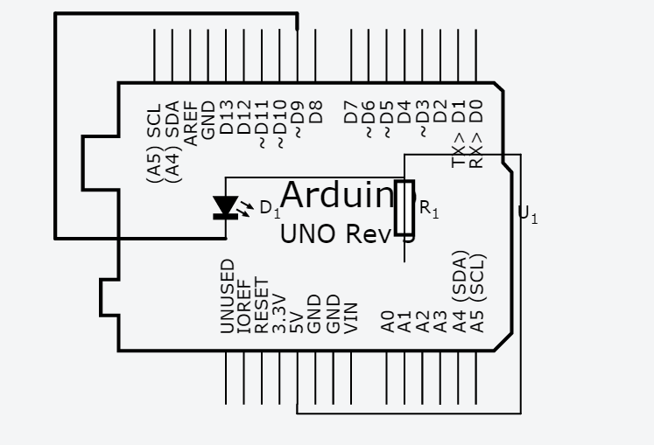
- 修正程式碼
after
// _ ___ _______ ___ ___ ___ ___ _ _ ___ _____ ___
// / |_ )__ / \ / __|_ _| _ \/ __| | | |_ _|_ _/ __|
// | |/ / |_ \ |) | | (__ | || / (__| |_| || | | | \__ \
// |_/___|___/___/ \___|___|_|_\\___|\___/|___| |_| |___/
//
// The Unnamed Circuit
//
// Made by Jason Sieh
// License: CC-BY-SA 3.0
// Downloaded from: https://circuits.io/circuits/4059831-the-unnamed-circuit
// Pin 13 has an LED connected on most Arduino boards.
// give it a name:
int led = 13;
// the setup routine runs once when you press reset:
void setup() {
// initialize the digital pin as an output.
pinMode(led, OUTPUT);
}
// the loop routine runs over and over again forever:
void loop() {
digitalWrite(led, HIGH); // turn the LED on (HIGH is the voltage level)
delay(500); // wait for a second
digitalWrite(led, LOW); // turn the LED off by making the voltage LOW
delay(1000); // wait for a second
}

