電通二乙微處理器實驗 實驗預報

實驗名稱 | Lab 04 –四合一七段顯示器
組別 | 09 | 組員 | 謝瑜軒04050555  武宏慧04052422

- 實驗目的
了解七段顯示器之顯示原理
- 實驗步驟\
Arduino 接好四合一七段顯示器之電路 * 四合一七段顯示器每隔 0.3 秒鐘會跳一個數字, 從 0000 -> 0059 -> 0100 -> 跳至 2359 後歸零
- 程式碼
1
#include "SevSeg.h" SevSeg sevseg; //Instantiate a seven segment object void setup() { byte numDigits = 4; byte digitPins[] = {2, 3, 4, 5}; byte segmentPins[] = {6, 7, 8, 9, 10, 11, 12, 13}; sevseg.begin(COMMON_ANODE, numDigits, digitPins, segmentPins);
Setting the Number sevseg.setNumber(3141,3); // Displays '3.141’
sevseg.setNumber(Hour * 100 + Min, 0); Min = Min + 1; If Min == 60 { Min = 0, If (Hour == 23) Hour=0 else Hour++ } sevseg.refreshDisplay(); sleep 0.3 second
2.
Pin10= DigitalRead (D10) // Reset If (Pin10 == LOW) Min = Hour = 0; sevseg.setNumber(Hour * 100 + Min, 0) Min = Min + 1; If Min == 60 { Min = 0, If (Hour == 23) Hour=0 else Hour++ } sevseg.refreshDisplay(); sleep 0.3 second
3.
Pin10= DigitalRead (D10) // Reset Pin11 = DigitalRead (D11) // Reverse If (Pin10 == LOW) Min = Hour = 0; If (Pin11 ==LOW) step = -1 // Reverse else step = 1 sevseg.setNumber(Hour * 100 + Min, 0) Min = Min + step; If Min == 60 {…} // overflow If Min == -1 { Min = 59, If (Hour == -1) Hour = 23 else Hour-- } // underflow sevseg.refreshDisplay(); sleep 0.3 second
- 電路圖
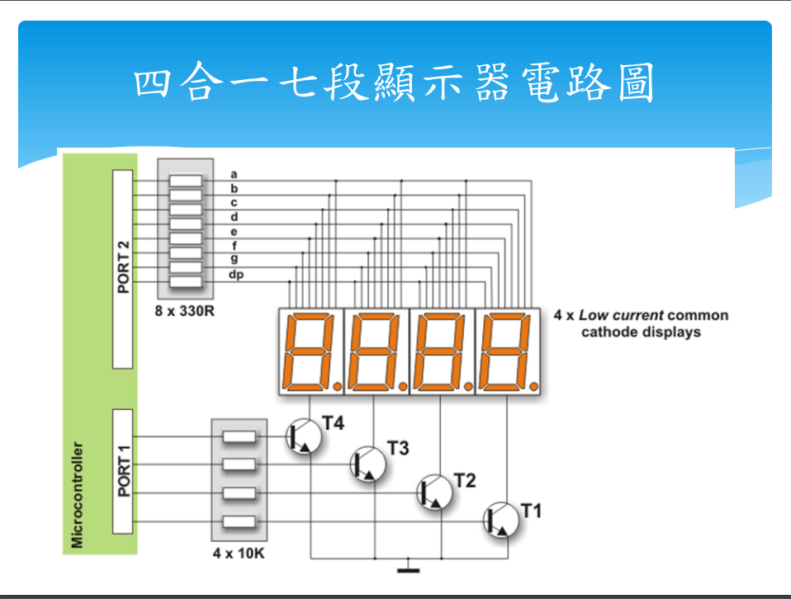
- 電路圖
