電通二甲微處理器實驗 實驗結報

實驗名稱 | Lab 09 –中斷控制與超音波測距
組別 | 09 | 組員 | 04050555謝瑜軒  04052422武宏慧

- 實驗目的
Arduino 於 當按下 Pin 2 外部中斷 0 時, 讀入超音波測距 之值並顯示於 PC上
- 實驗步驟
* 讀取超音波測距之值並顯示在 LCD 上
*規劃外部中斷 INT0
*暫停/重新打開中斷
- 程式碼
1.
// HCSR04Ultrasonic/examples/UltrasonicDemo/UltrasonicDemo.pde #include #define TRIGGER_PIN 12 #define ECHO_PIN 13 Ultrasonic ultrasonic(TRIGGER_PIN, ECHO_PIN); void setup() { Serial.begin(9600); } void loop(){ float cmMsec, inMsec; long microsec = ultrasonic.timing(); cmMsec = ultrasonic.convert(microsec, Ultrasonic::CM); // 計算距離，單位: 公分 inMsec = ultrasonic.convert(microsec, Ultrasonic::IN); // 計算距離，單位: 英吋 Serial.print("MS: "); Serial.print(microsec); Serial.print(", CM: "); Serial.print(cmMsec); Serial.print(", IN: "); Serial.println(inMsec); delay(1000); }
2.
const byte intPin=2; //interrupt pin const byte ledPin=13; //built-in LED volatile boolean state=LOW; //initial value of switch pin void setup() { pinMode(ledPin, OUTPUT); pinMode(intPin, INPUT_PULLUP); //enable pull-up resistor of input pin digitalWrite(ledPin, ledState); //set LED OFF attachInterrupt(0, int0, LOW); //assign int0 } void loop() { if (state) {digitalWrite(ledPin, HIGH);} //turn LED on else {digitalWrite(ledPin, LOW);} //turn LED off } void int0() { //interrupt handler state=!state; //reverse state }
- 實驗結果及分析
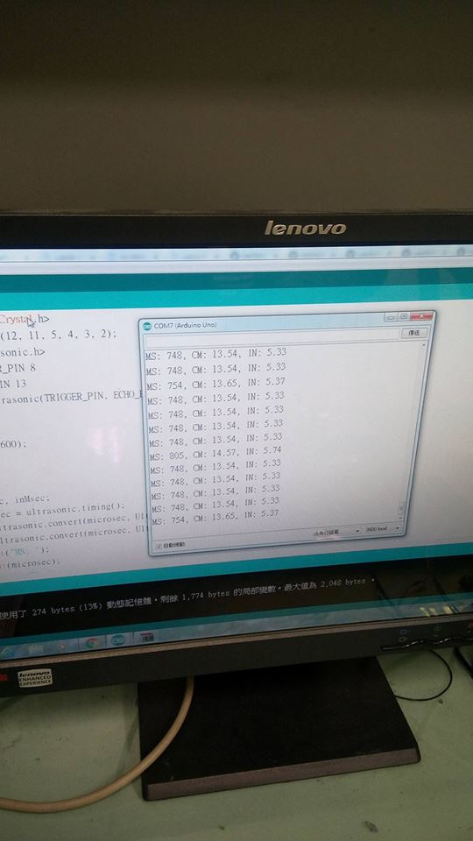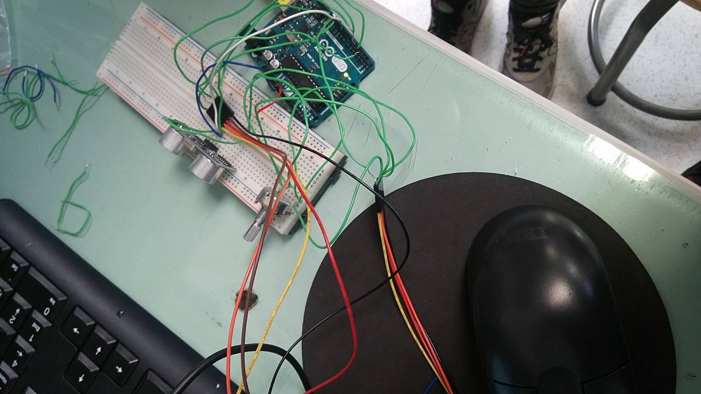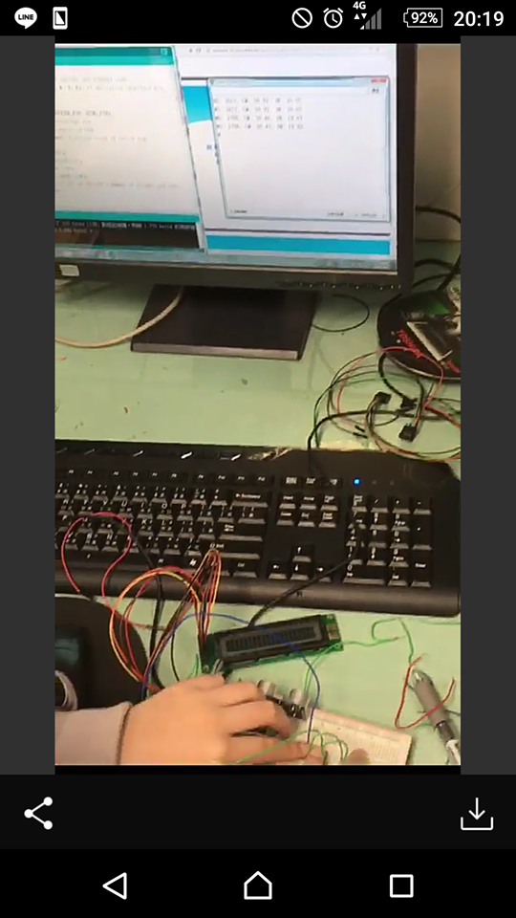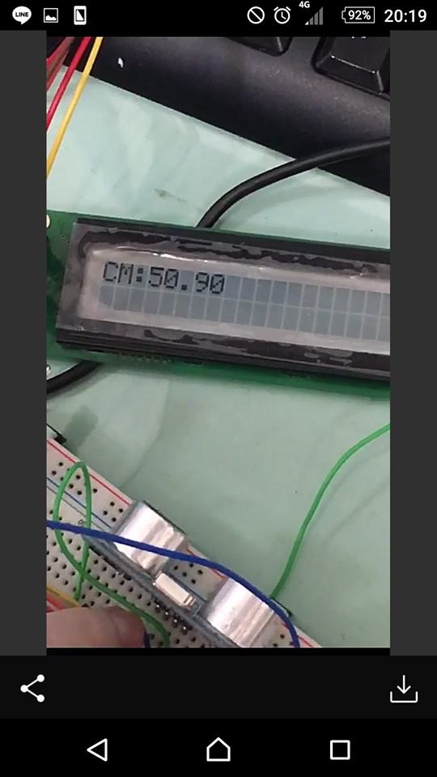
- 心得討論
檢查2.遇到監控窗無法讀取出字的狀況,後來發現是因為中斷的pinmode要接在固定腳位上才行,然後,我們在老師走後不到5分鐘完成檢查3,希望能通過
- 修正電路圖
1.2
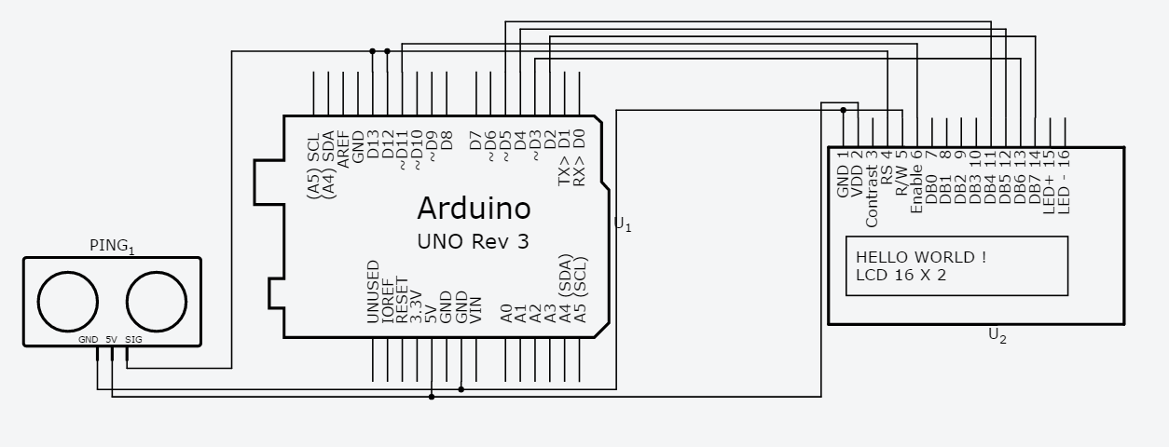

3
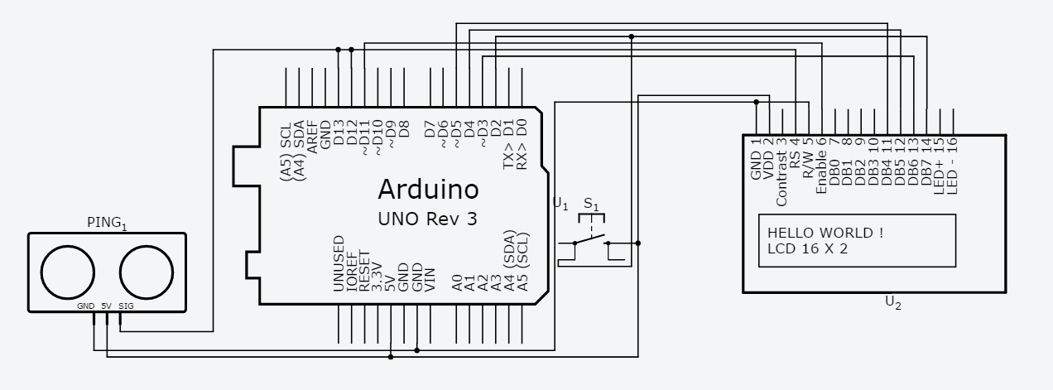
- 修正程式碼
1.
#include <LiquidCrystal.h>
LiquidCrystal lcd(12, 11, 5, 4, 3, 2);
#include <Ultrasonic.h>
#define TRIGGER_PIN 8
#define ECHO_PIN 13
Ultrasonic ultrasonic(TRIGGER_PIN, ECHO_PIN);
void setup()
{
Serial.begin(9600);
}
void loop()
{
float cmMsec, inMsec;
long microsec = ultrasonic.timing();
cmMsec = ultrasonic.convert(microsec, Ultrasonic::CM);
inMsec = ultrasonic.convert(microsec, Ultrasonic::IN);
Serial.print("MS: ");
Serial.print(microsec);
Serial.print(", CM: ");
Serial.print(cmMsec);
Serial.print(", IN: ");
Serial.println(inMsec);
lcd.print("CM:");
lcd.print(cmMsec);
delay(1000);
lcd.clear();
}

2.3
#include <Ultrasonic.h>
#include <LiquidCrystal.h> // include the library code
LiquidCrystal lcd(12, 11, 5, 4, 3, 6); // initialize interface pins
#define TRIGGER_PIN 8
#define ECHO_PIN 7
Ultrasonic ultrasonic(TRIGGER_PIN, ECHO_PIN);
const byte intPin=2; //interrupt pin
const byte ledPin=13; //built-in LED
volatile boolean state=1; //initial value of switch pin
void setup() {
pinMode(ledPin, OUTPUT);
pinMode(intPin, INPUT_PULLUP);
digitalWrite(ledPin, LOW);
attachInterrupt(0, int0, LOW);
lcd.begin(20, 2); // set up the LCD's number of columns and rows:
Serial.begin(9600);
}
void loop() {
}
void int0() {
if (state)
{digitalWrite(ledPin, HIGH);
}
else
{digitalWrite(ledPin, LOW);
}
float cmMsec, inMsec;
long microsec = ultrasonic.timing();
cmMsec = ultrasonic.convert(microsec, Ultrasonic::CM); // 計算距離，單位: 公分
inMsec = ultrasonic.convert(microsec, Ultrasonic::IN); // 計算距離，單位: 英吋
Serial.print("MS: ");
Serial.print(microsec);
Serial.print(", CM: ");
Serial.print(cmMsec);
Serial.print(", IN: ");
Serial.println(inMsec);
lcd.print("CM:");
lcd.print(cmMsec);
//lcd.print(ultrasonic.convert(microsec, Ultrasonic::CM));
delay(100000);
lcd.clear();
state=!state;
}

