電通二甲微處理器實驗 實驗結報

實驗名稱 | Lab 12 – WiFi Module
組別 | 09 | 組員 | 04050555謝瑜軒  04052422武宏慧

- 實驗目的
*使用 ESP-01 Wifi 模組, 使得 Arduino 變成一台 Web 伺服器
*可讓外界讀取溫濕度模組 DHT-11 數值
- 實驗步驟
- 1. 使用 SoftwareSerial 範例程式, 建立與 ESP-8266 之連線 (BaudRate: 115200)
- 測試使用 Serial Monitor 傳送 ESP-8266之 AT command
- 將 ESP-8266 設定成 AP Mode
- 使用手機搜尋是否找得到 ESP-8266 之基地台
- 撰寫 Arduino 程式接受手機 Web 連線
- 輸出 DHT-11 模組數值

- 程式碼
Software serial multple serial test
Receives from the hardware serial, sends to software serial.
Receives from software serial, sends to hardware serial.
The circuit:
* RX is digital pin 10 (connect to TX of other device)
* TX is digital pin 11 (connect to RX of other device)
Note:
Not all pins on the Mega and Mega 2560 support change interrupts,
so only the following can be used for RX:
10, 11, 12, 13, 50, 51, 52, 53, 62, 63, 64, 65, 66, 67, 68, 69
Not all pins on the Leonardo and Micro support change interrupts,
so only the following can be used for RX:
8, 9, 10, 11, 14 (MISO), 15 (SCK), 16 (MOSI).
created back in the mists of time
modified 25 May 2012
by Tom Igoe
based on Mikal Hart's example
This example code is in the public domain.
*/
#include <SoftwareSerial.h>
SoftwareSerial mySerial(10, 11); // RX, TX
void setup() {
// Open serial communications and wait for port to open:
Serial.begin(57600);
while (!Serial) {
; // wait for serial port to connect. Needed for native USB port only
}
Serial.println("Goodnight moon!");
// set the data rate for the SoftwareSerial port
mySerial.begin(4800);
mySerial.println("Hello, world?");
}
void loop() { // run over and over
if (mySerial.available()) {
Serial.write(mySerial.read());
}
if (Serial.available()) {
mySerial.write(Serial.read());
}
}
- 實驗結果及分析
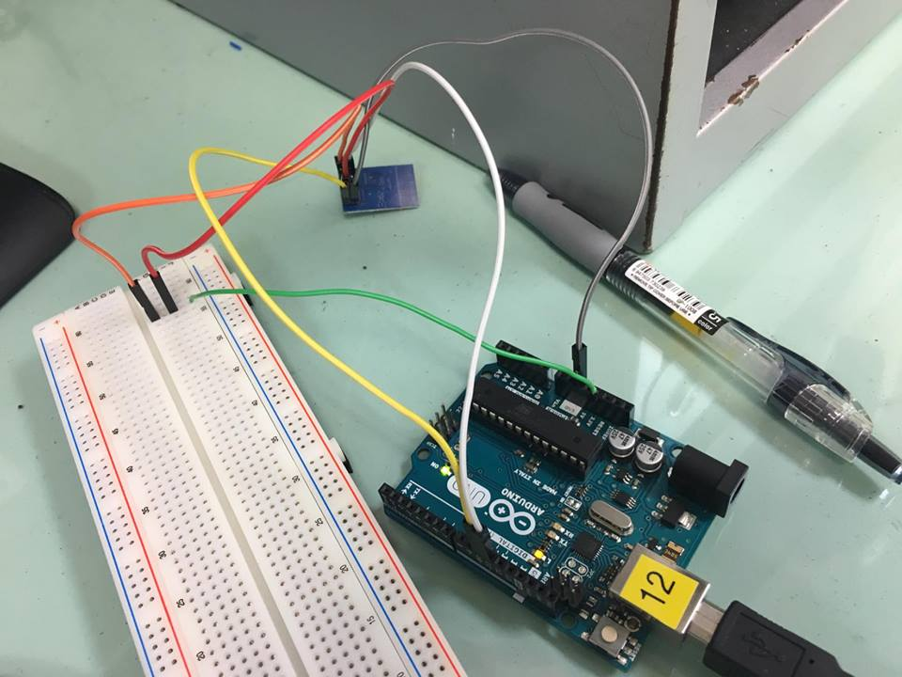
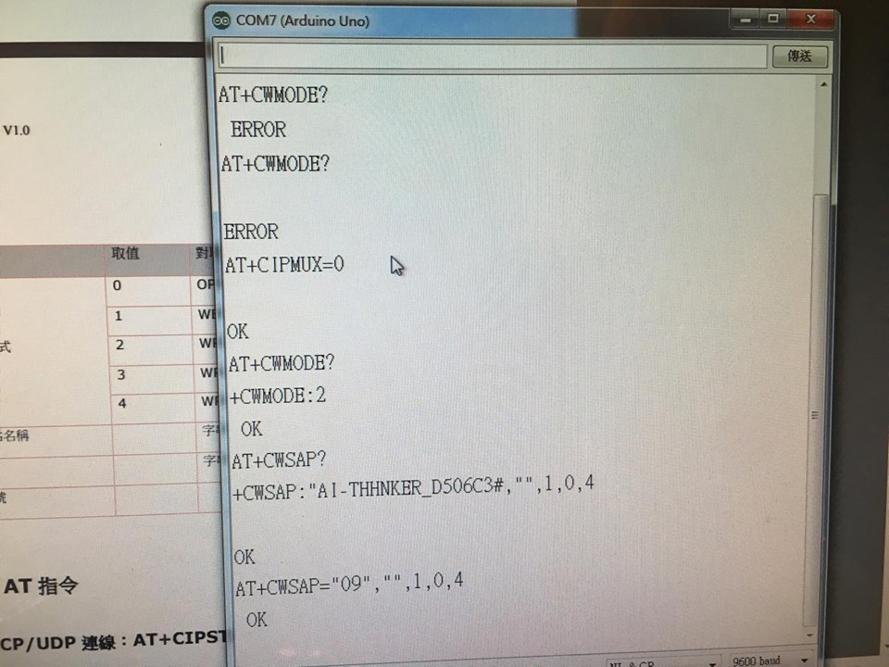
- 心得討論
指令要記熟,然後接縣政負極要接正確,這次實驗差點把版子給燒了==”
- 修正電路圖
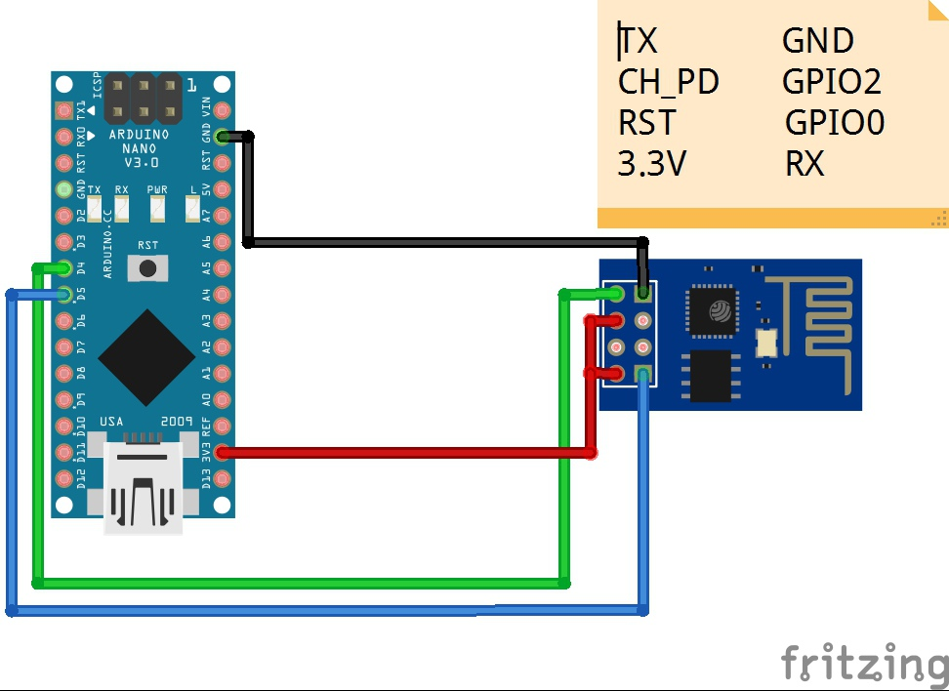
- 修正程式碼

#include <SoftwareSerial.h>
SoftwareSerial Serial1(10,11); // RX, TX
void setup(){
Serial1.begin(115200);
Serial.begin(9600);
Serial.println("START");
}
void loop(){
if (Serial1.available())
{
Serial.write(Serial1.read());
}
if (Serial.available())
{
char chars=Serial.read();
Serial1.write(chars);
}
}

