MCZbase Development Guidelines

Table of Contents

Contents

[Look and Feel 2](#_Toc24019983)

[Identity Style Guidelines 2](#_Toc24019984)

[Colors: 2](#_Toc24019985)

[Buttons 4](#_Toc24019986)

[Modal Boxes 4](#_Toc24019987)

[Menus 4](#_Toc24019988)

[Functional Requirements: 4](#_Toc24019989)

## Look and Feel

The “look and feel” is a term used with respect to a graphical user interface and comprises aspects of its design, including elements such as colors, shapes, layout, and typefaces (the "look"), as well as the behavior of dynamic elements such as buttons, boxes, and menus (the "feel").

The content should be accessible from any device and display similarly on popular browsers. The look and operation of the site should be consistent across pages allowing users to find and edit content without much instruction.

### Identity Style Guidelines

### **Colors:**

The following styles and functions will be followed throughout the website for consistency.

|  |  |  |  |  |  |
| --- | --- | --- | --- | --- | --- |
| **Name** | **Swatch** | **Pantone** | **CMYK** | **RGB** | **HEX** |
| Colors for Major Website Elements | | | | | |
| Crimson – header background |  | PMS 187U  PMS 1807C | **C=** 7  **M=** 94  **Y=** 65  **K=** 25 | **R=** 165 **G=** 28 **B=** 48 | A51C30 |
| Ink – header background |  | PMS Process Black U PMS Process Black C | **C**= 0 **M**= 0 **Y**= 0 **K**= 100 | **R**= 30 **G**= 30 **B**= 30 | 1E1E1E |
| Bookmark Blue – search background |  | PMS 7683 C | **C**= 82 **M=** 50 **Y**= 7 **K**= 0 | **R=** 50 **G=** 118 **B=** 177 | 3E6F7D |
| Shade – footer background |  | PMS 7542 U PMS 7542 C | **C**= 27 **M**= 16 **Y**= 18 **K**= 0 | **R**= 186 **G**= 197 **B**= 198 | BAC5C6 |
| Light Shade – column headers |  | PMS 7544 U  PMS 7544 C | **C**= 12 **M=** 2 **Y**= 6 **K**= 0 | **R=** 222 **G=** 235 **B=** 236 | DEEBEC |
| Links and accents | | | | | |
| Blue Highlight – Text record anchor links |  |  | **C**= 78 **M=** 53 **Y**= 0 **K**= 0 | **R=** 0 **G=** 123 **B=** 255 | 007BFF |
| Blue Highlight – Text major elements anchor links |  | PMS 3005 U | **C**= 99 **M=** 22 **Y**= 0 **K**= 1 | **R=** 0 **G=** 72 **B=** 112 | 004870 |
| Lemon – not used yet but could be a nice accent |  | PMS 120 U  PMS 120 C | **C**= 0 **M**= 9 **Y**= 58 **K**= 0 | **R**= 255 **G**= 219 **B**= 109 | FFDB6D |
| Green – used for text accents |  |  |  | **R**= 0 **G**= 97 **B**= 0 | 006100 |

Typography:

The font-family being used for the body is:

font-family: -apple-system, system-ui, BlinkMacSystemFont, "Segoe UI", Roboto, "Helvetica Neue", Arial, sans-serif;

Bootstrap:



Jqxgrid:



Arial:

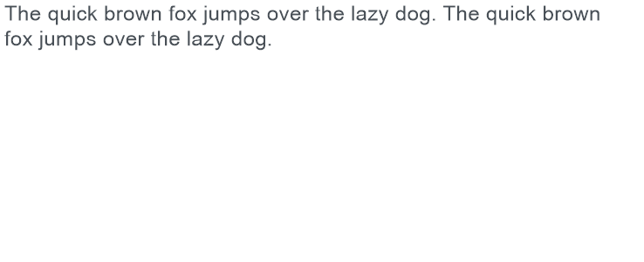

Neue Helvetica:

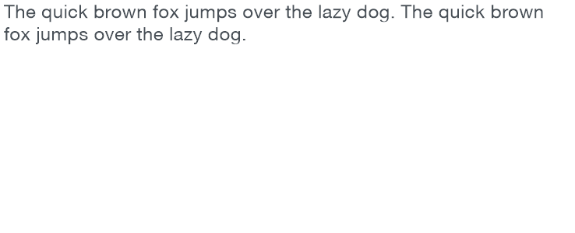

Roboto:

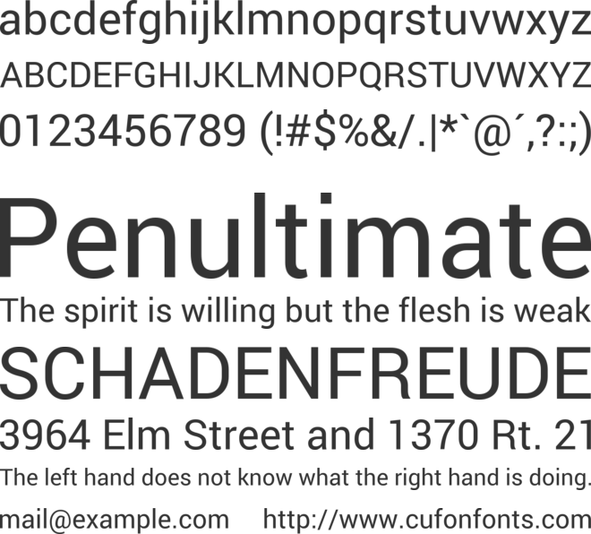

Logos:

MCZ Logo:

The logo consists of the Kronosaurus image with alt text of “Museum of Comparative Zoology Logo – Kronosaurus” so that it can be read by a screen reader. It is linked to the MCZ website [www.mcz.harvard.edu](http://www.mcz.harvard.edu).

|  |  |
| --- | --- |
| Hex Color Code | #FFFFFF |
| RGB Decimal | rgb(255, 255, 255) |
| CMYK | 0 0 0 0 |

C:\Users\mkennedy01\Documents\Sites\mczbase-dev_3may2019\redesign\includes\images\mcz_logo_white_wRed.jpg

Figure 1: MCZ logo--Kronosaurus skeleton image

The logo is white and sits on the banner of crimson:

Harvard Logos:

The Harvard Shield is used at the top and bottom of the webpage. The copyright information with links to the privacy statement and user agreement are at the bottom.



Header Harvard Logo – left side



Footer Harvard MCZ Logo – centered

Harvard University standard footer appears centered below the Harvard MCZ logo in the footer.



### Buttons

### Modal Boxes

### Menus

## Functional Requirements:

Return of Search Results:

Search results should initially be in the form of a table (similar to an Excel spreadsheet). Clicking on a row opens a record or provides more data about the row.