# Reading Data From Files

## Possible imports needed

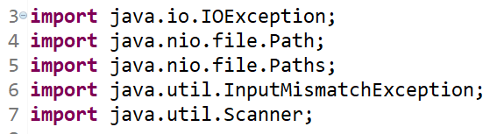

## To access file data use Path object

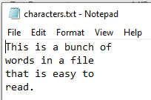

Checked – checked at compile time, programmer is required to handle.

Un checked, aka runtime exceptions – not checked at compile time, programmer is not required to handle them

When do we catch exceptions?

1. When you are sure you can improve the experience of the person debugging your application.

2. When your software can recover gracefully from an expected exception.

Checked vs Unchecked: Following is the bottom line from Java documents  
If a client can reasonably be expected to recover from an exception, it is a checked exception. If a client cannot do anything to recover from the exception, it is an unchecked exception.

## Scanner methods to read character data from the file







### Example of reading one WORD at a time:

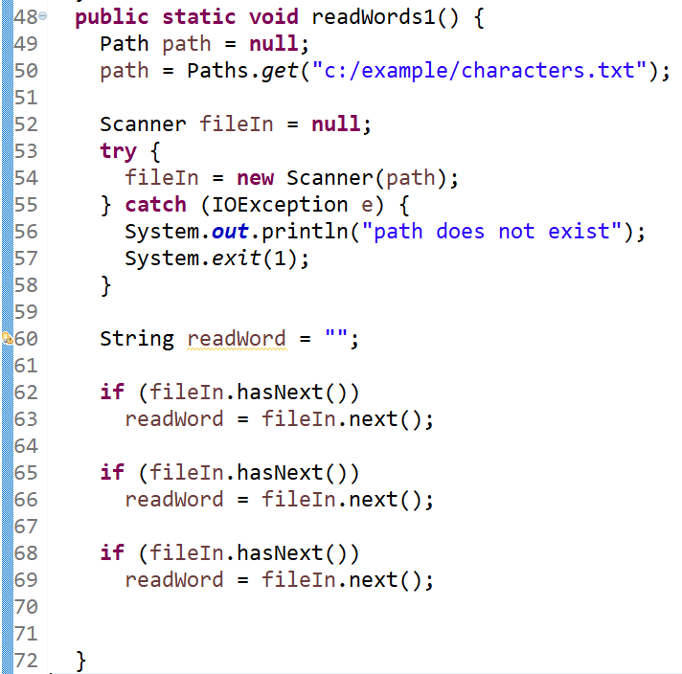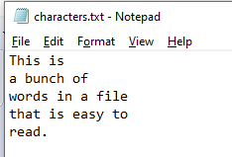

# Using a while loop to read every word in the file

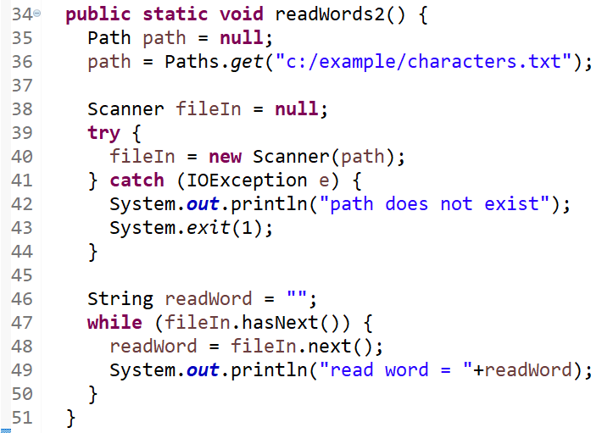

### Example of reading one LINE at a time:

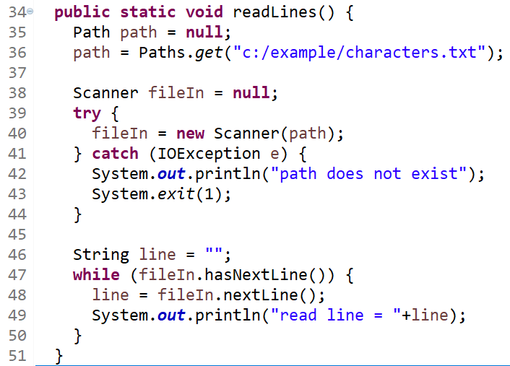

## Scanner methods to read integer data from the file



### Example of reading one integer at a time:

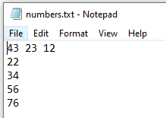

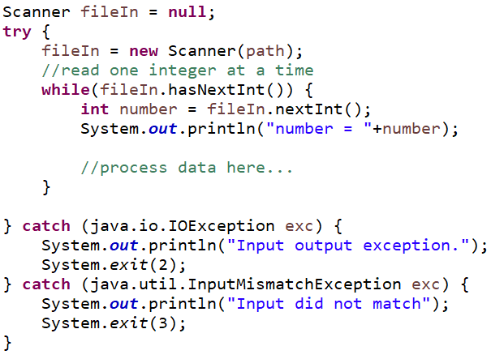

# Read String data as Integers

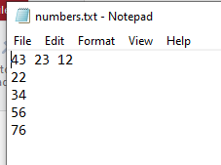

# Read String data as Integers, catch unchecked exception

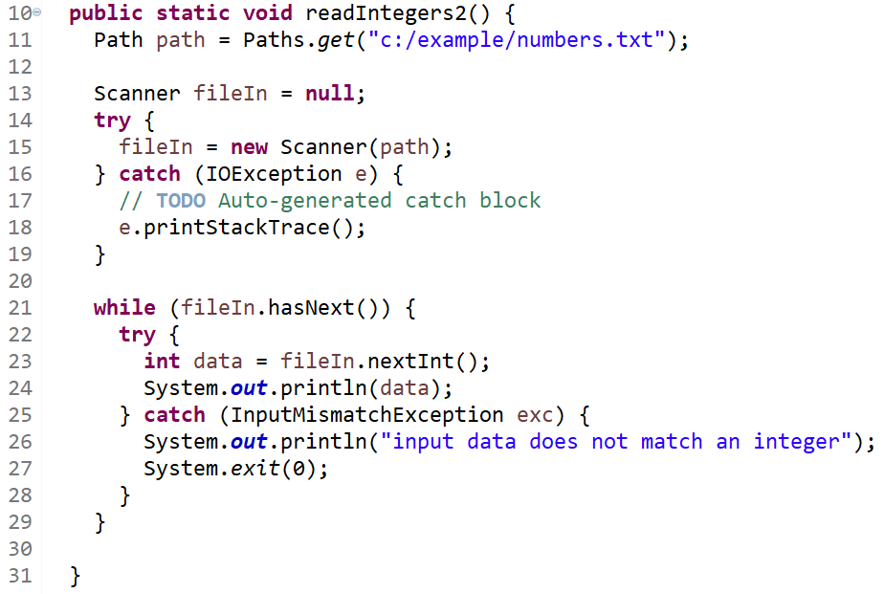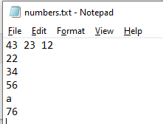

## Stream of data

