CIS 1250 Python Program11 –GRAPHICAL USER INTERFACE

# Turn in Requirements:

5 pts. Name your project LastnameP9, such as GarnerP10.

# Program Requirements:

1. 5 pts. Write the file name, your name, email address and purpose of the program at the top of your library source code in a comment.

# GarnerP11

# Programmer: Rob Garner

# EMail: Rgarner7 @cnm.edu

# Purpose: demonstrate how to use a GUI

1. 5 pts. Add comments as appropriate. Be sure that your program output is neatly presented to the user. Add documentation comments to your functions.
2. You are going to make a Graphical User Interface for the class you made in program 10.
3. The GUI should have a textbox where the user can enter the name of a file that contains a list of points and descriptions.
4. The GUI should have two more text boxes where the user can enter their coordinates.
5. The GUI should have a button the user can click.
6. When the user clicks the button the program should read the points from the file, create a point representing the user’s location from the coordinate textboxes, and finally display a message in another textbox that says something like:

You are closest to <description> which is located at <point’s x, y, z coordinates>

# Hints

1. You can reuse program 10 as a library. The GeoPoint class should be fine as is.
2. You can take the functionality in the main part of the program 10 place it in the Button click event handler and modify it as needed.
3. Alternatively, you can modify the functionality in the main part of the program 10 and turn it into functions in your library that you will call from the Button click event handler in your GUI.
4. A third, and likely most correct, method is to take the functionality in the main part of program 10 and create a GeoPointsList class that has a list of GeoPoints, a method that finds closest, and a method that loads points from file name. Then use that class in the Button click event handler in your GUI.
5. To install wxPython from home go to <http://www.wxpython.org/>. You will need to install the same the version of wxPython that matches your version of python. If you open a python IDLE you will see the python version and whether it is win23 or win64 at the top:

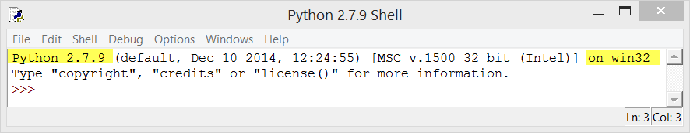

If you have the information above, you would pick wxPython3.0-win32-py27:

