CIS 1250 Python Program2 – State info

# Turn in Requirements:

5 pts. Name your project LastnameP1, such as NelsonE2.

# Documentation Requirements:

1. 5 pts. Write the file name, your name, email address and purpose of the program at the top of your source code in a comment.

# GarnerP2

# Programmer: Rob Garner

# EMail: Rgarner7 @cnm.edu

# Purpose: provides user capability to view contact info

1. 5 pts. Add comments as appropriate. Be sure that your program output is neatly presented to the user.

# Problem:

Write a program that will display information for a state typed in by the user. When the user types in the name of a state the program should display the state’s capital, number of congressional districts and the order the state joined the union (1st 2nd 3rd etc).

# Program

1. Your program will initialize lists to store information about the states. You should have one list for the names of the states, one list for the names of the capitals, one list for the number of districts per state and one list for the order number the state joined the union. Alternatively you can use a db list of lists as demonstrated in the exercises in the book to store the information in one structure.
2. Next ask the user to enter a name of a state.
3. Find the index of that name.
4. Use that index to report back to the user the name of the capital, the number of congressional districts and the order the state joined the union.
5. Program should look something like this:

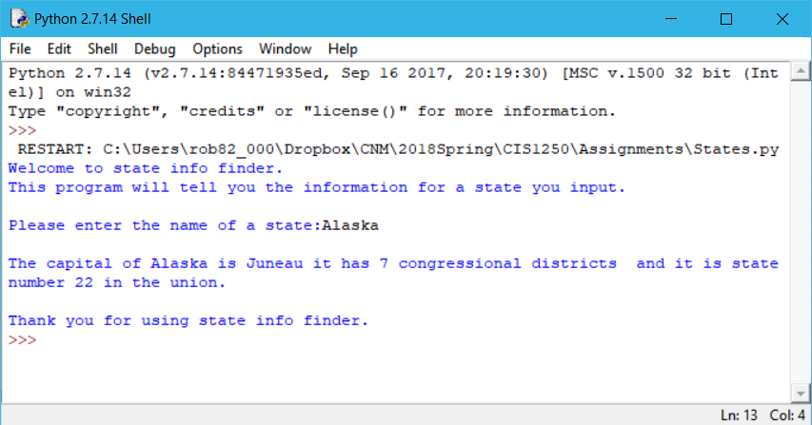

# Hints:

In order to see output with a program you have to use the print statement. Programs do not automatically output the results of expressions the same way the interactive interpreter does.

Use the index function to find the index of the name entered by the user (example: names.index(userInput) would return the index of userInput in the names list.).