CIS 1250 Python Program3 – FRUITFINDER

# Turn in Requirements:

5 pts. Name your project LastnameP3, such as GarnerP3.

# Program Requirements:

1. 5 pts. Write the file name, your name, email address and purpose of the program at the top of your source code in a comment.

# GarnerP3

# Programmer: Rob Garner

# EMail: Rgarner7 @cnm.edu

# Purpose: provides user capability to find fruit in a string

1. 5 pts. Add comments as appropriate. Be sure that your program output is neatly presented to the user.
2. Write a program that does the following:
   1. Creates a sequence that has the names of seven fruits.
   2. Asks the user for a sentence.
   3. Tells the user how many fruits are in that sentence.
   4. Displays a list of fruits in the sentence.
   5. Finds and replaces one instance of a fruit in the sentence with “Brussel Sprouts”.
   6. Displays the new sentence to the user.
3. The program should be able to find fruits whether they are capitalized or not. To do this use the .lower() method. Do not just put both upper and lower case versions in the fruit list.
4. Program should look something like this:

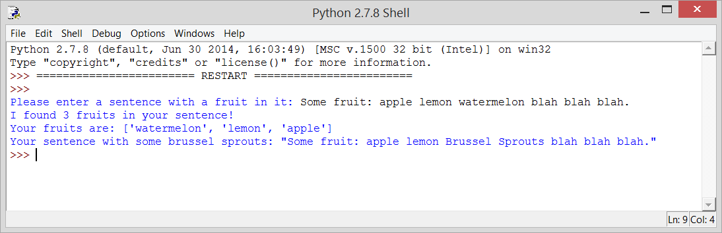

# Hints:

You can use list(set(list1)&set(list2)) or list(set(list1).intersection(set(list2))) to find the intersection of list1 and list2. See http://stackoverflow.com/questions/642763/python-intersection-of-two-lists.

I used the .split() method, the len(list) function and the string.replace(string1,string2) method.

To find the one instance of a fruit you can just use index 0 of the intersection list (intersecList[0] for example).

Review conversion specifiers in strings.