ESM_2. Grid points map and wood species
Carrero-Pazos, et al. Material type bias in radiocarbon-based diffusion models affects spatial models of Iberian megalithic origin and spread
2.1. Figure A. Grid Points used for quantile regression search
1,000 regular grid points (approx. 30 km spacing) used to conduct the unconstrained search for the best-fitting single source of megalithic spread across the Iberian Peninsula. These points serve as potential origins in the quantile regression models.
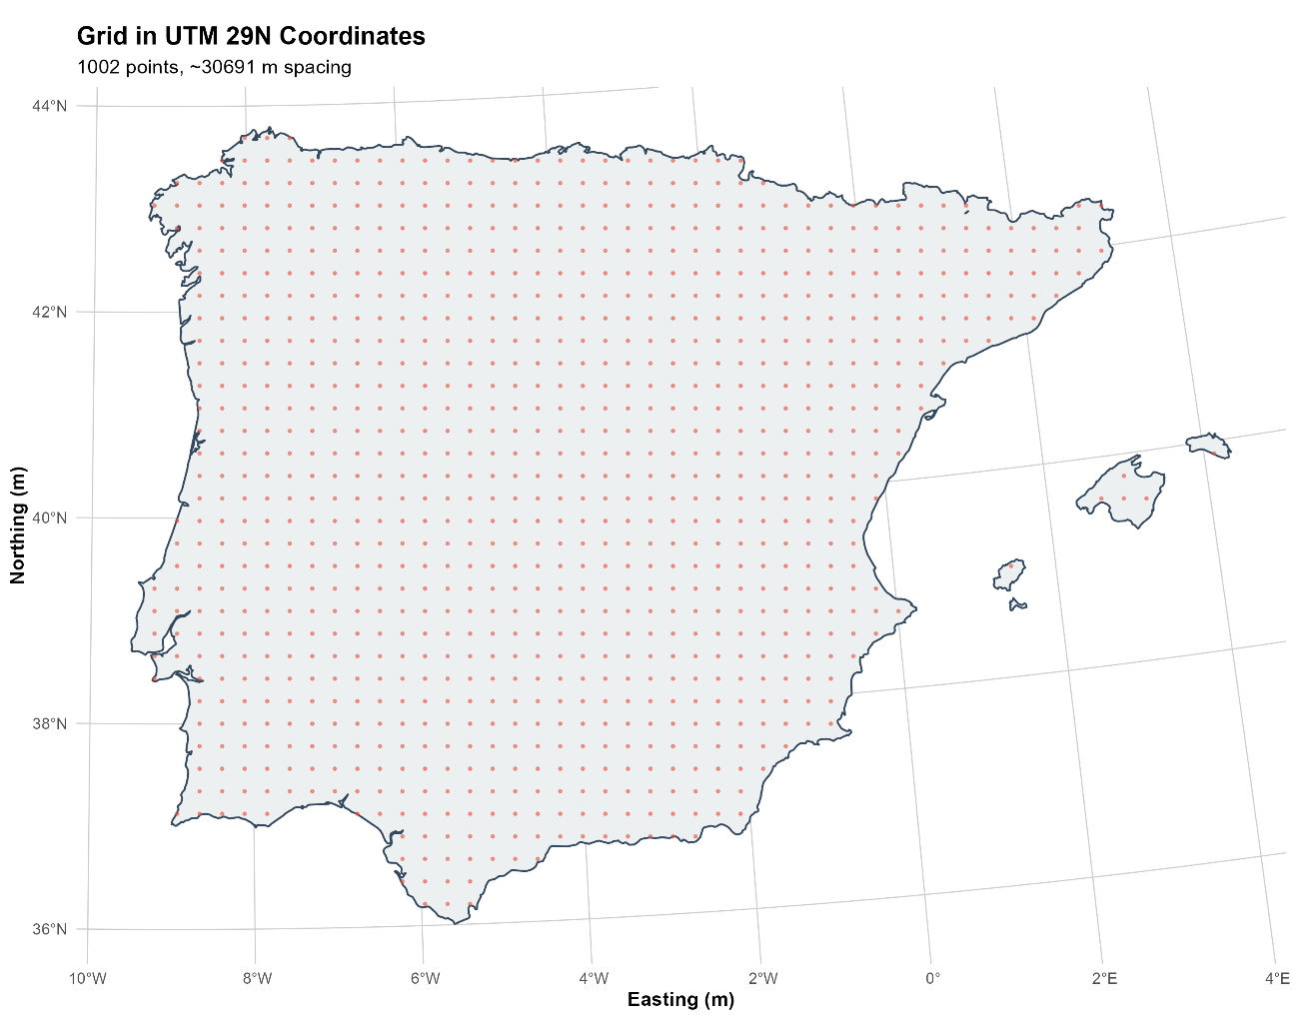
2.2. Wood species related to megalithic sites in NW Iberia
Taxa | Lifespan (years) * | Context | Reference
Quercus robur L. | 1000 | Archaeological site | Blas Cortina 2009
Quercus ilex. L | 1000 | Archaeological site | Blas Cortina 2013
Corylus avellana L. | 80-90 | Paleoambiental study and archaeological site | Ramil Rego, Fernández 1996; Gómez Orellana et al. 2001
Taxus baccata L. | 5000 | Paleoambiental study | Carrión Marco 2005
Pinus sylvestris | 400 | Paleoambiental study | Pérez Díaz, López Sáez, Lestón Gómez 2016
Alnus sp. | 60-160 | Paleoambiental study | Pérez Díaz, López Sáez, Lestón Gómez 2016
Salix sp. | 20-30 | Paleoambiental study and archaeological site | Ramil Rego, Fernández 1996; Gómez Orellana et al. 2001
Betula sp. | 90-100 | Paleoambiental study | Pérez Díaz, López Sáez, Lestón Gómez 2016
Poaceae | 1, 2, perennial depending on the species | Paleoambiental study | Pérez Díaz, López Sáez, Lestón Gómez 2016
- https://forest.jrc.ec.europa.eu/en/european-atlas/atlas-download-page/

2.3. Figure B. Comparison of posterior probability distributions for the four transition parameters (onset, peak, decline, and disappear) of regional Bayesian trapezoidal models restricted exclusively to radiocarbon samples recovered from within burial chambers
For each evaluated region (Duero basins, Tagus basins, and South), three models are compared: 1) All chamber samples; 2) Charcoal in chamber; and 3) Human bone/teeth in chamber. Horizontal bars represent the 95% (thin outer rectangle) and 50% (thick inner rectangle) highest posterior density intervals (HPDI), respectively, while vertical grey lines indicate posterior medians estimated from 100,000 MCMC samples.
