
Fit Finder
(Outfit Recommendation Application)
Project Engineering
Year 4
Mark Carroll
Bachelor of Engineering (Honours) in Software and Electronic Engineering
Atlantic Technological University
2025/2026
Declaration

This project is presented in partial fulfilment of the requirements for the degree of Bachelor of Engineering (Honours) in Software and Electronic Engineering at Atlantic Technological University.
This project is my own work, except where otherwise accredited. Where the work of others has been used or incorporated during this project, this is acknowledged and referenced.

____________________________________________

Acknowledgements

I would like to thank my friends, family and most of all my partner for providing me the support I needed to complete this project. A lot of time and effort has gone into this, and it wouldn’t have been possible without their help.

Table of Contents
1 Summary 6
2 Poster 7
3 Introduction 8
4 Background 9
5 Project Architecture 10
6 Project Plan 11
7 Technologies Used 12
7.1 FastAPI 12
7.2 Docker 12
7.3 Kubernetes (K8s) 13
7.4 MongoDB 14
7.5 Terraform 15
7.6 Amazon Web Services (AWS) 16
7.7 Amazon Elastic Kubernetes Service (EKS) 17
7.8 RabbitMQ 17
7.9 Next.js 18
7.10 Vercel 18
7.11 Gemini (AI) 19
8 Project Development 19
8.1 Recommendation Service (FF-Recom) 19
8.2 Clothes service (FF-Clothes) 24
8.3 Machine Learning Service (FF-ML) 25
8.4 User Service (FF-User) 26
8.5 Frontend (FF-Frontend) 30
8.6 Terraform 34
8.7 Amazon Web Services (AWS) 37
9 Ethics 41
10 Conclusion 43
11 References 44

Summary
Fit Finder is a clothing recommendation web-based application, that will recommend outfits to users and allow them to generate images of themselves in said outfits. The goal of the project is to show the skills that I have developed in backend development and cloud engineering.
The scope of the project was to create a web-based application with a hosted frontend, backend hosted on AWS, Azure or GCP. The backend was to use Kubernetes and docker to run microservices made with either python or java. The user and clothing information was to be stored on MongoDB. Terraform was to be used to deploy and manage the backend. This was all to be done within the confines of the academic year.
Jira was used to manage project planning. I chose to use the Agile methodology for project management as it allows the greatest leeway for project development. The sprints for the project were set to four-week intervals. This allowed a large amount of time to make substantial progress on the sprint goals.
The important features of the project are the react frontend being hosted on vercel, the backend, which is using AWS EKS and Kubernetes to host docker images of python microservices, and the terraform configurations that are being used to deploy and manage the project. The autoscaling is also a very important feature of the project, as it shows the practical use of the technology being used. For the autoscaling, KEDA and CloudWatch were used. KEDA is Kubernetes event driven autoscaling, it works alongside CloudWatch to monitor the traffic, scaling dynamically depending on the amount of data being sent and received.
All that was set out to be done for the project has been achieved. The AI generation of the user in the outfit was a later addition that was successfully added to the project to increase the complexity of Fit Finder.
The main conclusion was that my previous experience using the technology previously mentioned was incredibly useful to my development of Fit Finder, but this project has pushed me to learn so much more about them and how to manipulate them to do what I require.

Poster
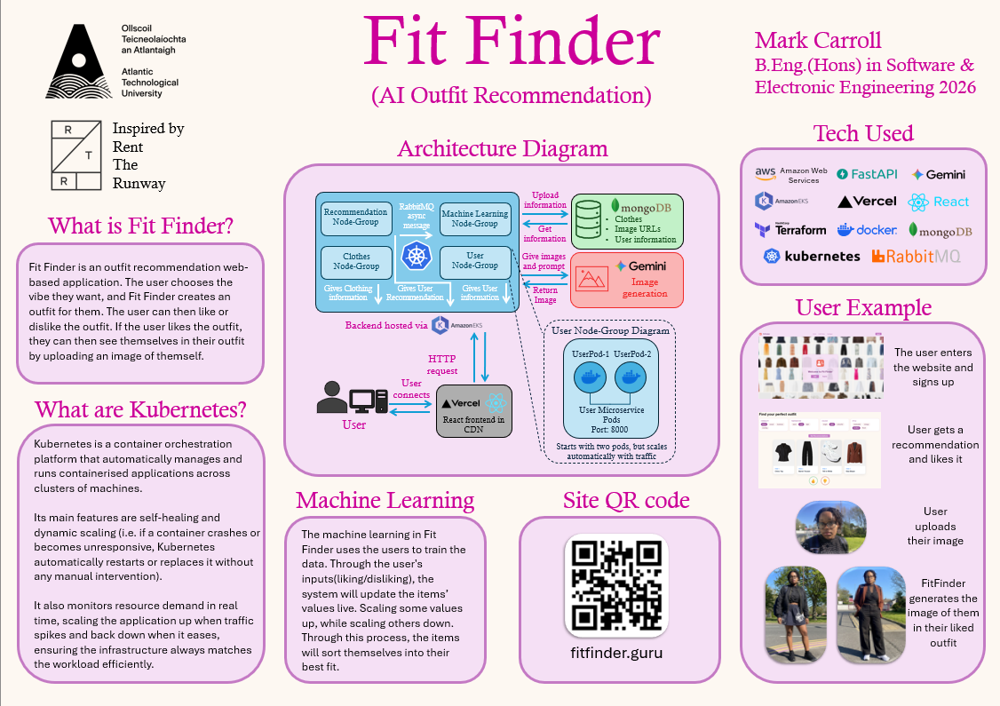
Figure 2-1 Project Poster

Introduction
The goal of Fit Finder is to make an outfit recommendation website that allows the user to find an outfit that they like, see themselves in it, all while providing a pleasant user experience. Fit Finder must be a production ready website, that can be used like any other website made by large companies. This involves the front and backend being hosted online.
The motivation behind this largely stems from my experience as an intern in Rent the Runway, as it gave me a huge insight as to how large sites function and are maintained. I found this incredibly interesting, so I decided that I wanted to strengthen my knowledge and experience with the same industry standard technologies that large companies use by making my own site.
The limitations I set for this project are that I must use industry standard technology to develop and deploy the application, make an enjoyable user experience, and to use machine learning to continually improve the recommendation algorithm.

Background
The background of this project is mostly related to my own personal experience. As previously mentioned, I interned at Rent the Runway. I worked on the site reliability engineering / platform engineering team. I really enjoyed the work I did there, as I was mentored by great people, and I found the work itself fascinating. Getting to understand the machinations of something as truly mundane as a website was incredible to me. While I was working there, I did my best to strengthen my knowledge of the architecture of web applications and the technology surrounding them, so that I could work as an SRE (site reliability engineer) again in the future, even if not for RTR (Rent the Runway).
As much as I had learned from RTR, I still had a very surface level knowledge of web development. This means for this project to work; I would have to undertake a great deal of learning about architecture and gain a deep understanding of the technologies that I am using, but I am more than willing to do so.

Project Architecture
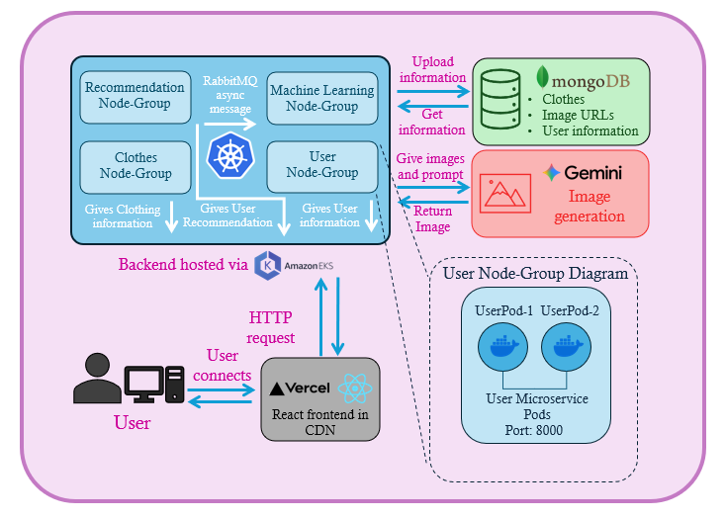
Figure 5-1 Architecture Diagram

Project Plan
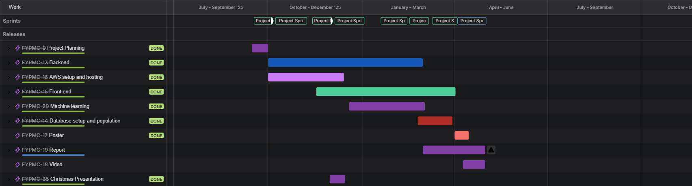
Figure 6-1 Project Plan

Technologies Used
In this section, I will be outlining the technologies that I have used to build Fit Finder. I will be outlining what the purpose of each one is and why I chose them.

FastAPI
FastAPI is a “modern, fast (high-performance), web framework for building APIs with Python” [T1]. It’s a very widely used framework that is incredibly simple to use compared to others.

Why I chose it
A large reason that I used FastAPI is that it is far simpler to use than other frameworks for building APIs. After learning how to use it in the CICD2 module, I found that I understood it far better API frameworks. FastAPI has an incredible amount of documentation that allows developers to be able to learn how to use it to fit their needs. From the documentation I learned how to return images for my project, just by going through the documentation they had provided. FastAPI is also used by large companies, such as Microsoft and Netflix.

Alternatives
One alternative that I could have used is SpringBoot for Java. I have used before in the module CICD. What I had found through my use of it, was that it was far more complexed for far less payoff. I couldn’t grasp an understanding of SpringBoot like I did with FastAPI, so it was an easy choice for me to go with FastAPI.

Docker
Docker is an “open platform for developing, shipping, and running applications”[T2]. Docker is used to containerise applications, meaning that you can run, test and distribute your application easily in isolation. Docker streamlines development for developers, as you can pull a docker container of an application and use it immediately, while running and testing your own. It is great for a continuous integration and continuous delivery (CI/CD) workflow. Docker images can be imported into the Docker image that the developer is creating for their own application to shorten development and simplify the building process. Being able to import official images for languages such as Python or Java, means that applications can be made much simpler.

Why I chose it
Docker is the obvious choice for my project, as I need to be able to containerise my applications to run them via Kubernetes, which will be detailed later. Docker is incredible for consistent and simple testing of microservices, as you can run multiple containers, hosting separate microservices via the Docker daemon. Docker also provides the ability to publish your own images to be used by others or by web applications hosted on the cloud, which is exactly what I needed it to do. I also had a great deal of experience with Docker as I had used it in RTR. I was tasked with redesigning the architecture for the automated base image creation for multiple languages for the developers of RTR. This was a great undertaking for me, but I was able to create a GitHub action that created base images for multiple versions of languages with Ansible. This is just to say that I have a good understanding of how Docker works, so it was an easy choice for me to use it.

Kubernetes (K8s)
Kubernetes (K8s) is “portable, extensible, open-source platform for managing containerized workloads and services that facilitate both declarative configuration and automation” [T3]. This means that K8s is a manager for containers, that would be running applications. This is where a lot of my project lies. K8s is used to build resilient and adaptive applications.

How it works
K8s takes a Docker image, and makes multiple pods, which are containers running the image. It then creates a service that the user contacts, this service will distribute the requests made across the pods, accelerating the response time, providing smaller latency than conventional applications. An example of the use of K8s is that an application is seeing a lot of traffic, and it is starting to fail. The K8s manager will see this, and it will either give more computational power to the pods, or it will create even more pods to distribute the load.

Why I chose it
The reason I wanted to use K8s is because to work in cloud engineering or SRE, you need to know what K8s are, as they are an industry standard for cloud architecture. To increase my understanding of how K8s function, I need to use them practically, which this project proved to be a perfect vehicle for. K8s are also, as stated previously, the best way to build resilient web applications. This would be necessary for making my own web application.

MongoDB
MongoDB is a “document database with the scalability and flexibility that you want with the querying and indexing that you need” [T4]. MongoDB stores data in JSON entries, this allows for a large amount of information to be stored dynamically, very easily. It is very easy to work with as MongoDB has very good integration with coding languages like Pymongo in Python.

Why I chose it
There are multiple reasons why I chose to use MongoDB. A large reason is that MongoDB is an industry titan when it comes to cloud hosted databases. Many companies use MongoDB and look for experience with it when hiring new developers. Another reason is that in college, we were learning how to use MongoDB in our modules. Modules such as CICD2, Full stack, Cloud Computing and Mobile Development. This meant that I would be able to develop my personal database in parallel with learning new applications of it throughout my classes. MongoDB is also free to use, which is a large incentive to use it. I also chose to use MongoDB as it was one of the database options of RTR.

Alternatives
There are many competitors to MongoDB that I could have chosen, such as Tinybird, FerretDB or Amazon DocumentDB [T5], but there are drawbacks to each of them. Tinybird is far more difficult to use because of their limited documentation. FerretDB has a higher latency and limited features, and Amazon DocumentDB isn’t free after 2GB. Another alternative that I have used before is Supabase. I have used it in my work as a backend developer for the company Clevermoney, and I have found it to have a far greater learning curve than MongoDB. A large reason for that is the row level security (RLS). This is a security measure set in place to protect information in tables from unauthorised access [T6]. While this is a great feature, it is far more complexed than is necessary for this project. One con that all these alternatives share, is that they lack the consistency that MongoDB has, as it is such a large company.

Terraform
Terraform is “an infrastructure as code tool that lets you define both cloud and on-prem resources in human-readable configuration files that you can version, reuse, and share” [T7]. This means that Terraform is a coding language that you can use to create and deploy resources onto your chosen cloud platform (i.e. AWS/GCP). This is what is used by some companies to deploy and manage their resources on cloud platforms, instead of doing it manually.

How it works
This works by the user defining what resources they want on their cloud platform, be that a cluster or an IAM role. For Terraform to work, the user must have valid credentials to upload or edit these resources. In my experience, this meant that I had to have valid AWS credentials saved when I was logged into the AWS CLI. After Terraform checks that the user has valid credentials, it will show the user what it plans to do (i.e. create, modify or delete). When the user confirms the changes, Terraform will make those changes using the same commands that the user would in their CLI, but in the order that best allows the creation of the resources. This means that the IAM role for a cluster would be made before the cluster so that there is no conflict in the creation. After the creation, it saves everything in a state log, allowing it to delete everything in the correct order.

Why I chose it
The reason that I chose to use Terraform was because I had learned about its use in RTR and found that it was a great tool to automate a very tedious and difficult process. I had very little previous experience with AWS, but I had experience with Terraform. This meant that I could compensate for my lack of knowledge with AWS for my knowledge of Terraform. While my previous experience with it helped me, I still had a huge learning curve before I was able to properly utilise it.

Amazon Web Services (AWS)
Amazon Web Services (AWS) is “the world’s most comprehensive and broadly adopted cloud” [T8]. AWS is a cloud platform that allows users to host their applications on their servers, letting users use the computational power of AWS to run their backend. AWS provides resources for user such as computing , database storage, networking and analytics.

Why I chose it
AWS was an easy choice for my cloud platform as it is such a huge industry standard. AWS is a cornerstone of the internet, hosting so many sites, including government sites. This means that having experience with AWS greatly increases my value as a software developer. AWS also provides 100$ free credit for new account which is a great incentive to use it. AWS also has such deep integration with a lot of software, such as Terraform, which I stated previously that I would be using. AWS was also being covered in two of my modules this year, albeit in second semester. This, like MongoDB, allows me to learn in parallel with the work that I am doing for my project. As AWS is such the industry powerhouse that it is, there are a very large number of resources available for developers to learn how to use it, including AWS’s own tutorials on how to use it. What I needed for my project, was to be able to host the backend for my application. AWS is more than capable of doing that and so much more.

Alternatives
There are competitors to AWS, being Google Cloud Platform (GCP) and Microsoft Azure. These are both very widely used by large companies, but not to the extent that AWS is. GCP was the cloud platform of choice for RTR. I had previous experience using it and while it was able to do what I wanted to do, at the time of choosing, I couldn’t get free trial. The GCP Kubernetes engine that I needed would have been far too expensive for me to use. Microsoft Azure wasn’t really considered as it had a fraction of the resources that the other had. That is something that GCP shared to a lesser extent, the fact that there was far less documentation and resources for development using that cloud platform.

Amazon Elastic Kubernetes Service (EKS)
Amazon Elastic Kubernetes Service is a “fully managed Kubernetes service that eliminates the complexity of operating Kubernetes clusters” [T9]. This is Amazons resource for hosting and managing K8s clusters. This is my solution for hosting my backend on the cloud.

How it works
EKS works by making an all-encompassing cluster for the resources. Here you can make node groups to attach the K8s deployments to. All the pods created are EC2 instances, which can have different computational power depending on the setup. The deployments are managed by the service, which uses a load balancer to distribute the network traffic. By using Nginx in combination with Terraform, I was able to automate the process of creating the EKS resources as well as the deployment of the K8s.

Why I chose it
EKS was my only choice for using K8s on AWS. It was exactly what I needed for my backend. I could have gone with the Kubernetes engine if I were to go with GCP, but as detailed previously, AWS was a far better choice for this project.

RabbitMQ
RabbitMQ is a “powerful, enterprise grade open-source messaging and streaming broker that enables efficient, reliable and versatile communication for applications” [T10]. In this project, RabbitMQ is being used to communicate asynchronously between microservices.

Why I chose it
The reason I chose RabbitMQ is because it, like other technologies I have used thus far, is an industry standard. There are other options like LavinMQ, but I chose RabbitMQ because we had used it in the CICD2 module in one of the labs. I needed message queueing for my project as I needed an asynchronous way to trigger the machine learning for the database, and RabbitMQ was the best solution for it.

Next.js
Next.js is a full stack framework that uses React to build web applications. Next.js is simple to learn and it can dynamically stream HTML pages to users. Next.js allows for asynchronous data fetching, while having built in API handling, which makes it perfect for the frontend for my project. I need a frontend that can handle querying data, making requests to an API and to be hosted on the web.

Why I chose it
Next.js is great for frontend development, it is one of the best frameworks, using React components to make for simple UI development, while facilitating the ability to make requests to an API. This is perfect for my project as I need to able to contact my backend on AWS through my frontend. Next.js is also covered in multiple modules this year, such as Full Stack and Mobile development. The only reason I needed a frontend is because I needed a vehicle to demonstrate the backend that I had developed.

Vercel
Vercel “builds a frontend-as-a-service product—they make it easy for engineers to deploy and run the user facing parts of their applications.”[T11]. Vercel is a content delivery network (CDN) that can host frontends for applications, making the process very simple. All you need to do to host your frontend, is to upload your GitHub repository for your Next.js frontend, and it will deploy it to a unique URL. The reason why it must be Next.js, is because they are the creators of it. Vercel also offers the ability to preview deployments before they go to production.

Why I chose it
I chose to use Vercel as it was very simple to use as previously stated. I have previously used Vercel before in my job and I found it to be the best option for my frontend as it was already using Next.js. As a CDN, it also gives analytics of the users contacting the frontend.

Gemini (AI)
Gemini is Google’s AI/LLM. It has various options for how it can be used, also providing multiple models which are best suited to certain tasks. Gemini has facilities to make videos, make music, and create images.

Why I chose it
The reason I chose to use Google Gemini, is because for my project, I needed to be able to generate images of people in clothing. After trying other LLMs I found that Gemini had the best output. I specifically chose the Nano-banana model, as it is their best image generation model. Another reason why I chose Gemini which will be expanded upon in the ethics section is that Google has made great strides in making AI/LLMs less impactful on the environment.

Project Development
This section, I will be covering my development process, Terraform and AWS first, then service by service. Here I will detail what each service does, the process of development referring to my weekly logs. The testing for each service will be included as well.

Recommendation Service (FF-Recom)

Purpose
The recommendation service (FF-Recom) is the service that provides the actual recommendation algorithm for Fit Finder. This service needs to be able to take the user input and provide the correct recommendation to them, and if not, take the feedback given to learn and develop.

Development
FF-Recom was the first repository made for Fit Finder. This is where all my development started, starting with FastAPI and MongoDB, then continuing with Terraform and AWS. The development started in week 4 (Each week is linked to the corresponding OneNote page), with FastAPI. In my CICD2 module, I was learning how to use the FastAPI in python. I was taking what I was learning and applying it to my project. I started implementing MongoDB into FF-Recom on week 5. I initially tried using MongoDB’s own tutorial for Python [PD1], but it wouldn’t work. My friend Pero helped me with getting everything connected, as he did it for the CICD2 project we were doing together. With this I was able to make a function that contacted the MongoDB database to get and add entries to the clothes collection.
I had to contend with how I was going to save images for my database, as I needed pictures of the clothing that were going to be recommended to the user. I played with the idea of storing the images as base64 or something of the like, but it wouldn’t work as I wanted [PD2]. I decided to then have links to the URLs of the images stored with the entries in the database, which I had copied from the RTR site.
A lot of time went into getting Terraform working and making Docker images (Dockerfile) of FF-Recom run as K8s on EKS. At this time, I was also researching into how to make a Dockerfile for the service. I read through documentation provided by FastAPI themselves [PD3]. This in combination with the Docker work we were doing in CICD2, meant that I had a solid base image that I could use for all my services. This image was then uploaded to my Docker Hub account so that it could be publicly accessed.
It wouldn’t be until week 1 of semester 2 before I went back to FF-Recom, as most of my time was going towards the Terraform and the frontend until the Christmas presentation. The way that I had the service running was that for each category of clothes (Shirts, Trousers, Jackets, Dresses, Skirts and Shoes), there was a route that you could contact for that specific category. This means that there was six files and multiple overlapping models for each category of clothing. After speaking with my friend Shine, he advised that I make a general function, that you can pass the category through as a variable. I did this and it worked perfectly, cutting down hundreds of lines of code. After this, I split the code for getting and creating clothes to the repository FF-Clothes.
In week 2 semester 2, I decided what criteria I was going to use to define the styles of the clothing (Light, Dark, Bright, Warm, Cool, Breathable, Cozy, Lightweight, Fancy, Casual, Business, Lounge, Evening, Minimalist, Vintage, Modern, Soft, Comfortable and Layerable). All items would be assigned a value for each of these categories, which would be attached to their entries in the database.
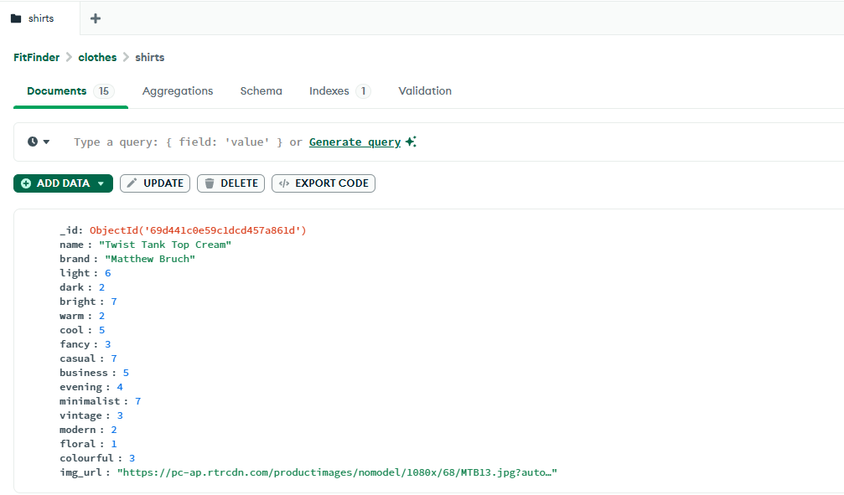
Figure 8.1-1 MongoDB Entry Example
The user would then choose from these categories, and the items of clothing that had the highest combination of values would then be returned to the user. This worked very well for the recommendation, as it returned a list of item IDs and URLs. The code for this can be found in app/recomRoute.py.
In week 4 semester 2, I started with the RabbitMQ integration. This involved setting up FF-ML to receive messages from the queue as well as setting up FF-Recom to send the messages. We had used RabbitMQ briefly in CICD2, but my team used it in our group project for it, so I was able to reuse that old code. Every time FF-Recom would publish to the queue, it would make a connection to RabbitMQ (app/publish.py). When the connection is successful, it then sends the ids of the recommended items, the categories, as well as the feedback given. For testing purposes, this was set to always be positive, and it would be sent every time the recommendation function was queried. This took weeks to get it working correctly, as it finally took shape in week 6.
Picking back up in week 9 semester 2, I wanted to make like and dislike functions. This would be necessary for sending messages to the queue to update the database values correctly. It was simple to make the functions for the like and dislike, as I had already had working code for publishing messages. All I had to do was change the value for the feedback, from positive to negative for the dislike.
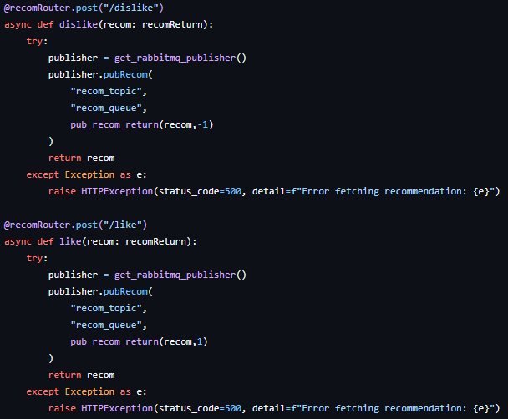
Figure 8.1-2 Like and Dislike functions
Also in week 9, I fixed how the recommendation worked. As previously, I had it so that it would only recommend the combination of shirt, jacket, trousers and shoes. This was because I didn’t know how to change it to include others at the time. I changed this by using the “Random” function in Python. This means that I would have it randomly choose what combination to recommend, that being shirt jacket trouser and shoes, shirt jacket skirt and shoes or dress jacket and shoes. I made the return a second return model for when it would be returning only three items instead of four, as that was the main issue with changing the recommendation (app/models.py).
In the break week, I had overhauled the categories for the recommendation. I wasn’t happy with the current list, as I felt that they often overlapped, and you could also select contradicting categories. So, I changed the categories and frontend so that they would correlate more with each other. The sections were, Light / Dark / Colourful, Warm / Cool / light, Fancy / Casual / Business / Evening, and Minimalist/ Vintage / Modern / Floral. Now that the categories were split into sections that relate to each other, the recommendation algorithm should work a lot better.
The last addition to FF-Recom was the Pytest for unit testing.

Testing
This is one of the more heavily tested sections of the project, as a large portion of the complexity of Fit Finder comes from the algorithm. This meant that I had to test run the algorithm a lot during development, which has been documented previously.
Part of the testing was also done by users, as I had a group of people test the entire site. After getting feedback from the users, I readdressed how the recommendation was being done, choosing from sections instead of a whole table of conflicting topics.
Pytest has been used to test all the base functions for the service. Below is an example of the Pytest being run, covering each section. MagicMock is being used to make mock databases for MongoDB and mock publishers for the RabbitMQ.
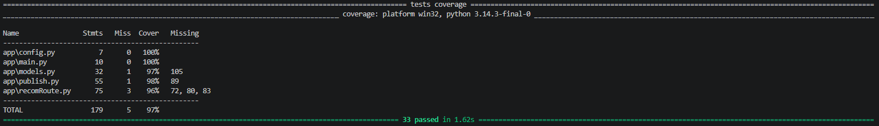
Figure 8.1-3 FF-Recom Pytest Coverage
AI was used in the creation of the test files for FF-Recom, citing the prompt “Please add Pytest to the test folder so that the project has 80% coverage ”. I chose to use AI for this task as creating the test configs is a relatively menial task, that AI would be more suited for.

Clothes service (FF-Clothes)

Purpose
The purpose of the clothes service (FF-Clothes) is to provide the clothing information for the frontend. It is to be the sole service that the frontend contacts to display the clothing.

Development
The code for FF-Clothes, as detailed before, was first created in the early weeks of the project in FF-Recom. This left very little development for the FF-Clothes, with there only being four total PRs on GitHub. The only thing that was added after the initial splitting of FF-Recom was the Terraform configurations for everything.

Testing
This service had the least need for testing as it had already proven to be functional when it was a part of FF-Recom.
Pytest has been used to test all the base functions for the service. Below is an example of the Pytest being run.
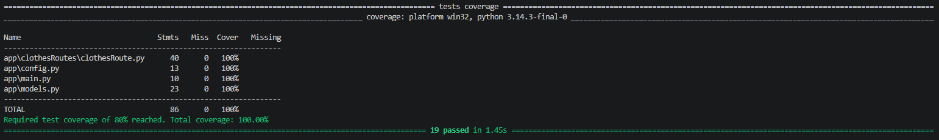
Figure 8.2-1 FF-Clothes Pytest Coverage
AI was used in the creation of the test files for FF-Clothes, citing the prompt “Please add Pytest to the test folder so that the project has 80% coverage ”. The reason is consistent across all services.

Machine Learning Service (FF-ML)

Purpose
The purpose of the machine learning service (FF-ML) is to asynchronously update the values of the categories of items in the database based on the feedback from users. The reason why it must be done asynchronously is because the site would get slowed down far too much if waiting for responses.

Development
Development for FF-ML started late in the timeline. I knew from early on what I had to do, needing to use machine learning to update the database live. How I would do this was not known until week 4 semester 2.
I investigated how to do the machine learning using resources I had found online [PD4]. From this research, I had learned that I needed to use reinforcement learning for my project. This made the most sense as it would be using user feedback to reinforce the values of the clothing in the database.
I started the machine learning by just making a function that could be fed a clothing item and categories, and change the values depending on the feedback given, which would just be a 1 or a -1 depending on it being positive or negative.
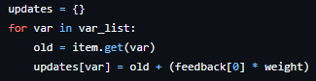
Figure 8.3-1 Simple Update Function
This worked very simply. From this point I was able to start on the asynchronous section of the service. I chose RabbitMQ as the message queue for reasons previously stated. I worked on this in parallel with the publish for FF-Recom as they would be communicating with each other. I had gotten into the RabbitMQ in week 6 as mentioned in the FF-Recom section. I had to get the service to run a constant connection to the queue so that it would be able to receive the messages. Luckily, this was covered in a class in CICD2, and my teammate Nasir had done this work for our team project.
I had gotten this working partially, it would receive messages, but it would have an issue processing them. This turned out to be to issue with how the data was being and received, I was able to change format of the messages being sent and how they were being received. This put FF-ML in a state where it was able to be containerised and put on the EKS.

Testing
Testing had to be done frequently during development as it was difficult to get functioning correctly. There was continuous testing being done on the message receiving, as it was such an important aspect of the service, so it was pivotal that it worked consistently. Pytest was also added to the service, as unit testing the functions is good for sanity checks.
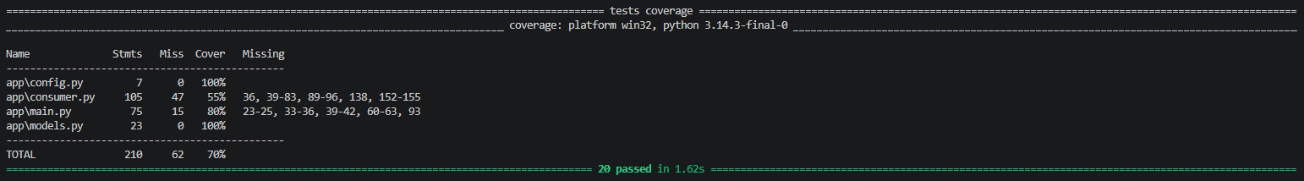
Figure 8.3-2 FF-ML Pytest Coverage

User Service (FF-User)

Purpose
The purpose of the user service (FF-User) is to handle the user information for Fit Finder. Users need to be able to create accounts, save their likes and generate images of themselves in their liked outfits.

Development
User service development started in week 9 of semester 2. What was important to me, was to be able to create user profiles and encrypt their private information, such as their password. This process was relatively easy, as we had just covered password hashing in Mobile Development and Cloud Computing. The process of hashing is essentially destroying the password. The string data is sectioned and scrambled to put it simply. The only way to replicate the output is to put the same password into the encryptor and comparing the outputs. This is how we can safely store the user’s password on the database ‌[PD5].
The functions for the user service were basic CRUD, create user, edit user and delete user. The login function would take the email and password of the user and compare them to the database.
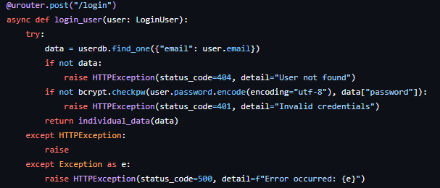
Figure 8.4-1 User Login Function
The inputted password would be encrypted and compared to the stored password in the database, and if all matched, then it would return the user ID to be stored in the cookies.
For a period, the login didn’t work, because the way I had it working, was that it would encrypt the word “user.password”, instead of encrypting the actual variable. After realising that, I was able to fix it quickly.
In week 10, I started the image generation. What I needed to get working first was user file upload. I needed to be able to take an image of the user and store it to be used later. I had theorised earlier that the only way I could have been able to do this is to have stored the image externally in something such as the Imgur API. This is something that I have had to do for previous projects, so it was my first idea. I wanted to avoid this as it would mean the images of the users would be publicly available. This is obviously a privacy issue. The way I then thought of was to convert the image to a base64 string and store it in a table that refers to the user ID.
It turns out that FastAPI has built in integration for file uploads which were very easy to understand and implement [PD6].
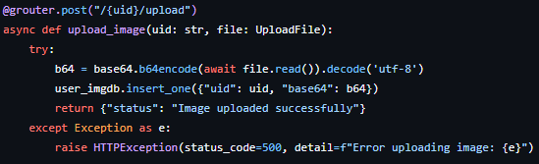
Figure 8.4-2 User File Upload.
This was perfect as when a test function to retrieve the image was used, it worked flawlessly. After this, the only thing remaining was the AI integration. This is where I had to choose what AI to use and which model. I had tested image creation with ChatGPT, but the results weren’t brilliant. I had used ChatGPT to get a basic function to make requests to it to generate an image. My thought process being that the best way to find how to contact the AI was to ask the AI itself. When testing the function, I had to change how some things were set up. To send the images of the clothes, I had to temporarily download the images and send them alongside the user image that was converted from base64 back into an image. This was because the AI was unable to read image URLs.
Below is an early example of the image generation. My classmate David Jayakumar volunteered to test the user image upload and the image generation. This resulted in the following image. While I was happy that the code was working, I found the result frankly terrifying. The image looks very uncomfortable as proportions were so inconsistent. This was consistent with further testing with other inputs.

Figure 8.4-3 Early Image Generation
After this, I chose to investigate other image generation models. Google Gemini was recommended to me by Nasir, so I decided to investigate it. From brief investigations, it looked like a far better option. So, I followed the same process as I did with ChatGPT. I asked Google Gemini how to contact its latest image generation model, attaching images to the request. What Gemini returned was partially functional. I had to reference to documentation provided by Google to fix the image upload with the prompt. After getting it working, this was the result.

Figure 8.4-4 Current Image Generation
This is quite clearly an incredible improvement. After getting this operational, all that was left in the user service was to add an option to delete your account and delete your uploaded image.

Testing
There was quite a bit of testing in the development process of the user service. Multiple sections required extensive testing as it was key to the service working. The user login and password hashing was tested extensively, as there were multiple issues with it that were outlined above. The image generation was also a large part of the service that needed to be tested. The prompt to generate the image went through multiple iterations, to see what gave the optimal output (app/routes/genRoute.py).
Pytest was added for unit testing.
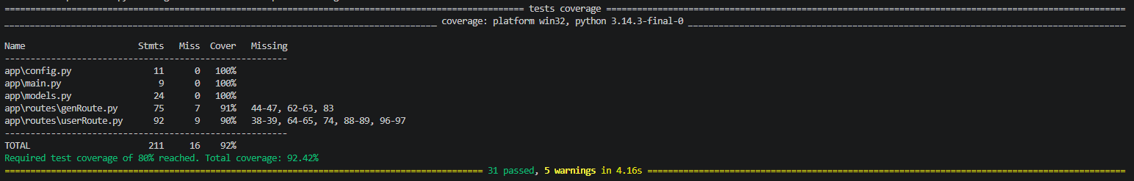
Figure 8.4-5 FF-User Pytest Coverage

Frontend (FF-Frontend)

Purpose
The frontend (FF-Frontend) is the what the user will interact with when they use Fit Finder. The frontend is to be hosted online, contacting the backend hosted on AWS.

Development
The frontend development started in week 9 of semester 1. The way that it started was by taking an example template from the Fullstack module and modifying to contact my backend on AWS. I had just gotten FF-Recom working on AWS, and I was able to contact the service locally. Getting it working initially wasn’t very difficult, even though I ran into some issues [PD6]. I had the frontend contact the service when hosted locally, which allowed me to retrieve clothing information from the database.
The issues started when I tried to contact the service while it was hosted on AWS. I could contact the service via http request in a browser, but when it came to the frontend I wasn’t able to get it to work. This took some research, but I eventually found the issue in week 11. What I needed to do was set up CORS middleware in the service. What this does is define what IP addresses can access the service via authentication [PD7]. The way that I set it up was to allow all traffic so that nothing would get blocked.
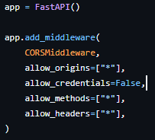
Figure 8.5-1 CORS Middleware
This allowed me to contact the backend with axios on the frontend. From here I could set up how I was going to display the clothes on the site. I settled on a carousel to show all the clothes as I thought it would look best.
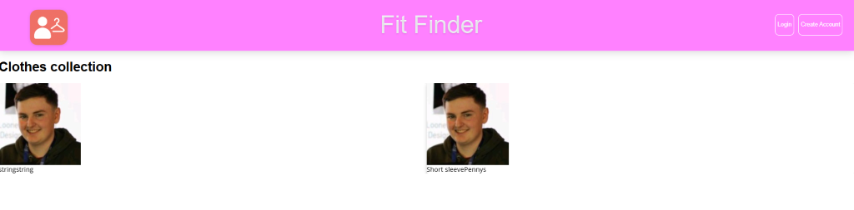
Figure 8.5-2 Early Stages of the Frontend
The above example was the early example of how the frontend was working. I used the image URL of my dear friend Nathan’s LinkedIn as a test value for the example entries. This was also incredibly funny.
I had picked the frontend back up in week 7 of semester 2. I had taken the architecture of the frontend from my CICD2 project’s frontend, as it was simple to understand and improve upon. I used AI to generate a logo for Fit Finder, and I added it to the site.

Figure 8.5-3 Fit Finder Logo
I started working on the recommendation page as that was the most important thing to have operational on the site. I had used a checkbox list to display the options for the clothing categories. When the user would choose categories, they would get sent with the recommendation. From there, the response would be mapped with a list to be shown to the user.
I used AI in the development of the frontend as AI can do CSS far better than I can. I wanted the site to look good, and I don’t believe I would do a good enough job. I feel that the frontend is more of a vehicle to show the technology that I have learned to use, more than it is a key aspect of my project. While it is very important, that’s not what I want to focus on.
In week 8, I had the frontend hosted on Vercel. It was a very simple process, as I just had to log into my GitHub from Vercel and choose FF-Frontend. After that I had a working website. To make database population easier for me, I had set up a database entry page on the site. AI was used to help with the format of the page as it was going to be removed from the site shortly after.
In week 9, I started on the user pages (i.e. login, register and profile). I wanted to store the user ID in the cookies so that it would be able to send it along with any necessary requests. I found a resource that plainly showed how to do it, so it was easy to implement in the site [PD10]. After setting that up, login and register were basically finished.
I decided that the recommendation page needed to be changed, as the current list of categories was ugly and provided a poor user experience. From here, I split the categories into related sections, such as colour and style. I set it so that the user could only choose one from each section, so that contradicting categories couldn’t be selected in the same request as well.
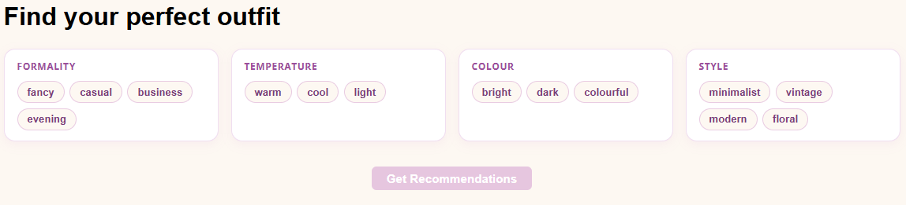
Figure 8.5-4 Recommendation Page Section
This was a huge improvement to the user experience.
The next big task for the frontend was the user profile. Here, I wanted to display the user information, have an edit function, show the users likes, upload the user image and generate the images of the user in their outfits. Between week 10 and break week 1 I got the bulk of this working. Since I had the cookies set up, it was easy to use that to fetch all the user information, and have it fetched when the page was opened. The image upload was also simple, as the “input” type in React has a file option, so that could be sent to the user service on AWS. The image generation was easy to display as it the response could just be used in the “src” of the element on the page.
Apart from any minor style changes and renting the domain name “fitfinder.guru”, this is where development for FF-Frontend finished.

Testing
A lot of user testing went into the frontend, as I had family and friends use the site and give me feedback on it. I changed the layout of the recommendation page after multiple users said that it was uncomfortable to use. After making those changes, I presented Fit Finder to RTR. There, they gave me great feedback about the security of the site. As I had set the CORS to completely open, anyone was able to query it for information. There was also no safety features in place to protect against DDOS attacks. Aside from those recommendations, they believe that Fit Finder provided a good user experience and would have been a useful project for RTR.

Terraform

Purpose
The purpose of Terraform in Fit Finder is to automate and simplify the deployment and destruction of AWS and K8s resources. It must deploy each service independently, including its K8s. It must be able to modify and destroy the resources it creates, as I am using the free tier of AWS, and leaving resources running means that credits are wasted.

Development
Terraform in FF-Recom was one of the first things I worked on, starting in week 6 . While I had used Terraform in my time at RTR, I had quite a bit of trouble setting it up myself. Aside from Terraforms own documentation, there was little information on how to use it for what I wanted to do with it. This could also be attributed to the possibility I wasn’t looking in the right places for it. I began my search with [PD11], as it looked hopeful. Being the first thing I saw, I thought it would be exactly what I needed, which it ended up not being.
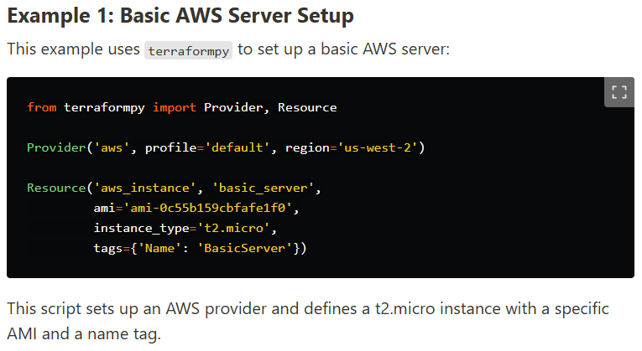
Figure 8.6-1 Python Terraform
It detailed how to use Terraform in Python which was not what I wanted. I was looking for a way to deploy a Python microservice to AWS via Terraform. This was how I believed it worked, but I would later learn it’s not. After a week of research and few results, I finally found something hopeful. I had found a blog that detailed how to use Docker, Kubernetes, AWS and Terraform [PD12]. This blog gave exact steps on how to set up the AWS CLI and deploy Terraform resources to it. It was exactly what I needed to start my project. Over week 7 and week 8, I worked using the guide from the blog, also taking from this repo [PD13] where applicable as it referenced by the blog. In week 8, I had a breakthrough with the Terraform. I had successfully gotten it to create a cluster and node group in AWS (aws-tf/main.tf), and deploy K8s to it (k8s-tf/main.tf). It took some time, but I figured out how to use the K8s while they were on AWS, but it was working. This is where the advancements in Terraform stalled, as I had to focus on the frontend for the Christmas presentation which can be seen in the week 9 logs.
Picking back up in week 12, I had tried to redo the Terraform code for the K8s using [PD14]. It ended up not working. This mad dash to remake the K8s code was also done the night before the presentation. It was at this time that I had realised that the autoscaling wasn’t working. It turns out that I would have to use a third-party software called Kubernetes Event Driven Autoscaling (KEDA) [PD15]. This was a tough realisation as the autoscaling was a large reason why I chose to use K8s. Not being able to demo it would look poorly. In the end, I reverted to previously working configurations.
From here, there was very little development in the Terraform. The most being done was copying over the Terraform code for FF-Recom to the other services. This took a little more effort as there was an issue with it trying to create the EKS cluster when it was already there. The solution to the issue was to import the details of the cluster for the rest of the configs to be able to read it and create resources for it. An example being FF-Clothes(aws-tf/generated.tf).
The next time I would address Terraform, would be in week 8 of semester 2. Here I would start on the KEDA configs for FF-Recom. The way it worked was by setting up Amazon CloudWatch to monitor how much data is being sent by the services. When it hit a certain threshold, it would scale up the number of pods created. This was then copied over to the other services.

Testing
The process of testing Terraform was continuously creating and deleting resources. This was done over the weeks of development. You can see where the testing failed, as resources were left running, using up credits.
Testing was done for the KEDA configurations in Terraform. There was testing to gauge the threshold at which the pods would scale. As the site didn’t need to scale often there was a higher limit set. Each service was tested and gauged accordingly. As the services would be facing different loads, it is important that they scale independently.
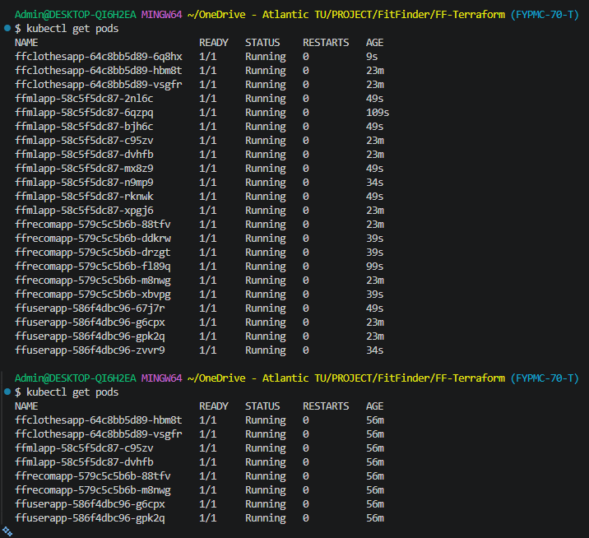
Figure 8.6-2 Example of KEDA Autoscaling

Amazon Web Services (AWS)

Purpose
AWS served to host my backend. Hosting the K8s deployed by each of the services for Fit finder. The K8s must be able to be contacted by the frontend, and auto scale depending on traffic.

Development
AWS was one of the first aspects of my project that I focused on. AWS was such an integral part of Fit Finder, that it was pivotal that I was able to get it working as soon as possible. I had no previous experience using AWS, as in RTR, the cloud platform of choice there was GCP, which I didn’t use for previously stated reasons.
I had a lot of issues when it came to AWS accounts over the course of this project. I had set up an account with my college email account at some point in the past, which I didn’t realise until later, so that disqualified it from being a free account. I used it anyways, which I would come to regret. I had begun testing with some AWS resources in week 4. Somehow, checking the same account a week later, there was a 100$ charge on the account. I to this day have no idea how that happened. I had to abandon that account, changing my card details and deleting the account as there was no way I could pay that charge.
A lot of AWS development was directly tied to Terraform development, as Terraform was being used to create all the resources for AWS. In week 7, I made a second AWS account, as after considering alternatives to AWS, I wasn’t willing to change. I had Terraform creating EC2 instances on AWS after a lot of research and development [PD16]. While this was great progress, it wasn’t what I wanted. I needed to make a cluster for K8s. This meant I needed to use the AWS EKS. I struggled to find any relevant resources for this but there was one saving grace, that being [PD14]. I spoke about this blog previously, but it was instrumental in getting me started with AWS. This blog showed how to create an account for AWS, create a user that you could log into on the CLI, and use Terraform to deploy the resources you wanted to them.
In week 8, I had finally gotten things working. I followed the guide and had set up a very basic version of FF-Recom on EKS. An issue I had with this was that I was unable to view the resources on the AWS console. What I had to do was give the IAM user the permission to view the clusters resources in the Terraform configurations. This let me view everything on the console which was exactly what I needed.
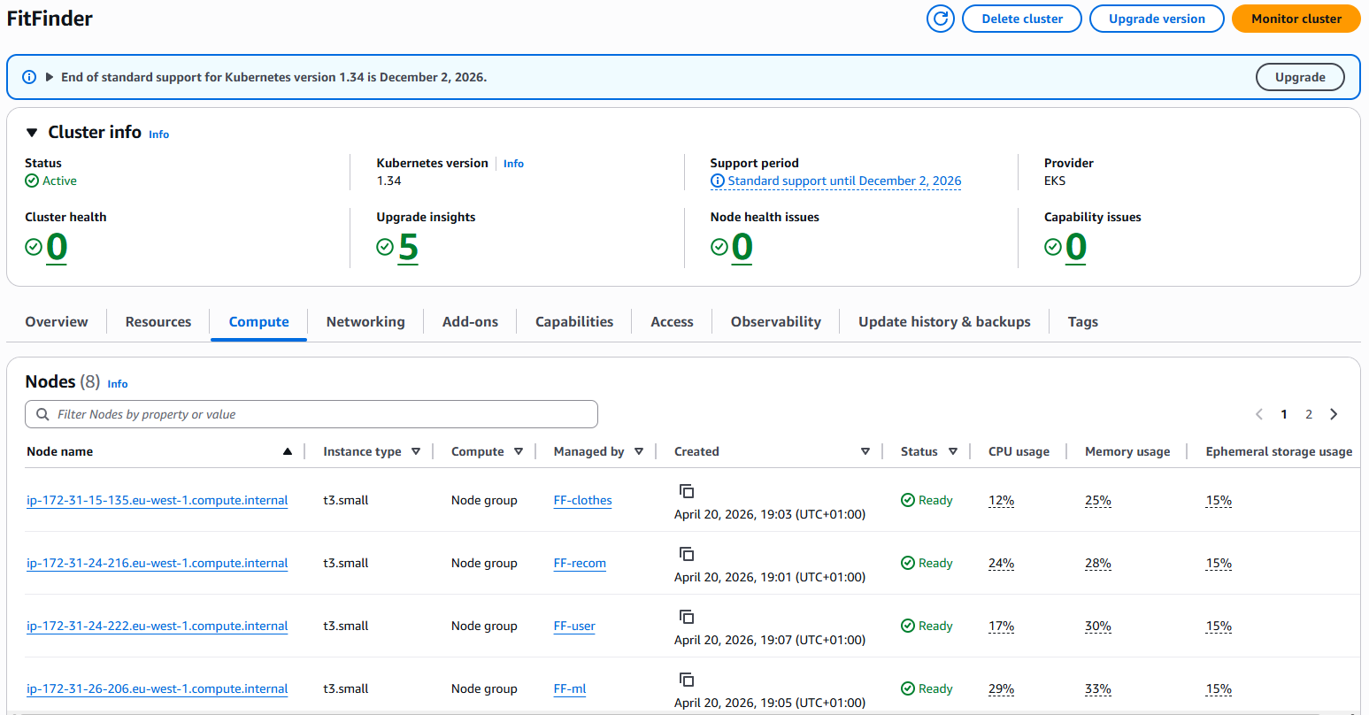
Figure 8.7-1 AWS Console with Resources
The next thing I had an issue with, was connecting the frontend and the backend. I touched on this in previous sections. I researched multiple GitHub repositories and guides to set up this connection, but none of them were what I needed [PD17][PD18]. The solution to this, was setting up CORS for the services in combination with using axios.
What I had found out in week 12, was that the autoscaling wasn’t working. After doing some research, I had found that I needed to set up KEDA with Amazon CloudWatch. CloudWatch was the observability that AWS provided for user’s resources [PD19]. With CloudWatch, I would be able to use the statistics given to scale my K8s accordingly.
Week 2 of semester 2 started with me using all the credits of another account, since there were resources left running on the account. After this, not much progress was made with AWS. I had been able to deploy all my clusters on AWS using Terraform, not needing any more development for the time being.
I returned to AWS in week 8 of semester 2. I had to get the KEDA working, so I had to figure out how to use CloudWatch. After days of research, I had found little to no resources for this, so I resorted to AI to aid in development. The following is the prompt I used “I am using terraform to scale the Kubernetes in an AWS EKS cluster, using KEDA and amazon CloudWatch. I have this YAML file that I want to use as the configuration for my scaler. How would I structure the terraform file to fulfill this”. I used Claude for this as it was recommended to me by my classmate, saying it was the best AI for software. It took multiple tries of using the AI, but it eventually gave some Terraform code that compiled and created a working autoscaler for one of my services. I had it set to check how much data was being sent by the services, and when it hit a certain threshold, it would increase the number of pods.
This is where I left off with my AWS development.

Testing
I had performed tests on all the AWS resources throughout development. The testing for AWS also correlates to the testing of Terraform, as I needed to be certain that the resources being created were correct and functional. Through these tests, I had found that the autoscaling for my K8s wasn’t working, which led to my research on KEDA.

Ethics
There is a discussion to be had about the ethics of using AI/LLMs. While they have great use in software development and can provide unique features, they also have a terrible impact on the environment. I will be deriving this information from [E1], this being a trusted source coming from MIT. The energy requirements for generative AI is understandably very high, as there is a great deal of computing involved in every response. This of course puts a strain on the power grid, leading to far more carbon emissions. There is a global spread of the effects of the power consumption, as data centres such as Amazon have more than one hundred sites globally [E2]. Since there is so much power consumption, there is no choice but for data centres to rely on fossil fuel based powerplants. This obviously greatly contributes to global warming, which has been ignored by the large companies running these LLMS.
Electricity isn’t the only resource that has been consumed by AI. Water, our most basic and vital resource is being consumed in such large quantities. Large data centres can consume up to 5 million gallons per day, equivalent to the water use of a town populated by 10,000 to 50,000 people [E3]. That fact is terrifying, as water is a limited resource we have, that people are being actively deprived of by these data centres. The water being used by the data centres is freshwater as well, which only 3% of all water globally is [E3]. Town are having their water supply reduced, simply by having a data centre near them.
Aside from the environmental consequences of AI, many jobs have been lost due to AI. So many artists and digit designers have been completely stripped of work, as companies have found cheap alternatives in AI. People who have dedicated their time, their life and their money to their craft, have lost their livelihood.
All of this without touching on the fact that AI has had a terrible impact on the software industry in terms of employment. In the US, unemployment in the IT sector rose from 3.9% to 5.7% [E4]. This is only in the US, but if it is at all consistent with the rest of the world, then it means that hundreds of thousands of people will face unemployment if the statistics in [E5] are to be believed.
The reason that I chose to use Google Gemini in my project is because AI is unfortunately unavoidable in today’s world. The best thing you can do is be responsible about your use of it. Google has made advances in AI technology, using new compression technology to reduce RAM usage and increase accuracy [E6]. Steps like this shows that AI can become less impactful on the environment if the right steps are taken.

Conclusion
In this project, I achieved my goal to create a fully developed web application, using the industry standard technologies that I had set out to use.
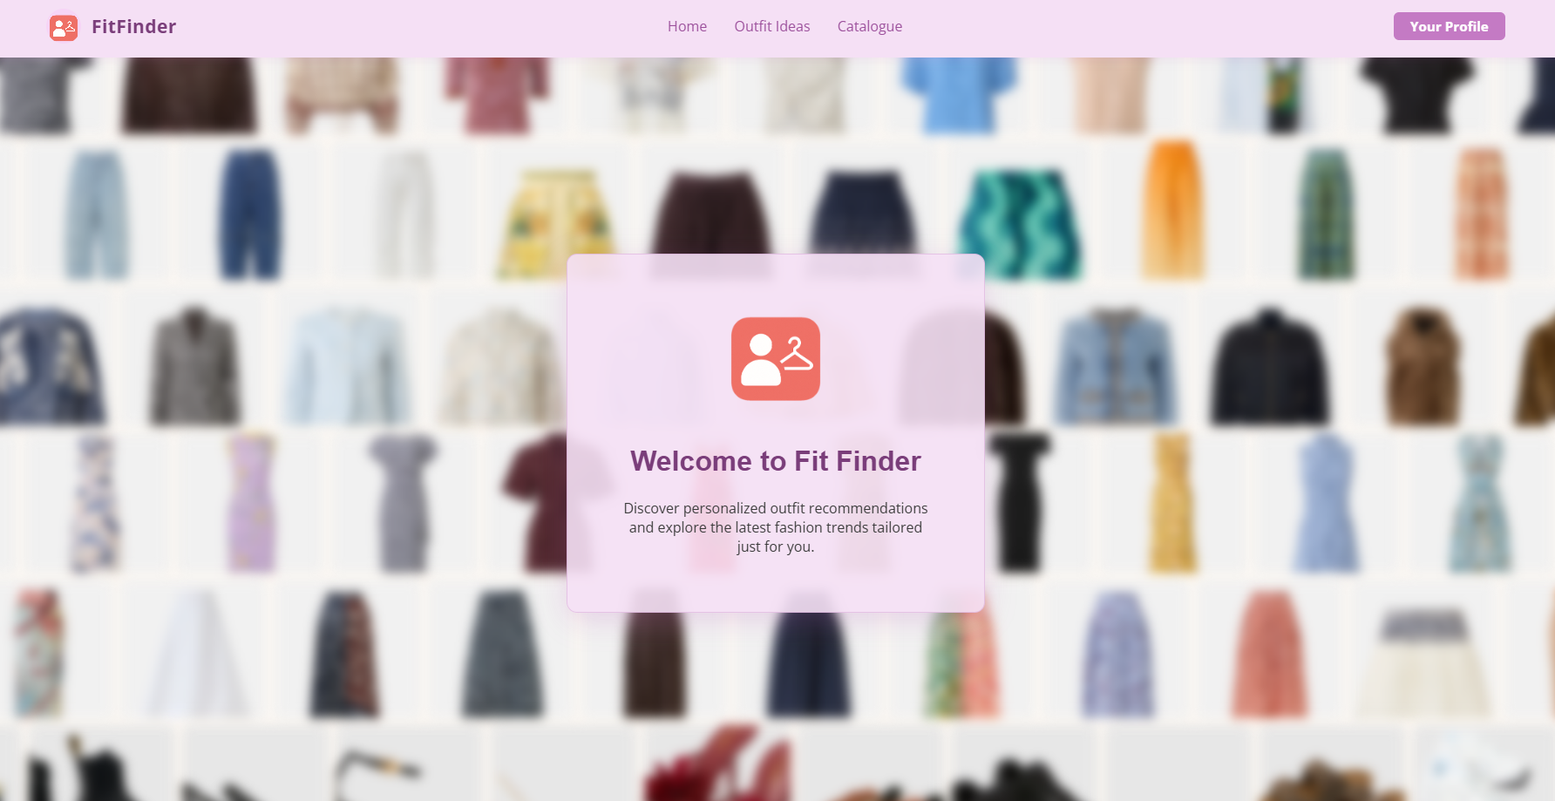
Figure 10-1 Fit Finder Main Screen
https://fitfinder.guru
Above is the link to Fit Finder, it is completely hosted online. The frontend end is made with React and Next.js, being hosted by Vercel. The frontend connects to the backend that is being hosted by AWS. K8s have been used alongside Docker to deploy the services. Terraform was used to deploy and manage the entire backend. Autoscaling was implemented by using KEDA and Amazon CloudWatch.
The services are all Python microservices created with FastAPI. These services connect to the MongoDB database, that is being used to store user information, as well as the clothing for the recommendation algorithm. The services connect to Google Gemini to create the images of the users in their chosen outfits. RabbitMQ is being used by the services to communicate with each other asynchronously. Machine learning is being used to update the database live using user feedback.

References
[T1] “FastAPI,” fastapi.tiangolo.com. https://fastapi.tiangolo.com
[T2] Docker, “What is Docker?,” Docker Documentation, 2024. https://docs.docker.com/get-started/docker-overview/
[T3] Kubernetes, “Overview,” Kubernetes, Sep. 19, 2023. https://kubernetes.io/docs/concepts/overview/
[T4] MongoDB, “What Is MongoDB?,” MongoDB, 2024. https://www.mongodb.com/company/what-is-mongodb
[T5] Tinybird, “MongoDB Alternatives: 10 Best Options Compared for 2026,” Tinybird.co, Dec. 26, 2025. https://www.tinybird.co/blog/MongoDB-Alternatives (accessed Apr. 20, 2026).
[T6] Supabase, “Row Level Security | Supabase Docs,” Supabase, Apr. 05, 2024. https://supabase.com/docs/guides/database/postgres/row-level-security
[T7] Hashicorp, “What is Terraform | Terraform | HashiCorp Developer,” What is Terraform | Terraform | HashiCorp Developer, 2024. https://developer.hashicorp.com/terraform/intro
[T8] Amazon, “What Is AWS? - Amazon Web Services,” Amazon Web Services, Inc., 2025. https://aws.amazon.com/what-is-aws/
[T9] “What is Amazon EKS? - Amazon EKS,” docs.aws.amazon.com. https://docs.aws.amazon.com/eks/latest/userguide/what-is-eks.html
‌ [T10] “Messaging that just works — RabbitMQ,” www.rabbitmq.com. https://www.rabbitmq.com
‌ [T11] J. Gage, “What does Vercel do? – Vercel,” vercel.com, May 10, 2023. https://vercel.com/blog/what-is-vercel
[PD1] “PyMongo Tutorial: MongoDB and Python,” MongoDB, 2026. https://www.mongodb.com/resources/languages/pymongo-tutorial?msockid=14437fe7a0466e3328fe6962a1d96f4a (accessed Apr. 21, 2026).
‌ [PD2] “How to store images in MongoDB (and why you should not) - Sling Academy,” Slingacademy.com, 2024. https://www.slingacademy.com/article/how-to-store-images-in-mongodb-and-why-you-should-not/
‌ [PD3] “FastAPI in Containers - Docker - FastAPI,” Tiangolo.com, 2026. https://fastapi.tiangolo.com/deployment/docker/#create-the-fastapi-code (accessed Apr. 21, 2026).
‌[PD4] GeeksforGeeks, “Top 7 Python Libraries for Reinforcement Learning,” GeeksforGeeks, Oct. 2024. https://www.geeksforgeeks.org/machine-learning/top-7-python-libraries-for-reinforcement-learning/
‌ [PD5] GeeksforGeeks, “How to Hash Passwords in Python,” GeeksforGeeks, Jun. 21, 2022. https://www.geeksforgeeks.org/python/how-to-hash-passwords-in-python/
‌[PD6] “Request Files - FastAPI,” Tiangolo.com, 2025.
https://fastapi.tiangolo.com/tutorial/request-files/
‌[PD6] Aaron, “Objects are not valid as a React child (found: [object Promise]),” Stack Overflow, Dec. 05, 2017. https://stackoverflow.com/questions/47658765/objects-are-not-valid-as-a-react-child-found-object-promise
‌ [PD7] GeeksforGeeks, “How to Hash Passwords in Python,” GeeksforGeeks, Jun. 21, 2022. https://www.geeksforgeeks.org/python/how-to-hash-passwords-in-python/
[PD8] GeeksforGeeks, “Creating a carousel with ReactJS Slick,” GeeksforGeeks, Mar. 24, 2022. https://www.geeksforgeeks.org/reactjs/creating-a-carousel-with-reactjs-slick/ (accessed Apr. 22, 2026).
‌[PD9] “W3Schools.com,” W3schools.com, 2026. https://www.w3schools.com/react/react_forms_checkbox.asp (accessed Apr. 22, 2026).
‌[PD10] R. Chenkie, “React Authentication: How to Store JWT in a Cookie,” Medium, Apr. 30, 2020. https://medium.com/@ryanchenkie_40935/react-authentication-how-to-store-jwt-in-a-cookie-346519310e81 (accessed Apr. 22, 2026).
[PD11] Alexander_Yizchak, “5 Practical Examples of Terraform with Python,” DEV Community, Oct. 08, 2024. https://dev.to/alexander_yizchak/5-practical-examples-of-terraform-with-python-3hbn (accessed Apr. 20, 2026).
[PD12] “Gruntwork Blog | The Docker, Kubernetes, Terraform, and AWS crash course series,” Gruntwork.io, 2022. https://www.gruntwork.io/blog/the-docker-kubernetes-terraform-and-aws-crash-course-series (accessed Apr. 20, 2026).
[PD13] “Securly - Geolocation sharing,” Github.com, 2026. https://github.com/brikis98/terraform-up-and-running-code/blob/master/code/terraform/07-working-with-multiple-providers/modules/services/eks-cluster/main.tf (accessed Apr. 20, 2026).
[PD14] F. Hashem, “How to Deploy Kubernetes Resources with Terraform,” Spacelift, Aug. 27, 2024. https://spacelift.io/blog/terraform-kubernetes-deployment (accessed Apr. 20, 2026).
[PD15] “KEDA,” KEDA, 2025. https://keda.sh (accessed Apr. 21, 2026).
[PD16] “Compile N Run,” Compilenrun.com, 2026. https://www.compilenrun.com/docs/devops/terraform/terraform-for-specific-use-cases/terraform-for-microservices/ (accessed Apr. 22, 2026).
[PD17] joozero, “GitHub - joozero/amazon-eks-frontend,” GitHub, 2025. https://github.com/joozero/amazon-eks-frontend/tree/main (accessed Apr. 22, 2026).
[PD18] G. Georgiev, “Hosting a Full-Stack React App on AWS: A Beginner’s Guide (EC2 & EKS),” Apps Forest, Jun. 11, 2025. https://appsforest.com/blog/aws-fullstack-hosting/ (accessed Apr. 22, 2026).
‌[PD19] Amazon Web Services, “Amazon CloudWatch - Application and Infrastructure Monitoring,” Amazon Web Services, Inc., 2024. https://aws.amazon.com/cloudwatch/
[E1] A. Zewe, “Explained: Generative AI’s environmental impact,” MIT News, Jan. 17, 2025. https://news.mit.edu/2025/explained-generative-ai-environmental-impact-0117
[E2] AWS, “AWS Global Infrastructure,” Amazon Web Services, Inc., 2024. https://aws.amazon.com/about-aws/global-infrastructure/
[E3] M. Yañez-Barnuevo, “Data Centers and Water Consumption | Article | EESI,” Eesi.org, Jun. 25, 2025. https://www.eesi.org/articles/view/data-centers-and-water-consumption
‌[E4] B. Lin, “IT Unemployment Rises to 5.7% as AI Hits Tech Jobs,” The Wall Street Journal, Feb. 08, 2025. https://www.wsj.com/articles/it-unemployment-rises-to-5-7-as-ai-hits-tech-jobs-7726bb1b
‌[E5] S. Team, “There are 47.2 million developers in the world - Global developer population trends 2025,” SlashData, May 02, 2025. https://www.slashdata.co/post/global-developer-population-trends-2025-how-many-developers-are-there
‌[E6] “TurboQuant: Redefining AI efficiency with extreme compression,” Research.google, 2026. https://research.google/blog/turboquant-redefining-ai-efficiency-with-extreme-compression/
‌

