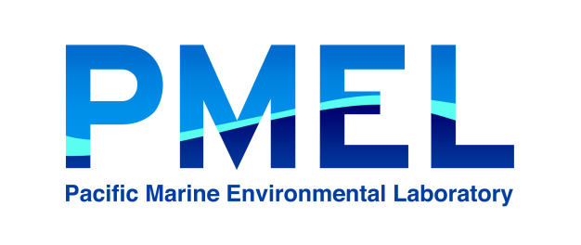Pacific Marine Environmental Laboratory-Engineering Development Division

National Oceanic and Atmospheric Administration

7600 Sandpoint Way

Seattle, WA 98115

To:

From:

Cc:

Subj:

Date:

Test Setup

Test results

Recommendation: