

**CMPSC 472: Project1: Individual proejct**

Mohamed Chikani

**TABLE OF CONTENTS**

|  |  |  |
| --- | --- | --- |
| 1 | ABSTRACT | 1 |
| 2 | INTRODUCTION | X |
| 3 | BACKGROUND | x |
| 4 | DESIGN | x |
| 5 | RESULTS | X |
| 6 | CONCLUSION | X |
| 7 | REFERENCE | x |

# **Project Description**

The project aims to develop a comprehensive operating system simulation with key features including multi-process and thread management, inter-process communication (IPC) mechanisms, parallel text file processing, and a simple user interface for CLI interaction. The system provides users with tools to manage processes, threads, perform IPC operations, and process text files efficiently.

# **Code Structure**

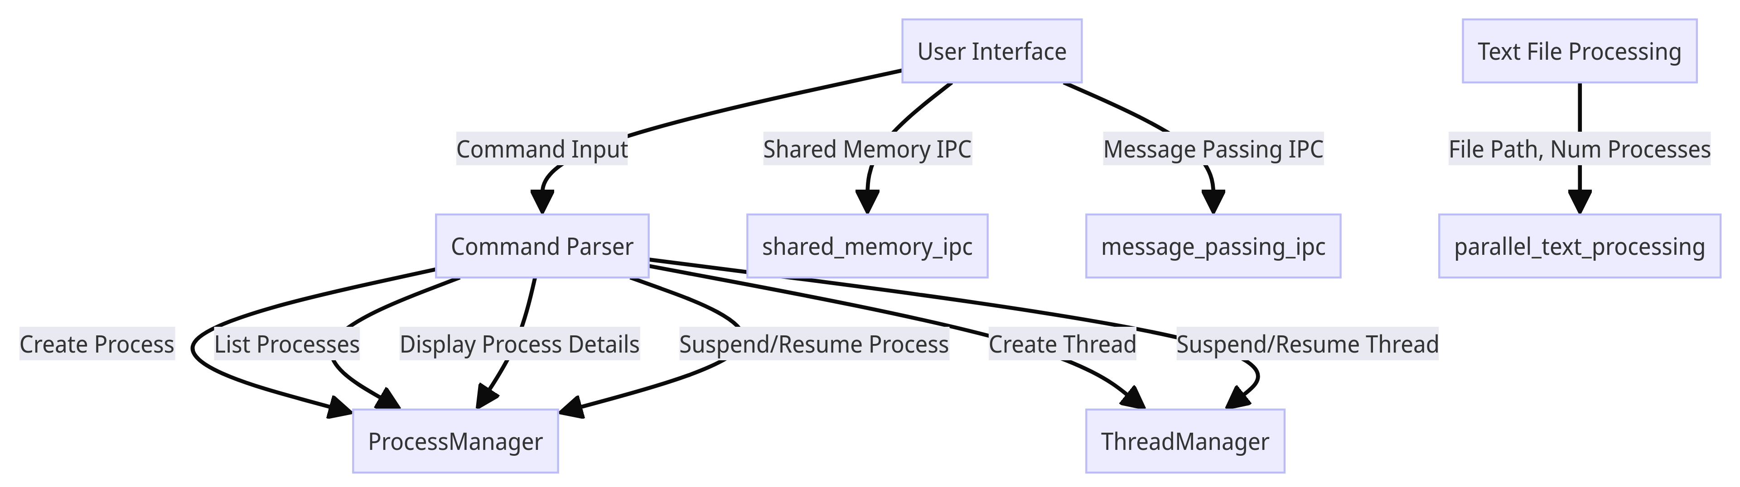

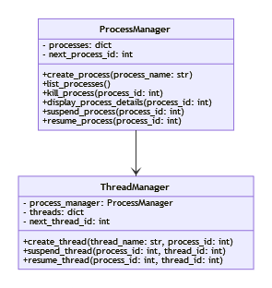

* **Multi-Process and Thread Manager:**
  + ProcessManager class handles process creation, listing, termination, and process details display.
  + ThreadManager class manages thread creation, suspension, and resumption within processes.
* **Inter-Process Communication (IPC) Mechanisms:**
  + Implement shared memory IPC and message passing IPC using multiprocessing and threading modules.
  + Evaluate and compare the performance of each IPC mechanism with short and long messages.
* **Parallel Text File Processing:**
  + Develop parallel text file processing system to convert characters to uppercase and count occurrences efficiently.
  + Implement parallelized operations for processing large text files and measure performance metrics.
* **Simple User Interface:**
  + Commands for managing processes, threads, IPC operations, and text file processing tasks.

# **Instructions for Full Functionalities**

Run main.py and follow the CLI prompts.

# **Code Sanity Verification**

