Financial RAG Pipeline: Solution Document
LangChain + LangGraph + Ollama | SEC filing question answering

1. Introduction
This project was built as a hands-on way to understand how a RAG system actually behaves on dense financial documents. Instead of treating the LLM as the main component, I focused on the retrieval decisions before generation, because that is where most of the answer quality came from in this experiment.
The final system answers questions over a JPMorgan Chase SEC 10-K filing using LangChain, LangGraph, Chroma, BAAI embeddings, a cross-encoder reranker, and Ollama running locally. The main experiment compares fixed-size chunking with paragraph-aware semantic chunking on the same set of financial questions.

2. Use Case
The use case is a financial analyst or student asking questions about a company's SEC filing through a local CLI/internal assistant. The system retrieves relevant filing chunks, reranks them, and generates a grounded answer with chunk references.

3. The Framework
Framework field | Decision made in this project
Use case | Answer financial-analysis questions about SEC 10-K filings for users such as analysts, students, or consultants through a CLI/internal assistant. The system is useful when a user wants a quick grounded answer instead of manually searching a long filing.
Corpus | The corpus for this experiment is JPMorgan Chase's SEC 10-K filing downloaded from EDGAR. The source of truth is the SEC filing itself, and the format starts as SEC HTML/TXT with XBRL content in English.
Ingestion + cleaning | The filing is downloaded using sec-edgar-downloader, then cleaned before chunking. Cleaning removes HTML tags, scripts, style blocks, hidden XBRL metadata, SEC boilerplate-like noise, and normalizes whitespace.
Ingestion + freshness | For this project the ingestion is run manually, which is enough for a reproducible experiment. In production, the pipeline could refresh after quarterly or annual filings are published, with a freshness SLA of about 24 hours after the filing is available on EDGAR.
Chunking + embedding | I compared fixed-size chunking using RecursiveCharacterTextSplitter with paragraph-aware semantic chunking that preserves nearby related paragraphs. Both strategies use BAAI/bge-base-en-v1.5 embeddings because it is free, local, and strong for semantic retrieval.
Retrieve | Chunks are stored in ChromaDB and retrieved using dense vector search with top-k=10 before reranking. Dense retrieval was selected because the main goal was semantic search across financial explanations, not exact keyword matching.
Rerank | A cross-encoder reranker, cross-encoder/ms-marco-MiniLM-L-6-v2, reranks the top retrieved chunks and keeps the best 5. This improves ordering because the reranker reads the query and chunk together instead of only comparing separate embeddings.
Generate | Ollama with llama3.2:3b generates the final answer locally using only the reranked chunks as context. The prompt tells the model to avoid outside knowledge and cite chunk IDs where possible.
Evaluate | Evaluation uses the same set of five financial questions for both chunking strategies. The results.csv file stores retrieved chunks, reranked chunks, generated answers, and manual evaluation fields for comparison.

4. Architecture
The architecture below shows the complete flow from SEC filing ingestion to answer generation and evaluation.

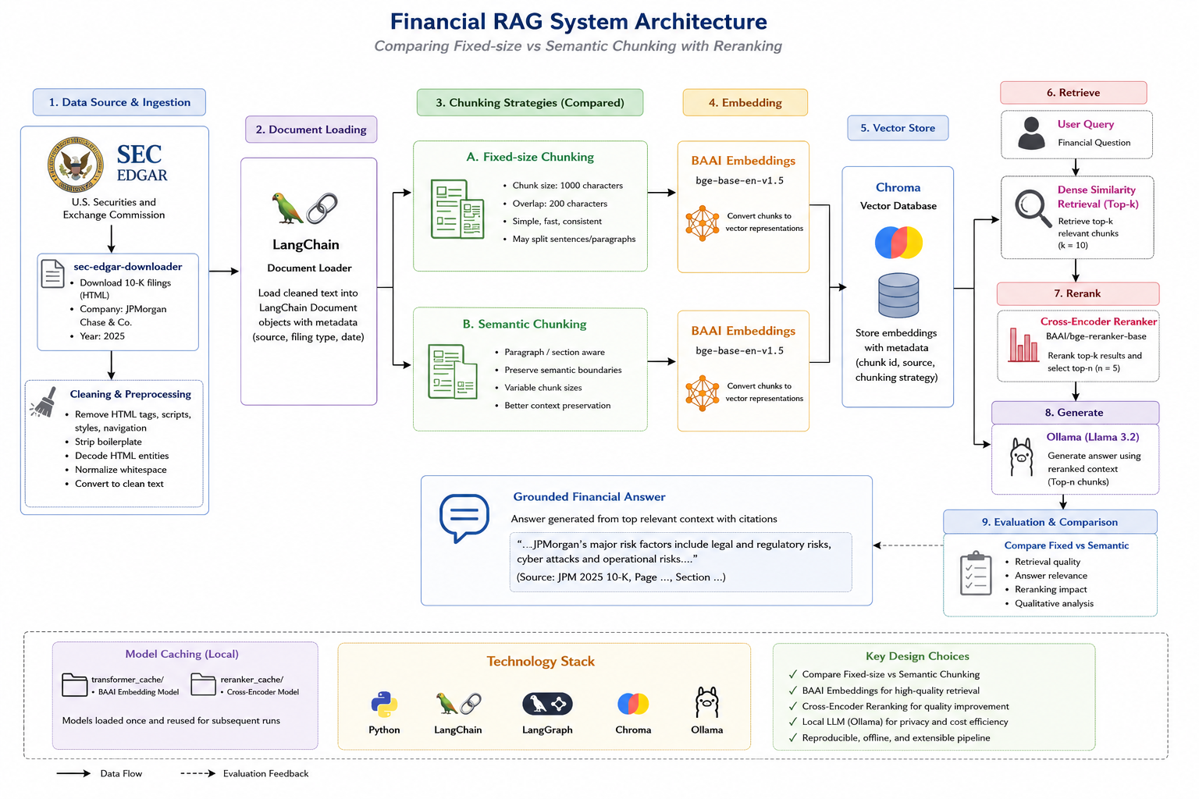
Figure: Financial RAG architecture comparing fixed-size and semantic chunking with reranking.

5. Design Decisions
Decision | Reasoning
SEC EDGAR | SEC filings are public, finance-heavy, and structured enough to make retrieval non-trivial. A 10-K contains risk factors, business segments, management discussion, and financial details, so it is a realistic financial RAG corpus.
LangChain | LangChain provided the main RAG building blocks: Documents, splitters, embeddings, Chroma integration, and prompt chains. I used it so the project followed a production-track RAG stack instead of being only custom scripts.
LangGraph | LangGraph was used to make the retrieve -> rerank -> generate workflow explicit. Even though the current graph is simple, it makes the flow modular and leaves room for future nodes like query rewriting or confidence checks.
BAAI embeddings | I used BAAI/bge-base-en-v1.5 because the project needed to stay free and local. It gives good semantic retrieval quality without depending on paid embedding APIs.
Chroma | Chroma is lightweight and stores vector indexes locally, which matched the scope of this project. It also integrates easily with LangChain and avoids a cloud vector database dependency.
Ollama | Ollama allowed the generation step to run locally using llama3.2:3b. This kept the full pipeline free and made the project reproducible without paid API keys.
Reranking | The first vector search is fast but approximate, so I added a cross-encoder reranker to improve the order of evidence before sending it to the LLM. This matters because the LLM can only answer well if the best context is actually near the top.

6. Challenge: SemanticChunker was too slow
Initially I tried LangChain's experimental SemanticChunker because it seemed like the most direct way to create semantic chunks. However, when I ran it on a full SEC 10-K, it became very slow on CPU because it calculates embeddings for many sentence groups before deciding where the semantic breaks should be.
At that point I changed the approach. Instead of forcing the experimental SemanticChunker to process the entire filing, I implemented a paragraph-aware semantic chunker that groups nearby paragraphs and enforces a maximum chunk size. This was a practical engineering tradeoff: it preserved more natural financial context than fixed-size chunks, while still being fast enough to run locally.

7. Codebase Flow
File | Purpose
config.py | Stores paths, model names, chunk sizes, and retrieval settings so they are not hardcoded across the project.
ingest.py | Downloads the SEC filing, finds the actual downloaded file, cleans it, and saves a processed text version.
chunking.py | Creates fixed-size and paragraph-aware semantic chunks, then saves them as JSONL files.
build_index.py | Loads chunks, embeds them with BAAI embeddings, and stores them in Chroma indexes.
retrieve.py | Loads the Chroma vector store and retrieves top-k relevant chunks for a query.
rerank.py | Uses a cross-encoder to reorder retrieved chunks and return the most relevant top-n chunks.
generate.py | Formats the reranked chunks and sends the prompt to Ollama for grounded answer generation.
graph.py | Defines the LangGraph workflow: retrieve, rerank, and generate.
evaluate.py | Runs test questions through fixed and semantic strategies and saves the comparison output to CSV.

8. Security and Production Considerations
- SEC user identity is stored in environment variables instead of hardcoding personal details directly into the source code.
- Retrieved filing text is treated as evidence, not as instructions. The prompt explicitly tells the LLM not to follow instructions inside the retrieved context.
- The current corpus is public SEC data, but a production version for insurance claims or loan documents would need access control, PII redaction, audit logs, and encryption at rest.
- Model objects are cached at module level for embeddings and reranking, reducing repeated loading during the same Python process.

9. Evaluation Summary
The evaluation used five questions covering risk factors, credit risk, liquidity risk, business segments, and regulatory risk. Each question was run through both fixed-size and semantic chunking pipelines, then the retrieved chunks were reranked and passed to Ollama.
From the observed outputs, semantic chunking generally gave more complete and better organized answers, especially for broad questions such as major risk factors and business segments. Fixed-size chunking was still useful and even performed better for the liquidity-risk question because it retrieved broader related snippets.

10. Limitations and Future Work
- The current experiment uses one company filing; a stronger benchmark would include multiple companies and multiple years.
- The semantic chunking method is paragraph-aware rather than a full embedding-distance semantic chunker, chosen because of local CPU constraints.
- Manual scoring columns are present in results.csv but need to be filled by the evaluator for a more formal relevance analysis.
- Future improvements could include hybrid search, metadata filters, section-aware parsing, query rewriting, confidence thresholds, and LangSmith-style tracing.

11. Conclusion
This project helped me understand importance of chunking strategy, retrieval setup, and reranking step, influencing RAG quality and effect on the final answer. The most important lesson from the experiment was that preserving document context before embedding usually leads to better grounded answers.

