# Experimental setup

Oculus quest

Delsys sEMG

EEG

# Placement of the sEMG electrodes

## Determined by palpation

<https://journals.plos.org/plosone/article?id=10.1371/journal.pone.0186132>

<https://www.nature.com/articles/sdata201453>

<https://www.hindawi.com/journals/isrn/2012/604314/>

Ask the subject to perform the gestures that will be recorded and determine, by palpation, the main activity spots on the forearm.

**Advantages :**

* Easy to do
* We can find any number of points

**Disadvantages :**

* Not precise (we might need precise location that is the same for all the subjects)

## Pre-identified zones

<https://www.nature.com/articles/s41597-019-0285-1>

<https://jneuroengrehab.biomedcentral.com/articles/10.1186/s12984-018-0437-0>

Jarque-Bou, N.J., Vergara, M., Sancho-Bru, J.L. et al. determined 30 zones on the forearm that are relevant for classification of hand gesture using sEMG and showed that 7 of them are sufficient to not loose any relevant information.

As we have 16 sEMG electrodes, we can also record other areas to have more redondant informations. We can choose them using their results so that we take points that are not too much related and that have strong muscular activity.

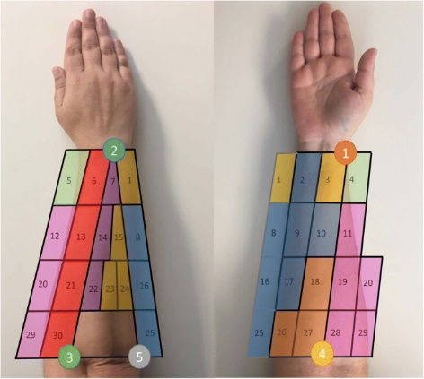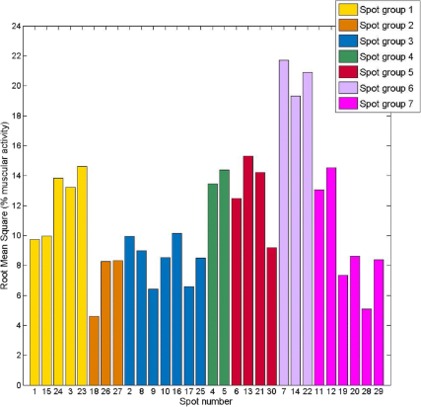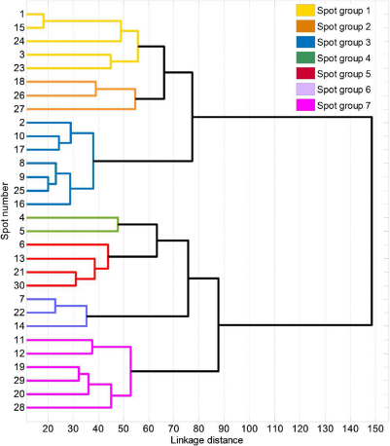

**Advantages:**

* Much more precise and reproducible
* We are sure to get all the relevant information

**Disadvantages:**

* /

## Arm band of electrode

“CAMERA - GUIDED INTERPRETATION OF ( 56 ) NEUROMUSCULAR SIGNALS” from Facebook

<https://www.mdpi.com/2079-9292/9/12/2143/pdf>

<https://www.mdpi.com/1424-8220/19/14/3170/pdf-vor>

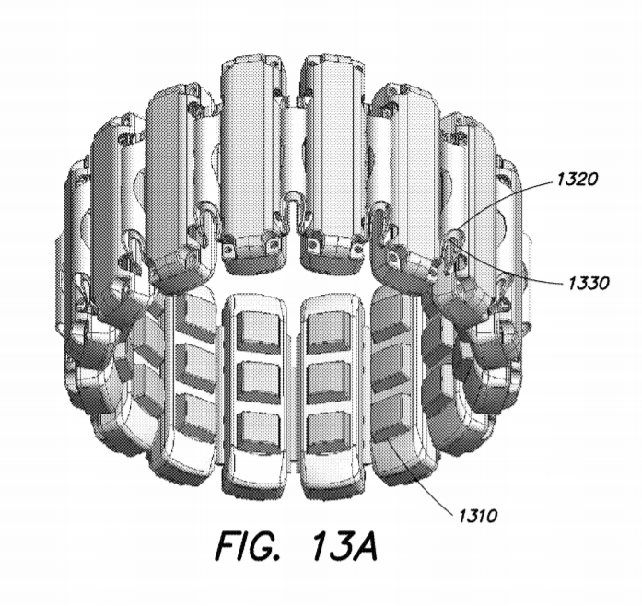

More realistic for real life usage but might not get as much information as 2.2. (or at least need more electrodes)

# Gestures to perform

## ADL

<https://www.nature.com/articles/s41597-019-0285-1>

ADL = activities of daily living

<https://www.tandfonline.com/doi/abs/10.3109/02844319509034334> : movements that simulate ADL

* <https://www.nature.com/articles/s41597-019-0285-1/tables/2>

Not possible with the VR headset

* Would require the subject to see what’s in front of him to use real life objects
* When grabing an object, the hand is no more completely visible from the Oculus Quest camera, so, the hand position might not be as precise as expected
* If we replace the objects by virtual ones (in the VR), we do not take into account the grasping force

## Single finger gesture

<https://www.researchgate.net/publication/341629918_Simultaneous_Hand_Gesture_Classification_and_Finger_Angle_Estimation_via_a_Novel_Dual-Output_Deep_Learning_Model>

Ask the subject to move one finger at a time with maimum contraction level

Does not show the muscle activity when moving multiple fingers at a the same time

## Pinching

The oculus quest recognizes the pinching movement, we can use it as a classification problem on the data.

## Simple gestures

<https://www.mdpi.com/1424-8220/19/14/3170/pdf-vor>

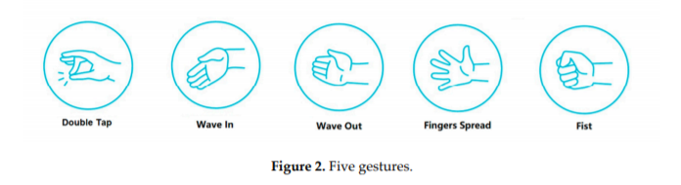

mostly used for classification of hand gesture

# Data

Hand angles could be saved using International Society of Biomechanics (ISB) sign critera

* <https://www.sciencedirect.com/science/article/abs/pii/S002192900400301X?via%3Dihub>
* Gives standardisation of encoding of the anatomital angles of the hand