# Experimental setup

Oculus quest

Delsys sEMG

EEG

# Placement of the sEMG electrodes

## Determined by palpation

<https://journals.plos.org/plosone/article?id=10.1371/journal.pone.0186132>

<https://www.nature.com/articles/sdata201453>

<https://www.hindawi.com/journals/isrn/2012/604314/>

Ask the subject to perform the gestures that will be recorded and determine, by palpation, the main activity spots on the forearm.

**Advantages :**

* Easy to do
* We can find any number of points

**Disadvantages :**

* Not precise (we might need precise location that is the same for all the subjects)

## Pre-identified zones

<https://www.nature.com/articles/s41597-019-0285-1>

<https://jneuroengrehab.biomedcentral.com/articles/10.1186/s12984-018-0437-0>

Jarque-Bou, N.J., Vergara, M., Sancho-Bru, J.L. et al. determined 30 zones on the forearm that are relevant for classification of hand gesture using sEMG and showed that 7 of them are sufficient to not loose any relevant information.

As we have 16 sEMG electrodes, we can also record other areas to have more redondant informations. We can choose them using their results so that we take points that are not too much related and that have strong muscular activity.

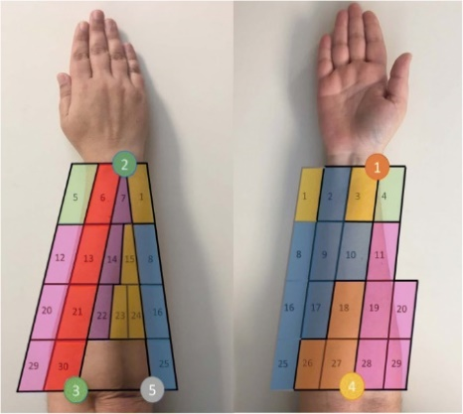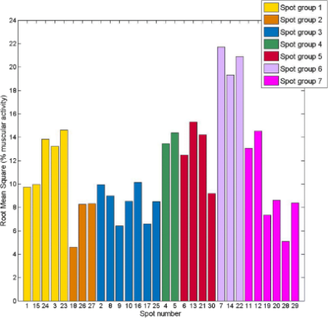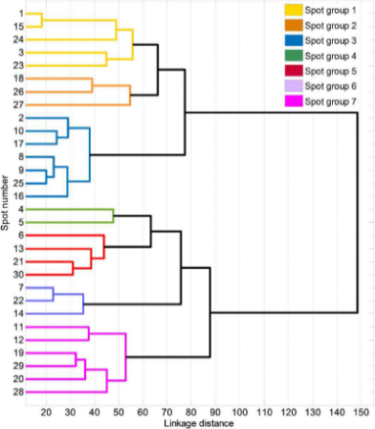

**Advantages:**

* Much more precise and reproducible
* We are sure to get all the relevant information

**Disadvantages:**

* The location of the electodes are not realistic for real life usage (prosthetic, …)

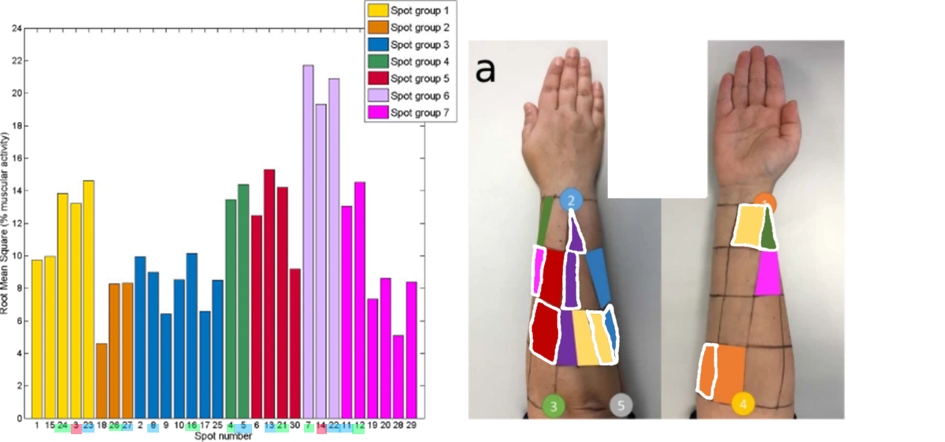

## Arm band of electrode

“CAMERA - GUIDED INTERPRETATION OF ( 56 ) NEUROMUSCULAR SIGNALS” from Facebook

<https://www.mdpi.com/2079-9292/9/12/2143/pdf>

<https://www.mdpi.com/1424-8220/19/14/3170/pdf-vor>

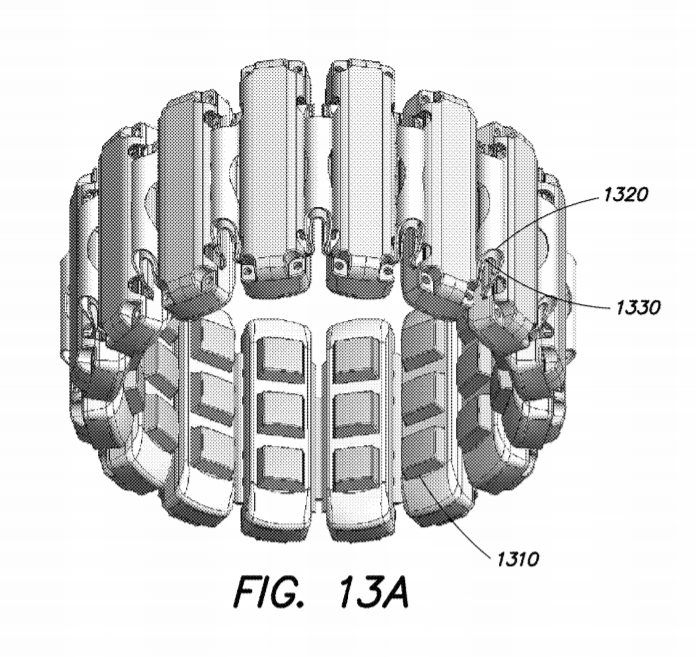

More realistic for real life usage but might not get as much information as 2.2. (or at least need more electrodes)

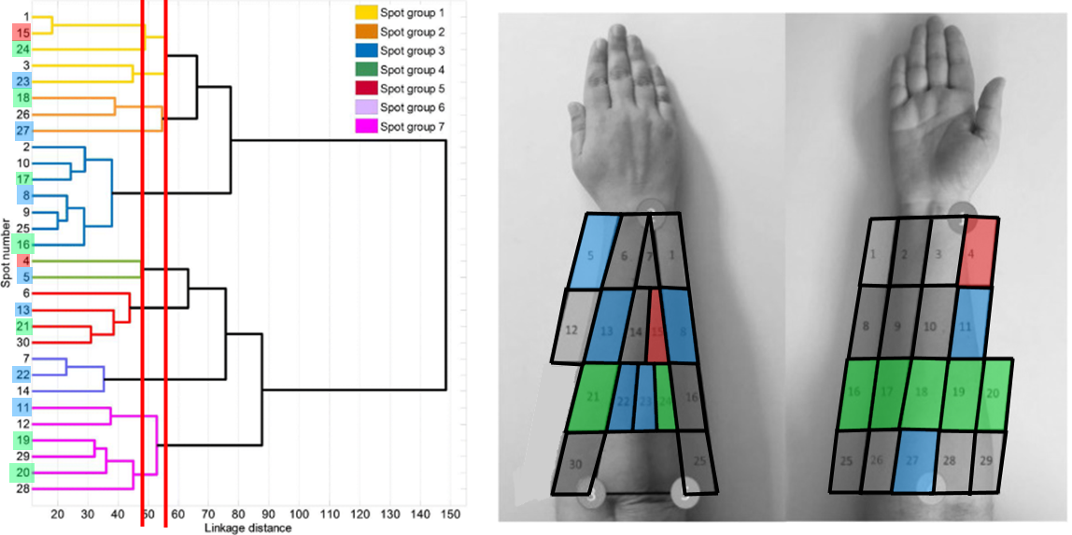

We can combine this with point 2.2 (gives 14 points)

# Gestures to perform

## ADL

<https://www.nature.com/articles/s41597-019-0285-1>

ADL = activities of daily living

<https://www.tandfonline.com/doi/abs/10.3109/02844319509034334> : movements that simulate ADL

* <https://www.nature.com/articles/s41597-019-0285-1/tables/2>

Not possible with the VR headset

* Would require the subject to see what’s in front of him to use real life objects
* When grabing an object, the hand is no more completely visible from the Oculus Quest camera, so, the hand position might not be as precise as expected
* If we replace the objects by virtual ones (in the VR), we do not take into account the grasping force

## Single finger gesture

<https://www.researchgate.net/publication/341629918_Simultaneous_Hand_Gesture_Classification_and_Finger_Angle_Estimation_via_a_Novel_Dual-Output_Deep_Learning_Model>

Ask the subject to move one finger at a time with maimum contraction level

Does not show the muscle activity when moving multiple fingers at a the same time

## Pinching

The oculus quest recognizes the pinching movement, we can use it as a classification problem on the data.

## Simple gestures

<https://www.mdpi.com/1424-8220/19/14/3170/pdf-vor>

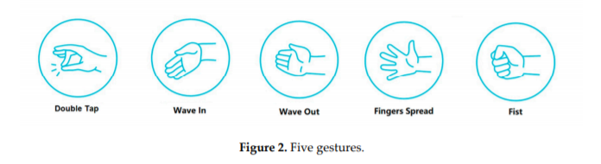

mostly used for classification of hand gesture

Some article base their gesture on sign language

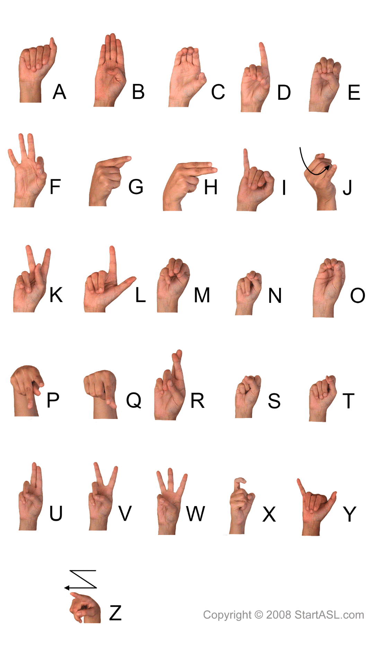

## Same gesture with different arm rotation

# How to tell the subject what to do

We can remotely tell the oculus quest to show images to the subject that tell him what kind of gesture to perform

# Acquisition protocol

* 1. <https://www.nature.com/articles/sdata201453>

details the information about the subjects (age, gender, height, weight, laterality, injured…)

start by oral explanation of the experiment and its risks + sign consent form + Declaration of Helsinki : https://www.wma.net/policies-post/wma-declaration-of-helsinki-ethical-principles-for-medical-research-involving-human-subjects/

note : they also use a placement of the electrodes that is a mix between an armband and the other technique

image on a laptop to tell the subject which gesture to perform

3 exercices phase with pause in between for the subject to rest

Training phase starts with unrecorded sequence of exercices for the subject to become familiar with the experiment

Exercices :

* Mimic movies of movement shown on the screen
* The set of movements was selected from the hand taxonomy, robotics, and rehabilitation literature to cover most ADL movements[4](https://www.nature.com/articles/sdata201453#ref-CR4),[12](https://www.nature.com/articles/sdata201453#ref-CR12),[26](https://www.nature.com/articles/sdata201453#ref-CR26)–[30](https://www.nature.com/articles/sdata201453#ref-CR30) (grabbing gesture)
* Sequence of movement is repeated and not randomized to encourage unconcious mouvements
* Exercices where we ask to perform different level of force
* Right hand for non amputees. Hand the is missing for amputees while recording ground truth on the other hand

No information about how long the keep the gestures

* 1. <https://www.nature.com/articles/s41597-019-0285-1>

# while the subject sat comfortably with an elbow resting on a table, arm flexed 90° compared to the forearm, and the palm of the hand facing the subject, as detailed in a previous work[17](https://www.nature.com/articles/s41597-019-0285-1#ref-CR17)

ADL -> SHFT scenario

Some experiment made with subject standing and other sitted

Perform tasks in advance as many times as necessary to become familiar

Start and end each task in the same posture

Mark time stamp of gesture by hand (not useful for us)

* What gesture starts and ends when
* When the hand comes into contact with an object
* -> tries to see the gesture change muscle activity and the gesture hold muscle activity

Reference posture (open hand flat on table) considered as zero for all rotation angles

7 recodes of maximum volontary contraction (MVC), each repeated 3 times. 3 minutes of resting between each repetition

* Flexion and extension of the wrist
* Flexion and extension of the fingers
* Pronation of the forearm
* Ulnar deviation of the wrist
* Elbow flexion
  1. <https://www.mdpi.com/1424-8220/20/10/2972>

The Taiwanese Sign Language includes 50 fundamental gestures: <https://www.researchgate.net/publication/243769865_A_Sign_Language_Recognition_System_Using_Hidden_Markov_Model_and_Context_Sensitive_Search>

Declaration of Hensinki

Kept each position for 25s

* 10 posture
* 10 trial of each posture
  1. <https://jneuroengrehab.biomedcentral.com/articles/10.1186/1743-0003-11-122>

place electrodes by palpation

3 types of move

* One finger at a time
* All finger together
* moves finger freely (even irregular is encouraged)

move at any velocity (as normal as possible)

reach maximum flexion extension each time

maintain th position of the forearm as neutral as possible

mvc: <https://pubmed.ncbi.nlm.nih.gov/29355119/>

# Data

Hand angles could be saved using International Society of Biomechanics (ISB) sign critera

* <https://www.sciencedirect.com/science/article/abs/pii/S002192900400301X?via%3Dihub>
* Gives standardisation of encoding of the anatomital angles of the hand