# Continuous and simultaneous estimation of finger kinematics using inputs from an EMG-to-muscle activation

*File name = Continuous and simultaneous estimation of finger kinematics using inputs from an EMG-to-muscle model.pdf*

Classification approach are not sufficient for natural prosthetic motion as they use a sequential strategy where only one class of movement is active at a time.

* Need simultaneous control of multiple DOF

Difficult to predict the movement of multiple figer simultaneously even if they are recorded simultaneously because the number of involved channel is big

EMD : time delay between muscle motor action (offset in the EMG) and actual movement (tension in the muscle)

* Can be used as a parameter : EMD-to-muscle activation model
* 10 to 150 ms (depending on the task)

This study present a method to control simultaneously 15 DOF on all 5 fingers (3 angle per finger)

* Using a fast forward neural network and a non-parametric gaussian process regression

A motion capture system was used to capture the gesture at the same time than the sEMG to serve as ground truth

Data collection :

* Arms placed on the table
* 3 tasks
  + The subjects is asked to move one finger at a time (flexion extension)
  + Move all finger at the same time (flexion extension)
  + Move any finger freely in any direction (even irregular movement)
* Move in the same speed as they would normally do
* Reach maximum flexion/extension
* The rest of the arm stays fixed (marker on the wrist ensure that it stays fixed)
* Multiple set of each task were made
* After that, additional trials were made to collect MVC
  + Flex arm in all possible plane to induce maximum contraction of all targeted muscles
* Data was then analysed separately for each subject

MVC = maximum volontary contraction

* Gives the maximum EMG

Data processing

* EMG-to-muscle activation model
  + Depends on the current level of EMG and on its recent history
* Low pass filter

ANN

* Useful for its ability to estimate non-linear function
* Multi-layer feed forward neural network
  + Hestimates all 15 DOFs at te same time
* 80% of data for training

Gaussian process of regression

* One dedicated GP for each DOF

ANOVA statitical analysis

Results :

* It works even for all DOF predediction at the same time
* GP gives higher prediction accuracy than ANN
* GP can handle missing data better than ANN
* GP is 10 times slower than ANN
* PCA analysis showed that only the 4 to 6 PCA really have an impact on the hand posture
* Implemantation done offline
  + Need to be able to do it online for real life application
* Don’t know what happens if we change wrist position

# Estimation of Finger Joint Angles from sEMG Using a Neural Network Including Time Delay Factor and Recurrent Structure

*File name = Estimation of Finger Joint Angles from sEMG Using a NN.pdf*

sEMG are useful because they are generated by volontary muscle movement

target : predict position of each finger simulataneously and independantly using few sEMG electrodes

model :

* Neural network using 3 layer perceptrons and multioutput system
* Feedback stream
* Time delay (so that the perceptron take information about current and past sEMG and feedback)

4 electrodes are used on the forearm

* Position determined by palpation so that each of them is triggered for finger flexion/extension

CyberGlove to record joint angles of the fingers

* 20 measured finger joints

Featyre selection :

* Waveform length (include time domain and frequency domain features)
* Normalisation of the feature vector

Estimation system using an NN

* 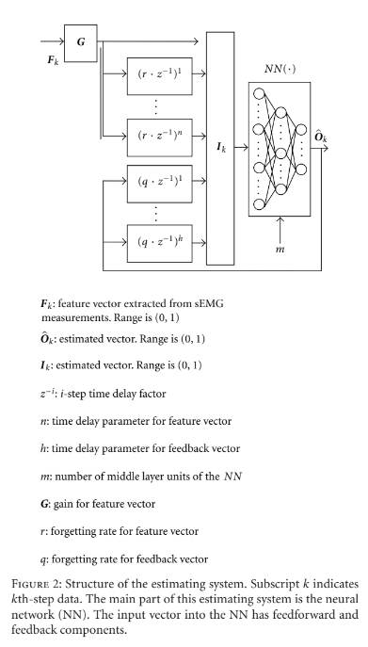

Training phase :

* Uses estimation system but does not use feedback

Experiment

* 2 set of finger motion
  + Finger individual flexion and extension
    - Shows independancy of finger
  + Finger flexsion and extension individually and together
    - Shows complecity for both single and multifinger motion
* Combination of system parameters
  + As they are a lot of parameters, too many combination are possible. So, only some possible value of each parameter were considered
* Experimental procedure (each repeated 1000 times for both motion sets except for the 1st one)
  + Data aquisition (from sEMG and glove)
  + Determination of system parameters
  + Training
  + Estimating
    - Estimate the finger joint angles with data not used for training (compared with the data from the glove for validation)
      * Root mean square (RMS) used for evaluation

Discussion

* Component related to sEMG are more important than those related to feedback
* The NN is able to accurately estimate angles with little sEMG information