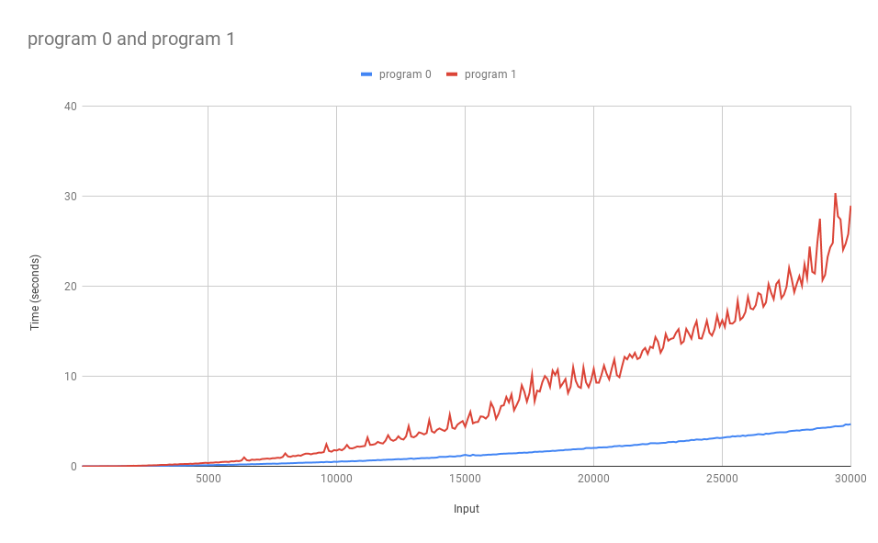

Program 0 and 1 have the same complexity. The only difference in the source code is that program 0 loops through memory through rows in an array (to the next memory address), where program 1 loops through columns (a distant memory address). By looping to the next memory address, program 1 uses fewer ALU operations and so executes faster. “i\*size” can be calculated once per outer loop iteration, where j\* size must be calculated every iteration of i and j.