SoftwareX — Original software publication
NFert: an open-source R package for transparent and reproducible crop fertilization planning based on nutrient balances
Michele Croci ^{a,*}, Giorgio Impollonia ª, Andrea Ferrarini ª, Andrea Fiorini ª, Manuele Ragazzi ª, Nicolaj Franceschi ª, Vincenzo Tabaglio ª, Stefano Amaducci ª
ª Department of Sustainable Crop Production (DI.PRO.VE.S.), Università Cattolica del Sacro Cuore, via Emilia Parmense 84, 29122 Piacenza, Italy
* Corresponding author. E-mail: michele.croci@unicatt.it
ARTICLE INFO  Article history:  Received 16 April 2026  Received in revised form  Accepted  Keywords:  R package  Nutrient balance  Decision-support system  Precision agriculture  Fertilizer management  Soil fertility | A B S T R A C T  The NFert R package is an open-source software that computes nitrogen (N), phosphorus (P₂O₅) and potassium (K₂O) fertilization requirements for herbaceous and tree crops using balance-based and simplified-dose methods. NFert implements (i) a full crop nutrient balance accounting for crop demand, soil supply, leaching, immobilization, previous crop effects and organic amendments, (ii) simplified standard-dose schemes with decrement/increment adjustments, (iii) soil texture, P, K and chemistry classifiers, (iv) regulatory checks including maximum N-dose limits and the 170 kg N ha⁻¹ ceiling of the EU Nitrates Directive in Nitrate Vulnerable Zones, (v) a fertilization distribution plan that combines organic and mineral fertilizers, (vi) a spatially-explicit balance that applies the nutrient budget pixel-by-pixel to soil-property rasters, and (vii) NDVI-based variable-rate algorithms tied to the balance through a mass-balance constraint. Coefficient tables and classification thresholds are exposed as standard R objects and can be extended or substituted, so the package is portable across regulatory contexts. NFert ships with a reference parameterization for the Emilia-Romagna Integrated Production Guidelines (DPI 2026) as a first fully-working case study and a bundled set of real soil-property rasters for a 12-ha field in Northern Italy.

Code metadata
Code metadata description
Current code version | v0.13.0
Permanent link to code/repository used for this code version | https://github.com/mcroci/NFert
Code Ocean compute capsule | NA
Legal Code License | MIT License (https://opensource.org/licenses/MIT)
Code versioning system used | git
Software code languages, tools and services used | R programming language
Compilation requirements, operating environments & dependencies | R >= 4.0; package raster; tested on Windows, macOS and Linux
Link to developer documentation/manual | https://github.com/mcroci/NFert
Support email for questions | michele.croci@unicatt.it

1. Motivation and significance
Nitrogen, phosphorus and potassium fertilization is one of the most consequential agronomic decisions in European agriculture. Excess nitrogen contaminates surface and groundwater, drives nitrous oxide emissions and erodes nitrogen use efficiency, while insufficient supply limits yield, quality and farm profitability [1]. Phosphorus and potassium dynamics are strongly buffered by soil texture, and long-term fertilization plans must consider availability classes and legacy stocks to avoid either depletion or unwanted accumulation [2].
Many regulatory and advisory frameworks encode these principles into formal fertilization plans, based either on a crop nutrient balance or on simplified standard-dose schemes. These plans are typically distributed through closed, spreadsheet-based decision-support tools that, although widely used by farm advisors, are difficult to version, not suited to batch analysis and hard to couple with remote-sensing data. One such example is the Emilia-Romagna Disciplinari di Produzione Integrata (DPI) 2026 [3], whose balance method (Allegato 2) and simplified standard-dose scheme are operationalized in the regional spreadsheet application FertDPI/Fert_Office (v1.26, February 2026) [4]; comparable frameworks exist across Europe and in other continents, typically sharing the same underlying balance logic with locally calibrated coefficients.
Progress has been made on data accessibility and on tools bringing open documentation of fertilization protocols to stakeholders (e.g. the FRST initiative in the United States [5]), but, to our knowledge, no open software combines a full balance-based planner with regulatory N-dose checks and native variable-rate support in a reproducible way. This gap impedes the adoption of integrated-fertilization methods beyond the individual advisory communities that maintain each closed tool and limits the ability of researchers to replicate fertilization plans at scale [6].
We therefore developed NFert, an R package that implements a full balance-based fertilization planner for N, P₂O₅ and K₂O. Every coefficient, classification threshold and lookup table is stored as a standard, lazy-loaded R object, so the package is portable: by editing or replacing those objects the same balance machinery can be repurposed for other national or regional guidelines. NFert ships with a reference parameterization drawn from the DPI 2026 guidelines [3] as a first fully-worked case study. R was chosen because of its central role in data science, its open-source philosophy and the availability of CRAN as a global dissemination network [7]. NFert allows agronomists, researchers and extension services to compute fertilization plans for hundreds of fields reproducibly, to couple them with spatial data and to extend the model through scenarios that cannot be tested within spreadsheet-based tools.
The methodology behind NFert builds on the general balance framework documented in the agronomic literature and in regional guidelines such as the Guida alla Fertilizzazione Minerale e Organica [8]. Default regulatory constraints — including maximum allowed N doses and the 170 kg N ha⁻¹ ceiling in Nitrate Vulnerable Zones, which implements the European Nitrates Directive 91/676/EEC [9] — are taken, in the current release, from Emilia-Romagna Regulations 2/2024 [10] and 3/2017 [11], but the MAS tables are user-editable and can be repopulated for other jurisdictions. For precision-agriculture applications, NFert integrates the sufficiency-index approach of Holland and Schepers [12], one of the most widely adopted NDVI-based algorithms for in-season nitrogen management. Compared with generic process models (e.g. DSSAT, APSIM), NFert is intentionally lightweight: it is a balance-based decision-support tool, not a dynamic simulator, and is therefore particularly suited to operational planning, regulatory compliance and teaching.

2. Software description
NFert is a pure-R package, operating within the R environment (R >= 4.0). It depends on the raster package [13] as its only hard dependency and has optional Suggests on knitr, rmarkdown and testthat. The package currently exports 54 functions and ships with 33 internal datasets — lazy-loaded R objects such as uptake_table, mas.table and mineral_fertilizers.table — plus six bundled GeoTIFF rasters in inst/extdata/ for the 12-ha Cremonesi reference field; these datasets constitute the agronomic reference parameterization and can be extended or substituted by the user to adapt the workflow to other guidelines.

2.1. Functions in NFert
The package is organized into six loosely coupled modules: (i) the N balance, (ii) the P and K balances, (iii) the simplified standard-dose scheme, (iv) the fertilization distribution plan, (v) the soil chemistry classifiers and (vi) the precision-agriculture module (Fig. 1). All internal datasets are lazy-loaded R objects with English names, designed to be transparent and user-modifiable; identifiers from the reference parameterization are retained in _it companion columns to preserve traceability to the source documents.
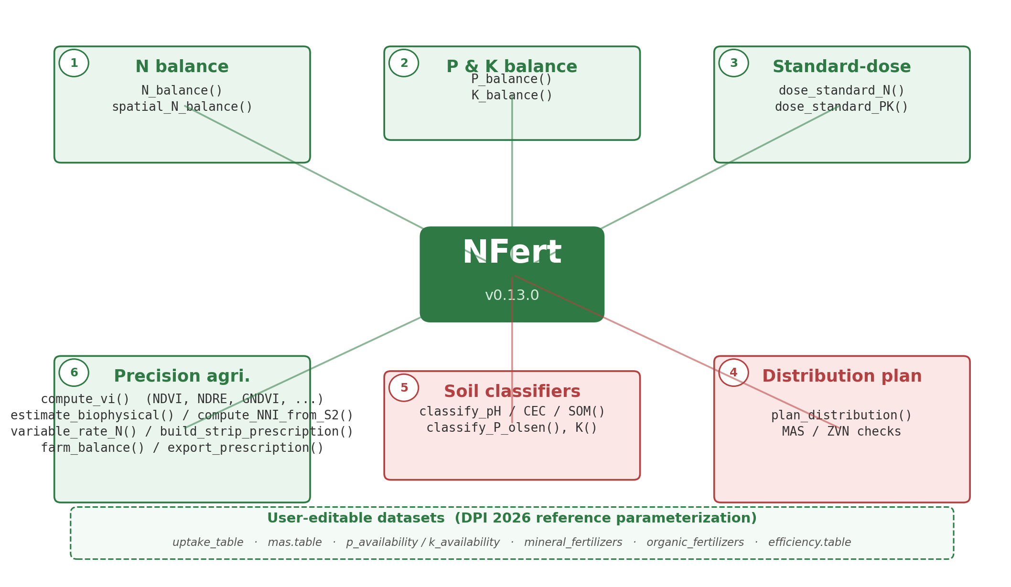
Fig. 1. Overall architecture of the NFert package. Six loosely coupled modules (N balance; P and K balance; simplified standard-dose scheme; Fertilization distribution plan with regulatory checks including the 170 kg N ha⁻¹ ceiling of the EU Nitrates Directive; Soil chemistry classifiers; Precision-agriculture module with NDVI-based variable-rate algorithms) share a common layer of internal datasets, parameterized by default from the DPI 2026 reference framework and user-editable.

2.1.1. N_balance()
Implements a full crop nitrogen balance in the formulation of the DPI 2026 Allegato 2 [3], which is used as the reference parameterization. Computes the terms A (crop demand), B1/B2 (soil N supply from mineralization and ready-N), C1/C2 and H (leaching), D (immobilization), E (previous crop), F and F_org (organic contributions, previous and current year) and G (natural deposition), returning the mineral N to apply (Fig. 2). Every term entering the balance is expressed as efficient N (N utile) available to the crop in the current growing season: the current-year organic contribution F_org is obtained by multiplying the total N delivered by the organic matrix times an efficiency coefficient that is a function of effluent type, soil texture (sandy, loamy or clay textures) and distribution technique (high for injection or incorporation within four hours, medium for surface application with incorporation, low for surface spreading without incorporation), while the previous-years contribution F applies multi-year recovery coefficients (e.g. 30/15/10% for cattle slurry in the first, second and third year after application; 50/30/20% for composted manure and other ammendanti). Leaching (C1, C2) is a time-dependent function of autumn–winter and early-spring rainfall, with a surplus-pluviometric flag activated when their sum exceeds 300 mm, and immobilization (D) is modulated by the oxygen-availability and drainage coefficient fc_D from the DPI reference table. Options include soil_seeding = "no-till" (−3 kg/ha on B1), greenhouse = TRUE (+2 kg/ha on D) and automatic folding of a negative E term into D.
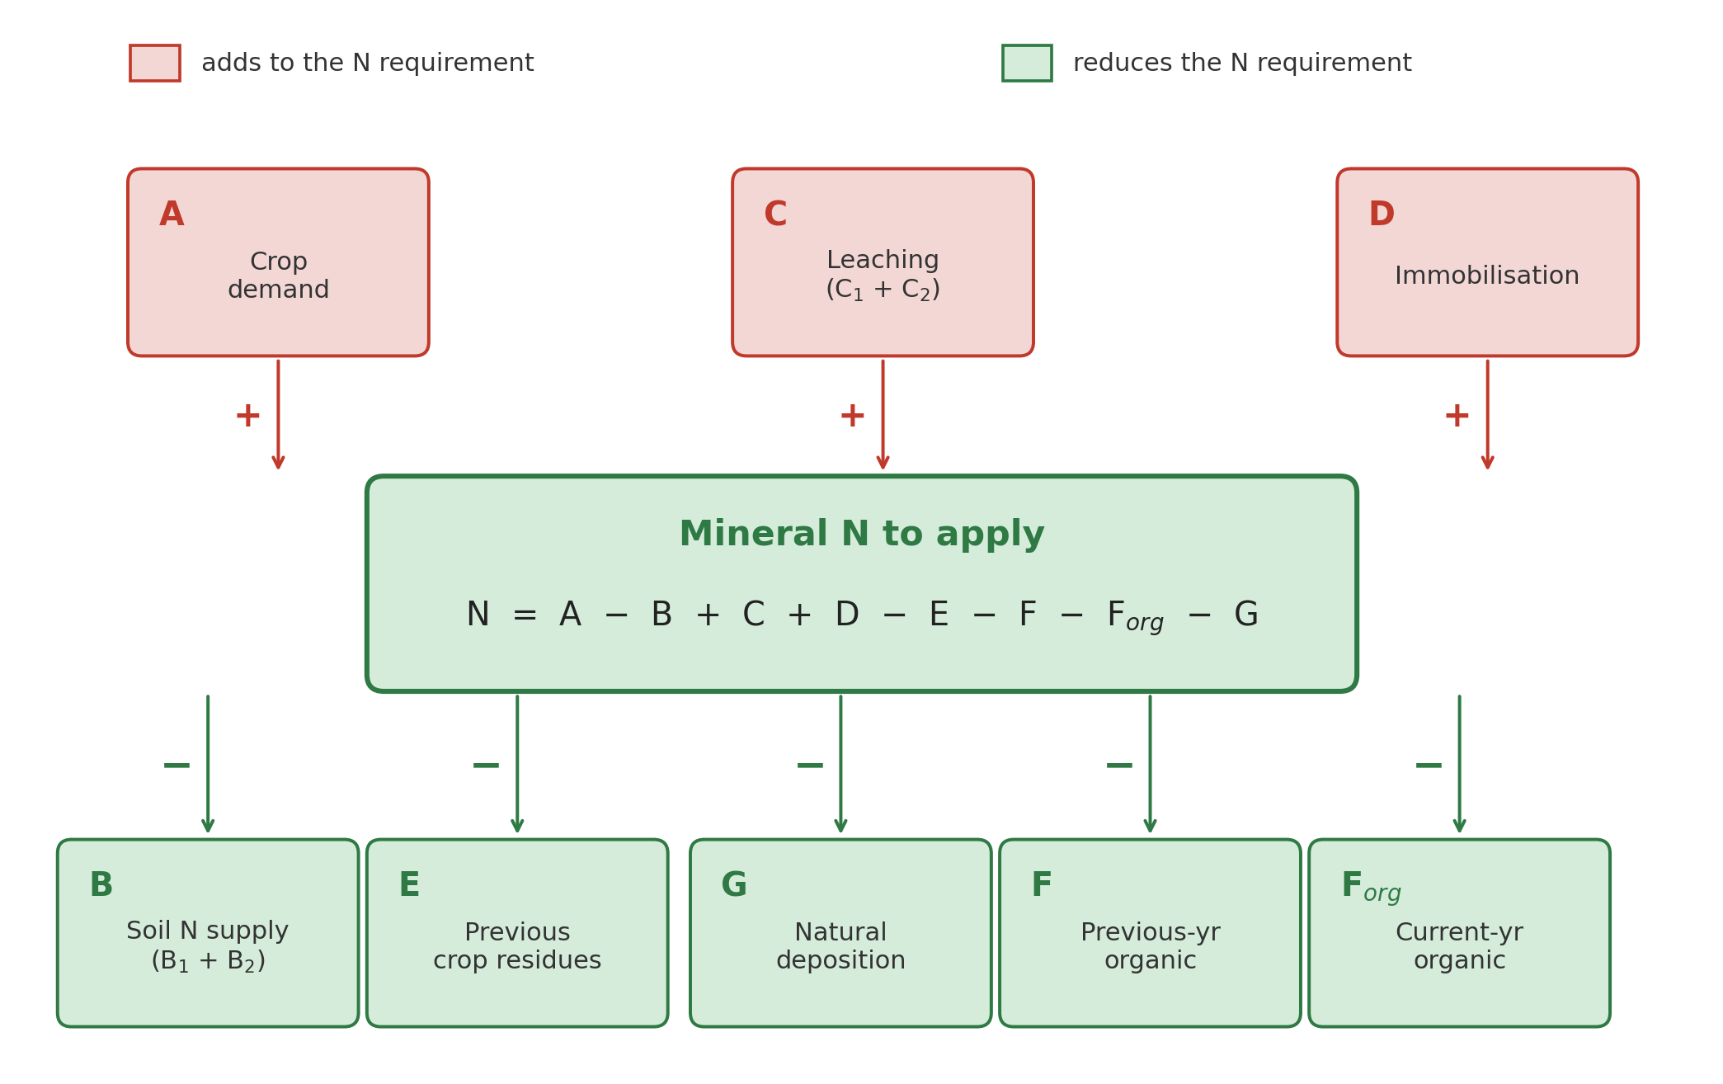
Fig. 2. Conceptual scheme of the crop nitrogen balance implemented by N_balance(). Red boxes add to the N requirement (crop demand A, leaching C and immobilization D); green boxes reduce it (soil supply B, previous crop E, natural deposition G, and organic contributions F and F_org). The residual mineral N to apply is returned together with every intermediate term.

2.1.2. P_balance() and K_balance()
The phosphorus and potassium balances follow the DPI 2026 Allegato 2 formulation implemented in Fert_Office v1.26 (fogli Gri_P and Gri_K). Unlike the nitrogen balance, which is a multi-term mass budget, the P and K balances are driven by a soil-availability strategy that determines whether the field needs nutrient enrichment, maintenance of current stocks, or a reduction in inputs.
P_balance() first classifies the analytical Olsen P value (expressed as P or P₂O₅, ppm) into five DPI availability classes via classify_P_olsen(). Low availability (classes 1–2) triggers an “Arricchimento” (enrichment) strategy: the crop P₂O₅ demand A (from uptake_table) is augmented by an enrichment term B1 proportional to the distance between the measured P₂O₅ and the upper bound of the “bassa” class (22.9 ppm), the soil weight at 30 cm depth (texture-dependent bulk density) and a P immobilisation factor (1.6 in the current DPI parameterization). Normal availability (classes 3–4) activates “Mantenimento”: only the crop uptake A is returned. High availability (class 5) triggers “Riduzione”: A is set to zero, meaning no P fertilization is recommended. Default thresholds are drawn from [8].
K_balance() works analogously. classify_K() assigns the exchangeable K (or K₂O, ppm) to one of four DPI availability classes, whose boundaries depend on the soil texture group (sandy, loamy or clay textures). A clay-driven leaching term H is added via K_leaching_by_clay(): the function implements a four-step lookup (60, 30, 20 or 10 kg K₂O ha⁻¹ for clay content ≤ 5, 5–15, 15–25 or > 25 %, respectively; the thresholds are implemented as 5.1, 15.1 and 25.1 % to replicate the right-open intervals of the Gri_K sheet of Fert_Office v1.26). In the “Mantenimento” strategy, the K₂O to apply equals the crop uptake A plus the leaching loss H; in “Arricchimento” the same formula applies (B1 is reserved for user-specified enrichment); in “Riduzione” the required dose is zero. Both functions return a diagnostic data frame with every intermediate term, the identified strategy and the final P₂O₅ or K₂O to apply.

2.1.3. dose_standard_N() and dose_standard_PK()
Implement the simplified standard-dose scheme with a full catalogue of decrements and increments (yield deviation, rainfall, previous crop, organic legacy), populated by default with the DPI 2026 values. Standard doses are capped by the maximum allowed N dose (MAS).

2.1.4. plan_distribution()
Builds the fertilization distribution plan by combining organic matrices (N efficiency coefficients by soil group, dose and sector, with DPI 2026 defaults) and mineral fertilizers (146-entry mineral_fertilizers.table), returning Excess/Deficit alerts and enforcing the 170 kg N ha⁻¹ check in Nitrate Vulnerable Zones [9]. Consistently with the DPI convention, mineral fertilizers are assumed to deliver 100% efficient N when applied in-season at crop demand (their titre is taken directly as N utile), while each organic application is converted to N utile through the soil-group- and dose-level-dependent coefficient from efficiency.table, so that the plan’s N utile total can be checked against the mineral N target returned by N_balance() on a like-for-like basis.

2.1.5. Soil chemistry and MAS
The functions classify_pH(), classify_carbonate_tot(), classify_carbonate_att(), classify_CEC(), classify_SOM(), ratio_Mg_K() and ratio_K_CEC() return soil chemistry classes used as modifiers of the balance. get_MAS() and check_MAS() return and enforce maximum allowed N doses per crop; the default lookup table follows the DPI 2026 and Regional Regulation 2/2024 values [10] and can be replaced with equivalent tables from other jurisdictions.

2.1.6. End-of-cycle soil prediction
estimate_soil_P_end_of_cycle() and estimate_soil_K_end_of_cycle() project Olsen P and exchangeable K at the end of the crop cycle, enabling multi-year planning.

2.1.7. Precision nitrogen fertilization
The precision-agriculture module turns the N target produced by N_balance() or dose_standard_N() into a spatially explicit, variable-rate prescription (VRT). NFert implements two complementary algorithms widely adopted in the literature and in commercial farm-management software: a user-defined calibration-curve method and the sufficiency-index method of Holland and Schepers [12]. Both functions accept a single-band NDVI RasterLayer and return a prescription raster (kg N ha⁻¹) with the same geometry, ready to be loaded into GIS or farm-management software. Regardless of the method, the total N applied across the field is constrained by the balance-based target and by user-defined min_rate / max_rate caps, so the VRT map remains fully compliant with the regulatory plan.
Fig. 5 shows the two response functions side by side, and Fig. 4 illustrates the full Holland & Schepers pipeline on a synthetic field with two low-vigor patches: (a) the NDVI input raster, (b) the sufficiency index SI = NDVI/NDVI$_{ref}$ (with SI = 1 as the reference of a fully-fertilized N-rich strip) and (c) the resulting VRT N prescription, in which pixels below the reference vigor receive a higher rate and pixels above it a lower rate.
Calibration-curve method.
estimate_N_rate_from_calibration_curve() fits either a two-point linear or a three-point regression between user-defined N rates (minN, maxN, optionally meanN) and the observed NDVI extremes, then applies the fitted function pixel-wise. The two-point calibration (default) is appropriate for standard on-farm N-response trials with a low- and a high-N reference; the three-point calibration accommodates a non-monotonic or saturating behaviour around an intermediate NDVI value. In both cases high-vigor pixels receive less N and low-vigor pixels more, and the resulting rate raster is clipped to the experimental range. Two illustrative calibrations are shown in Fig. 5a. The method is particularly appropriate when the grower has access to local yield-response data and wants to encode an experimentally validated relationship between canopy reflectance and optimum N rate.
Holland & Schepers method.
estimate_N_rate_from_holland_schepers() implements the sufficiency-index approach of Holland and Schepers [12], one of the most widely adopted NDVI-based algorithms for in-season nitrogen management in corn and cereals. The method compares the NDVI of each pixel with the NDVI of an N-rich reference strip (NDVI$_{ref}$, taken by default as the 95th percentile of the input raster) to compute a sufficiency index SI = NDVI/NDVI$_{ref}$. When SI < 1 the pixel is assumed to be N-deficient and receives an extra N rate proportional to the deficit; when SI ≥ 1 the vigor matches or exceeds the reference and the rate is reduced toward the user-defined minimum (Fig. 5b). The low-level estimator accepts a base N rate and returns the dose raster plus the SI raster. In most use cases the user calls the higher-level wrapper variable_rate_N(ndvi_raster, n_dose, method = "holland", minN, maxN, mas_cap), which anchors the field-mean rate to the balance-based N target n_dose, clips each pixel to user-defined minN / maxN bounds and, optionally, caps it at the crop-specific MAS limit, so the user retains full control over the aggressiveness of the prescription while enforcing the regulatory constraints at the pixel scale.

2.1.8. Bilingual crop handling
resolve_crop() and list_crops() accept either the Italian canonical name or an English alias for the 235 crops of the reference catalogue (54 curated English translations at present; all other crops fall back to the Italian label). All public functions route user input through resolve_crop(), so downstream code is language-agnostic.

2.2. From the field-scale balance to the variable-rate prescription
The balance-based module and the precision-agriculture module of NFert are designed to operate as a single coherent pipeline rather than as two independent workflows (Fig. 6). The field-scale nitrogen target N* produced by N_balance() (Section 2.1.1) and refined by plan_distribution() (Section 2.1.4) is the mass-balance constraint that the spatial prescription returned by the VRT functions (Section 2.1.7) is required to respect: for a raster of n pixels of equal area, the per-pixel rates rᵢ satisfy (1/n) Σ rᵢ = N*, subject to minN ≤ rᵢ ≤ maxN, so that the field-averaged N rate in the VRT map coincides, by construction, with the regulatory-compliant N target returned by the balance. This constraint is enforced by the variable_rate_N() wrapper, which re-scales the raster returned by the low-level NDVI estimators so that its pixel mean equals N*. Under this constraint the NDVI-based redistribution changes where fertilizer is delivered within the field, but never how much is delivered overall, which keeps the prescription map compliant with the 170 kg N ha⁻¹ ceiling of the EU Nitrates Directive [9] in Nitrate Vulnerable Zones and with crop-specific MAS limits [10] whenever these are respected at the balance stage.
This coupling supports two complementary use cases. At the pre-sowing stage, the balance is computed with uniform field-level inputs (soil analysis, previous crop, organic history, expected yield) and is split by plan_distribution() into organic and mineral applications; when a single-band NDVI raster becomes available in-season from UAV or satellite, the residual mineral share is redistributed by estimate_N_rate_from_holland_schepers() or estimate_N_rate_from_calibration_curve() without altering the field total. At the post-season stage, the spatial dispersion of SI = NDVI/NDVI$_{ref}$ and its correlation with soil-texture or organic-history maps provides a cell-level diagnostic of which balance terms (B1, B2, D, E, F$_{org}$) deserve refinement for the following season, enabling data-driven updates of the coefficient tables that feed the balance (dashed feedback arrow in Fig. 6).
Operationally, this pipeline turns NFert into a bridge between the regulatory and agronomic literature on nutrient budgets and the expanding body of evidence on in-season variable-rate fertilization: the balance provides the legally defensible field-level ceiling, the VRT functions provide the spatial resolution, and the two are reconciled by a single mass-balance constraint exposed to the user as explicit minN / maxN / n_dose arguments of variable_rate_N(). To our knowledge, no other open-source tool implements this round-trip between a full DPI-compliant balance and an NDVI-driven prescription under a shared mass-balance invariant.
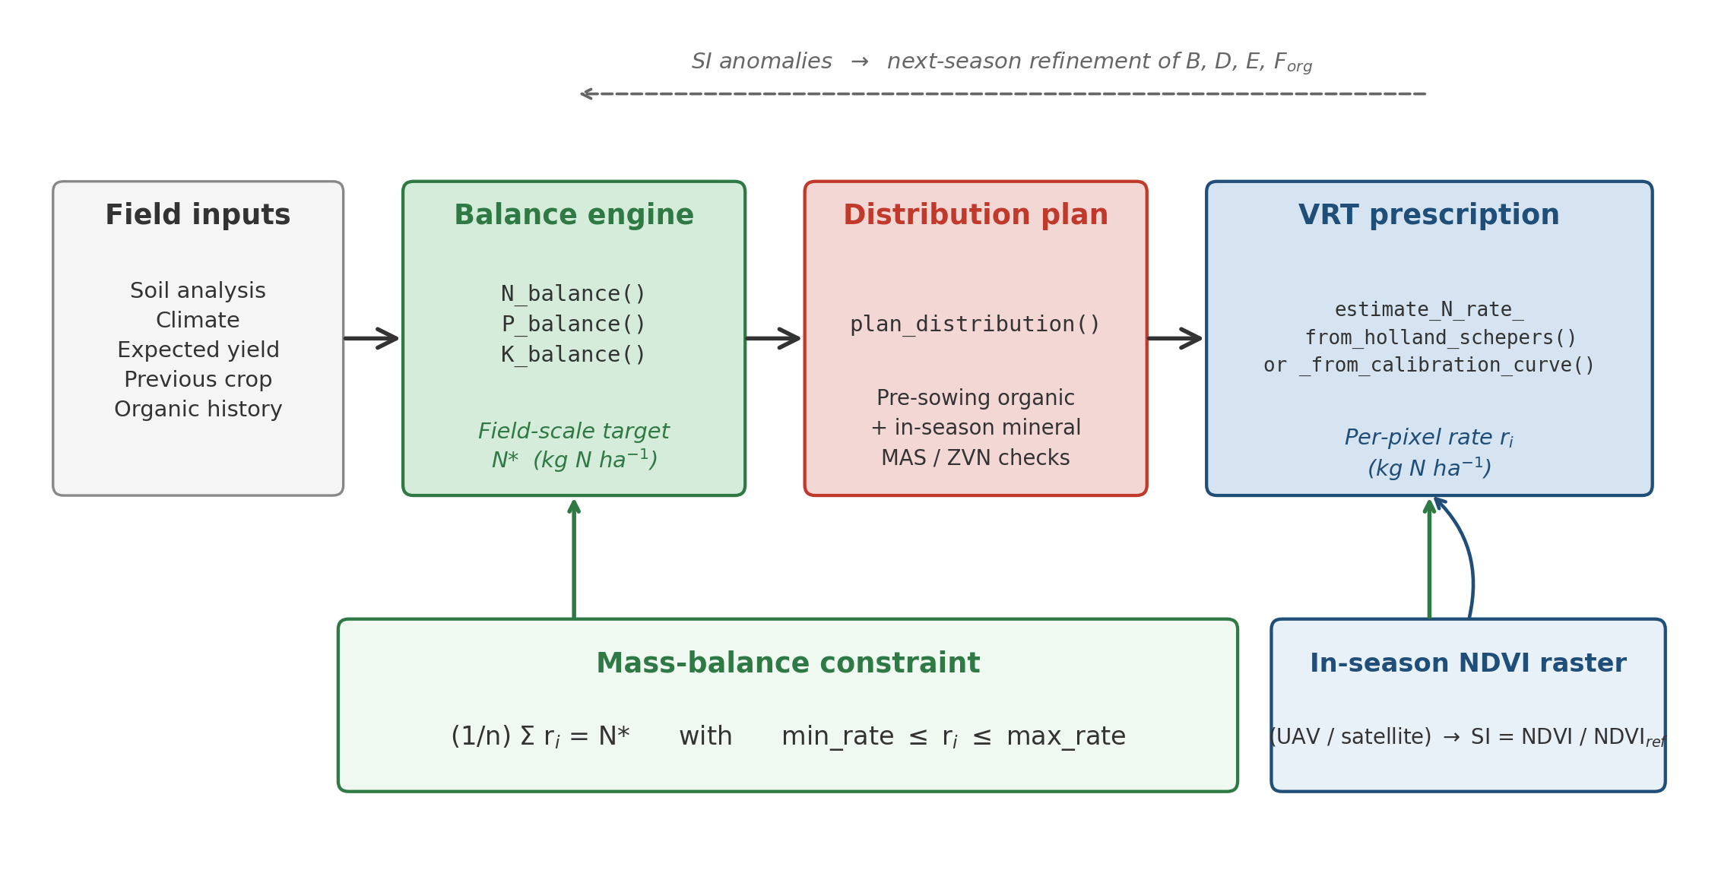
Fig. 6. Workflow connecting the analytical nutrient balance to the variable-rate prescription in NFert. Field-level inputs feed the balance engine (N_balance, P_balance, K_balance), which returns a field-scale target N* (kg N ha⁻¹); plan_distribution() splits the target into pre-sowing organic and in-season mineral applications and enforces the MAS and 170 kg N ha⁻¹ ZVN checks; the in-season NDVI raster is finally redistributed by the VRT functions under the mass-balance constraint (1/n) Σ rᵢ = N* so that the spatial prescription preserves the balance-based field total. The dashed top arrow highlights the post-season feedback: pixel-level SI anomalies can inform the refinement of the balance coefficients (B, D, E, F$_{org}$) for the following season.

2.3. Remote sensing diagnosis: multi-index engine and Nitrogen Nutrition Index
The variable-rate pipeline described in Section 2.2 assumes a normalised 0–1 vegetation index as input, and the reference literature has historically adopted NDVI (Rouse et al. 1974) for its operational simplicity. NDVI, however, saturates at leaf area index (LAI) greater than 3–4, so in mid- and late-vegetative stages — precisely the canopy stages at which a side-dressing VRT is applied on cereals (GS30–32 for winter wheat and durum wheat; V8–V10 for maize) — its sensitivity to canopy nitrogen status drops markedly. The remote-sensing literature of the last two decades has converged on the red-edge band as the preferred spectral region for N diagnosis in closed canopies, with indices such as NDRE = (NIR − RedEdge) / (NIR + RedEdge) (Gitelson & Merzlyak 1994) and CIred-edge = NIR / RedEdge − 1 (Gitelson et al. 2003) providing almost linear sensitivity up to LAI ≈ 6 and substantially higher accuracy than NDVI on wheat and maize (Clarke et al. 2001; Li et al. 2014; Cao et al. 2015). NFert therefore exposes the six most widely adopted VIs — NDVI, NDRE, GNDVI, CIred-edge, MCARI, MSAVI2 — through a single multi-index engine, compute_vi(), that takes a multi-band RasterStack or RasterBrick and returns a RasterLayer of the selected index. The engine is band-agnostic: the user supplies a list mapping the index inputs (red, red_edge, nir, green) to layer names or indices in the input stack, with Sentinel-2 L2A naming (B04, B05, B08, B03) as the default. An optional scale_factor argument rescales integer Sentinel-2 DN to reflectance on the fly. Because the existing VRT functions (variable_rate_N(), estimate_N_rate_from_calibration_curve(), estimate_N_rate_from_holland_schepers()) already accept any 0–1 normalised index, the same balance-to-prescription pipeline can be driven by NDRE or CIred-edge at GS30+ without any change in the calling code.
A vegetation index remains, by construction, a proxy for canopy N content. Moving from proxy to biophysical diagnosis requires a second step: the Nitrogen Nutrition Index (NNI) framework of Lemaire & Gastal (1997), rooted on the species-specific critical-N dilution curve Nₜ = a · W^(−b) (Nₜ in % DM, W aboveground dry biomass in t DM ha⁻¹), and defined as NNI = N_actual / Nₜ. The NNI is dimensionless, biomass-normalised and directly interpretable: NNI < 0.90 indicates N deficiency, 0.90 ≤ NNI ≤ 1.10 indicates an optimal N status, and NNI > 1.10 indicates luxury consumption. NFert implements the framework through three functions: critical_N_curve(), which returns the (a, b, W_min) coefficients of the dilution curve for the main Italian arable crops with species-specific parameterizations from the literature (wheat: a = 5.35, b = 0.44, Justes et al. 1994; maize: a = 3.40, b = 0.37, Plénet & Lemaire 2000; rice: a = 5.18, b = 0.52, Sheehy et al. 1998; rapeseed: a = 4.48, b = 0.25, Colnenne et al. 1998; grass: a = 4.80, b = 0.32, Duru et al. 1997; sorghum: a = 3.90, b = 0.39, van Oosterom et al. 2010; sunflower: a = 4.53, b = 0.42, Debaeke et al. 2012); compute_NNI(), which accepts N_content (% DM or fraction), biomass (t DM ha⁻¹) and crop and returns NNI as a scalar, a vector or a RasterLayer depending on the input types; and diagnose_N_status(), which wraps compute_NNI() and classifies the NNI raster into deficient / optimal / excessive zones under user-configurable thresholds, also returning the fraction of the field falling into each class.
The NNI closes the diagnostic loop of the NFert pipeline. A remote-sensing acquisition at the VRT application window is turned into a biomass layer W and an N-concentration layer N_actual by user-supplied retrieval models (which, typically, are empirical VI → biomass and VI → N% regressions calibrated on the field or borrowed from the literature); compute_NNI() combines the two into a continuous NNI map, diagnose_N_status() discretises it into fertilization zones, and the NNI classes are then used either as a spatial filter on the variable-rate prescription returned by variable_rate_N() — so that no mineral N is applied where the crop is already in luxury consumption — or as an explicit modifier of the minN / maxN envelope in the mass-balance constraint. Under this arrangement the spatial prescription is no longer a heuristic redistribution of a constant dose along a single-proxy gradient, but an NNI-guided correction anchored to the critical-N curve of the species, while the field-scale ceiling returned by the balance remains strictly preserved. The vignette remote-sensing-diagnosis in the NFert source tree walks through the full loop end-to-end on a synthetic multi-band stack.
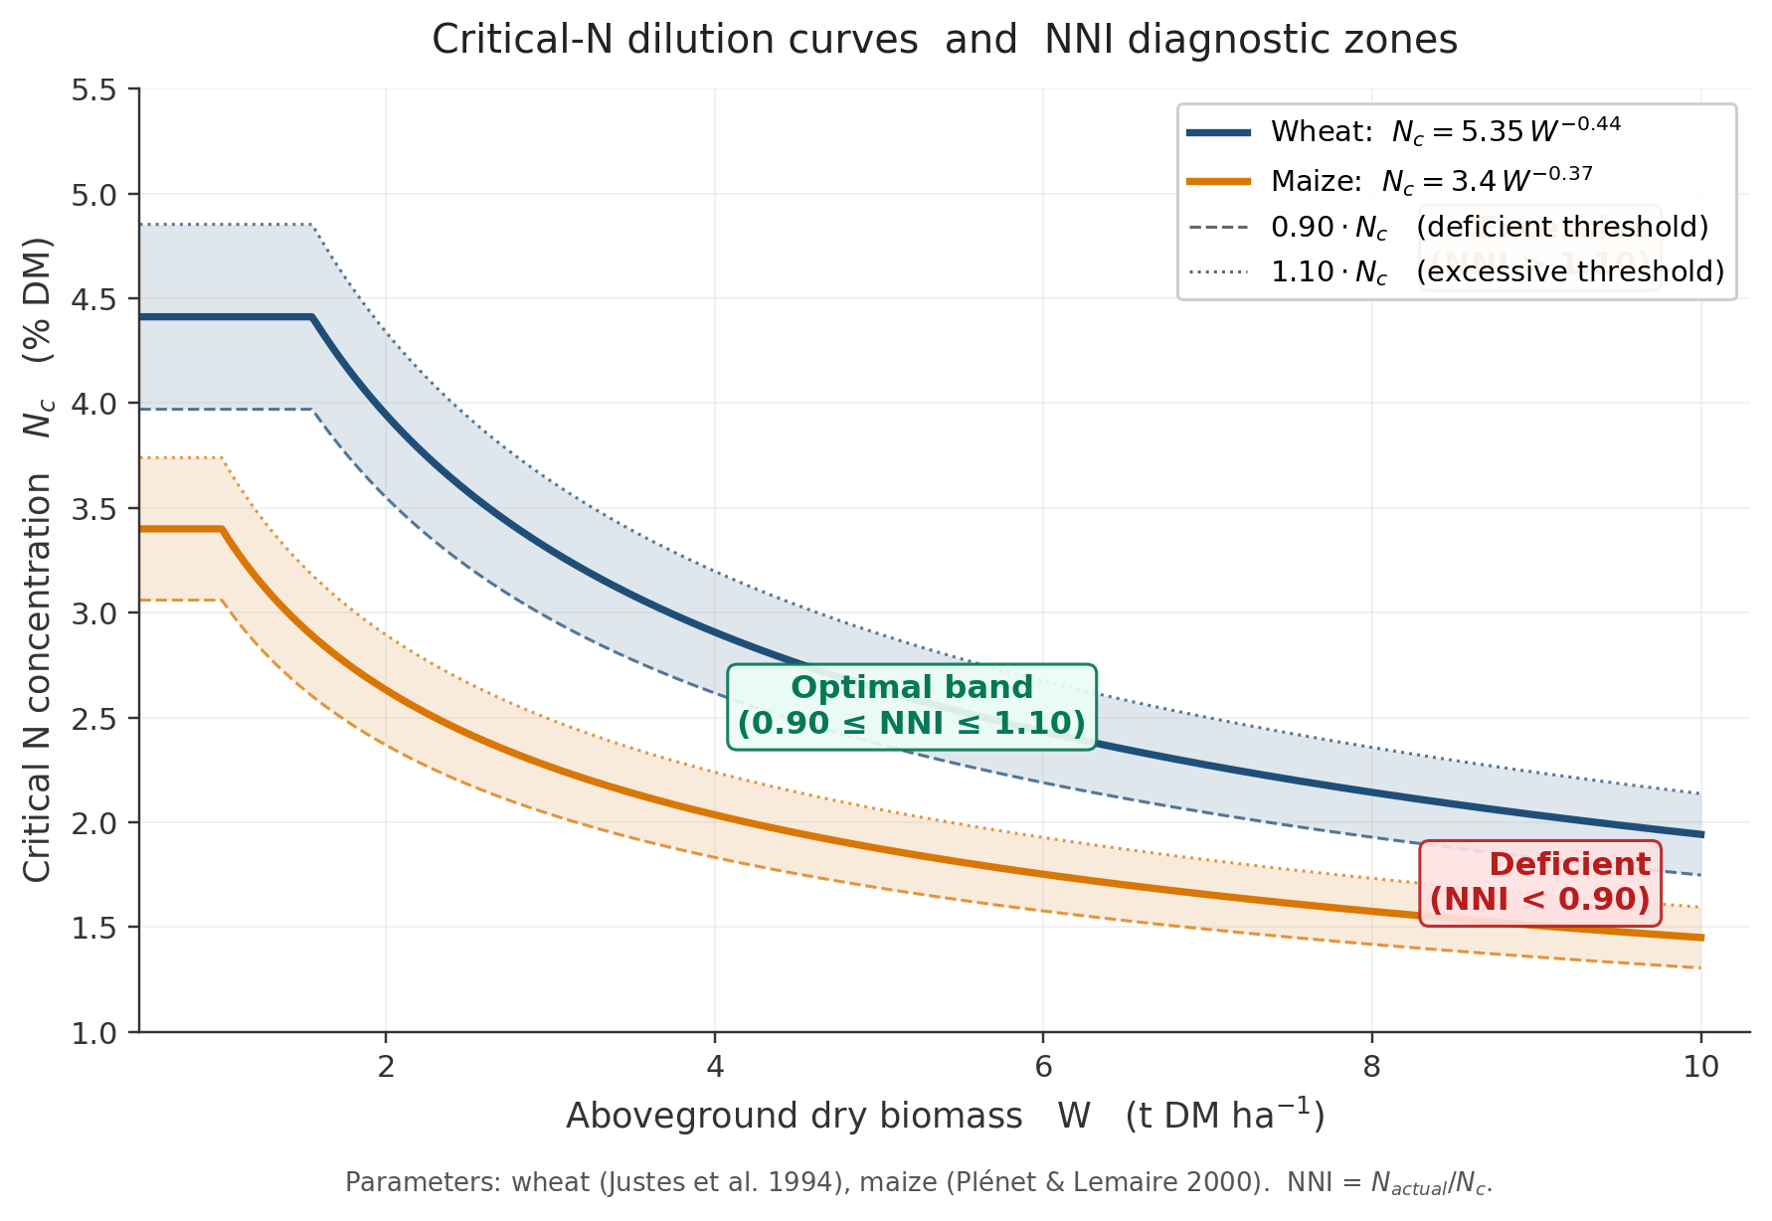
Fig. 7. Critical-N dilution curves and NNI diagnostic zones implemented by critical_N_curve() and diagnose_N_status(). Solid lines: species-specific critical-N curve N_{c} = a · W^{−b} for wheat (Justes et al. 1994) and maize (Plénet & Lemaire 2000); dashed and dotted lines: 0.90 · N_{c} and 1.10 · N_{c} boundaries of the optimal NNI band (default thresholds of diagnose_N_status()), which separate the deficient, optimal and excessive N-status zones. Field points above the upper band receive zero mineral N under the NNI-guided VRT, while points in the deficient band receive the full agronomic dose returned by the mass balance.

2.3.1. GPR retrieval of canopy biophysical variables from Sentinel-2
The NNI defined in the previous section requires two quantities that are not routinely measured in farms: the aboveground dry biomass W and the plant N concentration N_actual. NFert closes this gap with estimate_biophysical(), a pure-R port of the pyeogpr Gaussian Process Regression (GPR) pipeline of Estevez et al. [14], adapted so it runs as a regular R function without any Python or GEE dependency. The function takes a 10-band Sentinel-2 Level-2A surface-reflectance raster in the canonical band order (B02, B03, B04, B05, B06, B07, B08, B8A, B11, B12) and applies a set of pre-trained PROSAIL+N GPR models, one per trait, stored as JSON files in a user-specified directory. For every trait it writes a GeoTIFF with the posterior mean and, when the corresponding model exposes the pre-computed inverse Cholesky factor, a second GeoTIFF with the per-pixel prediction standard deviation. The full catalogue of retrievable variables includes leaf area index (LAI), leaf dry-matter content (Cm, g cm⁻²), canopy water content (Cw), fractional vegetation cover (FVC), leaf chlorophyll (Cab), the classic pyeogpr LAI·Cab product, and two canopy-N products (CNC_Cab and CNC_Cprot, both in g N m⁻² ground). The implementation was benchmarked against the reference Python code on 200 random pixels across the six LAI / Cm / Cw / FVC / CNC_Cab / CNC_Cprot models and matches at correlation 1.0, with a maximum relative error below 1.4×10⁻⁸ — i.e. differences only in the last digits of double precision. The raster is processed in row blocks (default 512 rows) so memory consumption is bounded and the function scales to full Sentinel-2 tiles.
The end-to-end wrapper compute_NNI_from_S2() combines these retrievals with a crop-specific critical-N dilution curve in a single call. Following the classical formulation of Lemaire and Gastal [15] and Houles et al. [16], leaf dry-matter per unit ground is derived from the GPR outputs as Wₗₑₐƒ = LAI · Cm · 10⁴ (g m⁻²), rescaled to total aboveground biomass W via a leaf-allocation coefficient αₗₑₐƒ (~0.30-0.45, crop- and stage-dependent), and then expressed in t DM ha⁻¹. Canopy N is obtained either directly from the protein-based retrieval (Nₜₒₜₐₗ = CNC_Cprot) or, when the chlorophyll path is used, via a canopy-level N:Chl ratio k (Nₜₒₜₐₗ = k · CNC_Cab, with k typically in the 50-80 range). The plant N concentration N_actual (% DM) = 100 · Nₜₒₜₐₗ / W is then divided by the crop-specific critical-N concentration Nₑ = a · W⁻ᵇ to yield the pixel-level NNI, which is finally discretised into deficient (NNI < 0.90), optimal (0.90-1.10) and excessive (NNI > 1.10) zones. The dedicated crop_params_NNI() helper ships with literature defaults for eight crops (winter wheat, maize, rice, barley, rapeseed, sorghum, sunflower, soybean) and accepts Italian aliases.
Two masks are applied before the NNI is computed: pixels with W below w_min (default 1 t DM ha⁻¹) are dropped because the dilution curve is not defined in the seedling stage, and pixels with fractional vegetation cover below fvc_min (default 0.50) are discarded because the soil background contaminates the BRDF. The Sentinel-2 Scene Classification Layer (SCL) can be passed optionally so that cloud, shadow and snow pixels are excluded as well. The NNI map can then be fed back to variable_rate_N() as an explicit modifier of the minN / maxN envelope: pixels in the deficient band receive the full agronomic dose returned by the balance, pixels in the excessive band receive zero in-season mineral N, and the pipeline remains strictly mass-balance constrained at the field level. This closes the loop Sentinel-2 → canopy traits → NNI → VRT, with the balance as the legally defensible ceiling and the GPR retrieval as the physical, radiative-transfer-based evidence of in-season crop N status.
Calibration caveats. The dilution-curve coefficients a and b are well established across European cropping systems and rarely need to be recalibrated. By contrast, the two locally sensitive parameters — αₗₑₐƒ and, if the chlorophyll path is used, k — are known to introduce biases of 15-30 % in operational settings when adopted without local verification [16]. A minimal recalibration dataset consists of 30-50 plot-level samples collected across the target growing season, each characterised by oven-dried aboveground biomass and total plant N (Kjeldahl or Dumas), paired with the nearest cloud-free Sentinel-2 acquisition. NNI retrieval is furthermore meaningful only inside crop-specific phenological windows (e.g. GS31-GS55 for wheat, V6-V12 for maize); the pipeline therefore does not attempt to interpolate between S2 acquisitions, and the user is expected to supply scenes whose dates fall in those windows.
The pipeline returns a named list of rasters (W, N_actual, N_crit, NNI and zones) that can be written to disk with terra::writeRaster() or fed directly to variable_rate_N() without any further conversion. A worked example is provided in the remote-sensing-diagnosis vignette shipped with the package.

3. Illustrative example

3.1. System requirements and installation
NFert operates within the R environment. After installing R 4.0 or later, the development version of NFert can be installed from GitHub:
devtools::install_github("mcroci/NFert")
library(NFert)
A CRAN release is planned for 2026. All package dependencies are installed automatically.

3.2. Demonstration
The following example uses the default (DPI 2026) parameterization of NFert to compute the nitrogen balance for a silage maize targeted at 60 t ha⁻¹ of fresh product (≈ 20 t ha⁻¹ of dry matter) on a medium-textured soil with cattle slurry applied every year:
n_bal <- N_balance(
expected_yield_tons_ha = 60,
crop = "Maize silage (class 700)",
ccp = "Spring-summer crop 100–130 days",
sand = 50, clay = 35,
Ntot = 1.2, SOM = 1.2, CN = 9.5,
oxygen_availability = "Normal",
winter_rain = 160, start_spring_rain = 40,
prev_crop = "Winter cereals straw removal",
source = "Cattle slurry",
fertorg_frequency = "every year",
location = "Plain adjacent to urbanized areas",
forg_quantity = 100)
print(n_bal) # A, B, b1, b2, C1, C2, D, E, F, Forg, G, surplus_pluviometrico
n_target <- calculate_N_fertilization(n_bal)
check_MAS(crop = "Maize silage (class 700)", N_planned = n_target)
The object returned by N_balance() exposes every intermediate term of the balance, so the user can audit each contribution and compare scenarios (Fig. 3).
The same example field can be used to compute the P and K balances. With Olsen P = 25 ppm P₂O₅ (normal availability, “Mantenimento” strategy) and exchangeable K = 150 ppm K₂O (normal availability on a loamy soil), the two calls are:
p_bal <- P_balance(
expected_yield_tons_ha = 60,
crop = "Maize silage (class 700)",
olsen_value = 25, olsen_unit = "P2O5",
clay = 35, sand = 50)
k_bal <- K_balance(
expected_yield_tons_ha = 60,
crop = "Maize silage (class 700)",
k_value = 150, k_unit = "K2O",
clay = 35, sand = 50)
P_balance() returns the crop uptake A (maintenance dose), the enrichment term B1 (zero under “Mantenimento”), and the final P₂O₅ to apply. K_balance() additionally includes the clay-dependent leaching term H (10 kg K₂O ha⁻¹ for the 35 % clay of this example). The breakdown of the nitrogen balance is shown in Fig. 3; the P₂O₅ and K₂O balances are omitted because, under the “Mantenimento” strategy selected here, they collapse to only one or two terms.
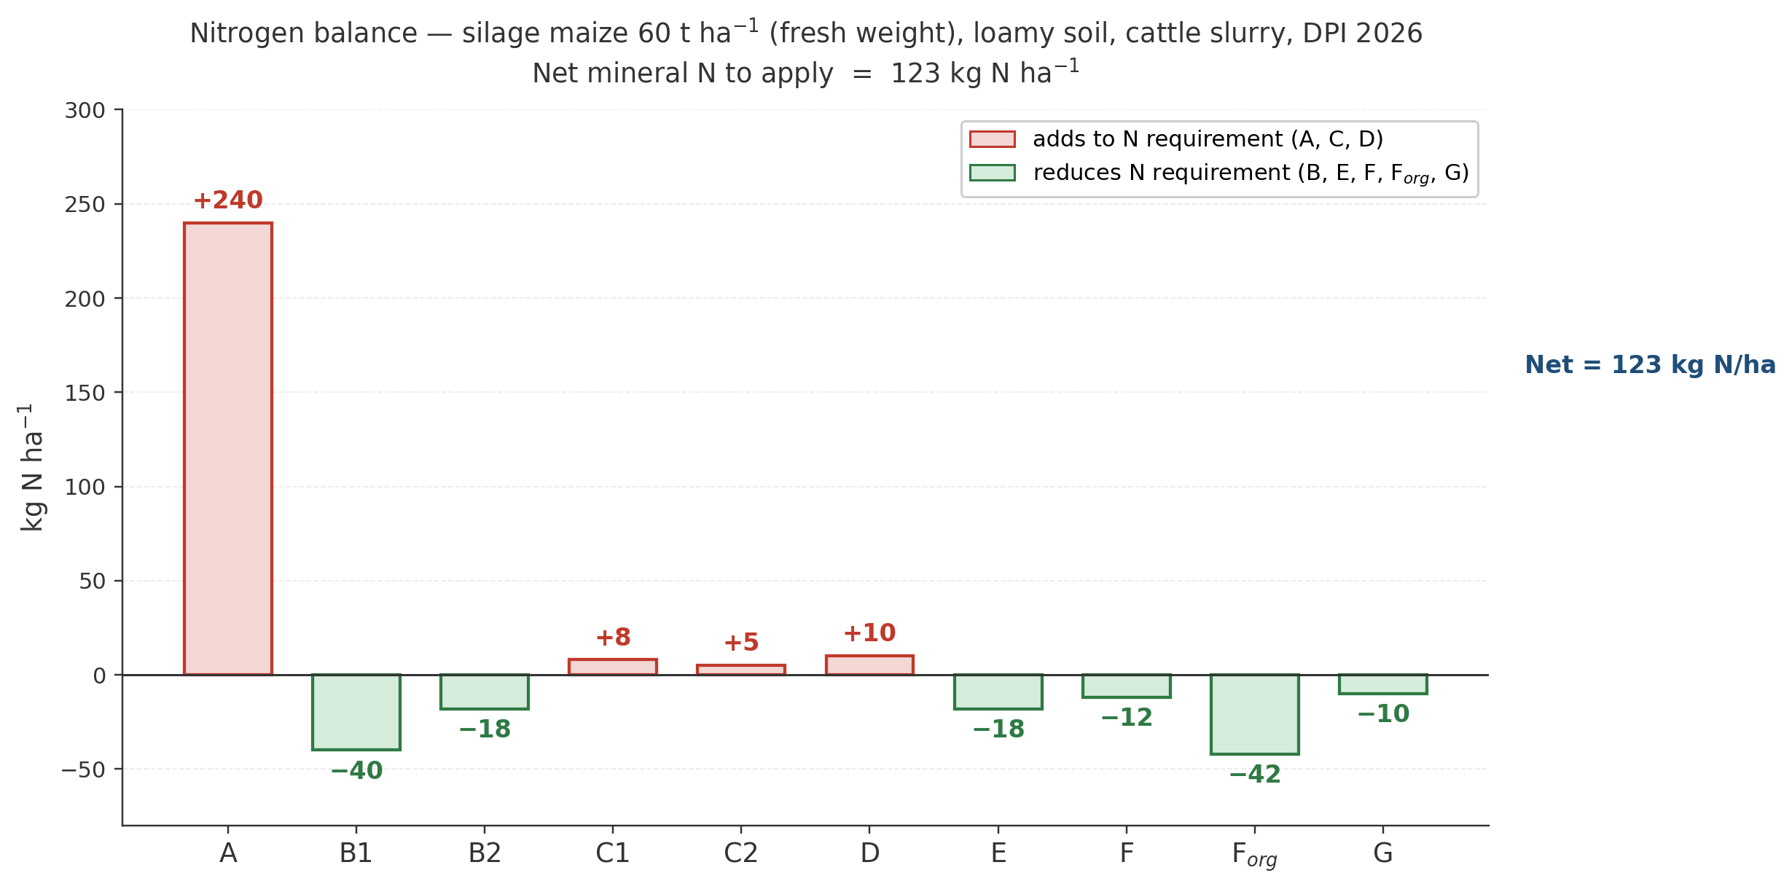
Fig. 3. Nitrogen balance for the silage maize example (60 t ha⁻¹ fresh weight, loamy soil, cattle slurry, DPI 2026). Positive bars (red) add to the N requirement (crop demand A, leaching C₁+C₂, immobilisation D); negative bars (green) reduce it (soil supply B₁+B₂, previous crop residues E, previous-year and current-year organic contributions F and F_org, natural deposition G). The net mineral N to apply is the algebraic sum of all terms (123 kg N ha⁻¹ in this example). The P₂O₅ and K₂O balances are not shown because under a “Mantenimento” strategy they collapse to one or two terms (crop uptake plus, for K₂O, a clay-driven leaching term).

3.2.1. End-to-end fertilization plan
After computing the N, P and K balances with N_balance(), P_balance() and K_balance(), plan_distribution() distributes the required doses across pre-sowing organic and in-season mineral applications:
plan <- plan_distribution(
soil_group = "Loamy textures",
n_balance = n_target,
p_balance = p_bal$P2O5_required,
k_balance = k_bal$K2O_required,
organic_rows = list(
list(fertilizer = "liquame bovino",
quantity_t_ha = 30,
year = 2026,
modality_epoch = 1,
level = "media")),
mineral_rows = list(
list(fertilizer = "UREA AGRICOLA PRIL.46%",
quantity_q_ha = 3,
modality_epoch = 11)),
zvn = TRUE)
plan$alerts # Eccesso / Deficit / ZVN 170 kg N/ha
plan$zvn_alert # Livestock N / 170 kg N ha⁻¹ check
The plan refuses to exceed 170 kg N/ha/year from livestock effluents when the ZVN check is enabled, in compliance with Directive 91/676/EEC [9].

3.2.2. NDVI-based variable-rate prescription
The same N target from the balance can be redistributed in space according to a UAV- or satellite-derived NDVI raster:
vr <- variable_rate_N(
ndvi_raster = ndvi_raster,
n_dose = n_target,
method = "holland",
minN = 20, maxN = 160,
mas_cap = get_MAS(crop = "Maize silage (class 700)")$mas_N)
raster::writeRaster(vr$rate_raster, "VRT_prescription.tif")
The resulting prescription (Fig. 4c) can be loaded directly into farm-management software, turning the balance-based N rate into a spatially explicit, regulatory-compliant map. The comparison of the two response functions implemented in NFert is reported in Fig. 5.
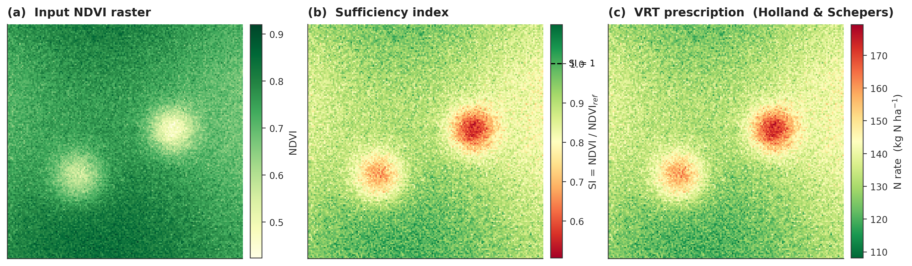
Fig. 4. Full Holland & Schepers pipeline implemented by estimate_N_rate_from_holland_schepers(). (a) Input NDVI raster with two low-vigor patches. (b) Pixel-wise sufficiency index SI = NDVI / NDVI$_{ref}$, with the dashed line on the colour bar marking SI = 1 (match with the N-rich reference strip). (c) Resulting VRT N prescription: pixels below the reference vigor (SI < 1) receive a higher rate, pixels at or above the reference a lower rate, within user-defined minN / maxN caps.
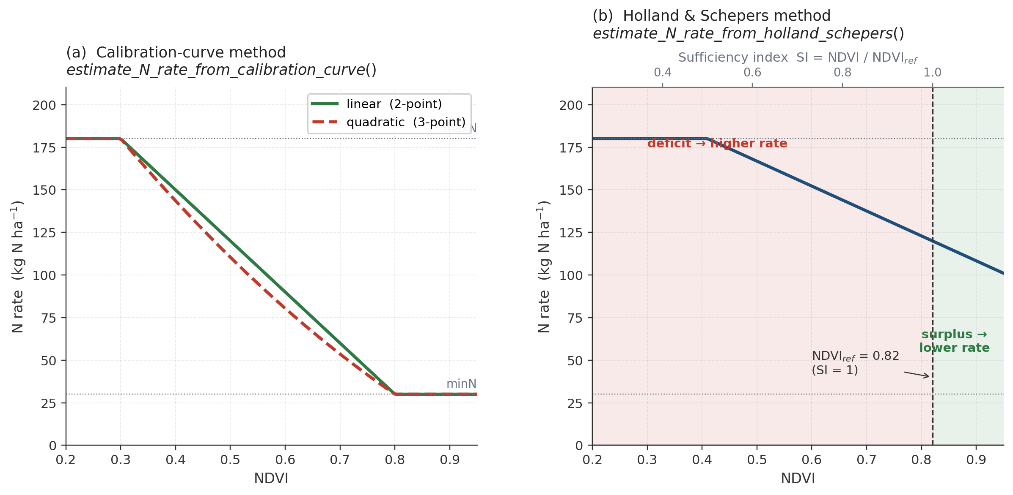
Fig. 5. Response functions of the two variable-rate algorithms implemented in NFert. (a) Calibration-curve method: a two- or three-point linear regression fitted between user-defined N rates (minN, maxN, optionally meanN) and the observed NDVI extremes maps NDVI to the N rate, clipped at minN and maxN. (b) Holland & Schepers method: the N rate decreases monotonically as NDVI approaches the value of the N-rich reference strip (NDVI$_{ref}$, vertical dashed line at SI = 1). The secondary axis on top shows the equivalent sufficiency index.

3.2.3. Spatial nitrogen balance on a real field
NFert ships with a set of soil-property rasters for a 12-ha arable field near Cremona (Northern Italy), bundled in inst/extdata/. The six single-band GeoTIFF files (SOM, TN, Clay, Sand, Silt, CN ratio) were derived from proximal soil-sensing surveys at approximately 3.5 m resolution, georeferenced in EPSG:4326. The field is characterised by very clayey soils (50–65 % clay), SOM 2.2–2.6 %, total N 0.20–0.21 % and a C/N ratio of 6–7.5.
The new function spatial_N_balance() applies N_balance() pixel-by-pixel to a RasterStack of soil properties, while keeping crop, climate and management parameters uniform across the field:
library(raster)
ext <- system.file("extdata", package = "NFert")
soil <- stack(
file.path(ext, "Cremonesi_TN.tif"),
file.path(ext, "Cremonesi_SOM.tif"),
file.path(ext, "Cremonesi_Clay.tif"),
file.path(ext, "Cremonesi_Sand.tif"),
file.path(ext, "Cremonesi_CNratio.tif"))
names(soil) <- c("TN","SOM","Clay","Sand","CNratio")

n_map <- spatial_N_balance(
soil_stack = soil,
expected_yield_tons_ha = 60,
crop = "Maize silage (class 700)",
ccp = "Spring-summer crop 100-130 days",
winter_rain = 160, start_spring_rain = 40,
prev_crop = "Winter cereals straw removal",
source = "Cattle slurry",
fertorg_frequency = "every year",
location = "Plain adjacent to urbanized areas",
forg_quantity = 100)

plot(n_map[["N_to_apply"]])
Fig. 8 shows the result. Panels (a) and (b) map the two soil inputs that drive most of the spatial variability in the balance: SOM (which controls the mineralisation term B1) and clay content (which determines the DPI texture group and, through it, the coefficients for B1, B2 and the immobilisation term D). Panel (c) maps the mineral N to apply returned by spatial_N_balance(): the field-average is approximately 103 kg N ha⁻¹ and the within-field range is narrow (≈1 kg N ha⁻¹) because the soil is relatively homogeneous. Panel (d) demonstrates the complementary role of the VRT module: when an NDVI raster is acquired in-season, estimate_N_rate_from_holland_schepers() redistributes the field-mean N target across the canopy-vigor gradient (40–129 kg N ha⁻¹ in this simulation), while preserving the field total under the mass-balance constraint described in Section 2.2. The balance thus provides the legally defensible field budget, and the VRT layer adds the spatial resolution that site-specific management requires.
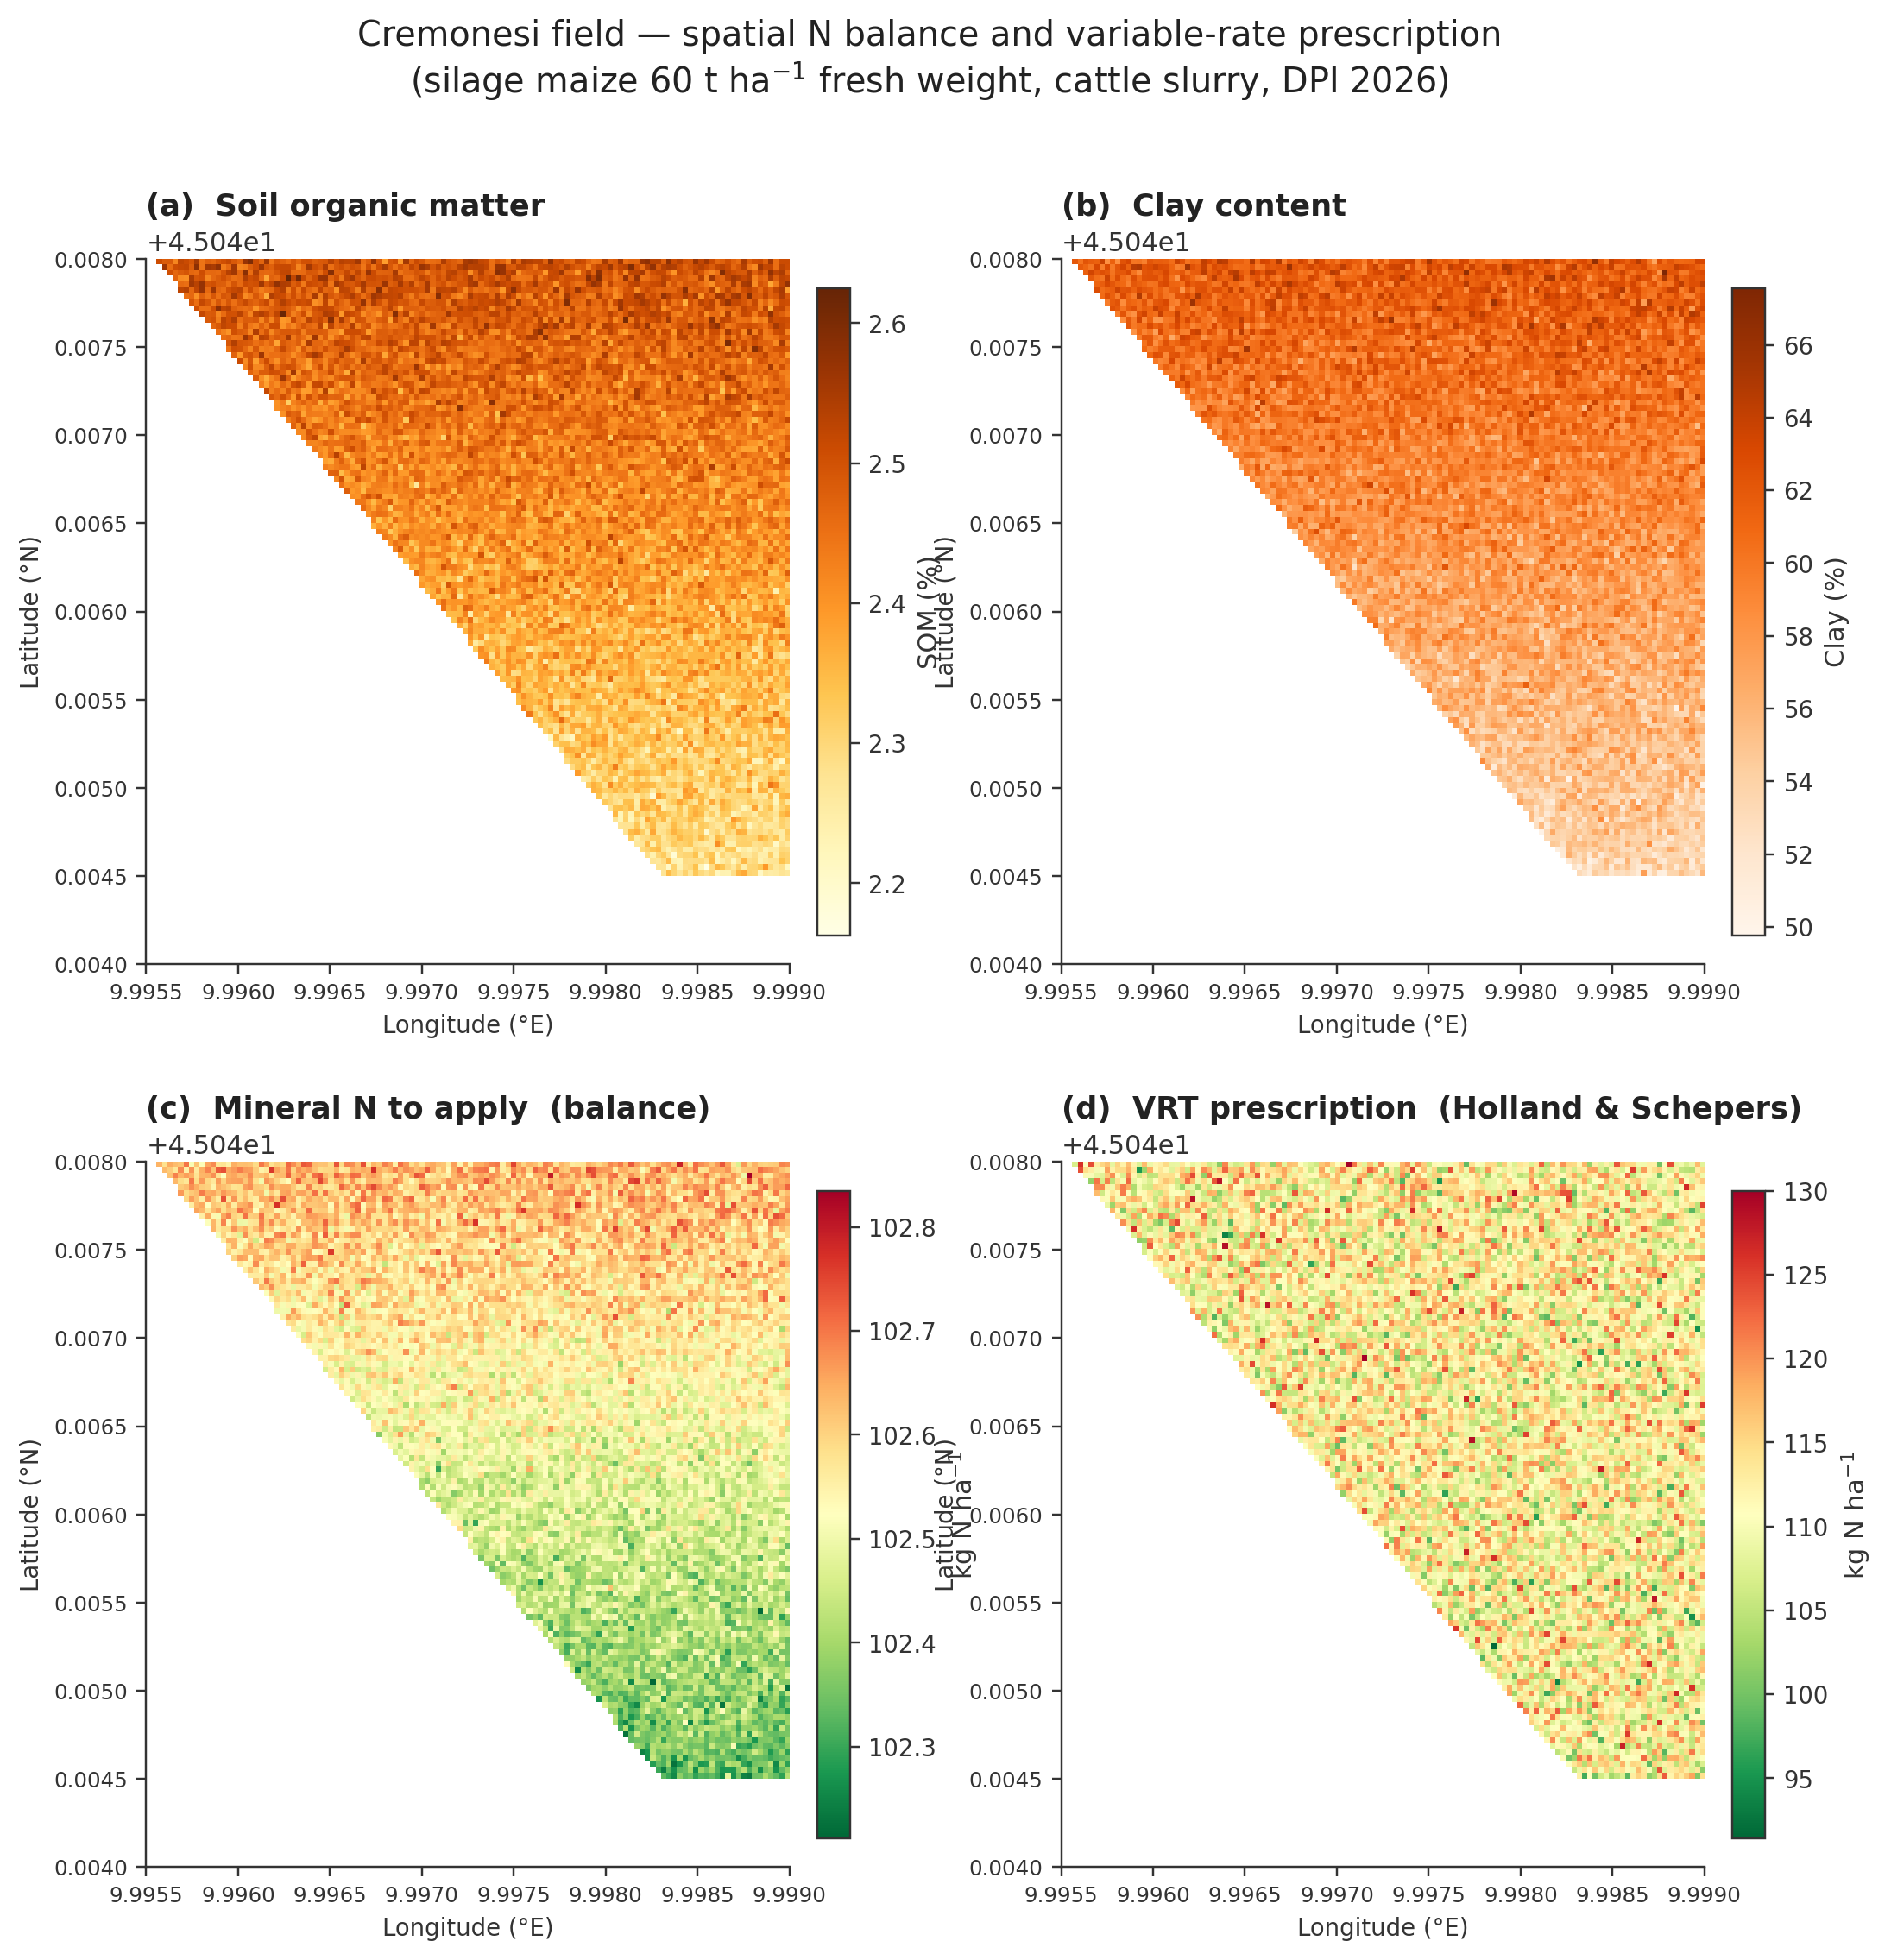
Fig. 8. Spatial nitrogen balance and VRT prescription for the bundled Cremonesi field (12 ha, Northern Italy). (a) Soil organic matter, SOM (%). (b) Clay content (%). (c) Mineral N to apply computed pixel-by-pixel by spatial_N_balance() under the DPI 2026 parameterization (silage maize 60 t ha⁻¹ fresh weight, cattle slurry). The within-field range is approximately 1 kg N ha⁻¹, reflecting the relative soil homogeneity. (d) Variable-rate prescription produced by estimate_N_rate_from_holland_schepers() on a synthetic NDVI raster correlated with SOM. The field-mean VRT rate (≈103 kg N ha⁻¹) is constrained to match the balance target, but the spatial range spans 40–130 kg N ha⁻¹.

4. Impact
NFert fills a practical gap between balance-based fertilization theory and operational decision-support, a space historically occupied by closed, region-specific spreadsheet tools. By re-expressing the full workflow in R, and by exposing every coefficient table as a user-editable object, it benefits three distinct communities.
For researchers, NFert enables batch computation of fertilization plans over hundreds of fields and multi-year scenarios. It supports new research questions on the environmental and economic trade-offs of alternative organic amendments, on benchmarking balance-based recommendations against crop growth models and on quantifying nutrient-surplus variability across farm typologies. Because every intermediate term of the balance is exposed as an R object, the package also supports methodological work aimed at refining the default coefficients with local field data, or at deriving alternative parameterizations for other agro-climatic contexts.
For extension services and agronomic consultants, NFert accelerates the daily workflow of producing fertilization plans. A script of a few dozen lines can read a spreadsheet of soil analyses, compute the N, P and K balances for each field, select suitable fertilizers and export a compliant plan. Version control with git makes it possible to audit the entire recommendation chain across crop cycles, which is impractical with Excel-based tools.
For farmers and precision-agriculture service providers, NFert is the bridge between a compliant fertilization plan and a variable-rate application map. The same N target that appears on the regulatory plan is redistributed in space according to NDVI, reducing in-field variability and nutrient losses while maintaining full traceability. To our knowledge, NFert is the first R package combining a complete balance-based fertilization planner, regulatory N-dose checks and native NDVI-driven VRT support in a single open-source tool.
The open-source characteristic of NFert increases end-user adoption and invites feedback for future updates. The software is hosted on GitHub under the MIT license, documented through a README, a vignette and function-level help pages, and distributed with a test suite based on testthat; a CRAN submission is in preparation.

5. Conclusions
NFert provides a transparent, reproducible and extensible R implementation of balance-based fertilization planning for nitrogen, phosphorus and potassium. The package ships with a reference parameterization for the Emilia-Romagna DPI 2026 guidelines as a first fully-worked case study, but its coefficient tables and classification thresholds are user-editable, so the same machinery can be repurposed for other national or regional frameworks. By combining the balance method, the simplified standard-dose scheme, the distribution plan and NDVI-based variable-rate algorithms in a single package, NFert lowers the barrier to compliant, science-based and precision-oriented nutrient management. Future developments will extend the English crop translation catalogue and add bundled parameterizations for other fertilization guidelines.

Declaration of competing interest
The authors declare that they have no known competing financial interests or personal relationships that could have appeared to influence the work reported in this paper.

Data availability
The code and data used for the NFert package are available on the corresponding GitHub repository (https://github.com/mcroci/NFert) under the MIT License.

Acknowledgements
The authors thank the Servizio Agricoltura Sostenibile of Regione Emilia-Romagna for publishing the DPI 2026 guidelines and the FertDPI reference tool (v1.26, February 2026), which were used as the first case study for NFert.

Funding
This work was supported by the EOAGRITWIN project.

References
[1] Oenema O, Kros H, de Vries W. Approaches and uncertainties in nutrient budgets: implications for nutrient management and environmental policies. Eur J Agron 2003;20:3–16. https://doi.org/10.1016/S1161-0301(03)00067-4.
[2] Johnston AE, Poulton PR, Coleman K. Soil organic matter: its importance in sustainable agriculture and carbon dioxide fluxes. Adv Agron 2009;101:1–57. https://doi.org/10.1016/S0065-2113(08)00801-8.
[3] Regione Emilia-Romagna. Disciplinari di Produzione Integrata – Norme Generali, Allegato 2 (metodo del bilancio). Edizione 2026. Bologna: Regione Emilia-Romagna; 2026.
[4] Regione Emilia-Romagna. FertDPI / Fert_Office_v1_26 – strumento regionale per il piano di fertilizzazione. Febbraio 2026.
[5] Lyons SE, Osmond DL, Slaton NA, Spargo JT, Kleinman PJ, Arthur DK, McGrath JM. FRST: a national soil testing database to improve fertility recommendations. Agric Environ Lett 2020;5:e20008. https://doi.org/10.1002/ael2.20008.
[6] Seibold H, Czerny S, Decke S, Dieterle R, Eder T, Fohr S, et al. A computational reproducibility study of PLOS ONE articles featuring longitudinal data analyses. PLoS One 2021;16:e0251194. https://doi.org/10.1371/journal.pone.0251194.
[7] R Core Team. R: a language and environment for statistical computing. Vienna: R Foundation for Statistical Computing; 2025. https://www.r-project.org/.
[8] Regione Emilia-Romagna. Guida alla Fertilizzazione Minerale e Organica – Azoto, Fosforo, Potassio. Bologna: Regione Emilia-Romagna; 2026.
[9] Council Directive 91/676/EEC of 12 December 1991 concerning the protection of waters against pollution caused by nitrates from agricultural sources. Off J Eur Communities 1991;L375:1–8.
[10] Regolamento regionale Emilia-Romagna 2/2024. Massimali di apporto di azoto (MAS). Bologna: Regione Emilia-Romagna; 2024.
[11] Regolamento regionale Emilia-Romagna 3/2017. Utilizzazione agronomica degli effluenti zootecnici e del digestato. Bologna: Regione Emilia-Romagna; 2017.
[12] Holland KH, Schepers JS. Derivation of a variable rate nitrogen application model for in-season fertilization of corn. Agron J 2010;102:1415–24. https://doi.org/10.2134/agronj2010.0015.
[13] Hijmans RJ. raster: geographic data analysis and modeling. R package version 3.6. 2024. https://CRAN.R-project.org/package=raster.
[14] Estevez J, Salinero-Delgado M, Berger K, Pipia L, Rivera-Caicedo JP, Wocher M, Reyes-Munoz P, Tagliabue G, Boschetti M, Verrelst J. Gaussian processes retrieval of crop traits in Google Earth Engine based on Sentinel-2 top-of-atmosphere data. Remote Sens Environ 2022;273:112958. https://doi.org/10.1016/j.rse.2022.112958.
[15] Lemaire G, Gastal F. N uptake and distribution in plant canopies. In: Lemaire G, editor. Diagnosis of the Nitrogen Status in Crops. Berlin: Springer; 1997. p. 3–43.
[16] Houlès V, Guérif M, Mary B. Elaboration of a nitrogen nutrition indicator for winter wheat based on leaf area index and chlorophyll content for making nitrogen recommendations. Eur J Agron 2007;27:1–11. https://doi.org/10.1016/j.eja.2006.10.001.

