NFert: an open-source R package for transparent and reproducible crop fertilization planning based on nutrient balances
2026-06-25
Abstract
NFert is an open-source R package that computes nitrogen, phosphorus and potassium fertilization requirements for herbaceous and tree crops using balance-based and simplified-dose methods. It implements a full crop nutrient balance (crop demand, soil supply, leaching, immobilization, previous-crop and organic contributions), soil texture and chemistry classifiers, regulatory checks (maximum allowed N doses and the 170 kg N per hectare ceiling of the EU Nitrates Directive in Nitrate Vulnerable Zones), an organic plus mineral distribution plan, a pixel-by-pixel spatial balance, and remote-sensing-driven variable-rate algorithms tied to the balance by a mass-balance constraint, including Gaussian-process retrieval of canopy traits from Sentinel-2 and the Nitrogen Nutrition Index. Coefficient tables are exposed as editable R objects, so the package is portable across regulatory contexts; it ships with a reference parameterization for the Emilia-Romagna Integrated Production Guidelines (DPI 2026).
Michele Croci^{a,*}, Giorgio Impolloniaª, Andrea Ferrariniª, Andrea Fioriniª, Manuele Ragazziª, Nicolaj Franceschiª, Vincenzo Tabaglioª, Stefano Amaducciª
ª Department of Sustainable Crop Production (DI.PRO.VE.S.), Universita Cattolica del Sacro Cuore, via Emilia Parmense 84, 29122 Piacenza, Italy
* Corresponding author. E-mail: michele.croci@unicatt.it

Code metadata
Code metadata for the NFert package
Nr | Code metadata description | Value
C1 | Current code version | v0.14.0
C2 | Permanent link to code/repository
C3 | Permanent link to reproducible capsule | (Zenodo DOI to be minted at release)
C4 | Legal code license | MIT
C5 | Code versioning system used | git
C6 | Software code languages, tools and services used | R
C7 | Compilation requirements, operating environments and dependencies | R (>= 4.0); imports terra; optional Suggests on sf, jsonlite, Rquefts, shiny, knitr, rmarkdown, testthat; tested on Windows, macOS and Linux
C8 | Link to developer documentation/manual
C9 | Support email for questions | michele.croci@unicatt.it

Motivation and significance
Nitrogen, phosphorus and potassium fertilization is one of the most consequential agronomic decisions in European agriculture. Excess nitrogen contaminates surface and groundwater, drives nitrous oxide emissions and erodes nitrogen use efficiency, while insufficient supply limits yield, quality and farm profitability (Oenema et al. 2003). Phosphorus and potassium dynamics are strongly buffered by soil texture, so long-term plans must account for availability classes and legacy stocks to avoid either depletion or unwanted accumulation (Johnston et al. 2009).
Many regulatory and advisory frameworks encode these principles into formal fertilization plans, based either on a crop nutrient balance or on simplified standard-dose schemes. These plans are typically distributed through closed, spreadsheet-based decision-support tools that, although widely used by farm advisors, are difficult to version, ill-suited to batch analysis and hard to couple with remote-sensing data. One example is the Emilia-Romagna Disciplinari di Produzione Integrata (DPI) 2026 (Regione Emilia-Romagna 2026a), whose balance method (Allegato 2) and standard-dose scheme are operationalized in the regional spreadsheet FertDPI / Fert_Office (v1.26) (Regione Emilia-Romagna 2026b); comparable frameworks exist across Europe, sharing the same balance logic with locally calibrated coefficients.
Progress has been made on data accessibility and on open documentation of fertilization protocols, for example the FRST soil-testing initiative in the United States (Lyons et al. 2020), but, to our knowledge, no open software combines a full balance-based planner with regulatory N-dose checks and native variable-rate support in a reproducible way. This gap impedes the adoption of integrated-fertilization methods beyond the advisory communities that maintain each closed tool, and limits the ability of researchers to replicate fertilization plans at scale (Seibold et al. 2021).
We therefore developed NFert, an R package (R Core Team 2025) that implements a full balance-based planner for N, P2O5 and K2O. Every coefficient, threshold and lookup table is a standard, lazy-loaded R object, so the package is portable: by editing those objects the same balance machinery can be repurposed for other guidelines. NFert ships with a reference parameterization drawn from the DPI 2026 guidelines (Regione Emilia-Romagna 2026a, 2026c) as a first fully-worked case study. Default regulatory constraints, including the maximum allowed N doses and the 170 kg N per hectare ceiling that implements the EU Nitrates Directive (European Council 1991) in Nitrate Vulnerable Zones, are taken from Emilia-Romagna Regulations 2/2024 (Regione Emilia-Romagna 2024) and 3/2017 (Regione Emilia-Romagna 2017), but the tables are user-editable. For precision-agriculture applications NFert integrates the sufficiency-index approach of Holland and Schepers (2010). Compared with generic process models such as DSSAT or APSIM, NFert is intentionally lightweight: it is a balance-based decision-support tool, not a dynamic simulator, and is therefore particularly suited to operational planning, regulatory compliance and teaching.

Software description
NFert is a pure-R package (R >= 4.0) whose only hard dependency is terra (Hijmans 2024) for spatial input and output. It exports roughly seventy-five functions and ships internal datasets, lazy-loaded R objects such as uptake_table, mas.table and mineral_fertilizers.table, that constitute the agronomic reference parameterization and can be extended or substituted by the user. The package is organized as a chain of loosely coupled modules: soil and site classifiers, the per-term nutrient balance, the regulatory limits and distribution plan, and the precision-agriculture module (Figure 1).

The agronomic core
N_balance() implements the full crop nitrogen balance of DPI Allegato 2 (Regione Emilia-Romagna 2026a), composing the terms A (crop demand), B1 and B2 (soil supply from mineralization and ready N), C1 and C2 (leaching), D (immobilization), E (previous crop), F and Forg (residual and current-year organic contributions) and G (natural deposition), and returning the mineral N to apply. Every term is expressed as efficient N available to the crop in the current season: Forg multiplies the organic N delivered by an efficiency coefficient that depends on effluent type, soil texture and distribution technique, while F applies multi-year recovery coefficients (for example 30, 15 and 10 percent for cattle slurry in the first three years). Leaching is a function of autumn-winter and early-spring rainfall, with a surplus flag above 300 mm, and immobilization is modulated by the drainage coefficient from the DPI table. P_balance() and K_balance() follow the same source but are driven by a soil-availability strategy (enrichment, maintenance or reduction) keyed to Olsen P and exchangeable K classes, with a clay-driven leaching term for potassium. dose_standard_N() and dose_standard_PK() provide the simplified standard-dose scheme. Regulatory limits and planning close the core: get_MAS() and check_MAS() enforce the maximum allowed N doses (Regione Emilia-Romagna 2024), plan_distribution() combines organic and mineral fertilizers and enforces the 170 kg N per hectare check in Nitrate Vulnerable Zones (European Council 1991), and farm_balance() applies the whole chain to every plot of a farm supplied as an sf layer. Soil chemistry classifiers (classify_pH(), classify_CEC(), classify_SOM() and others) and end-of-cycle predictors of Olsen P and exchangeable K support multi-year planning.
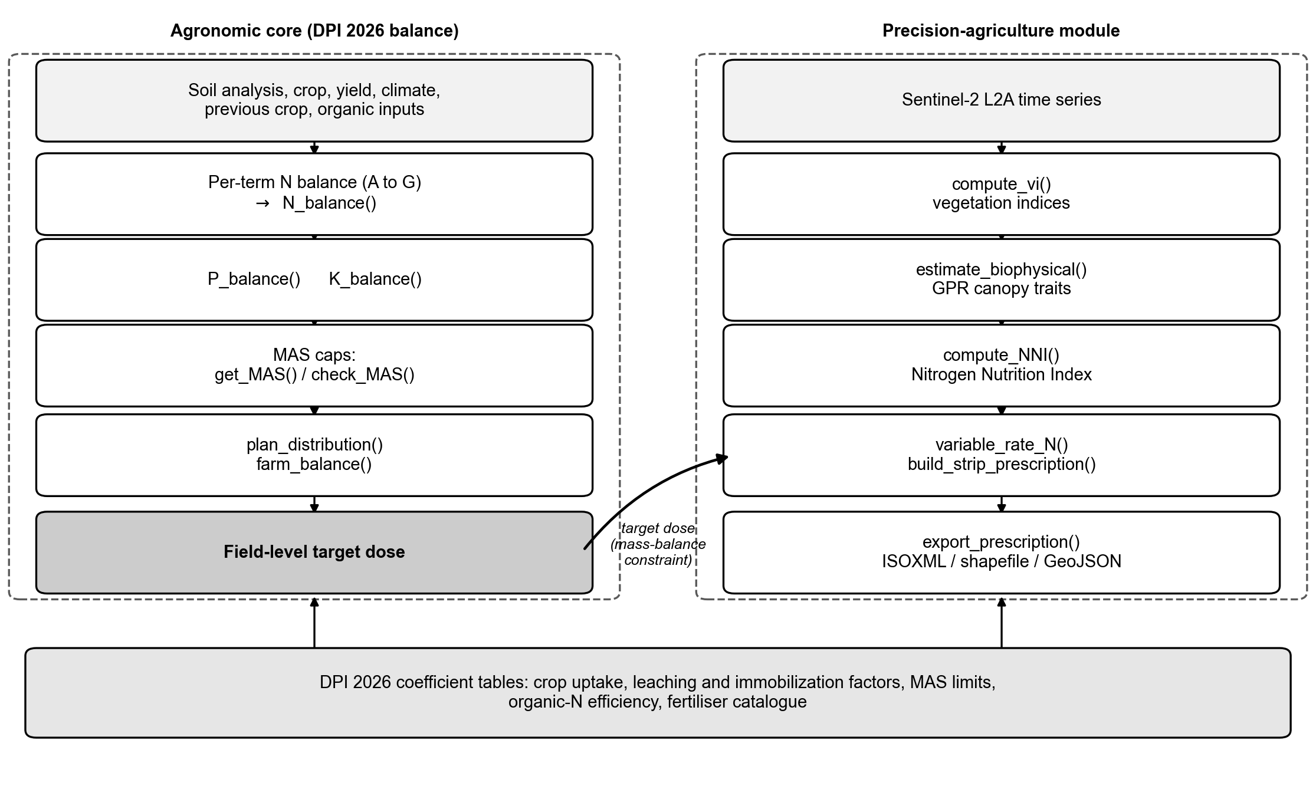
NFert architecture. The agronomic core composes the per-term DPI balance into N_balance() (and the P and K balances), applies the MAS caps and the organic plus mineral distribution plan, and produces a field-level target dose; this dose flows, under the mass-balance constraint, into the precision-agriculture module, which derives vegetation indices and Gaussian-process canopy traits, the Nitrogen Nutrition Index, mass-balance-constrained variable-rate prescriptions and machine-ready exports. The DPI 2026 coefficient tables underpin the package.

From the field balance to the variable-rate prescription
The agronomic and precision modules operate as a single pipeline. The field-scale target N* returned by N_balance() is the mass-balance constraint that the spatial prescription must respect: for a raster of equal-area pixels, the per-pixel rates satisfy a field mean equal to N* subject to user-defined minimum and maximum bounds, so the field-averaged rate of the variable-rate map coincides by construction with the regulatory-compliant target. variable_rate_N() enforces this by rescaling the raster so that its pixel mean equals N*. The spatial redistribution therefore changes where fertilizer is delivered, never how much, which keeps the prescription compliant with the Nitrates Directive ceiling and the MAS limits whenever these are respected at the balance stage.

Remote-sensing diagnosis and the Nitrogen Nutrition Index
compute_vi() derives six vegetation indices (NDVI, NDRE, GNDVI, CIred-edge, MCARI, MSAVI2) from a multi-band raster. Because NDVI saturates above a leaf area index of 3 to 4, the red-edge indices are preferred for nitrogen diagnosis in closed canopies, and any normalised index can drive the variable-rate functions unchanged. To move from a spectral proxy to a biophysical diagnosis, NFert implements the Nitrogen Nutrition Index of Lemaire and Gastal (1997), defined as the ratio of actual to critical nitrogen concentration along the species-specific critical-N dilution curve, with values below 0.90 indicating deficiency, 0.90 to 1.10 optimal status and above 1.10 luxury consumption (Houlès et al. 2007). estimate_biophysical() is a pure-R port of the pyeogpr Gaussian-process regression pipeline (Estévez et al. 2022) that retrieves canopy traits (leaf area index, dry-matter and water content, chlorophyll, canopy nitrogen) from a 10-band Sentinel-2 Level-2A raster; it reproduces the reference Python implementation at a correlation of 1.0 with a maximum relative error below 1.4e-8, and processes full tiles in bounded memory. compute_NNI() and compute_NNI_from_S2() combine these retrievals with the dilution curve into a continuous NNI map, and diagnose_N_status() discretises it into fertilization zones, which then guide the variable-rate prescription without altering the field-scale ceiling. build_strip_prescription() and export_prescription() tile the field and write the result to machine formats (ISOXML, shapefile, GeoJSON), and a Shiny application launched with run_app() exposes the whole workflow interactively.

Illustrative example
The nitrogen balance for a silage maize crop targeted at 60 t per hectare of fresh product on a medium-textured soil with annual cattle slurry is computed, audited term by term and checked against the regulatory maximum, in a few lines:
library(NFert)
n_bal <- N_balance(
expected_yield_tons_ha = 60, crop = "Shredded corn class 700",
ccp = "Spring-summer crop 100-130 days", sand = 50, clay = 35,
Ntot = 1.2, SOM = 1.2, CN = 9.5, oxygen_availability = "Normal",
winter_rain = 160, start_spring_rain = 40,
prev_crop = "Winter cereals straw removal", source = "Cattle slurry",
fertorg_frequency = "every year", location = "Plain adjacent to urbanized areas",
forg_quantity = 100)
n_target <- calculate_N_fertilization(n_bal) # mineral N to apply
check_MAS("Mais da insilato", n_target) # within the DPI maximum?
The object returned by N_balance() exposes every intermediate term, so the user can audit each contribution and compare scenarios, while P_balance() and K_balance() add the phosphorus and potassium doses from a soil test.

Case study: in-season diagnosis and variable-rate prescription at CERZOO
The full pipeline is demonstrated on a real field of the CERZOO experimental farm of the Universita Cattolica del Sacro Cuore, in the Po Valley near Piacenza (about 45.0 degrees N, 9.7 degrees E). Field 3 is a 3.24 ha silage maize plot (second harvest), on a clay-rich soil (37 percent clay, 16.8 percent sand, 1.74 percent organic matter, C/N 8.84), with a target yield of 60 t per hectare and a Sentinel-2 Level-2A time series for the 2024 and 2025 seasons. The field boundary and a cropped Sentinel-2 scene ship with the package, so the example runs out of the box. All quantities below are produced by NFert from these inputs.
For every acquisition, estimate_biophysical() retrieves the canopy traits and their field means and standard deviations are interpolated over the season (Figure 2). compute_NNI() then derives the Nitrogen Nutrition Index from the maize critical-N curve for dates with sufficient biomass (W greater than or equal to 1.0 t DM per hectare). Reading the NNI against the leaf area index (Figure 3) makes the diagnosis interpretable: within the two maize cycles, where LAI is high, the canopy moves between deficiency, the optimal band and luxury consumption, whereas the off-season scatter and gaps fall where LAI is near zero and no crop is present and should be disregarded.
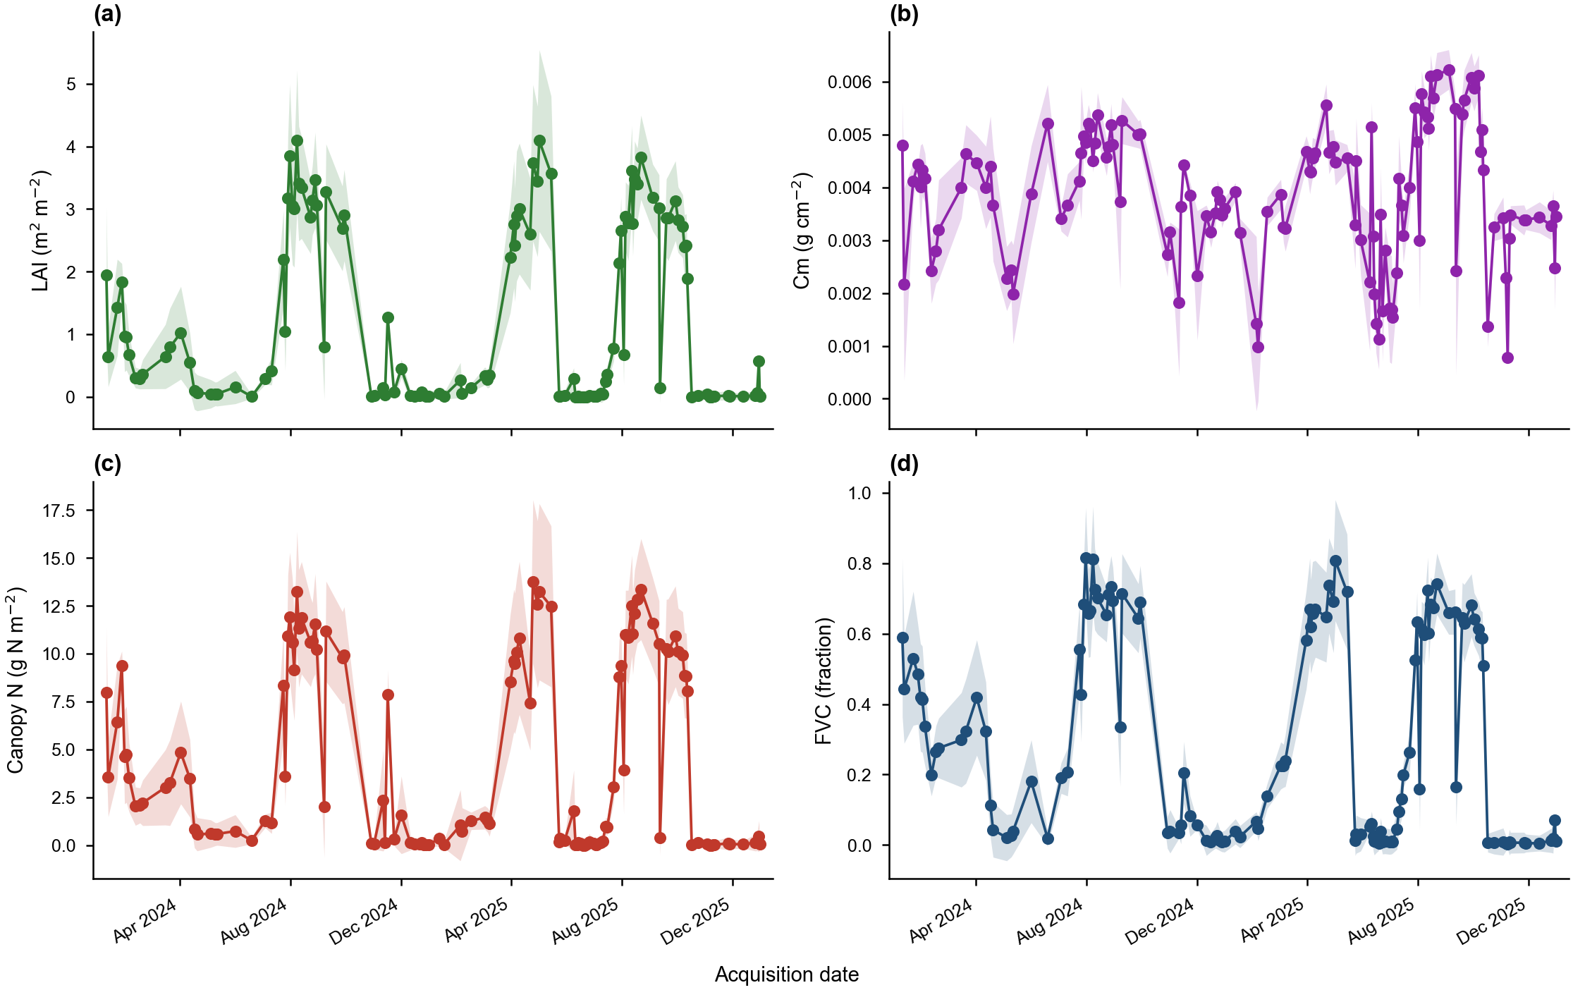
Field-mean seasonal trajectory of the canopy biophysical variables (LAI, Cm, canopy nitrogen content, FVC) retrieved from the Sentinel-2 time series by Gaussian-process regression for CERZOO Field 3. Points are the field mean plus or minus one standard deviation at each acquisition; lines are the natural-spline interpolation.
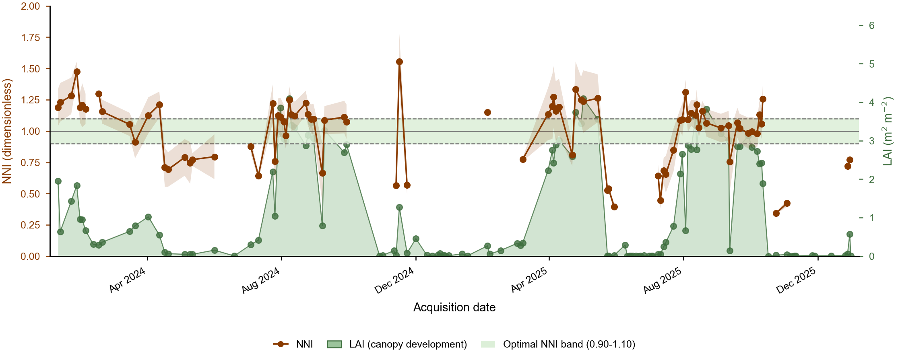
Seasonal Nitrogen Nutrition Index (NNI, left axis) for CERZOO Field 3, read against the canopy leaf area index (LAI, right axis, green area). NNI is derived from the maize critical-nitrogen curve for dates with sufficient biomass; the shaded band and dashed lines mark the optimal range (0.90 to 1.10). The two LAI peaks are the maize cycles in which NNI is agronomically reliable, whereas the off-season scatter and gaps correspond to low LAI when no crop canopy is present.
Each variability method is a response function that maps the per-strip vegetation index, or the NNI zone, to a nitrogen rate (Figure 4). The calibration ramp interpolates linearly between two NDVI anchors (here 0.35 and 0.80), either in the inverse sense, where a more vigorous canopy receives less nitrogen, or in the direct sense, and clips the rate to the dose envelope; the Holland and Schepers method instead lowers the rate as the NDVI approaches an N-rich reference strip. The prescription map is then built in three steps: the field is tiled into operational strips, the mean vegetation index of each strip is run through the chosen response, and the whole map is rescaled so that its area-weighted mean equals the agronomic target. That final rescaling is what keeps every map mass-balance compliant.
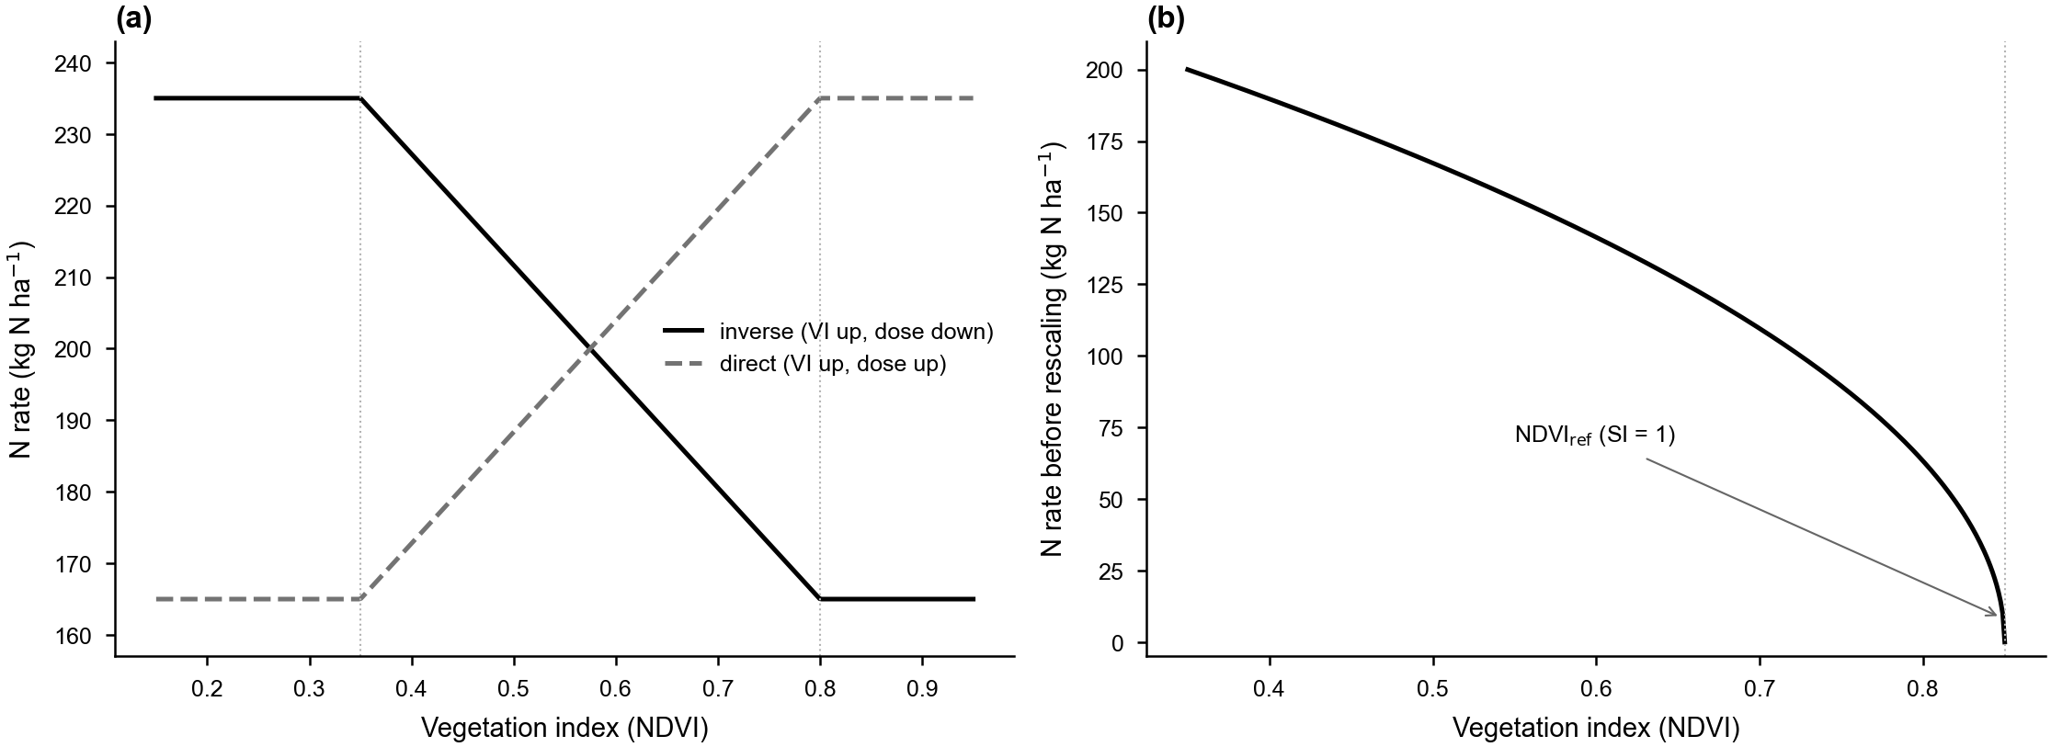
Response functions of the variable-rate methods. (a) Calibration ramp: a two-point linear function maps the vegetation index to the nitrogen rate, in the inverse form (higher NDVI, less nitrogen) or the direct form, clipped to the dose envelope (here 165 to 235 kg N per hectare between the NDVI anchors 0.35 and 0.80). (b) Holland and Schepers: the rate decreases as the NDVI approaches the N-rich reference strip (NDVIref, sufficiency index SI = 1). In both cases NFert rescales the per-strip rates so the field mean matches the balance target.
For the acquisition of 13 August 2024, build_strip_prescription() builds the prescription on 24 m by 30 m strips, here with the inverse NDVI calibration ramp, rescaled to the field-mean target of 200 kg N per hectare:
library(NFert); library(sf); library(terra)
farm <- sf::st_read(system.file("extdata/cerzoo_field.geojson", package = "NFert"),
quiet = TRUE)
field <- farm[farm$id == 3, ]
s2 <- terra::rast(system.file("extdata/sentinel-2/S2_cerzoo_field3_20240813.tif",
package = "NFert"))
ndvi <- compute_vi(s2, "NDVI", scale_factor = 10000)
rx <- build_strip_prescription(field, machine_width = 24, cell_length = 30,
variability = "calibration", vi_raster = ndvi,
vi_low = 0.35, vi_high = 0.80,
n_target = 200, min_dose = 165, max_dose = 235)
# export_prescription_all(rx, "rx_maps", "cerzoo_field3", formats = c("geojson", "isoxml"))
The resulting prescription maps (Figure 5) all reproduce the field-mean target, confirming the mass-balance constraint, but differ markedly in the within-field contrast they create (Table 2): the quantile-class method spreads the dose most widely (standard deviation 24.6 kg per hectare), the NNI-zone method concentrates the variation where the in-season diagnosis flags deficiency (19.8), and the direct NDVI ramp is the most conservative (4.8). The choice of method is therefore a deliberate agronomic decision about how much, and on what evidence, to vary nitrogen across the field, which NFert makes explicit and reproducible.
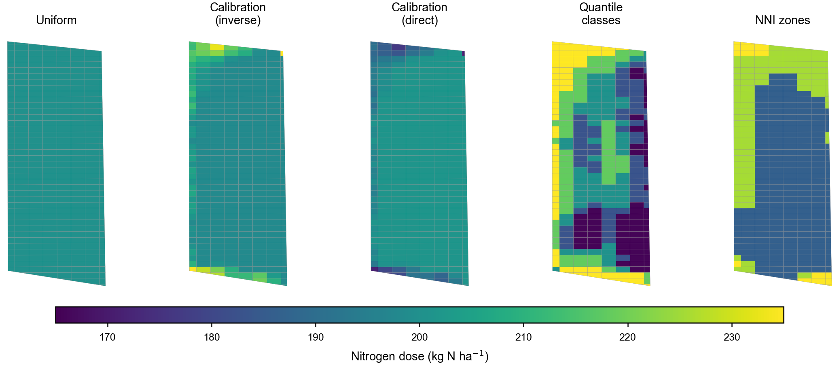
Variable-rate nitrogen prescriptions for CERZOO Field 3 (Sentinel-2 scene of 13 August 2024) under the prescription methods of Table 2, each constrained to the same field-mean dose of 200 kg N per hectare.
Per-strip nitrogen dose (kg N per hectare) for CERZOO Field 3 under each prescription method (328 strips), all constrained to the same field-mean target.
Prescription method | Min | Mean | Max | SD
Uniform | 200.0 | 200.0 | 200.0 | 0.0
NDVI calibration, inverse | 198.1 | 200.7 | 235.0 | 6.5
NDVI calibration, direct | 171.4 | 199.5 | 201.4 | 4.8
NDVI quantile classes (5) | 165.6 | 200.7 | 235.0 | 24.6
NNI zones (3) | 186.2 | 201.0 | 235.0 | 19.8

Impact
NFert fills a practical gap between balance-based fertilization theory and operational decision-support, a space historically occupied by closed, region-specific spreadsheet tools. By re-expressing the full workflow in R and exposing every coefficient table as a user-editable object, it benefits three communities. For researchers, it enables batch computation of fertilization plans over hundreds of fields and multi-year scenarios, and, because every balance term is an R object, it supports methodological work aimed at refining the default coefficients with local data or deriving parameterizations for other agro-climatic contexts. For extension services and consultants, a script of a few dozen lines can read a spreadsheet of soil analyses, compute the N, P and K balances for each field, select fertilizers and export a compliant plan, with git providing an auditable recommendation chain that is impractical with spreadsheets. For farmers and precision-agriculture service providers, NFert is the bridge between a compliant plan and a variable-rate application map: the same N target that appears on the regulatory plan is redistributed in space according to vegetation indices or the NNI, reducing in-field variability and nutrient losses while preserving full traceability. To our knowledge, NFert is the first R package to combine a complete balance-based planner, regulatory N-dose checks and native remote-sensing-driven variable-rate support in a single open-source tool.

Conclusions
NFert provides a transparent, reproducible and extensible R implementation of balance-based fertilization planning for nitrogen, phosphorus and potassium. It ships with a reference parameterization for the Emilia-Romagna DPI 2026 guidelines as a first fully-worked case study, but its coefficient tables and thresholds are user-editable, so the same machinery can be repurposed for other frameworks. By combining the balance method, the standard-dose scheme, the distribution plan and remote-sensing-driven variable-rate algorithms in one package, NFert lowers the barrier to compliant, science-based and precision-oriented nutrient management. Future work will extend the English crop-translation catalogue and add bundled parameterizations for other fertilization guidelines.

Declaration of competing interest
The authors declare that they have no known competing financial interests or personal relationships that could have appeared to influence the work reported in this paper.

Data availability
The code and bundled data of NFert are available in the GitHub repository () under the MIT License.

Acknowledgements
The authors thank the Servizio Agricoltura Sostenibile of Regione Emilia-Romagna for publishing the DPI 2026 guidelines and the FertDPI reference tool (v1.26), used as the first case study for NFert.

Funding
This work was supported by the EOAGRITWIN project.

References
Estévez, Jochem, Matias Salinero-Delgado, Katja Berger, et al. 2022. “Gaussian Processes Retrieval of Crop Traits in Google Earth Engine Based on Sentinel-2 Top-of-Atmosphere Data.” Remote Sensing of Environment 273: 112958. https://doi.org/10.1016/j.rse.2022.112958.
European Council. 1991. Council Directive 91/676/EEC of 12 December 1991 Concerning the Protection of Waters Against Pollution Caused by Nitrates from Agricultural Sources. Official Journal of the European Communities L375:1–8.
Hijmans, Robert J. 2024. Terra: Spatial Data Analysis. https://CRAN.R-project.org/package=terra.
Holland, Kyle H., and James S. Schepers. 2010. “Derivation of a Variable Rate Nitrogen Application Model for in-Season Fertilization of Corn.” Agronomy Journal 102 (5): 1415–24. https://doi.org/10.2134/agronj2010.0015.
Houlès, Vianney, Martine Guérif, and Bruno Mary. 2007. “Elaboration of a Nitrogen Nutrition Indicator for Winter Wheat Based on Leaf Area Index and Chlorophyll Content for Making Nitrogen Recommendations.” European Journal of Agronomy 27: 1–11. https://doi.org/10.1016/j.eja.2006.10.001.
Johnston, A. Edward, Paul R. Poulton, and Kevin Coleman. 2009. “Soil Organic Matter: Its Importance in Sustainable Agriculture and Carbon Dioxide Fluxes.” Advances in Agronomy 101: 1–57. https://doi.org/10.1016/S0065-2113(08)00801-8.
Lemaire, Gilles, and François Gastal. 1997. “N Uptake and Distribution in Plant Canopies.” In Diagnosis of the Nitrogen Status in Crops, edited by Gilles Lemaire. Springer-Verlag. https://doi.org/10.1007/978-3-642-60684-7_1.
Lyons, Sarah E., Deanna L. Osmond, Nathan A. Slaton, et al. 2020. “FRST: A National Soil Testing Database to Improve Fertility Recommendations.” Agricultural & Environmental Letters 5: e20008. https://doi.org/10.1002/ael2.20008.
Oenema, Oene, Hans Kros, and Wim de Vries. 2003. “Approaches and Uncertainties in Nutrient Budgets: Implications for Nutrient Management and Environmental Policies.” European Journal of Agronomy 20: 3–16. https://doi.org/10.1016/S1161-0301(03)00067-4.
R Core Team. 2025. R: A Language and Environment for Statistical Computing. R Foundation for Statistical Computing. https://www.r-project.org/.
Regione Emilia-Romagna. 2017. Regolamento Regionale Emilia-Romagna 3/2017: Utilizzazione Agronomica Degli Effluenti Zootecnici e Del Digestato. Bologna, Italy.
Regione Emilia-Romagna. 2024. Regolamento Regionale Emilia-Romagna 2/2024: Massimali Di Apporto Di Azoto (MAS). Bologna, Italy.
Regione Emilia-Romagna. 2026a. Disciplinari Di Produzione Integrata (DPI): Norme Generali, Allegato 2 (Metodo Del Bilancio Dell’azoto), Edizione 2026. Regione Emilia-Romagna, Servizio Agricoltura Sostenibile.
Regione Emilia-Romagna. 2026b. FertDPI / Fert_office V1.26: Strumento Regionale Per Il Piano Di Fertilizzazione. Regional decision-support spreadsheet.
Regione Emilia-Romagna. 2026c. Guida Alla Fertilizzazione Minerale e Organica: Azoto, Fosforo, Potassio. Regione Emilia-Romagna.
Seibold, Heidi, Severin Czerny, Siona Decke, et al. 2021. “A Computational Reproducibility Study of PLOS ONE Articles Featuring Longitudinal Data Analyses.” PLOS ONE 16: e0251194. https://doi.org/10.1371/journal.pone.0251194.

