From regulatory nitrogen balances to sensor-driven variable rate: a methodological review of nitrogen recommendation systems in precision agriculture, with an open reproducible implementation
2026-06-25
Abstract
Precision nitrogen management must match supply to crop demand in space and time while respecting environmental regulation. The methods proposed for this fall into a few families: regulatory nutrient balances, soil-test and standard-dose schemes, crop-growth models, sensor-based empirical algorithms, biophysical diagnosis through the Nitrogen Nutrition Index, and, increasingly, machine learning. This review compares these families across operational dimensions (data needs, spatio-temporal resolution, regulatory fit, openness and reproducibility), argues that they are complementary rather than competing, and shows that a single field-level mass-balance constraint can unify a regulation-compliant budget with an in-season, remote-sensing-driven variable-rate prescription. It further identifies a reproducibility and integration gap: the regulatory methods are typically locked in closed spreadsheets, and remote-sensing diagnosis is rarely coupled to them in a versioned, open workflow. We illustrate an open, reproducible implementation of the integrated framework, the NFert R package, on a real maize field of the CERZOO experimental farm, comparing prescription methods under the shared constraint, and we outline the research gaps that remain in calibration transfer, operational Nitrogen Nutrition Index retrieval, validation and economics.
Michele Croci^{a,*}, Giorgio Impolloniaª, Andrea Ferrariniª, Andrea Fioriniª, Manuele Ragazziª, Nicolaj Franceschiª, Vincenzo Tabaglioª, Stefano Amaducciª
ª Department of Sustainable Crop Production (DI.PRO.VE.S.), Universita Cattolica del Sacro Cuore, via Emilia Parmense 84, 29122 Piacenza, Italy
* Corresponding author. E-mail: michele.croci@unicatt.it
NOTE TO CO-AUTHORS: this is a working draft of a methodological review. Sections that reuse the software-paper material are largely complete; passages marked [REVIEW: …] or [CITATION: …] need additional literature synthesis that the authors should curate. The literature still to add is listed at the end.

Introduction
Nitrogen fertilization is among the most consequential agronomic decisions in European cropping systems. Excess nitrogen contaminates surface and groundwater, drives nitrous oxide emissions and erodes nitrogen use efficiency, while insufficient supply limits yield, quality and farm profitability (Oenema et al. 2003). Regulation has responded: the EU Nitrates Directive (European Council 1991) caps livestock-effluent nitrogen in vulnerable zones, and regional Integrated Production guidelines translate the principle into operational fertilization plans (Regione Emilia-Romagna 2026a, 2026b). The agronomic challenge is therefore a constrained optimisation: match nitrogen supply to crop demand in space and time, subject to a regulatory ceiling.
A large and diverse body of methods has been proposed to support this decision. A recent scoping review of side-dress nitrogen recommendation systems identified 151 systems and found that the great majority are empirical and based on spatialized vegetation indices, with a minority built on mechanistic crop simulation models and only a small fraction on machine learning (Corti et al. 2022). Yet these families are usually presented and used in isolation, and two practical problems recur: the regulatory balance methods that determine the legally admissible dose are typically distributed as closed, region-specific spreadsheets that are hard to version and to couple with data, while the remote-sensing methods that resolve within-field variability are rarely tied back to that regulatory ceiling in a single reproducible workflow.
This review has three aims. First, to organise the methods into a taxonomy and to compare them critically across the operational dimensions that matter in practice (data requirements, spatial and temporal resolution, regulatory fit, openness and reproducibility). Second, to argue that the families are complementary rather than competing, and that a single field-level mass-balance constraint can unify a regulation-compliant budget with an in-season, sensor-driven variable-rate prescription. Third, to demonstrate this integrated framework with an open, reproducible implementation and a real case study, and to map the research gaps that remain. This is a methodological and critical review with a worked implementation, not a systematic review; the quantitative diffusion of the method families is taken from the scoping review of Corti et al. (2022).

A taxonomy of nitrogen recommendation methods
We group the methods into six families (Sections 2.1 to 2.6) and machine learning (2.7), following and extending the categories of Corti et al. (2022). Table A (Section 6) summarises them against the operational dimensions.

Balance-based and regulatory methods
Balance methods compute the mineral nitrogen to apply as a mass budget that reconciles crop demand with soil supply and environmental losses. In the DPI Allegato 2 formulation (Regione Emilia-Romagna 2026a) the budget combines crop demand (A), soil supply from mineralization and ready nitrogen (B1, B2), leaching (C1, C2), immobilization (D), the previous-crop contribution (E), residual and current-year organic nitrogen (F, Forg) and atmospheric deposition (G), and returns the residual mineral nitrogen to apply (Figure 1). Their strengths are transparency and regulatory defensibility: every term is auditable and the result is, by construction, compliant with maximum allowed doses (Regione Emilia-Romagna 2024) and the Nitrate Vulnerable Zone ceiling (European Council 1991). Their limits are that they are static, field-uniform and bound to locally calibrated coefficients, so they neither resolve within-field variability nor respond to the actual season.
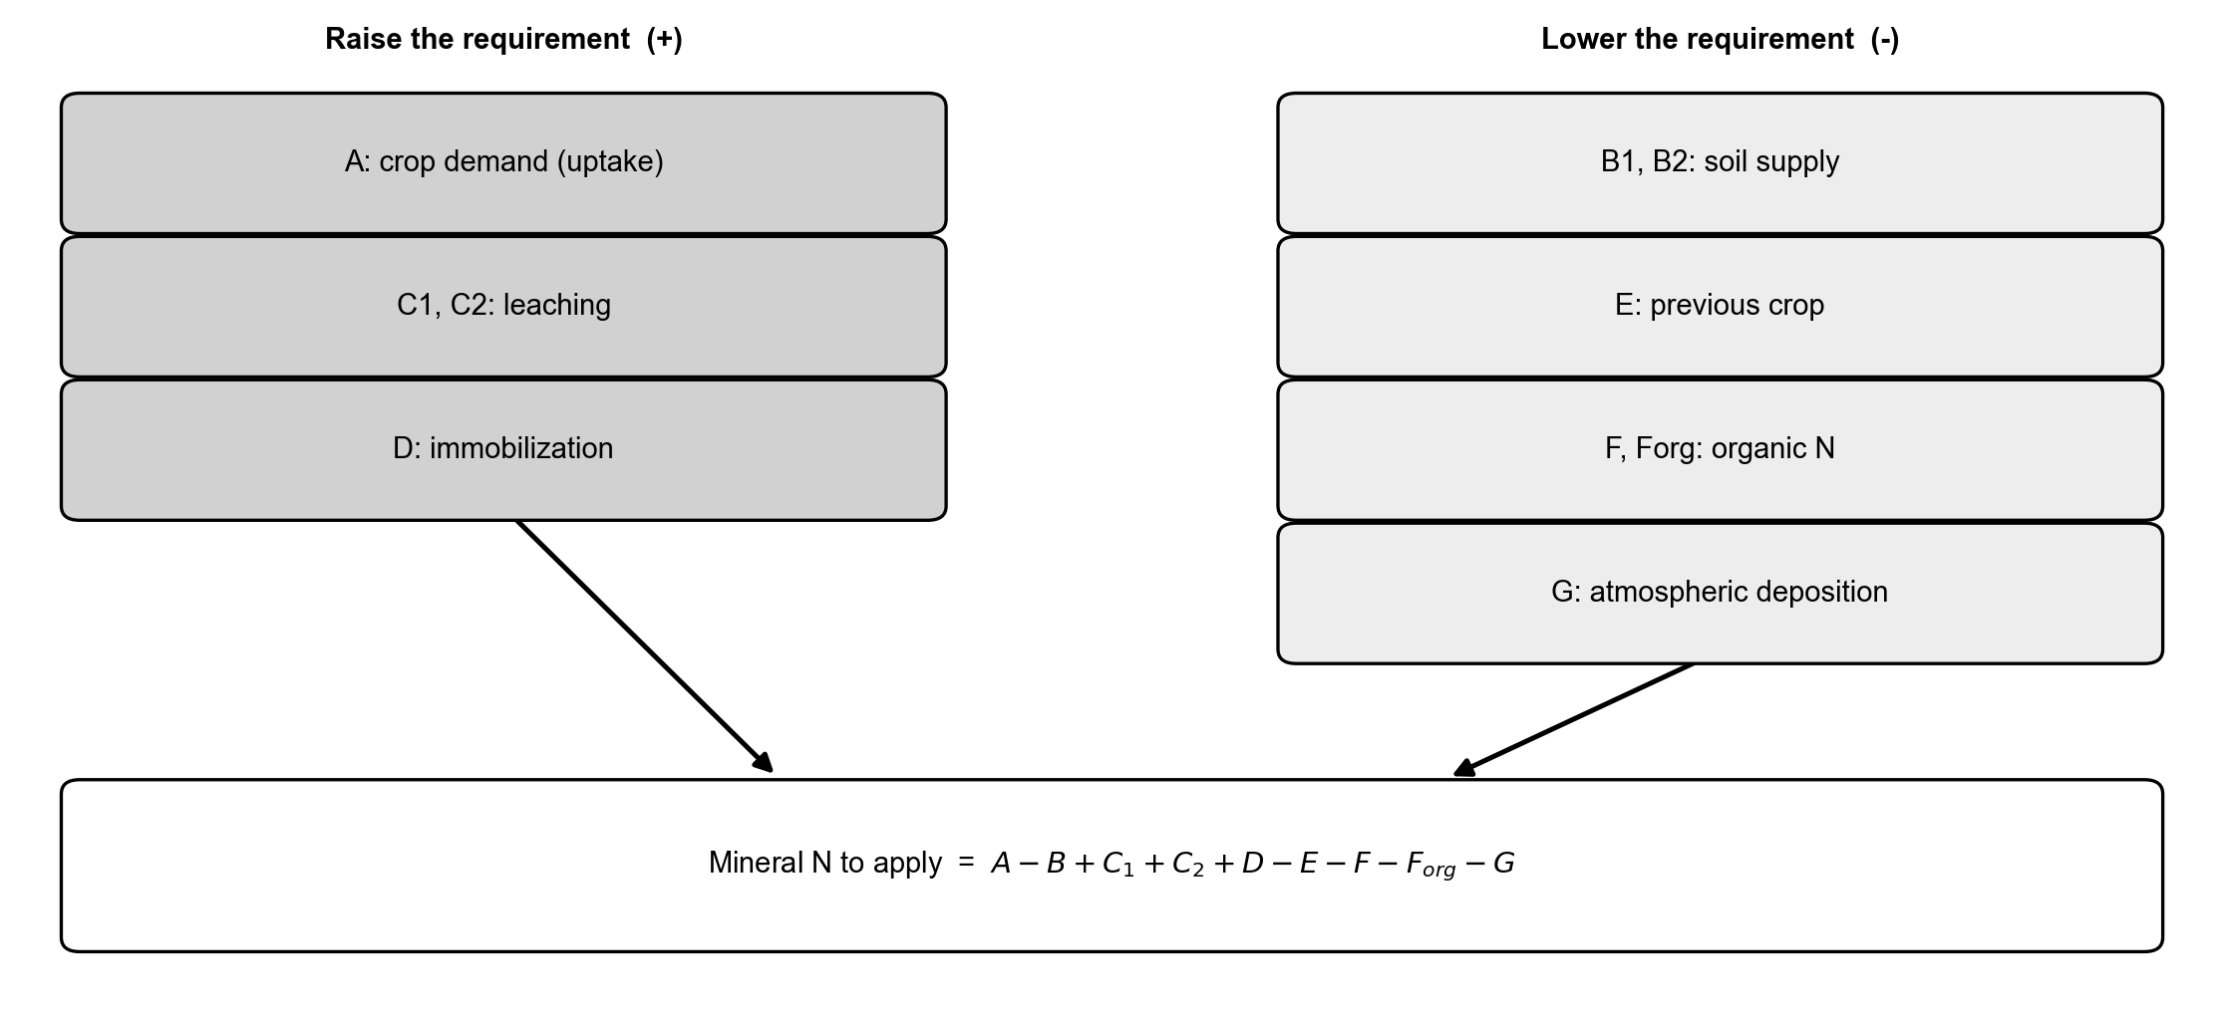
Conceptual scheme of the crop nitrogen balance. The terms that raise the requirement (crop demand A, leaching C, immobilization D) and those that lower it (soil supply B, previous crop E, organic contributions F and Forg, natural deposition G) combine into the residual mineral N to apply.

Soil-test and standard-dose methods
Soil-test methods set the dose from analytical soil values interpreted against calibrated response classes, often simplified into standard-dose schemes with documented decrements and increments. Open soil-test databases such as FRST have improved the transparency of the underlying calibrations (Lyons et al. 2020). [REVIEW: add soil-test calibration and standard-dose literature; note the trade-off between simplicity and site-specificity.]

Crop-growth and process models
Mechanistic crop models (for example DSSAT, APSIM and STICS) simulate nitrogen uptake and loss dynamically and can in principle produce site- and season-specific recommendations; in the scoping review they account for about one fifth of the systems, with limited use of spatialized data (Corti et al. 2022). [CITATION: model-based N recommendation / decision-support references.] Their strength is process fidelity; their cost is parameterisation, weather data and computational weight, which limits operational uptake.

Sensor-based empirical methods
The most common family maps a canopy-reflectance signal to a nitrogen rate. The calibration-curve approach fits a relationship between an index and the rate from on-farm reference strips and applies it pixel-wise (Figure 2a), while the sufficiency-index approach of Holland and Schepers lowers the rate as the index approaches an N-rich reference strip (Figure 2b) (Holland and Schepers 2010). NDVI is the historical default but saturates at a leaf area index above 3 to 4, precisely at the side-dressing stages, so red-edge indices are increasingly preferred for nitrogen diagnosis in closed canopies. [CITATION: active optical sensors / GreenSeeker; red-edge index references.] These methods resolve within-field variability and respond to the season, but a reflectance index is a proxy and, on its own, sets no field-level ceiling.
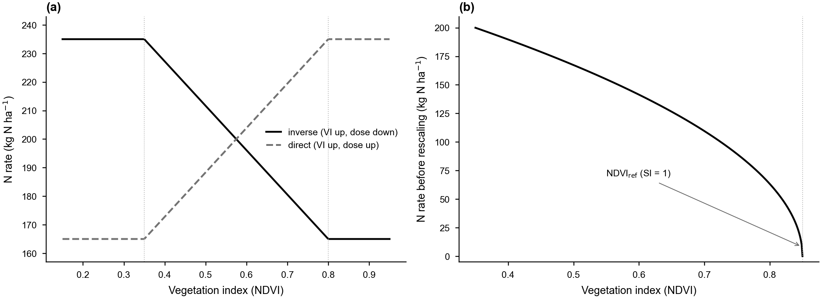
Response functions of the variable-rate methods. (a) Calibration ramp mapping the vegetation index to the nitrogen rate, inverse and direct forms, clipped to the dose envelope. (b) Holland and Schepers: the rate decreases as the NDVI approaches the N-rich reference strip (sufficiency index SI = 1). The per-strip rates are rescaled so the field mean matches the balance target.

Critical-N dilution and the Nitrogen Nutrition Index
The Nitrogen Nutrition Index (NNI) moves from a spectral proxy to a biomass-normalised diagnosis. It is the ratio of actual to critical nitrogen concentration along the species-specific critical-N dilution curve Nc = a W^(-b) (Lemaire and Gastal 1997), with values below 0.90 indicating deficiency, 0.90 to 1.10 optimal status and above 1.10 luxury consumption (Figure 3) (Houlès et al. 2007). The curve coefficients are well established for the main crops [CITATION: Justes 1994 wheat; Plenet and Lemaire 2000 maize]. The NNI is interpretable and physiologically grounded, but it requires biomass and plant nitrogen concentration, which are not routinely measured and must be retrieved (Section 2.6); recent reviews discuss its estimation from remote sensing ( 2023).
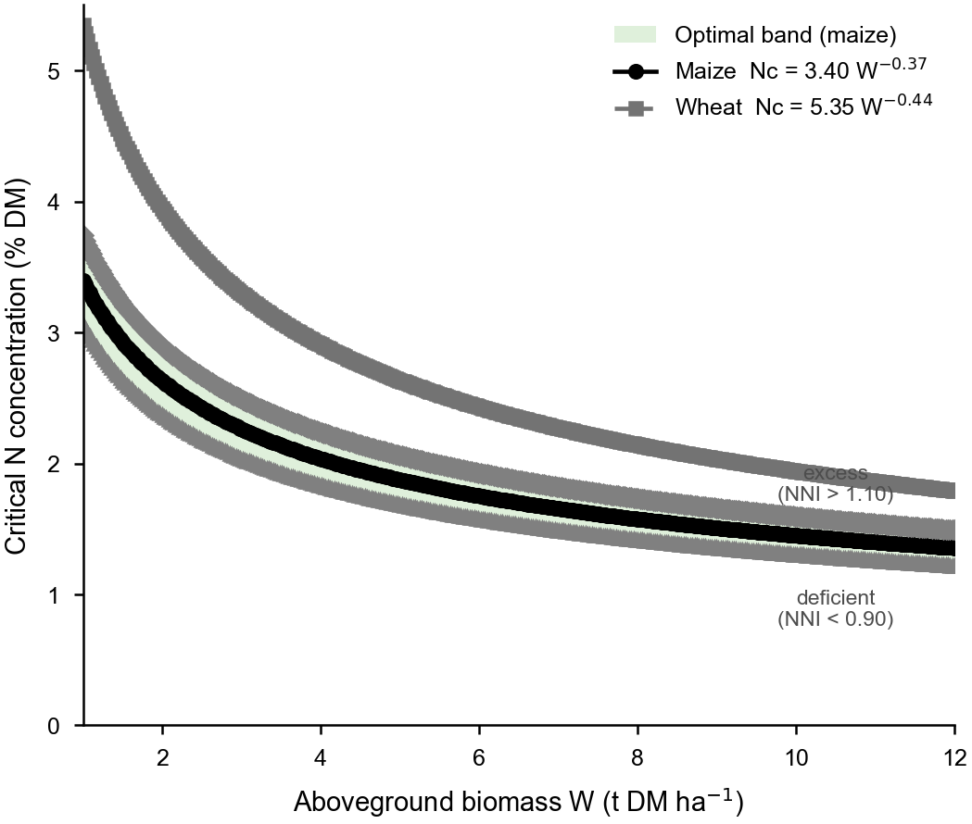
Critical-nitrogen dilution curves for maize and wheat on a biomass versus N-concentration plane. The shaded band (0.90 to 1.10 times Nc, shown for maize) is the optimal NNI zone; points above it are in luxury consumption and points below are deficient.

Biophysical retrieval as the bridge from reflectance to NNI
Retrieving canopy biophysical variables (leaf area index, dry-matter and water content, chlorophyll, canopy nitrogen) from multispectral imagery closes the gap between reflectance and the NNI. Hybrid approaches that train machine-learning regressors on radiative-transfer (PROSAIL) simulations, in particular Gaussian-process regression, have become a standard (Estévez et al. 2022). [CITATION: hybrid / PROSAIL retrieval review.] These retrievals provide the biomass and nitrogen layers the NNI needs, but they inherit calibration sensitivities (Section 7).

Machine-learning approaches
Purely data-driven models predict nitrogen status or the recommended rate from large labelled datasets; they are still a small minority of systems (Corti et al. 2022). [CITATION: ML for N recommendation references.] They can capture complex interactions but are data-hungry and opaque, and they do not by themselves enforce a regulatory ceiling.

Integration: from the field budget to the variable-rate prescription
The families above are usually treated as alternatives, but they answer different questions: the balance answers how much nitrogen the field may receive, the sensor answers where within the field it should go. They can be unified by a single mass-balance constraint. For a raster of n equal-area pixels, the per-pixel rates are required to average to the field target N* set by the balance, subject to user-defined minimum and maximum bounds, so the spatial redistribution changes where fertilizer is delivered, never how much overall. Under this constraint a sensor-driven map remains compliant with the Nitrate Vulnerable Zone ceiling (European Council 1991) and with crop-specific maximum doses (Regione Emilia-Romagna 2024) whenever these are respected at the balance stage. Figure 4 shows this integrated pipeline.
This coupling supports two complementary use cases. At the pre-sowing stage the balance is computed with uniform field inputs and split into organic and mineral applications; when an index raster becomes available in-season, the residual mineral share is redistributed without altering the field total. At the post-season stage the spatial pattern of the index, and its correlation with soil or organic-history maps, provides a cell-level diagnostic of which balance terms deserve refinement for the following season, closing a feedback loop. To our knowledge this round-trip between a regulation-compliant balance and an index-driven prescription under a shared invariant is rarely implemented in open software, which motivates the gap discussed next.
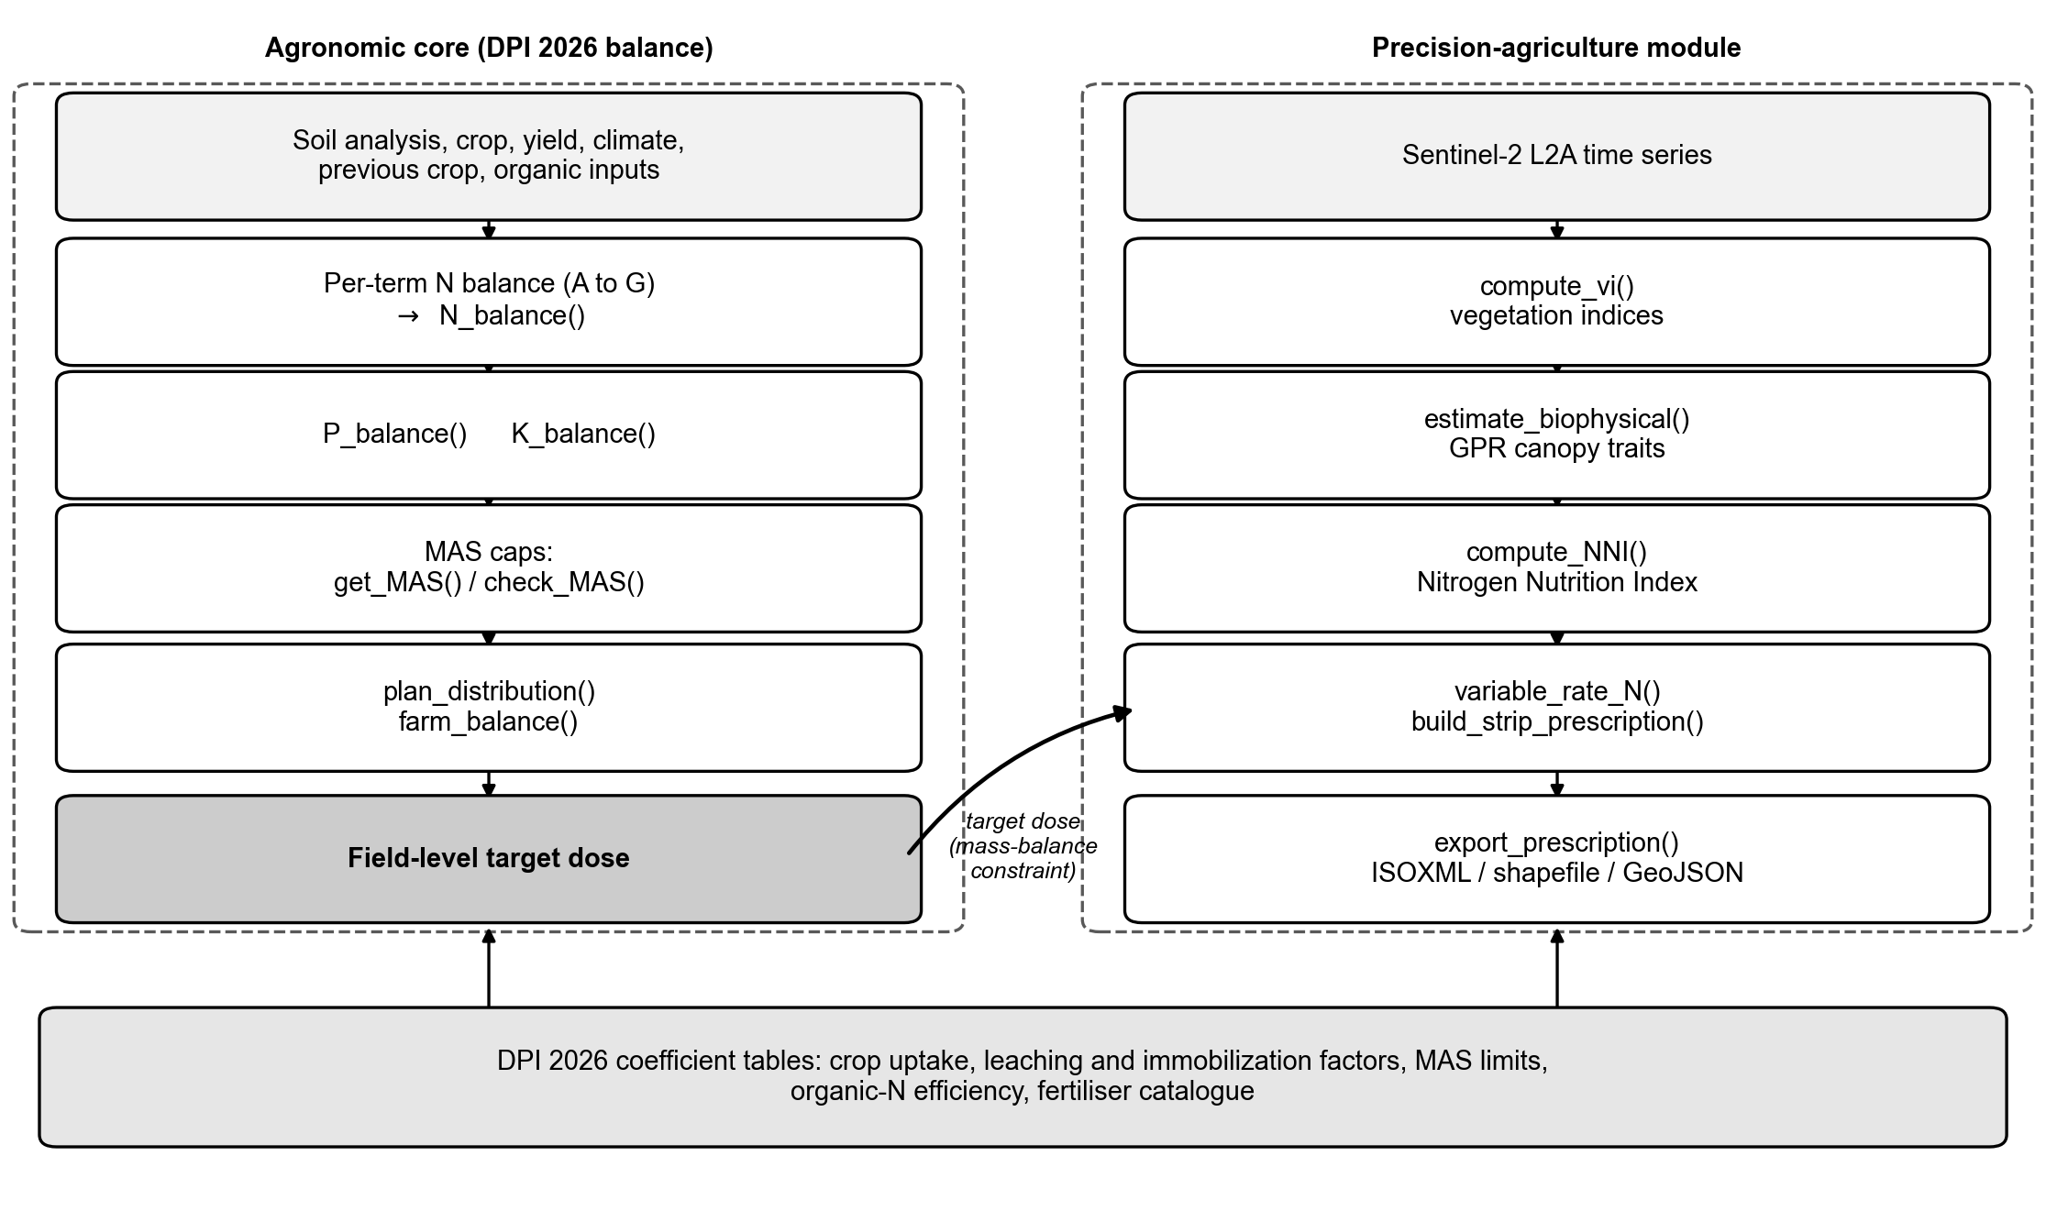
An integrated pipeline. The agronomic core composes the per-term balance into a field-level target dose, applies the regulatory limits and the distribution plan, and feeds the target, under the mass-balance constraint, to the precision module, which derives vegetation indices and canopy traits, the Nitrogen Nutrition Index, variable-rate prescriptions and machine-ready exports.

The reproducibility and openness gap
Two structural problems limit the methods above. First, the regulatory balance methods that set the admissible dose are typically distributed as closed, region-specific spreadsheets: they are widely used by advisors but are hard to version, unsuited to batch analysis and difficult to couple with spatial data, which impedes replication and cross-region transfer (Seibold et al. 2021). Second, the remote-sensing methods that resolve variability are frequently delivered through proprietary platforms, so the algorithm and its parameters are not inspectable. The consequence is that the two halves of an integrated recommendation, the legally defensible ceiling and the spatial pattern, rarely live in the same open, reproducible workflow. [REVIEW: add FAIR-data / open-science / reproducibility-in-agronomy references and discuss the case for editable, inspectable coefficient tables.]

An open, integrated implementation and a real case study
We illustrate the integrated framework with NFert, an open-source R package that implements every family of Section 2 except pure machine learning, under the shared mass-balance constraint of Section 3. The agronomic core computes the N, P and K balances and the standard-dose scheme, applies the maximum allowed doses and a combined organic-plus-mineral distribution plan, and produces a field-level target; the precision module computes vegetation indices, retrieves canopy traits by Gaussian-process regression, derives the NNI, and builds mass-balance-constrained variable-rate prescriptions with machine-ready export (Figure 4). All coefficient tables are exposed as editable R objects, so the same machinery can be repurposed for other guidelines, which directly addresses the openness gap of Section 4.

Case study: in-season diagnosis and prescription at CERZOO
We demonstrate the workflow on Field 3 of the CERZOO experimental farm of the Universita Cattolica del Sacro Cuore, in the Po Valley near Piacenza, a 3.24 ha silage maize plot on a clay-rich soil, with a Sentinel-2 Level-2A time series for the 2024 and 2025 seasons. For every acquisition the biophysical variables are retrieved and their field means interpolated over the season (Figure 5). The NNI is then derived from the maize critical-N curve and read against the leaf area index (Figure 6): within the two maize cycles, where leaf area is high, the canopy moves between deficiency, the optimal band and luxury consumption, whereas the off-season scatter and gaps fall where the canopy is absent and should be disregarded. This illustrates a practical caveat of the NNI family, that the diagnosis is only meaningful inside the phenological window.
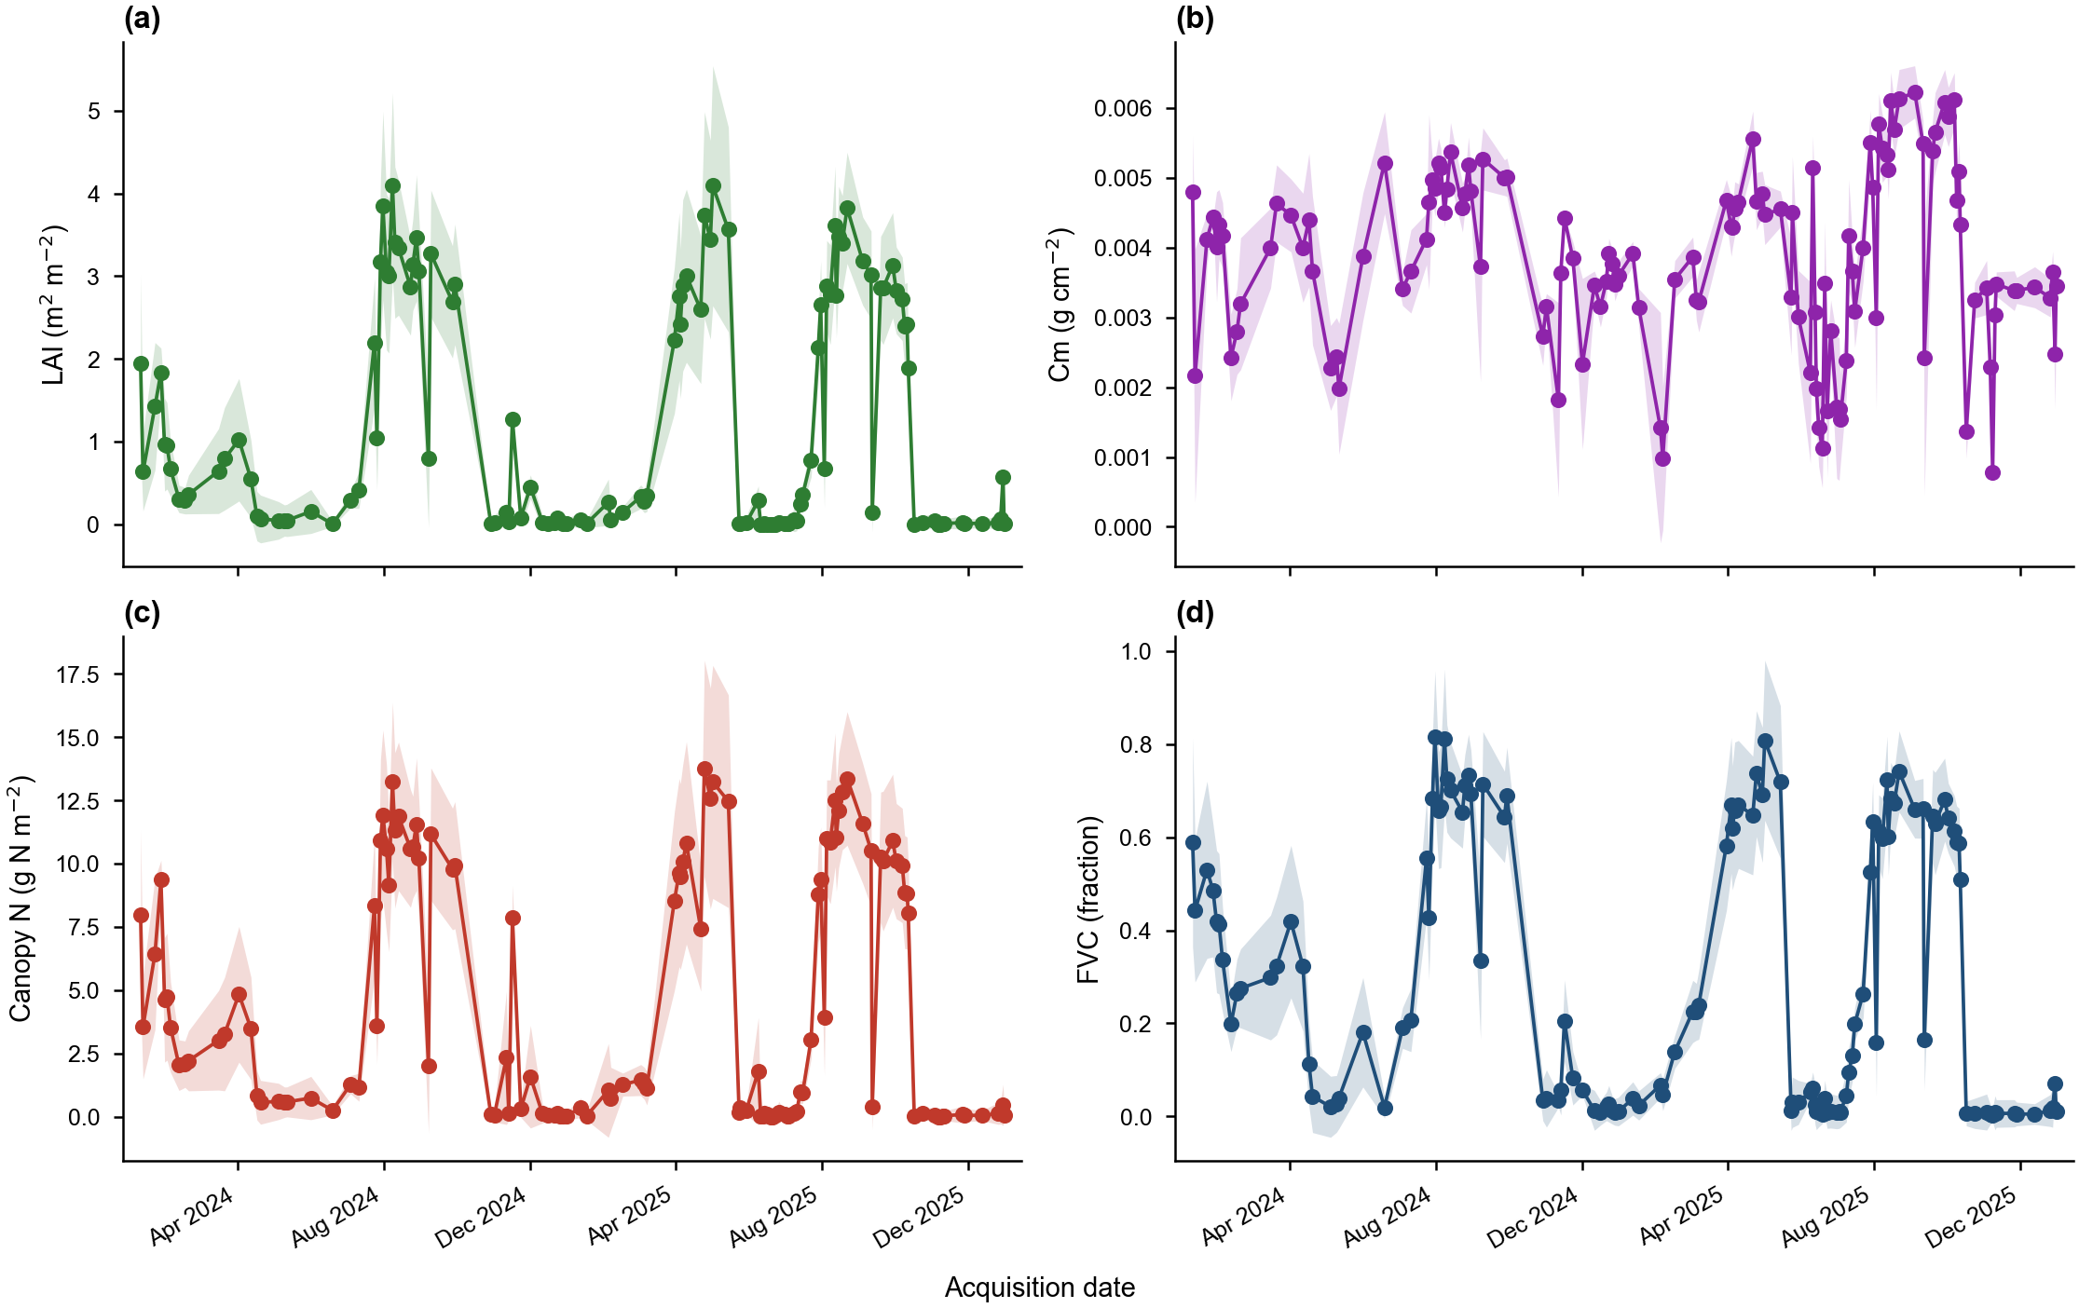
Field-mean seasonal trajectory of the canopy biophysical variables (LAI, Cm, canopy nitrogen content, FVC) for CERZOO Field 3. Points are the field mean plus or minus one standard deviation; lines are the spline interpolation.
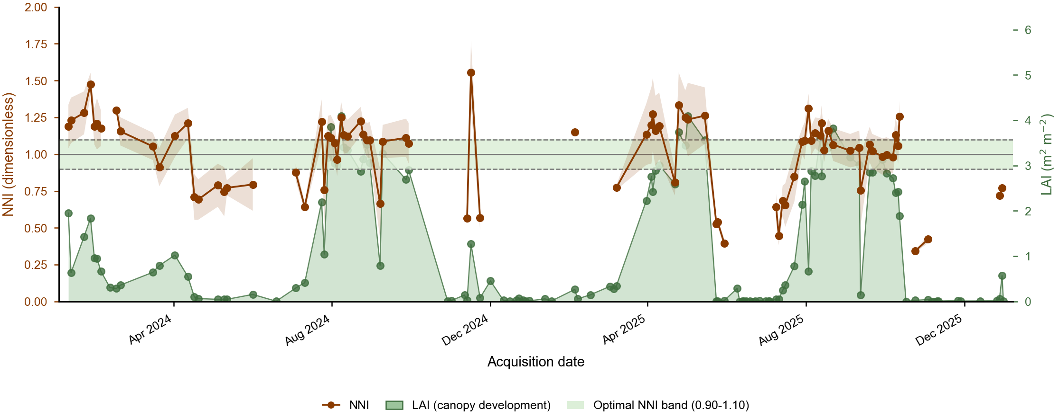
Seasonal Nitrogen Nutrition Index (left axis) for CERZOO Field 3 read against the leaf area index (right axis, green area). The shaded band marks the optimal range; the LAI peaks are the maize cycles in which the NNI is reliable, while the off-season scatter and gaps correspond to low LAI.
The same scene drives the prescription. Each variability method is a response function mapping the per-strip index, or the NNI zone, to a rate (Figure 2); the field is tiled into strips, the mean index of each strip is run through the chosen response, and the map is rescaled so its area-weighted mean equals the 200 kg N per hectare target. All methods reproduce that target (Table B, Section 6) but differ markedly in within-field contrast: quantile classes spread the dose most widely (standard deviation 24.6 kg per hectare), the NNI-zone method concentrates variation where the diagnosis flags deficiency (19.8), and the direct NDVI ramp is the most conservative (4.8). The choice of method is thus an explicit agronomic decision about how much, and on what evidence, to vary nitrogen, made reproducible (Figure 7).
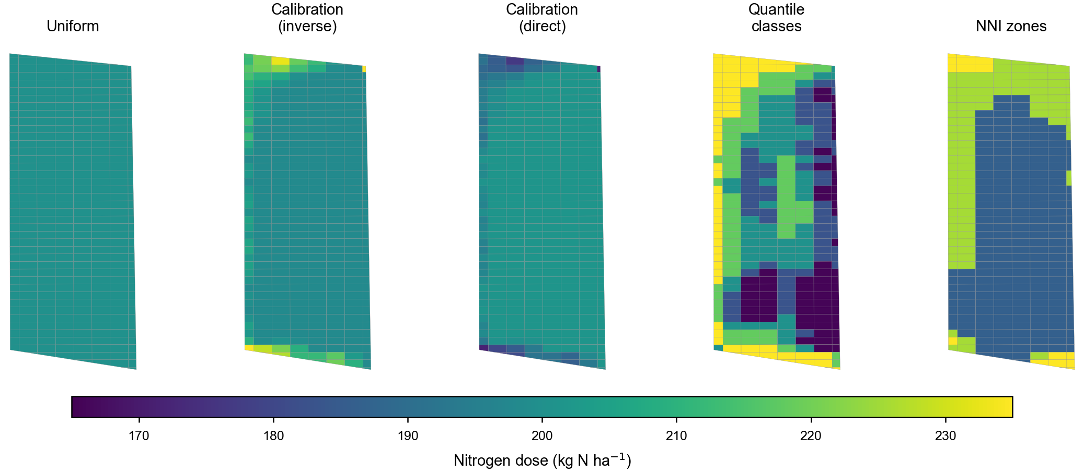
Variable-rate prescriptions for CERZOO Field 3 under the methods of Table B, each constrained to the same field-mean dose of 200 kg N per hectare.

Comparative discussion

Method families across operational dimensions
Table A places the families of Section 2 against the dimensions that decide their practical use. [REVIEW: complete the qualitative cells with cited evidence; add a short narrative on when to prefer each family and on the trade-off between calibration cost, spatial resolution, regulatory fit and reproducibility.]
Families of nitrogen recommendation methods across operational dimensions (qualitative; to be completed with cited evidence).
Family | Data required | Spatial res. | Timing | Regulatory fit | Openness / reproducibility
Regulatory balance | soil analysis, crop, climate, history | field | pre-sowing | high (by design) | usually closed spreadsheets
Soil-test / standard dose | soil test, crop | field | pre-sowing | high | mostly closed
Crop-growth models | weather, soil, management | field / zone | pre and in-season | medium | open models exist, heavy
Sensor-based empirical | canopy imagery, reference | pixel / zone | in-season | needs a ceiling | mixed; often closed
NNI / critical-N | biomass, plant N (or proxies) | plot / pixel | in-season | diagnostic | conceptual; few open tools
Biophysical retrieval | multispectral imagery | pixel | in-season | input to NNI | research code, often Python
Machine learning | large labelled data | pixel / zone | in-season | opaque | varies

Evidence on variable-rate effectiveness
[REVIEW: synthesise the evidence on whether variable-rate nitrogen improves nitrogen use efficiency, yield and environmental outcomes relative to uniform application; cite field trials and, where available, meta-analyses. This is a central claim of the precision-N literature and the review should weigh it critically rather than assert it.]
Per-strip nitrogen dose (kg N per hectare) for the CERZOO case study under each prescription method (328 strips), all constrained to the same field-mean target.
Prescription method | Min | Mean | Max | SD
Uniform | 200.0 | 200.0 | 200.0 | 0.0
NDVI calibration, inverse | 198.1 | 200.7 | 235.0 | 6.5
NDVI calibration, direct | 171.4 | 199.5 | 201.4 | 4.8
NDVI quantile classes (5) | 165.6 | 200.7 | 235.0 | 24.6
NNI zones (3) | 186.2 | 201.0 | 235.0 | 19.8

Research gaps and outlook
Several gaps limit the operational integration argued here. Calibration transfer is the first: the locally sensitive parameters of the biophysical-to-NNI step (the leaf-allocation coefficient and the canopy nitrogen-to-chlorophyll ratio) introduce biases of 15 to 30 percent when adopted without local verification (Houlès et al. 2007), and the critical-N curve coefficients, although well established, are species- and sometimes cultivar-specific. Second, operational NNI retrieval is constrained by cloud cover, satellite revisit and the need to acquire inside the phenological window, as the CERZOO series makes visible. Third, independent validation of variable-rate recommendations against yield and environmental outcomes, and their economics, remains thin [REVIEW: cite the validation and economics literature]. Finally, the families could be combined further: coupling balance methods with crop models or machine learning, extending the constraint to phosphorus and potassium, and moving from single-season to multi-year planning.

Conclusions
Nitrogen recommendation for precision agriculture is served by several method families that are usually treated as competitors but in fact answer complementary questions. We have argued that a single field-level mass-balance constraint unifies the regulation-compliant budget produced by balance methods with the within-field pattern produced by sensor-based and NNI methods, and that the main obstacle to this integration in practice is not conceptual but infrastructural: the methods live in closed, disconnected tools. An open, reproducible implementation that exposes every coefficient as an editable object, demonstrated here on a real maize field, shows that the integrated framework is feasible today. The remaining work is in calibration transfer, operational retrieval, independent validation and economics, and in extending the same constraint across nutrients and seasons.

Declaration of competing interest
The authors declare that they have no known competing financial interests or personal relationships that could have appeared to influence the work reported in this paper.

Funding
This work was supported by the EOAGRITWIN project.

Acknowledgements
The authors thank the Servizio Agricoltura Sostenibile of Regione Emilia-Romagna for publishing the DPI 2026 guidelines and the FertDPI reference tool, and the CERZOO experimental farm for the field data.

References
. 2023. “Remote Monitoring of Crop Nitrogen Nutrition to Adjust Crop Models: A Review.” Agriculture 13 (4): 835. https://doi.org/10.3390/agriculture13040835.
Corti, Martina, Virginia Fassa, and Luca Bechini. 2022. “A Scoping Review of Side-Dress Nitrogen Recommendation Systems and Their Perspectives in Precision Agriculture.” Italian Journal of Agronomy 17 (1): 1951. https://doi.org/10.4081/ija.2021.1951.
Estévez, Jochem, Matias Salinero-Delgado, Katja Berger, et al. 2022. “Gaussian Processes Retrieval of Crop Traits in Google Earth Engine Based on Sentinel-2 Top-of-Atmosphere Data.” Remote Sensing of Environment 273: 112958. https://doi.org/10.1016/j.rse.2022.112958.
European Council. 1991. Council Directive 91/676/EEC of 12 December 1991 Concerning the Protection of Waters Against Pollution Caused by Nitrates from Agricultural Sources. Official Journal of the European Communities L375:1–8.
Holland, Kyle H., and James S. Schepers. 2010. “Derivation of a Variable Rate Nitrogen Application Model for in-Season Fertilization of Corn.” Agronomy Journal 102 (5): 1415–24. https://doi.org/10.2134/agronj2010.0015.
Houlès, Vianney, Martine Guérif, and Bruno Mary. 2007. “Elaboration of a Nitrogen Nutrition Indicator for Winter Wheat Based on Leaf Area Index and Chlorophyll Content for Making Nitrogen Recommendations.” European Journal of Agronomy 27: 1–11. https://doi.org/10.1016/j.eja.2006.10.001.
Lemaire, Gilles, and François Gastal. 1997. “N Uptake and Distribution in Plant Canopies.” In Diagnosis of the Nitrogen Status in Crops, edited by Gilles Lemaire. Springer-Verlag. https://doi.org/10.1007/978-3-642-60684-7_1.
Lyons, Sarah E., Deanna L. Osmond, Nathan A. Slaton, et al. 2020. “FRST: A National Soil Testing Database to Improve Fertility Recommendations.” Agricultural & Environmental Letters 5: e20008. https://doi.org/10.1002/ael2.20008.
Oenema, Oene, Hans Kros, and Wim de Vries. 2003. “Approaches and Uncertainties in Nutrient Budgets: Implications for Nutrient Management and Environmental Policies.” European Journal of Agronomy 20: 3–16. https://doi.org/10.1016/S1161-0301(03)00067-4.
Regione Emilia-Romagna. 2024. Regolamento Regionale Emilia-Romagna 2/2024: Massimali Di Apporto Di Azoto (MAS). Bologna, Italy.
Regione Emilia-Romagna. 2026a. Disciplinari Di Produzione Integrata (DPI): Norme Generali, Allegato 2 (Metodo Del Bilancio Dell’azoto), Edizione 2026. Regione Emilia-Romagna, Servizio Agricoltura Sostenibile.
Regione Emilia-Romagna. 2026b. Guida Alla Fertilizzazione Minerale e Organica: Azoto, Fosforo, Potassio. Regione Emilia-Romagna.
Seibold, Heidi, Severin Czerny, Siona Decke, et al. 2021. “A Computational Reproducibility Study of PLOS ONE Articles Featuring Longitudinal Data Analyses.” PLOS ONE 16: e0251194. https://doi.org/10.1371/journal.pone.0251194.

