From regulatory nitrogen balances to sensor-driven variable rate: a methodological review of nitrogen recommendation systems in precision agriculture, with an open reproducible implementation
2026-06-25
Abstract
Precision nitrogen management must match supply to crop demand in space and time while respecting environmental regulation. The methods proposed for this fall into a few families: regulatory nutrient balances, soil-test and standard-dose schemes, crop-growth models, sensor-based empirical algorithms, biophysical diagnosis through the Nitrogen Nutrition Index, and, increasingly, machine learning. This review compares these families across operational dimensions (data needs, spatio-temporal resolution, regulatory fit, openness and reproducibility), argues that they are complementary rather than competing, and shows that a single field-level mass-balance constraint can unify a regulation-compliant budget with an in-season, remote-sensing-driven variable-rate prescription. It further identifies a reproducibility and integration gap: the regulatory methods are typically locked in closed spreadsheets, and remote-sensing diagnosis is rarely coupled to them in a versioned, open workflow. We illustrate an open, reproducible implementation of the integrated framework, the NFert R package, on a real maize field of the CERZOO experimental farm, comparing prescription methods under the shared constraint, and we outline the research gaps that remain in calibration transfer, operational Nitrogen Nutrition Index retrieval, validation and economics.
Michele Croci^{a,*}, Giorgio Impolloniaª, Andrea Ferrariniª, Andrea Fioriniª, Manuele Ragazziª, Nicolaj Franceschiª, Vincenzo Tabaglioª, Stefano Amaducciª
ª Department of Sustainable Crop Production (DI.PRO.VE.S.), Universita Cattolica del Sacro Cuore, via Emilia Parmense 84, 29122 Piacenza, Italy
* Corresponding author. E-mail: michele.croci@unicatt.it
NOTE TO CO-AUTHORS: this is a working draft of a methodological review. All previously open literature gaps (Sections 2.2-2.7, 4, 6 and 7, and the regulatory framing in Section 1) have been filled with peer-reviewed sources located and DOI-verified against Crossref (49 new entries in references_review.bib; the broken nni_models_review2023 entry was repaired to its real authors, Silva et al. 2023). A short list of items still worth a manual check before submission: (i) confirm the chapter page ranges of the two SSSA book chapters (Dahnke and Olson 1990; Olson et al. 1987) against the print volumes; (ii) the quantitative figures attributed to (Colaço and Bramley 2018) (5-45% N saving; profit -US$30 to +US$70 per hectare) were taken from the article abstract, as the publisher full text was inaccessible, and should be checked against the full paper; (iii) a grass critical-N curve (Duru & Ducrocq 1997) and a formal variable-rate-vs-uniform N meta-analysis were not located and remain genuine gaps; (iv) verify that the in-text use of (Lemaire and Gastal 1997) matches the intended Lemaire & Gastal chapter rather than the companion Lemaire & Meynard chapter in the same volume.

Introduction
Nitrogen fertilization is among the most consequential agronomic decisions in European cropping systems. Excess nitrogen contaminates surface and groundwater, drives nitrous oxide emissions and erodes nitrogen use efficiency, while insufficient supply limits yield, quality and farm profitability (Oenema et al. 2003). Regulation has responded: the EU Nitrates Directive (European Council 1991) caps livestock-effluent nitrogen in vulnerable zones, and regional Integrated Production guidelines translate the principle into operational fertilization plans (Regione Emilia-Romagna 2026a, 2026b). Three decades of benchmarking show this regulation to be only partially effective: Action Programmes have measurably reduced agricultural nitrogen losses across the EU-27 (Velthof et al. 2014), yet nitrate hotspots persist where regional implementation is weak (Grinsven et al. 2012; Musacchio et al. 2020), and the European Nitrogen Assessment puts the environmental and health cost of reactive nitrogen at EUR 70 to 320 billion per year, roughly twice the agronomic benefit of nitrogen fertilization (Sutton et al. 2011). The agronomic challenge is therefore a constrained optimisation: match nitrogen supply to crop demand in space and time, subject to a regulatory ceiling.
A large and diverse body of methods has been proposed to support this decision. A recent scoping review of side-dress nitrogen recommendation systems identified 151 systems and found that the great majority are empirical and based on spatialized vegetation indices, with a minority built on mechanistic crop simulation models and only a small fraction on machine learning (Corti et al. 2022). Yet these families are usually presented and used in isolation, and two practical problems recur: the regulatory balance methods that determine the legally admissible dose are typically distributed as closed, region-specific spreadsheets that are hard to version and to couple with data, while the remote-sensing methods that resolve within-field variability are rarely tied back to that regulatory ceiling in a single reproducible workflow.
This review has three aims. First, to organise the methods into a taxonomy and to compare them critically across the operational dimensions that matter in practice (data requirements, spatial and temporal resolution, regulatory fit, openness and reproducibility). Second, to argue that the families are complementary rather than competing, and that a single field-level mass-balance constraint can unify a regulation-compliant budget with an in-season, sensor-driven variable-rate prescription. Third, to demonstrate this integrated framework with an open, reproducible implementation and a real case study, and to map the research gaps that remain. This is a methodological and critical review with a worked implementation, not a systematic review; the quantitative diffusion of the method families is taken from the scoping review of Corti et al. (2022).

A taxonomy of nitrogen recommendation methods
We group the methods into six families (Sections 2.1 to 2.6) and machine learning (2.7), following and extending the categories of Corti et al. (2022). Table A (Section 6) summarises them against the operational dimensions.

Balance-based and regulatory methods
Balance methods compute the mineral nitrogen to apply as a mass budget that reconciles crop demand with soil supply and environmental losses. In the DPI Allegato 2 formulation (Regione Emilia-Romagna 2026a) the budget combines crop demand (A), soil supply from mineralization and ready nitrogen (B1, B2), leaching (C1, C2), immobilization (D), the previous-crop contribution (E), residual and current-year organic nitrogen (F, Forg) and atmospheric deposition (G), and returns the residual mineral nitrogen to apply (Figure 1). Their strengths are transparency and regulatory defensibility: every term is auditable and the result is, by construction, compliant with maximum allowed doses (Regione Emilia-Romagna 2024) and the Nitrate Vulnerable Zone ceiling (European Council 1991). Their limits are that they are static, field-uniform and bound to locally calibrated coefficients, so they neither resolve within-field variability nor respond to the actual season.
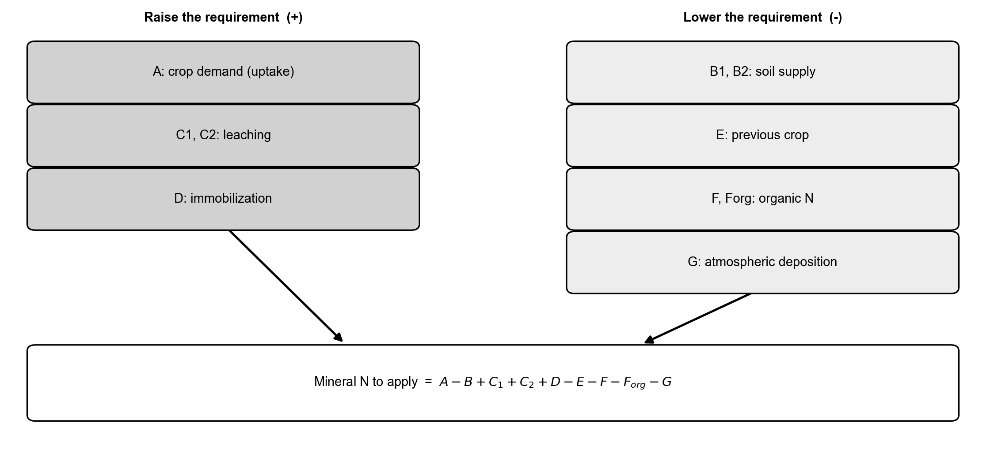
Conceptual scheme of the crop nitrogen balance. The terms that raise the requirement (crop demand A, leaching C, immobilization D) and those that lower it (soil supply B, previous crop E, organic contributions F and Forg, natural deposition G) combine into the residual mineral N to apply.

Soil-test and standard-dose methods
Soil-test methods set the dose from analytical soil values interpreted against calibrated response classes, often simplified into standard-dose schemes with documented decrements and increments. Open soil-test databases such as FRST have improved the transparency of the underlying calibrations (Lyons et al. 2020). The approach rests on a three-step framework, the correlation of a routine extractant index with crop response, its calibration against field trials and the resulting recommendation, formalised for extension practice by Dahnke and Olson (Dahnke and Olson 1990; Fixen and Grove 1990). Central to it is the critical soil-test value separating responsive from non-responsive sites, classically delineated by the Cate and Nelson partitioning of relative-yield data (Cate and Nelson 1971; Mallarino and Blackmer 1992), above which little fertiliser response is expected. How a recommendation is built around that value reflects two competing philosophies: a sufficiency, maximum-economic-return approach that supplies only the minimum nutrient needed in the current season, versus a build-up-and-maintenance strategy that raises and then sustains soil reserves above the critical level (Olson et al. 1987). Standard-dose, response-class schemes are operationally simple and cheap to deploy at scale, but their reliance on a few soil-test categories and regionally fixed coefficients limits site-specificity, and the resulting recommendations vary markedly across institutions for nominally identical soil-test values (Lyons et al. 2023).

Crop-growth and process models
Mechanistic crop models (for example DSSAT, APSIM and STICS) simulate nitrogen uptake and loss dynamically by coupling soil water and nitrogen balances to phenology- and radiation-driven crop growth on a daily time step (Jones et al. 2003; Keating et al. 2003; Brisson et al. 2003), and successive releases have broadened their process coverage and modularity (Holzworth et al. 2014). In principle they produce site- and season-specific recommendations; in the scoping review they account for about one fifth of the systems, with limited use of spatialized data (Corti et al. 2022). Because they resolve the interacting dynamics of mineralization, crop demand, weather and management, such models can be run across long climate records to derive economic-optimum nitrogen rates: Puntel and co-workers, for instance, used APSIM constrained by a sixteen-year Iowa experiment to estimate the economic optimum nitrogen rate for maize (Puntel et al. 2016). Their strength is process fidelity; their cost is parameterisation, weather data and computational weight, which limits operational uptake.

Sensor-based empirical methods
The most common family maps a canopy-reflectance signal to a nitrogen rate. The calibration-curve approach fits a relationship between an index and the rate from on-farm reference strips and applies it pixel-wise (Figure 2a), while the sufficiency-index approach of Holland and Schepers lowers the rate as the index approaches an N-rich reference strip (Figure 2b) (Holland and Schepers 2010). Active canopy sensors such as the GreenSeeker underpin many in-season tools, the in-season estimate of yield (INSEY) translating mid-season NDVI into a variable nitrogen recommendation for cereals (Raun et al. 2002). NDVI is the historical default but saturates once the canopy closes and the leaf area index exceeds about 3 to 4, precisely at the side-dressing stages, so its sensitivity to additional biomass and nitrogen is lost (Mutanga and Skidmore 2004). Indices that exploit the red-edge region remain responsive to chlorophyll and canopy nitrogen at high leaf area index: the red-edge chlorophyll index provides a near-linear, species-transferable estimator of canopy chlorophyll and nitrogen in maize, soybean and grass canopies (Gitelson et al. 2005; Clevers and Gitelson 2013), and red-edge indices from active sensors outperform broadband red-NIR indices for diagnosing the nitrogen nutrition index across growth stages (Cao et al. 2013). These methods resolve within-field variability and respond to the season, but a reflectance index is a proxy and, on its own, sets no field-level ceiling.
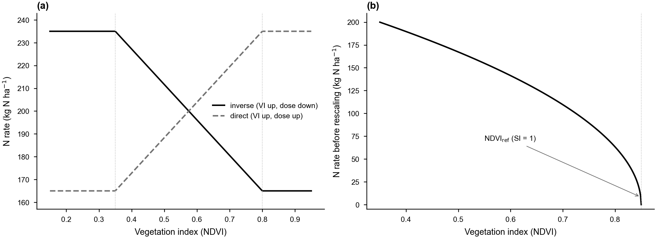
Response functions of the variable-rate methods. (a) Calibration ramp mapping the vegetation index to the nitrogen rate, inverse and direct forms, clipped to the dose envelope. (b) Holland and Schepers: the rate decreases as the NDVI approaches the N-rich reference strip (sufficiency index SI = 1). The per-strip rates are rescaled so the field mean matches the balance target.

Critical-N dilution and the Nitrogen Nutrition Index
The Nitrogen Nutrition Index (NNI) moves from a spectral proxy to a biomass-normalised diagnosis. It is the ratio of actual to critical nitrogen concentration along the species-specific critical-N dilution curve Nc = a W^(-b) (Lemaire and Gastal 1997), with values below 0.90 indicating deficiency, 0.90 to 1.10 optimal status and above 1.10 luxury consumption (Figure 3) (Houlès et al. 2007). The curve coefficients are well established for the main crops, derived from dedicated N-fertilization experiments that isolate the critical concentration as the minimum shoot nitrogen sustaining maximum biomass at a given dry matter; species-specific parameters are available for winter wheat (Justes et al. 1994), maize (Plénet and Lemaire 1999), winter oilseed rape (Colnenne et al. 1998), tropical rice (Sheehy et al. 1998), grain sorghum (Oosterom et al. 2001) and sunflower (Debaeke et al. 2012), the differing exponents reflecting contrasting dry-matter partitioning among crops. The NNI is interpretable and physiologically grounded, but it requires biomass and plant nitrogen concentration, which are not routinely measured and must be retrieved (Section 2.6); recent reviews discuss its estimation from remote sensing (Silva et al. 2023).
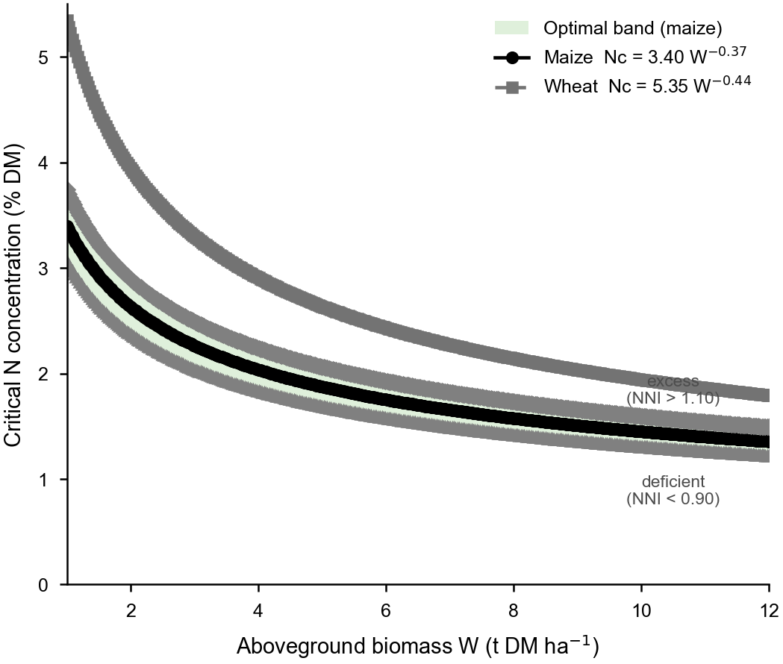
Critical-nitrogen dilution curves for maize and wheat on a biomass versus N-concentration plane. The shaded band (0.90 to 1.10 times Nc, shown for maize) is the optimal NNI zone; points above it are in luxury consumption and points below are deficient.

Biophysical retrieval as the bridge from reflectance to NNI
Retrieving canopy biophysical variables (leaf area index, dry-matter and water content, chlorophyll, canopy nitrogen) from multispectral imagery closes the gap between reflectance and the NNI. Hybrid approaches that train machine-learning regressors on radiative-transfer (PROSAIL) simulations, in particular Gaussian-process regression, have become a standard (Estévez et al. 2022). Such schemes invert the coupled PROSPECT and SAIL leaf-canopy model, the de facto standard for simulating vegetation reflectance (Jacquemoud et al. 2009), and have come to dominate the retrieval literature because they combine the physical generality of radiative transfer with the speed and flexibility of nonparametric regression (Verrelst et al. 2015, 2019). Methodological reviews report that kernel-based regressors trained on radiative-transfer look-up tables yield accurate, transferable estimates of leaf area index, canopy chlorophyll and nitrogen with pixel-wise uncertainty, and that such workflows are now the leading route to canopy nitrogen retrieval ahead of the forthcoming imaging-spectroscopy missions (Verrelst et al. 2019; Berger et al. 2020; Weiss et al. 2020). These retrievals provide the biomass and nitrogen layers the NNI needs, but they inherit calibration sensitivities (Section 7).

Machine-learning approaches
Purely data-driven models predict nitrogen status or the recommended rate from large labelled datasets, using algorithms ranging from random forests and support-vector machines to deep neural networks (Chlingaryan et al. 2018; Liakos et al. 2018); they are still a small minority of systems (Corti et al. 2022). Applied implementations have diagnosed in-season nitrogen status and prescribed side-dress rates for maize from canopy-sensor data (Wang et al. 2021), and convolutional neural networks have been trained on on-farm experiments to model the spatial yield response to nitrogen (Barbosa et al. 2020). They can capture complex, non-linear interactions but are data-hungry, prone to out-of-domain overfitting and opaque, and they do not by themselves enforce a regulatory ceiling.

Integration: from the field budget to the variable-rate prescription
The families above are usually treated as alternatives, but they answer different questions: the balance answers how much nitrogen the field may receive, the sensor answers where within the field it should go. They can be unified by a single mass-balance constraint. For a raster of n equal-area pixels, the per-pixel rates are required to average to the field target N* set by the balance, subject to user-defined minimum and maximum bounds, so the spatial redistribution changes where fertilizer is delivered, never how much overall. Under this constraint a sensor-driven map remains compliant with the Nitrate Vulnerable Zone ceiling (European Council 1991) and with crop-specific maximum doses (Regione Emilia-Romagna 2024) whenever these are respected at the balance stage. Figure 4 shows this integrated pipeline.
This coupling supports two complementary use cases. At the pre-sowing stage the balance is computed with uniform field inputs and split into organic and mineral applications; when an index raster becomes available in-season, the residual mineral share is redistributed without altering the field total. At the post-season stage the spatial pattern of the index, and its correlation with soil or organic-history maps, provides a cell-level diagnostic of which balance terms deserve refinement for the following season, closing a feedback loop. To our knowledge this round-trip between a regulation-compliant balance and an index-driven prescription under a shared invariant is rarely implemented in open software, which motivates the gap discussed next.
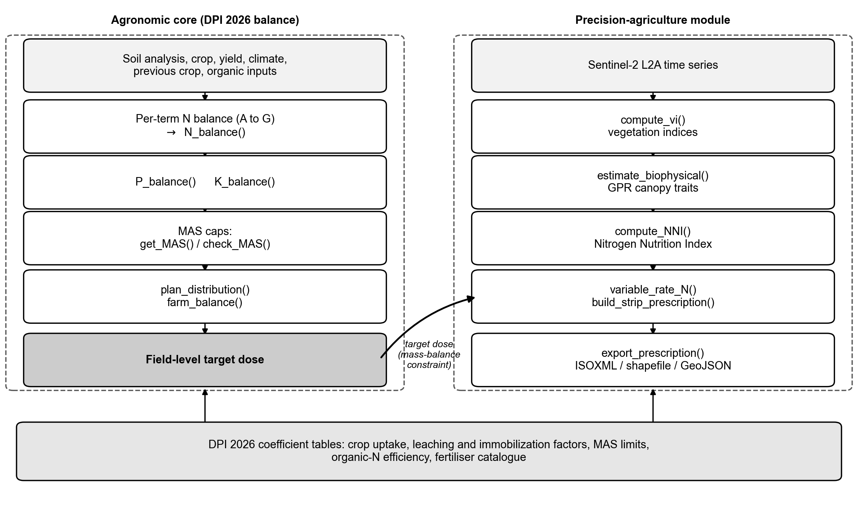
An integrated pipeline. The agronomic core composes the per-term balance into a field-level target dose, applies the regulatory limits and the distribution plan, and feeds the target, under the mass-balance constraint, to the precision module, which derives vegetation indices and canopy traits, the Nitrogen Nutrition Index, variable-rate prescriptions and machine-ready exports.

The reproducibility and openness gap
Two structural problems limit the methods above. First, the regulatory balance methods that set the admissible dose are typically distributed as closed, region-specific spreadsheets: they are widely used by advisors but are hard to version, unsuited to batch analysis and difficult to couple with spatial data, which impedes replication and cross-region transfer (Seibold et al. 2021). Second, the remote-sensing methods that resolve variability are frequently delivered through proprietary platforms, so the algorithm and its parameters are not inspectable. The consequence is that the two halves of an integrated recommendation, the legally defensible ceiling and the spatial pattern, rarely live in the same open, reproducible workflow. The FAIR Guiding Principles, that data and computational resources be Findable, Accessible, Interoperable and Reusable, have become the de facto standard for research-data stewardship (Wilkinson et al. 2016), and have been extended explicitly to research software, of which the coefficient tables and lookup rules embedded in a fertilization tool are an integral part (Barker et al. 2022). Within agricultural-systems modelling the same logic underpins calls for an open, community-curated and interoperable generation of data, models and tools, since fragmented, closed implementations impede component re-use and the reproducibility of model-based recommendations (Janssen et al. 2017). These concerns echo the broader open-science movement, which reframes data and code as objects of stewardship rather than ownership and treats versioned, inspectable pipelines as a precondition for computational reproducibility (Hampton et al. 2015; Powers and Hampton 2019). Closed regional fertilization spreadsheets, whose embedded coefficients cannot be inspected, cited or version-controlled, are squarely at odds with these principles; recasting them as openly licensed, versioned packages with editable, machine-readable coefficient tables directly operationalizes FAIR and open-science requirements for agronomic decision support.

An open, integrated implementation and a real case study
We illustrate the integrated framework with NFert, an open-source R package that implements every family of Section 2 except pure machine learning, under the shared mass-balance constraint of Section 3. The agronomic core computes the N, P and K balances and the standard-dose scheme, applies the maximum allowed doses and a combined organic-plus-mineral distribution plan, and produces a field-level target; the precision module computes vegetation indices, retrieves canopy traits by Gaussian-process regression, derives the NNI, and builds mass-balance-constrained variable-rate prescriptions with machine-ready export (Figure 4). All coefficient tables are exposed as editable R objects, so the same machinery can be repurposed for other guidelines, which directly addresses the openness gap of Section 4.

Case study: in-season diagnosis and prescription at CERZOO
We demonstrate the workflow on Field 3 of the CERZOO experimental farm of the Universita Cattolica del Sacro Cuore, in the Po Valley near Piacenza, a 3.24 ha silage maize plot on a clay-rich soil, with a Sentinel-2 Level-2A time series for the 2024 and 2025 seasons. For every acquisition the biophysical variables are retrieved and their field means interpolated over the season (Figure 5). The NNI is then derived from the maize critical-N curve and read against the leaf area index (Figure 6): within the two maize cycles, where leaf area is high, the canopy moves between deficiency, the optimal band and luxury consumption, whereas the off-season scatter and gaps fall where the canopy is absent and should be disregarded. This illustrates a practical caveat of the NNI family, that the diagnosis is only meaningful inside the phenological window.
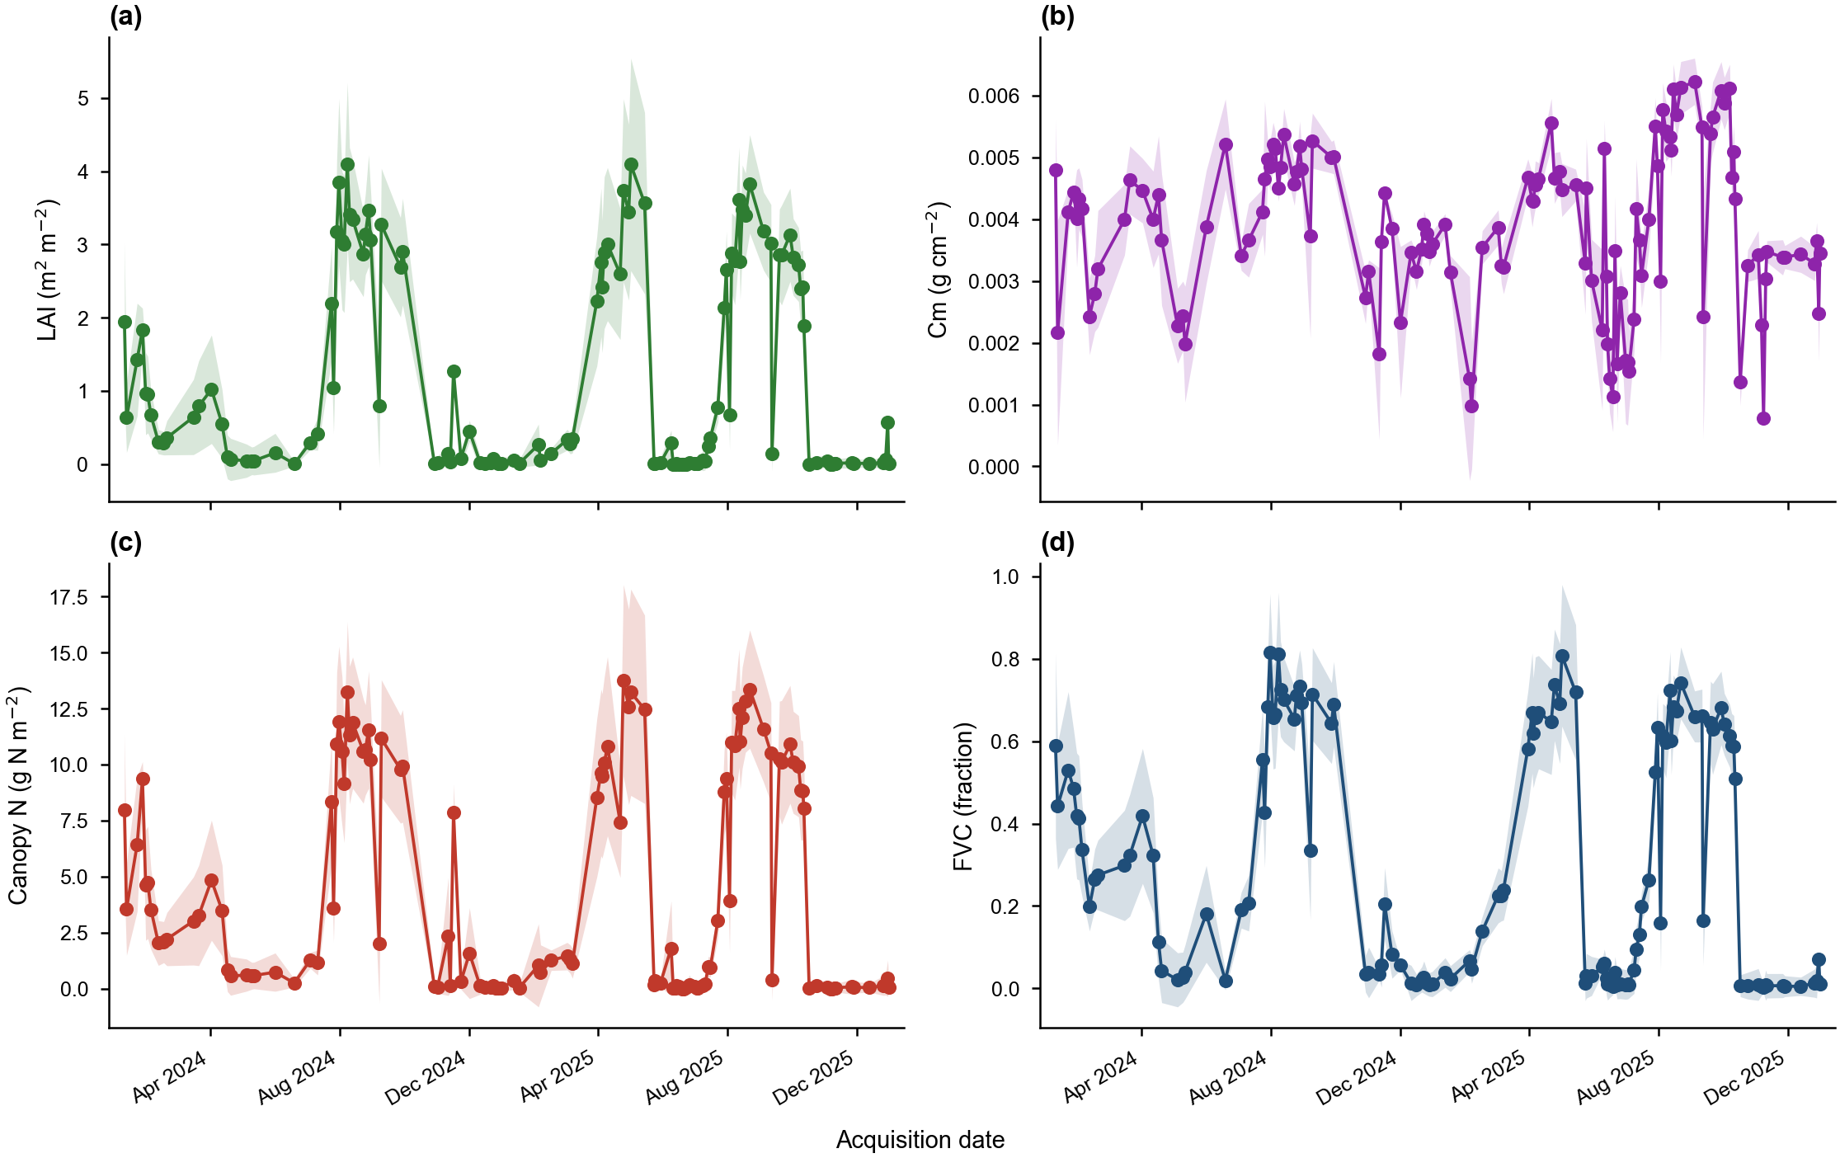
Field-mean seasonal trajectory of the canopy biophysical variables (LAI, Cm, canopy nitrogen content, FVC) for CERZOO Field 3. Points are the field mean plus or minus one standard deviation; lines are the spline interpolation.
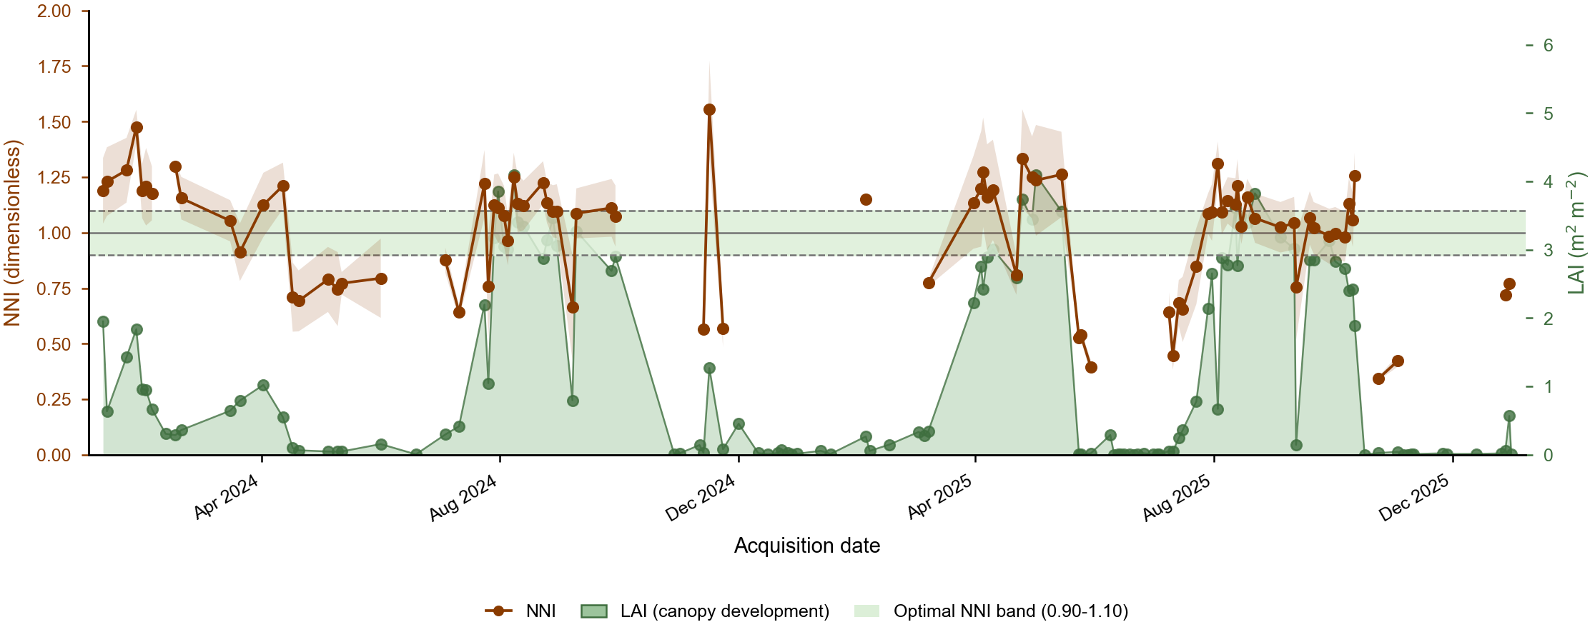
Seasonal Nitrogen Nutrition Index (left axis) for CERZOO Field 3 read against the leaf area index (right axis, green area). The shaded band marks the optimal range; the LAI peaks are the maize cycles in which the NNI is reliable, while the off-season scatter and gaps correspond to low LAI.
The same scene drives the prescription. Each variability method is a response function mapping the per-strip index, or the NNI zone, to a rate (Figure 2); the field is tiled into strips, the mean index of each strip is run through the chosen response, and the map is rescaled so its area-weighted mean equals the 200 kg N per hectare target. All methods reproduce that target (Table B, Section 6) but differ markedly in within-field contrast: quantile classes spread the dose most widely (standard deviation 24.6 kg per hectare), the NNI-zone method concentrates variation where the diagnosis flags deficiency (19.8), and the direct NDVI ramp is the most conservative (4.8). The choice of method is thus an explicit agronomic decision about how much, and on what evidence, to vary nitrogen, made reproducible (Figure 7).
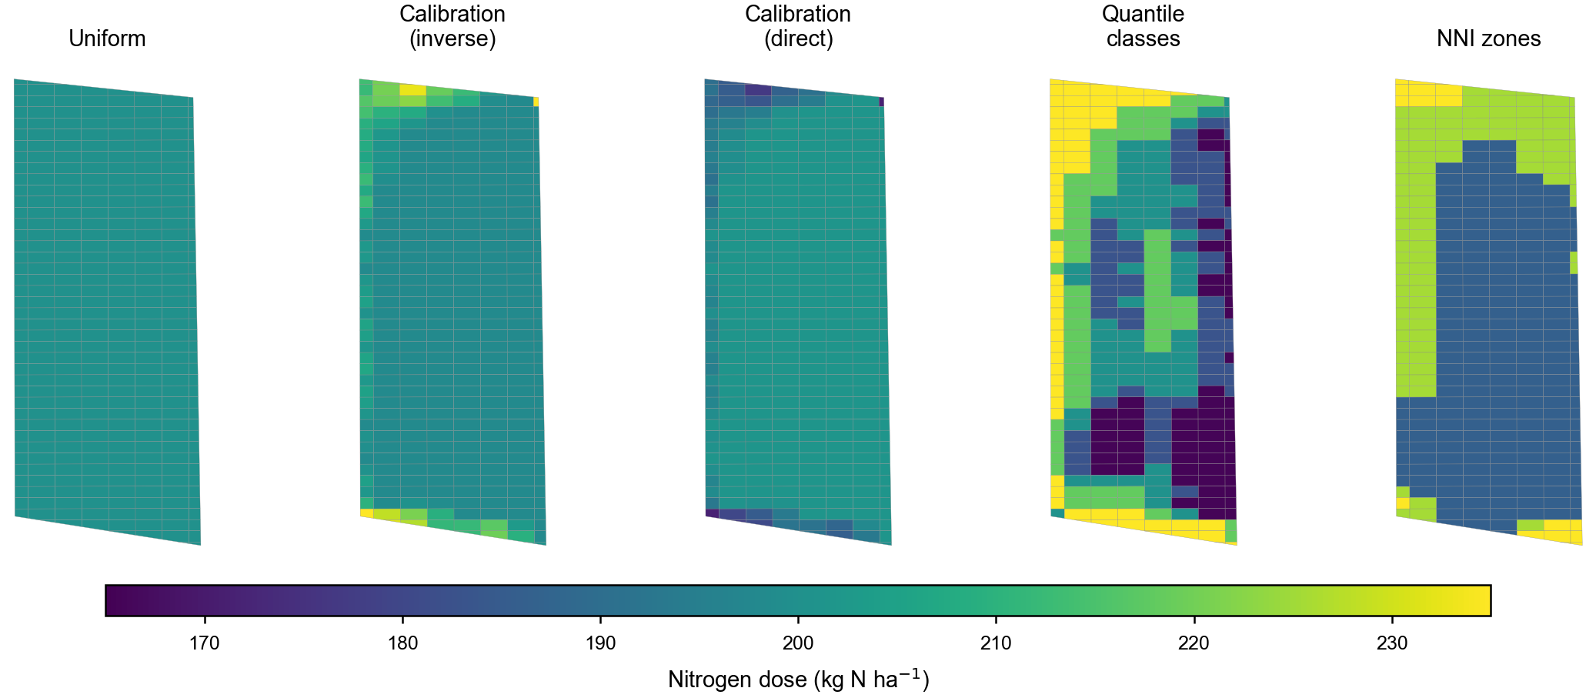
Variable-rate prescriptions for CERZOO Field 3 under the methods of Table B, each constrained to the same field-mean dose of 200 kg N per hectare.

Comparative discussion

Method families across operational dimensions
Table A places the families of Section 2 against the dimensions that decide their practical use. No single family is universally preferable; the right choice depends on the operational constraints of the decision. Regulatory mass-balance and soil-test or standard-dose schemes are the cheapest and most reproducible to deploy at regional scale and map directly onto compliance frameworks, but they rely on a few soil-test categories and regionally fixed coefficients that limit site-specificity and produce recommendations that vary across institutions for identical soil-test values (Dahnke and Olson 1990; Cate and Nelson 1971; Lyons et al. 2023). Mechanistic crop models (DSSAT, APSIM, STICS) offer the highest process fidelity and can derive site- and season-specific rates across long climate records, at the cost of heavy parameterisation, weather data and computational weight that constrain routine field use (Jones et al. 2003; Keating et al. 2003; Brisson et al. 2003; Puntel et al. 2016). Sensor-empirical algorithms and the NNI or critical-N framework occupy the in-season, high-resolution niche: active-canopy and red-edge indices diagnose nitrogen status non-destructively at fine resolution and suit variable-rate topdressing, though NDVI saturates in closed canopies and the underlying critical-N curves remain crop-specific (Raun et al. 2002; Cao et al. 2013; Justes et al. 1994; Plénet and Lemaire 1999; Debaeke et al. 2012). Biophysical, PROSAIL-based hybrid retrieval bridges reflectance to NNI inputs with physically generalisable, transferable estimates of canopy chlorophyll and nitrogen plus pixel-wise uncertainty, making it the most defensible route for satellite-scale, reproducible monitoring, whereas purely machine-learning models capture complex non-linear interactions and can prescribe rates directly but are data-hungry, prone to out-of-domain overfitting and comparatively opaque (Jacquemoud et al. 2009; Verrelst et al. 2019; Berger et al. 2020; Chlingaryan et al. 2018; Barbosa et al. 2020). In practice current operational systems remain dominated by empirical vegetation-index logic, with mechanistic and machine-learning approaches still marginal, so the pragmatic recommendation is to match the method to data availability, required spatial resolution, decision timing, regulatory fit and the openness needed for independent reproducibility rather than to seek one dominant family (Corti et al. 2022; Silva et al. 2023).
Families of nitrogen recommendation methods across operational dimensions (qualitative; to be completed with cited evidence).
Family | Data required | Spatial res. | Timing | Regulatory fit | Openness / reproducibility
Regulatory balance | soil analysis, crop, climate, history | field | pre-sowing | high (by design) | usually closed spreadsheets
Soil-test / standard dose | soil test, crop | field | pre-sowing | high | mostly closed
Crop-growth models | weather, soil, management | field / zone | pre and in-season | medium | open models exist, heavy
Sensor-based empirical | canopy imagery, reference | pixel / zone | in-season | needs a ceiling | mixed; often closed
NNI / critical-N | biomass, plant N (or proxies) | plot / pixel | in-season | diagnostic | conceptual; few open tools
Biophysical retrieval | multispectral imagery | pixel | in-season | input to NNI | research code, often Python
Machine learning | large labelled data | pixel / zone | in-season | opaque | varies

Evidence on variable-rate effectiveness
Whether variable-rate, sensor-driven nitrogen management actually outperforms uniform application remains the central, unresolved question of the precision-N literature, and the evidence is decidedly mixed. Individual field trials are frequently encouraging: site-specific application guided by canopy sensing or low-altitude remote sensing has reduced nitrogen inputs while maintaining or modestly improving yield, nitrogen use efficiency and gross margin in winter wheat (Stamatiadis et al. 2018; Argento et al. 2021), and a field-plus-modelling study in a nitrate-vulnerable zone reported concurrent economic gains and reductions in nitrate leaching relative to uniform rates (Basso et al. 2016). Reviews are more guarded. Diacono and co-workers concluded that, although variable-rate nitrogen can raise the agronomic efficiency of applied nitrogen, yield responses across studies are inconsistent and strongly site- and season-dependent (Diacono et al. 2013). The most pointed critique comes from a synthesis of grain-crop trials, which found that most studies achieved nitrogen savings of roughly 5 to 45 per cent with little effect on grain yield, yet impacts on profit typically ranged from losses of about US$30 per hectare to gains of US$70 per hectare, with around a quarter of studies reporting outright economic losses; the authors attributed the slow uptake of crop sensors to this lack of consistent, demonstrable benefit (Colaço and Bramley 2018). Taken together, the literature supports cautious optimism that variable-rate nitrogen can improve nitrogen efficiency and reduce environmental surplus, but it does not justify a blanket claim of yield or profitability gains over well-managed uniform application: realised benefits hinge on the magnitude of within-field variability, the fidelity of the sensor-to-rate algorithm, and local pedoclimatic and economic conditions.
Per-strip nitrogen dose (kg N per hectare) for the CERZOO case study under each prescription method (328 strips), all constrained to the same field-mean target.
Prescription method | Min | Mean | Max | SD
Uniform | 200.0 | 200.0 | 200.0 | 0.0
NDVI calibration, inverse | 198.1 | 200.7 | 235.0 | 6.5
NDVI calibration, direct | 171.4 | 199.5 | 201.4 | 4.8
NDVI quantile classes (5) | 165.6 | 200.7 | 235.0 | 24.6
NNI zones (3) | 186.2 | 201.0 | 235.0 | 19.8

Research gaps and outlook
Several gaps limit the operational integration argued here. Calibration transfer is the first: the locally sensitive parameters of the biophysical-to-NNI step (the leaf-allocation coefficient and the canopy nitrogen-to-chlorophyll ratio) introduce biases of 15 to 30 percent when adopted without local verification (Houlès et al. 2007), and the critical-N curve coefficients, although well established, are species- and sometimes cultivar-specific. Second, operational NNI retrieval is constrained by cloud cover, satellite revisit and the need to acquire inside the phenological window, as the CERZOO series makes visible. Third, independent validation of variable-rate recommendations against yield and environmental outcomes, and their economics, remains thin: sensor-based application reliably saves 5 to 45 per cent of nitrogen with little yield penalty, but its profitability is inconsistent and farm-scale economic gains are typically small, which is widely held to explain the slow grower uptake of precision nitrogen technologies (Colaço and Bramley 2018; Schimmelpfennig 2016; Robertson et al. 2012; Lowenberg-DeBoer and Erickson 2019). Finally, the families could be combined further: coupling balance methods with crop models or machine learning, extending the constraint to phosphorus and potassium, and moving from single-season to multi-year planning.

Conclusions
Nitrogen recommendation for precision agriculture is served by several method families that are usually treated as competitors but in fact answer complementary questions. We have argued that a single field-level mass-balance constraint unifies the regulation-compliant budget produced by balance methods with the within-field pattern produced by sensor-based and NNI methods, and that the main obstacle to this integration in practice is not conceptual but infrastructural: the methods live in closed, disconnected tools. An open, reproducible implementation that exposes every coefficient as an editable object, demonstrated here on a real maize field, shows that the integrated framework is feasible today. The remaining work is in calibration transfer, operational retrieval, independent validation and economics, and in extending the same constraint across nutrients and seasons.

Declaration of competing interest
The authors declare that they have no known competing financial interests or personal relationships that could have appeared to influence the work reported in this paper.

Funding
This work was supported by the EOAGRITWIN project.

Acknowledgements
The authors thank the Servizio Agricoltura Sostenibile of Regione Emilia-Romagna for publishing the DPI 2026 guidelines and the FertDPI reference tool, and the CERZOO experimental farm for the field data.

References
Argento, F., T. Anken, F. Abt, E. Vogelsanger, A. Walter, and F. Liebisch. 2021. “Site-Specific Nitrogen Management in Winter Wheat Supported by Low-Altitude Remote Sensing and Soil Data.” Precision Agriculture 22 (2): 364–86. https://doi.org/10.1007/s11119-020-09733-3.
Barbosa, Alexandre, Rodrigo Trevisan, Naira Hovakimyan, and Nicolas F. Martin. 2020. “Modeling Yield Response to Crop Management Using Convolutional Neural Networks.” Computers and Electronics in Agriculture 170: 105197. https://doi.org/10.1016/j.compag.2019.105197.
Barker, Michelle, Neil P. Chue Hong, Daniel S. Katz, et al. 2022. “Introducing the FAIR Principles for Research Software.” Scientific Data 9 (1): 622. https://doi.org/10.1038/s41597-022-01710-x.
Basso, Bruno, Benjamin Dumont, Davide Cammarano, Andrea Pezzuolo, Francesco Marinello, and Luigi Sartori. 2016. “Environmental and Economic Benefits of Variable Rate Nitrogen Fertilization in a Nitrate Vulnerable Zone.” Science of The Total Environment 545–546: 227–35. https://doi.org/10.1016/j.scitotenv.2015.12.104.
Berger, Katja, Jochem Verrelst, Jean-Baptiste Féret, et al. 2020. “Crop Nitrogen Monitoring: Recent Progress and Principal Developments in the Context of Imaging Spectroscopy Missions.” Remote Sensing of Environment 242: 111758. https://doi.org/10.1016/j.rse.2020.111758.
Brisson, N., C. Gary, E. Justes, et al. 2003. “An Overview of the Crop Model STICS.” European Journal of Agronomy 18 (3-4): 309–32. https://doi.org/10.1016/S1161-0301(02)00110-7.
Cao, Qiang, Yuxin Miao, Hongye Wang, et al. 2013. “Non-Destructive Estimation of Rice Plant Nitrogen Status with Crop Circle Multispectral Active Canopy Sensor.” Field Crops Research 154: 133–44. https://doi.org/10.1016/j.fcr.2013.08.005.
Cate, Robert B., and Larry A. Nelson. 1971. “A Simple Statistical Procedure for Partitioning Soil Test Correlation Data into Two Classes.” Soil Science Society of America Journal 35: 658–60. https://doi.org/10.2136/sssaj1971.03615995003500040048x.
Chlingaryan, Anna, Salah Sukkarieh, and Brett Whelan. 2018. “Machine Learning Approaches for Crop Yield Prediction and Nitrogen Status Estimation in Precision Agriculture: A Review.” Computers and Electronics in Agriculture 151: 61–69. https://doi.org/10.1016/j.compag.2018.05.012.
Clevers, J. G. P. W., and A. A. Gitelson. 2013. “Remote Estimation of Crop and Grass Chlorophyll and Nitrogen Content Using Red-Edge Bands on Sentinel-2 and -3.” International Journal of Applied Earth Observation and Geoinformation 23: 344–51. https://doi.org/10.1016/j.jag.2012.10.008.
Colaço, A. F., and R. G. V. Bramley. 2018. “Do Crop Sensors Promote Improved Nitrogen Management in Grain Crops?” Field Crops Research 218: 126–40. https://doi.org/10.1016/j.fcr.2018.01.007.
Colnenne, C., J. M. Meynard, R. Reau, E. Justes, and A. Merrien. 1998. “Determination of a Critical Nitrogen Dilution Curve for Winter Oilseed Rape.” Annals of Botany 81 (2): 311–17. https://doi.org/10.1006/anbo.1997.0557.
Corti, Martina, Virginia Fassa, and Luca Bechini. 2022. “A Scoping Review of Side-Dress Nitrogen Recommendation Systems and Their Perspectives in Precision Agriculture.” Italian Journal of Agronomy 17 (1): 1951. https://doi.org/10.4081/ija.2021.1951.
Dahnke, W. C., and R. A. Olson. 1990. “Soil Test Correlation, Calibration, and Recommendation.” Chap. 4 in Soil Testing and Plant Analysis, 3rd ed. SSSA Book Series 3. Soil Science Society of America. https://doi.org/10.2136/sssabookser3.3ed.c4.
Debaeke, P., E. J. van Oosterom, E. Justes, et al. 2012. “A Species-Specific Critical Nitrogen Dilution Curve for Sunflower (Helianthus Annuus l.).” Field Crops Research 136: 76–84. https://doi.org/10.1016/j.fcr.2012.07.024.
Diacono, Mariangela, Pietro Rubino, and Francesco Montemurro. 2013. “Precision Nitrogen Management of Wheat. A Review.” Agronomy for Sustainable Development 33: 219–41. https://doi.org/10.1007/s13593-012-0111-z.
Estévez, Jochem, Matias Salinero-Delgado, Katja Berger, et al. 2022. “Gaussian Processes Retrieval of Crop Traits in Google Earth Engine Based on Sentinel-2 Top-of-Atmosphere Data.” Remote Sensing of Environment 273: 112958. https://doi.org/10.1016/j.rse.2022.112958.
European Council. 1991. Council Directive 91/676/EEC of 12 December 1991 Concerning the Protection of Waters Against Pollution Caused by Nitrates from Agricultural Sources. Official Journal of the European Communities L375:1–8.
Fixen, P. E., and J. H. Grove. 1990. “Testing Soils for Phosphorus.” Chap. 7 in Soil Testing and Plant Analysis, 3rd ed. SSSA Book Series 3. Soil Science Society of America. https://doi.org/10.2136/sssabookser3.3ed.c7.
Gitelson, Anatoly A., Andrés Viña, Verónica Ciganda, Donald C. Rundquist, and Timothy J. Arkebauer. 2005. “Remote Estimation of Canopy Chlorophyll Content in Crops.” Geophysical Research Letters 32 (8): L08403. https://doi.org/10.1029/2005GL022688.
Grinsven, H. J. M. van, H. F. M. ten Berge, T. Dalgaard, et al. 2012. “Management, Regulation and Environmental Impacts of Nitrogen Fertilization in Northwestern Europe Under the Nitrates Directive; a Benchmark Study.” Biogeosciences 9 (12): 5143–60. https://doi.org/10.5194/bg-9-5143-2012.
Hampton, Stephanie E., Sean S. Anderson, Sarah C. Bagby, et al. 2015. “The Tao of Open Science for Ecology.” Ecosphere 6 (7): art120. https://doi.org/10.1890/ES14-00402.1.
Holland, Kyle H., and James S. Schepers. 2010. “Derivation of a Variable Rate Nitrogen Application Model for in-Season Fertilization of Corn.” Agronomy Journal 102 (5): 1415–24. https://doi.org/10.2134/agronj2010.0015.
Holzworth, Dean P., Neil I. Huth, Peter G. deVoil, et al. 2014. “APSIM – Evolution Towards a New Generation of Agricultural Systems Simulation.” Environmental Modelling & Software 62: 327–50. https://doi.org/10.1016/j.envsoft.2014.07.009.
Houlès, Vianney, Martine Guérif, and Bruno Mary. 2007. “Elaboration of a Nitrogen Nutrition Indicator for Winter Wheat Based on Leaf Area Index and Chlorophyll Content for Making Nitrogen Recommendations.” European Journal of Agronomy 27: 1–11. https://doi.org/10.1016/j.eja.2006.10.001.
Jacquemoud, Stéphane, Wout Verhoef, Frédéric Baret, et al. 2009. “PROSPECT+SAIL Models: A Review of Use for Vegetation Characterization.” Remote Sensing of Environment 113: S56–66. https://doi.org/10.1016/j.rse.2008.01.026.
Janssen, Sander J. C., Cheryl H. Porter, Andrew D. Moore, et al. 2017. “Towards a New Generation of Agricultural System Data, Models and Knowledge Products: Information and Communication Technology.” Agricultural Systems 155: 200–212. https://doi.org/10.1016/j.agsy.2016.09.017.
Jones, J. W., G. Hoogenboom, C. H. Porter, et al. 2003. “The DSSAT Cropping System Model.” European Journal of Agronomy 18 (3-4): 235–65. https://doi.org/10.1016/S1161-0301(02)00107-7.
Justes, E., B. Mary, J.-M. Meynard, J. M. Machet, and L. Huché-Thélier. 1994. “Determination of a Critical Nitrogen Dilution Curve for Winter Wheat Crops.” Annals of Botany 74 (4): 397–407. https://doi.org/10.1006/anbo.1994.1133.
Keating, B. A., P. S. Carberry, G. L. Hammer, et al. 2003. “An Overview of APSIM, a Model Designed for Farming Systems Simulation.” European Journal of Agronomy 18 (3-4): 267–88. https://doi.org/10.1016/S1161-0301(02)00108-9.
Lemaire, Gilles, and François Gastal. 1997. “N Uptake and Distribution in Plant Canopies.” In Diagnosis of the Nitrogen Status in Crops, edited by Gilles Lemaire. Springer-Verlag. https://doi.org/10.1007/978-3-642-60684-7_1.
Liakos, Konstantinos G., Patrizia Busato, Dimitrios Moshou, Simon Pearson, and Dionysis Bochtis. 2018. “Machine Learning in Agriculture: A Review.” Sensors 18 (8): 2674. https://doi.org/10.3390/s18082674.
Lowenberg-DeBoer, James, and Bruce Erickson. 2019. “Setting the Record Straight on Precision Agriculture Adoption.” Agronomy Journal 111 (4): 1552–69. https://doi.org/10.2134/agronj2018.12.0779.
Lyons, Sarah E., Jason D. Clark, Deanna L. Osmond, et al. 2023. “Current Status of US Soil Test Phosphorus and Potassium Recommendations and Analytical Methods.” Soil Science Society of America Journal 87 (4): 985–98. https://doi.org/10.1002/saj2.20536.
Lyons, Sarah E., Deanna L. Osmond, Nathan A. Slaton, et al. 2020. “FRST: A National Soil Testing Database to Improve Fertility Recommendations.” Agricultural & Environmental Letters 5: e20008. https://doi.org/10.1002/ael2.20008.
Mallarino, A. P., and A. M. Blackmer. 1992. “Comparison of Methods for Determining Critical Concentrations of Soil Test Phosphorus for Corn.” Agronomy Journal 84 (5): 850–56. https://doi.org/10.2134/agronj1992.00021962008400050017x.
Musacchio, Arianna, Viviana Re, Josep Mas-Pla, and Elisa Sacchi. 2020. “EU Nitrates Directive, from Theory to Practice: Environmental Effectiveness and Influence of Regional Governance on Its Performance.” Ambio 49 (2): 504–16. https://doi.org/10.1007/s13280-019-01197-8.
Mutanga, O., and A. K. Skidmore. 2004. “Narrow Band Vegetation Indices Overcome the Saturation Problem in Biomass Estimation.” International Journal of Remote Sensing 25 (19): 3999–4014. https://doi.org/10.1080/01431160310001654923.
Oenema, Oene, Hans Kros, and Wim de Vries. 2003. “Approaches and Uncertainties in Nutrient Budgets: Implications for Nutrient Management and Environmental Policies.” European Journal of Agronomy 20: 3–16. https://doi.org/10.1016/S1161-0301(03)00067-4.
Olson, R. A., F. N. Anderson, K. D. Frank, P. H. Grabouski, G. W. Rehm, and C. A. Shapiro. 1987. “Soil Testing Interpretations: Sufficiency Vs. Build-up and Maintenance.” Chap. 5 in Soil Testing: Sampling, Correlation, Calibration, and Interpretation. SSSA Special Publication 21. Soil Science Society of America. https://doi.org/10.2136/sssaspecpub21.c5.
Oosterom, E. J. van, P. S. Carberry, and R. C. Muchow. 2001. “Critical and Minimum n Contents for Development and Growth of Grain Sorghum.” Field Crops Research 70 (1): 55–73. https://doi.org/10.1016/S0378-4290(00)00152-0.
Plénet, D., and G. Lemaire. 1999. “Relationships Between Dynamics of Nitrogen Uptake and Dry Matter Accumulation in Maize Crops. Determination of Critical n Concentration.” Plant and Soil 216 (1–2): 65–82. https://doi.org/10.1023/A:1004783431055.
Powers, Stephen M., and Stephanie E. Hampton. 2019. “Open Science, Reproducibility, and Transparency in Ecology.” Ecological Applications 29 (1): e01822. https://doi.org/10.1002/eap.1822.
Puntel, Laila A., John E. Sawyer, Daniel W. Barker, et al. 2016. “Modeling Long-Term Corn Yield Response to Nitrogen Rate and Crop Rotation.” Frontiers in Plant Science 7: 1630. https://doi.org/10.3389/fpls.2016.01630.
Raun, William R., John B. Solie, Gordon V. Johnson, et al. 2002. “Improving Nitrogen Use Efficiency in Cereal Grain Production with Optical Sensing and Variable Rate Application.” Agronomy Journal 94 (4): 815–20. https://doi.org/10.2134/agronj2002.8150.
Regione Emilia-Romagna. 2024. Regolamento Regionale Emilia-Romagna 2/2024: Massimali Di Apporto Di Azoto (MAS). Bologna, Italy.
Regione Emilia-Romagna. 2026a. Disciplinari Di Produzione Integrata (DPI): Norme Generali, Allegato 2 (Metodo Del Bilancio Dell’azoto), Edizione 2026. Regione Emilia-Romagna, Servizio Agricoltura Sostenibile.
Regione Emilia-Romagna. 2026b. Guida Alla Fertilizzazione Minerale e Organica: Azoto, Fosforo, Potassio. Regione Emilia-Romagna.
Robertson, M. J., R. S. Llewellyn, R. Mandel, et al. 2012. “Adoption of Variable Rate Fertiliser Application in the Australian Grains Industry: Status, Issues and Prospects.” Precision Agriculture 13 (2): 181–99. https://doi.org/10.1007/s11119-011-9236-3.
Schimmelpfennig, David. 2016. Farm Profits and Adoption of Precision Agriculture. Economic Research Report ERR-217. U.S. Department of Agriculture, Economic Research Service. https://doi.org/10.22004/ag.econ.249773.
Seibold, Heidi, Severin Czerny, Siona Decke, et al. 2021. “A Computational Reproducibility Study of PLOS ONE Articles Featuring Longitudinal Data Analyses.” PLOS ONE 16: e0251194. https://doi.org/10.1371/journal.pone.0251194.
Sheehy, J. E., M. J. A. Dionora, P. L. Mitchell, et al. 1998. “Critical Nitrogen Concentrations: Implications for High-Yielding Rice (Oryza Sativa l.) Cultivars in the Tropics.” Field Crops Research 59 (1): 31–41. https://doi.org/10.1016/S0378-4290(98)00105-1.
Silva, Luís, Luís Alcino Conceição, Fernando Cebola Lidon, and Benvindo Maçãs. 2023. “Remote Monitoring of Crop Nitrogen Nutrition to Adjust Crop Models: A Review.” Agriculture 13 (4): 835. https://doi.org/10.3390/agriculture13040835.
Stamatiadis, S., J. S. Schepers, E. Evangelou, et al. 2018. “Variable-Rate Nitrogen Fertilization of Winter Wheat Under High Spatial Resolution.” Precision Agriculture 19 (3): 570–87. https://doi.org/10.1007/s11119-017-9540-7.
Sutton, Mark A., Clare M. Howard, Jan Willem Erisman, et al., eds. 2011. The European Nitrogen Assessment: Sources, Effects and Policy Perspectives. Cambridge University Press. https://doi.org/10.1017/CBO9780511976988.
Velthof, G. L., J. P. Lesschen, J. Webb, et al. 2014. “The Impact of the Nitrates Directive on Nitrogen Emissions from Agriculture in the EU-27 During 2000–2008.” Science of the Total Environment 468–469: 1225–33. https://doi.org/10.1016/j.scitotenv.2013.04.058.
Verrelst, Jochem, Gustau Camps-Valls, Jordi Muñoz-Marí, et al. 2015. “Optical Remote Sensing and the Retrieval of Terrestrial Vegetation Bio-Geophysical Properties – a Review.” ISPRS Journal of Photogrammetry and Remote Sensing 108: 273–90. https://doi.org/10.1016/j.isprsjprs.2015.05.005.
Verrelst, Jochem, Zbyněk Malenovský, Christiaan Van der Tol, et al. 2019. “Quantifying Vegetation Biophysical Variables from Imaging Spectroscopy Data: A Review on Retrieval Methods.” Surveys in Geophysics 40 (3): 589–629. https://doi.org/10.1007/s10712-018-9478-y.
Wang, Xinbing, Yuxin Miao, Rui Dong, et al. 2021. “Machine Learning-Based in-Season Nitrogen Status Diagnosis and Side-Dress Nitrogen Recommendation for Corn.” European Journal of Agronomy 123: 126193. https://doi.org/10.1016/j.eja.2020.126193.
Weiss, Marie, Frédéric Jacob, and Grégory Duveiller. 2020. “Remote Sensing for Agricultural Applications: A Meta-Review.” Remote Sensing of Environment 236: 111402. https://doi.org/10.1016/j.rse.2019.111402.
Wilkinson, Mark D., Michel Dumontier, IJsbrand Jan Aalbersberg, et al. 2016. “The FAIR Guiding Principles for Scientific Data Management and Stewardship.” Scientific Data 3: 160018. https://doi.org/10.1038/sdata.2016.18.

