NFert: an open, uncertainty-aware nitrogen-balance tool from field variable-rate prescription to farm accounting

Highlights
- Open R tool runs the regulatory nitrogen balance from pixel to farm
- Cross-validated soil maps and their uncertainty give the prescription an uncertainty band
- The confidence in the nitrogen total depends on the soil-error correlation length
- Field and farm nitrogen accounting from one auditable computation
- A variance decomposition shows which soil property to sample more densely

Abstract
Precision nitrogen management must match supply to crop demand in space and time while respecting economic and regulatory limits, yet the operational tools that set the rate give a single deterministic number, at a single scale, in closed spreadsheets, and ignore the uncertainty of their soil inputs. We present NFert, an open-source R package (version 0.14.2, MIT license, versioned on GitHub with continuous integration and an archived release) that implements the Emilia-Romagna Integrated Production nitrogen balance (DPI 2026, Allegato 2), couples it under a single mass-balance constraint to a Sentinel-2 diagnosis of nitrogen status and to a variable-rate prescription, and runs the same balance from the pixel to the farm. Two features distinguish it from existing tools: it propagates the uncertainty of the soil inputs (texture, organic carbon, total nitrogen) through the balance by correlated Monte Carlo, and it reports the rate and its confidence at field and farm scale. On the CERZOO experimental farm (Po Valley, Italy: eight fields of silage maize (main and second crop) and soft wheat, about 32 ha), soil maps and their cross-validated estimation uncertainty give a variable-rate prescription with an uncertainty band and a per-crop decomposition of the soil sources of uncertainty, and the same computation produces the farm nitrogen total (6.6 t N) with its uncertainty. The confidence in that total depends on the spatial correlation length of the soil error, from about 0.9 percent under short-range error to about 4.0 percent under long-range error. NFert offers a transparent, uncertainty-aware, multi-scale alternative to closed tools, and, downstream of the cited soil input layer, the analysis is reproducible from the open code and the released rasters.
Keywords: variable-rate nitrogen; nutrient balance; uncertainty propagation; multi-scale nutrient accounting; Sentinel-2; reproducible research

1. Introduction
Fertilization is among the most consequential decisions in arable cropping, and the rate of nitrogen applied is the decision that most directly determines its outcome: the yield and quality achievable, the profitability of the operation, and the size of the nitrogen surplus lost to water and air (Oenema et al. 2003; Sutton et al. 2011). The rate is a constrained optimization in which agronomic, economic and regulatory objectives must be satisfied at once, and for nitrogen the regulatory ceiling is explicit: the European Nitrates Directive constrains application in vulnerable zones (European Council 1991), and regional integrated-production schemes translate it into an auditable field budget (Regione Emilia-Romagna 2026a).
The methods proposed to set the nitrogen rate form a small number of recurring families: regulatory or mass-balance budgets; soil-test and standard-dose schemes; crop-growth models; sensor-based empirical algorithms; biophysical diagnosis through the Nitrogen Nutrition Index; and, more recently, machine learning. A scoping review of side-dress recommendation systems found the empirical, vegetation-index-based family dominant, with mechanistic and machine-learning systems a minority (Corti et al. 2022). Here we take the families as given and address three gaps that a practical tool must close.
The first gap is integration. A reflectance index resolves within-field variability but sets no field-level ceiling, while a mass balance sets a defensible ceiling but no spatial pattern; the two are rarely coupled in one reproducible workflow, so a sensor-driven map and a compliant budget are seldom reconciled (Raun et al. 2002; Holland and Schepers 2010). The second gap is openness and reproducibility. The regulatory methods are typically locked in closed regional spreadsheets, and research code is fragmented and often not versioned or inspectable, which undermines replication and cross-region transfer (Seibold et al. 2021; Wilkinson et al. 2016). The third gap, less often made explicit, is that operational tools give a deterministic rate at a single scale: they ignore the uncertainty of their soil inputs, and they disconnect the field decision from the farm accounting that advisers and regulators need.
The closest precedent couples a mass balance to variable-rate nitrogen in a nitrate-vulnerable zone (Basso et al. 2016), but as a case study rather than an open, reusable tool, and without propagating the soil-input uncertainty or reporting across nested scales. Table 1 positions NFert against the families of nitrogen-rate tools along the dimensions a practical, auditable tool must satisfy: open and inspectable code, uncertainty-aware output, field-and-farm reporting, a regulatory-compliant budget, and a sensor-driven prescription in a machine-ready format.
Table 1. How NFert compares with the main families of nitrogen rate-setting tools. “Yes”, “partial” and “no” indicate whether a family typically provides each property.
Tool family | Open, inspectable | Uncertainty-aware | Field + farm | Compliant budget | Sensor VRT + export
Regional regulatory spreadsheet, e.g. Fert_Office (Regione Emilia-Romagna 2026b) | No | No | Partial | Yes | No
Sensor-based VRT algorithms (Raun et al. 2002; Holland and Schepers 2010) | Partial | No | Field | No | Yes
Crop-growth models, e.g. QUEFTS (Janssen et al. 1990) | Partial | No | Field | No | No
Coupled balance and VRT nitrogen in vulnerable zones (Basso et al. 2016) | No | No | Field | Yes | Partial
NFert (this work) | Yes | Yes | Yes | Yes | Yes
This paper presents NFert, an open, versioned R implementation that closes these gaps for nitrogen. NFert makes two contributions beyond existing tools: it propagates soil-input uncertainty through the regulatory balance, and it reports the rate and its confidence in one computation across field and farm scale. Around these, it implements the regional regulatory balance end to end, couples it under a single mass-balance constraint to a Sentinel-2 nitrogen-status diagnosis and a variable-rate prescription, and demonstrates the tool on a real maize and wheat farm. A key methodological point, which the open implementation makes computable in a few lines, is that the confidence in an aggregate nitrogen total is not a fixed number but depends on the spatial correlation length of the soil error. The remainder of the paper describes the tool and its methods (Section 2), the field and farm application (Section 3), the discussion of the cross-scale uncertainty (Section 4), and the impact and outlook (Section 5).

2. Materials and methods

2.1 Design and implementation
NFert is an R package (version 0.14.2, MIT license) with a single hard runtime dependency (terra, for raster handling (Hijmans 2024)) and optional packages that enable the Sentinel-2 retrieval, the machine-format exports and the interactive app. It is hosted on GitHub, tested by a unit-test suite that regression-checks the balance against the regional Fert_Office reference tool, run under continuous integration across Linux, macOS and Windows, and archived with a persistent identifier. Its design principle is that every coefficient table is an editable, inspectable object rather than a hidden spreadsheet cell, so a recommendation can be verified, corrected and transferred. The package exposes the balance, the diagnosis and the prescription as scriptable functions, and an optional interactive interface. Figure 1 shows the architecture: the agronomic core (the balance and its regulatory caps) feeds, under the mass-balance constraint, the precision module (the vegetation-index engine, the biophysical retrieval, the Nitrogen Nutrition Index, the variable-rate step and the export formats).
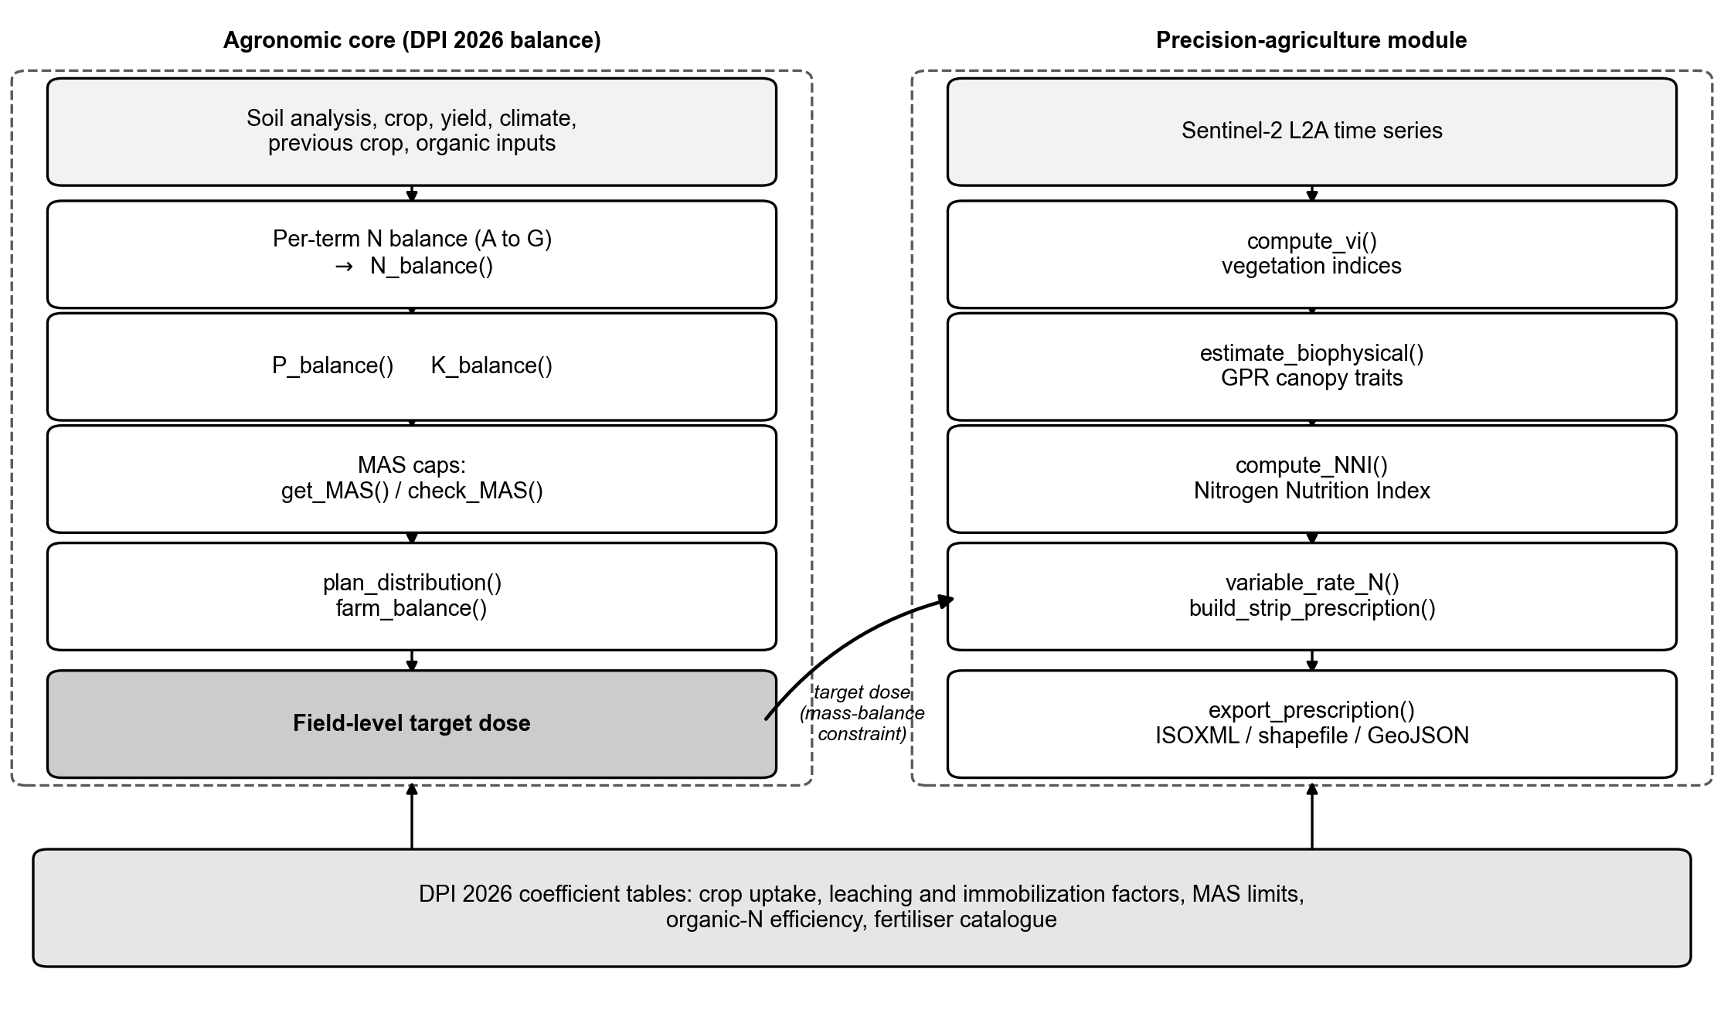
Figure 1. Architecture of NFert. The regulatory nitrogen balance sets the compliant field budget; the precision module resolves the within-field pattern from Sentinel-2; the mass-balance constraint reconciles the two into a variable-rate prescription, exported to farm-monitor formats. The same computation is applied at field and farm scale, and soil-input uncertainty is propagated throughout.
The nitrogen rate rests on a small number of functional forms that recur across recommendation methods and that NFert draws on (Figure 2): the yield response to nitrogen and its economic optimum, the critical-nitrogen dilution curve and the Nitrogen Nutrition Index, and the sensor sufficiency-index ramp. Each is detailed in the sections that follow.
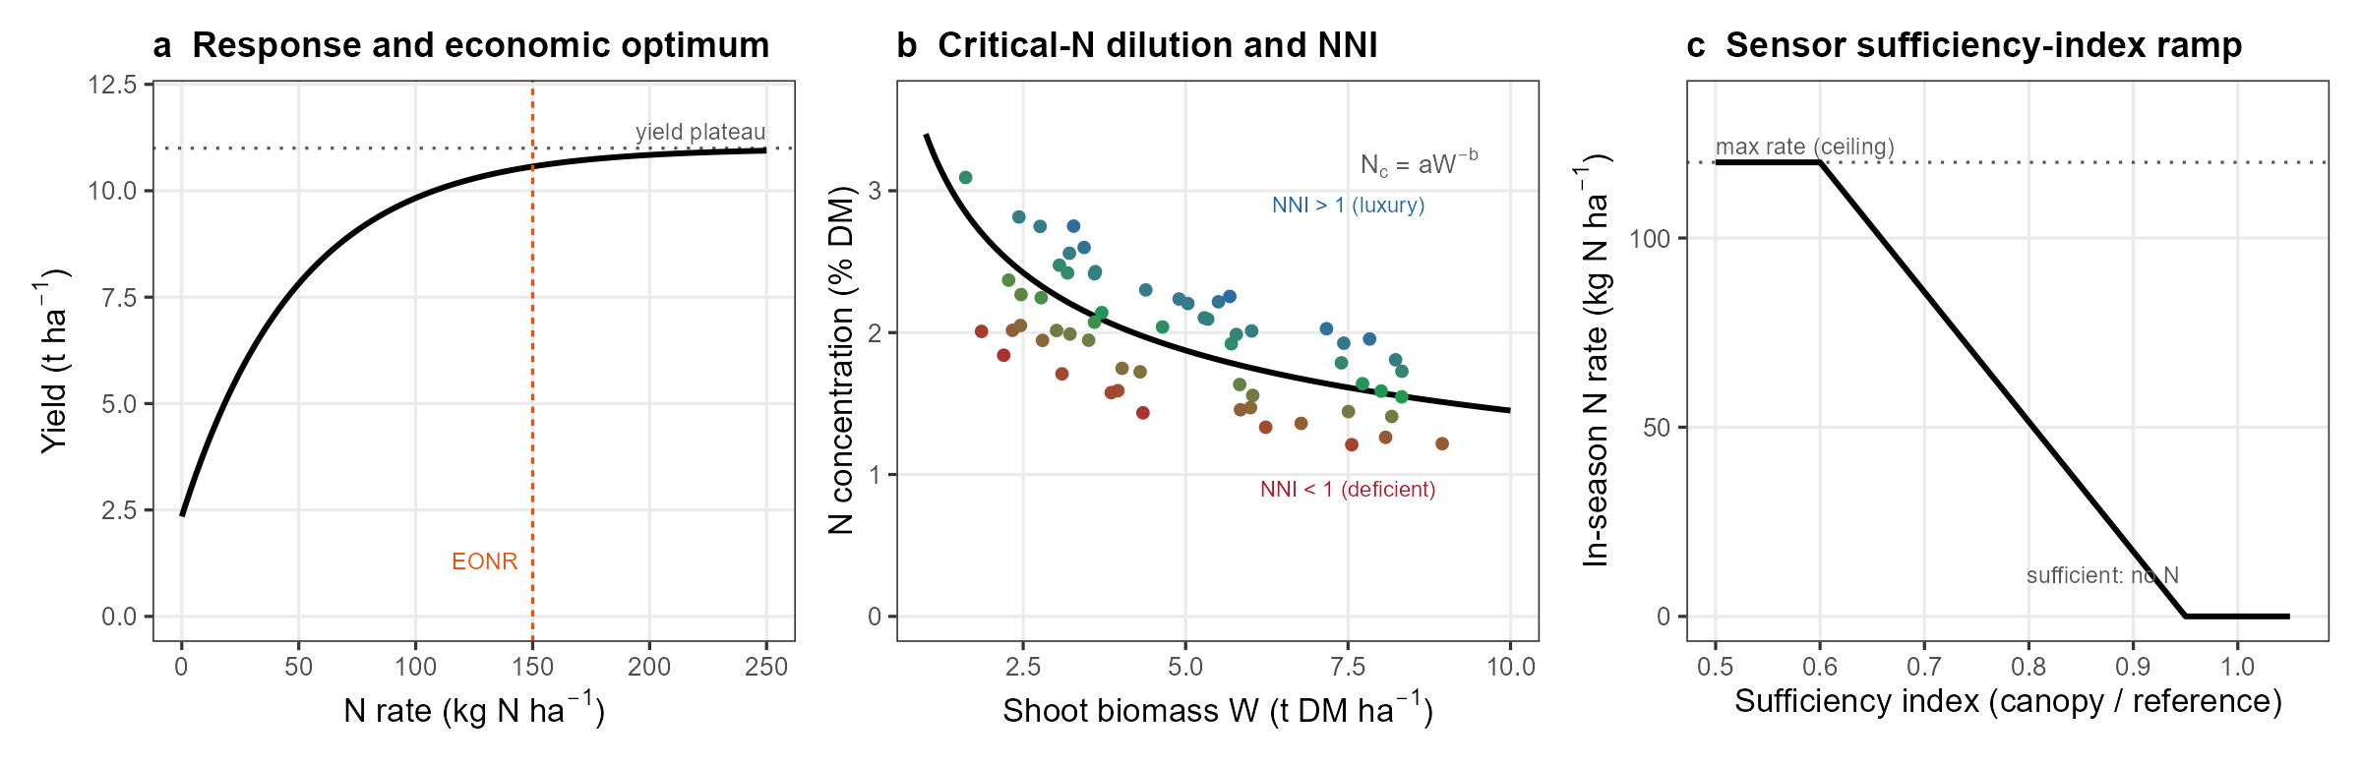
Figure 2. Functional forms underlying the main nitrogen rate-setting methods that NFert integrates. (a) The yield response to nitrogen and its economic optimum (EONR), the rate at which the marginal yield value equals the nitrogen cost. (b) The species-specific critical-nitrogen dilution curve and the Nitrogen Nutrition Index: canopy observations above the curve are in luxury consumption (NNI above 1) and below it deficient (NNI below 1). (c) The sensor sufficiency-index ramp: the in-season rate falls from the regulatory ceiling when the canopy is deficient to zero when it is sufficient. The panels are schematic and illustrative, not fitted to CERZOO data; panel (a) shows the economic-optimum module, which the case study does not exercise.
A minimal end-to-end session is a few lines of R; the full arguments are documented in the package help and vignettes:
library(NFert)
# 1. Regulatory field dose from crop, yield and soil (DPI 2026 balance)
b <- N_balance(expected_yield_tons_ha = 9, crop = "Grano tenero FF (granella)",
sand = 30, clay = 38, Ntot = 1.3, SOM = 2.4, CN = 10)
# 2. The same balance per pixel on soil rasters, or per field across a farm
n_field <- spatial_N_balance(soil_stack, expected_yield_tons_ha = 9,
crop = "Grano tenero FF (granella)", ccp = ccp,
winter_rain = 150, start_spring_rain = 0,
prev_crop = "Maize stalks buried")
farm <- farm_balance("fields.gpkg")
# 3. Sentinel-2 diagnosis and a machine-ready variable-rate prescription
bio <- estimate_biophysical("s2_scene.tif")
nni <- compute_NNI_from_S2(bio$LAI, bio$Cm, bio$CNC_Cprot, crop = "maize", fvc = bio$FVC)
rx <- build_strip_prescription(field, machine_width = 24, nni_raster = nni$NNI,
n_target = 190)
export_prescription(rx, "prescription.shp")
# Optional: an open, global default soil layer from SoilGrids (no local map needed)
soil_stack <- soilgrids_input(field, crs_out = 32632)

2.2 Soil properties and their uncertainty (input layer)
The balance is a function of soil texture and of soil carbon and nitrogen, so a spatially explicit and uncertainty-aware estimate of these properties is the first input. For the case study, clay, sand, organic carbon and total nitrogen and their per-pixel uncertainty were estimated from [confirm 20] georeferenced soil samples and a bare-soil Sentinel-2 Level-2A composite by a multi-model machine-learning spatialization (gradient-boosting and random-forest regressors, selected by spatial leave-one-point-out cross-validation, with a bootstrap estimate of the per-pixel uncertainty and an area-of-applicability mask, the mapped region where the model interpolates among its training data rather than extrapolating beyond them) [CITATION NEEDED: the soil-spatialization method, companion work]. That estimation is a separate contribution and is not the subject of this paper: the prediction and uncertainty rasters are taken here as the soil input layer. The maps have hold-out errors within the laboratory range and an area of applicability covering [confirm 80 to 91] percent of the mapped area; the prescription is reported only within the area of applicability, and the fraction lying outside it is stated, since the estimate is extrapolated there. Because a bootstrap standard deviation can understate the total prediction error, the hold-out (leave-one-point-out) RMSE of each property, in the property’s own units (clay 3.25 and sand 4.44 percent, organic carbon 0.10 percent, total nitrogen 0.015 percent), was used as the primary, more conservative soil-input uncertainty, and the small sample size ([confirm 20] points) is carried through as uncertainty rather than hidden.
Where a bespoke local soil map is not available, the same inputs can be built from the open, global SoilGrids product (function soilgrids_input()), which supplies the balance properties and their per-pixel uncertainty quantiles under a permissive licence (Poggio et al. 2021). SoilGrids is a 250 m global product with modest local accuracy, so it resolves the field-mean dose and the farm total rather than the within-field pattern; it is used here as the open default that makes the whole pipeline reproducible anywhere, and as a benchmark for the value of local sampling, not as a substitute for it.

2.3 The regulatory nitrogen balance
The field nitrogen dose is computed by the DPI 2026 Allegato 2 balance (N_balance()), which reconciles crop demand with soil supply and losses. The mineral nitrogen to apply, N, is the residual of the terms that raise the requirement (crop demand, leaching and immobilization) and those that lower it (soil supply and the residue, organic and atmospheric credits):
$$N=A−B+C_{1}+C_{2}+D−E−F−F_{org}−G$$
where A is the crop nitrogen demand, B the soil nitrogen supply (readily available plus mineralisable), C1 and C2 the winter and spring leaching losses, D immobilization, E the previous-crop residue credit, F and F_org the residual and current-year organic-nitrogen credits, and G the atmospheric deposition. Soil texture, organic matter, total nitrogen (as a mass fraction, in g per kg) and the carbon to nitrogen ratio enter the supply and loss terms, which is why their uncertainty propagates to the dose. The dose is capped by the crop maximum admissible dose and, in nitrate-vulnerable zones, by the regulatory ceiling, so the output is compliant by construction (Regione Emilia-Romagna 2026a, 2024). The balance reproduces the regional decision tool Fert_Office (Regione Emilia-Romagna 2026b).

2.4 In-season diagnosis of nitrogen status
In-season status is diagnosed through the Nitrogen Nutrition Index, the ratio of the actual to the critical nitrogen concentration along the species-specific critical-nitrogen dilution curve (Figure 2b) (Lemaire and Gastal 1997; Justes et al. 1994; Plénet and Lemaire 1999). The canopy biomass and nitrogen the index requires are retrieved from Sentinel-2 Level-2A reflectance by a hybrid Gaussian-process regression trained on radiative-transfer simulations (estimate_biophysical()) (Estévez et al. 2022; Verrelst et al. 2015), which compute_NNI_from_S2() combines into the index. A multi-index vegetation engine (compute_vi()), including red-edge chlorophyll indices that remain sensitive once the canopy closes, provides the empirical alternative (Gitelson et al. 2005; Clevers and Gitelson 2013).

2.5 The variable-rate step and the economic optimum
The prescription follows the mass-balance constraint: the balance sets the field mean dose, the nitrogen-status pattern sets the relative distribution, and the two are reconciled by rescaling so the area-weighted mean equals the field target, keeping the prescription compliant while redistributing nitrogen within the field (build_strip_prescription() and variable_rate_N(), exported to farm-monitor formats by export_prescription()). The within-field distribution follows one of two response forms, a calibration ramp from the vegetation index to the rate (estimate_N_rate_from_calibration_curve()) or the Holland and Schepers sufficiency-index curve (estimate_N_rate_from_holland_schepers(), Figure 2c), each rescaled to the balance-derived field mean (Holland and Schepers 2010; Raun et al. 2002). An optional economic-optimum module (optimize_VR_DPI()) couples the balance to the QUEFTS crop model (Janssen et al. 1990) through the Rquefts package: QUEFTS returns a per-cell economic optimum from the soil supply implied by the balance and a grain price, the economic optimum sets the applied field level, and the regulatory budget acts as a ceiling. This module is described here as an available capability; it is not exercised in the case study, whose recommendations follow the regulatory balance. When used, the economic optimum is reported over a range of grain-to-nitrogen price ratios, and its calibration against the balance soil-supply term is checked, because the optimum is sensitive to both.
A further module (plan_distribution()) turns the recommended dose into a compliant application plan. Given the balance requirement, it combines organic sources (manures and slurries, each credited for its plant-available nitrogen through a soil-group and application-timing efficiency) with mineral fertilisers, reports the useful nitrogen delivered against the requirement as a surplus or deficit, and enforces the 170 kg N per ha ceiling on organic nitrogen in nitrate-vulnerable zones. This connects the agronomic rate to the fertilisers actually applied and to the Nitrates Directive constraint, which is the step an adviser needs to act on the recommendation.

2.6 Propagation of the soil uncertainty
The balance is a deterministic function of the soil inputs, so their uncertainty maps onto the dose. This uncertainty was propagated by Monte Carlo with correlated Gaussian draws, on a 20 m analysis grid (a two-fold aggregation of the 10 m soil maps, for a tractable Monte Carlo), so that the structure of the soil data is respected rather than each property drawn independently. In each draw a property was perturbed by adding a normal deviate with standard deviation equal to its hold-out RMSE (Section 2.2): clay and sand were drawn jointly with the empirical clay-to-sand correlation (-0.644) and rescaled so that clay, silt and sand sum to 100 percent (silt as the residual, sand capped at 98 minus clay), while organic carbon and total nitrogen were drawn jointly with their empirical correlation (0.904) so that the carbon-to-nitrogen ratio stays physically plausible, with organic carbon and total nitrogen floored at small positive values. The balance was evaluated per pixel over K = 100 draws from a fixed seed, accumulating the per-pixel mean and standard deviation of the dose. A separate variance decomposition perturbed one correlated group at a time (texture, then carbon-nitrogen) over 3000 draws at the field-mean soil values, and reports each group’s first-order contribution to the dose variance as a share of their sum, so the small texture-by-carbon-nitrogen interaction is absorbed into the two reported shares.
The dependence of the aggregate uncertainty on the spatial structure of the soil error was modelled, not assumed. The soil error was assigned a spatial correlation length L, and the mapped area A was treated as a mosaic of independent correlation blocks of side L, giving an effective number of independent samples n_eff = min(max(A / L^2, 1), N) over the N mapped pixels. The standard deviation of the farm nitrogen total was then obtained by Monte Carlo (2000 draws): in each draw a single correlated soil-error realisation per property (with the clay-sand and carbon-nitrogen correlations above) was applied to all fields at once, each property’s hold-out RMSE scaled by 1 / sqrt(n_eff), and the per-field balance re-evaluated and summed to the farm total. Sweeping L from the pixel size (about 20 m) to beyond the farm extent traces the standard deviation of the total from the short-range regime, in which the per-pixel errors average out (n_eff approaches N), to the long-range regime, in which a systematic error persists undiminished on aggregation (n_eff = 1). This block model is a transparent first-order description of how spatial correlation controls the aggregate uncertainty; because it is scriptable against an open balance function, the whole propagation is a few lines of code, which a closed spreadsheet cannot express.

2.7 Field and farm aggregation
The same balance was evaluated at two nested scales. At the field scale the per-pixel prescription and its uncertainty band were produced on the 10 m grid within the area of applicability by applying the balance to the soil-property rasters (spatial_N_balance()). At the farm scale the balance was run per field with the field crop and yield (farm_balance()), and the per-field dose, the field nitrogen total and the farm total were aggregated with their propagated uncertainty. The per-field totals are a strict sub-aggregation of the farm total, so the two scales share one computation and are not double-counted.

2.8 Case study and data
The field and farm scales are demonstrated on the CERZOO experimental farm of the Università Cattolica del Sacro Cuore, in the Po Valley near Piacenza. The farm comprises eight fields with the crops declared for 2025 (silage maize as a main crop, silage maize as a second crop with or without a preceding grass, and soft wheat), covering about 32 ha of mapped soil. The expected yields that drive the balance demand term (silage maize 70 t/ha fresh forage for the well-managed main crop and 60 t/ha for the second crop, soft wheat 6 t/ha grain) are benchmarked against the official provincial statistics for Piacenza (silage maize 43 to 65 t/ha fresh, soft wheat about 6 t/ha, 2020 to 2025) (Istat (Istituto Nazionale di Statistica) 2025): the wheat and second-crop values sit at the provincial mean and range, while the main-crop 70 t/ha is an upper-range value for a fully irrigated field, above the rain-fed provincial average. Soil properties were taken from the input layer of Section 2.2; in-season nitrogen status used a Sentinel-2 Level-2A time series for 2024 to 2025. All analyses were run in R version 4.5.1 (R Core Team 2025) with terra (Hijmans 2024) and NFert. The package, the case-study rasters and the analysis scripts are openly available [confirm: repository and DOI]. The soil input maps of Section 2.2 are produced by a separate, proprietary pipeline [CITATION NEEDED: companion work] and are available from the provider; where they cannot be released, the package function soilgrids_input() rebuilds the whole pipeline on the open, global SoilGrids layer (250 m, CC-BY 4.0) (Poggio et al. 2021), so the tool and its computation are reproducible from open code and data even without the proprietary maps, at the cost of the coarser resolution discussed in Section 2.2.

3. Results

3.1 In-season diagnosis at CERZOO
The Sentinel-2 time series resolves the cropping calendar of the whole farm: the two silage-maize cycles as summer canopy peaks, the second crops as a distinct later flush, and the winter wheat as a spring peak, with the Gaussian-process retrieval tracking leaf area and canopy nitrogen through each cycle (Figure 3). At peak canopy the Nitrogen Nutrition Index moves between deficiency, optimal status and luxury consumption, and it varies within every field (Figure 4). This in-season within-field variation, and not the soil (Section 3.3), is what the variable-rate step redistributes. The diagnosis requires an active canopy, which the tool approximates by masking pixels below a leaf-area (open-canopy) threshold; this bounds the diagnosis to a closed canopy but does not, on its own, restrict it to the vegetative window in which the critical-nitrogen curve is defined, so the peak-canopy acquisition dates were chosen accordingly.
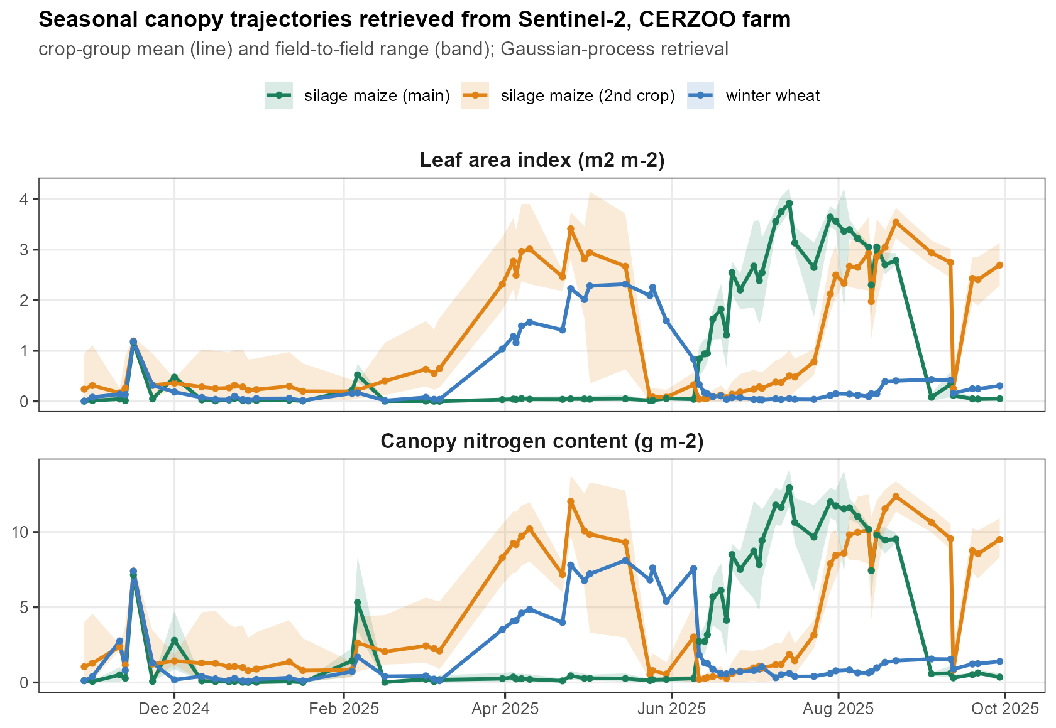
Figure 3. Farm-scale seasonal canopy trajectories at CERZOO, retrieved from the Sentinel-2 time series by Gaussian-process regression: leaf area index (top) and canopy nitrogen content (bottom) as the crop-group mean (line) with the field-to-field range (band). The main-crop silage maize peaks in late summer, the second-crop fields in spring and late summer, and the winter wheat in spring.
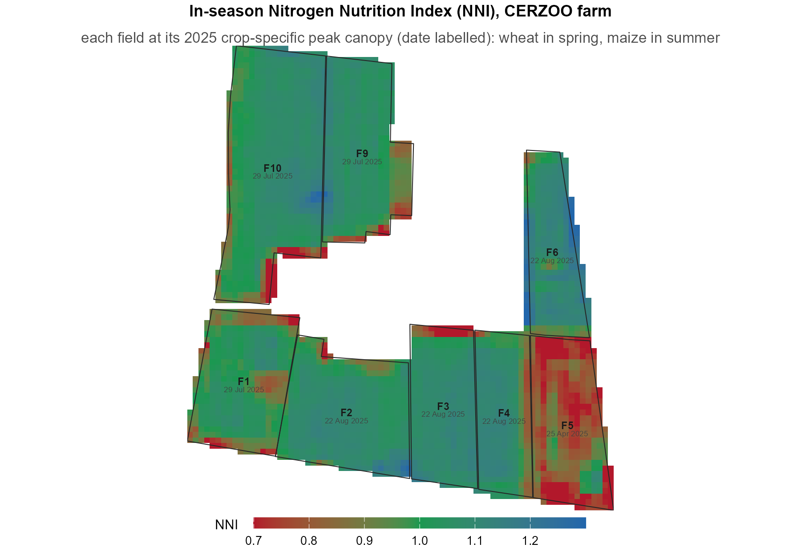
Figure 4. In-season Nitrogen Nutrition Index across the CERZOO farm, each field mapped at its 2025 crop-specific peak canopy (date labelled: wheat in spring, maize in summer) from Sentinel-2 by Gaussian-process biophysical retrieval and the species-specific critical-nitrogen curve. The index moves between deficiency (red, below 0.9), optimal status (green, 0.9 to 1.1) and luxury consumption (blue, above 1.1), and it varies within every field; NNI = 1 is the theoretical critical value and 0.9 to 1.1 the operational band around it. The absolute index is a first-guess, relative diagnosis: the biophysical retrieval uses uncalibrated leaf-allocation and nitrogen-to-chlorophyll coefficients that can bias the absolute Nitrogen Nutrition Index by 15 to 30 percent, so the classes should be read as relative status, not as calibrated absolute values.

3.2 Prescription and its uncertainty
Under the mass-balance constraint, the five prescription strategies all reproduce the field target while differing in within-field contrast, from the uniform baseline to the vegetation-index and Nitrogen-Nutrition-Index-driven maps (Figure 5). Propagating the soil-map uncertainty through the balance (Section 2.6) gives, for each pixel, the nitrogen recommendation and its soil-propagated standard deviation (Figure 6a, b). The farm-mean recommendation is about 207 kg N per ha (area-weighted), from 148 kg N per ha on the wheat field to 234 kg N per ha on the high-yield silage-maize fields. The correlated propagation (with the hold-out RMSE as the input error) gives a per-pixel uncertainty of the recommendation of 9.0 kg N per ha, or 4.4 percent of the dose: a modest field-scale uncertainty that reflects the precision of the cross-validated maps within a field. What drives this uncertainty, and how it scales from the pixel to the farm total, is taken up in Section 3.4.
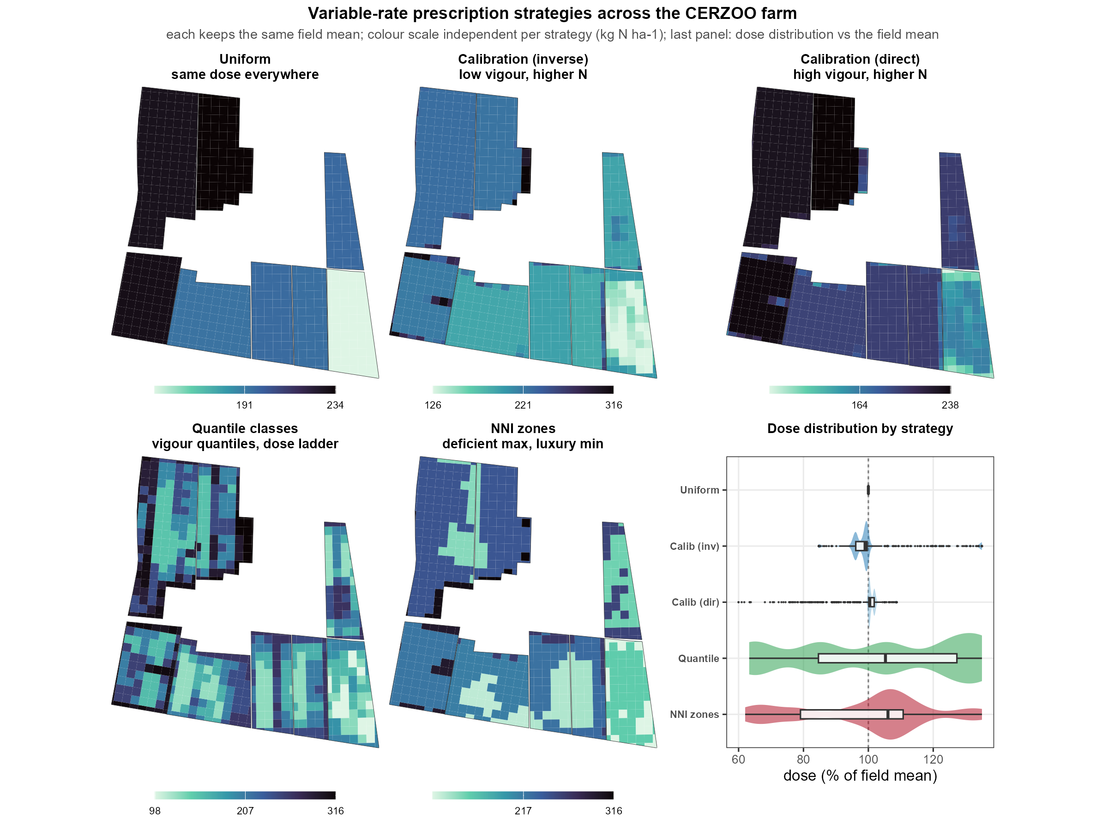
Figure 5. Variable-rate prescription maps across the eight CERZOO fields under five strategies (uniform, calibration inverse and direct, vegetation-index quantile classes, and Nitrogen-Nutrition-Index zones), each constrained to its own field mean and shown on its own colour scale. The uniform strategy varies only between fields (by crop), while the sensor-driven strategies add the within-field pattern from the canopy. The last panel gives the distribution of the prescribed dose relative to the field mean for each strategy: uniform is a spike at the mean, calibration spreads mildly, and the discrete-zone strategies (quantile and NNI) differentiate most, spanning about 60 to 135 percent of the mean.
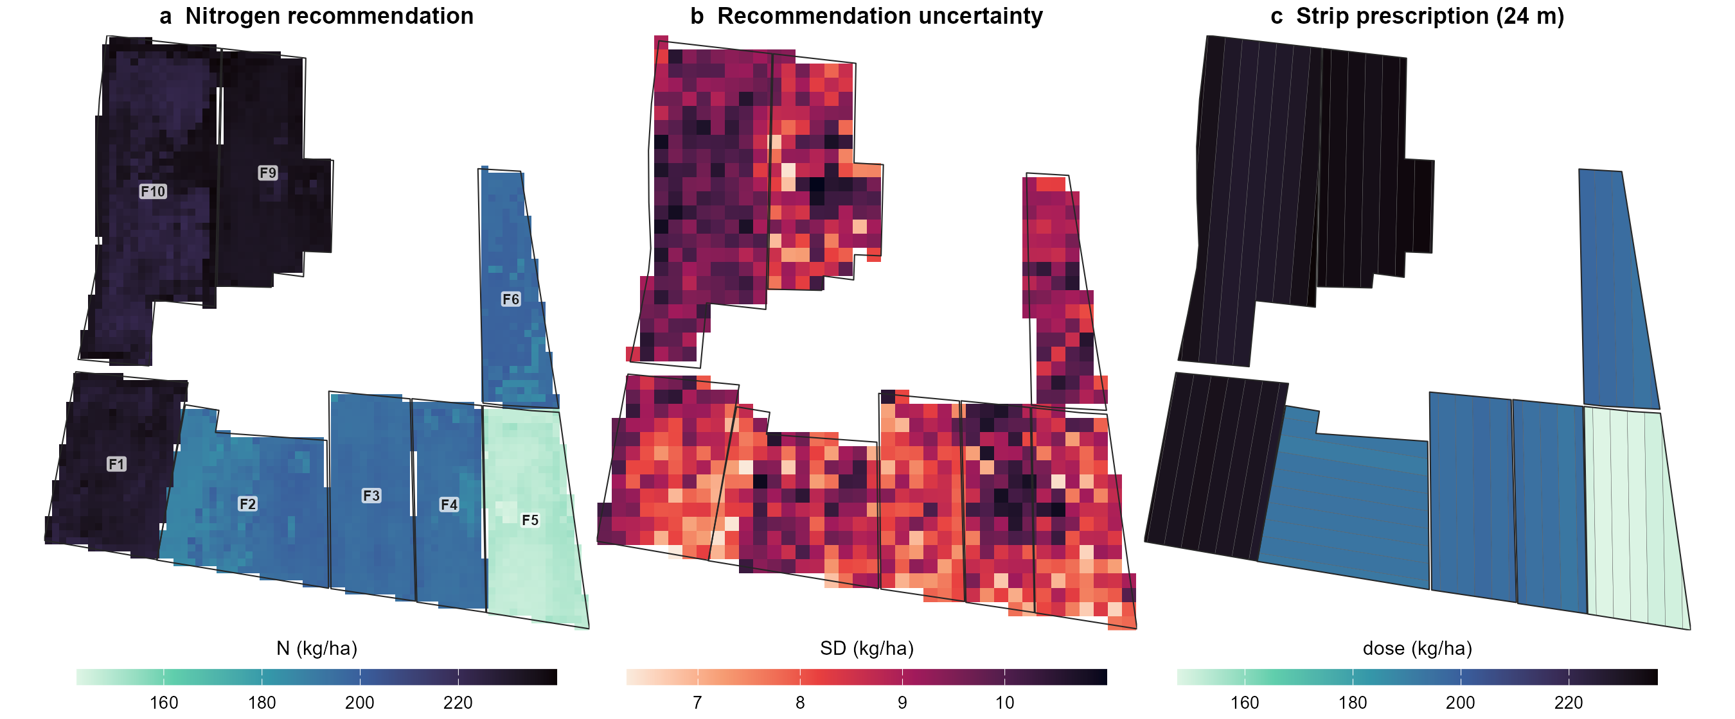
Figure 6. Farm-scale application on the eight CERZOO fields in one computation: (a) the nitrogen recommendation, with the crop-driven contrast between the silage-maize fields (F1, F9, F10), the second-crop maize fields (F2, F3, F4, F6) and the wheat field (F5); (b) the soil-propagated standard deviation of the recommendation; (c) the machine-width strip prescription (24 m strips) delivered to the farm monitor. Within-field variation is small on these homogeneous soils, so the between-field crop difference dominates the pattern, while the propagated uncertainty (b) has a within-field texture of its own.
From the same computation the prescription is delivered as machine-ready strips (Figure 6c) or as a two-dimensional cell grid. The builder tiles each field along its working direction, the A-B guidance line, into passes of the chosen working width. By default this direction is derived from the longest edge of the field’s minimum-area rotated rectangle, the orientation that minimises the number of passes and headland turns. The operator can instead set the A-B line manually, passing the builder an explicit driving track (an A-B line geometry, for example a track recorded in the field) or a fixed azimuth, so the prescription follows the driver’s own guidance line, such as a slope contour, a drainage line or a shared headland. Each pass is optionally subdivided along its length into cells, and the zonal-mean recommendation is assigned to every strip or cell while preserving the field mean. Changing only the machine geometry re-tiles the whole farm automatically (Supplementary Figure S1): a 24 m strip delivery gives 58 passes over the eight fields, while a full two-dimensional grid ranges from 359 cells at a 36 m working width to 2547 at 12 m, the finer machine resolving the within-field pattern more closely. Each prescription is exported to the interoperable formats read by farm monitors (shapefile, GeoJSON, KML, GeoPackage, ISOXML, and the John Deere and Trimble formats).
The choice of cell size trades machine simplicity against spatial fidelity, at a rate that depends on the strategy. Reproducing the finest (10 m) within-field prescription with a coarser square grid loses pattern progressively (Supplementary Figure S2): at a 24 m cell only about 42 to 68 percent of the finest pattern is reproduced, and by 60 m about 26 to 36 percent, the loss being fastest for the sharp Nitrogen-Nutrition-Index zones and most gradual for the vegetation-index quantile classes. On these homogeneous soils this sets a practical cell size below which a finer machine adds little differentiation.

3.3 Farm accounting
Aggregating the per-field recommendation to the farm gives a total of 6.6 t N over about 32 ha, with the per-field totals ranging from 0.53 t on the smallest second-crop field to 1.59 t on the largest silage-maize field (Table 2). Each total carries the propagated soil uncertainty, which is the subject of Section 4.
Table 2. Per-field and farm nitrogen accounting at CERZOO: crop, expected yield, area, area-weighted mean recommendation, and nitrogen total (corrected run; source: farm_accounting.csv). Silage-maize yields are fresh forage weight; the wheat yield is grain.
Field | Crop | Yield (t ha^-1) | Area (ha) | Mean rate (kg N ha^-1) | N total (t)
F1 | Silage maize | 70 | 3.90 | 231 | 0.90
F2 | Grass + second-crop silage maize | 60 | 4.53 | 193 | 0.88
F3 | Grass + second-crop silage maize | 60 | 3.23 | 196 | 0.63
F4 | Grass + second-crop silage maize | 60 | 2.78 | 195 | 0.54
F5 | Soft wheat | 6 | 3.67 | 148 | 0.55
F6 | Second-crop silage maize | 60 | 2.72 | 196 | 0.53
F9 | Silage maize | 70 | 4.31 | 234 | 1.01
F10 | Silage maize | 70 | 6.93 | 230 | 1.59
Farm | 8 fields | – | 32.07 | 207 | 6.63
The method is applied to the whole farm in one computation (Figure 6). The recommendation is driven mainly by the crop and its expected yield between fields, from the main-crop silage maize (F1, F9, F10; 70 t/ha fresh forage, about 230 kg N per ha) through the second-crop maize (60 t/ha, about 195 kg N per ha) to the wheat field (F5; 6 t/ha grain, 148 kg N per ha), because within-field soil variation is small on these homogeneous alluvial soils: the within-field coefficient of variation of the recommendation is 0.4 to 2.5 percent across the eight fields. On such soils the balance alone gives a near-uniform field dose, and the within-field variable-rate contrast comes from the in-season Nitrogen Nutrition Index (Figure 5) rather than from the soil. The soil-propagated uncertainty, by contrast, has a spatial texture within each field (Figure 6b), and it is this uncertainty, not a strong within-field dose gradient, that the tool surfaces on homogeneous soils.

3.4 Sources and scaling of the soil-driven uncertainty
The soil-driven dose uncertainty and its behaviour on aggregation are summarised in Figure 7. A per-crop variance decomposition (Figure 7a) shows that soil texture dominates the dose uncertainty for both crops (84 percent for maize, 78 percent for wheat), soil carbon and nitrogen contributing the remainder (16 and 22 percent), so sampling texture more densely would tighten the recommendation most. How the pixel-scale uncertainty (4.4 percent of the dose, Figure 6b) scales to the farm total depends on the spatial structure of the soil error (Figure 7b): modelled with a spatial correlation length (Section 2.6), the standard deviation of the farm nitrogen total rises from about 0.9 percent when the error decorrelates near the pixel and the per-pixel errors average out, to about 4.0 percent when the error is systematic and field-wide, the latter approaching the 4.4 percent per-pixel value because a fully correlated error does not average out at all. The 4.0 percent long-range plateau is marginally below the 4.4 percent per-pixel value because the farm total is an area- and crop-weighted aggregate of fields that respond slightly differently to the same systematic soil shift.
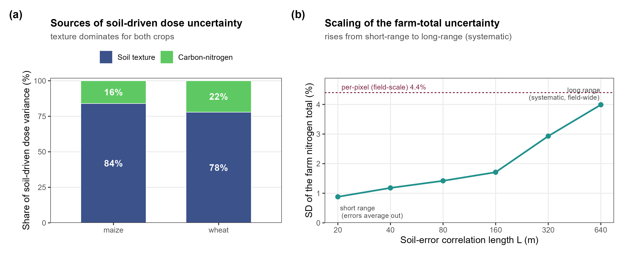
Figure 7. Sources and scaling of the soil-driven nitrogen-dose uncertainty. (a) Per-crop decomposition into soil-texture and carbon-nitrogen contributions: texture dominates for both crops, so denser texture sampling would tighten the recommendation most. (b) Standard deviation of the farm nitrogen total as a function of the soil-error correlation length, from the short-range (averaging) to the long-range (systematic) regime; the dashed line marks the per-pixel field-scale uncertainty (4.4 percent) that a fully correlated error approaches.

4. Discussion
The uncertainty of the nitrogen recommendation behaves differently across scales, and making that behaviour computable and auditable for a specific regulatory farm total, rather than left implicit, is a central contribution of the tool (Section 3.4).
That aggregation of correlated error does not cancel is a textbook property of error propagation; the contribution here is not to discover it but to make it computable and auditable for a specific regulatory total, against an open balance, and to present the full curve as a sensitivity envelope rather than assert a single unmeasured correlation length. The curve also closes the loop with the variance decomposition (Section 3.4): because soil texture dominates the dose uncertainty, where a farm sits on this curve is governed mainly by the spatial structure of the texture error, so knowing whether texture error is short- or long-range is what most sharpens a compliance total. The practical message for nitrogen accounting under the Nitrates Directive and nutrient-surplus targets is that a compliant farm total carries a confidence that is not a fixed number but a function of the soil-error structure, and that reporting it honestly requires knowing, or bounding, that structure.

5. Impact and perspectives
NFert shows that one open, auditable computation can serve three users across the field and the farm: the agronomist, through a within-field variable-rate prescription delivered as machine strips; the adviser, through a farm nitrogen accounting with its uncertainty; and the regulator, through an auditable, compliant farm nitrogen total and surplus. Reporting the uncertainty at each scale makes the recommendation auditable, and the openness of the implementation is what makes the uncertainty propagation possible at all: the same few lines of script that draw the soil inputs and re-run the balance cannot be written against a closed spreadsheet. The contribution is a transparent, compliant and uncertainty-aware computation and prescription, not a validated better way to fertilize.
The evidence on whether variable-rate nitrogen outperforms well-managed uniform application is mixed and context dependent, with input savings and nitrogen-use efficiency more consistently demonstrated than yield or profit gains (Diacono et al. 2013; Colaço and Bramley 2018). We therefore claim no yield or profit gain. The main limitations are:
- There is no independent agronomic validation of the prescriptions: every number is an output of the model, and outcome validation (whether following the prescription drives the Nitrogen Nutrition Index toward one and reduces surplus) is out of scope by design and is the explicit next step.
- The demonstration rests on a single site and a single season, so the specific magnitudes (4.4 percent per-pixel uncertainty, the 84 and 78 percent texture shares, the 0.9 to 4.0 percent correlation-length range) are site-specific; the tool and the method are site-independent by construction.
- The CERZOO soils are deliberately homogeneous alluvial Po Valley soils, so the within-field variable-rate benefit is expected to be larger on heterogeneous soils that this case study does not exercise; here the informative signal is the uncertainty texture, not a dose gradient.
- The soil maps rest on about twenty samples with optimistic leave-one-point-out cross-validation and are used only within their area of applicability, so the propagated 4.4 percent is a best-case, within-area estimate; the correlation-length result, however, is robust to the absolute magnitude of the input error, since its shape holds whatever the true per-pixel error.
- Only the soil-input uncertainty is propagated; the retrieval, vegetation-index and balance-coefficient errors are not yet included, so the reported band is a soil-propagated uncertainty, not the total predictive uncertainty. In particular the Nitrogen Nutrition Index used for the in-season pattern rests on uncalibrated leaf-allocation and nitrogen-to-chlorophyll coefficients (a 15 to 30 percent potential bias in the absolute index), so it is used here as a relative within-field diagnosis rather than a calibrated absolute status.
- The soil-error correlation length is modelled rather than measured, which is why the full sensitivity curve is reported rather than a single value.
Three directions follow. NFert already ships tested phosphorus and potassium balances and a distribution planner alongside the nitrogen balance (they reproduce the regional Fert_Office totals), so the extension to phosphorus and potassium is not the balance itself but coupling those nutrients to the sensor and to the same uncertainty propagation across seasons, which this nitrogen-focused paper does not exercise. The uncertainty propagation can be extended from the soil inputs to the full chain, adding the retrieval and index error. And the multi-scale accounting can be coupled to independent validation and to on-farm experimentation, which the open, scriptable design of the tool is built to support.

Declarations
CRediT authorship contribution statement. [confirm per-author roles: Michele Croci: conceptualization, methodology, software, writing; … ]
Declaration of competing interest. The authors declare no competing interests. [confirm; note any relationship with the soil-spatialization provider.]
Funding. This work was supported by the EOAGRITWIN project [confirm grant number and programme].
Data and code availability. NFert is available at https://github.com/mcroci/NFert with an archived release [confirm DOI]. The case-study rasters and analysis scripts are available at [confirm]. The ISTAT crop-yield benchmark (Section 2.8) and the open, SoilGrids-based soil pipeline are fully reproducible from the scripts under paper/data/ and the soilgrids_input() function, under their respective open licences (Istat CC-BY 3.0; SoilGrids CC-BY 4.0). The soil input maps of Section 2.2 are produced by a separate, proprietary pipeline and are available from [CITATION NEEDED: companion work]; their access and credit are stated there.
Acknowledgements. [confirm]

Supplementary figures
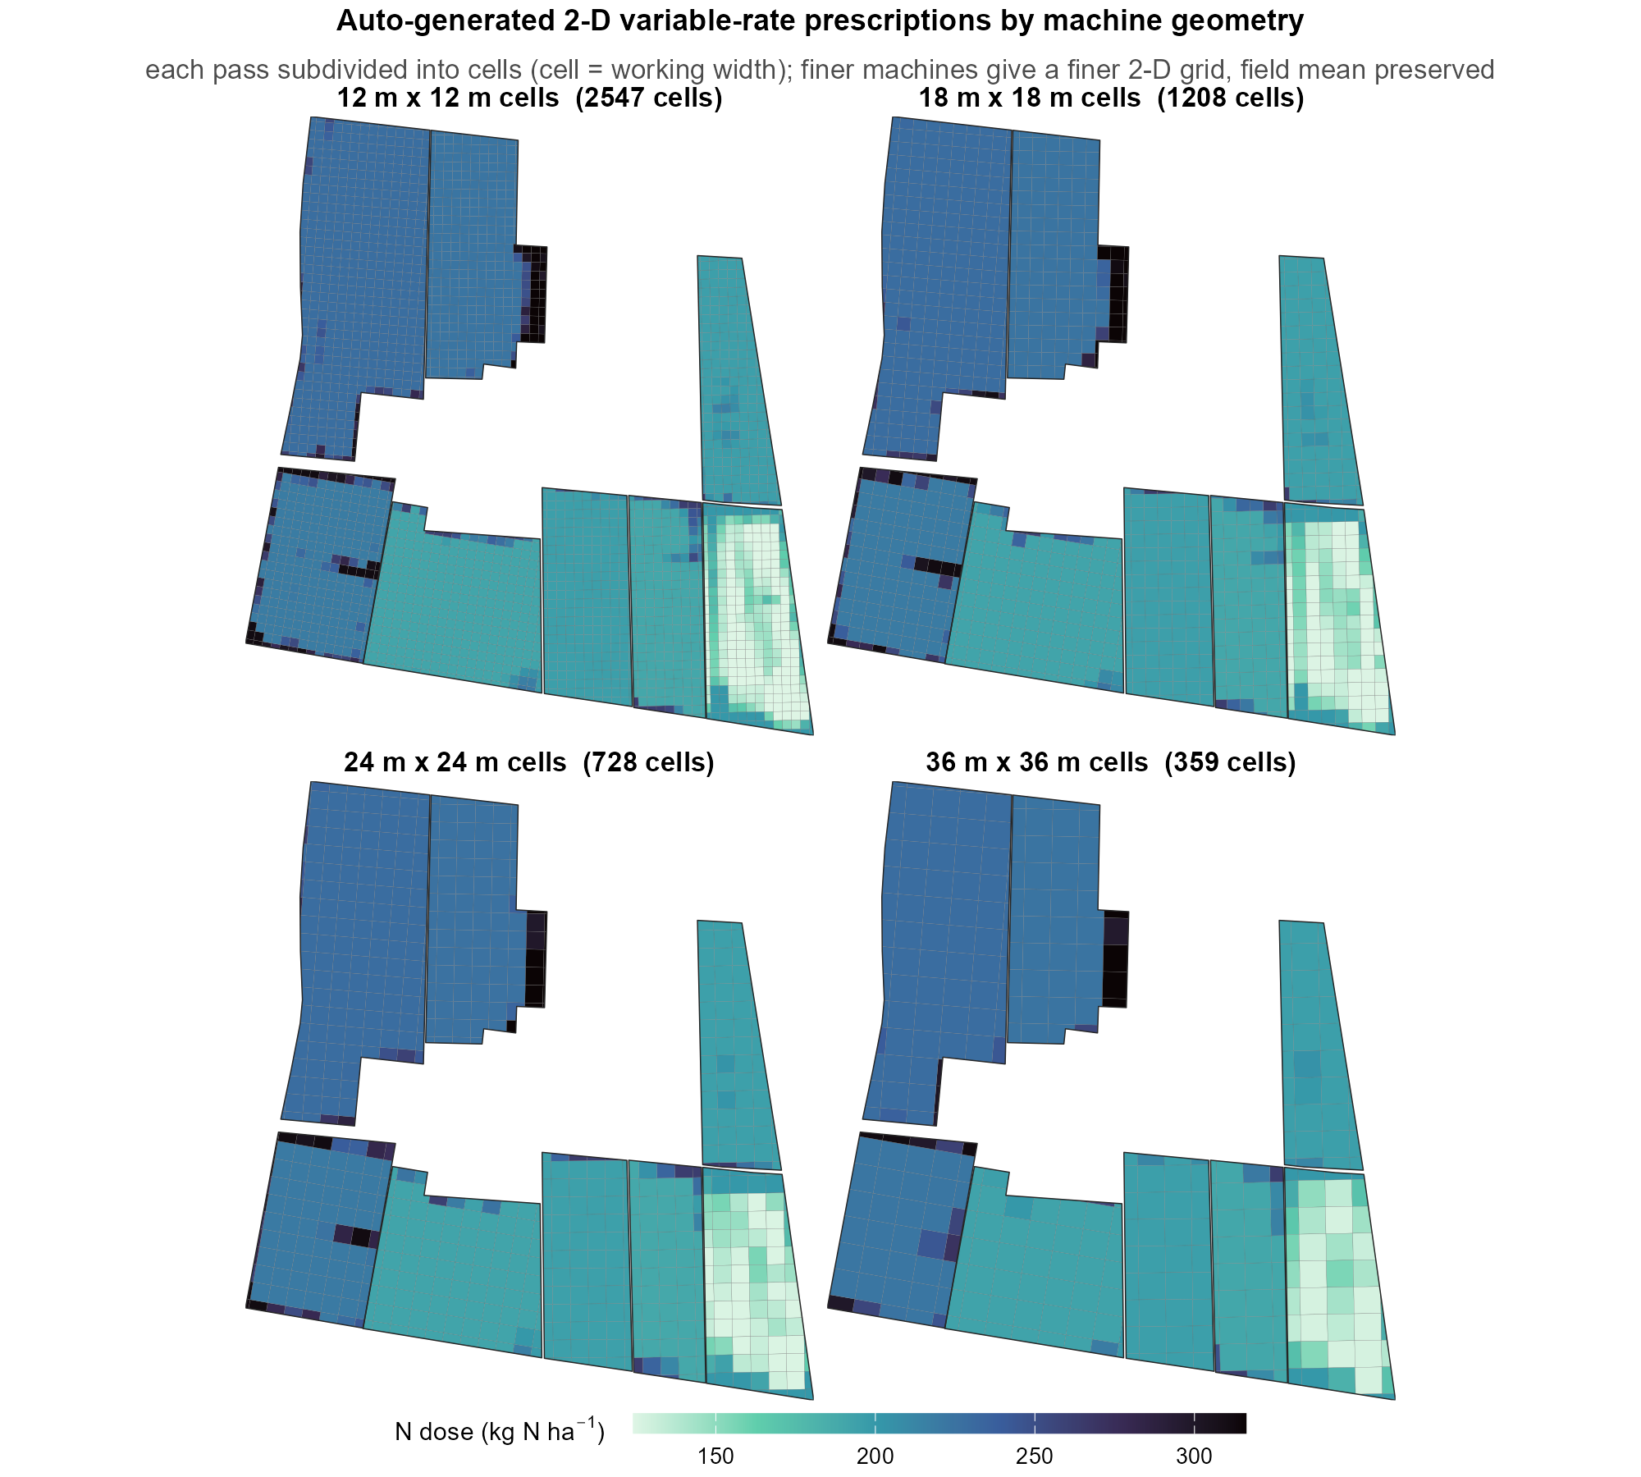
Supplementary Figure S1. Auto-generated two-dimensional variable-rate prescriptions for four machine geometries (working width equal to cell length, 12 to 36 m) across the eight CERZOO fields. The same builder re-tiles each field into cells and assigns the NDVI-driven dose per cell while preserving the field mean, so a finer machine gives a finer grid (2547 cells at 12 m to 359 at 36 m).
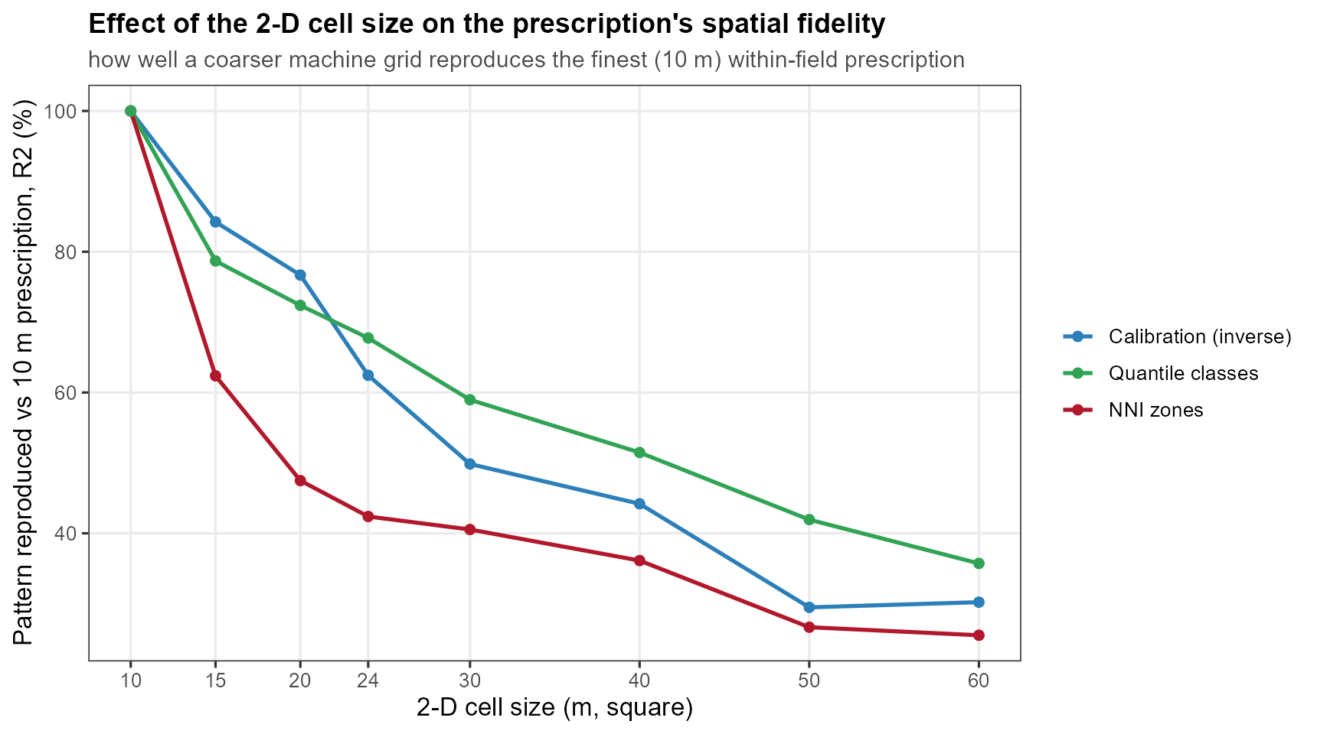
Supplementary Figure S2. Effect of the two-dimensional cell size on the spatial fidelity of the prescription: the coefficient of determination between the coarse-grid prescription and the finest (10 m) prescription, for the three within-field strategies, averaged over the eight CERZOO fields. Fidelity falls fastest for the Nitrogen-Nutrition-Index zones and most gradually for the vegetation-index quantile classes.

References
Basso, Bruno, Benjamin Dumont, Davide Cammarano, Andrea Pezzuolo, Francesco Marinello, and Luigi Sartori. 2016. “Environmental and Economic Benefits of Variable Rate Nitrogen Fertilization in a Nitrate Vulnerable Zone.” Science of The Total Environment 545–546: 227–35. https://doi.org/10.1016/j.scitotenv.2015.12.104.
Clevers, J. G. P. W., and A. A. Gitelson. 2013. “Remote Estimation of Crop and Grass Chlorophyll and Nitrogen Content Using Red-Edge Bands on Sentinel-2 and -3.” International Journal of Applied Earth Observation and Geoinformation 23: 344–51. https://doi.org/10.1016/j.jag.2012.10.008.
Colaço, A. F., and R. G. V. Bramley. 2018. “Do Crop Sensors Promote Improved Nitrogen Management in Grain Crops?” Field Crops Research 218: 126–40. https://doi.org/10.1016/j.fcr.2018.01.007.
Corti, Martina, Virginia Fassa, and Luca Bechini. 2022. “A Scoping Review of Side-Dress Nitrogen Recommendation Systems and Their Perspectives in Precision Agriculture.” Italian Journal of Agronomy 17 (1): 1951. https://doi.org/10.4081/ija.2021.1951.
Diacono, Mariangela, Pietro Rubino, and Francesco Montemurro. 2013. “Precision Nitrogen Management of Wheat. A Review.” Agronomy for Sustainable Development 33: 219–41. https://doi.org/10.1007/s13593-012-0111-z.
Estévez, Jochem, Matias Salinero-Delgado, Katja Berger, et al. 2022. “Gaussian Processes Retrieval of Crop Traits in Google Earth Engine Based on Sentinel-2 Top-of-Atmosphere Data.” Remote Sensing of Environment 273: 112958. https://doi.org/10.1016/j.rse.2022.112958.
European Council. 1991. Council Directive 91/676/EEC of 12 December 1991 Concerning the Protection of Waters Against Pollution Caused by Nitrates from Agricultural Sources. Official Journal of the European Communities L375:1–8.
Gitelson, Anatoly A., Andrés Viña, Verónica Ciganda, Donald C. Rundquist, and Timothy J. Arkebauer. 2005. “Remote Estimation of Canopy Chlorophyll Content in Crops.” Geophysical Research Letters 32 (8): L08403. https://doi.org/10.1029/2005GL022688.
Hijmans, Robert J. 2024. Terra: Spatial Data Analysis. https://CRAN.R-project.org/package=terra.
Holland, Kyle H., and James S. Schepers. 2010. “Derivation of a Variable Rate Nitrogen Application Model for in-Season Fertilization of Corn.” Agronomy Journal 102 (5): 1415–24. https://doi.org/10.2134/agronj2010.0015.
Istat (Istituto Nazionale di Statistica). 2025. Coltivazioni: Superfici e Produzioni (DCSP_COLTIVAZIONI). Data warehouse, dataflow IT1:101_1015, years 2020–2025. https://esploradati.istat.it/.
Janssen, B. H., F. C. T. Guiking, D. van der Eijk, E. M. A. Smaling, J. Wolf, and H. van Reuler. 1990. “A System for Quantitative Evaluation of the Fertility of Tropical Soils (QUEFTS).” Geoderma 46 (4): 299–318. https://doi.org/10.1016/0016-7061(90)90021-Z.
Justes, E., B. Mary, J.-M. Meynard, J. M. Machet, and L. Huché-Thélier. 1994. “Determination of a Critical Nitrogen Dilution Curve for Winter Wheat Crops.” Annals of Botany 74 (4): 397–407. https://doi.org/10.1006/anbo.1994.1133.
Lemaire, Gilles, and François Gastal. 1997. “N Uptake and Distribution in Plant Canopies.” In Diagnosis of the Nitrogen Status in Crops, edited by Gilles Lemaire. Springer-Verlag. https://doi.org/10.1007/978-3-642-60684-7_1.
Oenema, Oene, Hans Kros, and Wim de Vries. 2003. “Approaches and Uncertainties in Nutrient Budgets: Implications for Nutrient Management and Environmental Policies.” European Journal of Agronomy 20: 3–16. https://doi.org/10.1016/S1161-0301(03)00067-4.
Plénet, D., and G. Lemaire. 1999. “Relationships Between Dynamics of Nitrogen Uptake and Dry Matter Accumulation in Maize Crops. Determination of Critical n Concentration.” Plant and Soil 216 (1–2): 65–82. https://doi.org/10.1023/A:1004783431055.
Poggio, Laura, Luis M. de Sousa, Niels H. Batjes, et al. 2021. “SoilGrids 2.0: Producing Soil Information for the Globe with Quantified Spatial Uncertainty.” SOIL 7 (1): 217–40. https://doi.org/10.5194/soil-7-217-2021.
R Core Team. 2025. R: A Language and Environment for Statistical Computing. R Foundation for Statistical Computing. https://www.r-project.org/.
Raun, William R., John B. Solie, Gordon V. Johnson, et al. 2002. “Improving Nitrogen Use Efficiency in Cereal Grain Production with Optical Sensing and Variable Rate Application.” Agronomy Journal 94 (4): 815–20. https://doi.org/10.2134/agronj2002.8150.
Regione Emilia-Romagna. 2024. Regolamento Regionale Emilia-Romagna 2/2024: Massimali Di Apporto Di Azoto (MAS). Bologna, Italy.
Regione Emilia-Romagna. 2026a. Disciplinari Di Produzione Integrata (DPI): Norme Generali, Allegato 2 (Metodo Del Bilancio Dell’azoto), Edizione 2026. Regione Emilia-Romagna, Servizio Agricoltura Sostenibile.
Regione Emilia-Romagna. 2026b. FertDPI / Fert_office V1.26: Strumento Regionale Per Il Piano Di Fertilizzazione. Regional decision-support spreadsheet.
Seibold, Heidi, Severin Czerny, Siona Decke, et al. 2021. “A Computational Reproducibility Study of PLOS ONE Articles Featuring Longitudinal Data Analyses.” PLOS ONE 16: e0251194. https://doi.org/10.1371/journal.pone.0251194.
Sutton, Mark A., Clare M. Howard, Jan Willem Erisman, et al., eds. 2011. The European Nitrogen Assessment: Sources, Effects and Policy Perspectives. Cambridge University Press. https://doi.org/10.1017/CBO9780511976988.
Verrelst, Jochem, Gustau Camps-Valls, Jordi Muñoz-Marí, et al. 2015. “Optical Remote Sensing and the Retrieval of Terrestrial Vegetation Bio-Geophysical Properties – a Review.” ISPRS Journal of Photogrammetry and Remote Sensing 108: 273–90. https://doi.org/10.1016/j.isprsjprs.2015.05.005.
Wilkinson, Mark D., Michel Dumontier, IJsbrand Jan Aalbersberg, et al. 2016. “The FAIR Guiding Principles for Scientific Data Management and Stewardship.” Scientific Data 3: 160018. https://doi.org/10.1038/sdata.2016.18.

