NFert: an open, uncertainty-aware nitrogen-balance tool from field variable-rate prescription to farm accounting

Highlights
- Open R tool runs a regulatory nitrogen balance from soil pixel to farm total
- Soil texture, not organic carbon, drives soil-map error in the regulatory N dose
- Soil-map errors show no detectable spatial structure; farm N total SD below 1 %
- Measured rainfall raised the farm N dose 26 %, pushing 4 of 8 fields over the cap
- Sentinel-2 NNI strips keep the field N target and export to farm monitors

Abstract
Regulatory nitrogen balances set the maximum fertilizer dose from soil texture and organic matter, which digital soil maps now supply pixel by pixel, yet how reliable such a dose is, and how that reliability changes from the pixel to the farm total that regulators audit, is rarely quantified. We built NFert, an open-source R package that implements the Emilia-Romagna Integrated Production nitrogen balance (DPI 2026), couples it under one mass-balance constraint to a Sentinel-2 diagnosis of nitrogen status and a machine-ready variable-rate prescription, and propagates soil-map uncertainty by correlated Monte Carlo from the pixel to the farm. We evaluated it on the CERZOO experimental farm (Po Valley, Italy; eight maize and wheat fields, 32 ha, 6.9 t of nitrogen). The per-pixel dose uncertainty was 3.3 percent, and 95 to 96 percent of it came from soil texture, unlike a published process-model recommendation, where soil organic carbon dominated. Leave-one-out residuals of the soil maps showed no detectable spatial structure at the 45 m sampling spacing, which places the farm in the short-range regime: the standard deviation of the farm nitrogen total is at most about 0.6 percent, against 2.5 percent if the map errors were systematic. Under the rainfall measured in 2024 to 2025 the farm dose rose by 26 percent and exceeded the maximum allowed dose on four of the eight fields. Within a regulatory balance, the soil-map error of a well-sampled farm is therefore a second-order uncertainty, and the weather input matters more for compliance.
Keywords: variable-rate nitrogen; nutrient balance; uncertainty propagation; multi-scale nutrient accounting; Sentinel-2; reproducible research

1. Introduction
Fertilization is among the most consequential decisions in arable cropping, and the rate of nitrogen applied is the decision that most directly determines its outcome: the yield and quality achievable, the profitability of the operation, and the size of the nitrogen surplus lost to water and air (Oenema et al. 2003; Sutton et al. 2011). The rate is a constrained optimization in which agronomic, economic and regulatory objectives must be satisfied at once, and for nitrogen the regulatory ceiling is explicit: the European Nitrates Directive constrains application in vulnerable zones (European Council 1991), and regional integrated-production schemes translate it into an auditable field budget (Regione Emilia-Romagna 2026a).
The methods proposed to set the nitrogen rate form a small number of recurring families: regulatory or mass-balance budgets; soil-test and standard-dose schemes; crop-growth models; sensor-based empirical algorithms; biophysical diagnosis through the Nitrogen Nutrition Index (NNI); and, more recently, machine learning. A scoping review of side-dress recommendation systems found the empirical, vegetation-index-based family dominant, with mechanistic and machine-learning systems a minority (Corti et al. 2022). Here we take the families as given and address three gaps that a practical tool must close.
The first gap is integration. A reflectance index resolves within-field variability but sets no field-level ceiling, while a mass balance sets a defensible ceiling but no spatial pattern; the two are rarely coupled in one reproducible workflow, so a sensor-driven map and a compliant budget are seldom reconciled (Raun et al. 2002; Holland and Schepers 2010). The second gap is openness and reproducibility. The regulatory methods are typically locked in closed regional spreadsheets, and research code is fragmented and often not versioned or inspectable, which undermines replication and cross-region transfer (Seibold et al. 2021; Wilkinson et al. 2016). The third gap, less often made explicit, is that operational tools give a deterministic rate at a single scale: they ignore the uncertainty of their soil inputs, and they disconnect the field decision from the farm accounting that advisers and regulators need.
Propagating the error of digital soil maps through a model is established practice in spatial modelling, and so is the result that the uncertainty of a spatial total depends on how the map errors are correlated in space (HEUVELINK et al. 1989; Heuvelink and Pebesma 1999; Wadoux and Heuvelink 2023). The closest application to fertilization propagated soil-map uncertainty through the QUEFTS crop model into nitrogen, phosphorus and potassium recommendations, found that soil organic carbon drove almost all of the nitrogen uncertainty, and that the Monte Carlo doses differed from the deterministic ones (Takoutsing et al. 2024). Regulatory balances differ from such process models in two ways that matter for uncertainty. Their coefficients change in steps across soil classes, and the decision they support is legal: a field dose bounded by a crop maximum and a farm total that is audited. To our knowledge, no study has quantified how soil-map uncertainty propagates through a regulatory nitrogen balance, which soil property it comes from, how it scales from the pixel to the audited farm total, or how it compares with the weather input that the same balance needs. On the tool side, the regulatory calculation is usually a closed spreadsheet or web service (Regione Emilia-Romagna 2026b; Donauer et al. 2025), and the sensor-based prescription tools that resolve the within-field pattern do not enforce the regulatory budget (Hamie et al. 2026; Vizzari et al. 2019; Santaga et al. 2021). Compatibility with compliance demands is one of the factors that decide whether farmers and advisers adopt a decision-support tool (Rose et al. 2016). Table 1 compares NFert with the closest published tools and studies.
Table 1. NFert and the closest published nitrogen tools and studies. Properties are as reported in each publication (abstracts and main text as available); “Not stated” means the publication does not report it. [confirm each row against the full texts]
Tool or study | Method family | Regulatory budget | Spatial unit | Soil-input uncertainty | Remote sensing | Machine export | Open code | Evidence
Fert_Office (Regione Emilia-Romagna 2026b) | Regional balance, spreadsheet | Yes (DPI) | Field | No | No | No | No | Regional reference
webBESyD (Donauer et al. 2025) | Nutrient balance, web | Yes (German rules) | Field, farm | No | No | No | Not stated | Software description
Takoutsing et al. (Takoutsing et al. 2024) | Crop model (QUEFTS) | No | Pixel | Yes, Monte Carlo | No | No | Not stated | Regional case study
Basso et al. (Basso et al. 2016) | Crop model, VRT | Nitrate-vulnerable zone | Zone | No | No | No | No | Simulation case study
Vizzari et al.; Santaga et al. (Vizzari et al. 2019; Santaga et al. 2021) | Balance + NDVI VRT | Field balance | Zone | No | Sentinel-2 | Prescription map | Not stated | Field trials
AgroSat (Hamie et al. 2026) | NDVI VRT, web | No | Zone | No | Sentinel-2 | Prescription map | Not stated | Farm case study
NFert (this work) | Regional balance + NNI VRT | Yes (DPI, MAS) | Pixel, field, farm | Yes, correlated Monte Carlo | Sentinel-2 | Yes (ISOXML and others) | Yes (MIT) | Farm case study
We built NFert, an open, versioned R implementation of the Emilia-Romagna regulatory nitrogen balance coupled to a Sentinel-2 diagnosis and a variable-rate prescription (Croci et al. 2026), and used it on a 32 ha farm to answer four questions:
- RQ1. Can a within-field redistribution driven by the Sentinel-2 Nitrogen Nutrition Index keep the regulatory field target and be delivered as a machine prescription, and how much pattern is lost as the machine cell grows?
- RQ2. How large is the uncertainty of a regulatory nitrogen dose computed from digital soil maps, and how does it scale from the pixel to the farm total, given the measured spatial structure of the map errors?
- RQ3. Which soil property controls that uncertainty, and does propagating it shift the mean dose, as reported for process models?
- RQ4. How does the soil-map uncertainty compare with the effect of the weather input of the same balance, and what does each imply for the crop maximum allowed dose?

2. Materials and methods

2.1 Design and implementation
NFert is an R package (version 1.0.0, MIT license) with a single hard runtime dependency (terra, for raster handling (Hijmans 2024)) and optional packages that enable the Sentinel-2 retrieval, the machine-format exports and the interactive app. It is hosted on GitHub, tested by a unit-test suite (169 tests, about 87 percent line coverage) run under continuous integration across Linux, macOS and Windows, and archived with a persistent identifier [confirm DOI]. Its design principle is that every coefficient table is an editable, inspectable object rather than a hidden spreadsheet cell, so a recommendation can be verified, corrected and transferred. The package exposes the balance, the diagnosis and the prescription as scriptable functions, and an optional interactive interface. Figure 1 shows the architecture: the agronomic core (the balance and its regulatory checks) feeds, under the mass-balance constraint, the precision module (the vegetation-index engine, the biophysical retrieval, the NNI, the variable-rate step and the export formats).
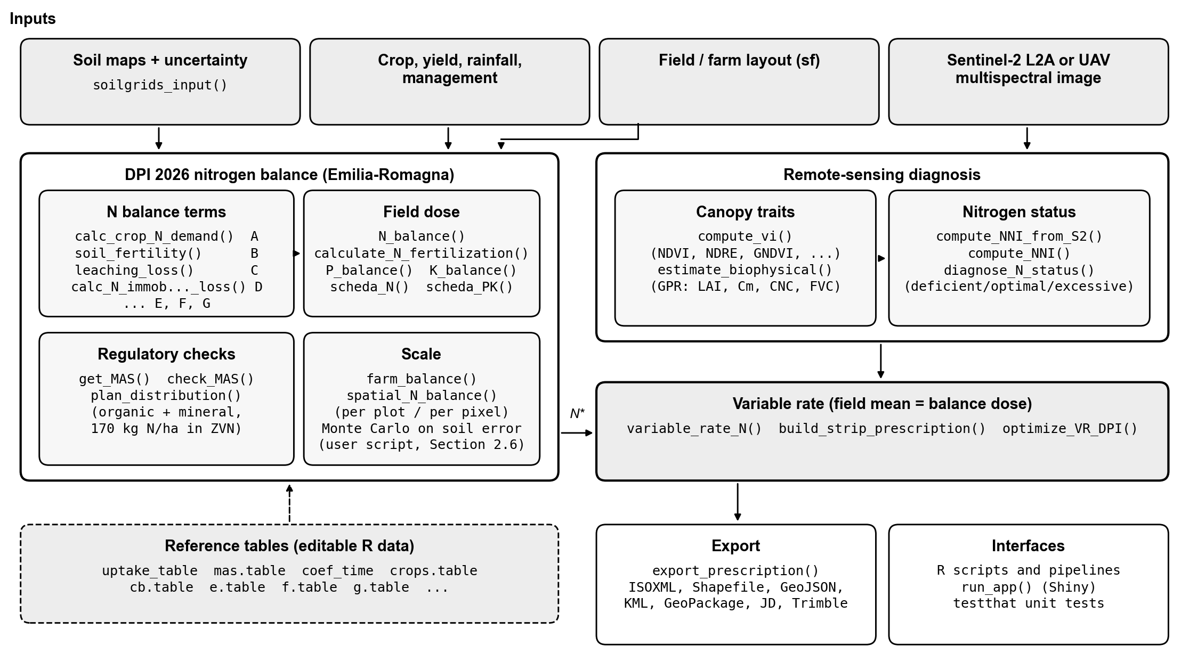
Figure 1. Architecture of NFert. The regulatory nitrogen balance sets the compliant field budget; the precision module resolves the within-field pattern from Sentinel-2; the mass-balance constraint reconciles the two into a variable-rate prescription, exported to farm-monitor formats. The same computation is applied at field and farm scale, and the propagation of the soil-map uncertainty is a short script on the open balance function. All coefficient tables are editable R datasets.
The nitrogen rate rests on a small number of functional forms that recur across recommendation methods and that NFert draws on (Figure 2): the yield response to nitrogen and its economic optimum, the critical-nitrogen dilution curve and the NNI, and the sensor sufficiency-index ramp. Each is detailed in the sections that follow.
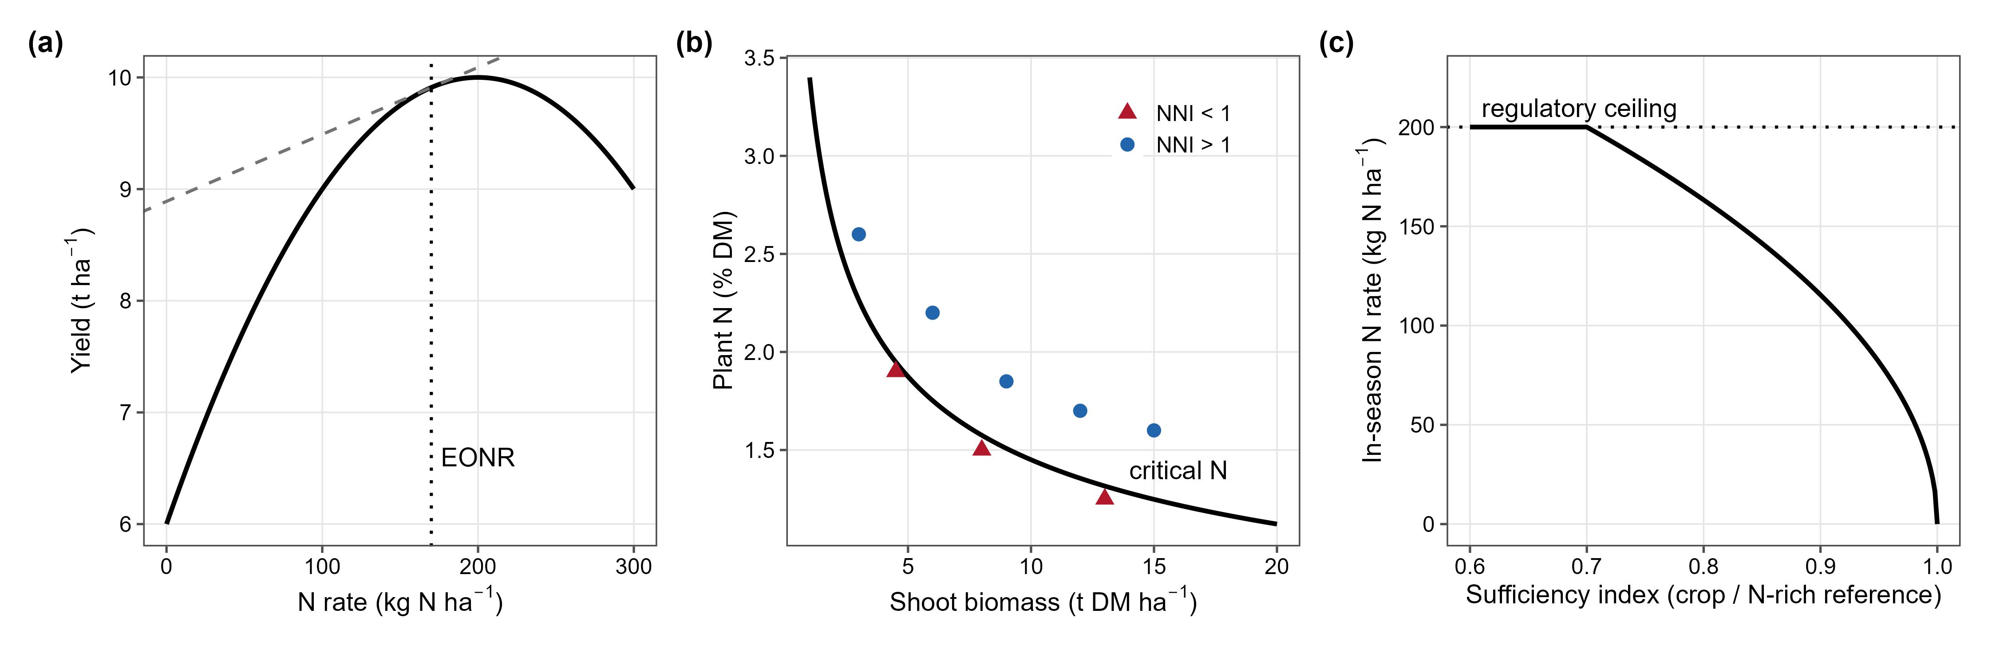
Figure 2. Functional forms underlying the main nitrogen rate-setting methods that NFert integrates. (a) The yield response to nitrogen and its economic optimum (EONR), the rate at which the marginal yield value equals the nitrogen cost. (b) The species-specific critical-nitrogen dilution curve and the NNI: canopy observations above the curve are in luxury consumption (NNI above 1) and below it deficient (NNI below 1). (c) The sensor sufficiency-index ramp: the in-season rate falls from the regulatory ceiling when the canopy is deficient to zero when it is sufficient. The panels are schematic and illustrative, not fitted to CERZOO data; panel (a) shows the economic-optimum module, which the case study does not exercise.
A minimal end-to-end session is a few lines of R; the full arguments are documented in the package help and vignettes:
library(NFert)
# 1. Regulatory field dose from crop, yield and soil (DPI 2026 balance)
b <- N_balance(expected_yield_tons_ha = 9, crop = "Grano tenero FF (granella)",
ccp = "Autumn-winter crop <150 days",
sand = 30, clay = 38, Ntot = 1.3, SOM = 2.4, CN = 10)
calculate_N_fertilization(b)
# 2. The same balance per pixel on soil rasters, or per field across a farm
n_field <- spatial_N_balance(soil_stack, expected_yield_tons_ha = 9,
crop = "Grano tenero FF (granella)", ccp = ccp,
winter_rain = 150, start_spring_rain = 0,
prev_crop = "Maize stalks buried")
farm <- farm_balance("fields.gpkg")
# 3. Sentinel-2 diagnosis and a machine-ready variable-rate prescription
bio <- estimate_biophysical("s2_scene.tif", output_dir = "bio")
nni <- compute_NNI_from_S2(bio$LAI, bio$Cm, bio$CNC_Cprot, crop = "maize", fvc = bio$FVC)
rx <- build_strip_prescription(field, machine_width = 24, variability = "nni",
nni_raster = nni$NNI, n_target = 190)
export_prescription(rx, "prescription.shp")
# Optional: an open, global default soil layer from SoilGrids (no local map needed)
soil_stack <- soilgrids_input(field, crs_out = 32632)

2.2 Soil properties and their uncertainty (input layer)
The balance is a function of soil texture and of soil carbon and nitrogen, so a spatially explicit and uncertainty-aware estimate of these properties is the first input. For the case study, clay, sand, organic carbon and total nitrogen and their per-pixel uncertainty were estimated from 20 georeferenced soil samples and a bare-soil Sentinel-2 Level-2A composite by a multi-model machine-learning spatialization [CITATION NEEDED: the soil-spatialization method, companion work]. For each property the best model was chosen among tree-based, linear and penalized regressors by leave-one-point-out cross-validation, subject to a physical-plausibility constraint (the map must stay within 15 percent of the range observed in the laboratory), and the per-pixel uncertainty is the standard deviation of 25 bootstrap resamples. That estimation is a separate contribution and is not the subject of this paper: the prediction and uncertainty rasters are taken here as the soil input layer. A bootstrap standard deviation can understate the total prediction error (the mean bootstrap deviation is 0.96 percent for clay, against a leave-one-point-out RMSE of 2.90), so the hold-out RMSE of each property, in its own units (clay 2.90 and sand 3.47 percent, organic carbon 0.103 percent, total nitrogen 0.013 percent), was used as the primary, more conservative soil-input uncertainty. An RMSE estimated from 20 points is itself uncertain: under normal errors its 95 percent interval spans 0.77 to 1.44 times the estimate, and the propagation was repeated at both ends (Section 2.6). An area-of-applicability analysis (Meyer and Pebesma 2021), which maps where a model interpolates among its training data, was run for the preceding model run with the same points and predictors [confirm for the final maps]; 82 percent of the mapped area lies inside the area of applicability of all four properties at once (84 to 91 percent for each property alone). The doses reported here are computed over the whole mapped area, and the doses inside and outside the area of applicability are compared in Section 3.3.
Where a bespoke local soil map is not available, the same inputs can be built from the open, global SoilGrids product (function soilgrids_input()), which supplies the balance properties and their per-pixel uncertainty quantiles under a permissive licence (Poggio et al. 2021). SoilGrids is a 250 m global product with modest local accuracy, so it resolves the field-mean dose and the farm total rather than the within-field pattern; it is used here as the open default that makes the whole pipeline reproducible anywhere, and as a benchmark for the value of local sampling, not as a substitute for it.

2.3 The regulatory nitrogen balance
The field nitrogen requirement is computed by the balance of Annex 2 of the Emilia-Romagna Integrated Production Guidelines (Disciplinari di Produzione Integrata, DPI 2026; N_balance()), which reconciles crop demand with soil supply and losses:
$$N=A−B+C_{1}+C_{2}+D−E−F−G$$
where A is the crop nitrogen demand (unit uptake times expected yield), B the soil nitrogen supply (readily available plus mineralisable), C₁ and C₂ the autumn-winter and end-of-winter leaching losses, D immobilization and dispersion, E the previous-crop residue credit, F the residual effect of organic fertilization in previous years and G atmospheric deposition plus biological fixation by legumes. Soil texture, organic matter, total nitrogen (in g per kg) and the carbon to nitrogen ratio enter the supply and loss terms, which is why their uncertainty propagates to the dose. Each term has its own exported function, and N_balance() returns all of them, so a dose can be audited term by term. calculate_N_fertilization() then multiplies the balance by the share admitted for the crop phase, bounds it to zero and to the crop ceiling, and subtracts the nitrogen of the organic fertilisers applied in the current season. In this paper the dose of the case study is the requirement before that last credit, because the aim is the prescription of the total requirement and the distribution between organic and mineral sources is a separate step (plan_distribution(), Section 2.5). The dose is checked against the crop maximum allowed dose (MAS, check_MAS()) (Regione Emilia-Romagna 2026a, 2024); the DPI allows the balance to exceed the MAS only when the yields of the previous years document it, so NFert reports the exceedance rather than truncating the balance silently. The balance reproduces the regional decision tool Fert_Office (Regione Emilia-Romagna 2026b), and takes the tool, not the printed tables of the guidelines, as the numerical reference where the two differ.

2.4 In-season diagnosis of nitrogen status
In-season status is diagnosed through the NNI, the ratio of the actual to the critical nitrogen concentration along the species-specific critical-nitrogen dilution curve (Figure 2b) (Lemaire and Gastal 1997; Justes et al. 1994; Plénet and Lemaire 1999). The canopy biomass and nitrogen the index requires are retrieved from Sentinel-2 Level-2A reflectance by a hybrid Gaussian-process regression trained on radiative-transfer simulations (estimate_biophysical()) (Estévez et al. 2022; Verrelst et al. 2015), which compute_NNI_from_S2() combines into the index. A multi-index vegetation engine (compute_vi()), including red-edge chlorophyll indices that remain sensitive once the canopy closes, provides the empirical alternative (Gitelson et al. 2005; Clevers and Gitelson 2013). The diagnosis requires an active canopy, which the tool approximates by masking pixels below a leaf-area (open-canopy) threshold. The mask restricts the diagnosis to a closed canopy but not, on its own, to the vegetative window in which the critical-nitrogen curve is defined, so the acquisition dates are chosen within the crop window (Section 2.8).

2.5 The variable-rate step and the economic optimum
The prescription follows the mass-balance constraint. The balance sets the field target dose N* (the balance dose capped at the MAS), and the nitrogen-status pattern sets the relative distribution within the field. The two are reconciled by rescaling, so that the area-weighted mean equals the target while every cell stays within the dose bounds. This rescaling keeps the prescription compliant while redistributing nitrogen within the field (build_strip_prescription() and variable_rate_N(), exported to farm-monitor formats by export_prescription()).
Five within-field strategies are compared in the case study, all on the same cells and with dose bounds of 60 and 135 percent of N*. Uniform applies N* to every cell. Calibration (inverse) maps the cell-mean NDVI to the dose along a two-point linear ramp (NDVI 0.35 to 0.80), the lowest NDVI receiving the highest dose, as in side-dress compensation; Calibration (direct) uses the same ramp with the opposite sign, the highest NDVI receiving the highest dose. Quantile classes split the cells into five NDVI quantiles and assign an equally spaced dose ladder, the lowest class receiving the highest dose. NNI zones assign the upper bound to deficient cells (NNI below 0.9), N* to optimal cells (0.9 to 1.1) and the lower bound to cells in luxury consumption (above 1.1) (Lemaire and Gastal 1997). Every strategy is then rescaled to N*. The package also provides the Holland and Schepers sufficiency-index curve (estimate_N_rate_from_holland_schepers(), Figure 2c) (Holland and Schepers 2010; Raun et al. 2002), which the case study does not use.
The builder tiles each field along its working direction, the A-B guidance line, into passes of the chosen working width, optionally subdivided along their length into cells; the zonal-mean dose is assigned to every strip or cell. By default the direction is the longest edge of the field’s minimum-area rotated rectangle, which minimises the number of passes and headland turns. The operator can instead pass an explicit A-B line (for example a track recorded in the field) or a fixed azimuth, so the prescription follows the driver’s own guidance line, such as a slope contour, a drainage line or a shared headland. Strips and cells are drawn in the local UTM zone, so working width and cell length are true ground distances. Two further modules are available but not used in the case study: an economic optimum from the QUEFTS crop model (Janssen et al. 1990), capped by the regulatory dose (optimize_VR_DPI()), and an application plan that splits the dose between organic and mineral fertilisers and enforces the 170 kg N per ha ceiling on organic nitrogen in nitrate-vulnerable zones (plan_distribution()).

2.6 Propagation of the soil uncertainty
The balance is a deterministic function of the soil inputs, so their uncertainty maps onto the dose. This uncertainty was propagated by Monte Carlo with correlated Gaussian draws, on a 20 m analysis grid (a two-fold aggregation of the 10 m soil maps; 866 pixels), so that the structure of the soil data is respected rather than each property drawn independently. In each draw a property was perturbed by adding a normal deviate with standard deviation equal to its hold-out RMSE (Section 2.2): clay and sand were drawn jointly with the empirical clay-to-sand correlation (-0.644) and constrained so that clay, silt and sand sum to 100 percent (silt as the residual, sand capped at 98 minus clay), while organic carbon and total nitrogen were drawn jointly with their empirical correlation (0.904) so that the carbon-to-nitrogen ratio stays physically plausible, with organic carbon and total nitrogen floored at small positive values. The balance was evaluated per pixel over K = 100 draws from a fixed seed, accumulating the per-pixel mean and standard deviation of the dose. A separate variance decomposition perturbed one correlated group at a time (texture, then carbon-nitrogen) over 3000 draws at the mean soil of each field, and reports each group’s first-order contribution to the dose variance as a share of their sum, so the small texture-by-carbon-nitrogen interaction is absorbed into the two reported shares; the shares are averaged over the fields of each crop, weighted by area.
The dependence of the aggregate uncertainty on the spatial structure of the soil error was modelled, not assumed. The soil error was assigned a spatial correlation length L, and the mapped area A was treated as a mosaic of independent correlation blocks of side L, giving an effective number of independent samples n_{eff} = min(max(A / L², 1), N) over the N mapped pixels. For a response that is linear in the soil error, the standard deviation of the farm total is then SD_{sys} / sqrt(n_{eff}), where SD_{sys} is its standard deviation under a fully systematic error (n_{eff} = 1). SD_{sys} was obtained by Monte Carlo at pixel level (400 draws): in each draw a single correlated soil-error realisation per property (with the clay-sand and carbon-nitrogen correlations above) was applied to every pixel, the balance was re-evaluated per pixel and summed to the farm total. The block formula was checked by re-evaluating the pixel-level balance with each property’s RMSE scaled by 1 / sqrt(n_{eff}) at two correlation lengths (100 and 340 m, 150 draws each), and its short-range end against the independent per-pixel Monte Carlo above. Sweeping L from the pixel size (20 m) to beyond the farm extent (1100 m) traces the standard deviation of the total from the short-range regime, in which the per-pixel errors average out (n_{eff} approaches N), to the long-range regime, in which a systematic error persists undiminished on aggregation (n_{eff} = 1). This block model is a transparent first-order description of how spatial correlation controls the aggregate uncertainty (Heuvelink and Pebesma 1999; Wadoux and Heuvelink 2023).
The correlation length of the CERZOO map errors was then bounded from the data, following the idea of estimating the error correlation from standardised residuals (Wadoux and Heuvelink 2023). Per-point leave-one-out predictions are not stored by the soil mapping pipeline, so a random forest was re-fitted on the same bare-soil Sentinel-2 predictors; it reproduced the leave-one-point-out RMSE of the maps within 5 percent (clay 2.87, sand 3.56, organic carbon 0.107, total nitrogen 0.013 percent). The residuals were divided by their RMSE, pooled over the four properties, and their semivariance was computed in five distance classes (0 to 150, 150 to 300, 300 to 450, 450 to 600 and 600 to 1000 m; 31 to 47 point pairs each; minimum spacing 45 m). Spatial structure would lower the semivariance at short distances, so each class was compared with the 95 percent envelope of 999 random permutations of the residuals among the sampling points.
Two further checks used the same per-pixel Monte Carlo. The mean shift is the difference between the Monte Carlo mean dose and the deterministic dose on the same 20 m support, per field and for the farm, because thresholds in a model can shift the mean as well as add spread (Takoutsing et al. 2024). The sensitivity to the input error repeated the per-pixel Monte Carlo (50 draws) with every RMSE multiplied by the two ends of its 95 percent interval (0.77 and 1.44).

2.7 Field and farm aggregation
The same balance was evaluated at two nested scales. At the field scale the per-pixel prescription and its uncertainty band were produced on the 10 m grid by applying the balance to the soil-property rasters (spatial_N_balance()). At the farm scale the balance was run per field with the field crop and yield, and the per-field dose, the field nitrogen total and the farm total were aggregated with their propagated uncertainty. The per-field totals are a strict sub-aggregation of the farm total, so the two scales share one computation and are not double-counted.

2.8 Case study and data
The field and farm scales are demonstrated on the CERZOO experimental farm of the Università Cattolica del Sacro Cuore, in the Po Valley near Piacenza. The farm comprises eight fields with the crops declared for 2025 (silage maize as a main crop, silage maize as a second crop with or without a preceding grass, and soft wheat), covering 32.06 ha of mapped soil. The expected yields that drive the balance demand term (silage maize 70 t/ha fresh forage for the well-managed main crop and 60 t/ha for the second crop, soft wheat 6 t/ha grain) are benchmarked against the official provincial statistics for Piacenza (silage maize 43 to 65 t/ha fresh, soft wheat about 6 t/ha, 2020 to 2025) (Istat (Istituto Nazionale di Statistica) 2025): the wheat and second-crop values sit at the provincial mean and range, while the main-crop 70 t/ha is an upper-range value for a fully irrigated field, above the rain-fed provincial average. The main case study uses the DPI reference weather (150 mm of rain from October to January and none in February, so that the leaching terms are zero), the previous crop recorded as maize stalks buried, and the main maize phase (spring-summer, 100 to 130 days) for all maize fields, including the second crops; wheat is an autumn-winter crop shorter than 150 days. A sensitivity run uses the rainfall measured in 2024 to 2025 (301 mm from October to January, 98 mm in February) and the recorded previous crops. All inputs are listed in paper/sat/cerzoo_field_inputs.csv and cerzoo_field_inputs_season.csv [confirm the management inputs]. Soil properties were taken from the input layer of Section 2.2; in-season nitrogen status used the Sentinel-2 Level-2A scene of highest mean NDVI of 2025 in the crop window of each field (wheat March to June, maize June to September). All analyses were run in R version 4.5.1 (R Core Team 2025) with terra (Hijmans 2024) and NFert. The package and the analysis scripts are openly available at https://github.com/mcroci/NFert [confirm: DOI]. The soil input maps of Section 2.2 are produced by a separate, proprietary pipeline [CITATION NEEDED: companion work] and are available from the provider; where they cannot be released, the package function soilgrids_input() rebuilds the whole pipeline on the open, global SoilGrids layer (250 m, CC-BY 4.0) (Poggio et al. 2021), so the tool and its computation are reproducible from open code and data even without the proprietary maps, at the cost of the coarser resolution discussed in Section 2.2.

3. Results

3.1 In-season diagnosis and variable-rate prescription (RQ1)
The Sentinel-2 time series resolves the cropping calendar of the whole farm: main-crop maize as a summer peak, the second-crop fields as a spring peak (the preceding winter crop) followed by a late-summer maize peak, and wheat as a spring peak, with the Gaussian-process retrieval tracking leaf area and canopy nitrogen through each cycle (Figure 3). At peak canopy the NNI moves between deficiency, optimal status and luxury consumption, and it varies within every field (Figure 4). At its peak on 25 April, 76 percent of the wheat pixels are in the deficient class, whereas the optimal class dominates in five of the seven maize fields (58 to 81 percent of the pixels); in the second-crop fields F4 and F6 the excess class dominates (49 and 62 percent). This in-season within-field variation, and not the soil (Section 3.2), is what the variable-rate step redistributes.
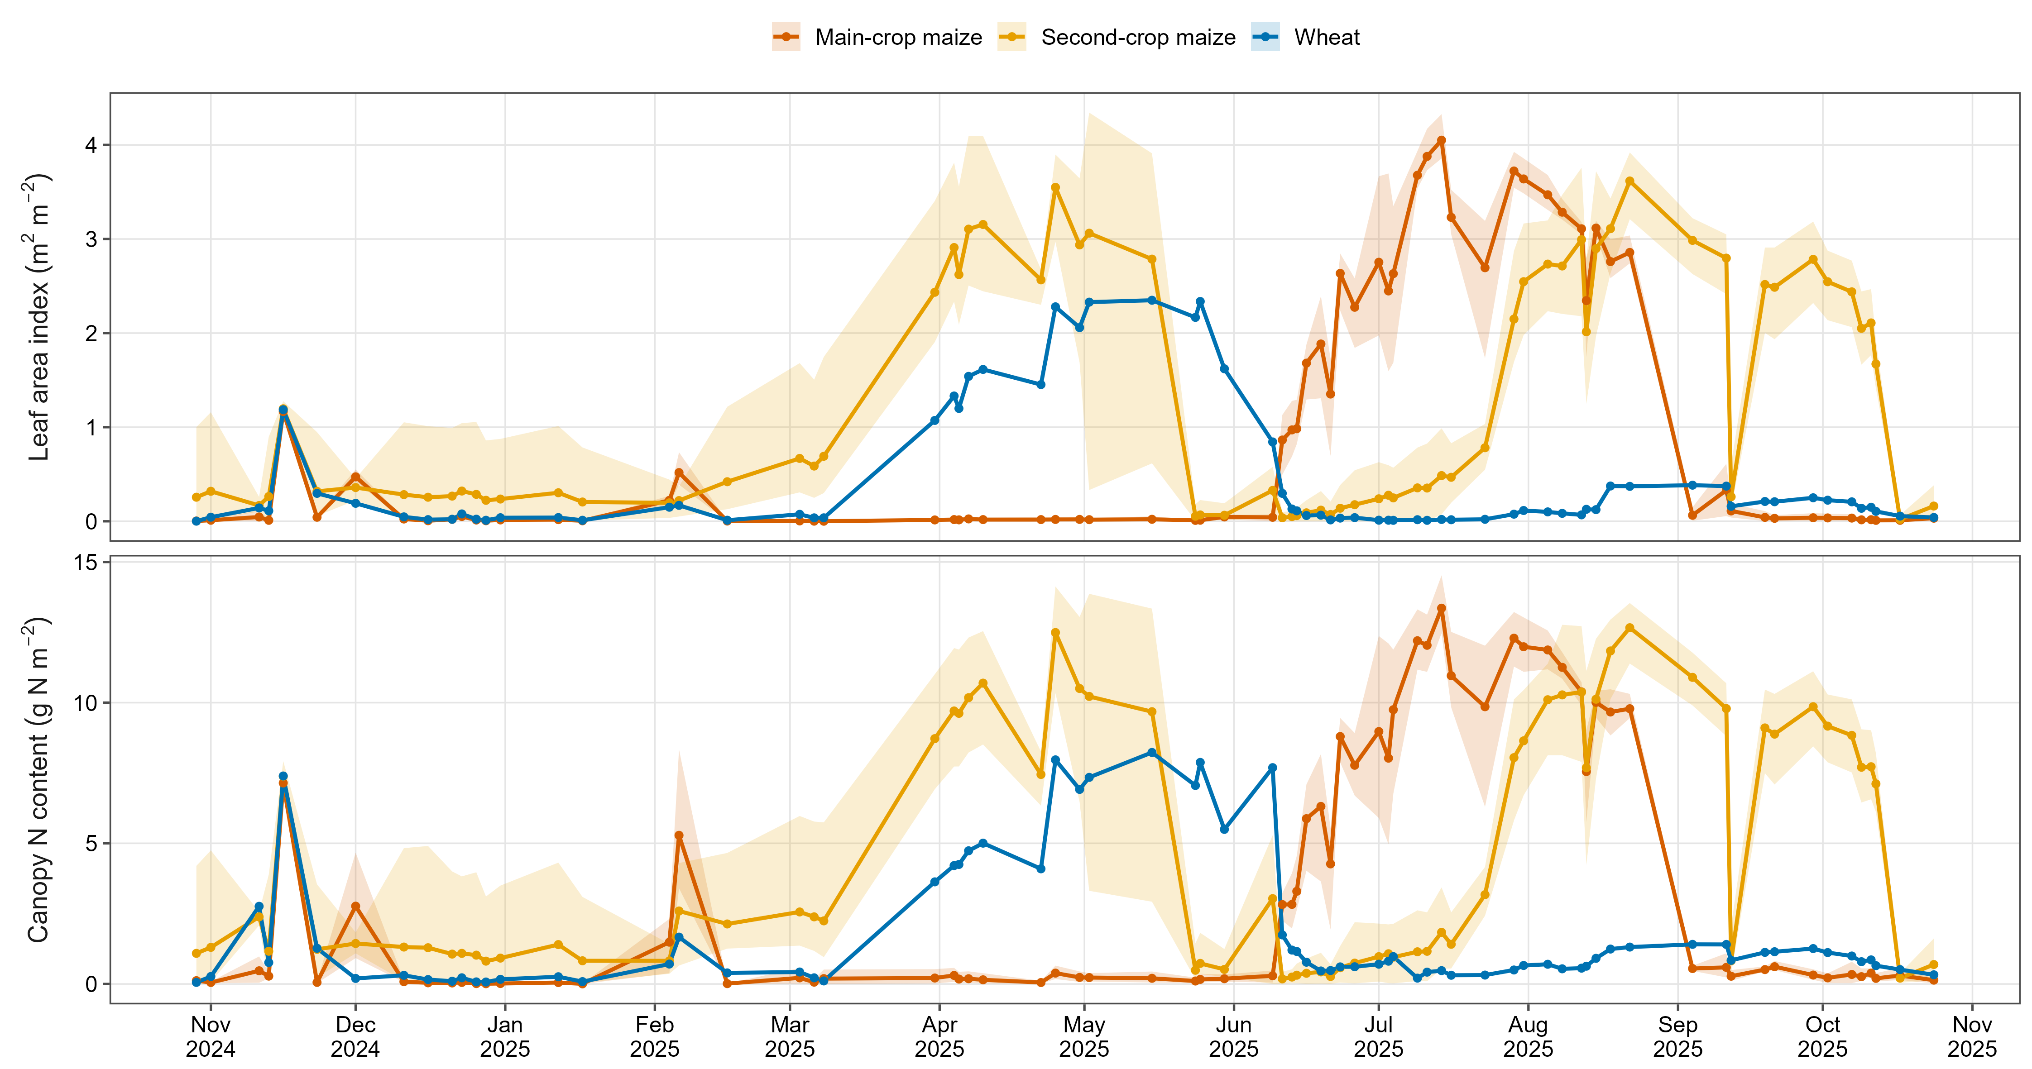
Figure 3. Farm-scale seasonal canopy trajectories at CERZOO, retrieved from the Sentinel-2 time series (October 2024 to October 2025, cloud-masked scenes) by Gaussian-process regression: leaf area index (top) and canopy nitrogen content (bottom) as the crop-group mean (line) with the field-to-field range (band). Main-crop maize peaks in summer, the second-crop fields in spring (the preceding winter crop) and again in late summer (the maize), and wheat in spring.
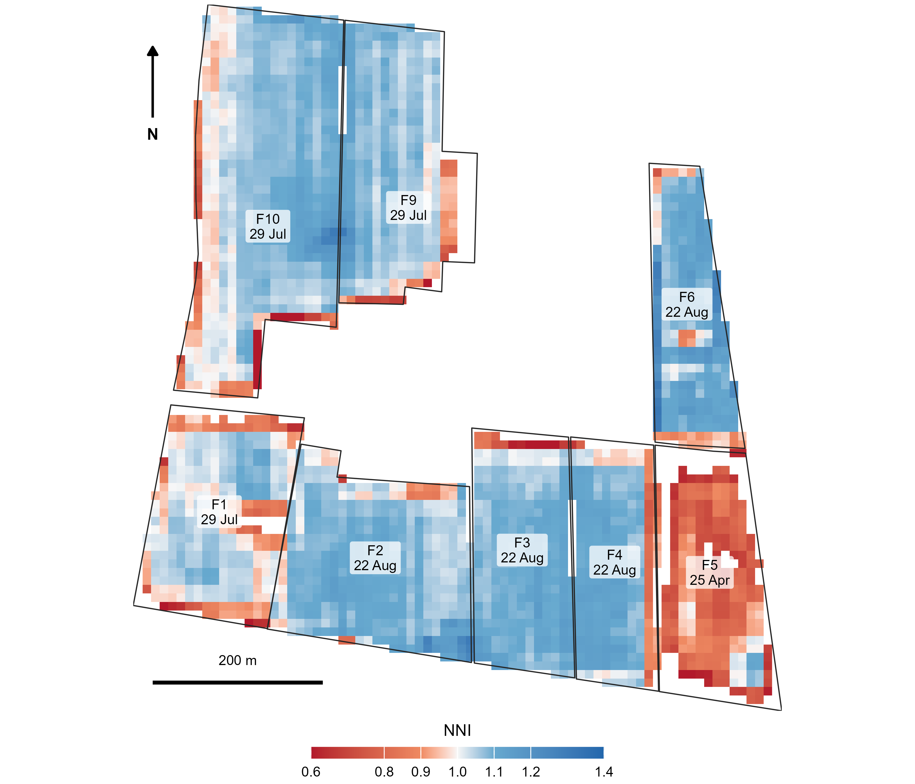
Figure 4. In-season NNI across the CERZOO farm, each field mapped at its 2025 crop-specific peak canopy (date labelled: F5, wheat, on 25 April; the maize fields on 29 July or 22 August) from Sentinel-2 by Gaussian-process biophysical retrieval and the species-specific critical-nitrogen curve. The index moves between deficiency (red, below 0.9), optimal status (pale, 0.9 to 1.1) and luxury consumption (blue, above 1.1), and it varies within every field; NNI = 1 is the theoretical critical value and 0.9 to 1.1 the operational band around it. The absolute index is a first-guess, relative diagnosis: the biophysical retrieval uses uncalibrated leaf-allocation and nitrogen-to-chlorophyll coefficients that can bias the absolute NNI by 15 to 30 percent, so the classes should be read as relative status, not as calibrated absolute values.
Under the mass-balance constraint, the five prescription strategies all reproduce the field target to within 0.04 kg N per ha while differing in within-field contrast (Figure 5). The two calibrations move 1.1 and 2.1 percent of the farm nitrogen between cells of the same field, the NNI zones 7.6 percent and the quantile classes 11.3 percent; 13 percent of the area reaches the dose bounds with the quantile classes, against 4 percent or less with the other strategies.
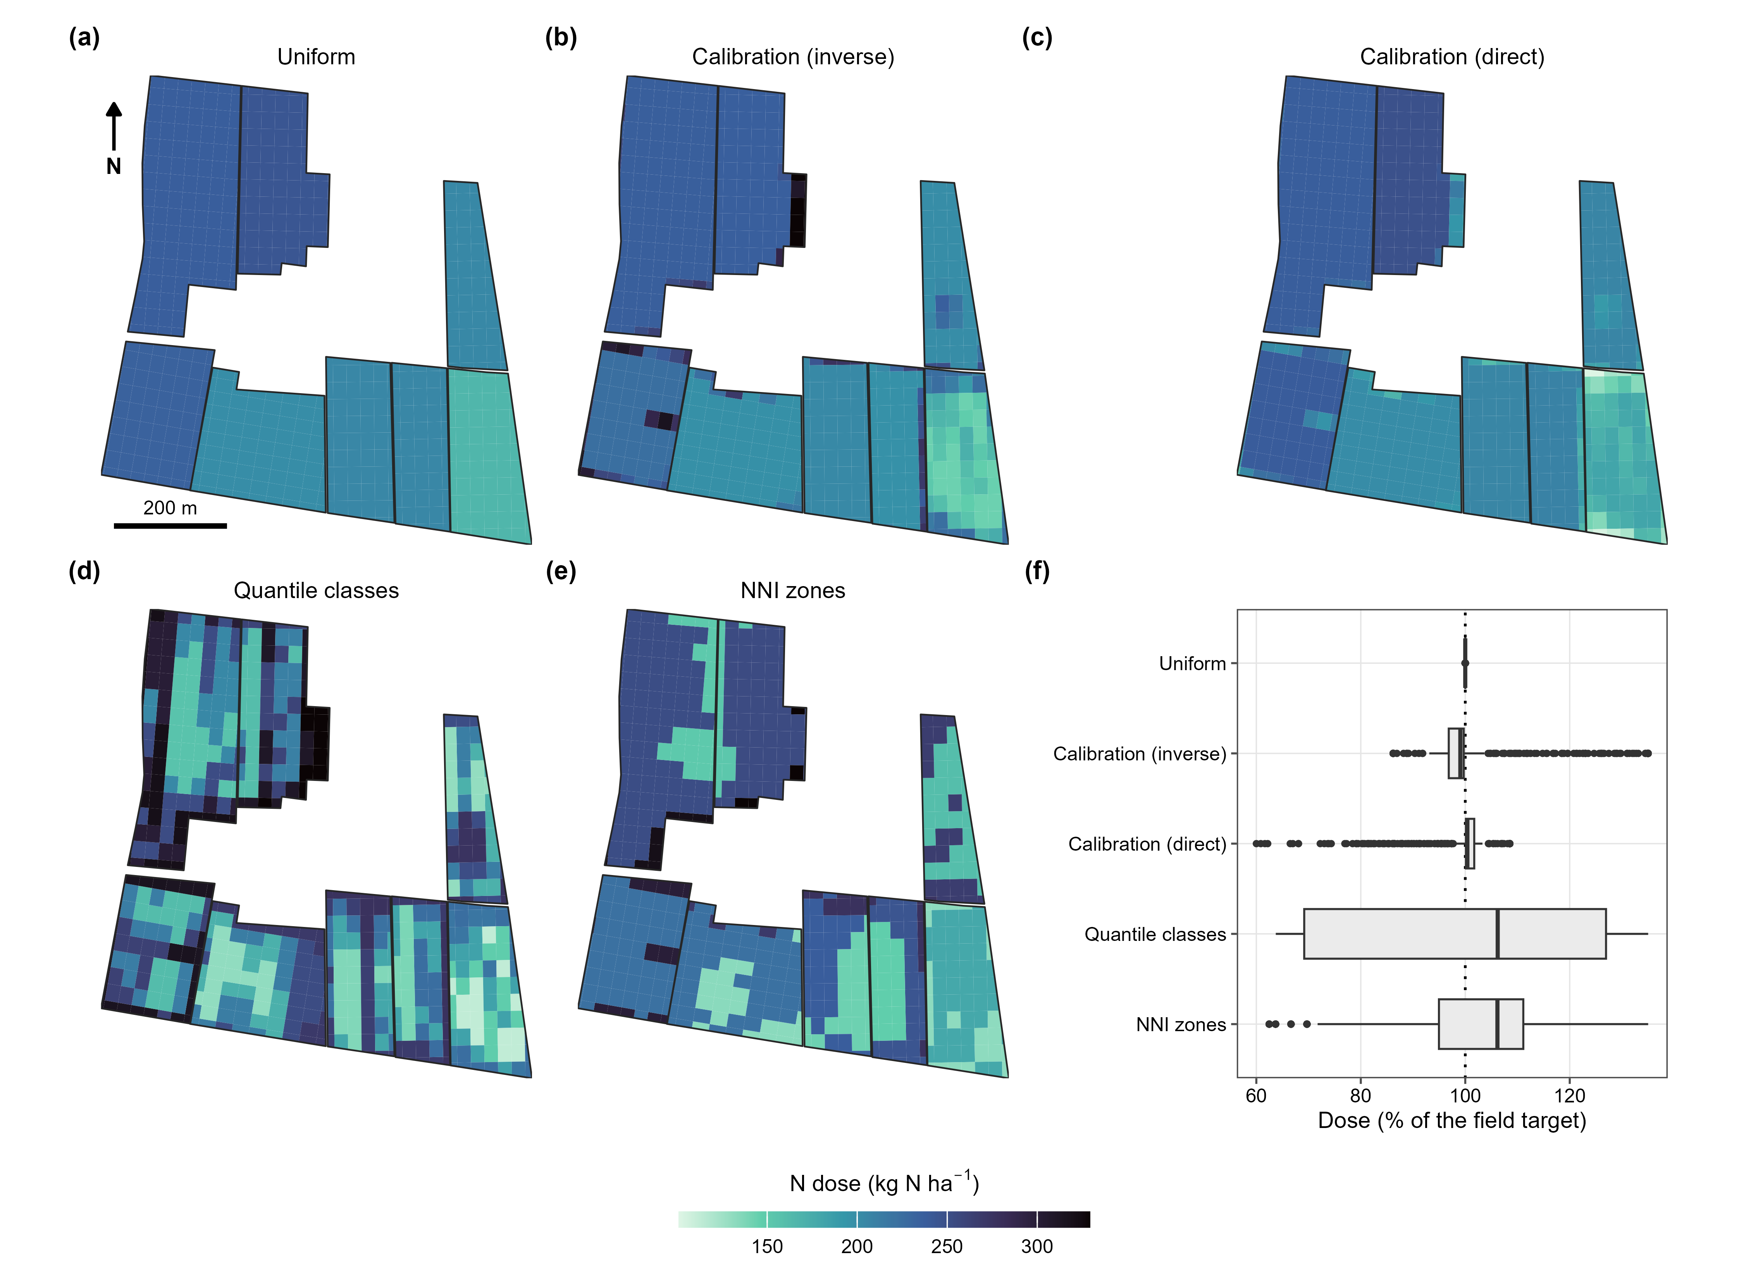
Figure 5. Variable-rate prescription maps across the eight CERZOO fields under five strategies (uniform, calibration inverse and direct, vegetation-index quantile classes, and NNI zones), each constrained to its own field target and shown on a common colour scale. The uniform strategy varies only between fields (by crop), while the sensor-driven strategies add the within-field pattern from the canopy. The last panel gives the area-weighted distribution of the prescribed dose relative to the field target for each strategy (box: quartiles; whiskers: 1.5 times the interquartile range): uniform sits at the target; the two calibrations spread it moderately (inverse 86 to 135 percent, direct 60 to 109 percent, mostly downward); the quantile classes and the NNI zones differentiate most (about 62 to 135 percent).
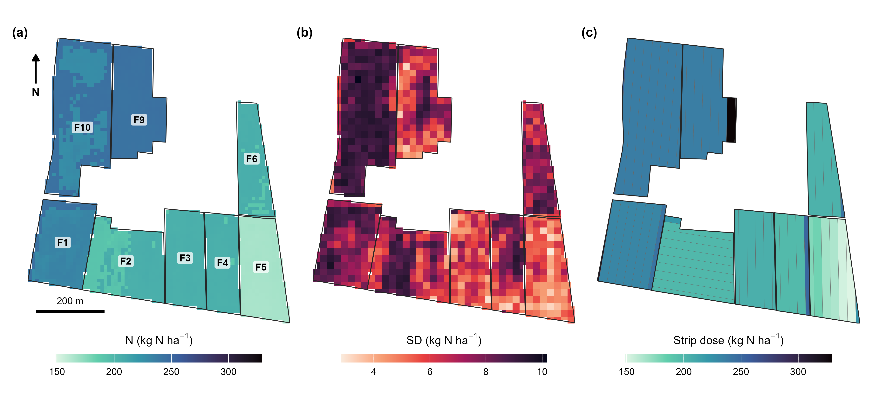
Figure 6. Farm-scale application on the eight CERZOO fields in one computation: (a) the nitrogen dose, with the crop-driven contrast between the main-crop maize fields (F1, F9, F10), the second-crop maize fields (F2, F3, F4, F6) and the wheat field (F5); (b) the soil-propagated standard deviation of the dose; (c) the machine-width strip prescription (24 m strips) delivered to the farm monitor. Within-field variation is small on these homogeneous soils, so the between-field crop difference dominates the pattern, while the propagated uncertainty (b) has a within-field texture of its own.
From the same computation the prescription is delivered as machine-ready strips (Figure 6c) or as a two-dimensional cell grid (Section 2.5), always preserving the field mean. Changing only the machine geometry re-tiles the whole farm automatically (Supplementary Figure S1): a 24 m strip delivery gives 58 passes over the eight fields, while a full two-dimensional grid ranges from 359 cells at a 36 m working width to 2547 at 12 m, the finer machine resolving the within-field pattern more closely. Each prescription is exported to the interoperable formats read by farm monitors (shapefile, GeoJSON, KML, GeoPackage, ISOXML, and the John Deere and Trimble formats).
The choice of cell size trades machine simplicity against spatial fidelity, at a rate that depends on the strategy. Reproducing the finest (10 m) within-field prescription with a coarser square grid loses pattern progressively (Supplementary Figure S2): at a 24 m cell only about 46 to 61 percent of the finest pattern is reproduced, and by 60 m about 24 to 35 percent, the loss being fastest for the sharp NNI zones (up to 50 m) and most gradual for the vegetation-index quantile classes. On these homogeneous soils this sets a practical cell size below which a finer machine adds little differentiation.

3.2 Farm nitrogen accounting
Aggregating the per-field dose to the farm gives a total of 6.91 t N over 32.06 ha (215 kg N per ha, area-weighted), with the per-field totals ranging from 0.55 t on the smallest second-crop field to 1.64 t on the largest main-crop maize field (Table 2). Every field is below its MAS.
Table 2. Per-field and farm nitrogen accounting at CERZOO under the DPI reference weather: crop, expected yield, area, area-weighted mean dose, crop maximum allowed dose (MAS) and nitrogen total (source: paper/sat/data/farm_accounting.csv). Silage-maize yields are fresh forage weight; the wheat yield is grain.
Field | Crop | Yield (t ha⁻¹) | Area (ha) | Mean dose (kg N ha⁻¹) | MAS (kg N ha⁻¹) | N total (t)
F1 | Silage maize | 70 | 3.90 | 234 | 280 | 0.91
F2 | Grass + second-crop silage maize | 60 | 4.53 | 200 | 280 | 0.90
F3 | Grass + second-crop silage maize | 60 | 3.23 | 205 | 280 | 0.66
F4 | Grass + second-crop silage maize | 60 | 2.78 | 205 | 280 | 0.57
F5 | Soft wheat | 6 | 3.67 | 166 | 190 | 0.61
F6 | Second-crop silage maize | 60 | 2.72 | 204 | 280 | 0.55
F9 | Silage maize | 70 | 4.31 | 244 | 280 | 1.05
F10 | Silage maize | 70 | 6.93 | 237 | 280 | 1.64
Farm | 8 fields | – | 32.06 | 215 | – | 6.91
The dose is driven mainly by the crop and its expected yield between fields, from the main-crop maize (F1, F9, F10; 70 t/ha fresh forage, about 240 kg N per ha) through the second-crop maize (60 t/ha, about 205 kg N per ha) to the wheat field (F5; 6 t/ha grain, 166 kg N per ha), because within-field soil variation is small on these homogeneous alluvial soils: the within-field coefficient of variation of the dose is 0.2 to 3.5 percent across the eight fields. On such soils the balance alone gives a near-uniform field dose, and the within-field variable-rate contrast comes from the in-season NNI (Figure 5) rather than from the soil. The soil-propagated uncertainty, by contrast, has a spatial texture within each field (Figure 6b), and it is this uncertainty, not a strong within-field dose gradient, that the tool surfaces on homogeneous soils.

3.3 Soil-map uncertainty from pixel to farm (RQ2, RQ3)
The per-pixel standard deviation of the dose is 7.1 kg N per ha, or 3.3 percent of the dose (Figure 6b). Soil texture contributes 95 percent of the dose variance for maize and 96 percent for wheat, soil carbon and nitrogen the remainder (Figure 7a). Propagation hardly shifts the mean: the Monte Carlo mean dose differs from the deterministic dose by -1.8 to +1.5 percent per field (-3.6 to +3.6 kg N per ha) and by -0.4 percent for the farm. With the RMSE at the ends of its 95 percent interval, the per-pixel uncertainty becomes 2.8 and 3.8 percent: a 44 percent larger input error raises it by only 16 percent, because the class thresholds of the balance, not the size of the error, set most of the response. Doses inside and outside the area of applicability differ by 3 percent (217 against 210 kg N per ha; 82 and 18 percent of the mapped area).
How the pixel uncertainty scales to the farm total depends on the spatial correlation of the map error (Figure 7b). Under the block model, the standard deviation of the farm nitrogen total rises from 0.1 percent when the error decorrelates within a pixel to 2.5 percent when it is systematic. The systematic value stays below the 3.3 percent per-pixel uncertainty because the pixels cross the class thresholds of the balance at different points of the same error, so even a common error does not move all pixel doses together. Direct re-evaluation at two correlation lengths gives 0.44 and 1.50 percent, within 4 percent of the block model (0.42 and 1.44 percent). The leave-one-out residuals of the soil maps show no spatial structure: in every distance class, including the shortest (0 to 150 m), their semivariance lies inside the permutation envelope (Supplementary Table S1). No spatial structure is detectable at the sampling spacing (45 m or more); taking 150 m, the width of the first distance class, as a conservative bound, the block model gives at most 0.6 percent for the farm total, and CERZOO sits in the short-range regime.
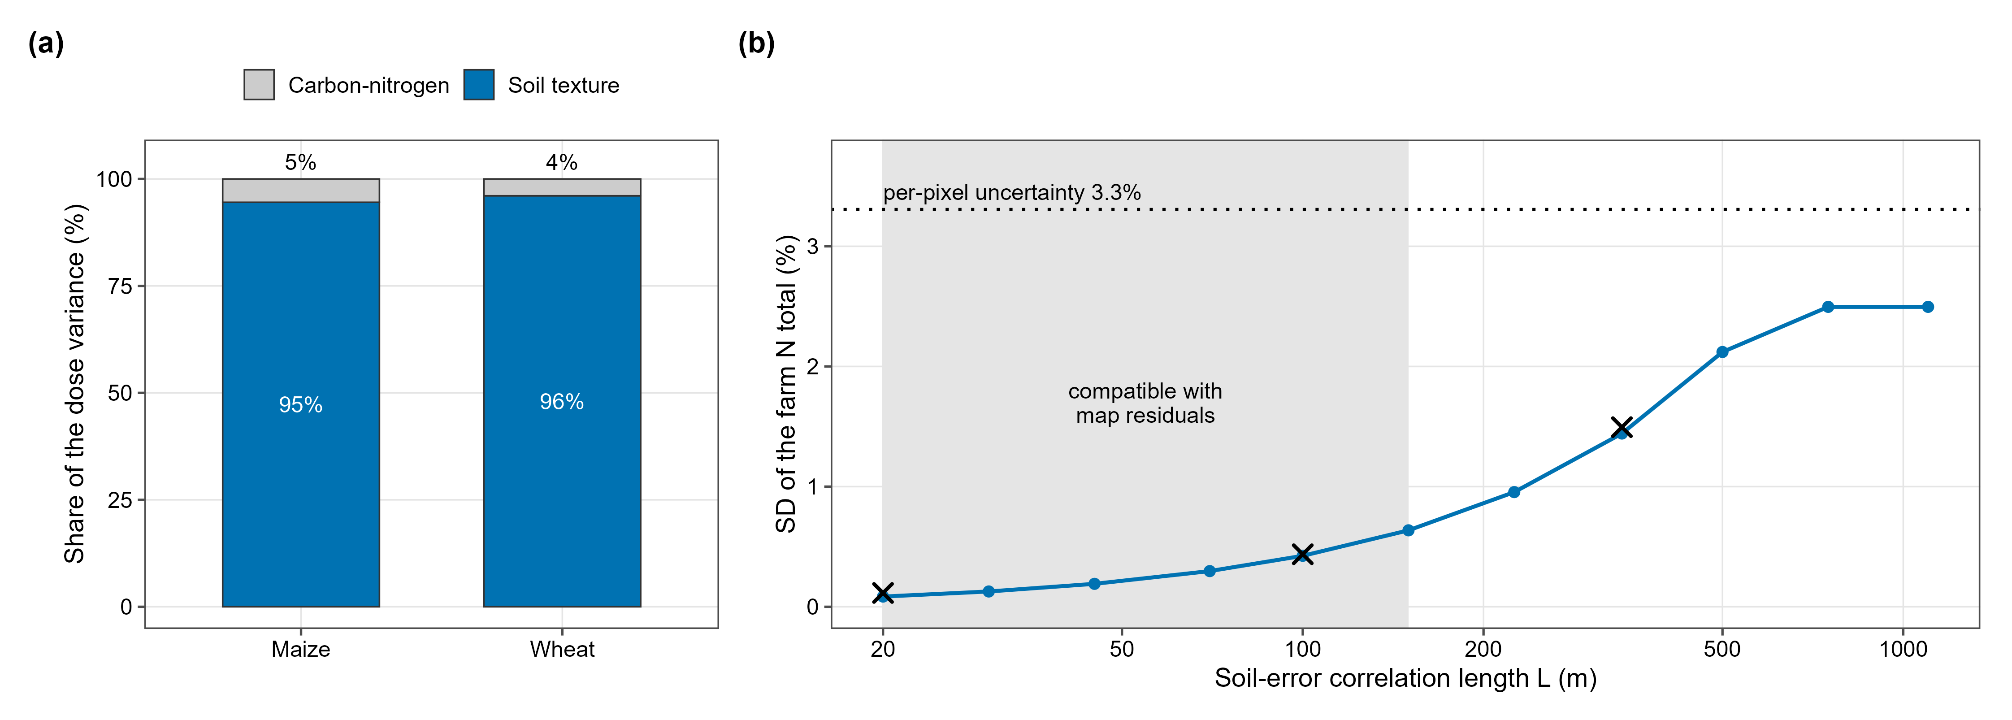
Figure 7. Sources and scaling of the soil-driven nitrogen-dose uncertainty. (a) Per-crop decomposition into soil-texture and carbon-nitrogen contributions: texture dominates for both crops, so denser texture sampling would tighten the dose most. (b) Standard deviation of the farm nitrogen total as a function of the soil-error correlation length, from the short-range (averaging) to the long-range (systematic) regime; crosses mark direct re-evaluations of the balance at two correlation lengths and, at the left end, the independent per-pixel Monte Carlo; the dotted line marks the per-pixel uncertainty (3.3 percent); the shaded band marks the correlation lengths compatible with the leave-one-out residuals of the soil maps (below 150 m).

3.4 Weather input and the maximum allowed dose (RQ4)
With the rainfall measured in 2024 to 2025 (301 mm from October to January and 98 mm in February), all of the ready nitrogen is leached before the crops use it, and the farm total rises to 8.71 t N (272 kg N per ha), 26 percent more than under the reference weather. The dose then exceeds the MAS on four of the eight fields: the three main-crop maize fields (302 to 309 kg N per ha against 280) and the wheat field (231 against 190). Under the DPI such an excess is allowed only if the yields of the previous years document it, which is why NFert reports the check next to the dose.

4. Discussion

4.1 What is established and what is new
The soil-map uncertainty of the regulatory dose at CERZOO is small and stays small on aggregation: 3.3 percent per pixel and at most about 0.6 percent for the farm total, because the map errors show no detectable spatial structure at the sampling spacing. That the uncertainty of a spatial total depends on the correlation of the errors, and that systematic errors do not average out, is established (HEUVELINK et al. 1989; Heuvelink and Pebesma 1999); so is estimating that correlation from map residuals (Wadoux and Heuvelink 2023). What this study adds is the application to a legal instrument: a dose bounded by a crop maximum and a farm total that is audited, computed by a balance whose coefficients change in steps across soil classes. The full correlation-length curve (Figure 7b) is kept because it tells a user of another map where the farm total would sit if the map errors were spatially structured; the residual analysis places CERZOO at the short-range end. The bound rests on 20 points with a minimum spacing of 45 m and on 31 point pairs in the shortest distance class, so the test can exclude only strong structure, and structure at shorter distances cannot be excluded; it would raise the farm uncertainty only within the shaded band of Figure 7b.

4.2 The form of the model decides which soil property matters
In the regulatory balance, soil texture produced 95 to 96 percent of the dose variance, whereas a Monte Carlo propagation through the QUEFTS crop model attributed almost all of the nitrogen uncertainty to soil organic carbon (Takoutsing et al. 2024). The difference follows from the model structure, not from the maps. In the DPI balance, texture sets the soil-supply coefficients and, in wet seasons, the leaching terms, and those coefficients change in steps between texture classes; organic carbon and total nitrogen enter through smoother terms and a carbon-to-nitrogen class. A similar dominance may therefore be expected on other farms under the same guideline, and the practical implication is that sampling for a regulatory dose should target texture. The step structure also explains two results that a smooth model would not produce: the mean dose shifts by up to 1.8 percent in either direction depending on where each field sits relative to a class boundary, and the per-pixel uncertainty grows less than in proportion to the input error. Takoutsing et al. (Takoutsing et al. 2024) found larger mean shifts with QUEFTS, a model whose response to soil inputs is non-linear.

4.3 Soil uncertainty against weather
Under the rainfall measured in 2024 to 2025, the farm dose rose by 26 percent and four fields exceeded the MAS, whereas the soil-map uncertainty of the farm total was below 1 percent. The two numbers are not the same statistic: the first is the difference between two weather scenarios, the second a standard deviation. Placing them on a common scale requires the distribution of the winter rainfall over many years, which this study did not use. Even as a scenario contrast, however, the comparison shows where better information pays off for compliance: on a farm sampled as densely as CERZOO, improving the soil map would barely change the farm total, whereas the weather input moves the dose across the legal cap. This is a value-of-information argument in the sense of Lark and Knights (Lark and Knights 2015). It also places the soil-map error against the 8 percent coefficient of variation reported for whole-farm nitrogen surpluses (Oenema et al. 2015) and the larger uncertainty of the loss terms of nutrient budgets (Oenema et al. 2003).

4.4 The maximum allowed dose as a binding cap
The four fields above the MAS under measured rainfall do not indicate non-compliance. Two rule layers meet there: the DPI balance, which a farmer follows voluntarily within the integrated production scheme, and the MAS, the regional legal cap on crop nitrogen (Regione Emilia-Romagna 2024). In a wet season the balance asks for more than the cap allows, and the DPI admits the excess only when earlier yields document it. NFert reports the check next to the dose for this reason. An auditable record of that decision, with the inputs and the uncertainty that produced it, is the kind of output that digital nutrient-management services can build on.

4.5 Limitations and validation roadmap
The prescriptions have not been validated agronomically: every number is an output of the model, and the evidence on whether variable-rate nitrogen outperforms well-managed uniform application is mixed, with input savings more consistent than yield or profit gains (Diacono et al. 2013; Colaço and Bramley 2018). We therefore claim no yield or profit gain, and call the CERZOO application a case study. The natural next step is a strip trial on the same farm, comparing the uniform balance dose with the NNI-driven prescription and measuring yield, crop nitrogen uptake and the nitrogen nutrition index at a later date. The demonstration rests on one site and one season on homogeneous alluvial soils, so the magnitudes reported here are site-specific; heterogeneous soils would give a larger within-field dose contrast. Only the soil-input uncertainty was propagated, not the error of the satellite retrieval, the weather or the balance coefficients. The NNI rests on uncalibrated leaf-allocation and nitrogen-to-chlorophyll coefficients, with a potential bias of 15 to 30 percent in the absolute index, so it serves here as a relative within-field diagnosis. The area of applicability was computed for the preceding soil model run; doses inside and outside it differ by only 3 percent.

5. Conclusions
Three results transfer beyond CERZOO. First, on a farm sampled at about one point per 1.6 ha, the soil-map uncertainty of a regulatory nitrogen dose is small per pixel (3.3 percent) and smaller still for the farm total (at most about 0.6 percent), because no spatial structure of the map errors was detectable. Second, in a regulatory balance with class coefficients, soil texture rather than organic carbon controlled that uncertainty, and may be expected to do so under similar guidelines, so a sampling plan for compliance should target texture. Third, the weather input moves the dose and the compliance check far more than the soil map does, and should be the next input to propagate.
NFert makes these analyses scriptable. The same open code computes the dose from the pixel to the farm, couples it to a Sentinel-2 diagnosis and a machine-ready prescription, and records how each number was obtained. The package already includes tested phosphorus and potassium balances and an organic-mineral distribution planner; coupling them to the sensor-based prescription and to the uncertainty propagation is future work. Because the coefficient tables are data, the same machinery can be re-parameterised for other regional guidelines that use balance methods.

Declarations
CRediT authorship contribution statement. [confirm per-author roles: Michele Croci: conceptualization, methodology, software, writing; … ]
Declaration of competing interest. The authors declare no competing interests. [confirm; note any relationship with the soil-spatialization provider.]
Funding. This work was supported by the EOAGRITWIN project [confirm grant number and programme].
Data and code availability. NFert is available at https://github.com/mcroci/NFert with an archived release [confirm DOI]. The case-study analysis scripts and data (paper/sat/) and the scripts that produce the figures are in the same repository. The ISTAT crop-yield benchmark (Section 2.8) and the open, SoilGrids-based soil pipeline are fully reproducible from the scripts under paper/data/ and the soilgrids_input() function, under their respective open licences (Istat CC-BY 3.0; SoilGrids CC-BY 4.0). The soil input maps of Section 2.2 are produced by a separate, proprietary pipeline and are available from [CITATION NEEDED: companion work]; their access and credit are stated there.
Declaration of generative AI and AI-assisted technologies in the writing process. [confirm: the authors state here whether and how AI-assisted tools were used, as required by the journal.]
Acknowledgements. The authors thank the Servizio Agricoltura Sostenibile of Regione Emilia-Romagna for publishing the DPI 2026 guidelines and the Fert_Office tool. [confirm]

Supplementary material
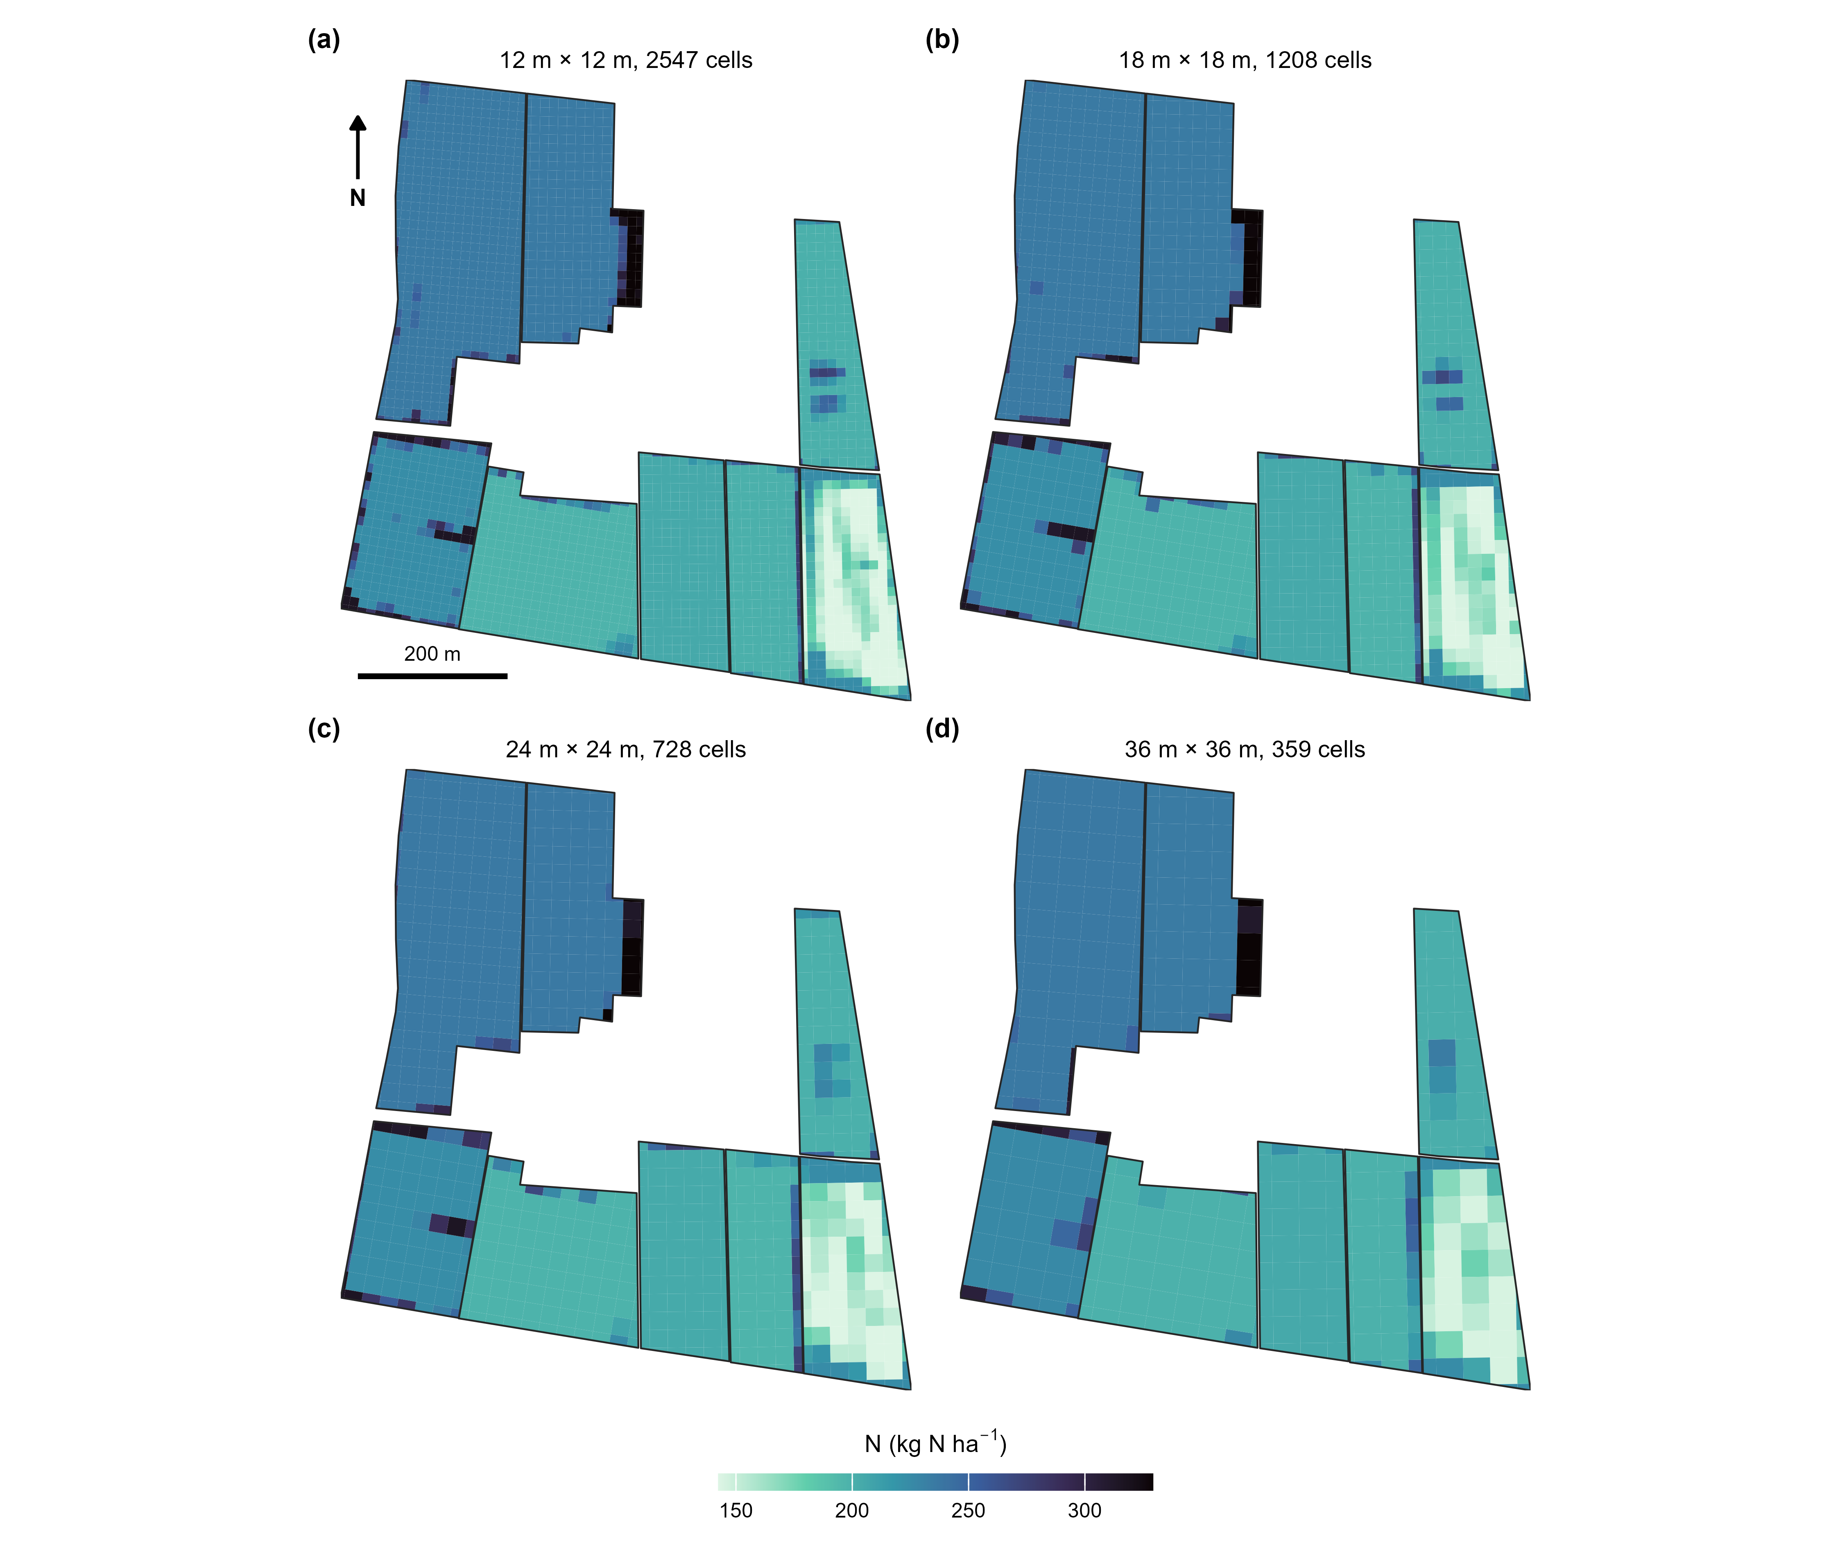
Supplementary Figure S1. Auto-generated two-dimensional variable-rate prescriptions for four machine geometries (working width equal to cell length, 12 to 36 m) across the eight CERZOO fields. The same builder re-tiles each field into cells and assigns the NDVI-driven dose per cell while preserving the field mean, so a finer machine gives a finer grid (2547 cells at 12 m to 359 at 36 m).
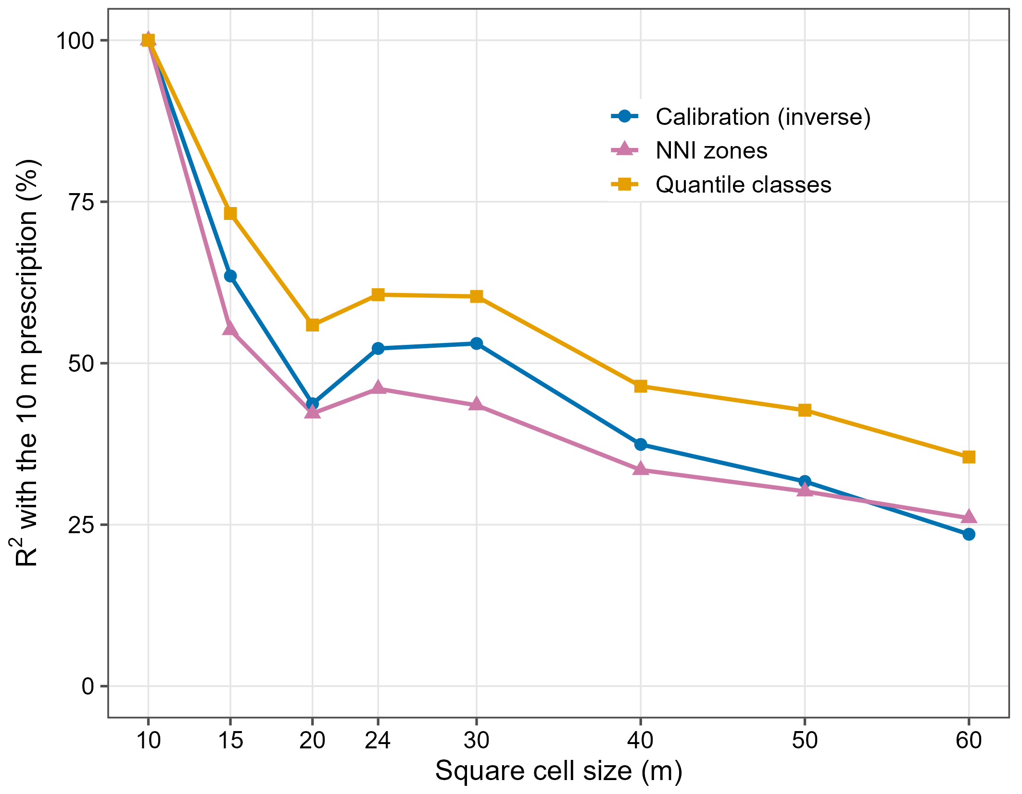
Supplementary Figure S2. Effect of the two-dimensional cell size on the spatial fidelity of the prescription: the coefficient of determination between the coarse-grid prescription and the finest (10 m) prescription, for the three within-field strategies, averaged over the eight CERZOO fields. Fidelity is lowest for the NNI zones up to 50 m and highest for the vegetation-index quantile classes; the curves are not strictly monotonic because grids of 15 and 24 m are not aligned with the 10 m reference.
Supplementary Table S1. Semivariance of the standardised leave-one-out residuals of the soil maps (clay, sand, organic carbon and total nitrogen pooled), by distance class, with the 95 percent envelope of 999 random permutations of the residuals among the 20 sampling points. Values inside the envelope indicate no detectable spatial structure.
Distance (m) | Point pairs | Semivariance | Envelope, 2.5 % | Envelope, 97.5 %
0 to 150 | 31 | 1.07 | 0.76 | 1.33
150 to 300 | 31 | 1.15 | 0.75 | 1.39
300 to 450 | 47 | 1.03 | 0.80 | 1.38
450 to 600 | 44 | 1.17 | 0.83 | 1.28
600 to 1000 | 37 | 0.80 | 0.69 | 1.43

References
Basso, Bruno, Benjamin Dumont, Davide Cammarano, Andrea Pezzuolo, Francesco Marinello, and Luigi Sartori. 2016. “Environmental and Economic Benefits of Variable Rate Nitrogen Fertilization in a Nitrate Vulnerable Zone.” Science of The Total Environment 545–546: 227–35. https://doi.org/10.1016/j.scitotenv.2015.12.104.
Clevers, J. G. P. W., and A. A. Gitelson. 2013. “Remote Estimation of Crop and Grass Chlorophyll and Nitrogen Content Using Red-Edge Bands on Sentinel-2 and -3.” International Journal of Applied Earth Observation and Geoinformation 23: 344–51. https://doi.org/10.1016/j.jag.2012.10.008.
Colaço, A. F., and R. G. V. Bramley. 2018. “Do Crop Sensors Promote Improved Nitrogen Management in Grain Crops?” Field Crops Research 218: 126–40. https://doi.org/10.1016/j.fcr.2018.01.007.
Corti, Martina, Virginia Fassa, and Luca Bechini. 2022. “A Scoping Review of Side-Dress Nitrogen Recommendation Systems and Their Perspectives in Precision Agriculture.” Italian Journal of Agronomy 17 (1): 1951. https://doi.org/10.4081/ija.2021.1951.
Croci, Michele, Andrea Ferrarini, Andrea Fiorini, et al. 2026. NFert: N, P and K Fertilization Following Emilia-Romagna DPI 2026. R Package Version 1.0.0. Https://github.com/mcroci/NFert.
Diacono, Mariangela, Pietro Rubino, and Francesco Montemurro. 2013. “Precision Nitrogen Management of Wheat. A Review.” Agronomy for Sustainable Development 33: 219–41. https://doi.org/10.1007/s13593-012-0111-z.
Donauer, Joseph, Marco Luthardt, Christiane Peter, et al. 2025. “Web-Based Nutrient Management with the Software webBESyD–Scientific Principles, Software Architecture and Model Validation.” Smart Agricultural Technology 11 (August): 100859. https://doi.org/10.1016/j.atech.2025.100859.
Estévez, Jochem, Matias Salinero-Delgado, Katja Berger, et al. 2022. “Gaussian Processes Retrieval of Crop Traits in Google Earth Engine Based on Sentinel-2 Top-of-Atmosphere Data.” Remote Sensing of Environment 273: 112958. https://doi.org/10.1016/j.rse.2022.112958.
European Council. 1991. Council Directive 91/676/EEC of 12 December 1991 Concerning the Protection of Waters Against Pollution Caused by Nitrates from Agricultural Sources. Official Journal of the European Communities L375:1–8.
Gitelson, Anatoly A., Andrés Viña, Verónica Ciganda, Donald C. Rundquist, and Timothy J. Arkebauer. 2005. “Remote Estimation of Canopy Chlorophyll Content in Crops.” Geophysical Research Letters 32 (8): L08403. https://doi.org/10.1029/2005GL022688.
Hamie, Najwane, Riccardo Dainelli, Leandro Rocchi, et al. 2026. “AgroSat: A Precision Farming Tool for Managing in-Field Variation of Optimal Input Rates and Supporting Agronomic Decisions.” Smart Agricultural Technology 14 (August): 102044. https://doi.org/10.1016/j.atech.2026.102044.
HEUVELINK, GERARD B. M., PETER A. BURROUGH, and ALFRED STEIN. 1989. “Propagation of Errors in Spatial Modelling with GIS.” International Journal of Geographical Information Systems 3 (4): 303–22. https://doi.org/10.1080/02693798908941518.
Heuvelink, Gerard B. M., and Edzer J. Pebesma. 1999. “Spatial Aggregation and Soil Process Modelling.” Geoderma 89 (1-2): 47–65. https://doi.org/10.1016/s0016-7061(98)00077-9.
Hijmans, Robert J. 2024. Terra: Spatial Data Analysis. https://CRAN.R-project.org/package=terra.
Holland, Kyle H., and James S. Schepers. 2010. “Derivation of a Variable Rate Nitrogen Application Model for in-Season Fertilization of Corn.” Agronomy Journal 102 (5): 1415–24. https://doi.org/10.2134/agronj2010.0015.
Istat (Istituto Nazionale di Statistica). 2025. Coltivazioni: Superfici e Produzioni (DCSP_COLTIVAZIONI). Data warehouse, dataflow IT1:101_1015, years 2020–2025. https://esploradati.istat.it/.
Janssen, B. H., F. C. T. Guiking, D. van der Eijk, E. M. A. Smaling, J. Wolf, and H. van Reuler. 1990. “A System for Quantitative Evaluation of the Fertility of Tropical Soils (QUEFTS).” Geoderma 46 (4): 299–318. https://doi.org/10.1016/0016-7061(90)90021-Z.
Justes, E., B. Mary, J.-M. Meynard, J. M. Machet, and L. Huché-Thélier. 1994. “Determination of a Critical Nitrogen Dilution Curve for Winter Wheat Crops.” Annals of Botany 74 (4): 397–407. https://doi.org/10.1006/anbo.1994.1133.
Lark, R. M., and K. V. Knights. 2015. “The Implicit Loss Function for Errors in Soil Information.” Geoderma 251-252 (August): 24–32. https://doi.org/10.1016/j.geoderma.2015.03.014.
Lemaire, Gilles, and François Gastal. 1997. “N Uptake and Distribution in Plant Canopies.” In Diagnosis of the Nitrogen Status in Crops, edited by Gilles Lemaire. Springer-Verlag. https://doi.org/10.1007/978-3-642-60684-7_1.
Meyer, Hanna, and Edzer Pebesma. 2021. “Predicting into Unknown Space? Estimating the Area of Applicability of Spatial Prediction Models.” Methods in Ecology and Evolution 12 (9): 1620–33. https://doi.org/10.1111/2041-210x.13650.
Oenema, Jouke, Saskia Burgers, Herman van Keulen, and Martin van Ittersum. 2015. “Stochastic Uncertainty and Sensitivities of Nitrogen Flows on Dairy Farms in the Netherlands.” Agricultural Systems 137: 126–38. https://doi.org/10.1016/j.agsy.2015.04.009.
Oenema, Oene, Hans Kros, and Wim de Vries. 2003. “Approaches and Uncertainties in Nutrient Budgets: Implications for Nutrient Management and Environmental Policies.” European Journal of Agronomy 20: 3–16. https://doi.org/10.1016/S1161-0301(03)00067-4.
Plénet, D., and G. Lemaire. 1999. “Relationships Between Dynamics of Nitrogen Uptake and Dry Matter Accumulation in Maize Crops. Determination of Critical n Concentration.” Plant and Soil 216 (1–2): 65–82. https://doi.org/10.1023/A:1004783431055.
Poggio, Laura, Luis M. de Sousa, Niels H. Batjes, et al. 2021. “SoilGrids 2.0: Producing Soil Information for the Globe with Quantified Spatial Uncertainty.” SOIL 7 (1): 217–40. https://doi.org/10.5194/soil-7-217-2021.
R Core Team. 2025. R: A Language and Environment for Statistical Computing. R Foundation for Statistical Computing. https://www.r-project.org/.
Raun, William R., John B. Solie, Gordon V. Johnson, et al. 2002. “Improving Nitrogen Use Efficiency in Cereal Grain Production with Optical Sensing and Variable Rate Application.” Agronomy Journal 94 (4): 815–20. https://doi.org/10.2134/agronj2002.8150.
Regione Emilia-Romagna. 2024. Regolamento Regionale Emilia-Romagna 2/2024: Massimali Di Apporto Di Azoto (MAS). Bologna, Italy.
Regione Emilia-Romagna. 2026a. Disciplinari Di Produzione Integrata (DPI): Norme Generali, Allegato 2 (Metodo Del Bilancio Dell’azoto), Edizione 2026. Regione Emilia-Romagna, Servizio Agricoltura Sostenibile.
Regione Emilia-Romagna. 2026b. FertDPI / Fert_office V1.26: Strumento Regionale Per Il Piano Di Fertilizzazione. Regional decision-support spreadsheet.
Rose, David C., William J. Sutherland, Caroline Parker, et al. 2016. “Decision Support Tools for Agriculture: Towards Effective Design and Delivery.” Agricultural Systems 149 (November): 165–74. https://doi.org/10.1016/j.agsy.2016.09.009.
Santaga, Francesco Saverio, Paolo Benincasa, Piero Toscano, Sara Antognelli, Emanuele Ranieri, and Marco Vizzari. 2021. “Simplified and Advanced Sentinel-2-Based Precision Nitrogen Management of Wheat.” Agronomy 11 (6): 1156. https://doi.org/10.3390/agronomy11061156.
Seibold, Heidi, Severin Czerny, Siona Decke, et al. 2021. “A Computational Reproducibility Study of PLOS ONE Articles Featuring Longitudinal Data Analyses.” PLOS ONE 16: e0251194. https://doi.org/10.1371/journal.pone.0251194.
Sutton, Mark A., Clare M. Howard, Jan Willem Erisman, et al., eds. 2011. The European Nitrogen Assessment: Sources, Effects and Policy Perspectives. Cambridge University Press. https://doi.org/10.1017/CBO9780511976988.
Takoutsing, Bertin, Gerard B. M. Heuvelink, Ermias Aynekulu, and Keith D. Shepherd. 2024. “Modelling and Mapping Maize Yields and Making Fertilizer Recommendations with Uncertain Soil Information.” Precision Agriculture 26 (1). https://doi.org/10.1007/s11119-024-10200-6.
Verrelst, Jochem, Gustau Camps-Valls, Jordi Muñoz-Marí, et al. 2015. “Optical Remote Sensing and the Retrieval of Terrestrial Vegetation Bio-Geophysical Properties – a Review.” ISPRS Journal of Photogrammetry and Remote Sensing 108: 273–90. https://doi.org/10.1016/j.isprsjprs.2015.05.005.
Vizzari, Marco, Francesco Santaga, and Paolo Benincasa. 2019. “Sentinel 2-Based Nitrogen VRT Fertilization in Wheat: Comparison Between Traditional and Simple Precision Practices.” Agronomy 9 (6): 278. https://doi.org/10.3390/agronomy9060278.
Wadoux, Alexandre M. J.‐C., and Gerard B. M. Heuvelink. 2023. “Uncertainty of Spatial Averages and Totals of Natural Resource Maps.” Methods in Ecology and Evolution 14 (5): 1320–32. https://doi.org/10.1111/2041-210x.14106.
Wilkinson, Mark D., Michel Dumontier, IJsbrand Jan Aalbersberg, et al. 2016. “The FAIR Guiding Principles for Scientific Data Management and Stewardship.” Scientific Data 3: 160018. https://doi.org/10.1038/sdata.2016.18.

