

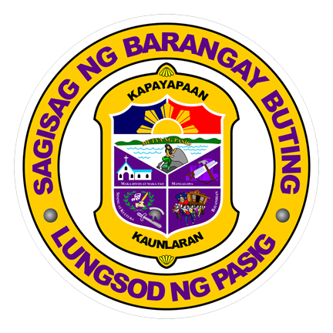

*“Laging angat ang tapat sa sama-samang paglilingkod tungo sa kaunlarang hinahangad”*

*“Laging angat ang tapat sa sama-samang paglilingkod tungo sa kaunlarang hinahangad”*

REPUBLIC OF THE PHILIPPINES

CITY GOVERNMENT OF PASIG

**BARANGAY BUTING**

**NO. 2 Coching St., Buting, Pasig City**

**Telephone Number 641-1440 / 642-7268**

Date: {{**Date**}}

New

Renew

Pursuant to the provision of the Local Government Code Sec. 152, CLEARANCE is issued to

Business Name : {{BusinessName}}

Business Address : {{BusinessAddress}}

Floor Area : {{FloorArea}}

DTI/SEC Reg.No. : {{DTI_SEC_RegNo}}

Business Contact No. : {{BusinessContactNo}}

Owner’s Name : {{OwnerFullName}}

Owner’s Address : {{OwnerAddress}}

Owner’s Contact No. : {{OwnerContactNo}}

This shall take effect upon approval and will terminate on December 31, {{Year}}

Unless sooner revoked for cause or in the interest of the public.

|  |  |  |
| --- | --- | --- |
| **KIND OF BUSINESS** | **CAPITALIZATION** | **REMARKS** |
| {{KindOfBusiness}} | {{Capitalization}} |  |

SUBJECT TO THE CONDITIONS SET AT THE BACK HEREOF:

**Hon. EVELYN TUANO**   
*PUNONG BARANGAY*

CONTROL NO.: {{ControlNo}}   
*NOT VALID WITHOUT DRYSEAL AND WITH ERASURE

{{**Image**}}

**BARANGAY BUSINESS PERMIT**