

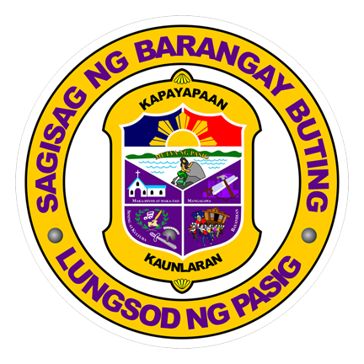

{{**IMAGE**}}

*“Laging angat ang tapat sa sama-samang paglilingkod tungo sa kaunlarang hinahangad”*

**HON. EVELYN G. TUAÑO**

*PUNONG BARANGAY*

*BARANGAY COUNCIL*

**JAYMER C. MALLARI**

**JEFFREY M. CATURA**

**DONNA H. OLIVA**

**PETRONILO B. CRUZ**

**BABY LYNN S. TERO**

**RONNIE R. SAN PEDRO**

**AVELINO A. SANTOS JR.**

**MICHAEL V. LANDICHO**

*BARANGAY SECRETARY*

**ESMERALDA M. PANGULAYAN**

*BARANGAY TREASURER*

**CERTIFICATE OF INDIGENCY**

This is to certify that

{{**FULLNAME**}}

of legal age, is a resident of this BARANGAY

with postal and residential Address at

{{**ADDRESS**}}

and further certified to belong to

an **indigent family**.

This BARANGAY CLEARANCE has been signed and issued to the bearer for whatever legal intent it may serve best.

Done this {{**DATE**}} at Barangay Buting, Pasig

City.

For: {{**PURPOSE**}}

**HON. EVELYN G. TUAÑO**

***PUNONG BARANGAY***

***CONTROL NO.******{{CONTROL NO.}}***

*“Laging angat ang tapat sa sama-samang paglilingkod tungo sa kaunlarang hinahangad”*

REPUBLIC OF THE PHILIPPINES

CITY GOVERNMENT OF PASIG

**BARANGAY BUTING**

**NO. 2 Coching St., Buting, Pasig City**

**Telephone Number 641-1440 / 642-7268**