|  |  |  |  |  |  |
| --- | --- | --- | --- | --- | --- |
| Variable | Hard Drug Use- QL & Lab [N = 36] | No Hard Drug Use – QL  [N = 428] | No Hard Drug Use – Lab  [N = 421] | Total – QL  [N = 464] | Total – Labs  [N = 457] |
| Mental Score Diff  [Mean (SD)] | 3.89 (15.65) | 2.19 (11.74) | NA | 2.32 (12.08) | NA |
| Physical Score Diff  [Mean (SD)] | -4.80 (8.38) | -1.48 (8.16) | NA | -1.73 (8.21) | NA |
| Log10 Viral Load Diff  [Mean (SD)] | -2.72 (1.32) | NA | -2.73 (1.22) | NA | -2.73 (1.22) |
| LEU3N count Diff  [Mean (SD)] | 11.18 (203.63) | NA | 182.59 (173.87) | NA | 169.08 (182.11) |
| Age [Mean (SD)] | 43.89 (9.52) | 43.21 (8.75) | 43.20 (8.78) | 43.26 (8.81) | 43.25 (8.83) |
| BMI [Mean (SD)] | 23.62 (3.45) | 25.38 (4.47) | 25.40 (4.49) | 25.24 (4.42) | 25.26 (4.44) |
| Race: NHW [N (%)] | 19 (52.78%) | 276 (64.49%) | 275 (65.32%) | 295 (63.58%) | 294 (64.33%) |
| Marijuana Use [N (%) – Yes] | 12 (33.33%) | 179 (41.82%) | 175 (41.57%) | 191 (41.16%) | 187 (40.92%) |
| >13 Drinks per Week [N (%)] | 2 (5.56%) | 31 (7.2%) | 32 (7.60%) | 33 (7.11%) | 34 (7.44%) |
| Current Smoker [N (%)] | 27 (75%) | 151 (35.28%) | 148 (35.15%) | 178 (38.36%) | 175 (38.29%) |
| Income <$10,000 [N (%)] | 14 (38.89%) | 84 (19.63%) | 85 (20.19%) | 98 (21.12%) | 99 (21.66%) |
| Income $10,000 - $40,000 [N (%)] | 13 (36.11%) | 183 (42.76%) | 179 (42.52%) | 196 (42.24%) | 192 (42.01%) |
| Income >$40,000 [N (%)] | 9 (25.00%) | 161 (37.62) | 157 (37.29%) | 170 (36.64%) | 166 (36.32%) |
| Education: < High School [N (%)] | 13 (36.11%) | 85 (19.86%) | 82 (19.48%) | 98 (21.12%) | 95 (20.79%) |
| Adherence: >95% [N (%)] | 35 (97.22%) | 384 (89.72%) | 377 (89.55%) | 419 (90.30%) | 412 (90.15%) |

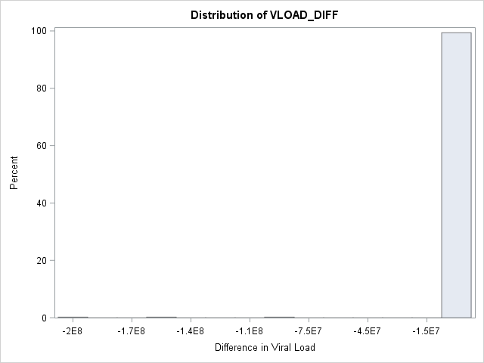

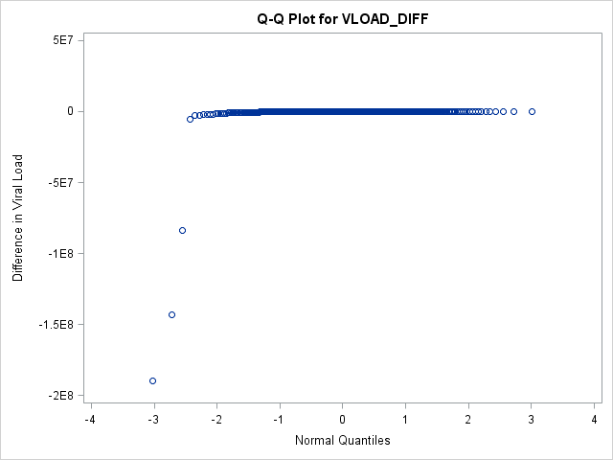

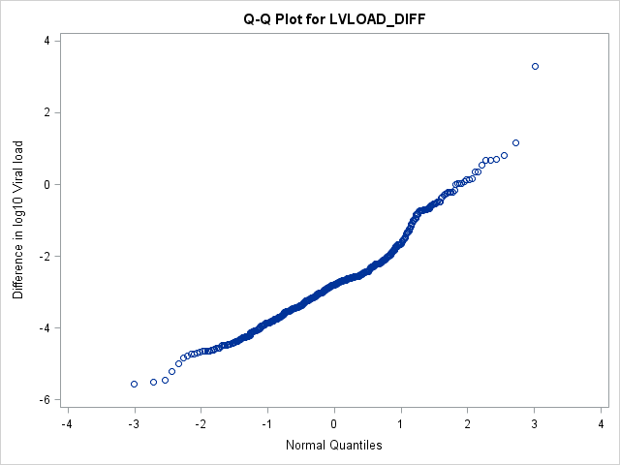

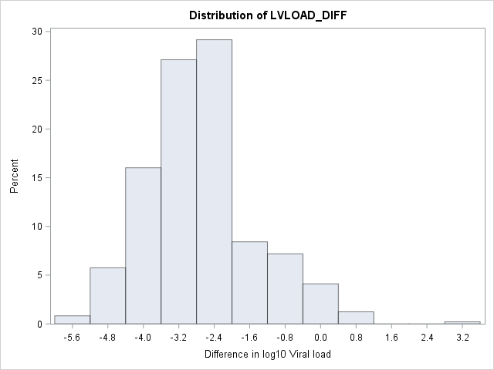

|  |  |  |
| --- | --- | --- |
| Variable | Number missing | Percent missing |
| Difference in Aggregate mental | 216 | 30.21% |
| Difference in Aggregate Physical | 216 | 30.21% |
| Difference in log10 Viral Load | 228 | 31.89% |
| Difference in LEU3N | 228 | 31.89% |
| BMI | 33 | 4.62% |
| Adherence | 209 | 29.23% |
| Income | 34 | 4.76% |