Technical University of Moldova

FCIM

**RAPORT**

Discipline:

«TWA»

Laboratory work nr. 1

«Creation of Quiz using JavaScript»

Made by : student TI-171M, Cvartin Maxim

Controlled by: Vladimir Poddukin

Chisinau 2018

**Task:**

Main task is to create a quiz using HTML and JavaScript. For storing objects use JSON.

**List of specifications:**

* List of questions is predefined in JSON. Question has possible answers and correct answer.
* Questions and answers are in English.
* Questions have three possible answers.
* Number of visible questions is predefined in code.
* Questions are selected automatically in random mode, out of existed questions. Questions should not be duped.
* User can select only one variant of quiz.
* Quiz starts when page is loaded.
* Results are submitted after user press “Submit” button.
* User need to select an answer to each question. In opposite case user will see an alert message.
* As quiz started stopwatch is run. After submit button user will see a message with result and solving time.

**Results:**

Quiz will look like list of questions and answers, with some headers. Representation could be fine in image 1. As shown stopwatch is running.

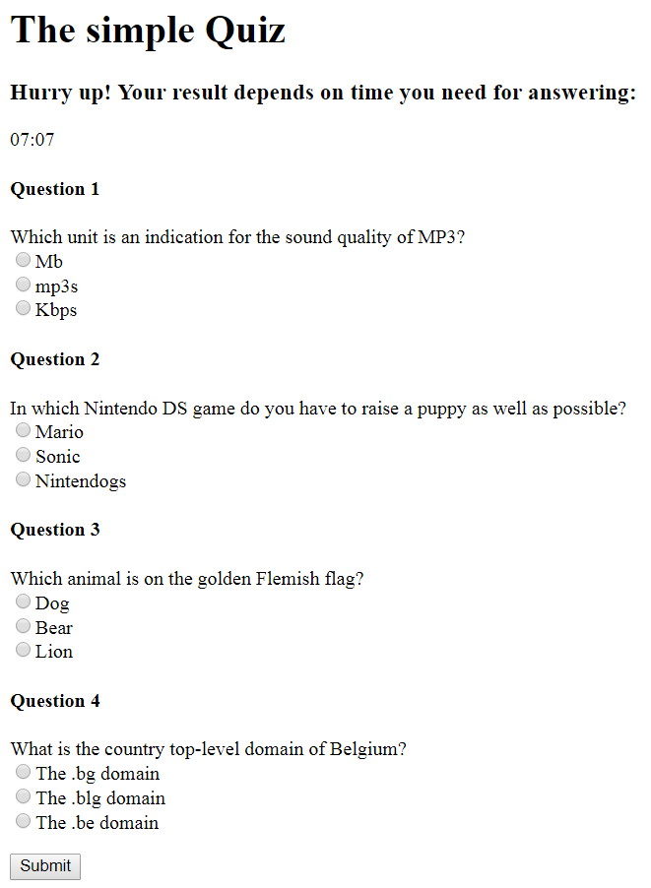

Image 1. Quiz representation.

When user press “Submit” button but not answers are selected he will see a message from image 2.

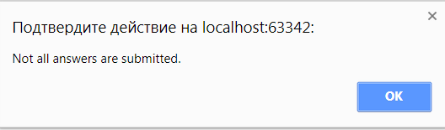

Image 2. Alert when not all answers were selected.

In case when all answers were selected, user will see a message with result. In result will appear number of correct answered questions and timestamp.

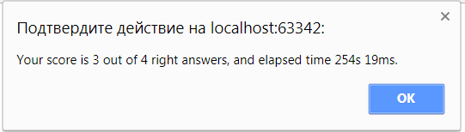

Image 3. Alert when all answers were selected.

**Code Listing**

JSON question structure:

|  |
| --- |
| **var *quizQuestions*** = [  {  **question**: **"What is the name of the network of computers from which the Internet has emerged?"**,  **answers**: {  **a**: **"Google"**,  **b**: **"MegaNet"**,  **c**: **"Arpanet"** },  **correctAnswer**: **"c"** },  {  **question**: **"In what year was Google launched on the web?"**,  **answers**: {  **a**: **"1992"**,  **b**: **"1968"**,  **c**: **"1998"** },  **correctAnswer**: **"c"** },  … |

Creation of question:

|  |
| --- |
| **for** (**var** i = 0; i < ***AVAILABLE_QUESTION_NUMB***; i++) {  hQuestions.push(***document***.createElement(**"H4"**));  hQuestions[i].**innerHTML** = **"Question "** + (i + 1);  ***document***.body.appendChild(hQuestions[i]);  **var** rndNumb = ***usedNumbers***[i];  pQuestions.push(***document***.createElement(**"P"**));  pQuestions[i].**innerHTML** = ***quizQuestions***[rndNumb].**question**;  pQuestions[i].**innerHTML** =***quizQuestions***[rndNumb].**question**+**'<br>'**+  **'<form action="">'**+  **'<input type="radio" value="a" name="r1'**+**'">'**+***quizQuestions***[rndNumb].**answers**.**a**+**'<br>'**+  **'<input type="radio" value="b" name="r1'**+**'">'**+***quizQuestions***[rndNumb].**answers**.**b**+**'<br>'**+  **'<input type="radio" value="c" name="r1'**+**'">'**+***quizQuestions***[rndNumb].**answers**.**c**+**'<br>'**+  **'</form>'**;  ***document***.body.appendChild(pQuestions[i]); } |

Logic in “Submit” button event:

|  |
| --- |
| **function** *submitAnswers*() {  **var** countAnswer = 0;  **var** totalSeconds;   **var** radios = ***document***.getElementsByName(**'r1'**);  **var** checkedRadios = [];  **for** (**var** i = 0; i < radios.length; i++) {  **if** (radios[i].checked) {  checkedRadios.push(radios[i]);  }  }  **var** counter = 0;   **if** (checkedRadios.length == ***AVAILABLE_QUESTION_NUMB***) {  **for** (**var** i = 0; i < ***AVAILABLE_QUESTION_NUMB***; i++) {  **if** (checkedRadios[i].**value** == ***quizQuestions***[i].**correctAnswer**) {  counter++;  }  }  **var** msg;  **if**(***seconds***<5){  msg=**"Your score is "**+ counter+**" out of "**+***AVAILABLE_QUESTION_NUMB***+ **" right answers, and elapsed time "** + ***seconds***+**"s "**+***tens***+**"ms. Way to go!"**;  }  **else if**(***seconds***>=5 && ***seconds***<10)  {  msg=**"Your score is "**+ counter+**" out of "**+***AVAILABLE_QUESTION_NUMB***+ **" right answers, and elapsed time "** + ***seconds***+**"s "**+***tens***+**"ms. Not bad!"**;   }  **else** {  msg=**"Your score is "**+ counter+**" out of "**+***AVAILABLE_QUESTION_NUMB***+ **" right answers, and elapsed time "** + ***seconds***+**"s "**+***tens***+**"ms."**;  }  *alert*(msg);  }  **else** {  *alert*(**'Not all answers are submitted.'**)  } } |

**Conclusions**

In this project were used JavaScript and HTML elements for creating quiz. For storing question with answers were used JSON. Were studied some JavaScript events, methods and functions.