**Lab Report No: 05**

**Name of the Lab Report:** Connecting database (MySQL) in Linux (Ubuntu) Operating System.

**Objective:** From this lab I learn how to connect MySQL in Linux (Ubuntu) operating system and use the MySQL program as a quick and easy way to access databases directly.

* Install MySQL on Ubuntu :

Open the terminal and execute these commands:

sudo apt-get update

sudo apt-get install mysql-server

mysql_secure_installation

* Log into MySQL with Ubuntu :

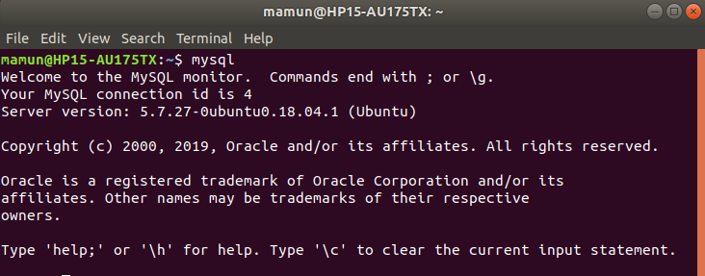

* Show and Create Database :

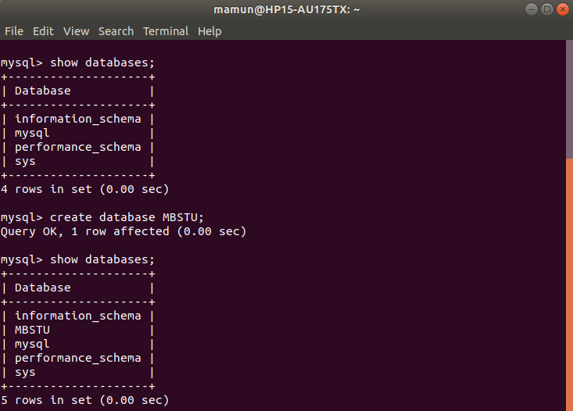

* Create Table :

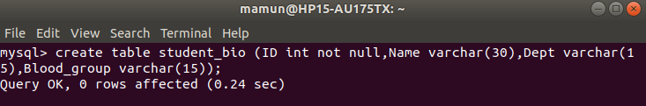

* Insert Data in Table :

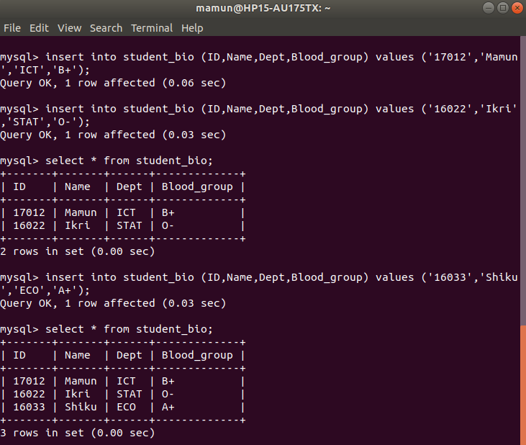

* Describe Table:

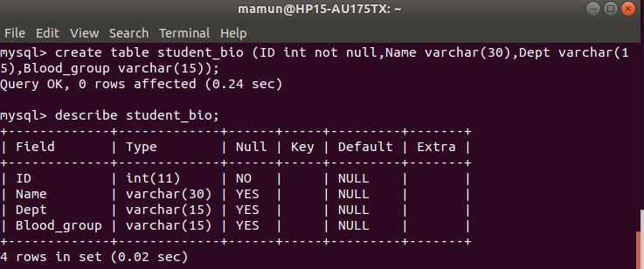

* Update Table:

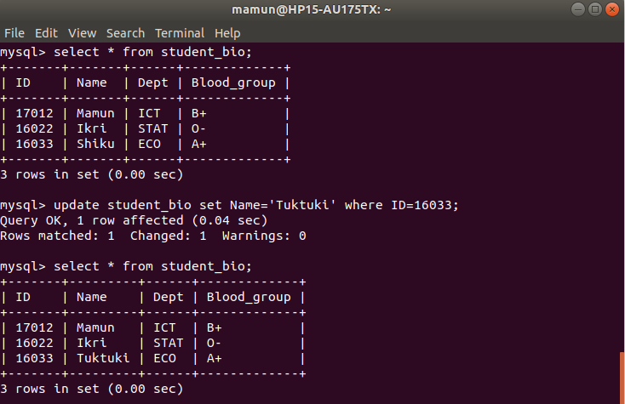

* Delete From Table:

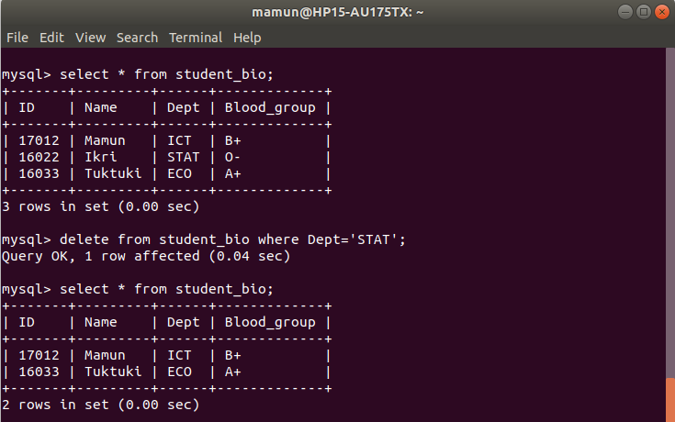

* Drop Table:

