PulseAir: GAN-Augmented Deep Learning and Ensemble Machine Learning for Wearable Air-Quality Risk Forecasting, with Conformal Uncertainty Quantification and External Validation for Bangladesh
A thesis submitted in partial fulfilment of the requirements
for the degree of Bachelor of Science in Computer Science
Submitted by
Md All Shahria
Sanjeda Dewan Mithila
Anik Sarker Rudro
Irfanul Islam Payel

Supervised by
_________________________
Department of Computer Science
American International University-Bangladesh (AIUB)
September 2026

Declaration
We hereby declare that this thesis is based on the results of our own work carried out in the Department of Computer Science, American International University-Bangladesh (AIUB), under the supervision of our supervisor. We further declare that the material contained in this thesis has not been submitted, either in whole or in part, for the award of any other degree or diploma at this or any other institution. Work taken from other sources has been acknowledged and cited in the references.
All code, data-processing pipelines, metrics and figures presented in this thesis are openly available at https://github.com/MD-ALL-SHAHRIA/pulseair. Every quantitative result reported here is reproducible from the committed metrics files in that repository.
_____________________________
Md All Shahria
Date: ______________________
_____________________________
Sanjeda Dewan Mithila
Date: ______________________
_____________________________
Anik Sarker Rudro
Date: ______________________
_____________________________
Irfanul Islam Payel
Date: ______________________

Certificate of Approval
This is to certify that the thesis entitled “PulseAir: GAN-Augmented Deep Learning and Ensemble Machine Learning for Wearable Air-Quality Risk Forecasting, with Conformal Uncertainty Quantification and External Validation for Bangladesh”, submitted by Md All Shahria, Sanjeda Dewan Mithila, Anik Sarker Rudro and Irfanul Islam Payel, has been carried out under my supervision in the Department of Computer Science, American International University-Bangladesh (AIUB). The work is original and, to the best of my knowledge, has not been submitted elsewhere for the award of any degree or diploma. I recommend that it be accepted in partial fulfilment of the requirements for the degree of Bachelor of Science in Computer Science.
_____________________________
Supervisor
Date: ______________________
_____________________________
Head of Department, Department of Computer Science, AIUB
Date: ______________________

Acknowledgement
We are grateful to our supervisor for guidance and for the freedom to report results as we found them, including the ones that did not go our way. We thank the Department of Computer Science at American International University-Bangladesh for the environment and resources that made this work possible, and the faculty whose teaching shaped how we approached it. We also thank the open-source community whose tools this project rests on, and the contributor who improved our evaluation toolkit after its public release. Finally, we thank our families for their patience and support throughout.

Abstract
Wearable air-quality devices are typically evaluated by reporting a headline accuracy for a proposed model. This thesis argues that such a number is uninterpretable without the zero-parameter baseline it must beat, and demonstrates the consequences on real data. At a one-hour horizon the AQI category is unchanged in 80.5% of samples and a persistence rule scores 0.7933 macro-F1 for free; moving the primary horizon to six hours lowers that floor to 0.5118 and turns a persistence echo into a forecasting task.
On the UCI Beijing multi-site dataset, a RandomForest reaches 0.5173 macro-F1 on the test split. Under five-fold rolling-origin cross-validation with an embargo and per-fold rescaling, no Beijing-trained model beats persistence in more than 2 of 5 folds, and persistence's own fold-to-fold spread exceeds any model-to-baseline difference. Three class-imbalance interventions were compared under a disqualification rule that rejects an aggregate gain bought by degrading a safety-critical class: CTGAN augmentation and SMOTE both raise macro-F1 while significantly degrading both advisory classes and are disqualified; only class weighting avoids that trade. Monte Carlo dropout attributes 98.3% of predictive entropy to aleatoric uncertainty, which explains why added capacity made both sequence architectures monotonically worse.
External validation used a published Bangladesh dataset. A data-integrity audit found that discarding its fabricated portion costs 19% of rows but 87% of the advertised twenty-five-year span, because the discarded part is one city at low density. On the surviving window, a class-weighted RandomForest beats persistence in 5 of 5 rolling-origin folds (mean +0.0354, one-sided p = 0.0312) — but the evaluation blocks contain too few advisory-class samples for that result to cover them. Validation against the US Embassy Dhaka reference monitor confirmed why: the reanalysis records 17 Hazardous hours where the instrument records 1,602. A PM2.5-only model trained on that ground truth closes the gap, reaching Hazardous F1 0.4451 against a 0.3167 persistence floor in 7 of 7 folds (p = 0.0156). A survey of OpenAQ found 0 stations near Dhaka meeting multi-pollutant coverage requirements, which bounds what any multi-channel model can currently be validated on.
The contributions are an evaluation protocol released as the open-source package PulseBench, a reusable data-integrity audit, split-conformal and Mondrian uncertainty quantification with per-class coverage, a validated LLM advisory layer whose honesty constraints are enforced outside the model, and a compressed ONNX predictor with measured latency. The device itself is a design, not a fabricated artefact. All code, metrics and figures are public.

Keywords: air-quality forecasting; persistence baseline; rolling-origin cross-validation; class imbalance; conformal prediction; uncertainty quantification; data integrity; edge deployment.

Table of Contents
Declaration
Certificate of Approval
Acknowledgement
Abstract
List of Figures
List of Tables
List of Abbreviations
1. Introduction
1.1 Background and motivation
1.2 The evaluation problem in this literature
1.3 Objectives and contributions
2. Related Work and Theoretical Background
2.1 Ensemble methods: Random Forest and gradient boosting
2.2 Sequence models: LSTM and Transformer
2.3 Synthetic tabular data: CTGAN
2.4 Classical resampling: SMOTE and class weighting
2.5 Conformal prediction
2.6 Explainability: SHAP
2.7 Evaluation protocol: rolling-origin cross-validation
2.8 Multiple comparisons
2.9 Uncertainty quantification
2.10 Edge deployment and TinyML
2.11 Language models for risk communication
3. Materials and Methods
3.1 Datasets
3.2 Preprocessing
3.3 Horizon selection
3.4 Baseline models and evaluation protocol
3.5 Class-imbalance interventions
3.6 Sequence models and uncertainty decomposition
3.7 Conformal prediction
3.8 Explainability and the LLM advisory layer
3.9 Compression and edge deployment
3.10 Rolling-origin cross-validation
3.11 Multiple-comparisons correction
3.12 The PulseBench toolkit
4. Results
4.1 The persistence floor
4.2 Baseline models and rolling-origin cross-validation
4.3 Class-imbalance interventions and the validity-metric failure
4.4 Sequence models, capacity and uncertainty
4.5 Conformal coverage
4.6 Compression and edge deployment
4.7 Sensitivity to the air-quality standard
4.8 Multiple-comparisons correction
4.9 External validation: Bangladesh
4.10 Ground truth: the US Embassy Dhaka monitor
4.11 The validated Hazardous detector
4.12 Monitoring infrastructure: the OpenAQ survey
4.13 The deployed system
4.14 Explainability: SHAP case studies
5. Discussion
5.1 An average says nothing about its tail
5.2 The ceiling is in the data
5.3 Methodology transferred; weights did not
5.4 Data integrity is a result, not a preliminary
5.5 Cheap controls change conclusions
5.6 What reproducibility required in practice
6. Limitations
7. Proposed Wearable Device (Concept — Not Yet Fabricated)
8. Conclusion and Future Work
Data and Code Availability
References
Appendix A: Full Hyperparameter Tables
Appendix B: Glossary of Terms
Appendix C: Index of Generated Reports

List of Figures
Figure 1. Persistence floor across forecast horizons. The highlighted bar is the primary horizon adopted for this thesis. (from horizon_comparison.json)
Figure 2. Every Beijing variant against the persistence floor, with 95% paired-bootstrap intervals on the difference. The dashed rule is the floor. (from ablation_h6.json, gapfill_h6.json, dl_h6.json, smote_h6.json, deployment_h6.json, deployment_h6_cw.json, conformal_h6.json, baseline_h6.json)
Figure 3. Precision, recall and F1 per class for the selected Beijing forest on observed test rows, with per-class support. (from baseline_h6.json)
Figure 4. Class prevalence across the chronological splits, and the validation-minus-test gap that drives repeated disagreement between them. (from hj633_h6.json)
Figure 5. Beijing rolling-origin cross-validation: per-fold macro-F1 across five chronological folds, with mean and standard deviation across folds. (from rolling_cv_h6.json)
Figure 6. What each imbalance intervention does to the aggregate metric and to the two advisory classes. Grey rules mark persistence. (from ablation_h6.json, smote_h6.json, gapfill_h6.json)
Figure 7. Per-class F1 across every Beijing variant, in absolute terms and as a change against the persistence floor. (from ablation_h6.json, gapfill_h6.json, dl_h6.json, smote_h6.json)
Figure 8. Physical validity of CTGAN output before and after the redesign, across both cyclical channels and the temperature/dew-point constraint. (from gan_h6.json, gan_validity_before_fix.json)
Figure 9. Validation macro-F1 against trainable parameter count for both sequence architectures. (from capacity_sweep_h6.json)
Figure 10. Decomposition of mean predictive entropy into aleatoric and epistemic components, by architecture. (from dl_h6.json)
Figure 11. Per-class empirical coverage under marginal and Mondrian conformal calibration, against the target. (from conformal_h6.json)
Figure 12. Distribution of prediction-set size under both calibrations. (from conformal_h6.json)
Figure 13. Serialised model size at each stage of the deployment pipeline, for both datasets, with the macro-F1 cost of compression. (from deployment_h6.json, deployment_h6_bd.json)
Figure 14. Class balance under EPA and HJ 633-2012 breakpoints, and each standard's model-versus-floor comparison. (from hj633_h6.json)
Figure 15. Every persistence comparison under family-wise correction, on a log p-axis, with the uncorrected threshold, the corrected threshold and the bootstrap resolution floor marked. (from ablation_h6.json, gapfill_h6.json, dl_h6.json, smote_h6.json, deployment_h6.json, deployment_h6_cw.json)
Figure 16. Coverage of each dataset: what is advertised against what survives inspection, with the verified-clean boundary marked. (from schematic — no metrics source, by design)
Figure 17. Bangladesh rolling-origin cross-validation: per-fold macro-F1 across five chronological folds. (from rolling_cv_h6_bangladesh.json)
Figure 18. Folds won against persistence on each dataset, under the same protocol. (from rolling_cv_h6.json, rolling_cv_h6_bangladesh.json)
Figure 19. The reanalysis against the reference monitor over their overlapping period: advisory-class hours and the PM2.5 distribution. (from dhaka_ground_truth.json)
Figure 20. Hazardous-class and aggregate performance against the persistence floor across seven rolling-origin folds, with every fold shown. (from dhaka_pm25_model_h6.json)
Figure 21. Stations near Dhaka by provider and by reported pollutant, and the number surviving each coverage filter. (from openaq_survey.json)
Figure 22. The deployed Bangladesh predictor, stage by stage, with the validator drawn outside the model column. (from schematic — no metrics source, by design)
Figure 23. The full project pipeline: the Beijing methodology track, the Bangladesh deployment track, and what each produced. (from schematic — no metrics source, by design)

List of Tables
Table 1. The four data sources used in this thesis. (from bangladesh_h6.json, dhaka_ground_truth.json, openaq_survey.json)
Table 2. Beijing class distribution across the chronological splits, under EPA breakpoints. The splits do not share a distribution, which Section 4.2 returns to. (from hj633_h6.json)
Table 3. Preprocessing configuration. (from configs/default.yaml)
Table 4. What the advisory validator rejects, and why. (from src/explainability/llm_advisory.py validation rules)
Table 5. The PulseBench public interface. (from pulsebench/ package interface)
Table 6. Persistence degrades monotonically as the forecast horizon grows. (from horizon_comparison.json)
Table 7. Every Beijing variant on the same test rows, against the persistence floor. Intervals are 95% paired bootstrap on the difference. (from ablation_h6.json, gapfill_h6.json, dl_h6.json, smote_h6.json)
Table 8. Beijing rolling-origin cross-validation over 5 folds, 24-hour embargo. The signed-rank floor for 5 folds is 0.0312 one-sided. (from rolling_cv_h6.json)
Table 9. Beijing rolling-origin folds in detail: evaluation window, sample counts and per-fold macro-F1 for every model. (from rolling_cv_h6.json)
Table 10. The three class-imbalance interventions, with their cost. (from ablation_h6.json, smote_h6.json, gapfill_h6.json)
Table 11. Physical validity of CTGAN output, before and after the redesign. The before column was regenerated by deliberately re-running the original broken configuration; it is a reproduction of the same failure, not the same random draw. (from gan_validity_before_fix.json, gan_h6.json)
Table 12. CTGAN synthesis plan. The majority class is Unhealthy at 102,722 observed rows; minorities are lifted to 51,361, not to parity. (from gan_h6.json)
Table 13. Synthetic Data Vault quality scores per class, for the corrected configuration. The configured flagging floor is 0.9. These scores are what the failed configuration also passed. (from gan_h6.json)
Table 14. Sequence models against the tabular baseline and the persistence floor, on the same observed test rows. (from dl_h6.json)
Table 15. Learning-rate sweep on validation macro-F1, 25 epochs with patience 6. Both architectures were optimisation-limited at the larger rates. (from dl_lr_sweep_h6.json)
Table 16. Capacity sweep at lr = 0.0003. Validation macro-F1 falls monotonically with size for both architectures. (from capacity_sweep_h6.json)
Table 17. Calibration measured two ways. The rankings disagree. (from dl_h6.json)
Table 18. Per-class conformal coverage under marginal and Mondrian calibration, with the change in mean set size. (from conformal_h6.json)
Table 19. Prediction-set size distribution under both calibrations. A single confident category is the exception under either. (from conformal_h6.json)
Table 20. Compression and export, both datasets. (from deployment_h6.json, deployment_h6_bd.json)
Table 21. The two-sided compression sweep on the deployment dataset. A candidate must be within tolerance of the full model *and* significantly above that dataset's own persistence floor. (from deployment_h6_bd.json)
Table 22. The same data under two national standards. (from hj633_h6.json)
Table 23. Bonferroni correction over 9 comparisons against persistence on the same test split (corrected threshold 0.0056). (from compile_results.collect() via pulsebench.bonferroni_report)
Table 24. Data-integrity audit of the published Bangladesh dataset. Every value is recomputed from the raw file at report time. (from bangladesh_h6.json (audit block))
Table 25. Bangladesh rolling-origin cross-validation over 5 folds, 24-hour embargo. The signed-rank floor for 5 folds is 0.0312 one-sided. (from rolling_cv_h6_bangladesh.json)
Table 26. Bangladesh rolling-origin folds in detail: evaluation window, sample counts and per-fold macro-F1 for every model. (from rolling_cv_h6_bangladesh.json)
Table 27. Per-class conformal coverage for the deployed Bangladesh model (Bangladesh-native RandomForest (class_weight=balanced)). (from bangladesh_h6.json)
Table 28. Reference monitor against the reanalysis over 23,010 overlapping hours. (from dhaka_ground_truth.json)
Table 29. PM2.5-only model on the reference series, 7 rolling-origin folds. The signed-rank floor over 7 folds is 0.0156 two-sided, which this result attains. (from dhaka_pm25_model_h6.json)
Table 30. Phase 11b folds in detail. The model leads on Hazardous F1 in every fold, including the folds whose evaluation window misses the winter pollution season. (from dhaka_pm25_model_h6.json)
Table 31. OpenAQ station survey around Dhaka. (from openaq_survey.json)
Table 32. The deployed Bangladesh predictor. (from deployment_h6_bd.json, bangladesh_h6.json)
Table 33. The 5 advisory examples, with the generated text each produced. Every advisory naming an ambiguous set hedges explicitly; that is enforced by the validator, not left to the model. (from reports/llm_advisory_examples.md)
Table 34. Global mean absolute SHAP attribution by channel. (from shap_h6.json)
Table 35. The 12 SHAP case studies, with the three channels carrying the largest attribution in each. (from shap_h6.json)
Table 36. Companion application features implied by the software built here. (from derived from the implemented software modules)
Table 37. ata and splits parameters. (from configs/default.yaml)
Table 38. reprocessing parameters. (from configs/default.yaml)
Table 39. abular baselines parameters. (from configs/default.yaml)
Table 40. ynthetic augmentation (CTGAN) parameters. (from configs/default.yaml)
Table 41. equence models parameters. (from configs/default.yaml)
Table 42. onformal prediction parameters. (from configs/default.yaml)
Table 43. xplainability and advisory parameters. (from configs/default.yaml)
Table 44. eployment parameters. (from configs/default.yaml)
Table 45. The 34 generated reports in the repository. (from reports/ directory listing)

List of Abbreviations
API | Application Programming Interface
AQI | Air Quality Index
CI | Confidence Interval
CO | Carbon Monoxide
CTGAN | Conditional Tabular Generative Adversarial Network
CV | Cross-Validation
DEWP | Dew Point
ECE | Expected Calibration Error
EPA | United States Environmental Protection Agency
ESP32 | Espressif 32-bit microcontroller
F1 | Harmonic mean of precision and recall
GAN | Generative Adversarial Network
HJ 633-2012 | Chinese Technical Regulation on Ambient Air Quality Index
LLM | Large Language Model
LSTM | Long Short-Term Memory
MC | Monte Carlo
MCE | Maximum Calibration Error
ONNX | Open Neural Network Exchange
PM10 | Particulate matter under 10 micrometres in diameter
PM2.5 | Particulate matter under 2.5 micrometres in diameter
QC | Quality Control
RF | Random Forest
SD | Standard Deviation
SHAP | SHapley Additive exPlanations
SMOTE | Synthetic Minority Over-sampling Technique
TEMP | Air Temperature
TFLite | TensorFlow Lite
XGBoost | Extreme Gradient Boosting

1. Introduction

1.1 Background and motivation
General framing, not a result of this project. The paragraphs in this subsection describe the wider context that motivates a wearable air-quality device. They are not findings of this thesis, and the epidemiological and exposure literature they would properly cite is outside the scope of what this project measured. No number in this subsection is used anywhere else in the document.
Fine particulate matter under 2.5 micrometres (PM2.5) penetrates deep into the respiratory tract, and sustained exposure is associated with cardiovascular and respiratory harm. In dense South Asian cities, including Dhaka, seasonal concentrations reach levels far above international guideline values during the winter months, while the monitoring infrastructure that would let an individual know their own exposure remains sparse. A person moving through such a city experiences a concentration that depends on street, hour and activity, not on the single citywide figure a public index reports.
Exposure studies in Bangladesh and comparable settings document both the magnitude of the problem and the difficulty of measuring it at the level of an individual (Rahman, Begum, Hopke, Nahar, Newman, Thurston 2021; Lee, Bayazid, Rosenthal, Khan, Arku, Barratt, Quayyum, Baumgartner 2025, Scientific Reports; Rahman & Meng 2024). Monitoring and reporting organisations track the resulting concentrations at city scale (CREA 2025), and applied machine-learning studies have modelled Dhaka's particulate levels from station and satellite inputs (Hasan, Rahman, Akhter, Mohinuzzaman, Kayes & Rahman 2024; Islam et al. 2023). What none of these give a person walking through the city is their own exposure.
Personal and mobile sensing has been proposed as the answer, using phones as exposure monitors ("Mobile phones as monitors of personal exposure to air pollution" 2018, PLOS ONE) and applications to make invisible pollution legible to the people breathing it ("Can Apps Make Air Pollution Visible?" 2019, Journal of Business Ethics). A dedicated wearable extends that idea with a sensor placed at the breathing zone rather than in a pocket.
That gap motivates a wearable: a device carried on the body that samples the air the wearer is actually breathing, forecasts where it is heading over the next few hours, and says something useful about it. PulseAir is such a device, designed around an ESP32 microcontroller. This thesis concerns everything that happens away from the device — the data preparation, the forecasting models, the uncertainty quantification, the explanation layer, and the compression that would let a trained model run on the hardware.
The device itself is a design in this thesis, not a fabricated artefact. Chapter 7 describes the concept and states plainly what has and has not been built.
This work also sits alongside an explicit national policy direction. Bangladesh's National Air Quality Management Plan 2024–2030 anticipates that, once forecasting systems are in place, restrictions on high-pollution days could be triggered days ahead on the basis of forecasts rather than only after measured exceedances (Government of Bangladesh 2024) (§3.4). The Department of Environment's own intended route to those forecasts is physics-based chemistry-transport modelling — models such as WRF-Chem or CAMx driven by meteorological forecasts and emissions inventories (§3.3.3). The present thesis develops the complementary, data-driven route, and — more to the point — subjects it to the kind of scrutiny that establishes what a statistical or machine-learning forecaster can and cannot deliver on this problem. Chapter 6 returns to this relationship.

1.2 The evaluation problem in this literature
A recurring pattern in applied air-quality forecasting is to propose a model, report a headline accuracy or macro-F1, and compare it against other learned models. The comparison that is usually missing is against doing nothing at all.
This matters because air quality is highly autocorrelated. At a one-hour horizon on the Beijing data used here, the AQI category at t+1 is identical to the category at t in 80.5% of samples. A rule with no parameters, no training and no inputs beyond the current reading — predict that the category does not change — scores 0.7933 macro-F1. Any model reporting a comparable figure at that horizon has demonstrated that it has learned to echo its input, which is not the same as having learned to forecast.
This thesis therefore adopts a single discipline throughout: every headline metric is reported beside the zero-parameter persistence floor for the same task and the same rows. Moving the primary horizon from one hour to six lowers that floor from 0.7933 to 0.5118, which is what makes the task a forecasting problem rather than a persistence echo. The floor is not a courtesy baseline; it is the thing a model must clear before its number means anything, and much of what follows is a record of models failing to clear it by a margin that survives scrutiny.
The problem is not unique to air quality. The same argument — that a headline accuracy is meaningless without the base rate it must exceed — has been made for financial forecasting benchmarks, where directional accuracy can look impressive while conveying nothing a naive rule does not already supply (Cheung 2026). Air quality simply makes the problem unusually easy to fall into, because its autocorrelation is unusually high.
A second discipline follows from the first. When a single train/validation/test split disagrees with itself — when validation and test pick different winners — the honest response is not to report whichever split is more flattering, but to re-run the comparison over multiple chronological folds and see whether the effect is stable. Section 3.10 describes the protocol; Section 4.2 reports what it found.

1.3 Objectives and contributions
The objectives of this work were:
- To build a complete off-device pipeline for wearable air-quality risk forecasting: preprocessing, forecasting, uncertainty quantification, explanation and edge export.
- To test whether GAN-based augmentation of rare, safety-critical classes improves a wearable risk classifier, under controls strong enough for the answer to be trusted either way.
- To quantify predictive uncertainty in a form a device can act on, rather than reporting a point prediction.
- To validate the methodology on the population the device targets, rather than on the benchmark it was developed against.
The contributions are:
- An evaluation protocol, released as software. The persistence floor, rolling-origin cross-validation with embargo and per-fold scaling, a protected-class disqualification rule, and multiple-comparisons correction with the resampling resolution floor stated explicitly, are packaged as PulseBench, an open-source Python library independent of this project's code. Section 3.12 describes it.
- A reproducible data-integrity audit of a published dataset. A widely indexed Bangladesh air-quality dataset is shown to be substantially fabricated over its advertised span, with the evidence recomputed from the raw file rather than asserted. Section 4.9.
- Negative results reported as results. CTGAN and SMOTE augmentation both improve aggregate macro-F1 while significantly degrading both advisory classes; added model capacity makes both sequence architectures worse; and no Beijing-trained model beats persistence in a majority of rolling-origin folds. Each is documented with the statistical test that established it.
- A demonstration that synthesiser quality scores do not measure validity. A CTGAN configuration scoring above 0.89 on the Synthetic Data Vault quality report emitted physically impossible records in both cyclical channels and in the temperature/dew-point relationship. Section 4.3.
- Ground-truth validation against a reference monitor, resolving why the advisory classes could not be validated on the published dataset, and a PM2.5-only model that closes that gap. Sections 4.10 and 4.11.
- A survey of available monitoring infrastructure near Dhaka that bounds what any multi-pollutant model can currently be validated against. Section 4.12.
- A deployable predictor with measured cost: a compressed forest exported to ONNX, wrapped in class-conditional conformal prediction, with a validated language-model advisory layer whose honesty constraints are enforced outside the model. Section 4.13.

2. Related Work and Theoretical Background
This chapter covers each technique the project actually uses, what it is, and why it was chosen here. Citations refer to entries in the reference list, which was compiled and verified against bibliographic registries as described in the References section.

2.1 Ensemble methods: Random Forest and gradient boosting
A Random Forest (Breiman 2001) fits many decision trees to bootstrap samples of the training data, each tree considering a random subset of features at every split, and averages their predictions. The averaging reduces the variance that makes a single deep tree unreliable, and the resulting model needs little tuning, handles mixed feature scales without standardisation, and produces calibrated class probabilities directly. For a tabular problem with nine engineered features and no spatial structure, that makes it the natural first model rather than a fallback.
Gradient-boosted trees, here XGBoost (Chen & Guestrin 2016), fit trees sequentially, each correcting the residual error of those before it. Boosting typically outperforms bagging on tabular benchmarks, which is why it is included as the stronger tabular comparator. Both were implemented through scikit-learn (Pedregosa et al. 2011). Recent applied work continues to find that lightweight and classical models remain competitive with deep architectures for air-quality prediction (Gondal, Qudous & Farhan 2025; Gondal, Qudous, Farhan & Alamri 2026), which is consistent with what Chapter 4 reports.

2.2 Sequence models: LSTM and Transformer
A Long Short-Term Memory network (Hochreiter & Schmidhuber 1997) processes a sequence one step at a time, carrying a gated cell state that lets gradients survive across long spans. A Transformer encoder (Vaswani, Shazeer, Parmar, Uszkoreit, Jones, Gomez, Kaiser, Polosukhin 2017) instead attends over all positions simultaneously, so any timestep can influence any other in one layer. Both were implemented in PyTorch (Paszke et al. 2019).
They are included because the tabular baselines see only the current hour, while the wearable records a continuous stream. If the preceding 24 hours carry information the current reading does not, a sequence model should find it. Domain-specific architectures exist — AirFormer (Liang, Xia, Ke, Wang, Wen, Zhang, Zheng, Zimmermann 2023 (AirFormer)) adapts attention to spatio-temporal air-quality fields — but the question here was whether sequence modelling helps at all on a single station's channels, which a standard encoder answers more cleanly than a specialised one.

2.3 Synthetic tabular data: CTGAN
A Conditional Tabular GAN (Xu, Skoularidou, Cuesta-Infante, Veeramachaneni 2019) adapts adversarial training to tabular data, using mode-specific normalisation for continuous columns and conditional sampling by discrete column so that rare categories are actually generated. It was used here through the Synthetic Data Vault framework (Patki, Wedge, Veeramachaneni 2016). Later tabular synthesisers, notably CTAB-GAN and its successor (Zhao, Kunar, Birke, Chen 2021; Zhao, Kunar, Birke, Chen 2022), extend the same idea.
The motivation is that the classes a wearable exists to warn about are, by construction, the rarest in the data. If a generator can learn the joint distribution of sensor channels during hazardous episodes and produce more such records, a classifier might learn those classes better. Whether that works is an empirical question, and the literature is mixed: comparative studies find CTGAN's advantage over classical resampling to be dataset- and context-dependent (Gündüz & Şahin 2026; Adiputra & Wanchai 2024). Section 4.3 reports what happened here.

2.4 Classical resampling: SMOTE and class weighting
SMOTE (Chawla, Bowyer, Hall, Kegelmeyer 2002) oversamples a minority class by interpolating between a sample and its nearest neighbours of the same class, implemented here through imbalanced-learn (Lemaître, Nogueira, Aridas 2017). Class weighting is cheaper still: it leaves the data alone and scales each class's contribution to the loss by the inverse of its frequency.
Both are included as controls, and the reason is methodological. A paper that proposes GAN augmentation for class imbalance has to show that the generator earns its cost against the two-second alternative and the one-line alternative. Without those controls, a reported improvement cannot be attributed to the generator rather than to rebalancing as such.

2.5 Conformal prediction
Conformal prediction (Angelopoulos & Bates 2023) converts any model's scores into prediction *sets* with a finite-sample coverage guarantee that holds without distributional assumptions, given exchangeable data. Split conformal reserves a calibration set, computes a nonconformity score on it, and takes the appropriate quantile as a threshold. Extensions address the assumptions this project strains: coverage beyond exchangeability (Barber, Candès, Ramdas, Tibshirani 2023) and adaptive coverage under distribution shift (Gibbs & Candès 2021).
The guarantee that split conformal provides is *marginal* — it holds on average over all classes. That is not what a safety-critical advisory needs. Mondrian, or class-conditional, conformal prediction calibrates a separate threshold per class, restoring coverage for rare classes at the cost of larger sets. Recent benchmarks on imbalanced data quantify that trade (Singh, Srikantha & Lakhanpal 2026; Ding, Fermanian & Salmon 2025). Section 4.5 shows the same effect on this data.

2.6 Explainability: SHAP
SHAP (Lundberg & Lee 2017) attributes a prediction to its input features using Shapley values from cooperative game theory, giving the unique attribution satisfying local accuracy, missingness and consistency. TreeExplainer (Lundberg, Erion, Lee 2018) computes these exactly and in polynomial time for tree ensembles, which is what makes the method practical for a Random Forest. SHAP is now standard in applied air-quality modelling (Gowri et al. 2025; Azani Hassan Abadi & Wang 2026).
Here it serves a specific purpose rather than a decorative one: the advisory layer needs to tell the wearer *which channel* drove a warning, and a per-prediction attribution is the input to that sentence.

2.7 Evaluation protocol: rolling-origin cross-validation
Random k-fold cross-validation is invalid on ordered data: it places future observations in folds used to predict the past. Rolling-origin evaluation (Tashman 2000) instead advances a cutoff through time, training on everything before it and evaluating on a block after it, so every prediction is made from data that genuinely preceded it. The conditions under which cross-validation is and is not safe for time-series model selection have been examined directly (Bergmeir & Benítez 2012; Liu & Zhou 2024), and evaluation-integrity failures remain a live problem in current time-series benchmarking (Meyer, Kaltenpoth, Zalipski & Müller 2025).
This protocol is the decisive experiment of the thesis. A single chronological split gives one number per model and no way to tell a real effect from the luck of where the split fell; five folds give a distribution, and a paired test over fold-level differences asks whether a model beats the baseline *consistently* rather than *once*.

2.8 Multiple comparisons
When one model is tested against a baseline, a p-value means what it says. When eleven are, the family-wise error rate is not what the individual p-values report. The standard correction over a family of comparisons, and the recommendation to use the Wilcoxon signed-rank test for paired model comparisons, come from (Demšar 2006); Bayesian alternatives to null-hypothesis testing in this setting are developed in (Corani, Benavoli, Demšar, Mangili & Zaffalon 2017).
A detail that matters for honest reporting: a resampling-based test cannot resolve a p-value below its own resolution. A bootstrap with 1,000 resamples cannot report a two-sided p below 2/1000, and a signed-rank test over n folds cannot report one below 2^(1-n). Values at that floor are reported here as bounded rather than exact.

2.9 Uncertainty quantification
Monte Carlo dropout (Gal & Ghahramani 2016) keeps dropout active at inference and averages over many stochastic forward passes, approximating Bayesian inference in a deep network. The spread across passes estimates *epistemic* uncertainty — what the model does not know, and which more data or capacity could reduce — while the remaining entropy is *aleatoric*, irreducible given the inputs. The decomposition is the argument for or against building a bigger model. Its reliability has been questioned (Djupskås, Stasik & Riemer-Sørensen 2025), a caveat Chapter 6 returns to.

2.10 Edge deployment and TinyML
Running inference on a microcontroller rather than in the cloud removes latency, connectivity and privacy costs, at the price of a few hundred kilobytes of memory. Surveys of the field (Somvanshi et al. 2025) and applied air-quality deployments on low-cost edge hardware (Huam Ming Ken & Behjati 2025) establish the envelope. Models were exported here to ONNX for portability and benchmarking; Section 4.6 is explicit that this is a portability proxy and not a claim of having flashed the device.

2.11 Prior applied air-quality forecasting
Applied air-quality forecasting is a large and active literature. Ensemble and hybrid models have been applied to urban AQI prediction across many cities (Liang, Maimury, Chen, Juarez 2020; Pak, Ma, Ryu, Ryom, Juhyok, Pak, Pak 2020; Mao, Wang, Jiao, Zhao, Liu 2021), with more recent work extending to deep and hybrid architectures (Zhou, Wang, Zhu, Qiao, Kang 2024; Wang 2025; Selva 2025) and to interpretable and IoT-oriented systems (Pineda-Tobón, Espinosa-Bedoya, Branch-Bedoya 2024; Ray 2022; Özüpak, Alpsalaz, Aslan 2025). Reviews of the field appear regularly (RSC Environmental Science: Atmospheres 2026).
Two observations position the present work against that body of literature. First, the reported improvements are usually stated against other learned models rather than against a zero-parameter rule, which is the gap Section 1.2 identifies. Second, where a naive comparator *is* included — as in the Dhaka study that reports a NAIVE baseline alongside ARIMA and neural alternatives (Hasan, Rahman, Akhter, Mohinuzzaman, Kayes & Rahman 2024) — the margin between the proposed model and the naive rule is frequently smaller than the framing suggests. Recent comparative work reaches the same conclusion directly, finding lightweight additive models competitive with deep architectures on urban air-quality series (Gondal, Qudous & Farhan 2025).
A related strand concerns the *inputs* rather than the models. Reanalysis and satellite-derived products are widely used where ground stations are sparse, and are known to misestimate surface concentrations — particularly at the top of the range (Ali et al. 2022; Singh et al. 2026). Section 4.10 reports a direct instance of that on the dataset used here, measured against a reference monitor.

2.12 Language models for risk communication
The final layer turns numbers into a sentence a wearer can act on. That is a risk-communication task, and language models are demonstrably unreliable at it: their hedging does not track probability, and they moderate their certainty in response to a user's emotional tone rather than the evidence (Cerda-Mardini, Chandar & Madathil 2026). Safety messaging in general-purpose models has also been observed to decline over successive releases (Sharma, Alaa & Daneshjou 2025).
The design consequence is the central one for this layer: the honesty constraints are enforced outside the model. Generated text is validated programmatically before use, and any output that fails is discarded in favour of a rule-based template. Section 3.8 describes the checks.

3. Materials and Methods
Every hyperparameter in this chapter is read from `configs/default.yaml` in the public repository; Appendix A reproduces that file's contents in full. Every count and threshold is read from the committed metrics files.

3.1 Datasets
Four sources were used. The benchmark is the UCI Beijing Multi-Site Air Quality dataset (UCI Machine Learning Repository 2017/2019). AQI categories are assigned throughout using the United States Environmental Protection Agency's PM2.5 breakpoints (U.S. EPA 2024); Section 4.7 repeats the central analysis under the Chinese national standard to show the conclusion does not depend on that choice.
Beijing Multi-Site Air Quality (methodology dataset). Hourly records from twelve monitoring stations, used in full. This is the dataset on which the evaluation protocol was developed.
Table 1. The four data sources used in this thesis.
Source | Role | Extent | Notes
UCI Beijing Multi-Site | Methodology development | 420,768 hourly records, 12 stations, 2013-03-01 to 2017-02-28 | Used in full; nothing from it is deployed
Mendeley Bangladesh AQI (9j447cynb9 v2) | External validation, deployment | 849,831 usable rows, 30 cities, 2022-08-05 onward | Advertised 2000–2025; only the post-cut window survives audit (Section 4.9)
US Embassy Dhaka reference monitor | Ground truth | 75,344 QC-passed hours, 2016-03-01 to 2025-03-24 | PM2.5 only, single station, per-row QC flag
OpenAQ v3 station survey | Infrastructure assessment | 22 stations within 25 km of Dhaka | Establishes what multi-pollutant validation is currently possible
Source: bangladesh_h6.json, dhaka_ground_truth.json, openaq_survey.json
Table 2. Beijing class distribution across the chronological splits, under EPA breakpoints. The splits do not share a distribution, which Section 4.2 returns to.
AQI class | Train | Validation | Test
Good | 40,266 (13.98%) | 11,180 (18.19%) | 11,006 (17.89%)
Moderate | 62,824 (21.81%) | 14,070 (22.89%) | 14,020 (22.79%)
Unhealthy (sensitive) | 37,697 (13.09%) | 8,952 (14.56%) | 6,439 (10.46%)
Unhealthy | 102,722 (35.66%) | 20,419 (33.22%) | 18,824 (30.59%)
Very unhealthy | 32,338 (11.23%) | 4,282 (6.97%) | 7,554 (12.28%)
Hazardous | 12,185 (4.23%) | 2,563 (4.17%) | 3,687 (5.99%)
Source: hj633_h6.json

3.2 Preprocessing
Missing values are forward-filled within each station, never across station boundaries. Every filled cell is recorded in a parallel `is_imputed` column that is not a model input: forward-filling roughly doubles the apparent prevalence of the rarest class, so every selection metric and every reported headline in this thesis is computed on observed-label rows only. That provenance tracking is what makes the restriction possible.
Hour and month are encoded as sine/cosine pairs so that hour 23 and hour 0 are adjacent. Continuous channels are standardised with a scaler fit on the training split alone; the cyclical encodings are left unscaled, since they already lie on the unit circle. Sequences are built by sliding a 24-hour window over contiguous runs, so no window spans a gap or two stations. Splits are chronological, never random.
Table 3. Preprocessing configuration.
Setting | Value | Rationale
Modelled channels | PM2.5, PM10, CO, TEMP, DEWP | The subset a wearable can plausibly carry
Cyclical encodings | hour, month | sin/cos pairs; hour 23 adjacent to hour 0
Window | 24 hours | One diurnal cycle of context
Primary horizon | 6 hours | Section 3.3
Horizons generated | 1, 6, 12, 24 | Secondary horizons exist for the degradation comparison only
Split | 70/15/15 | Chronological; random splitting leaks future information
Grouping key | station | Prevents windows spanning stations
Imputation | Forward fill within group, with provenance flag | Flag is a side-car, never a feature
Source: configs/default.yaml

3.3 Horizon selection
The primary horizon was set to 6 hours after measuring the persistence floor at every generated horizon. Section 4.1 reports the measurement. The shorter horizon was rejected not because models performed badly on it but because they performed well on it for the wrong reason.

3.4 Baseline models and evaluation protocol
Two tabular baselines were trained: a Random Forest (200 trees, maximum depth 16, minimum 50 samples per leaf) and XGBoost (400 rounds, maximum depth 8, learning rate 0.1). Full parameters are in Appendix A.
Model selection uses the validation split, never test. The configuration key `baseline.select_on` is set to `val_observed_macro_f1`, and the code reads it — an unsupported value raises rather than being silently ignored, because selecting on test, or on imputed rows, would invalidate every number that follows. Test is reserved for final reporting. This holds even where the two splits would choose the same model, since establishing that they agree requires looking at test, which is the thing being avoided.
Statistical comparisons between two predictors on the same rows use a paired bootstrap: resample the test rows with replacement, recompute both metrics on each resample, and take the percentile interval of their difference. Pairing matters — the two predictors are compared on identical rows, so the shared difficulty of those rows cancels.

3.5 Class-imbalance interventions
Three interventions were compared. CTGAN was fit on observed-label training rows only (observed_only), one synthesiser per minority class, for 300 epochs at batch size 500. A class counts as a minority below 50% of the majority count and is topped up to 50% of it — partial rebalancing, not parity, because a wearable does not meet hazardous air half the time and a classifier trained to expect that will over-warn. SMOTE was run on the same classes to the same ratio. Class weighting used inverse-frequency weights with no data modification.
Two design decisions in the CTGAN configuration follow from failures documented in Section 4.3. Hour and month are modelled as integer categoricals and their sine/cosine pairs recomputed after sampling, rather than being handed to the generator as free continuous columns. The constraint that dew point cannot exceed temperature is imposed during fitting and sampling as an `sdv.cag.Inequality` object, not checked afterwards.
The disqualification rule. An intervention is rejected if it significantly degrades either advisory class, whatever it does to the aggregate. Otherwise its aggregate gain must be both significant and at least 0.01 in absolute terms, because with roughly sixty thousand test rows a bootstrap resolves differences far below anything that matters in practice. The rule is implemented in PulseBench (Section 3.12) and applied identically to every intervention.

3.6 Sequence models and uncertainty decomposition
An LSTM (2 layers, hidden size 64) and a Transformer encoder (2 layers, 4 attention heads, model dimension 64, feed-forward dimension 128) were trained on the unaugmented sequences at learning rate 0.0003, batch size 512, for up to 100 epochs with early stopping after 8 epochs without improvement in validation observed-only macro-F1.
At inference, dropout is kept active and 50 stochastic forward passes are averaged. Total predictive entropy is decomposed into an epistemic component — the mutual information between the prediction and the model parameters, estimated as the spread across passes — and an aleatoric remainder. Calibration is measured two ways: expected calibration error, the support-weighted mean gap across reliability bins, and maximum calibration error, the worst single bin. Section 4.4 shows why reporting only the first would have been misleading.

3.7 Conformal prediction
Split conformal prediction was calibrated on the val split at a target coverage of 90%. The nonconformity score is one minus the predicted probability of the true class; the threshold is the appropriate empirical quantile of that score on the calibration set. At test time the prediction set is every class whose probability exceeds the threshold.
A Mondrian variant computes a separate threshold per class. Both are reported in Section 4.5, with per-class coverage for each, because the difference between them is the difference between a guarantee that holds on average and one that holds for the classes the device exists to warn about.

3.8 Explainability and the LLM advisory layer
SHAP values were computed with TreeExplainer against a background sample of 200 rows, and 12 cases were selected for detailed reporting, spanning confident correct predictions, confident errors and highly ambiguous cases.
The advisory layer passes the point prediction, the conformal set, the top three SHAP contributions and a wearer profile to `gemini-3.1-flash-lite` via the `gemini` API at temperature 0.3 and a 4096-token limit. The prompt supplies every fact explicitly; the model is asked to phrase, not to infer.
Table 4. What the advisory validator rejects, and why.
Rejection | Rationale
Unhedged language when the conformal set holds more than one category | The set is the honest statement of what the model knows; text that picks one member discards it
A claim of certainty about an individual reading | Conformal coverage is a property of the procedure across many readings, not of any one of them
Truncated output | Detected from the API's finish-reason metadata, not from the text: a truncated response still contains hedging words and passes a text-only check
Output not ending in terminal punctuation | A backstop for truncation the metadata misses
Any API failure — missing key, auth, rate limit, refusal | The device degrades to blunter wording, never to silence
Source: src/explainability/llm_advisory.py validation rules
Generated text is validated before use. The checks reject output that fails to hedge when the conformal set contains more than one category, output that claims certainty about an individual reading, and output that is truncated. Truncation is detected from the API's own finish-reason metadata rather than from the text, because a truncated response still contains hedging words and passes a text-only check — a failure encountered during development. Any rejection falls back to a rule-based template, so the device degrades to blunter wording rather than to silence.

3.9 Compression and edge deployment
A sweep over forest size and depth selected a compressed model under a two-sided constraint: the candidate must stay within 0.01 macro-F1 of the full model on validation *and* beat that dataset's own persistence floor significantly. The second condition exists because an earlier sweep, constrained only by tolerance, selected a model that satisfied it and then landed below the floor.
The selected model was exported to ONNX (opset 17), checked for numerical parity against the scikit-learn original, and benchmarked for single-sample latency. Conformal thresholds were re-derived on the compressed model, since a quantile is a property of one specific model's score distribution. A TFLite Micro conversion path was planned and abandoned: TensorFlow Lite Micro does not serve a scikit-learn tree ensemble, so the route would have required retraining as a different model and revalidating every result against it.

3.10 Rolling-origin cross-validation
An expanding-window protocol was used. Training starts at the first 40% of the chronological record; the cutoff then advances through 5 folds, each training on everything before the cutoff and evaluating on the block after it. An embargo of 24 hours separates train from evaluation so that no evaluation target overlaps a training window. The scaler is refit inside each fold on that fold's training data alone.
Fold-level differences between a model and the baseline are tested with a Wilcoxon signed-rank test, which asks whether the model wins consistently across folds rather than whether it wins on average. The test's resolution floor is reported explicitly: over n folds it cannot produce a two-sided p-value below 2^(1-n), so a result sitting at that floor is the strongest the design can yield and is described as such rather than as an exact value.

3.11 Multiple-comparisons correction
Every variant compared against persistence on the same test split forms one family. A Bonferroni correction is applied across that family, and the comparisons that were significant before correction but not after are named explicitly, since those are the ones a reader needs flagged. The bootstrap's resolution floor is carried through the reporting.

3.12 The PulseBench toolkit
The evaluation protocol is more reusable than the model it produced, so it was extracted into PulseBench, a standalone Python package released with this work. It depends on nothing in the thesis codebase and operates on any dataframe with a datetime axis and a categorical target.
Table 5. The PulseBench public interface.
Function | What it provides
`persistence_floor` | The zero-parameter baseline, paired by time join rather than row shift so gaps cannot create false pairs
`seasonal_naive_floor` | The seasonal counterpart — the class at this hour one cycle ago — contributed after release
`rolling_origin_cv` | Expanding-window folds with embargo, per-fold scaling and sparse-class handling
`make_folds`, `aggregate_folds` | Fold construction and Wilcoxon aggregation over fold deltas
`advisory_disqualification` | Rejects an intervention that improves an aggregate while significantly degrading a protected class
`bonferroni_report` | Family-wise correction with the resampling resolution floor made explicit
Source: pulsebench/ package interface
The extraction is load-bearing rather than decorative: the thesis code calls the package, and regression tests pin the pre-extraction numbers so that the refactor is demonstrably behaviour-preserving. One structural exception is documented in Section 6: the tabular baseline retains its own persistence implementation because it must return row-aligned predictions for the paired bootstrap, which is a different operation from returning a metrics summary.

4. Results
Unless stated otherwise, every Beijing figure is macro-F1 on observed-label test rows at the six-hour horizon, and every confidence interval is a 95% percentile interval from a paired bootstrap. Each figure caption names the metrics file it was generated from.

4.1 The persistence floor
Table 6. Persistence degrades monotonically as the forecast horizon grows.
Horizon | AQI category unchanged | Macro-F1 | Accuracy
1 h | 80.50% | 0.7933 | 0.8011
6 h | 53.87% | 0.5118 | 0.5356
12 h | 42.43% | 0.3994 | 0.4221
24 h | 30.40% | 0.2862 | 0.3036
Source: horizon_comparison.json

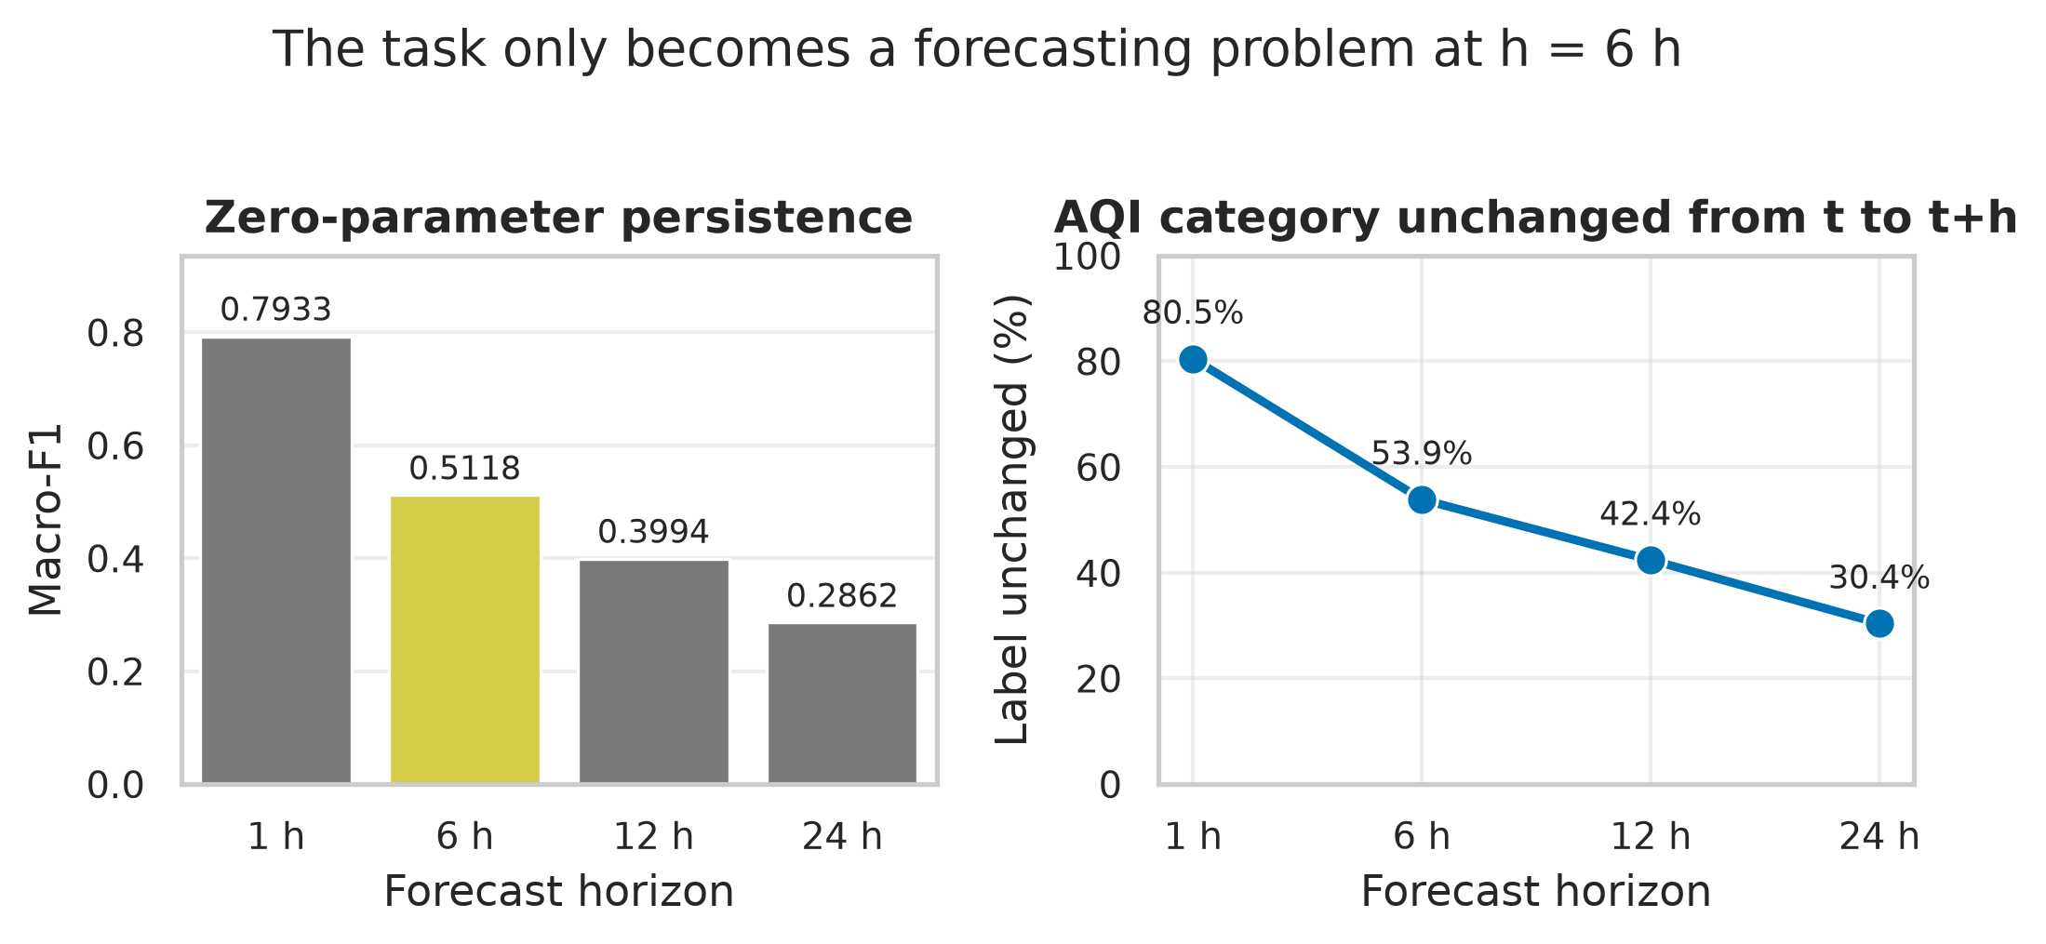
Figure 1. Persistence floor across forecast horizons. The highlighted bar is the primary horizon adopted for this thesis. Generated from horizon_comparison.json.
At one hour the label is unchanged in 80.50% of samples and persistence scores 0.7933 without a model. By six hours the floor has fallen to 0.5118, and by twenty-four hours to 0.2862. The decline is monotone at every step, so there is no diurnal rebound at twenty-four hours: landing on the same time of day does not recover the lost predictability.
This single table reframed the project. The six-hour horizon was adopted not because it is more useful to a wearer — a shorter warning would be — but because it is the shortest horizon at which a model has room to demonstrate anything a copy of the current reading does not already provide.

4.2 Baseline models and rolling-origin cross-validation
Table 7. Every Beijing variant on the same test rows, against the persistence floor. Intervals are 95% paired bootstrap on the difference.
Variant | Macro-F1 | Hazardous F1 | V. unhealthy F1 | vs persistence
Persistence (zero-parameter) | 0.5118 | 0.5897 | 0.5104 | — (reference)
RandomForest (Phase 3) | 0.5173 | 0.6098 | 0.5265 | +0.0055 [+0.0016, +0.0093]
XGBoost (Phase 3) | 0.4991 | 0.5607 | 0.5122 | -0.0127 [-0.0174, -0.0082]
RF + CTGAN, broad 4-class | 0.5212 | 0.5908 | 0.4973 | +0.0094 [+0.0055, +0.0136]
RF + CTGAN, targeted 2-class | 0.5043 | 0.5843 | 0.4903 | -0.0075 [-0.0115, -0.0033]
LSTM + MC dropout | 0.5074 | 0.5956 | 0.5265 | -0.0044 [-0.0087, -0.0002]
Transformer + MC dropout | 0.5094 | 0.5942 | 0.5252 | not tested
RF + SMOTE (imbalanced-learn) | 0.5207 | 0.5865 | 0.4757 | +0.0089 [+0.0047, +0.0134]
RandomForest, class_weight=balanced | 0.5149 | 0.5843 | 0.4733 | +0.0031 [-0.0008, +0.0071] (n.s.)
Compressed RF + class weight (10 trees x depth 10) | 0.5020 | 0.5827 | 0.4662 | -0.0098 [-0.0135, -0.0058]
Compressed RF (100 trees x depth 16) | 0.5152 | 0.6085 | 0.5251 | +0.0034 [-0.0003, +0.0073] (n.s.)
Source: ablation_h6.json, gapfill_h6.json, dl_h6.json, smote_h6.json

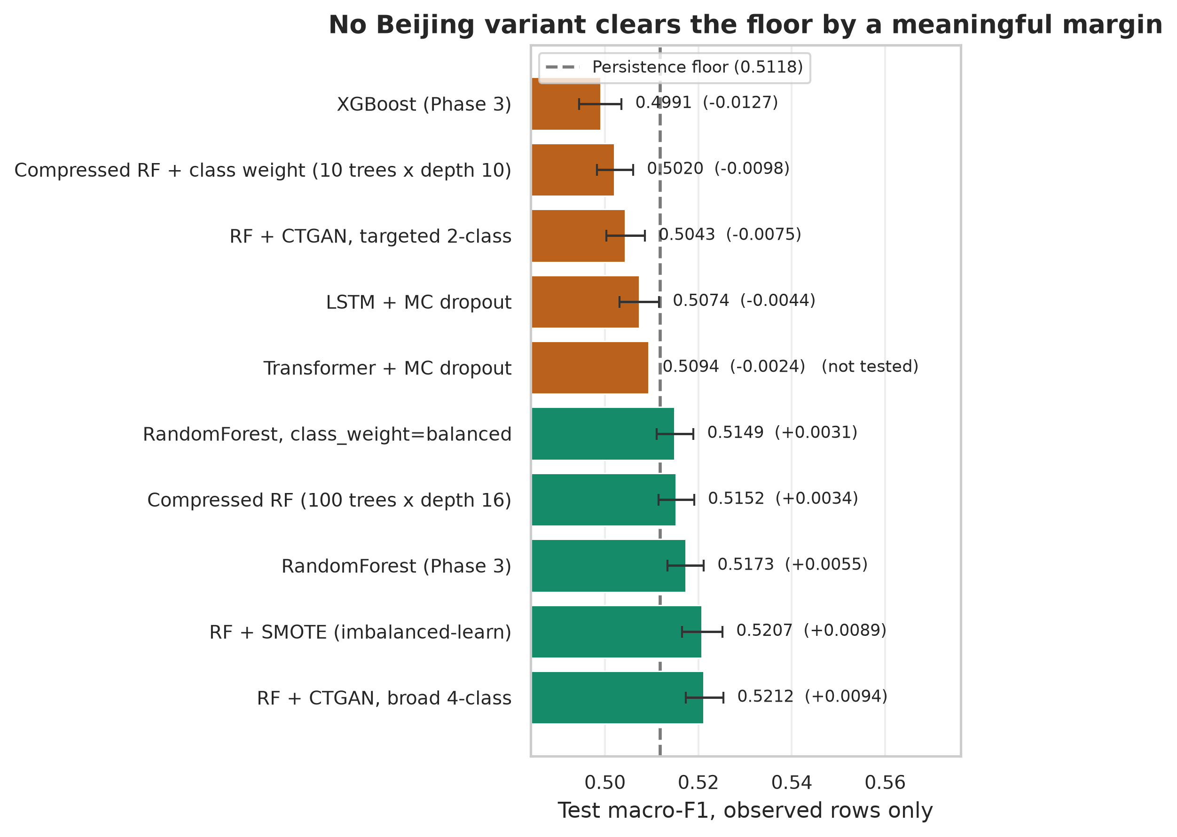
Figure 2. Every Beijing variant against the persistence floor, with 95% paired-bootstrap intervals on the difference. The dashed rule is the floor. Generated from ablation_h6.json, gapfill_h6.json, dl_h6.json, smote_h6.json, deployment_h6.json, deployment_h6_cw.json, conformal_h6.json, baseline_h6.json.
On the single chronological split the Random Forest clears the floor by +0.0055 [+0.0016, +0.0093], which is statistically significant and practically negligible. It also loses to persistence on the validation split, which is the split selection is allowed to use.

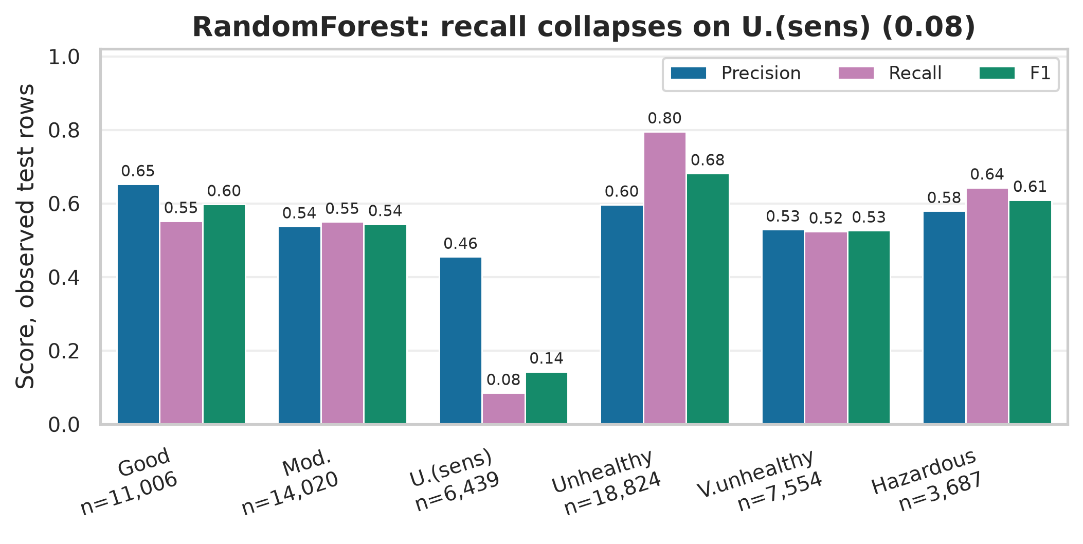
Figure 3. Precision, recall and F1 per class for the selected Beijing forest on observed test rows, with per-class support. Generated from baseline_h6.json.

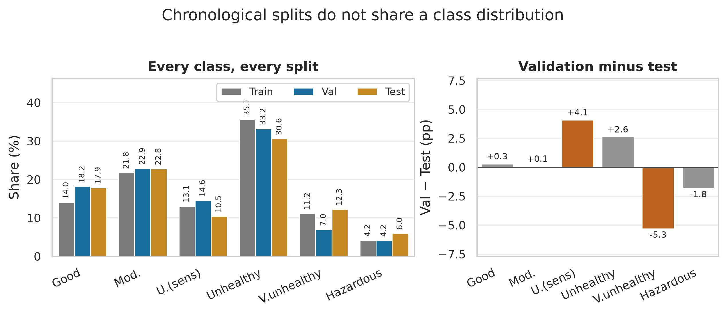
Figure 4. Class prevalence across the chronological splits, and the validation-minus-test gap that drives repeated disagreement between them. Generated from hj633_h6.json.
Because validation and test disagreed repeatedly, the comparison was re-run over rolling-origin folds. That is the decisive experiment.

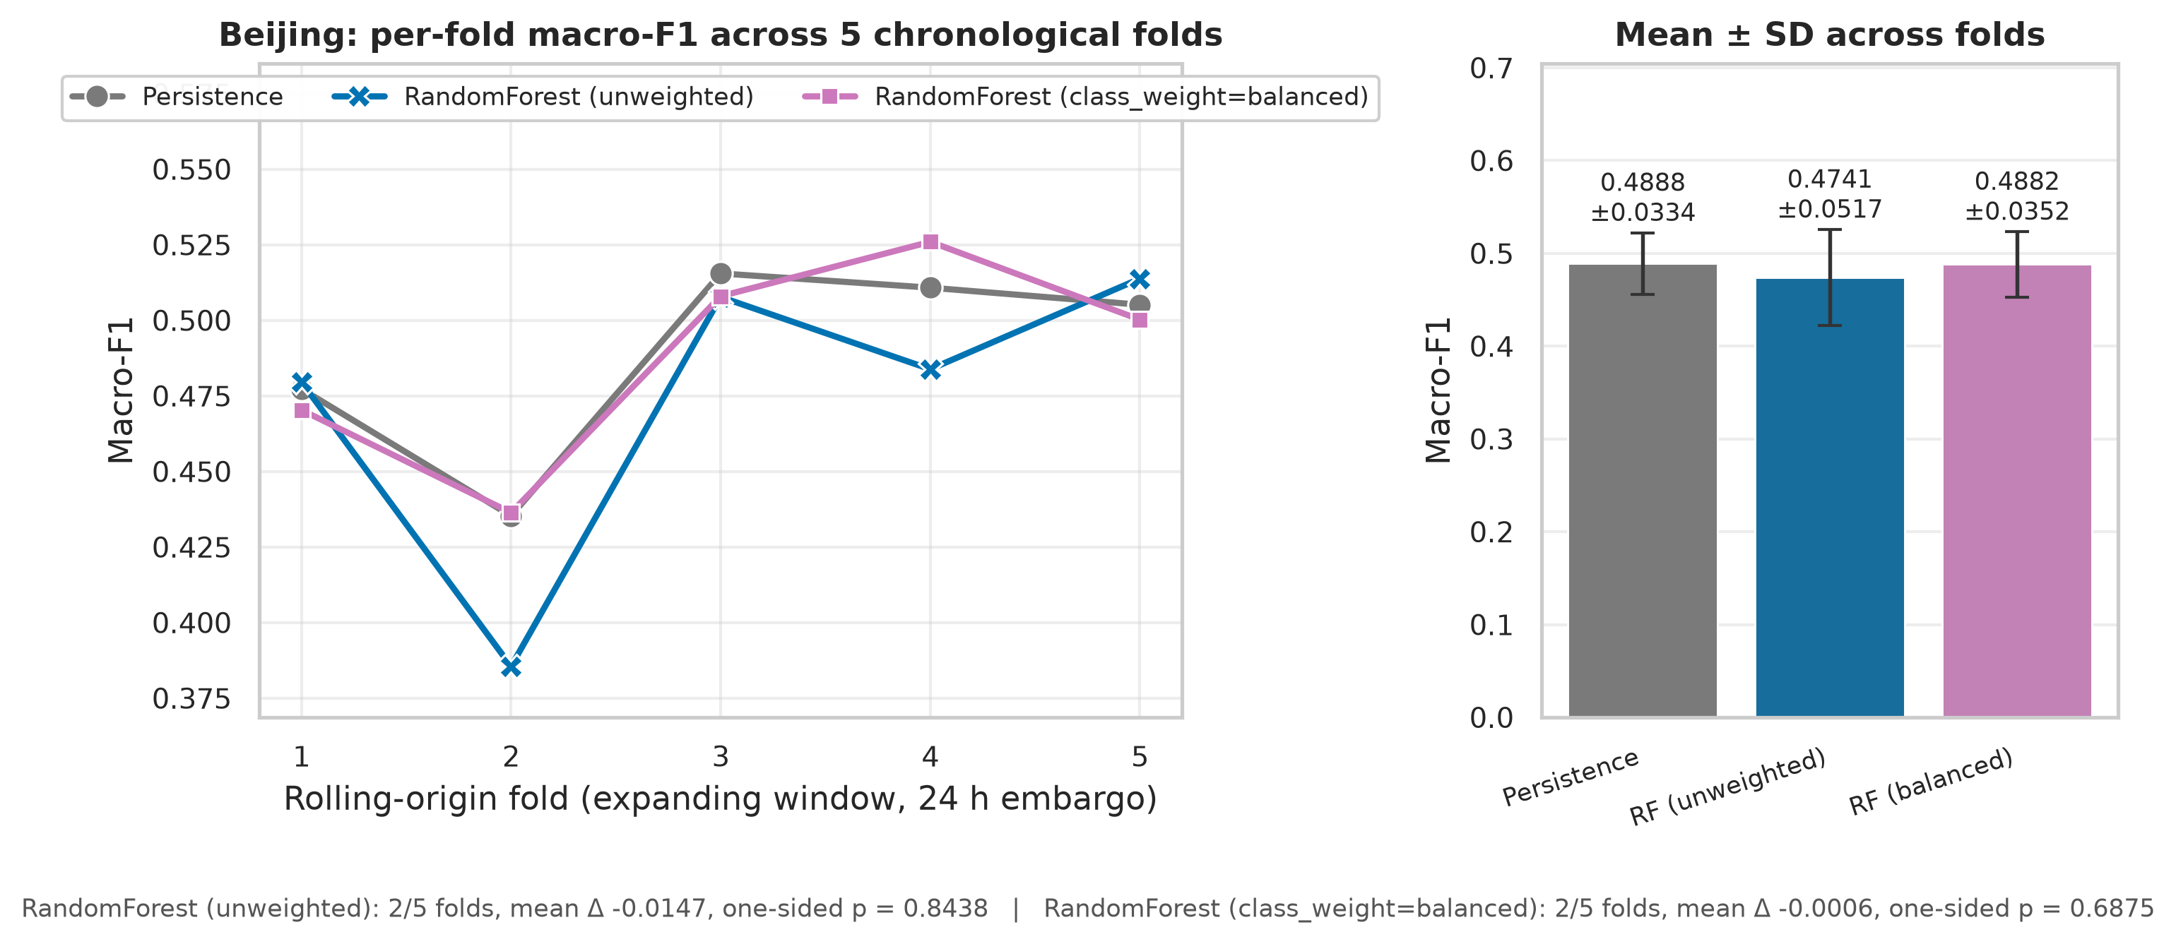
Figure 5. Beijing rolling-origin cross-validation: per-fold macro-F1 across five chronological folds, with mean and standard deviation across folds. Generated from rolling_cv_h6.json.
Table 8. Beijing rolling-origin cross-validation over 5 folds, 24-hour embargo. The signed-rank floor for 5 folds is 0.0312 one-sided.
Model | Mean ± SD | Range | Folds won | Mean Δ | p (one-sided)
Persistence | 0.4888 ± 0.0334 | 0.4353–0.5155 | — (reference) | — | —
RandomForest (unweighted) | 0.4741 ± 0.0517 | 0.3855–0.5138 | 2/5 | -0.0147 | 0.8438
RandomForest (class_weight=balanced) | 0.4882 ± 0.0352 | 0.4363–0.5260 | 2/5 | -0.0006 | 0.6875
Source: rolling_cv_h6.json
Table 9. Beijing rolling-origin folds in detail: evaluation window, sample counts and per-fold macro-F1 for every model.
Fold | Evaluation window | Train n | Eval n | Persistence | RF (unweighted) | RF (class_weight=balanced)
1 | 2014-10-06 to 2015-03-29 | 167,808 | 48,874 | 0.4773 | 0.4796 | 0.4703
2 | 2015-03-30 to 2015-09-20 | 218,172 | 48,948 | 0.4353 | 0.3855 | 0.4363
3 | 2015-09-21 to 2016-03-14 | 268,536 | 49,105 | 0.5155 | 0.5077 | 0.5080
4 | 2016-03-15 to 2016-09-06 | 318,912 | 48,822 | 0.5108 | 0.4838 | 0.5260
5 | 2016-09-07 to 2017-02-28 | 369,276 | 49,253 | 0.5051 | 0.5138 | 0.5002
Source: rolling_cv_h6.json
No Beijing-trained model beats persistence in more than 2 of 5 folds. Persistence's own fold-to-fold standard deviation, 0.0334, is larger than any model-to-baseline difference in the table. The single-split result that the forest beats the floor does not survive.

4.3 Class-imbalance interventions and the validity-metric failure
Table 10. The three class-imbalance interventions, with their cost.
Intervention | Macro-F1 | V. unhealthy F1 | Hazardous F1 | Cost
None (RandomForest) | 0.5173 | 0.5265 | 0.6098 | —
CTGAN, broad 4-class | 0.5212 | 0.4973 | 0.5908 | 82,958 rows, 22 min
CTGAN, targeted 2-class | 0.5043 | 0.4903 | 0.5843 | 58,199 rows
SMOTE | 0.5207 | 0.4757 | 0.5865 | 82,958 rows, 2.0 s
Class weighting | 0.5149 | 0.4733 | 0.5843 | no data added
Source: ablation_h6.json, smote_h6.json, gapfill_h6.json
SMOTE produced the same 82,958 synthetic rows in 2.0 seconds that CTGAN took 22 minutes to produce — a factor of roughly 663 in wall-clock cost, for an outcome that is no better and fails in the same direction.

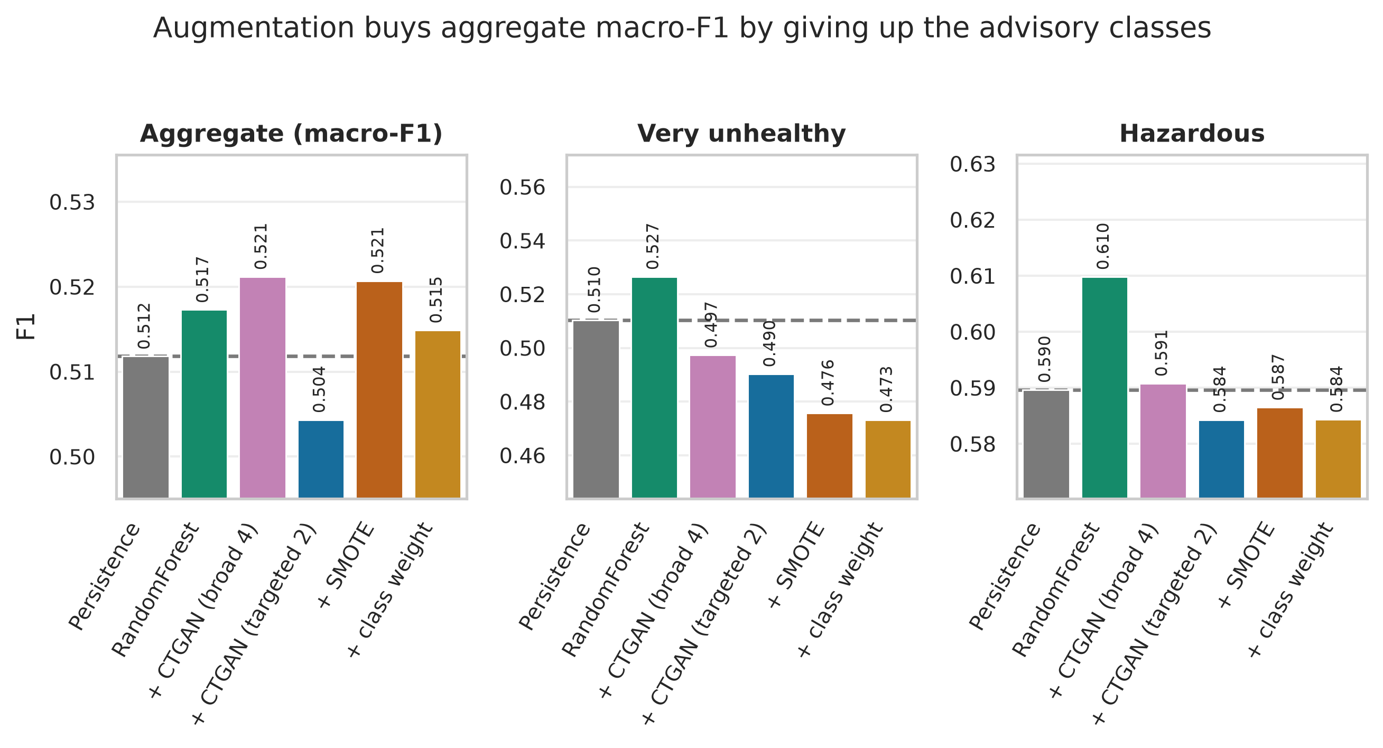
Figure 6. What each imbalance intervention does to the aggregate metric and to the two advisory classes. Grey rules mark persistence. Generated from ablation_h6.json, smote_h6.json, gapfill_h6.json.

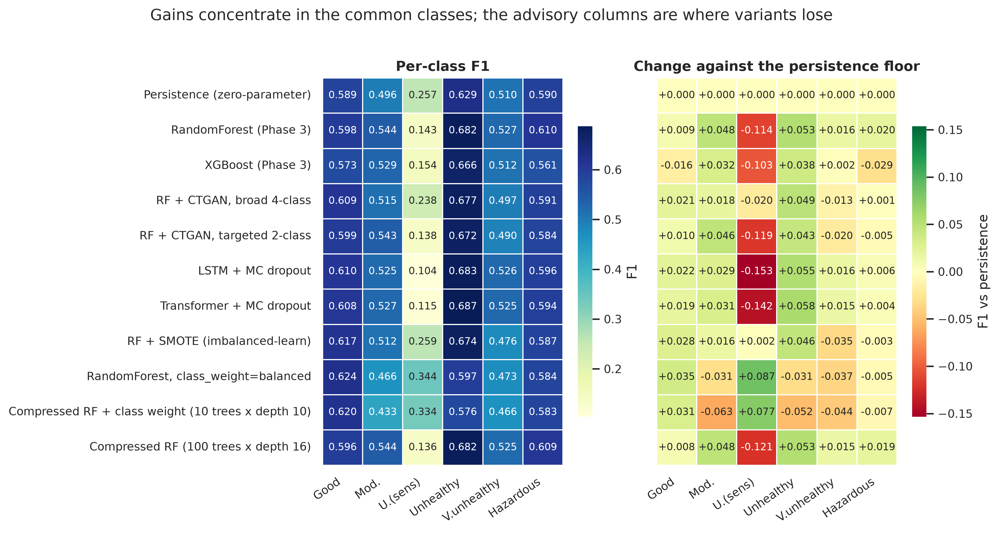
Figure 7. Per-class F1 across every Beijing variant, in absolute terms and as a change against the persistence floor. Generated from ablation_h6.json, gapfill_h6.json, dl_h6.json, smote_h6.json.
Both augmentation methods fail in the same direction. CTGAN and SMOTE each raise aggregate macro-F1 significantly and each significantly degrade both advisory classes. Under the disqualification rule of Section 3.5, both are rejected. Only class weighting avoids the trade, and it is also the cheapest of the three by a wide margin.
Synthesiser quality scores do not measure validity. The first CTGAN configuration scored above 0.89 overall on the Synthetic Data Vault quality report, with acceptable column-shape and pair-trend scores. Its output was nevertheless physically impossible at scale.
Table 11. Physical validity of CTGAN output, before and after the redesign. The before column was regenerated by deliberately re-running the original broken configuration; it is a reproduction of the same failure, not the same random draw.
Validity check | Before | After | Expected
hour_sin/cos on the unit circle | 22.06% | 100.00% | must be 100%
distinct hour_sin values | 82,710 | 21 | 24 possible
month_sin/cos on the unit circle | 74.28% | 100.00% | must be 100%
distinct month_sin values | 74,530 | 11 | 12 possible
dew point above temperature | 10.89% | 0% | 0.0014% in real data
Source: gan_validity_before_fix.json, gan_h6.json
Table 12. CTGAN synthesis plan. The majority class is Unhealthy at 102,722 observed rows; minorities are lifted to 51,361, not to parity.
Class | Observed rows | Ratio to majority | Minority? | Synthetic rows
Good | 40,266 | 0.3920 | yes | 11,095
Moderate | 62,824 | 0.6116 | no | —
Unhealthy (sensitive) | 37,697 | 0.3670 | yes | 13,664
Unhealthy | 102,722 | 1.0000 | no | —
Very unhealthy | 32,338 | 0.3148 | yes | 19,023
Hazardous | 12,185 | 0.1186 | yes | 39,176
Source: gan_h6.json
Table 13. Synthetic Data Vault quality scores per class, for the corrected configuration. The configured flagging floor is 0.9. These scores are what the failed configuration also passed.
Class | Overall | Column shapes | Column pair trends | Synthetic rows | Fit (min)
Good | 0.8643 | 0.8935 | 0.8350 | 11,095 | 7.3
Unhealthy (sensitive) | 0.8494 | 0.8815 | 0.8174 | 13,664 | 6.7
Very unhealthy | 0.8653 | 0.8918 | 0.8388 | 19,023 | 5.8
Hazardous | 0.7891 | 0.9057 | 0.6724 | 39,176 | 2.2
Source: gan_h6.json

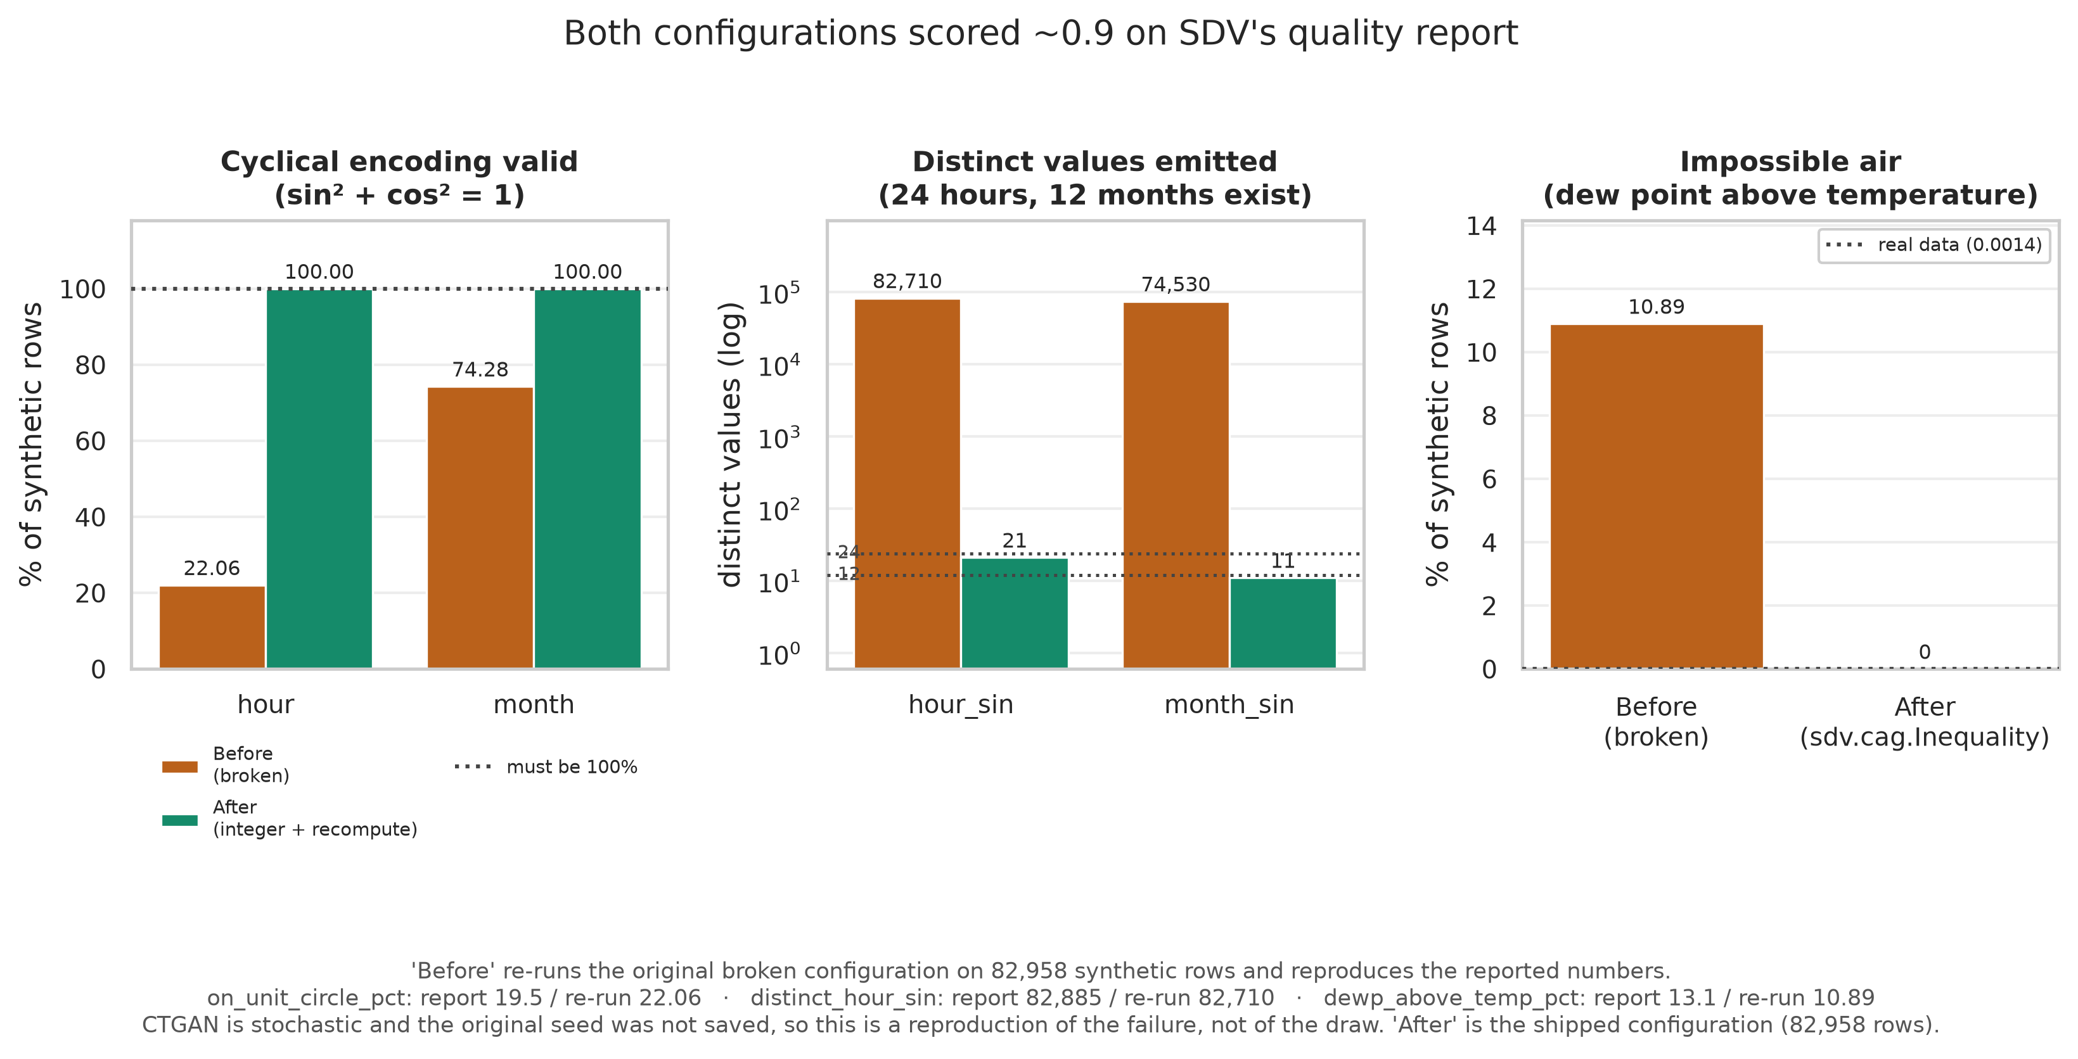
Figure 8. Physical validity of CTGAN output before and after the redesign, across both cyclical channels and the temperature/dew-point constraint. Generated from gan_h6.json, gan_validity_before_fix.json.
The failure is structural, not column-specific. Both cyclical pairs broke: handed to the generator as free continuous columns, both came back off the unit circle and with tens of thousands of distinct values where twenty-four and twelve exist. A quality score compares one marginal at a time and one pairwise correlation at a time; neither asks whether a row is possible. The fix was to model the underlying integer and recompute the derived encoding, and to impose the dew-point inequality as a constraint during fitting rather than to check it afterwards.
One API-specific trap is worth recording: passing the constraint as a plain dictionary is accepted without effect. The library now warns that dictionary constraints are ignored, which confirms the original diagnosis.

4.4 Sequence models, capacity and uncertainty
Table 14. Sequence models against the tabular baseline and the persistence floor, on the same observed test rows.
Model | Macro-F1 | Accuracy | Hazardous F1 | V. unhealthy F1
lstm (MC mean) | 0.5074 | 0.5734 | 0.5956 | 0.5265
lstm (deterministic) | 0.5082 | 0.5724 | 0.5953 | 0.5270
transformer (MC mean) | 0.5094 | 0.5752 | 0.5942 | 0.5252
transformer (deterministic) | 0.5170 | 0.5731 | 0.5955 | 0.5263
RandomForest (Phase 3) | 0.5173 | 0.5793 | 0.6098 | 0.5265
Persistence | 0.5118 | 0.5356 | 0.5897 | 0.5104
Source: dl_h6.json
Neither sequence architecture beats the tabular forest, and the LSTM is significantly worse than persistence on the aggregate. The obvious objection is that the models were too small, so capacity was swept directly.
Table 15. Learning-rate sweep on validation macro-F1, 25 epochs with patience 6. Both architectures were optimisation-limited at the larger rates.
Architecture | lr = 0.003 | lr = 0.001 | lr = 0.0003 | lr = 0.0001
lstm | 0.4962 | 0.4948 | 0.5151 | 0.5024
transformer | 0.4986 | 0.5026 | 0.5148 | 0.5127
Source: dl_lr_sweep_h6.json

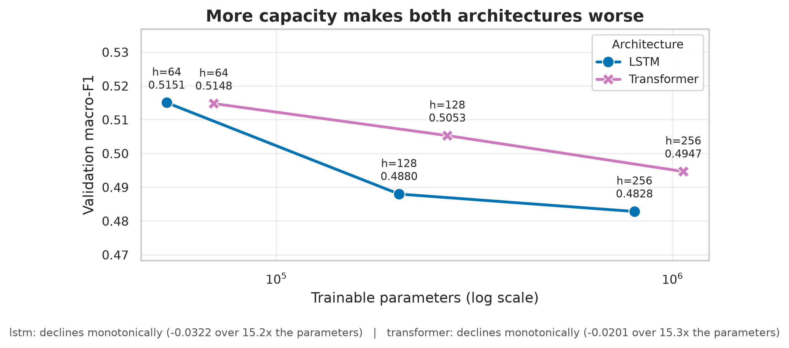
Figure 9. Validation macro-F1 against trainable parameter count for both sequence architectures. Generated from capacity_sweep_h6.json.
More capacity made both architectures worse. Across hidden sizes 64, 128, 256, the LSTM declines -0.0322 and the Transformer -0.0201 from smallest to largest, over roughly 15x the parameters. Both declines are monotone.
Table 16. Capacity sweep at lr = 0.0003. Validation macro-F1 falls monotonically with size for both architectures.
Architecture | Hidden size | Parameters | Val macro-F1 | Best epoch | Minutes
lstm | 64 | 52,870 | 0.5151 | 6 | 3.7
lstm | 128 | 204,038 | 0.4880 | 5 | 5.6
lstm | 256 | 801,286 | 0.4828 | 2 | 11.1
transformer | 64 | 69,510 | 0.5148 | 6 | 5.6
transformer | 128 | 270,086 | 0.5053 | 1 | 7.1
transformer | 256 | 1,064,454 | 0.4947 | 2 | 19.7
Source: capacity_sweep_h6.json
The learning-rate sweep rules out the other obvious objection. Both architectures improved at the smaller rate, which means the earlier configuration was optimisation-limited rather than capacity-limited, and the capacity sweep was run at the better rate. Neither knob rescues the architectures.

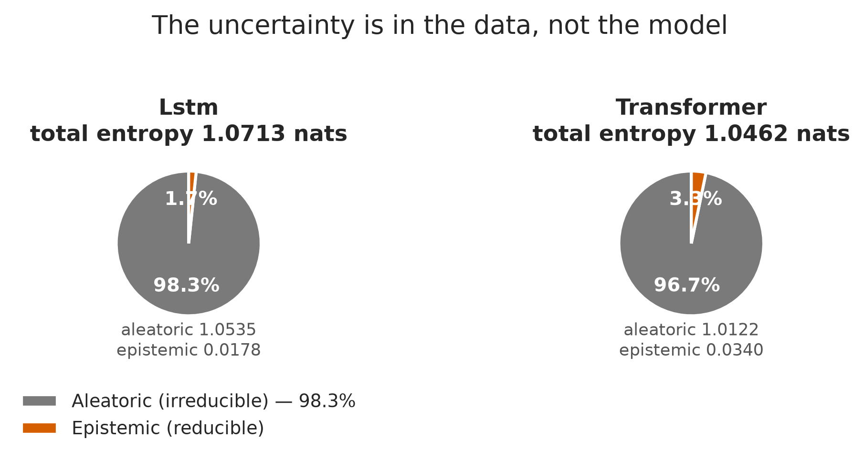
Figure 10. Decomposition of mean predictive entropy into aleatoric and epistemic components, by architecture. Generated from dl_h6.json.
The decomposition explains the sweep. 98.3% of predictive entropy is aleatoric — irreducible given these channels and this horizon — leaving only a small epistemic sliver that more capacity or more data could address. That is a statement about the task, not about the model. If the six-hour-ahead category is to be predicted better, the input has to change: more channels, a longer window, or spatial context from neighbouring stations.
Table 17. Calibration measured two ways. The rankings disagree.
Model | ECE (mean bin gap) | MCE (worst bin gap) | n
transformer | 0.0113 | 0.1969 | 61,530
lstm | 0.0190 | 0.0448 | 61,530
Source: dl_h6.json
Expected and maximum calibration error rank the two models in opposite directions. The Transformer is better calibrated on average and far worse in its worst bin. Because the advisory layer suppresses low-confidence warnings, the worst bin is the operative number, and a selection made on expected calibration error alone would have chosen the wrong model. This is the third instance in this project of an aggregate concealing a tail failure, after the augmentation ablation above and the conformal coverage result below.

4.5 Conformal coverage
Table 18. Per-class conformal coverage under marginal and Mondrian calibration, with the change in mean set size.
Class | Test n | Marginal coverage | Mondrian coverage | Mean set size
Good | 11,006 | 0.8331 | 0.8673 | 2.36 → 2.45
Moderate | 14,020 | 0.8912 | 0.8877 | 2.70 → 2.76
Unhealthy (sensitive) | 6,439 | 0.7776 | 0.8635 | 2.84 → 2.92
Unhealthy | 18,824 | 0.9668 | 0.8808 | 2.37 → 2.69
Very unhealthy | 7,554 | 0.9047 | 0.9357 | 2.41 → 2.37
Hazardous | 3,687 | 0.8432 | 0.9083 | 2.22 → 2.07
Source: conformal_h6.json

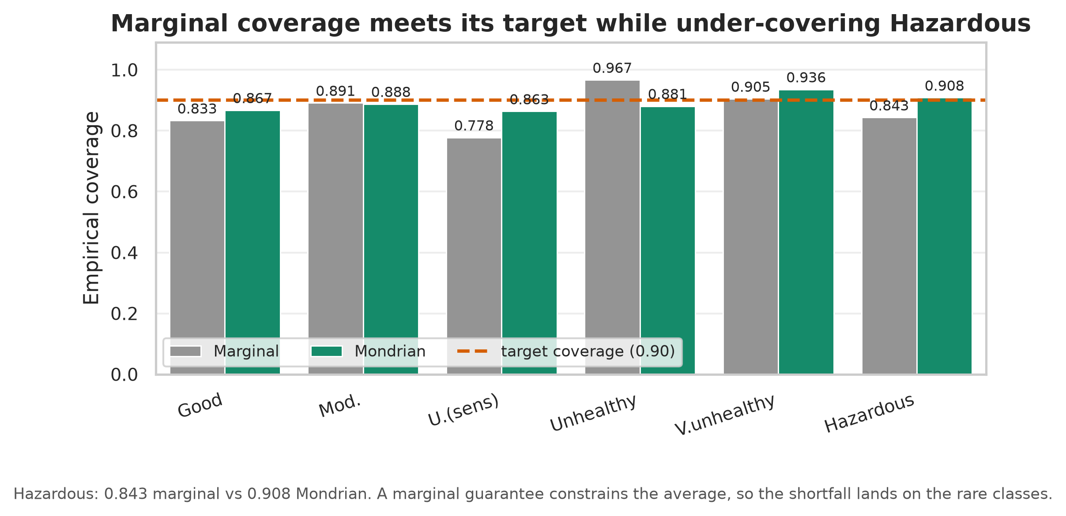
Figure 11. Per-class empirical coverage under marginal and Mondrian conformal calibration, against the target. Generated from conformal_h6.json.
Split conformal delivered 0.8908 marginal coverage against a 0.10 miscoverage target, which looks correct. Per class it was not: Hazardous was covered at only 0.8432. The slack in a marginal guarantee lands on the rare, hard classes. Mondrian calibration raises that to 0.9083 at the cost of larger sets.
Table 19. Prediction-set size distribution under both calibrations. A single confident category is the exception under either.
Categories in set | Marginal | Mondrian
1 | 4,410 (7.2%) | 1,299 (2.1%)
2 | 29,132 (47.3%) | 27,892 (45.3%)
3 | 21,625 (35.1%) | 26,442 (43.0%)
4 | 6,334 (10.3%) | 5,311 (8.6%)
5 | 29 (0.0%) | 566 (0.9%)
6 | 0 (0.0%) | 20 (0.0%)
Source: conformal_h6.json

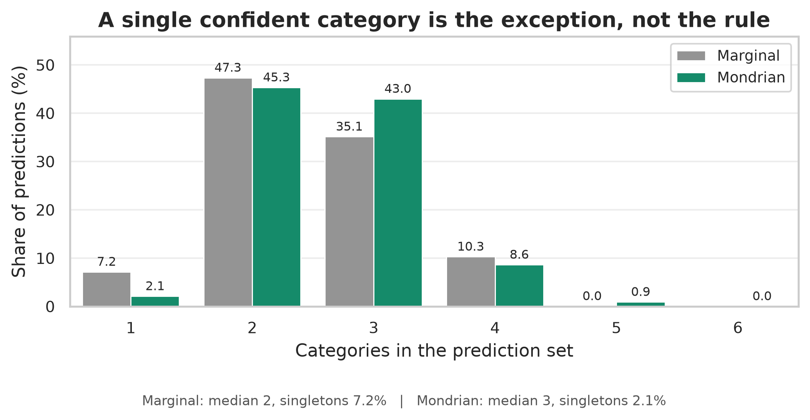
Figure 12. Distribution of prediction-set size under both calibrations. Generated from conformal_h6.json.
The cost is reported rather than hidden: mean set size rises from 2.487 to 2.610 and the singleton rate falls from 7.2% to 2.1%. A single confident category is the exception, not the rule, and the advisory layer is built to say so.

4.6 Compression and edge deployment

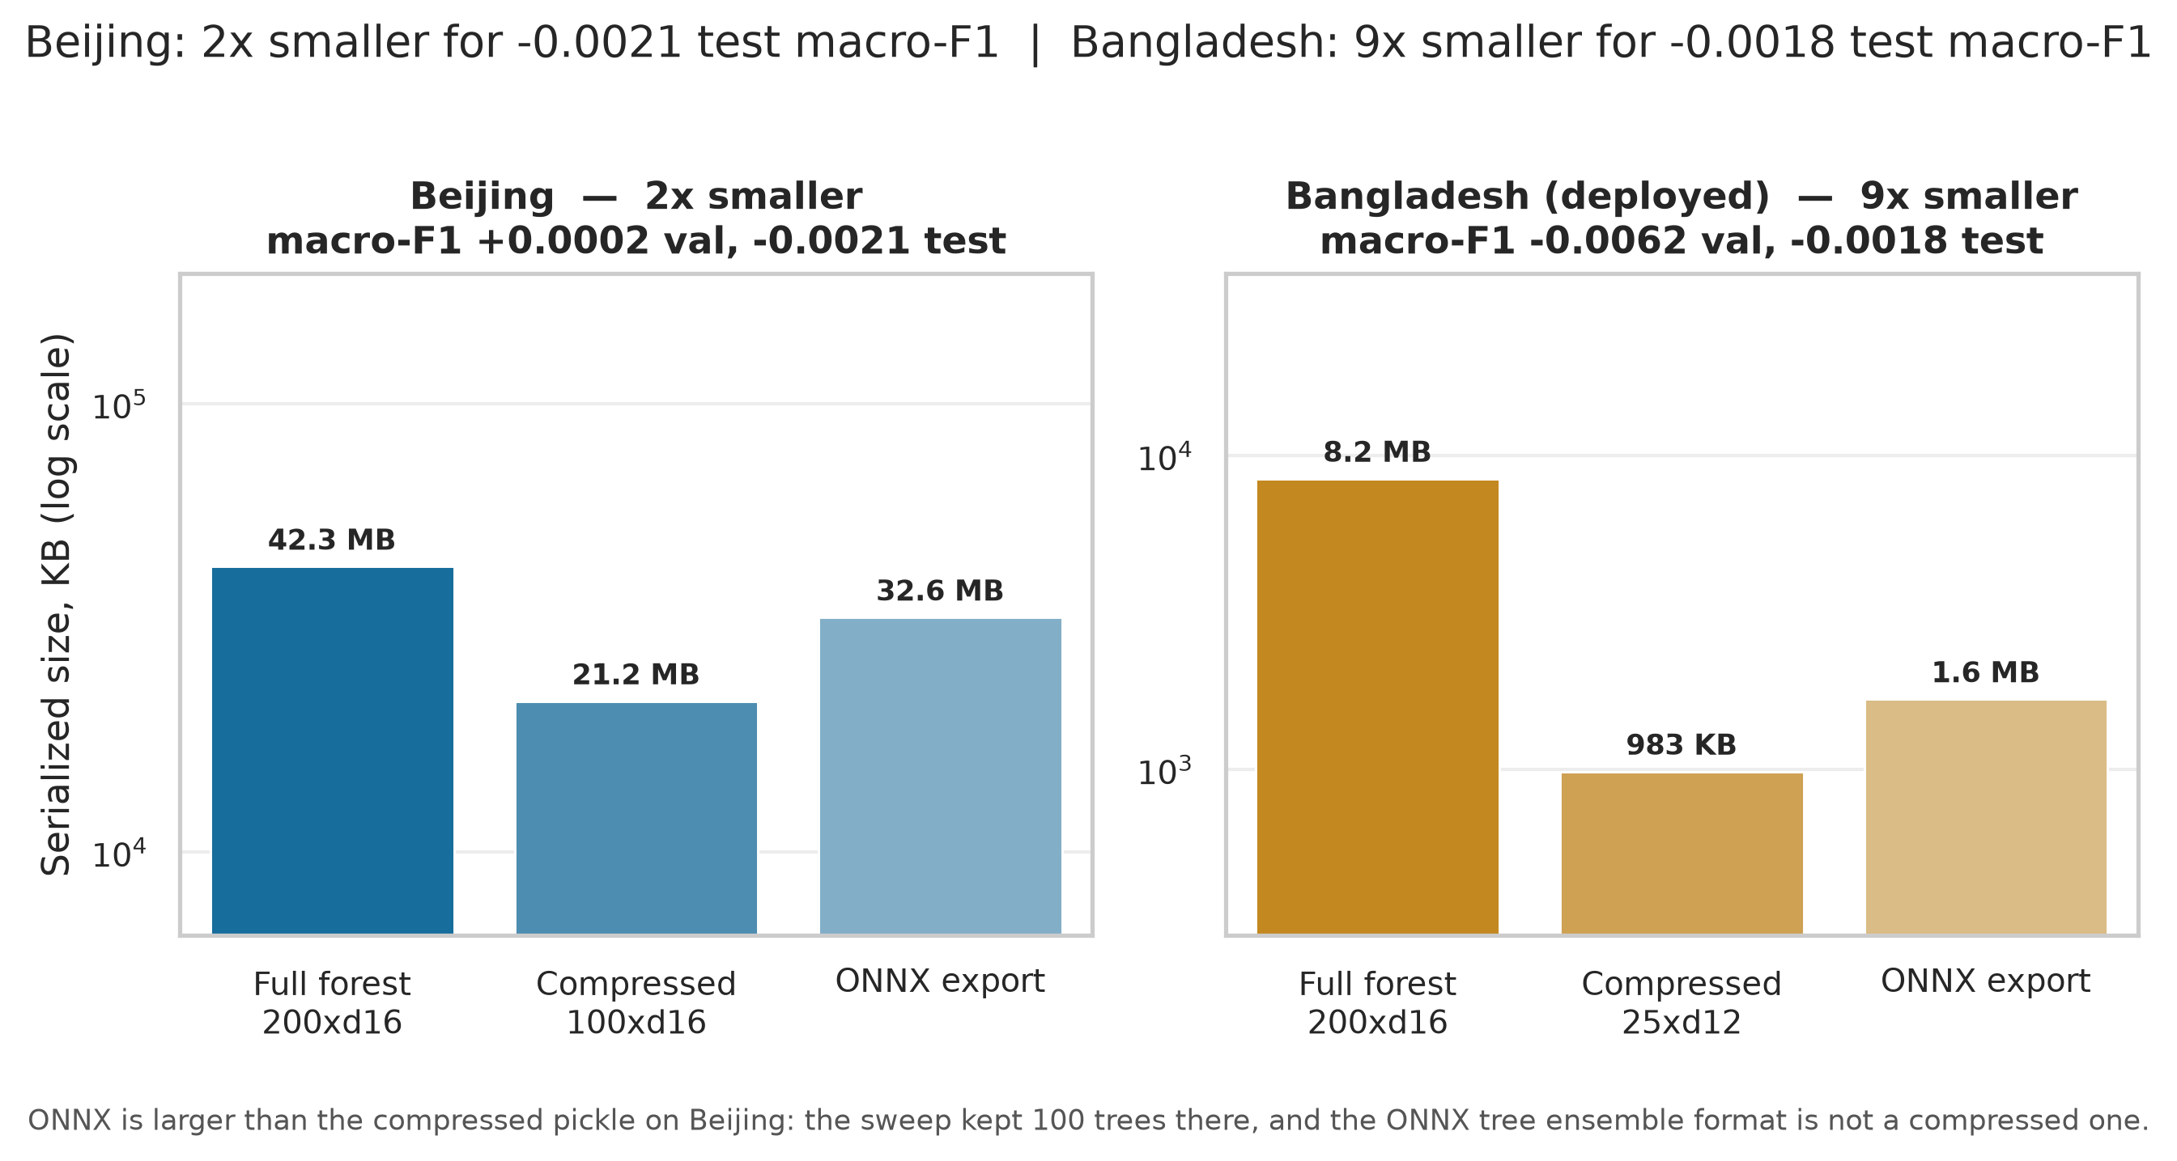
Figure 13. Serialised model size at each stage of the deployment pipeline, for both datasets, with the macro-F1 cost of compression. Generated from deployment_h6.json, deployment_h6_bd.json.
Table 20. Compression and export, both datasets.
Dataset | Forest | Serialised size | ONNX | Val macro-F1 change | ONNX/sklearn argmax agreement
Beijing | 200x d16 → 100x d16 | 42.3 MB → 21,708 KB | 33,379 KB | +0.0002 | 1.0000
Bangladesh (deployed) | 200x d16 → 25x d12 | 8.2 MB → 983 KB | 1,673 KB | -0.0062 | 1.0000
Source: deployment_h6.json, deployment_h6_bd.json
Table 21. The two-sided compression sweep on the deployment dataset. A candidate must be within tolerance of the full model *and* significantly above that dataset's own persistence floor.
Criterion | Value
Configurations evaluated | 30
Within the macro-F1 tolerance | 11
Significantly above the persistence floor | 28
Accepted under the two-sided rule | 11
Persistence floor used | 0.4322 (Bangladesh's own)
Tolerance | 0.01
Selection rule applied | both
Selected | 25 trees x depth 12, val macro-F1 0.4920
Source: deployment_h6_bd.json
The two-sided rule matters because the earlier, one-sided version selected a model that satisfied its tolerance test and then landed below the persistence floor. A compression criterion expressed only as "stay close to the full model" cannot detect that, because the full model may not have been far enough above the floor to give anything away. Requiring the compressed candidate to clear the floor in its own right closes that gap.
The accuracy/size curve is close to flat across orders of magnitude, which is another way of saying capacity was never the binding constraint on this task. The Beijing compression is reported for completeness only; as Section 4.2 establishes, nothing from the Beijing pipeline is deployed.
The ONNX benchmark is a portability proxy, not a flashability claim. There is no ONNX Runtime for the ESP32 — no interpreter and no execution provider to load the file with. Reaching the device requires a hand-written C tree traversal, a code generator such as `emlearn`, or retraining as a model some supported framework serves. A TFLite Micro path was planned for exactly this and abandoned, because TensorFlow Lite Micro does not serve a scikit-learn tree ensemble.

4.7 Sensitivity to the air-quality standard

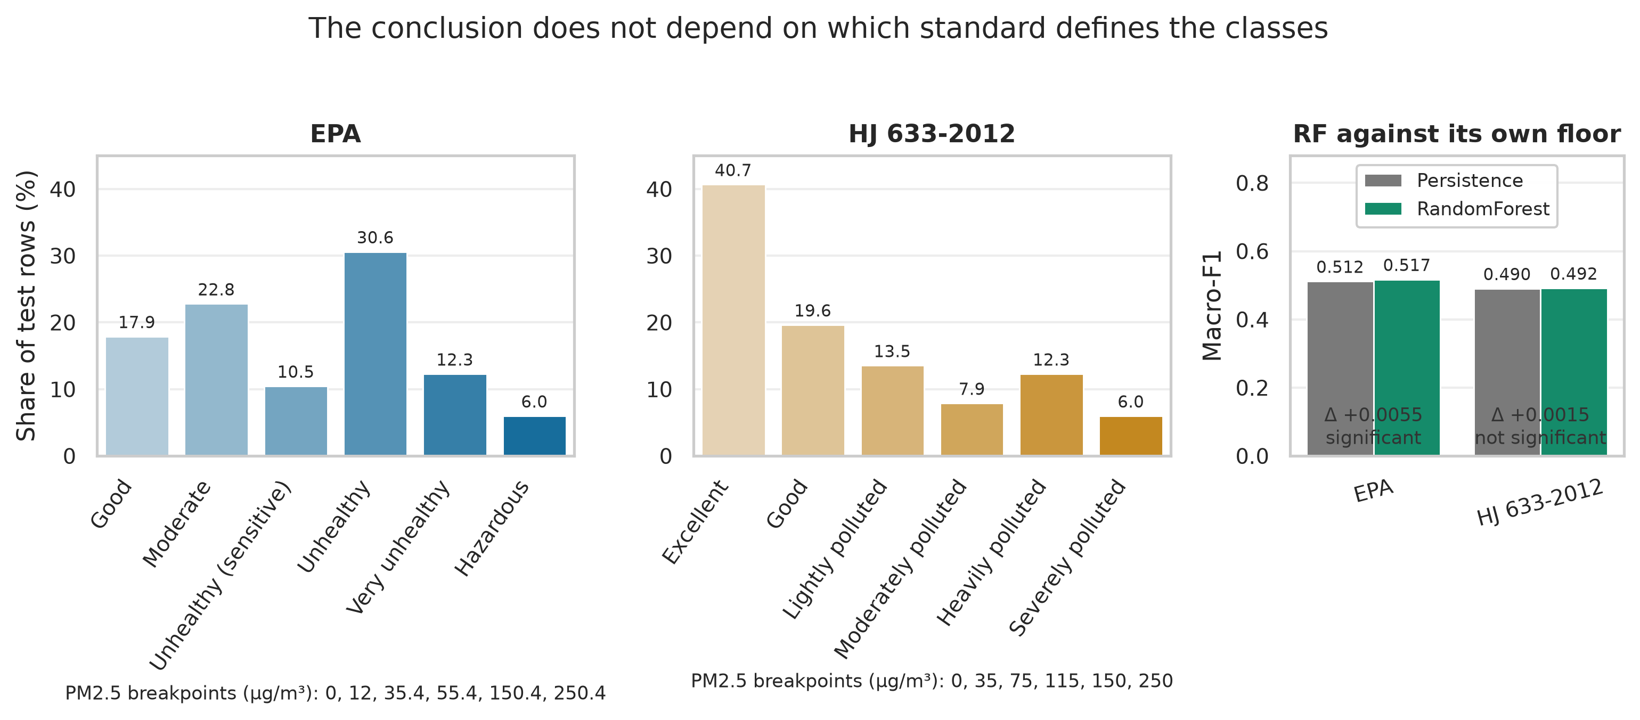
Figure 14. Class balance under EPA and HJ 633-2012 breakpoints, and each standard's model-versus-floor comparison. Generated from hj633_h6.json.
Table 22. The same data under two national standards.
Standard | PM2.5 breakpoints | Persistence | RandomForest | Difference | Test
EPA | 0, 12, 35.4, 55.4, 150.4, 250.4 | 0.5118 | 0.5173 | +0.0055 | significant
HJ 633-2012 | 0, 35, 75, 115, 150, 250 | 0.4905 | 0.4919 | +0.0015 | not significant
Source: hj633_h6.json
The class boundaries are a policy choice, not a property of the air, so the analysis was repeated under the Chinese national standard. The conclusion is unchanged in direction: the forest's margin over its own floor remains small under both standards. Reporting this matters because a reader is entitled to ask whether a negative result is an artefact of the American breakpoints.

4.8 Multiple-comparisons correction

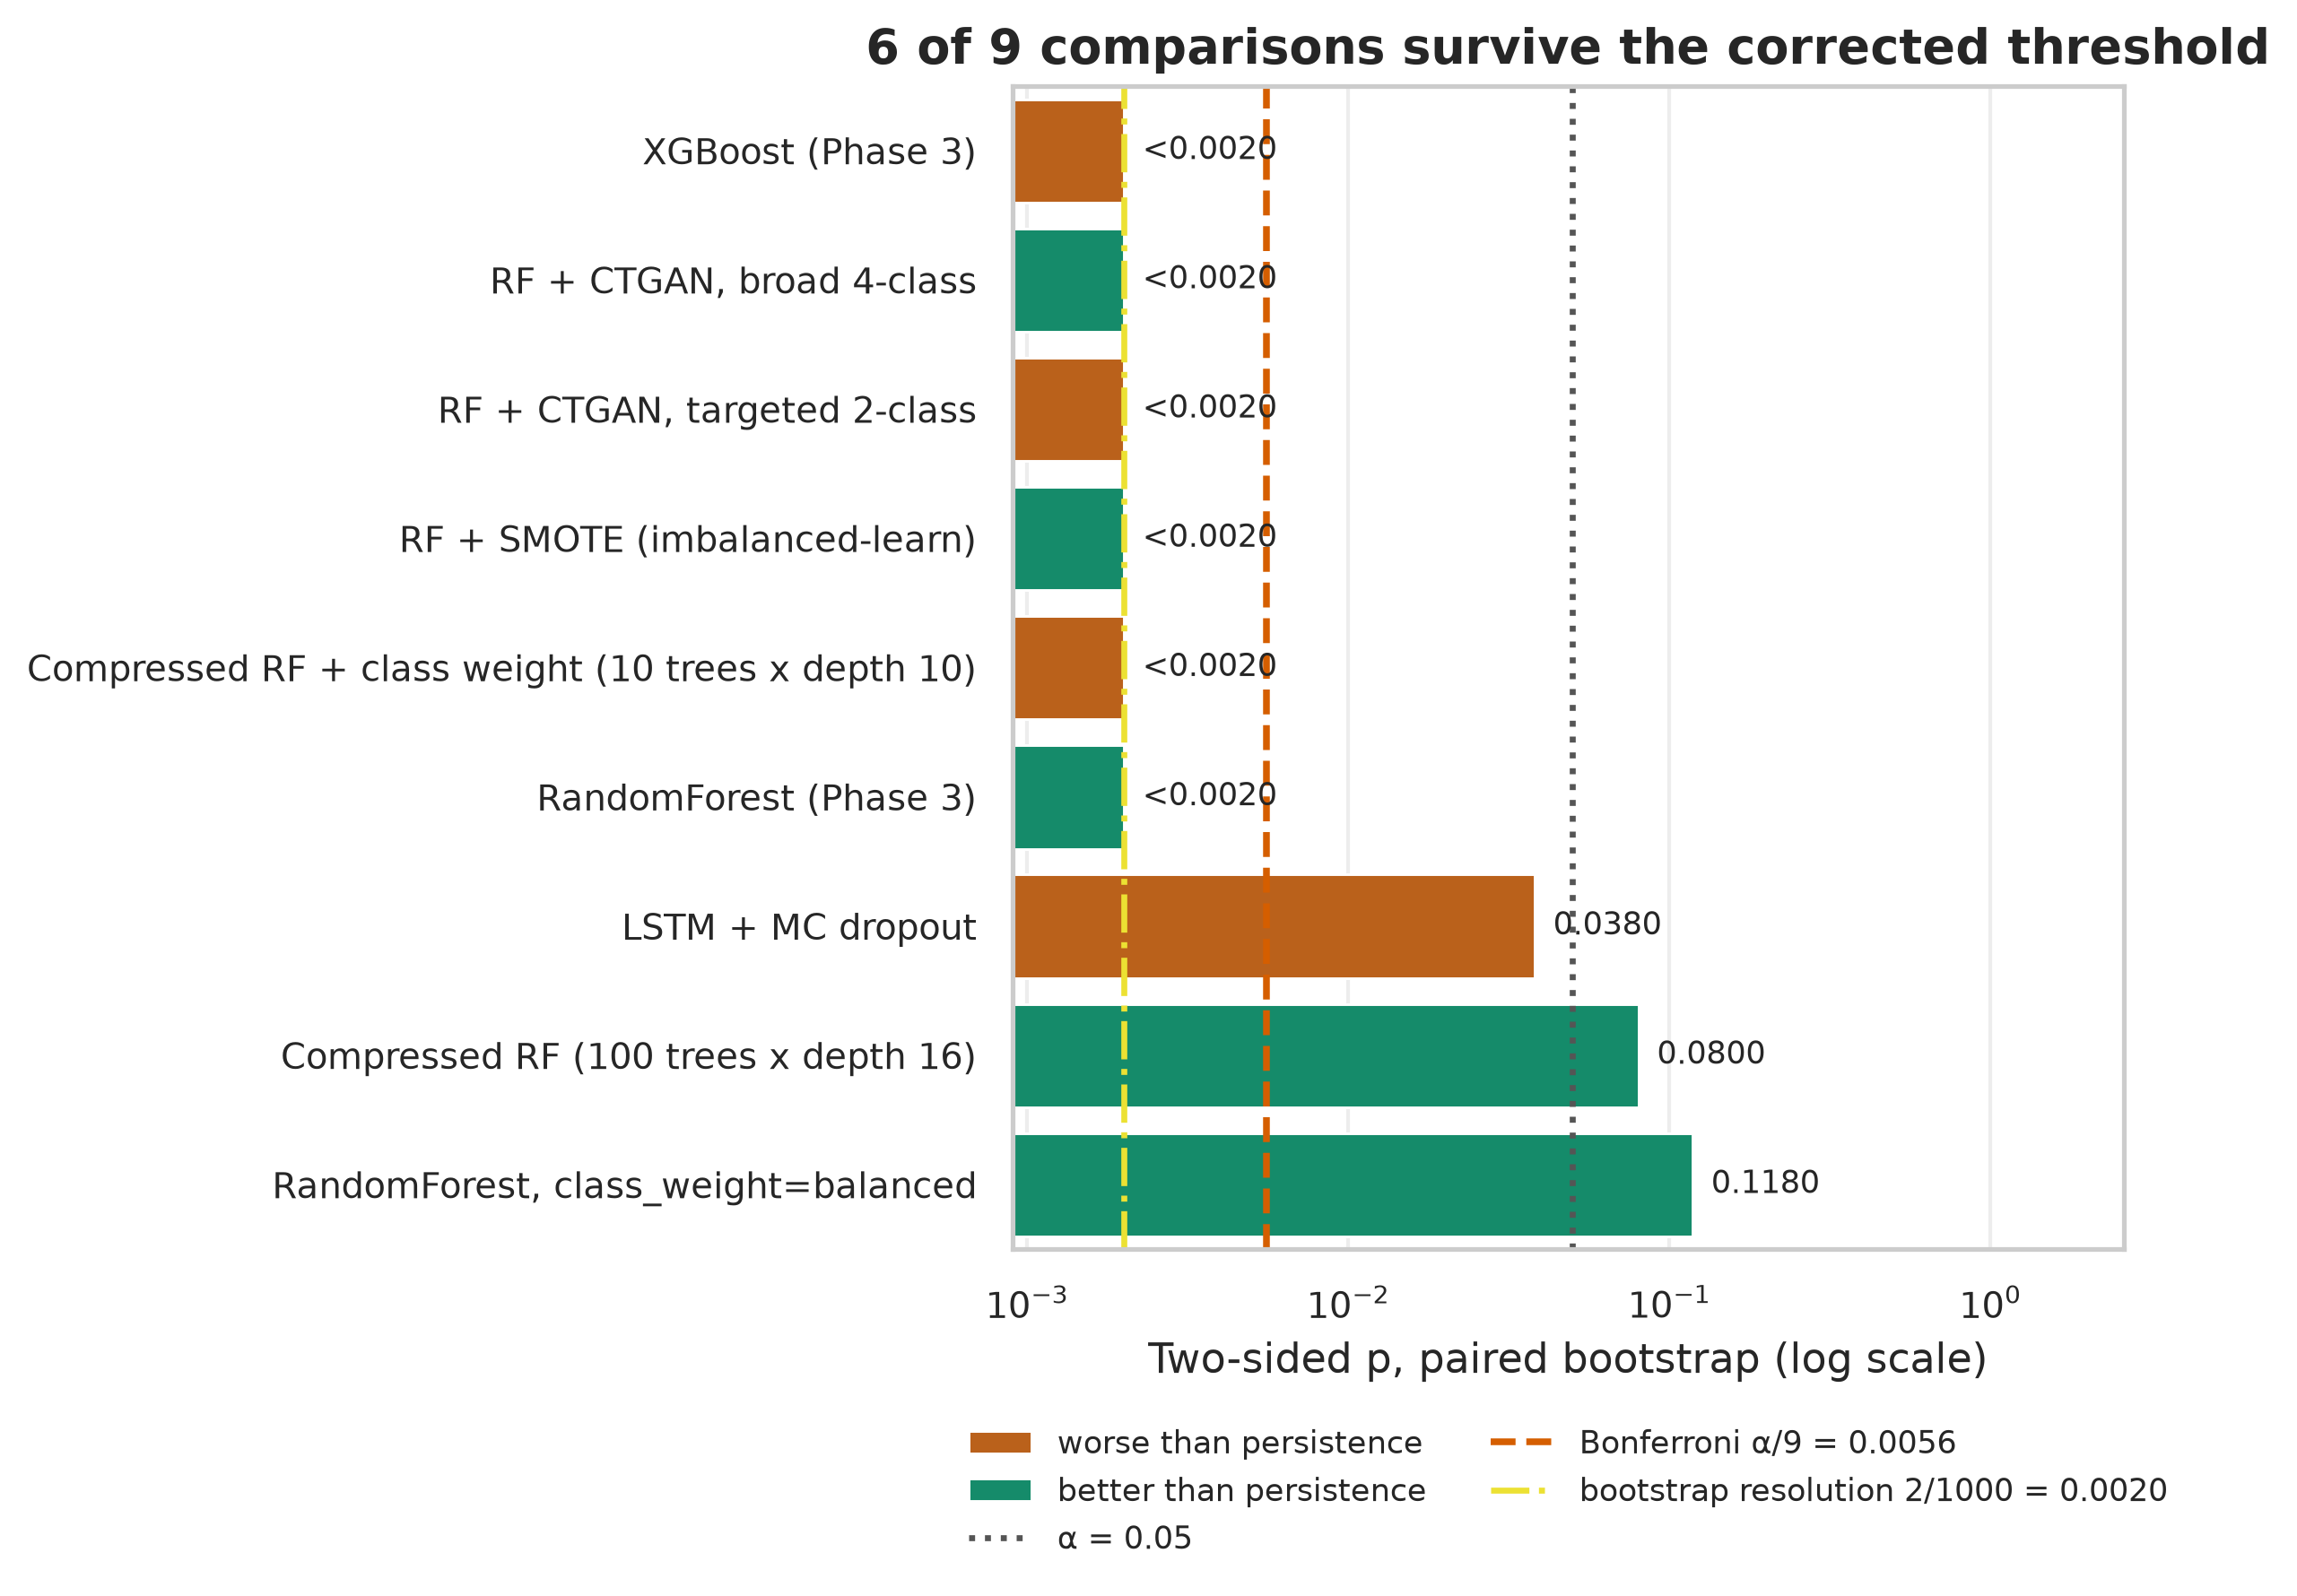
Figure 15. Every persistence comparison under family-wise correction, on a log p-axis, with the uncorrected threshold, the corrected threshold and the bootstrap resolution floor marked. Generated from ablation_h6.json, gapfill_h6.json, dl_h6.json, smote_h6.json, deployment_h6.json, deployment_h6_cw.json.
Table 23. Bonferroni correction over 9 comparisons against persistence on the same test split (corrected threshold 0.0056).
Variant | Difference | p | Direction | Significant at 0.05 | Survives correction
XGBoost (Phase 3) | -0.0127 | <0.0020 | worse | yes | yes
RF + CTGAN, broad 4-class | +0.0094 | <0.0020 | better | yes | yes
RF + CTGAN, targeted 2-class | -0.0075 | <0.0020 | worse | yes | yes
RF + SMOTE (imbalanced-learn) | +0.0089 | <0.0020 | better | yes | yes
Compressed RF + class weight (10 trees x depth 10) | -0.0098 | <0.0020 | worse | yes | yes
RandomForest (Phase 3) | +0.0055 | <0.0020 | better | yes | yes
LSTM + MC dropout | -0.0044 | 0.0380 | worse | yes | no
Compressed RF (100 trees x depth 16) | +0.0034 | 0.0800 | better | no | no
RandomForest, class_weight=balanced | +0.0031 | 0.1180 | better | no | no
Source: compile_results.collect() via pulsebench.bonferroni_report
Lost to correction: LSTM + MC dropout.
The p-values at the bootstrap's resolution floor are reported as bounded rather than exact, because a 1,000-resample bootstrap cannot resolve a two-sided p below 2/1000; printing an exact-looking value there would overstate what the procedure can produce.

4.9 External validation: Bangladesh
The methodology was developed on Beijing and validated on the population the device targets. The first result was about the data, not the models.

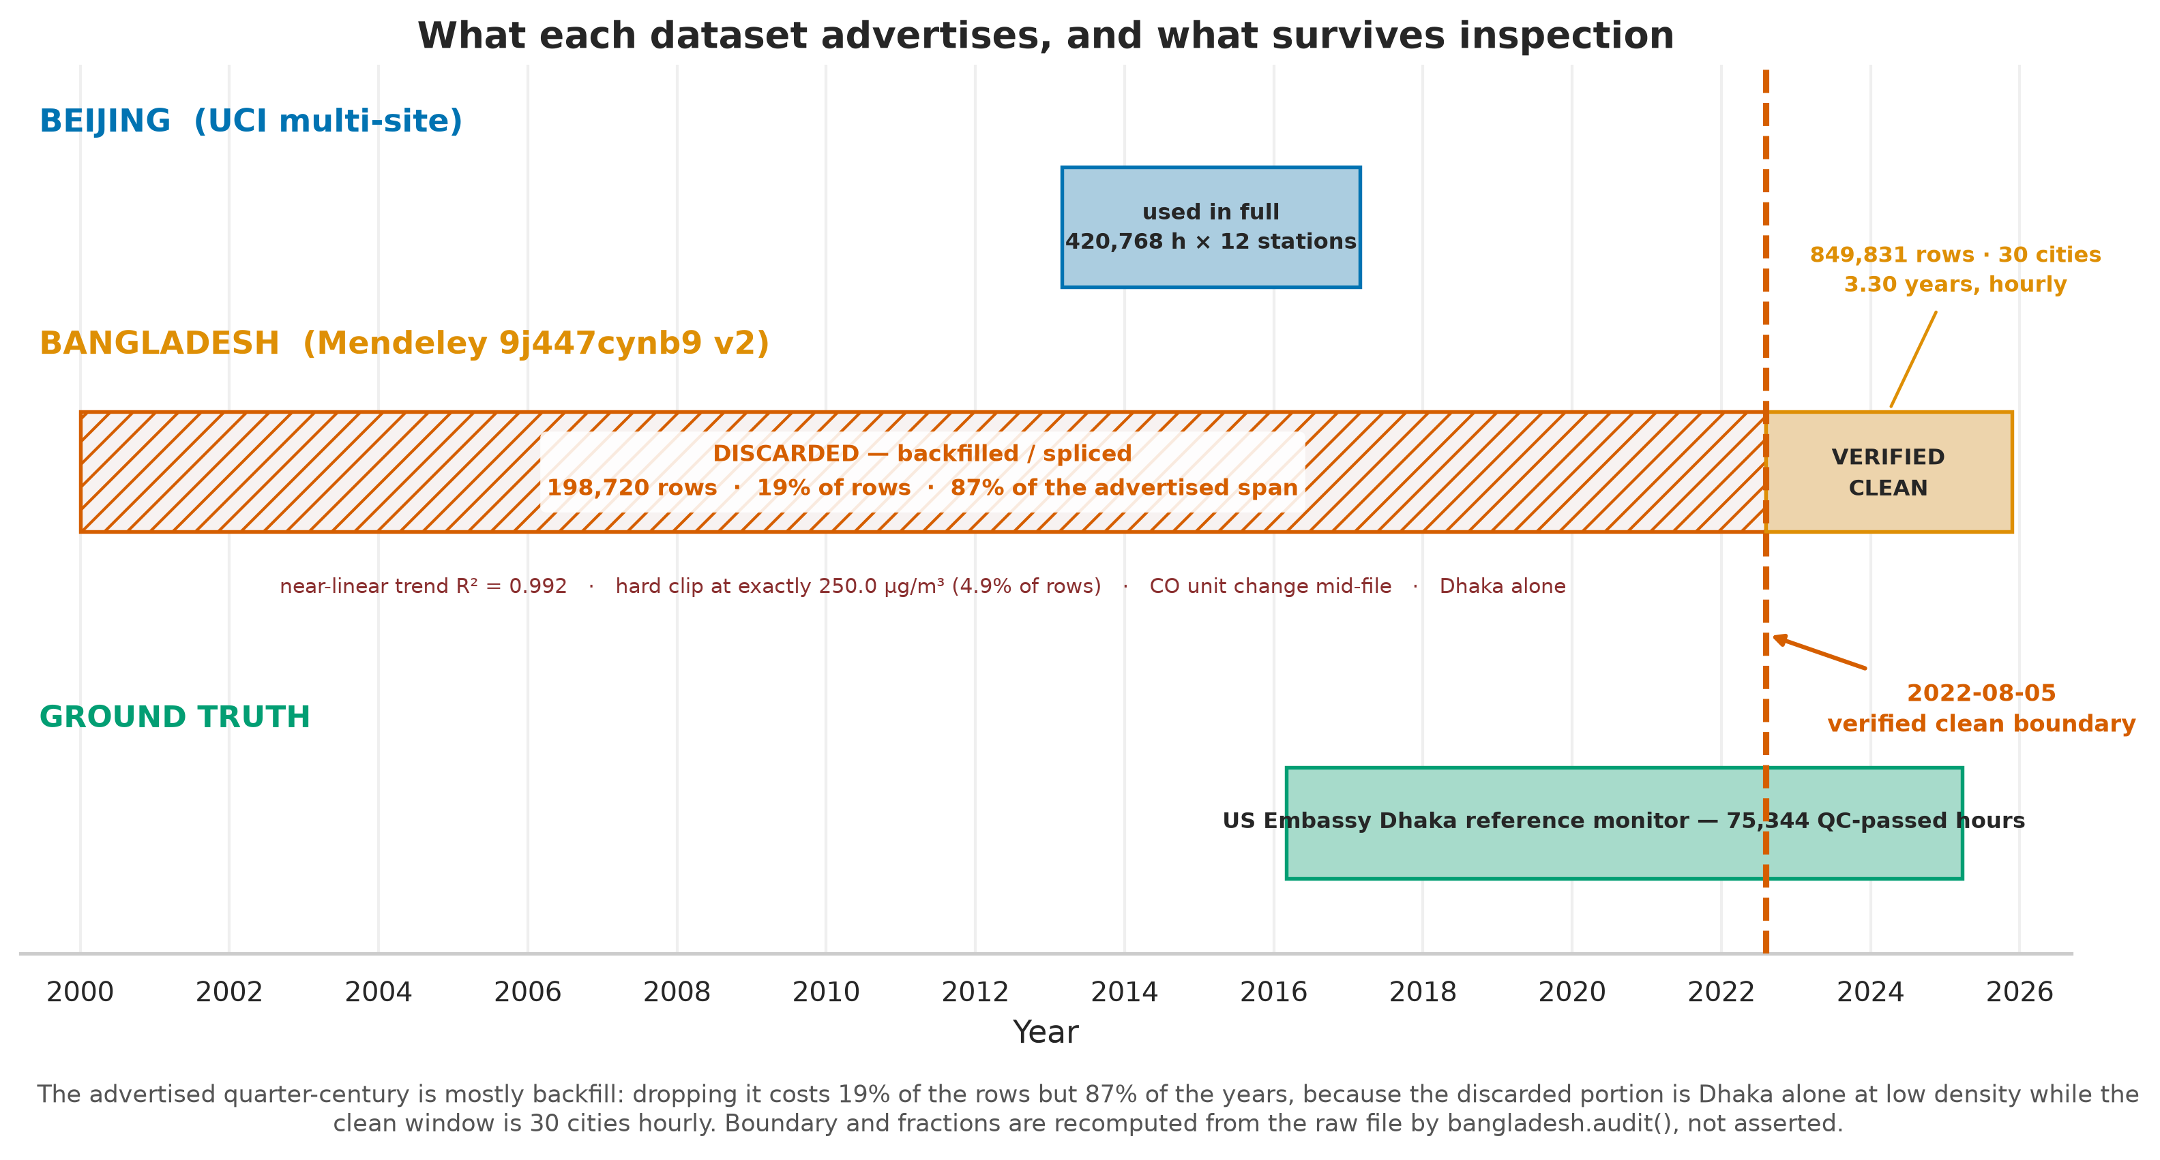
Figure 16. Coverage of each dataset: what is advertised against what survives inspection, with the verified-clean boundary marked. Generated from schematic — no metrics source, by design.
Table 24. Data-integrity audit of the published Bangladesh dataset. Every value is recomputed from the raw file at report time.
Check | Finding | Consequence
Advertised cities | 103 | 30 present
Advertised span | 2000-2025 | 2022-08-05 to 2025-11-23 usable
Rows in file | 1,048,551 | 849,831 usable (81%)
Rows discarded | 198,720 | 19% of rows, 87% of the span
Pre-cut PM2.5 trend | R-squared 0.9920 | near-linear; real air quality is not
Hard clip at 250.0 | 4.9% of pre-cut rows | an artefact of generation
Source: bangladesh_h6.json (audit block)
The advertised twenty-five-year history is 87% backfill. Everything before the clean boundary carries a near-linear synthetic trend (R-squared 0.9920), a hard clip at exactly 250.0 micrograms per cubic metre affecting 4.9% of rows, and carbon monoxide in different units. Discarding it costs 19% of the rows but 87% of the years, because the discarded portion is one city at low density while the clean window is 30 cities hourly. The span figure is the one worth quoting: the dataset's selling point is a long history, and the history is the generated part.
Every number in that audit is recomputed from the raw file at report time rather than asserted, so a reader with the file can check it.

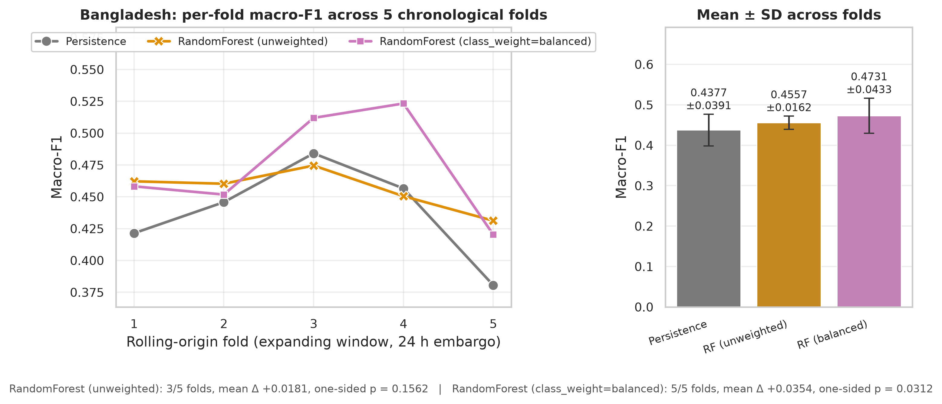
Figure 17. Bangladesh rolling-origin cross-validation: per-fold macro-F1 across five chronological folds. Generated from rolling_cv_h6_bangladesh.json.
Table 25. Bangladesh rolling-origin cross-validation over 5 folds, 24-hour embargo. The signed-rank floor for 5 folds is 0.0312 one-sided.
Model | Mean ± SD | Range | Folds won | Mean Δ | p (one-sided)
Persistence | 0.4377 ± 0.0391 | 0.3806–0.4841 | — (reference) | — | —
RandomForest (unweighted) | 0.4557 ± 0.0162 | 0.4312–0.4745 | 3/5 | +0.0181 | 0.1562
RandomForest (class_weight=balanced) | 0.4731 ± 0.0433 | 0.4203–0.5233 | 5/5 | +0.0354 | 0.0312
Source: rolling_cv_h6_bangladesh.json
Table 26. Bangladesh rolling-origin folds in detail: evaluation window, sample counts and per-fold macro-F1 for every model.
Fold | Evaluation window | Train n | Eval n | Persistence | RF (unweighted) | RF (class_weight=balanced)
1 | 2023-08-03 to 2024-01-18 | 34,700 | 16,108 | 0.4214 | 0.4622 | 0.4582
2 | 2024-01-19 to 2024-07-05 | 50,904 | 16,112 | 0.4458 | 0.4603 | 0.4517
3 | 2024-07-06 to 2024-12-21 | 67,112 | 16,108 | 0.4841 | 0.4745 | 0.5120
4 | 2024-12-22 to 2025-06-07 | 83,316 | 16,112 | 0.4566 | 0.4505 | 0.5233
5 | 2025-06-08 to 2025-11-23 | 99,524 | 16,112 | 0.3806 | 0.4312 | 0.4203
Source: rolling_cv_h6_bangladesh.json

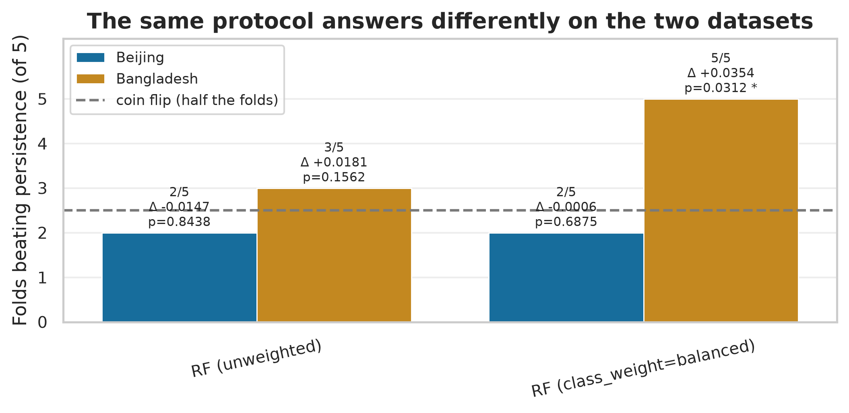
Figure 18. Folds won against persistence on each dataset, under the same protocol. Generated from rolling_cv_h6.json, rolling_cv_h6_bangladesh.json.
On Bangladesh the class-weighted forest beats persistence in 5 of 5 folds, mean difference +0.0354, one-sided p = 0.0312. The same protocol that rejected every Beijing model accepts this one, which is the result the deployment rests on.
Table 27. Per-class conformal coverage for the deployed Bangladesh model (Bangladesh-native RandomForest (class_weight=balanced)).
Class | Test n | Coverage | Mean set size | Status
Good | 6,176 | 0.9922 | 2.45
Moderate | 7,927 | 0.9179 | 2.92
Unhealthy (sensitive) | 1,757 | 0.7678 | 3.01
Unhealthy | 1,490 | 0.7785 | 3.00
Very unhealthy | 6 | 0.0000 | 3.67 | thin support
Hazardous | 0 | n/a | n/a | no test samples — not validated
Source: bangladesh_h6.json
The advisory classes are not covered by that result, and the bound travels with it. The Bangladesh test split contains 0 Hazardous and 6 Very-unhealthy samples. The five-fold result covers the four common classes and nothing more. A device shipped on this evidence could report ordinary air-quality bands; it could not yet be claimed to raise a reliable hazardous-air warning, which is the function that motivates the product.

4.10 Ground truth: the US Embassy Dhaka monitor
The advisory classes could not be validated on the reanalysis because it barely contains them. Whether that reflects Dhaka or reflects the dataset was tested directly against a reference-grade instrument.

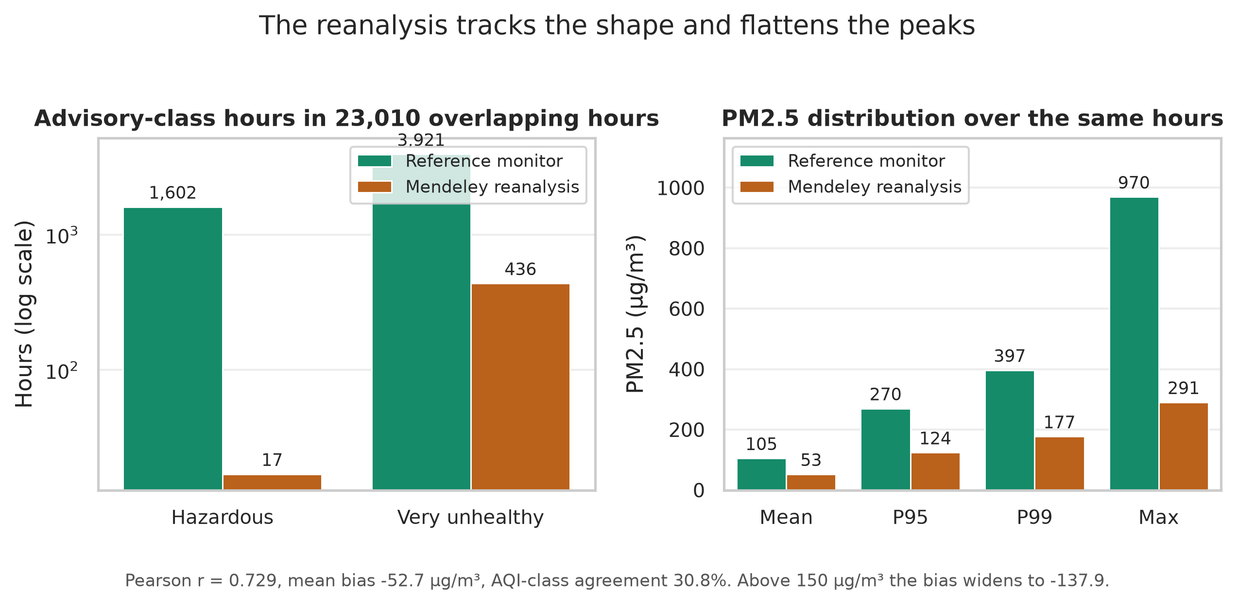
Figure 19. The reanalysis against the reference monitor over their overlapping period: advisory-class hours and the PM2.5 distribution. Generated from dhaka_ground_truth.json.
Table 28. Reference monitor against the reanalysis over 23,010 overlapping hours.
Quantity | Reference monitor | Mendeley reanalysis
Hazardous hours | 1,602 | 17
Very-unhealthy hours | 3,921 | 436
Mean PM2.5 | 105.3 | 52.6
99th percentile | 397.0 | 177.4
Maximum | 970.0 | 290.6
AQI class agreement | 30.8% | —
Source: dhaka_ground_truth.json
The reanalysis flattens the peaks. Over 23,010 overlapping hours the instrument records 1,602 Hazardous hours where the reanalysis records 17. Correlation is reasonable (Pearson r = 0.729), but the mean bias is -52.7 micrograms per cubic metre and widens to -137.9 above 150. The shape is tracked; the magnitude at the top of the range is not.
This confirms the hypothesis and moves the limitation. The absence of advisory-class samples was a property of the reanalysis product, not of Dhaka's air. Dhaka genuinely reaches hazardous concentrations; the dataset used for external validation does not represent that.

4.11 The validated Hazardous detector
A second model was trained directly on the reference series. It is PM2.5-only and single-station, so it is not the deployed multi-channel predictor; its purpose is to establish whether the advisory-class task is learnable at all on real data.

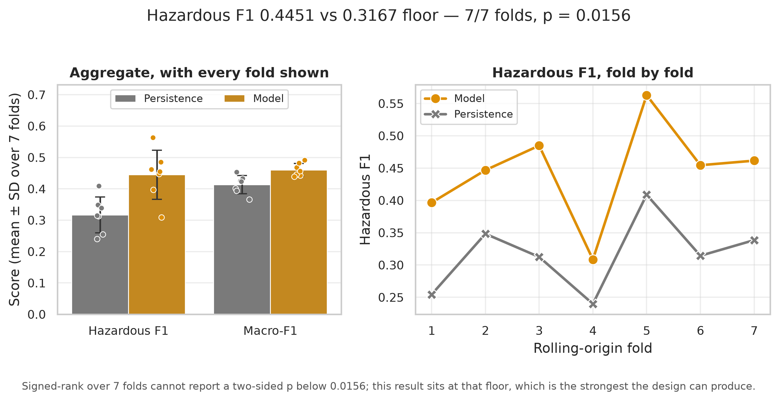
Figure 20. Hazardous-class and aggregate performance against the persistence floor across seven rolling-origin folds, with every fold shown. Generated from dhaka_pm25_model_h6.json.
Table 29. PM2.5-only model on the reference series, 7 rolling-origin folds. The signed-rank floor over 7 folds is 0.0156 two-sided, which this result attains.
Metric | Model (mean ± SD) | Persistence | Mean Δ | Folds won | p (two-sided)
Hazardous F1 | 0.4451 ± 0.0783 | 0.3167 | +0.1284 | 7/7 | 0.0156
Macro-F1 | 0.4603 ± 0.0205 | 0.4133 | +0.0470 | 7/7 | 0.0156
Source: dhaka_pm25_model_h6.json
Table 30. Phase 11b folds in detail. The model leads on Hazardous F1 in every fold, including the folds whose evaluation window misses the winter pollution season.
Fold | Evaluation window | Train n | Eval n | Model | Persistence | Δ | Winter
1 | 2019-01-28 to 2019-12-13 | 22,337 | 7,367 | 0.3966 | 0.2545 | +0.1421 | yes
2 | 2019-12-15 to 2020-11-01 | 29,784 | 7,382 | 0.4468 | 0.3483 | +0.0985 | yes
3 | 2020-11-03 to 2021-09-17 | 37,232 | 7,171 | 0.4848 | 0.3125 | +0.1723 | yes
4 | 2021-09-19 to 2022-08-30 | 44,680 | 7,386 | 0.3086 | 0.2398 | +0.0688 | yes
5 | 2022-09-01 to 2023-07-10 | 52,127 | 7,390 | 0.5629 | 0.4088 | +0.1542 | yes
6 | 2023-07-12 to 2024-05-17 | 59,575 | 7,389 | 0.4545 | 0.3144 | +0.1401 | yes
7 | 2024-05-19 to 2025-03-24 | 67,023 | 7,381 | 0.4615 | 0.3385 | +0.1230 | yes
Source: dhaka_pm25_model_h6.json
Hazardous F1 reaches 0.4451 against a 0.3167 persistence floor, winning 7 of 7 folds (two-sided p = 0.0156). That p-value sits at the signed-rank resolution floor for this fold count, which is the strongest the design can produce rather than a weak result.
What this does and does not establish. It is evidence about the *task*: hazardous-air prediction at six hours is learnable above its floor on instrument-grade data. It is not evidence about the deployed model, which is a different model on different inputs. The two results are reported as two results.

4.12 Monitoring infrastructure: the OpenAQ survey

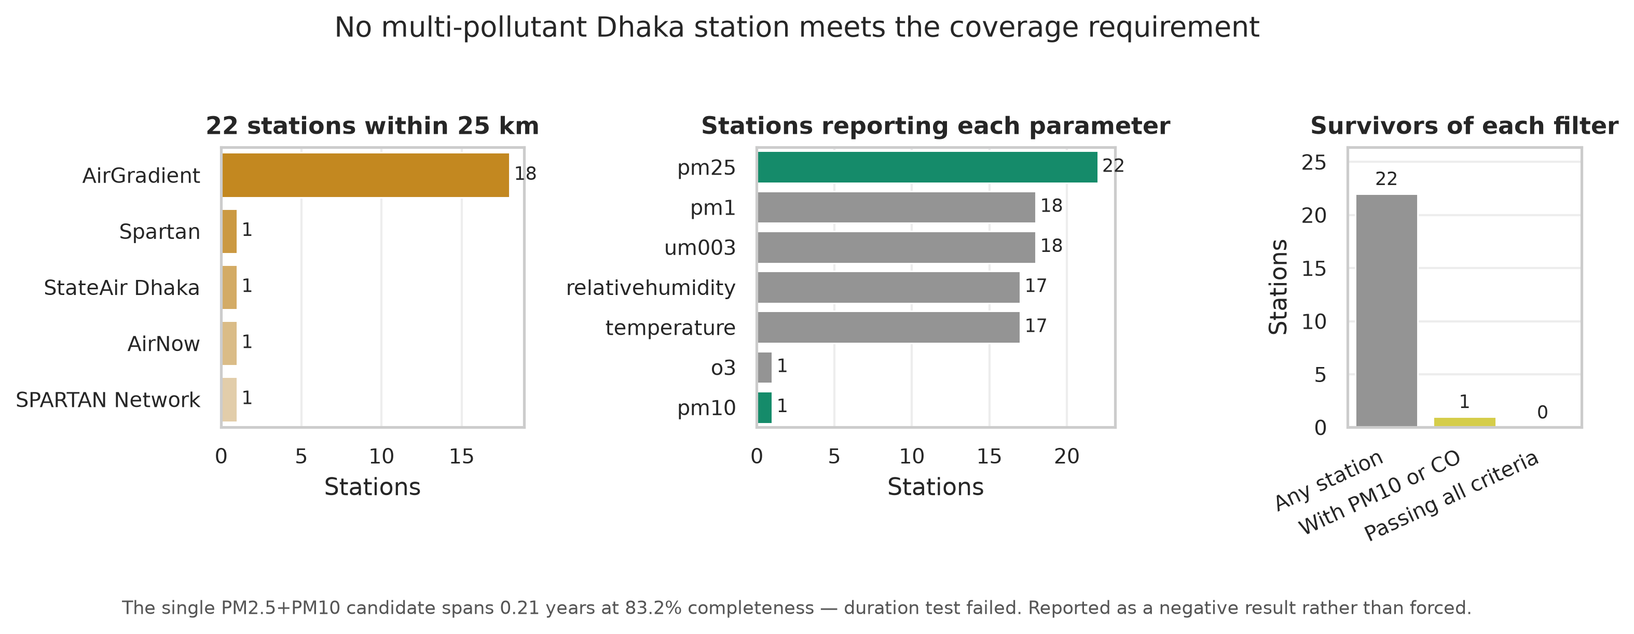
Figure 21. Stations near Dhaka by provider and by reported pollutant, and the number surviving each coverage filter. Generated from openaq_survey.json.
Table 31. OpenAQ station survey around Dhaka.
Criterion | Count | Note
Stations within radius | 22 | 25 km of Dhaka
Reporting PM2.5 | 22 | the common case
Reporting PM10 | 1 | required companion channel
Reporting CO | 0 | required companion channel
With PM10 or CO alongside PM2.5 | 1 | candidates
Passing all coverage criteria | 0 | none qualify
Best candidate span | 0.21 years | 83.2% complete; duration test failed
Source: openaq_survey.json
No station qualifies. Of 22 stations within 25 km, 1 report a companion pollutant alongside PM2.5, and 0 meet the duration and completeness requirements. The single candidate spans 0.21 years at 83.2% completeness, failing the duration test.
This is a finding about infrastructure, and it bounds the thesis. A multi-pollutant model cannot currently be validated against instrument-grade data in Dhaka through public open-data channels. A zero here is the correct answer, not a missing measurement, and it is reported rather than worked around.
The precise version of this claim matters, and it is stronger than the absence it first appears to be. The Department of Environment does operate a real monitoring network: the National Air Quality Management Plan 2024–2030 records 31 stations — 16 continuous air monitoring stations and 15 compact monitoring stations — across 13 cities in eight divisions (Government of Bangladesh 2024). None of these is registered on OpenAQ or any comparable international open-data platform, and the DoE's own real-time portal exposes its readings only through a token-gated application interface rather than a bulk download or documented public API. The obstacle is therefore access, not existence: the stations are real, but their data is not available in a form this study could consume, and this thesis does not claim the network is absent — only that it is closed to the kind of use made here. The primary source is retained in the repository at `docs/reference/NAQMP_2024-2030.pdf`.

4.13 The deployed system

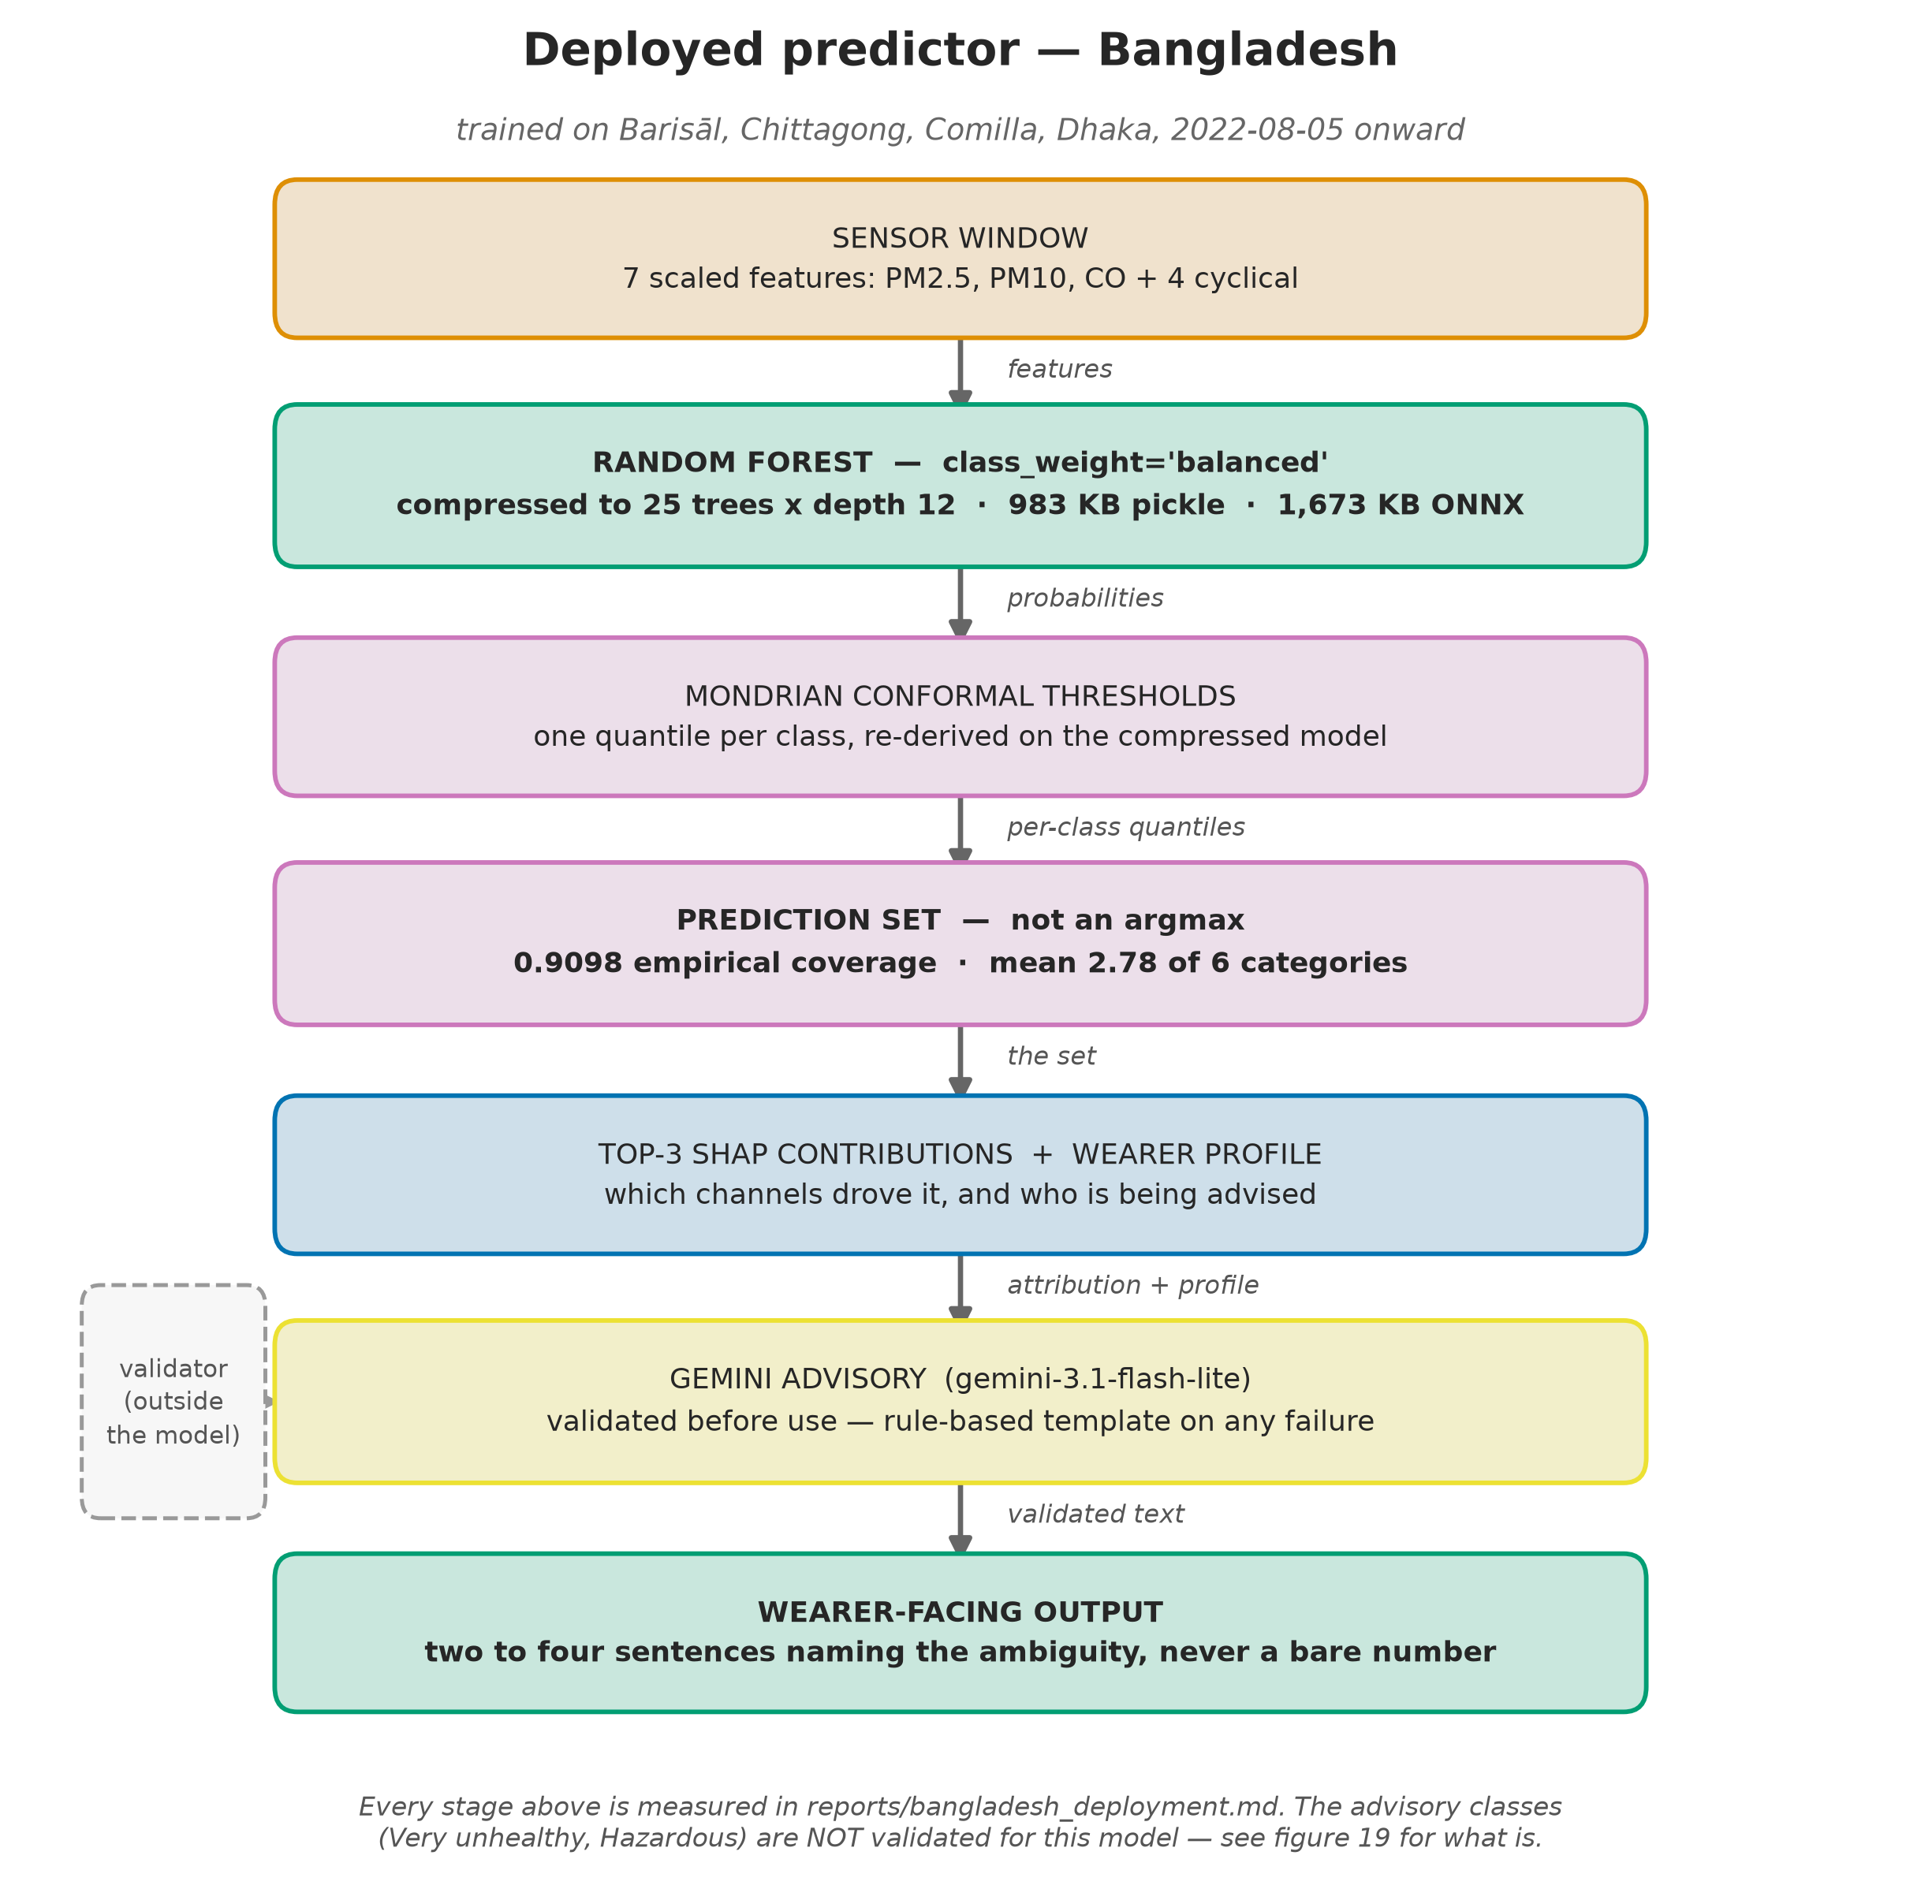
Figure 22. The deployed Bangladesh predictor, stage by stage, with the validator drawn outside the model column. Generated from schematic — no metrics source, by design.
Table 32. The deployed Bangladesh predictor.
Property | Value
Training data | Barisāl, Chittagong, Comilla, Dhaka, 2022-08-05 onward
Features | 7: PM2.5, PM10, CO, hour_sin, hour_cos, month_sin, month_cos
Model | RandomForest, class_weight='balanced', 25 trees x depth 12
Serialised size | 983 KB pickle, 1,673 KB ONNX
Single-sample latency | 0.0074 ms
Uncertainty layer | Mondrian conformal, empirical coverage 0.9098, mean set 2.78
ONNX parity | max |Δp| 2.6e-07, argmax agreement 1.0000
Advisory classes | not validated for this model — see Sections 4.9 and 4.11
Source: deployment_h6_bd.json, bangladesh_h6.json
Table 33. The 5 advisory examples, with the generated text each produced. Every advisory naming an ambiguous set hedges explicitly; that is enforced by the validator, not left to the model.
Case | Point prediction | Conformal set | True label | Generated advisory (excerpt)
1 — AMBIGUOUS — set of 2 | Very unhealthy (p = 0.44) | [Very unhealthy, Hazardous] | Hazardous | Your air quality forecast for six hours from now is ambiguous, ranging from Very Unhealthy to Hazardous. Because the model cannot rule out the Hazardous category, you should plan for the worst-case scenario by …
2 — confident — singleton set | Hazardous (p = 0.76) | [Hazardous] | Hazardous | The air quality is forecast to be Hazardous in six hours, a prediction based on the model weighting your PM2.5, PM10, and CO sensor channels most heavily. Because this method is correct 90.8% of the time for th…
3 — AMBIGUOUS — set of 3 | Moderate (p = 0.44) | [Good, Moderate, Unhealthy (sensitive)] | Moderate | Your air quality forecast for later today is currently ambiguous, as the model indicates the risk could range from Good to Unhealthy for sensitive groups. To be safe, I am basing this advice on the Unhealthy fo…
4 — AMBIGUOUS — set of 2 | Unhealthy (p = 0.56) | [Unhealthy, Very unhealthy] | Very unhealthy | Your air quality forecast for six hours from now is ambiguous, ranging between Unhealthy and Very unhealthy. Because the model weighted fine and coarse particulate levels most heavily, I am basing this precauti…
5 — AMBIGUOUS — set of 2 | Unhealthy (p = 0.72) | [Unhealthy, Very unhealthy] | Unhealthy | Your air quality forecast is currently ambiguous, ranging between Unhealthy and Very unhealthy. Because the model weighted fine and coarse particulates most heavily, you should prepare for the worst-case scenar…
Source: reports/llm_advisory_examples.md

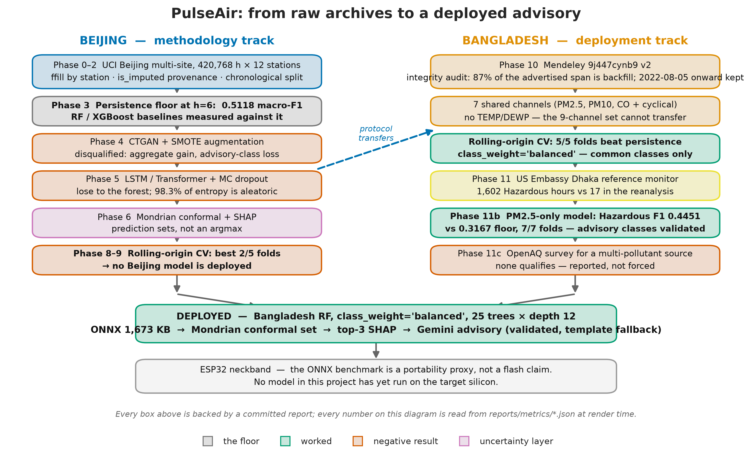
Figure 23. The full project pipeline: the Beijing methodology track, the Bangladesh deployment track, and what each produced. Generated from schematic — no metrics source, by design.
The deployed system is the Bangladesh model; the Beijing pipeline is the methodology that produced it. Those are two artefacts with two statuses, and conflating them would misrepresent both.

4.14 Explainability: SHAP case studies
Table 34. Global mean absolute SHAP attribution by channel.
Channel | Mean |SHAP|
PM2.5 | 0.08843
PM10 | 0.03466
CO | 0.01693
hour_cos | 0.01231
DEWP | 0.01229
hour_sin | 0.01077
month_cos | 0.01067
TEMP | 0.00730
month_sin | 0.00720
Source: shap_h6.json
Global mean absolute attribution is dominated by the pollutant channels, with the meteorological and cyclical channels contributing an order of magnitude less. That ordering is what the advisory layer reports to the wearer: the sentence names the channels that actually drove the prediction, not a fixed list.
Table 35. The 12 SHAP case studies, with the three channels carrying the largest attribution in each.
Case | True | Predicted | Set size | Top-3 attributions
Hazardous, confident (singleton set) | Hazardous | Hazardous | 1 | PM2.5 +0.376, PM10 +0.228, CO +0.068
Hazardous, confident (singleton set) | Hazardous | Hazardous | 1 | PM2.5 +0.369, PM10 +0.222, CO +0.048
Hazardous, ambiguous (set > 1) | Hazardous | Very unhealthy | 3 | PM2.5 +0.186, PM10 +0.064, hour_cos +0.040
Hazardous, ambiguous (set > 1) | Hazardous | Hazardous | 2 | PM2.5 +0.135, PM10 +0.130, hour_cos +0.062
Very unhealthy, ambiguous | Very unhealthy | Unhealthy | 3 | PM2.5 +0.201, PM10 +0.055, DEWP -0.048
Very unhealthy, ambiguous | Very unhealthy | Very unhealthy | 2 | PM2.5 +0.254, PM10 +0.106, CO +0.031
highly ambiguous (set >= 4) | Moderate | Moderate | 4 | PM2.5 +0.166, hour_sin +0.059, month_cos -0.039
highly ambiguous (set >= 4) | Unhealthy (sensitive) | Good | 4 | PM2.5 +0.150, CO +0.078, TEMP +0.055
confident, any class | Unhealthy | Unhealthy | 1 | PM2.5 +0.219, PM10 +0.086, CO +0.029
confident, any class | Unhealthy | Unhealthy | 1 | PM2.5 +0.238, PM10 +0.075, month_sin +0.044
random | Hazardous | Hazardous | 2 | PM2.5 +0.187, PM10 +0.096, hour_cos +0.057
random | Unhealthy | Moderate | 4 | PM2.5 +0.119, hour_cos +0.048, month_cos -0.032
Source: shap_h6.json
Each case is reproduced in the repository with a full attribution plot. The pattern that matters for the advisory layer is in the set-size column: a confident prediction and an ambiguous one are distinguishable before any text is generated, which is what lets the wearer-facing sentence hedge when it should and commit when it can.

5. Discussion
Three threads run through the results, and they are more connected than they first appear.

5.1 An average says nothing about its tail
The same failure appeared three times, in three unrelated places. Augmentation raised macro-F1 while significantly degrading both advisory classes. Marginal conformal prediction met its coverage target on average while under-covering the rarest class. And expected calibration error ranked the Transformer as the better-calibrated model while maximum calibration error ranked it the worse, by a factor of more than four in its worst bin.
In each case an aggregate over a distribution concealed a failure in its tail, and in each case the tail is the part the device exists for. A wearable that is accurate on ordinary air and unreliable on hazardous air has the performance profile of a device nobody needs. The methodological consequence is the disqualification rule of Section 3.5, and the reason it is stated as a rule rather than exercised as judgement is that the same mistake was available three separate times.

5.2 The ceiling is in the data
Every attempt to improve on the tabular baseline failed, and they failed consistently. Sequence models lost to the forest. Added capacity made both sequence architectures monotonically worse. Compression across three orders of magnitude cost almost nothing. The uncertainty decomposition says why: 98.3% of predictive entropy is aleatoric, leaving a sliver for any model to compete over.
This is a statement about the task as posed, not about deep learning. Six hours ahead, from one station's channels, the AQI category is substantially undetermined. Improving it requires changing the input — more channels, a longer window, spatial context from neighbouring stations — not the architecture. A paper reporting a large gain on this task from an architectural change should be read with that in mind.

5.3 Methodology transferred; weights did not
The Beijing pipeline produced no deployable model. What it produced was the protocol, and the protocol transferred cleanly: applied unchanged to Bangladesh, it rejected every Beijing model and accepted a Bangladesh-native one. A transferred Beijing model, tested directly on Bangladesh data, did not clear that dataset's own floor.
That is the desirable outcome rather than a disappointing one, and it is the argument for citing this work's Beijing phase as methodology rather than as a model. It is also the argument for releasing the protocol as software: PulseBench is the part of this thesis most likely to be useful to someone else, and it is the part that was validated twice.

5.4 Data integrity is a result, not a preliminary
The Bangladesh audit began as a preprocessing step and became a finding. A dataset indexed prominently, published with a DOI, and advertising a quarter-century of coverage turned out to be substantially generated over most of that span, with no indication in the record. Any external-validation claim built on the advertised span would have been built on generated numbers.
The subsequent comparison against a reference monitor turned that from a suspicion into a measurement, and then moved the project's central limitation from 'the model cannot detect hazardous air' to 'the validation data did not contain any'. Those are very different statements, and only an instrument could distinguish them.

5.5 Cheap controls change conclusions
The augmentation result would have read very differently without its controls. CTGAN raises aggregate macro-F1 significantly; reported alone, that is a positive finding and a publishable one. It survives neither of the two controls that were run. SMOTE produces the same aggregate gain in seconds rather than minutes, which removes the argument that the generator is earning its cost. And the per-class breakdown shows both methods buying that gain by degrading the classes the device exists for.
Neither control was expensive. SMOTE is a library call; class weighting is a single keyword argument; the per-class breakdown is a different aggregation of numbers already computed. The cost of running them was a few minutes, and the cost of not running them would have been a false claim at the centre of the thesis. That asymmetry is the argument for making such controls routine rather than optional.
The same applies to the validity checks on synthetic data. Section 4.3's checks are four assertions about whether a row is physically possible. They caught what a quality score above 0.89 did not, and they cost nothing to run. A distributional similarity score and a validity check answer different questions, and for engineered or physically constrained features the two can disagree completely.

5.6 What reproducibility required in practice
Every number in this document is read at build time from a committed metrics file; the generator inserts a visible marker rather than a plausible value when it cannot find one. That constraint was adopted after an error that is worth recording, because it is the kind that survives review.
An earlier draft of the Bangladesh audit reported the same percentage as both the share of rows kept and the share discarded, in adjacent sentences, because both were generated from one variable. The two are 81% and 19%. The mistake propagated into the public repository's documentation before it was caught by recomputing the fractions from the raw file rather than trusting the prose. The fix was not only to correct the text but to name the two quantities separately in the code, so that they can no longer collapse into one.
Two smaller instances followed the same pattern: a figure title asserting a compression ratio that the plotted data did not show, and a calibration result that sat unreported in a metrics file for weeks until an audit of committed-but-unused values found it. Generating prose and figures from the data, rather than writing them alongside it, is what turned all three from silent errors into build-time failures.

6. Limitations
The limitations below are ordered by how much they constrain the central claims. The first three bound what the thesis establishes; the remainder bound how far it generalises.

6.1 The deployed model's advisory classes remain unvalidated
This is the limitation that matters most, because it concerns the function the product exists for. The Bangladesh test split contains 0 Hazardous and 6 Very-unhealthy samples. A five-of-five-fold result computed over evaluation blocks that thin cannot speak to those classes, and the thesis does not claim it does.
Section 4.11 narrows the gap without closing it. A PM2.5-only model on reference-monitor data detects hazardous air significantly above its floor in every fold, which establishes that the *task* is learnable. It is a different model, on one station, with one channel. Transferring that conclusion to the seven-channel deployed model would be exactly the kind of unearned inference this thesis argues against elsewhere.
The honest statement is that the deployed system could report ordinary air-quality bands and could not yet be claimed to raise a reliable hazardous-air warning. Any deployment should carry that bound with it.

6.2 Multi-pollutant validation is currently impossible in Dhaka
Section 4.12 is a limitation as much as a finding. No station in the survey reports PM2.5 alongside a companion pollutant for long enough and completely enough to validate a multi-channel model. That is a property of the monitoring infrastructure, not of the method, and no modelling choice addresses it. It is the direct cause of Section 6.1 and the reason the stationary variant in Section 7.2 is worth considering. As Section 4.12 records, the constraint is one of access rather than absence: the Department of Environment's 31-station network exists but is not published in an openly consumable form (Government of Bangladesh 2024).
This limitation is worth reading against the government's own roadmap, because the two are complementary rather than competing. The National Air Quality Management Plan 2024–2030 foresees forecast-triggered management of high-pollution days once a forecasting capability is operational (§3.4), and the route it names for that capability is physics-based chemistry-transport modelling — WRF-Chem or CAMx, driven by meteorology and emissions inventories (§3.3.3) (Government of Bangladesh 2024). That is a deliberately different instrument from the one built here: a chemistry-transport model encodes atmospheric processes and can attribute and forecast without a long observational record, at the cost of gridded emissions data and substantial compute; the statistical and machine-learning approach this thesis develops needs only a monitoring record but, as every chapter above documents, is sharply bounded by what that record can support — a persistence floor that is hard to beat at short horizons, augmentation that helps the aggregate while hurting the safety-critical classes, and advisory classes that cannot yet be validated on local ground truth. Read that way, the contribution of this thesis to the national roadmap is not a rival forecaster but evidence about the data-driven option: it shows, with a protocol built to resist flattering itself, where a purely statistical approach delivers and where it does not — which is exactly the kind of prior a programme choosing between modelling routes needs before it commits.

6.3 Two datasets, and the negative results rest on one
The negative results — augmentation disqualified, capacity unhelpful, no model beating persistence — are established on Beijing and only partially re-tested on Bangladesh. Beijing 2013–2017 is a specific pollution regime with a specific seasonal structure and an unusually dominant middle class. Whether the same conclusions hold in a regime with different dynamics is untested, and the toolkit was released partly so that others can test them.

6.4 Methodological caveats
- Monte Carlo dropout is an approximation. The aleatoric/epistemic split is load-bearing in Section 5.2, and dropout-based uncertainty estimates have known weaknesses. A deep ensemble would be a stronger check and was not run; the conclusion should be read as well-supported rather than settled.
- Conformal coverage assumes exchangeability, which a chronological split strains. Calibration and test come from different periods, and air quality has trend and seasonality. The empirical coverage reported in Section 4.5 is measured rather than assumed, which is the relevant reassurance, but the theoretical guarantee is weaker here than in the exchangeable case.
- The horizon is fixed at six hours because it is the shortest horizon at which the task is not a persistence echo, not because it is the most useful to a wearer. A shorter actionable warning is what the product wants and what Section 5.2 explains it cannot currently have.
- One evaluation duplicate remains by design. The tabular baseline keeps its own persistence implementation because it must return row-aligned predictions for the paired bootstrap, which is a different operation from returning a metrics summary. Substituting the shared version would have invalidated every paired test in the thesis. The difference is structural, and it is documented rather than resolved.

6.5 Engineering and infrastructure caveats
- The device has not been fabricated. No model in this project has run on ESP32 silicon. The latency benchmark in Section 4.6 was measured on a workstation through a runtime that does not exist for the target microcontroller, and is reported as a portability proxy throughout.
- The advisory layer depends on an external hosted service. Output is validated and falls back to a rule-based template on any failure, so the system degrades safely, but the layer is not self-contained and the model behind it can change without notice. One such change occurred during this work, when a model version was retired mid-project.
- The synthetic-data findings are specific to one generator and one library version. The validity failures in Section 4.3 are properties of how CTGAN was configured and of what the library enforced at the time. The general lesson — that a distributional quality score is not a validity check — is broader than the instance, but the specific numbers are not.

7. Proposed Wearable Device (Concept — Not Yet Fabricated)
Nothing in this chapter has been built. It describes the device the software was designed for, together with a stationary variant. No hardware was fabricated, no firmware was flashed, and no measurement in this thesis was taken from a physical prototype. The latency and size figures in Section 4.6 come from a workstation benchmark.

7.1 The wearable concept
The original concept is a neckband built around an ESP32 microcontroller, chosen for integrated wireless connectivity and sufficient flash for a compressed model. It would carry a particulate sensor and, if the power budget allows, a gas sensor, sampling the air at the wearer's breathing zone rather than at a rooftop station kilometres away. Inference would run on-device so that a forecast survives loss of connectivity, with the companion application providing history, explanation and configuration.
Table 36. Companion application features implied by the software built here.
Feature | What supplies it | Status
Current risk category | The compressed forest | Implemented off-device
Six-hour forecast | Same model, horizon 6 | Implemented off-device
Confidence as a set of categories | Mondrian conformal thresholds | Implemented off-device
Which channel drove the warning | Top-3 SHAP attributions | Implemented off-device
Plain-language advisory | Validated language-model layer with template fallback | Implemented off-device
Exposure history | Not built | Design only
On-device inference | Requires a C tree traversal or `emlearn` | Not built — see Section 4.6
Source: derived from the implemented software modules

7.2 A stationary variant
A stationary, government-monitoring-style unit is also worth considering, and the results here argue for it more strongly than for the wearable. Section 4.12 found that the monitoring infrastructure needed to validate a multi-pollutant model does not exist around Dhaka. A fixed unit at a known location, reporting continuously, addresses that gap directly: it relaxes the power and size budget, permits a reference-grade sensor, and contributes to the public record rather than only to one wearer's phone.
This is a design direction, not a result. The repository contains no hardware or firmware notes for either variant; the stationary option is recorded here because the infrastructure finding points at it, not because any part of it was built.

8. Conclusion and Future Work
This thesis set out to build a GAN-augmented deep-learning pipeline for wearable air-quality risk forecasting. It produced one, and in the process produced the evidence that most of its components do not earn their place. GAN augmentation is disqualified for degrading the classes the device exists to warn about, and so is SMOTE. Sequence models lose to a Random Forest, and get worse as they get larger. At a six-hour horizon on Beijing data, no model beats a zero-parameter baseline in more than 2 of 5 rolling-origin folds.
What survived is smaller and better supported. A class-weighted Random Forest on Bangladesh data clears its own persistence floor in every fold, for the four common classes. Class-conditional conformal prediction restores coverage where the marginal guarantee failed. A PM2.5-only model on reference-monitor data detects hazardous air above its floor in every fold. A published dataset was audited and found substantially fabricated over its advertised span. And the evaluation protocol that established all of this is released as software.
The central claim of the thesis is methodological: a reported accuracy in this literature is uninterpretable without the zero-parameter baseline beside it, and a single chronological split is not enough to establish that a model beats one. Applying that discipline turned a project about model architecture into a project about evaluation, which is the more useful outcome.

8.1 Future work
- Port the compressed forest to C and measure it on ESP32 silicon. This is the largest self-contained piece of engineering the project leaves open, and it converts the portability proxy into a measurement.
- Find or build a multi-pollutant reference series for Dhaka. Section 4.12 shows none currently exists. A stationary unit (Section 7.2) is one route.
- Validate the deployed model's advisory classes once such a series exists, closing the gap Section 6 names first.
- Replace Monte Carlo dropout with a deep ensemble to check the aleatoric/epistemic split that Section 5.2 rests on.
- Extend the input rather than the architecture. Spatial context from neighbouring stations, or a longer window, addresses the aleatoric ceiling; more layers do not.
- Test the protocol on other pollution regimes. PulseBench is dataset-agnostic, and the negative results deserve a third and fourth city.

Data and Code Availability
All source code, configuration, generated reports, metrics files and figures are publicly available at:
https://github.com/MD-ALL-SHAHRIA/pulseair
Every quantitative claim in this thesis is reproducible from the committed metrics files in that repository, and every figure was generated from them by a script that fails rather than substituting a value when a number is missing. The evaluation toolkit described in Section 3.12 is installable independently of the thesis code. The raw datasets are third-party and are not redistributed; the repository documents how to obtain each.
The repository is released under the MIT Licence and has accepted an external contribution since publication.

References
The list below is reproduced from `reports/reference_list_expanded.md` in the repository. Entries marked [NEW] were added during this work and were each verified against a bibliographic registry — Crossref for DOIs, the arXiv API for preprints, or the publisher's own page — rather than from recollection. Entries not so marked are reproduced exactly as supplied and are not re-verified here.
[1] [NEW] Adiputra, I Nyoman Mahayasa; Wanchai, Paweena (2024). "CTGAN-ENN: a tabular GAN-based hybrid sampling method for imbalanced and overlapped data in customer churn prediction." Journal of Big Data 11(1), art. 121. DOI: 10.1186/s40537-024-00982-x
[2] [NEW] Ali, Md. Arfan; Bilal, Muhammad; Wang, Yu; Nichol, Janet E.; Mhawish, Alaa; Qiu, Zhongfeng; de Leeuw, Gerrit; Zhang, Yuanzhi; Zhan, Yating; Liao, Kuo; Almazroui, Mansour; Dambul, Ramzah; Shahid, Shamsuddin; Islam, M. Nazrul (2022). "Accuracy assessment of CAMS and MERRA-2 reanalysis PM2.5 and PM10 concentrations over China." Atmospheric Environment 288, 119297. DOI: 10.1016/j.atmosenv.2022.119297
[3] Angelopoulos & Bates 2023
[4] [NEW] Azani Hassan Abadi, Maede; Wang, Shouyi (2026). "Interpretable Machine Learning for Air Pollution and Respiratory Health Prediction: A Socioeconomic Subgroup Analysis." arXiv:2607.17024
[5] Barber, Candès, Ramdas, Tibshirani 2023
[6] Bergmeir & Benítez 2012
[7] Breiman 2001
[8] "Can Apps Make Air Pollution Visible?" 2019, Journal of Business Ethics
[9] [NEW] Cerda-Mardini, Diego; Chandar, Sarath; Madathil, Sreenath (2026). "Consistent but Miscalibrated: Evaluating LLM Limitations for Risk Communication in Natural Language." arXiv:2607.03882
[10] Chawla, Bowyer, Hall, Kegelmeyer 2002
[11] Chen & Guestrin 2016
[12] [NEW] Cheung, Taizhen (2026). "When Directional Accuracy Lies: A Base-Rate-Honest Benchmark for LoRA-Adapted TimesFM on Equity Forecasting." arXiv:2607.12248
[13] [NEW] Corani, Giorgio; Benavoli, Alessio; Demšar, Janez; Mangili, Francesca; Zaffalon, Marco (2017). "Statistical comparison of classifiers through Bayesian hierarchical modelling." Machine Learning 106(11), 1817–1837. DOI: 10.1007/s10994-017-5641-9
[14] CREA 2025
[15] [NEW] Demšar, Janez (2006). "Statistical Comparisons of Classifiers over Multiple Data Sets." Journal of Machine Learning Research 7(1), 1–30.
[16] [NEW] Ding, Tiffany; Fermanian, Jean-Baptiste; Salmon, Joseph (2025). "Conformal Prediction for Long-Tailed Classification." arXiv:2507.06867
[17] [NEW] Djupskås, Aslak; Stasik, Alexander Johannes; Riemer-Sørensen, Signe (2025). "Unreliable Uncertainty Estimates with Monte Carlo Dropout." arXiv:2512.14851
[18] Gal & Ghahramani 2016
[19] Gibbs & Candès 2021
[20] [NEW] Gondal, Moazzam Umer; Qudous, Hamad ul; Farhan, Asma Ahmad (2025). "Beyond the Hype: Comparing Lightweight and Deep Learning Models for Air Quality Forecasting." arXiv:2512.09076
[21] [NEW] Gondal, Moazzam Umer; Qudous, Hamad ul; Farhan, Asma Ahmad; Alamri, Sultan (2026). "Interpretable PM2.5 Forecasting for Urban Air Quality: A Comparative Study of Operational Time-Series Models." arXiv:2603.25495
[22] [NEW] Gowri, L.; Sriya, Nitta Sai; Sowmya, Muppa; Lakshmi, Anna Reddy Harshitha; Amirtharajan, Rengarajan (2025). "Explainable AI for urban air quality: SHAP interpretation of stacked ensemble AQI forecast." Theoretical and Applied Climatology 156(10), art. 533. DOI: 10.1007/s00704-025-05741-3
[23] [NEW] Gündüz, Ali Fatih; Şahin, Canan Batur (2026). "Synthetic Data Augmentation for Imbalanced Tabular Protein Subcellular Localization: A Comparative Study of SMOTE, CTGAN, TVAE, and TabDDPM Methods." Applied Sciences 16(8), 3694. DOI: 10.3390/app16083694
[24] [NEW] Hasan, Kamrul; Rahman, Mustafizur; Akhter, Momotaj; Mohinuzzaman, Mohammad; Kayes, Imrul; Rahman, Shahanaj (2024). "A new dynamic approach using data-driven and machine learning models for forecasting particulate matter in Dhaka megacity." Environmental Pollution and Management 1, 235–247. DOI: 10.1016/j.epm.2024.11.005
[25] Hochreiter & Schmidhuber 1997
[26] [NEW] Huam Ming Ken; Behjati, Mehran (2025). "Advancing Air Quality Monitoring: TinyML-Based Real-Time Ozone Prediction with Cost-Effective Edge Devices." arXiv:2504.03776. Also in Selected Proceedings from the 2nd ICIMR 2024, Lecture Notes in Networks and Systems vol. 1316, Springer, Singapore.
[27] [NEW] Islam, Abu Reza Md. Towfiqul; Al Awadh, Mohammed; Mallick, Javed; Pal, Subodh Chandra; Chakraborty, Rabin; Fattah, Md. Abdul; Ghose, Bonosri; Kakoli, Most. Kulsuma Akther; Islam, Md. Aminul; Naqvi, Hasan Raja; Bilal, Muhammad; Elbeltagi, Ahmed (2023). "Estimating ground-level PM2.5 using subset regression model and machine learning algorithms in Asian megacity, Dhaka, Bangladesh." Air Quality, Atmosphere & Health 16(6), 1117–1139. DOI: 10.1007/s11869-023-01329-w
[28] Lee, Bayazid, Rosenthal, Khan, Arku, Barratt, Quayyum, Baumgartner 2025, Scientific Reports
[29] Lemaître, Nogueira, Aridas 2017
[30] Liang, Maimury, Chen, Juarez 2020
[31] Liang, Xia, Ke, Wang, Wen, Zhang, Zheng, Zimmermann 2023 (AirFormer)
[32] [NEW] Liu, Siwei; Zhou, Di Jody (2024). "Using cross-validation methods to select time series models: Promises and pitfalls." British Journal of Mathematical and Statistical Psychology 77(2), 337–355. DOI: 10.1111/bmsp.12330 (published online 7 December 2023)
[33] Lundberg & Lee 2017
[34] Lundberg, Erion, Lee 2018
[35] Mao, Wang, Jiao, Zhao, Liu 2021
[36] [NEW] Meyer, Marcel; Kaltenpoth, Sascha; Zalipski, Kevin; Müller, Oliver (2025). "Rethinking Evaluation in the Era of Time Series Foundation Models: (Un)known Information Leakage Challenges." arXiv:2510.13654
[37] "Mobile phones as monitors of personal exposure to air pollution" 2018, PLOS ONE
[38] Özüpak, Alpsalaz, Aslan 2025
[39] Pak, Ma, Ryu, Ryom, Juhyok, Pak, Pak 2020
[40] Paszke et al. 2019
[41] Patki, Wedge, Veeramachaneni 2016
[42] Pedregosa et al. 2011
[43] Pineda-Tobón, Espinosa-Bedoya, Branch-Bedoya 2024
[44] Rahman & Meng 2024
[45] Rahman, Begum, Hopke, Nahar, Newman, Thurston 2021
[46] Ray 2022
[47] RSC Environmental Science: Atmospheres 2026
[48] Selva 2025
[49] [NEW] Sharma, Sonali; Alaa, Ahmed M.; Daneshjou, Roxana (2025). "A Systematic Analysis of Declining Medical Safety Messaging in Generative AI Models." arXiv:2507.08030
[50] [NEW] Singh, Manpreet; Srikantha, Akshatha; Lakhanpal, Shyamal (2026). "Cost-Sensitive Conformal Prediction and Human-in-the-Loop Abstention for Imbalanced High-Stakes Decision Support: A Multi-Domain Benchmark." arXiv:2607.27143
[51] [NEW] Singh, Vivek; Singh, Sumit; Sharma, Nabin; Singh, Amarendra; Srivastava, Aman; Srivastava, Atul Kumar; Bisht, Deewan Singh; Patel, Kalpana; Singh, Neeti; Almazroui, Mansour; Choudhary, Arti (2026). "Estimation of surface PM2.5 over the Indo-Gangetic Basin using MERRA-2 reanalysis and machine learning." Scientific Reports 16(1), art. 13755. DOI: 10.1038/s41598-026-37934-9
[52] [NEW] Somvanshi, Shriyank; Islam, Md Monzurul; Chhetri, Gaurab; Chakraborty, Rohit; Mimi, Mahmuda Sultana; Shuvo, Sawgat Ahmed; Islam, Kazi Sifatul; Javed, Syed Aaqib; Rafat, Sharif Ahmed; Dutta, Anandi; Das, Subasish (2025). "From Tiny Machine Learning to Tiny Deep Learning: A Survey." arXiv:2506.18927; ACM Computing Surveys (2025).
[53] Tashman 2000
[54] U.S. EPA 2024
[55] UCI Machine Learning Repository 2017/2019
[56] Vaswani, Shazeer, Parmar, Uszkoreit, Jones, Gomez, Kaiser, Polosukhin 2017
[57] Wang 2025
[58] Xu, Skoularidou, Cuesta-Infante, Veeramachaneni 2019
[59] Zhao, Kunar, Birke, Chen 2021
[60] Zhao, Kunar, Birke, Chen 2022
[61] Zhou, Wang, Zhu, Qiao, Kang 2024
[62] [PRIMARY SOURCE] Government of Bangladesh (2024). Ministry of Environment, Forest and Climate Change, Department of Environment. Bangladesh National Air Quality Management Plan 2024–2030. Retained in the repository at `docs/reference/NAQMP_2024-2030.pdf`. Figures cited in the text (31 stations = 16 CAMS + 15 compact monitoring stations across 13 cities in eight divisions, §3.3.2; forecast-triggered hazard-day management, §3.4; WRF-Chem / CAMx chemistry-transport modelling, §3.3.3; open data access for researchers, §3.3.4) were confirmed against the document's own text.
Total: 62 entries.

Appendix A: Full Hyperparameter Tables
Reproduced from `configs/default.yaml`. This file is the single source of every hyperparameter and threshold in the project; the code reads it rather than restating values.

A.1 Data and splits
Table 37. ata and splits parameters.
Key | Value
uci_id | 501
raw_file | data/raw/beijing_multisite.csv
expected_rows | 420768
raw_dir | data/raw
processed_dir | data/processed
pollutants | PM2.5, PM10, SO2, NO2, CO, O3
meteorology | TEMP, PRES, DEWP, RAIN, WSPM
categorical | wd, station
time_cols | year, month, day, hour
target | pm25_category
pm25_breakpoints | 0, 12, 35.4, 55.4, 150.4, 250.4
split | chronological
test_size | 0.15
val_size | 0.15
group_key | station
pm25_labels | Good, Moderate, Unhealthy (sensitive), Unhealthy, Very unhealthy, Hazardous
Source: configs/default.yaml

A.2 Preprocessing
Table 38. reprocessing parameters.
Key | Value
features | PM2.5, PM10, CO, TEMP, DEWP
cyclical | hour, month
window | 24
horizon | 6
horizons | 1, 6, 12, 24
fill | ffill
Source: configs/default.yaml

A.3 Tabular baselines
Table 39. abular baselines parameters.
Key | Value
artifacts_dir | src/models/artifacts
report | reports/baseline_metrics.md
select_on | val_observed_macro_f1
random_forest.n_estimators | 200
random_forest.max_depth | 16
random_forest.min_samples_leaf | 50
random_forest.max_features | sqrt
random_forest.class_weight | null (unset)
random_forest.n_jobs | -1
xgboost.n_estimators | 400
xgboost.max_depth | 8
xgboost.learning_rate | 0.1
xgboost.subsample | 0.8
xgboost.colsample_bytree | 0.8
xgboost.min_child_weight | 5
xgboost.reg_lambda | 1.0
xgboost.tree_method | hist
xgboost.n_jobs | -1
Source: configs/default.yaml

A.4 Synthetic augmentation (CTGAN)
Table 40. ynthetic augmentation (CTGAN) parameters.
Key | Value
model | ctgan
epochs | 300
batch_size | 500
synthetic_rows | 10000
fit_on | observed_only
minority_threshold | 0.5
target_ratio | 0.5
quality_floor | 0.9
Source: configs/default.yaml

A.5 Sequence models
Table 41. equence models parameters.
Key | Value
architecture | lstm, transformer
num_layers | 2
dropout | 0.2
lr | 0.0003
batch_size | 512
epochs | 100
patience | 8
class_weight | null (unset)
lstm.hidden_size | 64
transformer.d_model | 64
transformer.nhead | 4
transformer.dim_feedforward | 128
Source: configs/default.yaml

A.6 Conformal prediction
Table 42. onformal prediction parameters.
Key | Value
target_coverage | 0.9
calibration_split | val
score | inverse_probability
Source: configs/default.yaml

A.7 Explainability and advisory
Table 43. xplainability and advisory parameters.
Key | Value
shap_background_size | 200
shap_n_examples | 12
llm_provider | gemini
llm_model | gemini-3.1-flash-lite
llm_max_tokens | 4096
llm_temperature | 0.3
Source: configs/default.yaml

A.8 Deployment
Table 44. eployment parameters.
Key | Value
macro_f1_tolerance | 0.01
onnx_opset | 17
artifacts_dir | reports/deployment
Source: configs/default.yaml

Appendix B: Glossary of Terms
Advisory classes | The two highest AQI categories, Very unhealthy and Hazardous. The classes a wearable exists to warn about, and the ones treated as protected throughout this thesis.
Aleatoric uncertainty | Irreducible uncertainty arising from the data itself. No amount of additional data or model capacity removes it.
Bonferroni correction | Dividing the significance threshold by the number of comparisons in a family, so that testing many hypotheses does not inflate the chance of a false positive.
Conformal prediction | A method that converts model scores into prediction sets with a coverage guarantee holding without distributional assumptions.
Disqualification rule | The rule adopted here: an intervention that significantly degrades a protected class is rejected regardless of its effect on the aggregate.
Embargo | A gap inserted between a training period and the evaluation block that follows it, so no evaluation target overlaps a training window.
Epistemic uncertainty | Uncertainty arising from the model rather than the data. Reducible in principle with more data or capacity.
Expected calibration error | The support-weighted mean gap between predicted confidence and observed accuracy across reliability bins.
Macro-F1 | The unweighted mean of per-class F1 scores. Gives a rare class the same weight as a common one, which is why it is used here.
Marginal coverage | A conformal guarantee that holds on average across all classes, and therefore not necessarily for any one of them.
Maximum calibration error | The largest single-bin gap between confidence and accuracy. The worst case rather than the average.
Mondrian conformal prediction | Class-conditional conformal prediction: a separate calibration threshold per class, restoring per-class coverage.
Observed-only evaluation | Computing a metric over rows whose label was measured rather than forward-filled, using the imputation provenance flags.
Persistence floor | The score of the zero-parameter rule that predicts the future class equals the present one. The baseline every model must clear.
Resolution floor | The smallest p-value a resampling test can produce: 2/n for an n-resample bootstrap, 2^(1-n) for a signed-rank test over n folds.
Rolling-origin cross-validation | Advancing a cutoff through time, training before it and evaluating after it, so no prediction uses future information.
Seasonal-naive baseline | The rule that the class now equals the class one seasonal cycle ago. A stronger baseline than persistence on cyclical data.
Split conformal prediction | Conformal prediction using a held-out calibration set to compute the nonconformity threshold.

Appendix C: Index of Generated Reports
Every result in this thesis is backed by a generated report in the repository, each of which is itself produced from the committed metrics files. The list is read from the repository at build time.
Table 45. The 34 generated reports in the repository.
File | Title | Words
`bangladesh_deployment.md` | Edge deployment simulation — horizon 6 h | 2,417
`bangladesh_rolling_cv.md` | Rolling-origin cross-validation — Bangladesh, horizon 6 h | 1,270
`bangladesh_validation.md` | Phase 10 — external validation on Bangladesh | 1,998
`baseline_metrics_h1.md` | Baseline metrics -- horizon 1 h | 1,228
`baseline_metrics_h6.md` | Baseline metrics -- horizon 6 h | 1,228
`capacity_sweep_h6.md` | Sequence-model capacity sweep — horizon 6 h | 490
`conformal_h6.md` | Conformal prediction — horizon 6 h | 1,473
`deployment_report_h6.md` | Edge deployment simulation — horizon 6 h | 2,708
`deployment_report_h6_cw.md` | Edge deployment simulation — horizon 6 h | 2,373
`dhaka_ground_truth_model_h6.md` | Phase 11b — PM2.5-only model on Dhaka ground truth | 1,335
`dhaka_ground_truth_validation.md` | Phase 11 — ground-truth validation, US Embassy Dhaka reference monitor | 1,240
`dl_metrics_h6.md` | Sequence models — horizon 6 h | 1,700
`final_results_summary.md` | PulseAir — final results summary | 9,296
`fold_count_comparison_h6.md` | Fold-count sensitivity — Beijing rolling-origin CV, horizon 6 h | 720
`gan_ablation_h6.md` | CTGAN ablation — horizon 6 h | 965
`gan_quality_report_h6.md` | CTGAN quality report — horizon 6 h | 2,375
`gan_quality_report_h6_targeted.md` | CTGAN quality report — horizon 6 h | 2,094
`hj633_sensitivity.md` | HJ 633-2012 sensitivity analysis | 737
`horizon_comparison.md` | Horizon comparison -- how hard is the task, really? | 626
`llm_advisory_examples.md` | LLM risk advisory — worked examples | 2,195
`openaq_multichannel_validation.md` | Phase 11c — OpenAQ survey for a multi-pollutant Dhaka source | 1,401
`preprocessing_summary_h1.md` | Preprocessing summary -- horizon 1 h | 2,326
`preprocessing_summary_h12.md` | Preprocessing summary -- horizon 12 h | 2,326
`preprocessing_summary_h24.md` | Preprocessing summary -- horizon 24 h | 2,326
`preprocessing_summary_h6.md` | Preprocessing summary -- horizon 6 h | 2,319
`reference_list_expanded.md` | Expanded reference list | 1,814
`rolling_origin_cv_h6.md` | Rolling-origin cross-validation — horizon 6 h | 1,241
`rolling_origin_cv_h6_f8.md` | Rolling-origin cross-validation — horizon 6 h | 1,491
`rolling_origin_cv_h6_f8_seq.md` | Rolling-origin cross-validation — horizon 6 h | 1,379
`selective_prediction_h6.md` | Selective prediction — Beijing, horizon 6 h | 547
`selective_prediction_h6_bangladesh.md` | Selective prediction — Bangladesh (deployed model), horizon 6 h | 508
`sensor_noise_robustness_h6.md` | Sensor-noise robustness — Hazardous detector, horizon 6 h | 984
`station_holdout_h6.md` | Station-held-out cross-validation — horizon 6 h | 1,093
`figures/README.md` | Figure index with the source JSON for each of 23 figures | —
Source: reports/ directory listing

