**Department of Electrical and Computer Engineering**

**North South University**



**EEE499B – Senior Design II**

**Project Report**

5G and New Data Offloading Scheme over D2D

**Submitted By:**

Mohammed Shihab Ibne Tarek - 1511486043

Mohammad Hasin Arman Fahim - 1510886043

Md. Imran Hossain Noyon - 1320462042

Md. Arman Shanto - 1410471042

**Faculty Advisor:**

Mr. Rashed Shelim  
Senior Lecturer  
Department of Electrical and Computer Engineering  
North South University

**Date of Submission:** 27-12-2018

# **DECLARATION**

We have completed our Capstone Project at NSU under Electrical and Computer Engineering Department, North South University. We have developed this report on “5G and New Data Offloading Scheme over D2D”. This is to certify that this report is our original work. No part of this report has been submitted elsewhere partially or fully for the award of any other degree or diploma. Any material reproduced in this internship has been properly acknowledged.

Students’ name and Signature

Mohammed Shihab Ibne Tarek (ID# 1511486043)

Mohammad Hasin Arman Fahim (ID# 1510886043)

Md. Imran Hossain Noyon (ID# 1320462042)

Md. Arman Shanto (ID# 1410471042)

# **APPROVAL**

The Capstone Project course EEE499B entitled “Senior Design II” completed by Mohammed Shihab Ibne Tarek (ID#1511486043), Mohammad Hasin Arman Fahim (ID#1510886043), Md. Imran Hossain Noyon (ID# 1320462042) and Md. Arman Shanto (ID# 1410471042) is approved in partial fulfilment of the requirement of the Degree of Bachelor of Electrical and Electronic Engineering on January 2018 and has been accepted as satisfactory.

Faculty Supervisor’s Signature

Mr. Rashed Shelim  
Senior Lecturer

Department of Electrical and Computer Engineering  
North South University  
Dhaka, Bangladesh.

Department Chair’s Signature

Dr. Shazzad Hosain  
Associate Professor

Department of Electrical and Computer Engineering  
North South University  
Dhaka, Bangladesh.

# **ACKNOWLEDGMENT**

Apart from the authors’ own effort, many individuals have been very helpful in the journey of completing this project successfully. Therefore, he would like to take this opportunity to express his gratitude towards all those involved.

First and foremost, his acknowledgment goes to Mr. Rashed Shelim, to whom they would like to express their deepest gratitude. They can’t thank him enough for his tremendous support and encouragement throughout the course of their project. Secondly, the authors would like to thank North South University for presenting such an opportunity to the students to take part in such a course where students of electrical and computing departments can work together as a group under the guidance of brilliant faculties such as our very own Mr. Rashed Shelim to show their skills.

The authors would also like to thank Allah and their parents for ensuring his good health. Furthermore, they would like to thank the Mr. Amin, who’s also a faculty of North South University for some of guidance and encouragement.

The authors learned a great deal of knowledge from all the research work and acquired a lot of skills such as implementing theory in simulation software and most importantly working efficiently in a team.

# **ABSTRACT**

The idea of offloading 5G cellular data over WiFi is becoming very popular nowadays. Offloading data over active WiFi connection in Handsets may reduce the dependency on small cells in our environment, reduces the traffic at the Base Transceiver Station (BTS) and reduces the cost of setting up 5G infrastructure. Furthermore, offloading over WiFi does not compromise the 5G speed that is the huge amount of 5G data can be offloaded over WiFi connection in Handsets with the speed promised by the 5G cellular network. Many published paper suggested “delayed offloading” in which traffic will be delayed up to an allowed deadline if the WiFi connection is inactive or until the WiFi connection again becomes available. In this paper, we proposed a routing scheme for offloading 5G cellular data where the data at a user’s handset will first collect in WiFi queue to offload over WiFi and if the WiFi connection is inactive in the user’s handset then the data will wait in the queue for a given deadline and while it waits in the WiFi queue, the user’s handset will try to set up a device to device (D2D) connection with a neighboring handset with an active WiFi connection. When the deadline will reach for the data in the WiFi queue, the user data will be sent to the neighboring handset which has an active WiFi connection and which will allow the user’s data to be offloaded through it, otherwise, if no handset with an active WiFi connection is found in the environment, after the deadline the data will be sent in the typical gruesome manner to the BTS through several small cells.

# **TABLE OF CONTENTS**

**DECLARATION** i

**APPROVAL** ii

**ACKNOWLEDGMENT** iii

**ABSTRACT** iv

**TABLE OF CONTENTS** v

**LIST OF FIGURES** vii

**LIST OF TABLES** viii

**CHAPTER 1: 5th Generation** 1

**1.1 Introduction** 2

**1.2 The Advantages** 3

**1.3 The Disadvantages** 3

**1.5 Summary** 3

**CHAPTER 2: STOCHASTIC GEOMETRY AND QUEUING THEORY** 4

**2.1 Introduction** 5

**2.2 Stochastic Geometry** 5

**2.3 Deterministic vs. Stochastic Geometry** 6

**2.3 Different Stochastic Probability Distribution** 6

**2.4 Queuing Theory** 8

**2.5 Summary** 10

**CHAPTER 3: NEW ROUTING SCHEME** 11

**3.1 Introduction** 12

**3.2 Markov’s chain:** 13

**3.3 WiFi Queue** 15

**3.4 One-hop device to device (D2D) communication** 16

**3.5 Total expected delay:** 18

**3.6 Simulation** 21

**3.7 Summary** 21

**CHAPTER 4: COST ANALYSIS** 22

**4.1 Introduction** 23

**4.2 5G network costs** 23

**4.3 Cost analysis methodology** 24

**4.4 Cost Model** 25

**4.5 Recent 5G work in Bangladesh** 27

**4.7 Summary** 28

**CHAPTER 5: DESIGN IMPACT** 29

**5.1 Introduction** 30

**5.2 Economic Impact** 30

**5.3 Environmental Impact** 30

**5.4 Social Impact** 30

**5.5 Political Impact** 30

**5.6 Ethical Impact** 31

**5.7 Health and Safety Impact** 31

**5.8 Manufacturability** 31

**5.9 Sustainability** 31

**5.10 Summary** 32

**CHAPTER 6: SIMULATION** 33

**6.1 Introduction** 34

**6.2 Simevents Model** 34

**6.3 Summary** 38

**CHAPTER 7: FUTURE WORKS** 39

**7.1 Introduction** 40

**7.2 Network Layer (MAC)** 40

**7.3 Machine Learning** 42

**7.4 Summary** 45

**REFRENCES** 46

# **LIST OF FIGURES**

|  |  |  |
| --- | --- | --- |
| Fig. No. | Figure Caption | Page No. |
| 1.1 | Distance/Topology/Segments versus data speeds | 2 |
| 2.1 | The queue model for a UE in a 3-tier HetNet | 10 |
| 3.1 | 5G cellular data offloading using three different techniques | 13 |
| 3.2 | The 2D Markov Chain for the WiFi queue in delayed offloading with consideration to D2D. | 14 |
| 3.3 | Timer timing out when the deadline is reached. | 18 |
| 3.4 | The average delay of offloading over WiFi through D2D for a packet of size 7.5Mbyte. | 21 |
| 4.1 | Sequential Methodology. | 24 |
| 6.1 | No. of people versus waiting time (in mins) survey. | 34 |
| 6.2 | Simulink model of new routing scheme using simevents library. | 35 |
| 6.3 | Utilization factor of WiFi route. | 36 |
| 6.4 | Utilization factor of Device to Device route. | 36 |
| 6.5 | Utilization factor of cellular network. | 37 |
| 6.6 | Waiting time in FIFO queue. | 37 |
| 6.7 | Entity Attribute stem plot. | 38 |
| 7.1 | Urban canyon scenario in a 3D ray tracing simulator with vehicles of distinct sizes randomly positioned. | 44 |
| 7.2 | Rays obtained in a traffic jam situation. | 44 |
| 7.3 | A machine learning based intrusion detection system for software defined 5G network. | 45 |

# **LIST OF TABLES**

|  |  |  |
| --- | --- | --- |
| Table No. | Table caption | Page No. |
| 3.1 | Variables and Shorthand Notation. | 14 |
| 4.1 | Capital and operational expenditure cost | 26 |

# **CHAPTER 1: 5th Generation**

## **1.1 Introduction**

The world with its ever growing population and the continual increasing use of videos and the rise of Internet of Things (IoT) is having an increase of wireless data traffic at a rate of over 50% per year per subscriber [1][2]. Addressing this demand, the wireless communication sector is evolving into the next generation of communication, which is the Fifth Generation (5G) of wireless technology. This new generation proposes the use of millimeter wave (mmWave) frequencies to offer a completely new spectrum and multi-Gigabit-per-second (Gbps) data rates to a mobile device [3]. The previous generations of 2G, 3G and the ongoing 4G networks are all based on microwave frequencies, unlike these generations the 5G is based on millimeter waves which will provide a higher bandwidth (about 10 times greater than today’s 4G LTE) as a result it will have the ability to support more users and provide higher data speeds of up to 10Gbps and also lower the data traffic greatly. Fig.1 shows the different wired and wireless technologies and their corresponding data speeds [4].

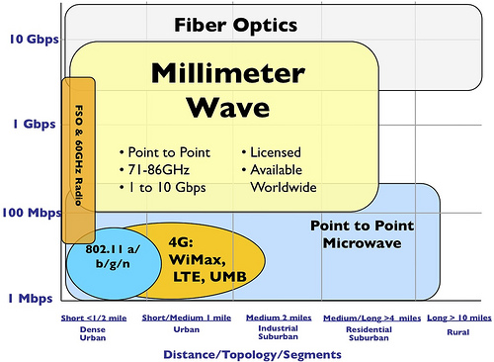

Fig. 1.1: Distance/Topology/Segments versus data speeds [4].

With all the advantages of the millimeter wave, there remains some challenges. The millimeter waves have lower penetrating powers than microwaves and thus it will not be easy to transmit such signals over a great distance or even through building walls. Thus, addressing this problem and many other, many new techniques such as the use of femto cells, beamforming, network slicing etc. have been introduced and proposed in recent papers.

The 5G wireless technology will also make use of cloud computing. This will allow smart and efficient handling of all the data, further reducing traffic and delays.

## **1.2 The Advantages**

The 5th generation of telecommunication networks proposes to bring a lot of good into the world. 5G will be able to achieve upto 10 times the speed of existing 4G netwroks. The immensely high data speeds itself brings forward lots of advantages. It will help improve the lifestyle of the population and make work more efficient.

## **1.3 The Disadvantages**

Along with all the advantages there will always be some disadvantages. Likewise, as the 5G is based on millimeter waves, the waves have low penetration power and the signal strength is easily lost over small distances, thus, more cell towers need to be introduced which will in turn increase expenses and require permissions. As of recent tests, the millimeter waves seem to effect the behavior of birds and some animals.

## **1.5 Summary**

The 5th Generation technology is projected to be launched in the year 2020. New 5G enabled phones are already being announced. However, there is a great deal of work left before the true beauty of 5G can be experienced.

# **CHAPTER 2: STOCHASTIC GEOMETRY AND QUEUING THEORY**

## **2.1 Introduction**

The design and simulation of telecommunication studies are all based on probabilistic equations. For 5G stochastic groemetry has been used to build its model. Queuing theory is also an essential part in any kind of communication and will be discussed in this chapter.

## **2.2 Stochastic Geometry**

Stochastic geometry is a branch of probability theory which deals with set-valued random elements. It describes the behavior of random configurations such as random graphs, random networks, random cluster processes, random unions of convex sets, random mosaics, and many other random geometric structures. Due to its strong connections to the classical field of stereology, to communication theory and spatial statistics it has a large number of important applications.

Stochastic geometry provides a natural way of defining and computing macroscopic properties of such networks, by averaging over all potential geometrical patterns for the nodes, in the same way as queuing theory provides response times or congestion, averaged over all potential arrival patterns within a given parametric class.

Modeling wireless communication networks in terms of stochastic geometry seems particularly relevant for large scale networks. In the simplest case, it consists in treating such a network as a snapshot of a stationary random model in the whole Euclidean plane or space and analyzing it in a probabilistic way. In particular the locations of the network elements are seen as the realizations of some point processes. When the underlying random model is ergodic, the probabilistic analysis also provides a way of estimating spatial averages which often capture the key dependencies of the network performance characteristics (connectivity, stability, capacity, etc.) as functions of a relatively small number of parameters.

Stochastic geometry, which we use as a tool for the evaluation of such spatial averages, is a rich branch of applied probability particularly adapted to the study of random phenomena on the plane or in higher dimension. It is intrinsically related to the theory of point processes.

## **2.3 Deterministic vs. Stochastic Geometry**

Deterministic and stochastic geometry, these are the two known available approaches for cellular network designing and analysis. GSM, UMTS and LTE networks, all have used deterministic based on hexagonal cell to design the coverage of the cellular network [5]. Deterministic method is only effective for networks which have fixed number of cell radius. Deterministic coverage allows to calculate necessary distance between co-channel cells and avoid interference. Despite this approach’s effectiveness, this method sometimes becomes ineffective for highly dense urban scenarios where there are obstacles like building high traffic because of huge number of users. Deterministic method decreases rapidly due to such high fluctuations of cells load and presence of skyscrapers that affects the network geometry negatively. When 5G will be implemented will have many access nodes, co-tier interference, cross-tier interference, new backhauling solution, cloud system, and many more. the cell site area will not be hexagonal and each cell site area will differ from the other. On top of all these, the cell sites will have a high powered base station under which there will be many small cell. The small cells will be inside the larger cell covered by the high powered base station which will create cross-tier interferences. The existing hexagonal methods will be a total failure for designing heterogeneous network as they are only suitable for topologies with fixed size of cells. Therefore, stochastic geometry was introduced to predict the probabilistic parameters of randomly designed HetNet and this stochastic approach is showing better solutions.

Stochastic geometry is the study of random spatial patterns. Stochastic geometry can be used to model K-tier heterogeneous network, where the small base stations are positioned by stochastic process in an unplanned random way. I stochastic geometry the properties of the heterogeneous networks like positions of small cells and macro cell, users’ location and mobility, co-tier and cross-tier interferences between access node are considered as a random stochastic process of specific probability distribution [6].

## **2.3 Different Stochastic Probability Distribution**

What is the most effective probability distribution to model small cells in heterogeneous network is still a debate. There are different node positioning model and work is going on to include as many parameters as possible to models so that the model can generate a more realistic topology of the 5G network.

* **Poisson point process (PPP):** PPP is an easy process to model heterogeneous network with infinite number of nodes in the infinite coverage area. It is used to model the position of base stations of single or K-tier cellular networks [7].
* **Binomial point process (BPP):** BPP is also used to model the position of base stations of single or K-tier cellular networks with the exceptions that number of network node is finite and the coverage area is also finite. BPP is often used to model the wireless sensor network behavior in local areas [8].
* **Matern’s hard core point process (Matern’s HCPP):** HCPP is a developed model of PPP. There are many problems with PPP such that PPP returns random network topology without any limitations of minimum distance between neighbor transmitters. Thus, with PPP planning some BSs may appear in the same place or very close to each other. This result in unrealistic network topology and leads to inaccuracy in modeling and calculating distance dependent network parameters such as transmission power and signal to interference to noise ratio (SINR). HCPP is used to model more realistic network topology by exploiting strict determination of minimum distance between any base station pair. HCPP is obtained from PPP eliminating all points, which are not satisfying However, HCPP is more complex and also provides inaccuracy in simulation because of violation of probabilistic distribution of network parameters [9], [10].
* **Voronoi tessellation:** It is used to model the random coverage area of small cells in dense urban environment. It uses the PPP or HCPP or other probability distribution to know the position of the small cells and then it defines the coverage area for all the small cells. Voronoi tessellation is created by taking pairs of neighbor points and drawing an line that is equidistant between them and perpendicular to the line connecting both points [11].
* **Poisson cluster process (PCP):** In real life user equipments (UEs) are concentrated around buildings, bus stations, shopping centers and other social places where there is hotspot or wifi. So PCP takes in to account that users are found clustered together most of the time and hence there will be more number of small cells required in a building or shopping malls. PCP method creates network topology with K-clustered access nodes [12].

New parameters are being added to such stochastic models to make the model more realistic. Some parameters are crucial and must be included in the stochastic modeling for position of small cells while others provide minor improvement in the stochastic model.

## **2.4 Queuing Theory**

Queuing theory explicitly used to analyse and design any kind of system that that involves waiting in lines for a service, such as restaurants, banks, mobile data etc. The queues can be formed at the receiving end only or the transmission end only or at both the ends. They act as data buffers and also protect data packets from crashing into one another. However queues can be a wasteful downtime.

Queuing models are usually identified by the notation: A/B/c/K, where A denotes the distribution of the inter-arrival time, B denotes the distribution of the service time, c denotes the number of servers, and K denotes the capacity of the queue [13]. If K is omitted, it is assumed that K = ∞. The inter-arrival time is the amount of time between the arrival of one customer and the arrival of the next customer. It is calculated for each customer after the first and is often averaged to get the mean inter-arrival time, represented by lambda. Service time is defined as the time required to serve a customer. There are lots of different queuing models and a few single server models have been discussed below:

**1)** **M/M/1**

M stands for Markov and is commonly used for the exponential or Poisson distribution. Hence an M/M/1 queue is one in which there is one server (and one channel) and both the inter-arrival time and service time are exponentially distributed [14]. The important equations for M/M/1 models are:

|  |  |
| --- | --- |
|  | (2.01) |
|  | (2.02) |
|  | (2.03) |
|  | (2.04) |

where, L denotes expected no. of customers in system, Lq denotes expected queue length, W denotes the waiting time in system and Wq denotes the waiting time in queue.

**2) M/G/1**

Here, the inter-arrival time is given by exponential distribution and the service time is given by general distribution. This model basically involves non-exponential distributions and gives the following equations [14]:

|  |  |
| --- | --- |
|  | (2.05) |
|  | (2.06) |
|  | (2.07) |
|  | (2.08) |

where, L denotes expected no. of customers in system, Lq denotes expected queue length, W denotes the waiting time in system and Wq denotes the waiting time in queue.

A modified M/G/1 queue has been used for the HetNet in [15].The queuing model introduced in [15] is an M/G/1 model with limited feedback. This feedback mimics the possibility of outage. High interference, fading, lower availability of power resources, no coverage by any basestation (BS) within the HetNet, etc., are some of the main reasons for outage. Therefore, the probability associated to this transition would be the outage probability seen from the UE’s perspective. This queue model is illustrated in Fig. 2.1.a and Fig. 2.1.b shows the time diagram notation.

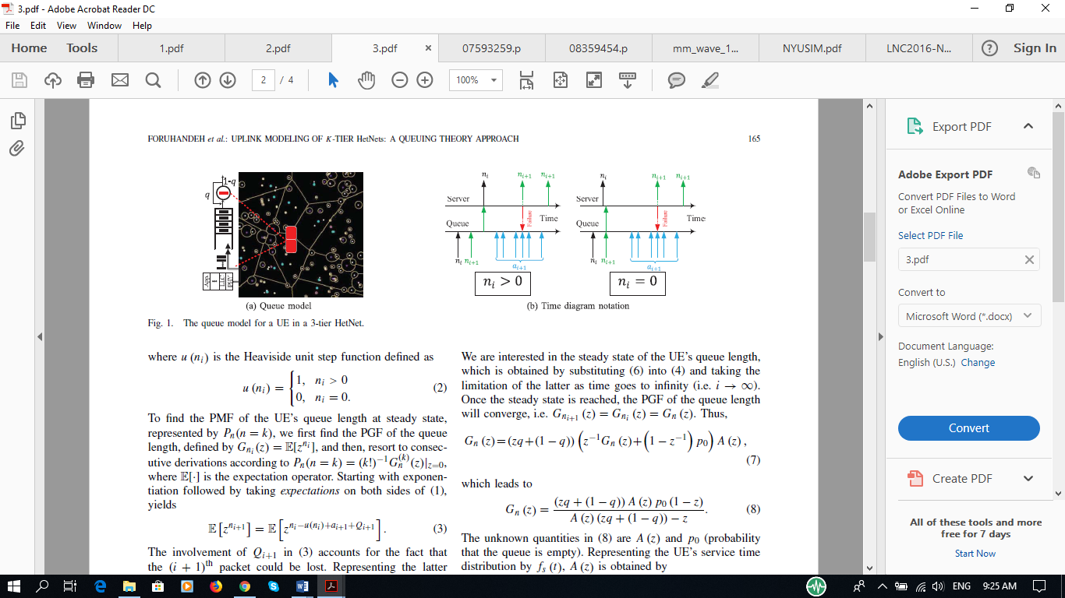

(a) Queue Model

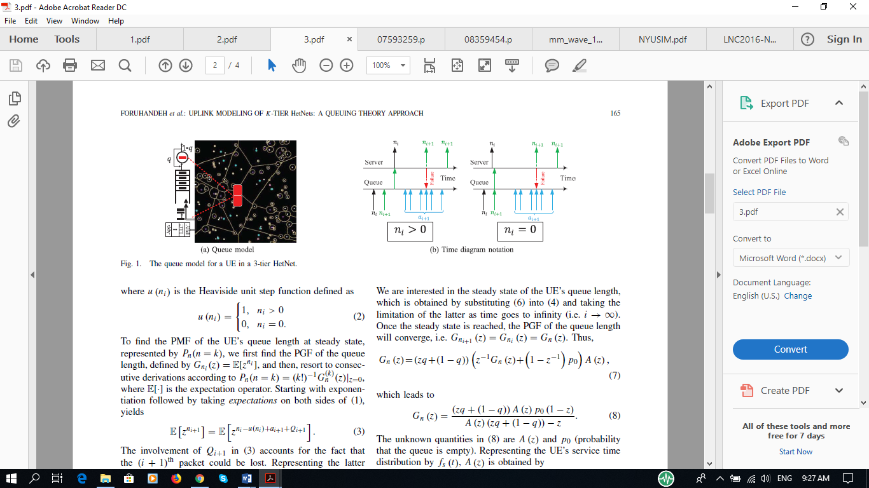

(b) Time Diagram Notation

Fig. 2.1: The queue model for a UE in a 3-tier HetNet [15].

## **2.5 Summary**

This chapter introduces the idea of stochastic geometry and queuing theory. Many queuing models have been introduced and discussed as well.

# **CHAPTER 3: NEW ROUTING SCHEME**

## **3.1 Introduction**

It is anticipated that the 5th generation of mobile systems (5G) will be provided by the telecommunication companies to the general public in the year 2020. But currently, we have enough technology to implement 5G so why the telecommunication companies are not providing 5G network? Millimeter-waves with high frequencies, 3Ghz too 300Ghz, need to be used to fronthaul 5G traffic as most of the good range of radio frequencies, 3Khz to 3Ghz, have already been used up. These millimeter-waves have short ranges i.e. they cannot travel a long distance and they get attenuated in space very easily. So to make these waves travel long distance small-cell need to be densely deployed in our environment to aid the millimeter-wave to travel through many small-cell until it reaches the Base Transceiver Station (BTS). Hence to make the 5G cellular network infrastructure less depended on small-cell, scientists and engineers are trying to develop ways to offload traffic without the assistance of small cells.

Currently, a lot of research is being done on two methods of offloading: WiFi offloading and D2D communication. These ways of offloading send less traffic at the BTS, reduces the cost of 5G infrastructure and reduces dependency on small-cells. This paper can be considered as an extended work of [16] where the traffic is offloaded over WiFi is available. Otherwise, if unavailable, the traffic is delayed to offload via cellular network until a deadline is reached. Our proposed routing scheme is as follows:

**Scenario 1:** User’s cell phone will check Wi-Fi availability. If WiFi is available, it will send its data to WLAN as Wi-Fi offloading offers much higher data rate, less power consumption and avoid traffic overload at base stations.

**Scenario 2:** If WiFi is not available data traffic will wait till its deadline is reached. While the data is waiting in the queue to reach the deadline time, it will run another process where it will do Device 2 Device (D2D) communication with its neighboring cell phones to check whether they have a WiFi connection or not. If they have, then the user’s cell phone will establish a D2D connection with one of the neighboring cell phones which are running WiFi and offload all the data to the neighboring device which in turn will offload these data over WiFi.

**Scenario 3:** if the user’s cell phone cannot find any neighboring device with an active WiFi connection then it will do the typical cellular communication with the base station to offload its data.

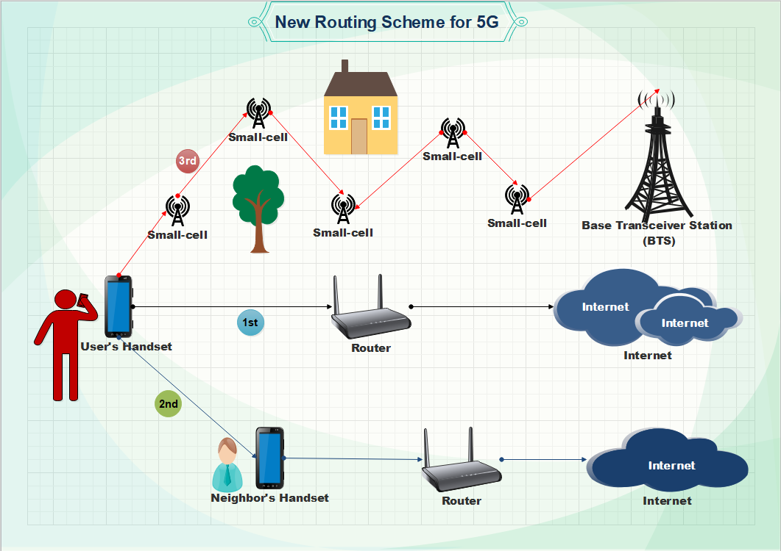

Fig. 3.1: 5G cellular data offloading using three different techniques

## **3.2 Markov’s chain:**

Paper [16] modeled their WiFi queue with a 2D Markov chain. We extended theirs modeled by considering D2D in the Markov chain in Fig.3.2. States with WiFi connectivity are denoted with {i,Wi-Fi}, states with only cellular connectivity {i,Cellular} and states with D2D connectivity {i,D2D}. Here, i represents the number of customers in the system (service + queue). While in the WiFi states, the system empties at the rate of µ and in both D2D state and cellular at a rate of iξ. The rate iξ represents the rate of offloading the files that abandoned the WiFi queue as there was no WiFi and now after the expiration of the deadline, these files are either being offloaded by the cellular state or by the D2D state. Unlike [16], we made no attempt to derive the total transmission delay of our proposed model from the above extended Markov chain instead we modelled our proposed model by taking equations or models for delay in each of the three states from existing published paper as we think that will make our equation for total transmission delay more appropriate. The total transmission delay of our model will be discussed in the later section of our paper.

Table 3.1: Variables and Shorthand Notation.

|  |  |
| --- | --- |
| Variable | Definition/Description |
| λ | Average packet arrival rate at the mobile user |
| η | The rate of leaving the WiFi state |
| µ | The servicing rate while in WiFi state |
| γ | The rate of leaving the cellular state |
| τ | The rate of leaving D2D state |
| ξ | The reneging rate or the rate of abandoning WiFi state |
| i | Number of customers in the system (service+ queue) |
| {i, Wi-Fi} | WiFi connectivity state |
| {i, Cellular} | Cellular connectivity state |
| {i, D2D} | D2D connectivity state |

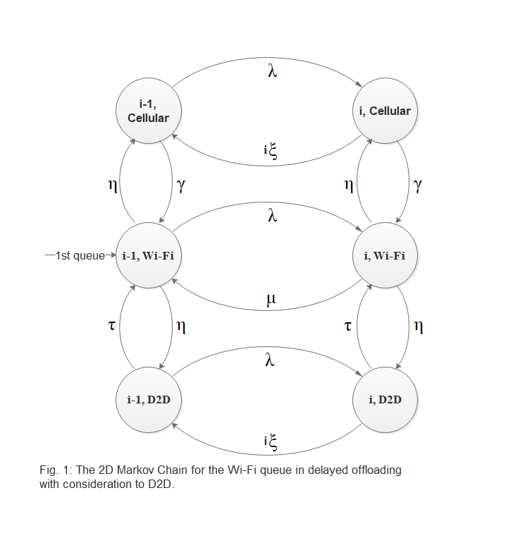

Fig. 3.2: The 2D Markov Chain for the WiFi queue in delayed offloading with consideration to D2D.

## **3.3 WiFi Queue**

Cisco [17] predicts that by 2020, more than 11.6 billion mobile connected devices and traffic will reach an annual rate of 30.6 Exabytes ( Terabytes ) per month. This huge amount of mobile device traffic will be tough for the cellular network to handle all on its own. One solution to this problem is to deploy a huge number of small cells in our environment. But telecommunication companies are feeling reluctant on bearing the huge cost of buying, installing and maintenance of these small cells. To date, WiFi offloading seems to an easy and inexpensive solution to the problem. WiFi AP are already found at the customer’s end: WiFi routers installed at homes and work. By sending the user’s traffic over WiFi, telecommunication companies will need to install less amount of small cells in our environment and it will also cause less traffic at the BTS.

[16] mentions two types of WiFi offloading: on-the-spot offloading and delayed offloading. In this paper, we are using the latter; delayed offloading. In delayed offloading all the user’s traffic will be sent over WiFi when there is an active WiFi connection in the user’s handset; otherwise, all traffic is sent over cellular interface after the traffic has waited for a deadline in the queue for the WiFi to come back. We extended this routing scheme and made it better and less depended on small cells by including D2D in the routing scheme.

At times we find ourselves within the coverage of a WiFi network but we fail to establish a WiFi connection in our mobile handset due to not knowing the password of the WiFi access point (AP). Delayed offloading can be made handy in those situations by making the user’s handset search its environment for any neighboring handset with an active WiFi connection with the AP while the user’s traffic is waiting in the WiFi queue to reach the deadline. WiFi access points have already become densely deployed in our environment: shopping mall, universities, schools, offices, and restaurants. Most of the time we fail to use these APs because of not knowing the security password of the access points. In such places, there is a high chance that someone in our environment knows the security password and he/she has already an active WiFi connection in his/her handset. By making user’s traffic offload through the WiFi connection of someone else’s handset after the deadline is reached, 5G data offloading can be made less depended on small cells.

We assumed that the data will offload according to First Come First Served (FCFS) queuing discipline and at all times the cellular network will be available. Whenever the WiFi connection will get lost, the packets in the WiFi queue will be given a deadline. The deadline time will be set in an increasing manner to the queued packets from the first to the last that is the 2nd packet waiting in the queue will be given a slightly longer deadline than the 1st packet in the queue. If the WiFi connection does not come within the deadline the packets will offload either by neighboring handset through D2D or by cellular network again offload according to First Come First Served (FCFS) queuing discipline. Also, if D2D connection is possible with WiFi activated neighboring handset, the packets that will collect in the WiFi queue of the neighbor’s handset will offload by First Come First Served (FCFS) queuing discipline.

## **3.4 One-hop device to device (D2D) communication**

D2D communication is another promising solution in minimizing the cost of implementing 5G cellular infrastructure and reducing traffic at the BTS. D2D communication in cellular network refers to the direct communication between the mobile users without the involvement of Base Station (BS) or the core network elements. Many papers have shown procedures for neighbor discovery and data offloading using D2D communication. In our routing scheme, we restrict to one-hop D2D communication which involves the transmission of data by a single hop. the reason for restricting to only one-hop D2D is because current technology is only just enough to do one-hop D2D and proves to be unreliable for multi-hop D2D.

D2D is of two types: Network-centric and Device centric. Network-centric means communication between mobile users depends on the network infrastructure. This means that the user of a particular network, for example, Airtel, will only be able to do D2D. Whereas, device-centric means network setup is managed by the proximate device. This means that the user of a particular mobile handset, for example, Samsung, will only be able to do D2D will each other. So, users of the same mobile network operator or same banded handsets can allow each other to offload their data.

[18] measured the average round-trip delay of 6.71ms for one-hop D2D where 20 ping packets were sent from a transmitting device to a 70m far apart receiving device. The maximum discovery distance and transmission rate for D2D communication are 354m and 50Mbps respectively which is greater than WiFi, 35m and 11Mbps (IEEE 802.11b) respectively [19]. The radio frequency for wireless communication can use any frequency band: licensed or unlicensed band. Millimeter wave of high frequency can deliver high speed for short distances between the two devices.

In our routing scheme, the user’s handset will search to find any handset in its environment with an active WiFi connection to a WLAN. After the discovery of such handset, user’s handset will then try to set up a reliable connection with the neighbor’s handset by assigning an IP address as proposed in [20]. The algorithm using Abstract Protocol Notation (APN) for the user’s handset to discover neighboring handset with active WiFi connection is given below:

bool WiFi_ack := true;

bool WiFi_reply := true;

var find_WiFi : Boolean

{init. find_WiFi = true}

begin

find_WiFi

send rqst(WiFi_ack) to broadcast request;

start reply timer;

find_WiFi := false;

rcv rply(WiFi_reply) from server

stop replytimer;

if WiFi_reply = true then

send ack to find IP address

else

end;

The algorithm using Abstract Protocol Notation (APN) for the neighboring handset with active WiFi connection to respond to the request of the user’s handset is given below:

bool availableWiFi : true;

var WiFi_reply : Boolean;

begin

rcv rqst(WiFi_reply) from client

if availableWiFi = true then

WiFi_reply := true;

else

WiFi_reply := false;

send rply(WiFi_reply) to client

end

The user’s handset broadcasts a request to find WiFi active handsets in its surroundings. As soon as the broadcast message is sent a timer is turned on. The timer will count time up to the deadline time of packets in the WiFi queue of the user’s handset to get replies from other handsets in its surroundings. If any affirmative reply of WiFi available handset comes then the user’s handset will send another request to establish D2D connection with the WiFi activated neighboring handset. Otherwise, if no WiFi active neighboring handset is found then the packets in the user’s handset will offload over the cellular network.

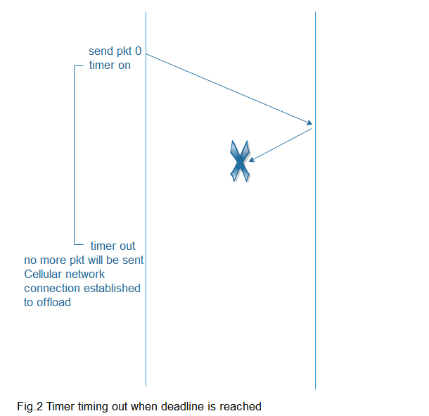

Fig. 3.3: Timer timing out when the deadline is reached.

## **3.5 Total expected delay:**

In order to send a packet from source to destination a packet experiences delay at every stage along its transmission. The total delay experienced by a packet is the accumulation of the delays: nodal processing delay, queuing delay, transmission delay and propagation delay. For our model, we assume that the traffic arrives as a Poisson process with rate λ, the WiFi available period as an exponential distribution with rate η, the WiFi unavailable period as an exponential distribution with rate γ, the deadline as an exponential distribution with rate ξ, and the file sizes are exponentially distributed. The WiFi queue is based on the Markov chains which is shown in Fig. 3.2. The total expected delay for our system is given below:

|  |  |
| --- | --- |
|  | (3.01) |

where is the probability that WiFi is available in user’s handset, stands for total end to end delay associated to offloading through WiFi, represents the probability that WiFi is available in the neighbour’s handset with condition that WiFi is unavailable in the user’s handset, denotes total end to end delay associated to offloading by WiFi through one-hop D2D communication with the neighbouring handset, indicates the probability that the WiFi and D2D communication are unavailable with condition that cellular network is always available, and means the total end to end delay associated to offloading through cellular network.

To calculate the end to end delay for scenario-2 where user’ WiFi is unavailable but D2D communication is possible with the neighbor’s handset, the delays: the delay occurred due to waiting till the deadline in the WiFi queue, the delay incurred to perform D2D communication and finally the delay accumulated to transmit data over the neighbor’s WiFi; need to be accounted each individually. The paper [21] gives WCETT which is the Weighted Cumulative  
Expected Transmission Time to offload to BTS through multi-hop D2D communication. The WCETT from [21] is given as:

|  |  |
| --- | --- |
|  | (3.02) |
| where *X j =* and |  |

ETX stands for the number of expected retransmission before a packet is successfully transmitted and S is the size of the packet and B is the bandwidth of the link. According to [21], the first term of WCETT expression, that multiplied (1-β), quantifies the resources consumption in the whole considered route, whatever the channels used and the second term, weighted by β, represents the channel diversity. From equ.3.2 we compute the delay equation for one–hop D2D as follows:

|  |  |
| --- | --- |
| For one-hop |  |
|  | (3.03) |
|  | (3.04) |
|  | (3.05) |
| Thus, |  |
|  | (3.06) |
|  | (3.07) |
|  | (3.08) |
|  |  |

From paper [16], we get the delay model associated with calculating delay experienced by a packet while it is being offloaded over WiFi. The delay model for offloading over WiFi from [16] is given below:

|  |  |
| --- | --- |
|  | (3.09) |
|  | (3.10) |

Now, computing the end to end delay where the data is offloaded through D2D over WiFi.

|  |  |
| --- | --- |
|  | (3.01) |
|  | (3.11) |
|  | (3.11) |
| where, |  |
|  | (3.12) |
|  |  |

## **3.6 Simulation**

We used the MATLAB software to simulate the Transmission delay vs packet arrival rate for scenario-2 in Fig. 3.4. The deadline time is chosen to be 1.11s or 10/9 second and the deadline rate is ξ = 0.9. The packet size is 7.5Mbyte and the bandwidth for D2D is chosen to be 6Ghz and the data rate for WiFi is 1Mbps.

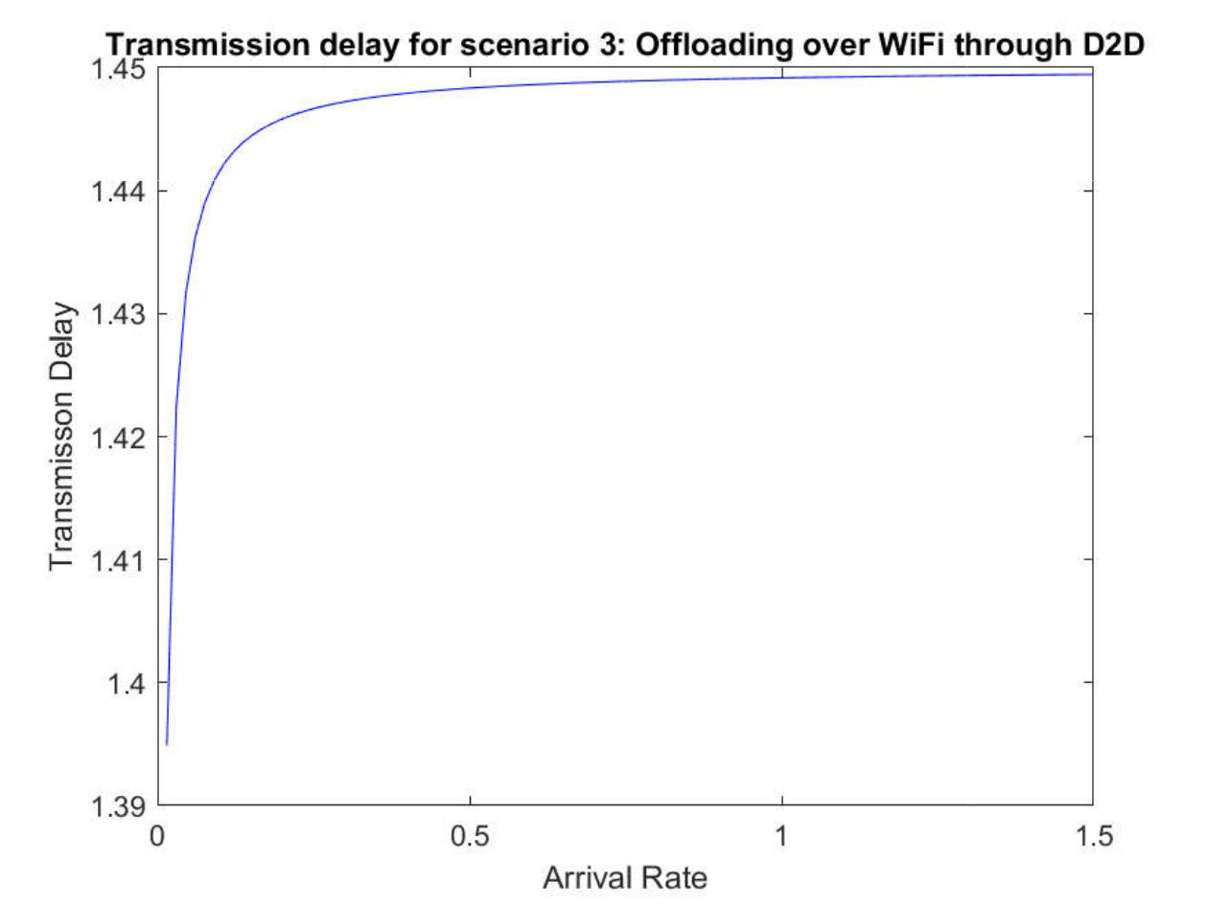

Fig. 3.4: The average delay of offloading over WiFi through D2D for a packet of size 7.5Mbyte.

## **3.7 Summary**

This chapter showed 3 scenarios which could occur while offloading data from user’s handset. The senarios depend on the availibility of WiFi and feasibility D2D communication. The total expected delay is model by the Equ. 3.01. Furthermore, the MATLAB simulation is shown too.

# **CHAPTER 4: COST ANALYSIS**

## **4.1 Introduction**

The quickly expanding measure of cell phones and interactive media information traffic, are pushing to re-modeler the present age of the cell versatile correspondence. The 5G systems are profoundly portrayed by 3 exceptional highlights: omnipresent network, amazingly low inertness and ultra-rapid information exchange. Thusly, Telecommunication Service Providers (TSPs) are obliged to buy and work new physical frameworks, contract engineers with high capabilities for working this gear and furthermore requires thick organizations of ending system hardware, for example, Base Stations (BSs). All these lead to high Capital Expenditure (CAPEX) and Operational Expenditure (OPEX) for TSPs, thusly it is essential to decrease the elements influencing the Total Cost of Ownership (TCO) for a versatile system administrator and portable administrations supplier. Moreover, the jumble between the necessities of the market and capacities given by system gear, and furthermore the interest for asset sharing. Current media transmission society turns into an observer of the assembly of cloud organizing, quick network and high handling force occurring over the current Internet display. Critical ideal models, for example, Software-Defined Networks (SDN) and Network Functions Virtualization (NFV), if fittingly planned and conveyed, can help in satisfying the previously mentioned prerequisites: actually, an effective mix of systems and IT could permit essential cost reserve funds, and the obtaining of greater adaptability in administration provisioning [22].

## **4.2 5G network costs**

Cost displaying is a methodology that enables one to think about the contrast between information traffic request and system costs for various organization situations. The expenses of 5G foundation densification depend vigorously on the required throughput thickness, intermittent loan fee, and base station cost. The decrease of these expenses is, in this way, important for successful, ultra-thick little cell organizations. Some have started to incorporate mmW groups range (28 GHz) into cost displaying heterogeneous systems whereby little cell arrangements, for example, Pico cells with mmW frameworks are sent in regions of appeal.

Late cost demonstrating of 5G has likewise investigated Software Defined Networks (SDN) with Network Function Virtualization (NFV). System foundation has high settled expenses of conveyance, subsequently is extraordinarily influenced by scale economies and populace thickness recognize that restricted to conquer this is to have 'open' organizations of impartial little cells serving endorsers of any specialist co-op. This mutual foundation approach would support advertise passage by making it less demanding for systems to draw nearer to a minimum amount [23].

## **4.3 Cost analysis methodology**

Concentrating on system densification and extra range, we adopt a gradual strategy for 5G arrange conveyance amid the 2020–2030 period. To evaluate sending costs crosswise over Bangladesh, we fragment regions that have comparative cost qualities together into explicit 'geo-types'. The geo-type division incorporates the key cost qualities, for example, populace thickness and existing site thickness, and in addition the base station innovation presently sent. For each geo-type, the expenses are surveyed considering two systems to take care of traffic demand which incorporate coordinating more range and sending green-field little cells [24].

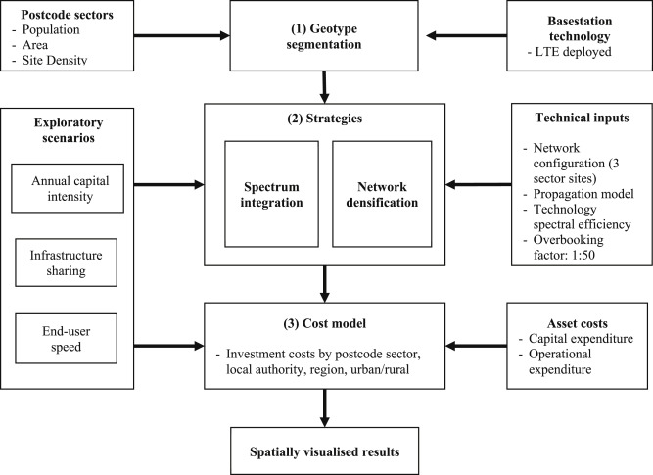

Fig. 4.1: Sequential Methodology.

## **4.4 Cost Model**

In this area, we give an outline of the cost display considered in this paper for a non-virtualized 5G framework. Despite the fact that the common measurement of the Total Cost of Ownership could be alluring for seeing every one of the costs that would be associated with a 5G-based business case, we have just viewed as capital consumption in this examination as we are evaluating yearly capital force in connection to the pace of 5G rollout [25].

For that reason, we figure the Capex of the rollout for each geo-type and for every year I of the investigation time frame (2020– 2030) considering these may shift after some time, as demonstrated in. The Capex is characterized in condition.

|  |  |
| --- | --- |
|  | (4.01) |
|  |  |

Table 4.1: Capital and operational expenditure cost

|  |  |  |  |  |
| --- | --- | --- | --- | --- |
| **Strategy** | **LTE**  **Availability** | **Cost Type** | **Capital**  **Expenditure**  **(Capex in Taka)** | **Operational**  **Expenditure**  **(Opex in Taka)** |
| Spectrum Integration on Network | Site with 4G  LTE  Site with no  4G LTE | Additional carrier on current Base Station  Deploying a multicarrier Base Station | 1589383.42/=  (approx. 1.5m)  4333718.80/=  (approx. 4.3m) | 190726.01/=  413027.77/= |
| ------- | --------- | Site Lease | ---------- | 529794.47/= |
| ------- | -------- | Civil Works | 1907260.11/= | ----------- |
| ------- | -------- | Fiber Backhaul  For Urban 1km Area | 2118540.71/= | ----------- |
| Network Densification through Small Cells | -------- | Small Cell Equipment  Small Cell Civil works  Small Cell Site Rental  Small Cell Backhaul | 264817.59/=  1408829.57/=  --------------  -------------- | 37074.46/=  ------------  529635.18/=  105927.04/= |

## **4.5 Recent 5G work in Bangladesh**

The administration currently plans to go for a preliminary keep running of 5G portable innovation, which has made the versatile clients raise an eyebrow, as its antecedent - 4G - is yet to cover real parts of the nation.

On July 25, Chinese telecom merchant Huawei will lead the daylong preliminary keep running of the 5G (fifth era) innovation with the assistance of two versatile administrators Robi and Teletalk, at Sonargaon Hotel in the capital.

Bangladesh Telecommunication Regulatory Commission has effectively allocated 800 Megahertz range to Huawei on a brief premise. The Chinese telecom monster should pay Tk 5 lakh to utilize the range on 27555 to 28355 groups for a week and the occasion will be composed under the title of Bangladesh 5G Summit [26].

**4.6 Bangladesh eyes 5G in 2020**

Bangladesh is yet to go under full 3G inclusion while 4G has recently been presented. In any case, there is now gossip about 5G. The fifth-age remote innovation is relied upon to be accessible from 2020.

Telecom and Information Technology Minister Mustafa Jabbar stated: "The world will grasp 5G in 2020. In this way, we also should acknowledge new innovation and must proceed onward to 5G. There is no choice for hesitation."

Be that as it may, he named proceeding onward to 5G in 2020 a yearning dream. "It will be a test for us," he said. After its presentation, all innovations, merchandise and ventures will progress toward becoming 5G-based, the priest stated, including that there ought to be more considerations with respect to these things.

He said innovation was consistently evolving. Before receiving another innovation we need to choose how it will profit us and in the event that it is good with the financial condition and, take essential arrangements [27].

It would require investment, he included, "On the off chance that the utilization of innovation prompts joblessness, it won't acquire a decent outcome."

## **4.7 Summary**

It is very clear that Bangladesh takes a step on 5G technology though the whole technology still in dark. 5G technology can be easily implemented in our country by the telecom industries by the help of our Government. The cost model could be redesign in future when 5G technology will be available.

# **CHAPTER 5: DESIGN IMPACT**

## **5.1 Introduction**

In this chapter we’ll be talking about some of the impact our project, which involved economic impact, mostly environmental impact and other related impact.

## **5.2 Economic Impact**

The economic impact of our project will be an efficient one, since our proposed system will cost much less. As we have a built-in system, we will just implement on it. Though it is a bit rusty to control at this moment. But the finished thing will be more suitable and economic. And eventually it will help the companies.

## **5.3 Environmental Impact**

Our project has a huge environmental effect. That’s the reason countries are not implementing 5G right now. This 5G will increase RF radiation in the vicinity of the antennas. Many countries such as China, India, Poland, Russia, Italy and Switzerland have far more protective and stricter radiation limits which will not allow the deployment of 5G as the increased 5G radiation would exceed their limits. And another thing will happen this 5G will create a huge electromagnetic frequency. There will be more and more small cells. That will impact in our environment.

## **5.4 Social Impact**

The social impact of our project is quite positive since it will increase the data flow, reduce latency. So, people will be benefited by these. It will change the lifestyle and teaching and learning experience also. Overall the networking experience will change.

## **5.5 Political Impact**

The political impact of our project is still somewhat unknown since this country still has no proper laws or regulations regarding quad copters. Since this country still doesn’t have many people using this kind of technology to an extent that the government will be forced to pass certain laws and legislations to control and monitor the proper use of this machinery, we stand in a grey area at this point in time.

## **5.6 Ethical Impact**

The ethical impact of our project lies solely on the hands of the ones using it. The user, if they should choose to indulge in unethical behavior like hurting, spying or causing someone any kind of trouble or discomfort, then the machine will be deemed unethical.

## **5.7 Health and Safety Impact**

This is the major issue here. It has a huge health hazard. From the study of a paper [9] short-term exposure to low-intensity millimeter wave radiation not only affects human cells, it may result in the growth of multi-drug resistant bacteria harmful to humans. Since little research has been conducted on the health consequences from long-term exposure to mm waves, widespread deployment of 5G or 5th generation wireless infrastructure constitutes a massive experiment that may have adverse impacts on the public’s health. Also, one thing as this wave biologically active so us military use this as a weapon. So it has a great health and safety impact.

## **5.8 Manufacturability**

From our perspective, it’s basically an improvement to a ready product. It can be easily manufactured and delivered.

## **5.9 Sustainability**

Our project is quite sustainable, according to our observations it can be implemented with some fine tuning and monitoring and acknowledging all the health fact. And if we can improve it more than it will be fine. So we have to work on it bit more.

## **5.10 Summary**

Finally, we want to say that there’s some pros and cons like every project. It is the initial stage so day by day it will improve and we can implement more things on that.

# **CHAPTER 6: SIMULATION**

## **6.1 Introduction**

The newly proposed routing scheme has been modeled and tested using the simulation software MATLAB/Simulink. The simevents library of Simulink has been used cleverly to replicate this data offloading scheme and the results and explanation of the simulation is given in the subtopics below.

## **6.2 Simevents Model**

The simevents library has been heavily utilized for the design of the model. First a FIFO (first in first out) queuing scheme has been set and then entity generator is used to replicate the packets of data. The entities have been given characteristics using the attributes blocks and then timers have been set in order to replicate how a mobile device would search for WiFi network for a fixed period of time and then keep switching to another route. M/M/1 model has been used. There’s only one server and both the inter-arrival time and the service time has been set to exponential distribution. To set a value for the timeout time we’ve also carried out a small survey and seen that most people would wait for at least two minutes time and thus we used two minutes for the simulation. The survey results and the Simulink model is shown below in Fig. 6.1 and Fig. 6.2.

Fig. 6.1: No. of people versus waiting time (in mins) survey.



Fig. 6.2: Simulink model of new routing scheme using simevents library.

The results of the utilization factors are shown in Fig. 6.3, Fig. 6.4 and Fig. 6.5. The graphs of waiting time and the entity attribute are shown in Fig. 6.6 and 6.7 respectively.

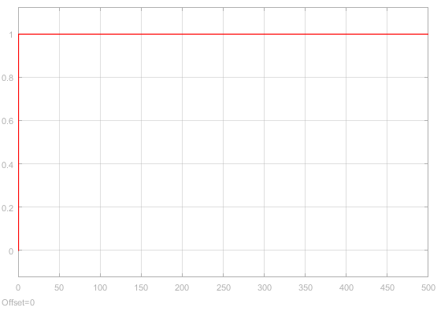

Fig. 6.3: Utilization factor of WiFi route.

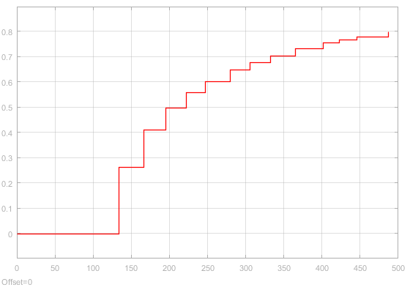

Fig. 6.4: Utilization factor of Device to Device route.

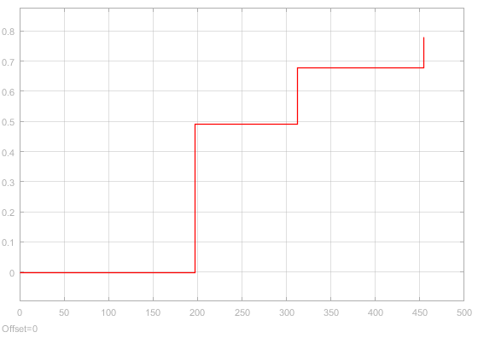

Fig. 6.5: Utilization factor of cellular network.

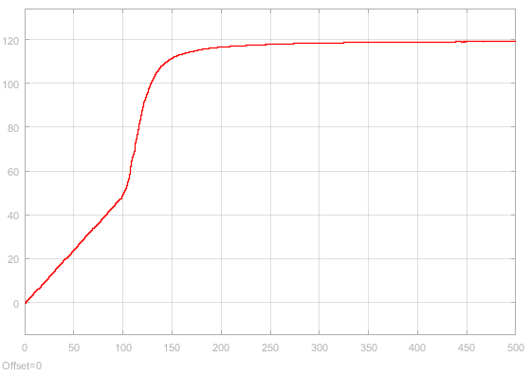

Fig. 6.6: Waiting time in FIFO queue.

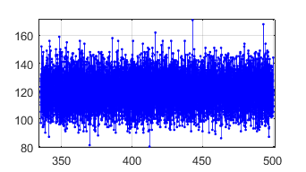

Fig. 6.7: Entity Attribute stem plot.

Even though the model gave promising results, it still needs improvements because the model needs to be made using only one FIFO queue to lower further delays.

## **6.3 Summary**

This chapter talks in details about the simulation and its results. The simulation also requires further improvements and has been acknowledged from the results.

# **CHAPTER 7: FUTURE WORKS**

## **7.1 Introduction**

In this section we’ll basically talk about the future work based on machine learning and network layer. We are planning to do this work. That will help to get more improved result. Machine learning will improve the beamforming selection and network layer will help to reduce the latency.

## **7.2 Network Layer (MAC)**

We can reduce latency in the MAC layer section. When we were doing our study, we saw a paper based on this. That paper actually talked about achieving low latency in cellular network or device. For this they proposed some topics and faced some issues to be solved. One topic was Low-Latency mmWave MAC.

They said that to evaluate the achievable latency with flexible TTI, the design assumes that the BS transceiver is able to support both analog BF and low-resolution digital BF as previously described, and can dynamically switch between the two modes. The key components of the frame structure and MAC scheme are as follows. So we actually found three major sector or section for this.

**Data Channel:** As already noted, we consider a system where data channel transmission relies on analog BF. Therefore, transmission of data slots must be strictly TDMA-based and, as consequence, the minimum time-domain chunk of resource allocation that can be assigned to a single user in the data period (i.e., the minimum slot length) is 1 OFDM symbol. There must be a small guard time between uplink (UL) and downlink (DL) transmissions as well as a transition time during which the BF vectors are updated at the transmitter and receiver. To reduce the number of these transitions, which are effectively wasted resources, symbols assigned to a particular user may be grouped together so that all DL and UL symbols/slots are contiguously mapped to the DL-DATA and UL-DATA regions, respectively. Thus, a slot refers to this grouping of consecutive symbols allocated to one UE.

**Downlink Control Channel:** The DL-CTRL period occupies the first several OFDM symbols of each subframe. We require that the location and duration of this region be fixed because the control messages it contains are periodic and must be decoded by all UEs at the beginning of the subframe. This allows a UE to decode only a small number of symbols to receive any control messages intended for itself, such as the DL control information (DCI), indicating the DL and UL assignments in the current or future subframe. If the control symbols were to be transmitted at any time during the subframe, every UE would have to continually receive and blindly decode even when they are not allocated, needlessly wasting battery power. For BSs that do not support digital BF and must transmit the control channel in TDMA mode only, a minimum of one control symbol per allocated user would be needed. Data could, of course, be multiplexed with the control messages for better utilization of the symbol; however, the UE would still have to blindly decode a number of symbols before finding its own DCI. Therefore, there is a strong case for the BS to support digital BF capability in order to multiplex DL control signals to multiple UEs within a single DL-CTRL symbol. [28]

**Uplink Control Channel:** The UL-CTRL period is used for the transmission of periodic control messages such as CQI reports, acknowledgments (ACKs), and scheduling requests (SRs) from the UEs to the BS. In the design presented here, the UL-CTRL is transmitted during the last OFDM symbol(s) of the subframe so that it is contiguous with the UL data symbols. Placement at the end of the subframe also allows ACKs to be transmitted quickly, possibly even in the same subframe as the corresponding DL transmission being ACKed (if it can be decoded in time).[28]

But key challenge for mmWave systems is that transmissions must be highly directional to overcome the high isotropic path loss. Most transceivers, at least in the near future, are likely to use phased arrays for directional beamforming. These arrays can achieve very high directional gains but are limited to transmitting to one user at a time, that is, via time-division multiple access. And to achieve very low latency and react to very rapidly varying channels, control messages such as scheduling requests and channel quality indicator (CQI) reports will need to have frequent opportunities for transmissions. These short control messages will thus incur significant overhead if they cannot be transmitted efficiently.

So basically they proposed some solution for that , some design architecture and all. there are at least three key modifications one could consider with respect to current 4G LTE OFDM systems.

Short symbol periods [29]

Flexible TTI [29]

Low-power digital beamforming for control. [30]

## **7.3 Machine Learning**

Now a days ML is a huge topic. Everyone is trying to implement it in every sector. So we can use it also. We can use it for beam selection, indoor positioning or also in uplink downlink control.

When we were studying on this, we found a paper based on ML and DL. They talked about many things. They went through beam selection process. From there they gone to machine learning and dataset for it. They said about ray beam tracing and traffic tracing. Then they talked about different types of beam and implementations.

They went through each and every topic that will help to implement deep learning in 5g and also problems and all that. And they concluded this way. “This paper presented a methodology for generating 5G propagation channel data that decouples the tasks of modeling mobility and channel. This facilitates the use of advanced features of traffic simulators. Given the current lack of freely available large amount of data for benchmarking deep learning algorithms in 5G, it is reasonable to use simulations especially in complicated configurations. The generated data incorporates the channel evolution over time and can be used, for example, in machine learning problems involving aspects of the 5G PHY with constraints from MAC and upper layers. The focus was mmWave MIMO but the methodology can be used in other scenarios. Future work includes simulating different sites and scenarios, while validating some of them with measurements. Currently, it is not clear how detailed must be the description of ray-tracing scenarios to support broad conclusions suchas average performance on distinct sites. Measurements can help tuning the methodology. Besides accurate modeling, it is important to minimize the computational cost. An alternative to speed up simulations is to combine ray-tracing outputs with statistical models and eventually avoid the longer simulation time caused by the diffuse-scattering feature. After escaping the small data regime, deep learning in 5G can be investigated using a systematic and reproducible experimental procedure.” [31]

From studying that paper, we find some initial area to implement ML or DL. And later on we can add more areas. So the sections are given below Scheduling Beamforming in Massive MIMO Networks: using neural networks we find the best schedule offline, and then later quickly predict the best schedules on demand.

Indoor Positioning: the approach will be, for multiple points in a room, measure the received signal strengths from each cell. Then, using these maps to train neural networks to predict the location of a device based on the strength of the signals it receives from nearby cells.

Configuring Uplink and Downlink Channels: a machine-learning system would first predict user equipment characteristics, such as mobility. Then, the system would make a prediction about what the uplink/downlink throughputs would be, against different settings, and pick the best setting.

All these things based on Ray Tracing technology. It is the recent and promising simulation strategy. RT can provide very accurate results, but its computational cost increases exponentially with the maximum allowed number of reflections and diffractions. [32]

So, we include figure from that paper, that use CAD and created how it will work. Fig.1.The geometrical aspects of the environment must be informed together with the corresponding electromagnetic parameters such as the scattering coefficient (S) for each material [33]. Given the simulation scenario, a RT simulator projects rays in the three-dimensional angular space with a predefined spacing. Then, the paths are ranked according to the received power of each ray. A detailed enough scenario description is the first challenge for RT usage. Another one is an appropriate modeling of the propagation channel, which has to take in account, for example, the scattering of mm Wave signals.

Fig. 7.2 shows an example of rays obtained in a simulation with a traffic jam (vehicles with receivers are marked in red) using 60 GHz.

In another study we found about the structure for the implementation of ML and DL on 5G. On that paper presents an intelligent intrusion detection system based on Software Defined 5G architecture using machine learning algorithms. It is implemented under Software Defined environment which facilitates status monitoring as well as traffic capturing under a global view. They gave a structure [34] and is shown in Fig. 7.3. The architecture of our proposed intelligent intrusion detection system is illustrated in Fig. 7.3. There are three layers: Forwarding Layer, Management & Control Layer and Data & Intelligence Layer. Forwarding Layer consisting of Open Flow controlled entities in 5G (OFs) is responsible for traffic monitoring and capturing. It can collect and upload network flows to the control layer, and block malicious flows according to the instructions of the controller. Management & Control Layer identifies suspicious flows and detects anomalies preliminarily using uploaded flow information. It also generates protection strategies according to decisions made by the intelligent layer and instructs Forwarding Layer. In Data & Intelligence Layer, Intelligent Center makes further analysis and judgment through feature selection and flow classification using adaptive machine learning algorithms.

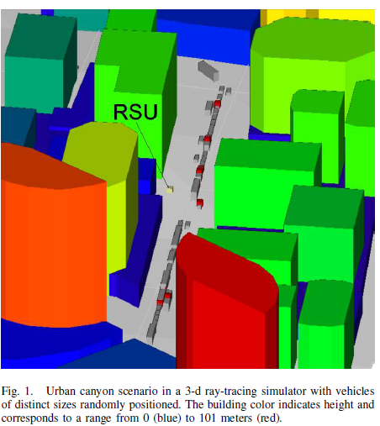

Fig. 7.1: Urban canyon scenario in a 3D ray tracing simulator with vehicles of distinct sizes randomly positioned.

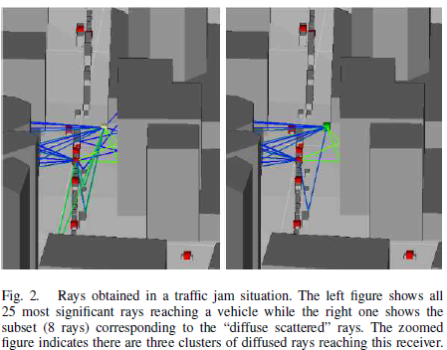

Fig. 7.2: Rays obtained in a traffic jam situation.

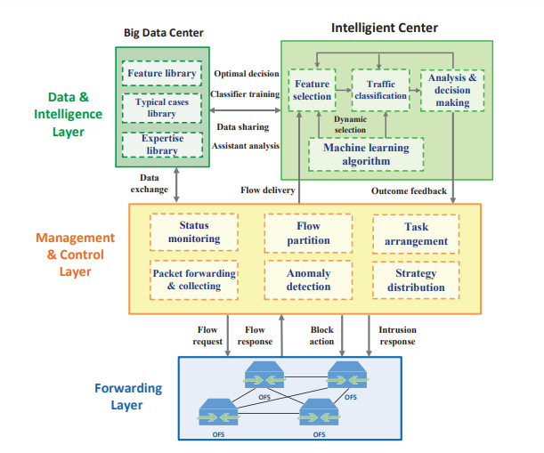

Fig. 7.3: A machine learning based intrusion detection system for software defined 5G network.

## **7.4 Summary**

Finally, we can finish this chapter with this line that we can easily implement machine learning on 5G implementation. And this will help to work with massive data flow and selection process. And by designing the mew network layer structure we can also reduce the latency.

## **REFRENCES**

[1] J. Gubbi et al., “Internet of Things (IoT): A vision, architectural elements, and future directions,” Future Generation Computer Systems, vol. 29, no. 7, pp. 1645–1660, Sept. 2013.

[2] T. S. Rappaport, “Spectrum Frontiers: The New World of Millimeter- Wave Mobile Communication,” Invited keynote presentation, The Federal Communications Commission (FCC) Headquarters, Mar. 10 2016.

[3] T. S. Rappaport et al., “Millimeter Wave Mobile Communications for 5G Cellular: It Will Work!” IEEE Access, vol. 1, pp. 335–349, May 2013.

[4] [Online Article] Sam Churchill, “Millimeter Frequencies Proposed for 5G”, July 19th, 2012.

[5] R. A. Leese, “A unified approach to the assignment of radio channels on a regular hexagonal grid,” IEEE Transactions on Vehicular Technology, vol. 46, no. 4, pp. 968-980, 1997

[6] H. S. Dhillon, R. K. Ganti, F. Baccelli, J. G. Andrews, “Modeling and analysis of K-tier downlink heterogeneous cellular networks,” IEEE Journal on Selected Areas in Communications, vol. 30,no.3,pp.550-560,2012.

[7] B. Blaszczyszyn, M. K. Karray , H.P. Keeler, “Using Poisson processes to model lattice cellular networks,” In Proceedings of IEEE INFOCOM ‘2013, pp. 773-781, Apr. 2013

[8] C. Zhu, C. Zheng, L. Shu, G. Han, “A survey on coverage and connectivity issues in wireless sensor networks,”Journal of Network and Computer Applications, vol. 35, no. 2, pp. 619-632, 2012.

[9] J. Teichmann, F. Ballani, K. G. van den Boogaart, “Generalizations of Matérn’s hard-core point processes,” Spatial Statistics, no. 3, pp. 33-53, 2013.

[10] M. Haenggi, J. Andrews, F. Baccelli, O. Dousse, M. Franceschetti, “Stochastic Geometry and Random Graphs for the Analysis and Design of Wireless Networks,” IEEE Journal on Selected Areas in Communications, vol. 27, no. 7, pp. 1029-1046, 2009.

[11] X. Xu, Y. Li, R. Gao, X. Tao, “ Joint Voronoi diagram and game theory-based power control scheme for the HetNet small cell networks,” EURASIP Journal on Wireless Communications and Networking, no.1, 2014.

[12] Mirahsan, M., Schoenen, R. and Yanikomeroglu, H. (2015). HetHetNets: Heterogeneous Traffic Distribution in Heterogeneous Wireless Cellular Networks. IEEE Journal on Selected Areas in Communications, 33(10), pp.2252-2265.

[13] Formulas, B. Q., Queues, S., & Queues, M. (n.d.). 2 Basic Queueing Formulas, 1–6. Retrieved from <http://web.mst.edu/~gosavia/queuing_formulas.pdf>.

[14] Wang, J. Y. (2009). Chap17 Queueing Theory, 1–24. <https://doi.org/10.1016/S0723-2020(11)80062-7>.

[15] Mahsa Foruhandeh, Navid Tadayon, and Sonia Aïssa,” Uplink Modeling of K-Tier Heterogeneous Networks: A Queuing Theory Approach”, IEEE COMMUNICATIONS LETTERS, vol. 21,no. 1, Jan. 2017.

[16] F. Mehmeti, “Is it Worth to be Patient ? Analysis and Optimization of Delayed Mobile Data Offloading,” pp. 2364–2372, 2017.

[17] "By 2020, 75% of Mobile Traffic will be Video [Cisco Study]", Tubular Insights, 2018. [Online]. Available: https://tubularinsights.com/2020-mobile-video-traffic/. [Accessed: 26- Dec- 2018].

[18] "An Experimental Study on Multihop D2D Communications Based on Smartphones - IEEE Conference Publication", Ieeexplore.ieee.org, 2018. [Online]. Available: http://ieeexplore.ieee.org/document/7504128/. [Accessed: 26- Dec- 2018].

[19] C. Liu, G. Zhu, X. Zhou, J. Liu, S. Xu and B. Ai, "The design and implementation of FPGA subsystem in D2D communication based on LTE network," 5th IET International Conference on Wireless, Mobile and Multimedia Networks (ICWMMN 2013), Beijing, 2013, pp. 276-279.

[20] M. Mohsin and R. Prakash, "IP address assignment in a mobile ad hoc network," MILCOM 2002. Proceedings, Anaheim, CA, USA, 2002, pp. 856-861 vol.2.

[21] C. Toham and F. Jan, "Multi-interfaces and Multi-channels Multi-hop Ad hoc Networks: Overview and Challenges," *2006 IEEE International Conference on Mobile Ad Hoc and Sensor Systems*, Vancouver, BC, 2006, pp. 696-701.  
doi: 10.1109/MOBHOC.2006.278636

[22] Bouras, C., Ntarzanos, P., & Papazois, A. (2016). Cost modeling for SDN/NFV based mobile 5G networks. 2016 8th International Congress on Ultra-Modern Telecommunications and Control Systemsand Workshops (ICUMT). doi:10.1109/icumt.2016.7765232.

[23] Oughton, E. J., & Frias, Z. (2016). Exploring the cost coverage and rollout implications of 5G in Britain - Oughton and Frias report for the NIC. London: National Infrastructure Commission.

[24] E. J. Oughton and Z. Frias, “The cost, coverage and rollout implications of 5G infrastructure in Britain,” Telecommunications Policy, vol. 42, no. 8, pp. 636–652, 2018.

[25] ACG Research, “Total cost of ownership study virtualizing mobile core,” tech. rep., <http://www.affirmednetworks.com/wpcontent/> uploads/2015/07/TCO-Report 7.13.15 ACG-Template.pdf, July 2015. (Cost Model and its Equation)

[26] M. Z. Islam, “5G trial run on July 25,” The Daily Star, 05-Jul-2018. [Online]. Available: https://www.thedailystar.net/business/5g-trial-run-july-25-1600813. [Accessed: 01-Jan-2019].

[27] “Bangladesh eyes 5G in 2020,” 15-Mar-2018. [Online]. Available: https://www.dhakatribune.com/technology/2018/03/15/bangladesh-eyes-5g-2020.

[28] Pakhomov AG, Akyel Y, Pakhomova ON, Stuck BE, Murphy MR. Current state and implications of research on biological effects of millimeter waves: a review of the literature. Bioelectromagnetics. 1998; 19(7):393-413.

[29] J. Ford, R.,Zhang, M., “Achieving Ultra-Low Latency in 5G Millimeter Wave Cellular Networks” IEEE Communications Magazine, Mar. 2017, pp.196–202.

[30] Klautau, A., & Batista, P.T. (2018). 5 G MIMO Data for Machine Learning : Application to Beam-Selection using Deep Learning.

[31] J. Cho et al., “SMORE: Software-Defined Networking Mobile Offloading Architecture,” Proc. 4th Wksp. All Things Cellular: Operations, Applications, & Challenges, Aug. 2014, pp. 21–26.

[32] P. V. Klaine, M. A. Imran, O. Onireti, and R. D. Souza, “A Survey of Machine Learning Techniques Applied to Self-Organizing Cellular Networks,” IEEE Commun. Surveys Tuts., vol. 19, no. 4, pp. 2392–2431, 2017.

[33] F. Fuschini, E. M. Vitucci, M. Barbiroli, G. Falciasecca, and V. Degli- Esposti, “Ray tracing propagation modeling for future small-cell and indoor applications: A review of current techniques,” Radio Sci., vol. 50, no. 6, p. 2015RS005659, Jun. 2015. [Online]. Available: <http://onlinelibrary.wiley.com/doi/10.1002/2015RS005659/abstract>

[34] Li, J., Zhao, Z., & Li, R. (2017). A Machine Learning Based Intrusion Detection System for Software Defined 5G Network. CoRR, abs/1708.04571.