Assignment 4:

Deploying an Application on Elastic Bean Stalk

1. Application and environment on Elastic Beanstalk

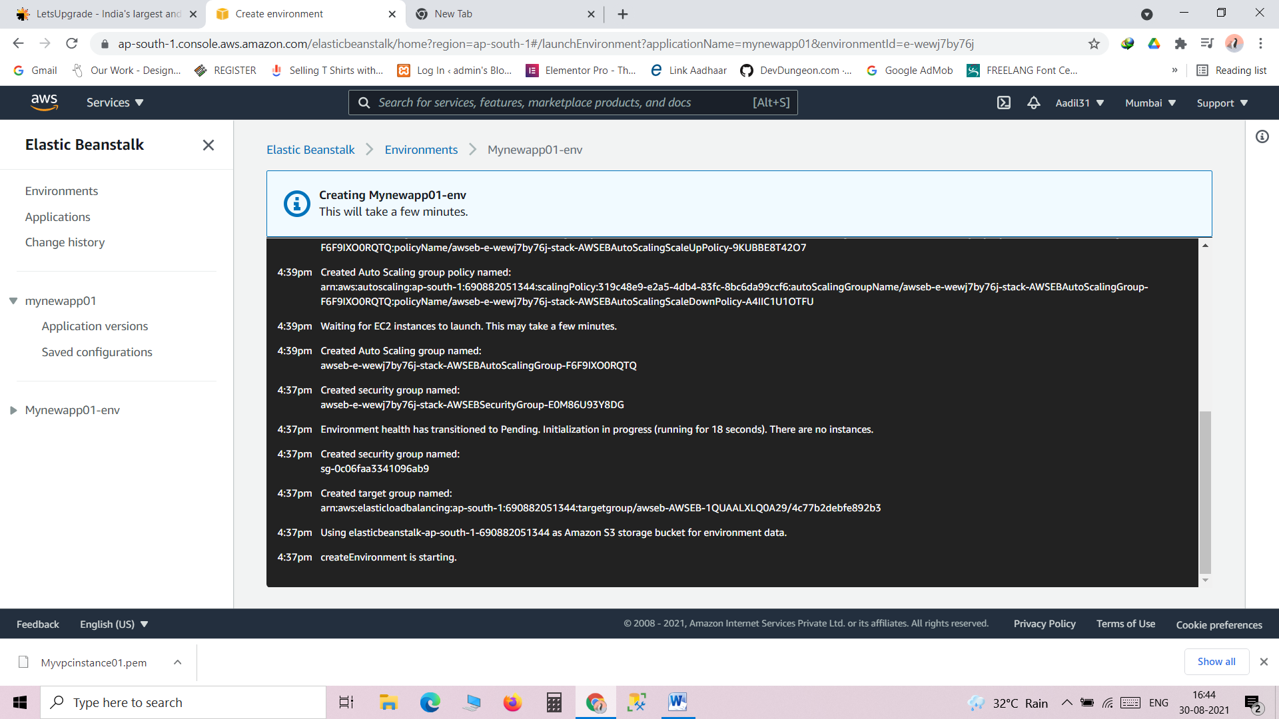

1. Application

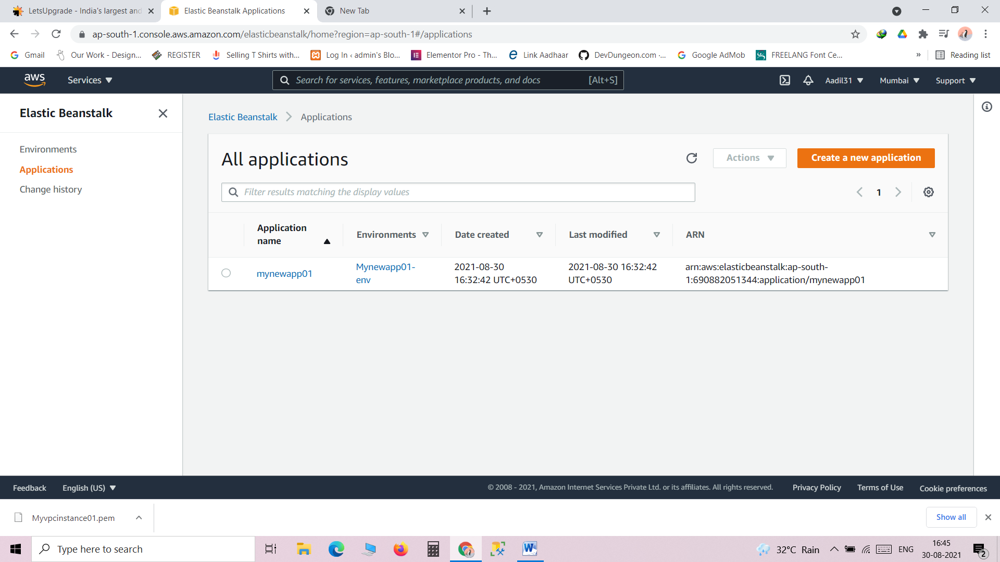

1. Environment

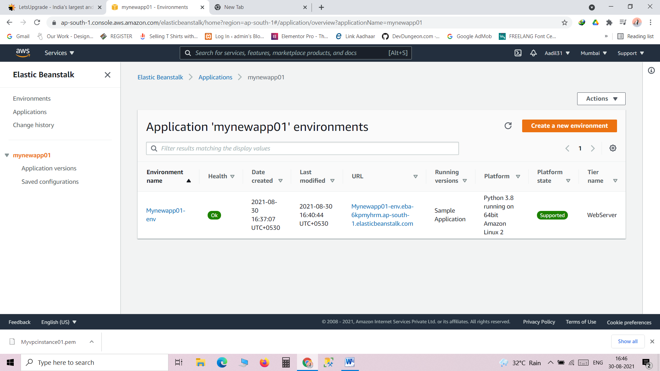

1. Sample deployed application

