Chongqing University of technology

Md Anower Hossain(an hao ming)

Student ID: 62017010084

Assignments -1

7th Semester

Sub: Computer Network

# Home Work 1

1. *Question: A system has an n-layer protocol hierarchy. Applications generate messages of length M bytes. At each of the layers, an h-byte header is added. What fraction of the network Bandwidth is filled with headers?*

Solution:-

Message M

Layer 1 M + h

Layer 2 M + h + h = M + 2h

Layer 3 M + 2h + h = M + 3h

……… ……………………

Layer n M + (n – 1) h + h = M + nh

The total number of header bytes with n-layers and h bytes per header is nh. The fraction of the network bandwidth filled with headers is $\frac{nh}{M+nh}$

For an Example

If we take no of layer (n) = 6

Message size (M) =15

Bytes header size (h) = 5 bytes

Total no of header = 6*5

= 30

Message size = 10+30

= 40

Fraction of the network bandwidth is filled with headers = $\frac{nh}{M+nh}$

$=\frac{30}{15+30}$

= 0.67%

1. *Question: What is the main difference between TCP and UDP?*

Solution:-

|  |  |
| --- | --- |
| TCP | UDP |
| Transmission control protocol | User Datagram protocol |
| TCP is a connection-oriented protocol  It needs to establish a connection between sender and receiver before the data can be sent. | UDP is connection less Protocol  UDP does not establish a connection before sending data. |
| TCP is reliable. Data sent using a TCP protocol is guaranteed to be delivered to the receiver. If data is lost in transit it will recover the data and resend it. | UDP is unreliable, it does not provide guaranteed delivery and a datagram packet may become corrupt or lost in transit. |
| TCP obey the ordering and sequencing to send data packets from a server will be delivered to the client in the same order they were sent. | UDP sends packets in any order. |
| TCP is slower | UDP is faster than TCP |

# Home Work 2

1. 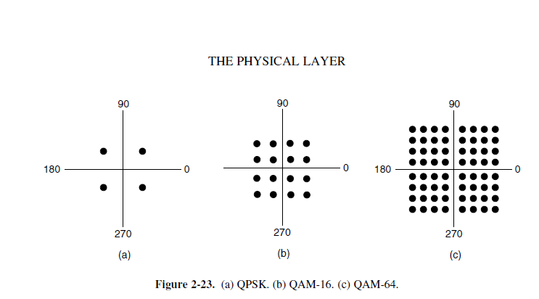*Question: A modem constellation diagram similar to Fig. 2-23 has data points at the following Coordinates: (1, 1), (1, −1), (−1, 1), and (−1, −1). How many bps can a modem with these parameters achieve at 1200 symbols/second?*

Solution:-

4 symbols are used therefore each symbol carries 2 bits.

Bit rate = Baud rate * r

= 1200 * 2

= 2400bps

1. *Question: How many frequencies does a full-duplex QAM-64 modem use?*

Solution: - two **frequencies.**

A Full-Duplex QAM 64 K Modem uses two frequencies. One frequency is used for upstream and the other for downstream. A variety of common QAM forms are available and include, 16 QAM, 32 QAM, 64 QAM, and 256 QAM. For example, for domestic broadcast use, 64 and 256 QAM are used for cable modem and digital cable TV. The modulation scheme for this modem uses both amplitude and phase.

1. *Question: Ten signals, each requiring 4000 Hz, are multiplexed onto a single channel using FDM. What is the minimum bandwidth required for the multiplexed channel? Assume that the guard bands are 400 Hz wide.*

Solution: - There are ten 4000 Hz signals. We need nine guard bands to avoid any interference. The minimum bandwidth required is 4000*10+400*9=43,600 Hz.

# Home Work 3

1. *Question: What is the remainder obtained by dividing $x^{7}+ x^{5}+1$ by the generator polynomial ${ x}^{3}+1$?*

*Solution:-*

${-x}^{2}+x+1$

**Step-by-step explanation:**

Dividend ${=x}^{7}+x^{5}+1$

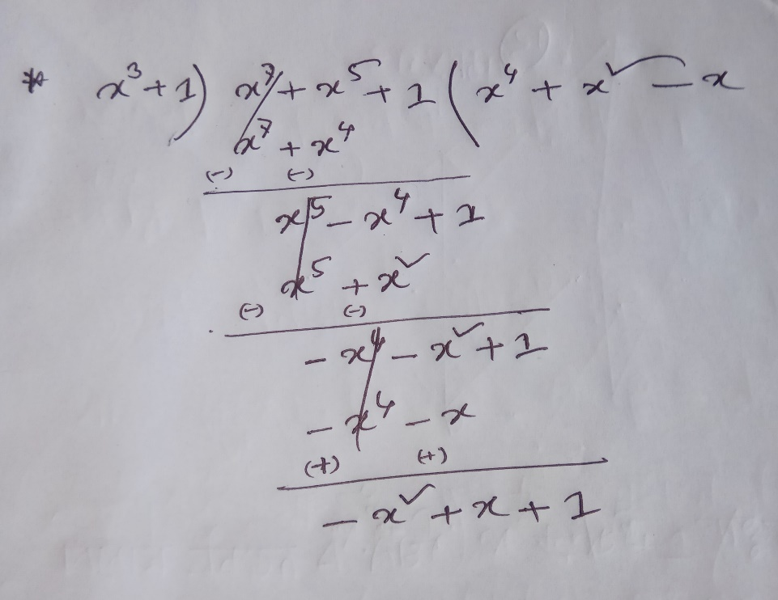Divisor ${= x}^{3}+1$

So, the remainder is ${-x}^{2}+x+1$

**Hence the remainder obtained by dividing $x^{7}+x^{5}+1$  by polynomial ${ x}^{3}+1$   is ${-x}^{2}+x+1$**

1. *Question 2: A bit stream 10011101 is transmitted using the standard CRC method described in the text. The generator polynomial is x 3 + 1. Show the actual bit string transmitted. Suppose that the third bit from the left is inverted during transmission. Show that this error is detected at the receiver’s end. Give an example of bit errors in the bit string transmitted that will not be detected by the receiver.*

Solution:-

Message M (x) = 10011101

= $x^{7}+x^{4}+x^{3}+x^{2}+1$

CRC Polynomial C (x) = $x^{3}$ + 1 = 1001

Multiply the message with $x^{3}$ since the divisor polynomial is of degree 3.

$→$ T (x) = $x^{3}$ ($x^{7}+x^{4}+x^{3}+x^{2}+1$)

= $x^{10}+x^{7}+x^{6}+x^{5}+x^{3}$

= 10011101000

Divide 10011101000 by 1001 (i.e., divide T (x) by C (x))

1000110

---------------------------------

1001 10011101000 $→$ Message

1001

-----------------

1101

1001

---------

1000

1001

-----------

100 $→$ Remainder

Since T (x) minus the remainder would be exactly divisible by C (x), we subtract

The remainder from T (x) as shown below:

Note: The minus operation in polynomial arithmetic is the logical XOR operation.

T (x): 10011101000

Remainder: 100

-------------------

10011101100 $→$ This turns out to be the original message with

The remainder appended to it.

If the third bit form the left is inverted during transmission, the bit stream would

Be: 10111101100. Dividing this by 1001 we get:

10101

---------------------------------------------

1001 10111101100 $→$ Message

1001

-----------------

1011

1001

---------

1001

1001

------------

0100 $→$ Remainder

Since the remainder is 100, which is different form 0, the receiver detects the

Error and can ask for retransmission.

# Home Work 4

1. *Question 1: Explain why networks might use an error-correcting code instead of error detection and retransmission.*

Solution: -

Fast transmission of data takes place. If any frame is received with error then receiver can regenerate the correct frame using the error control information. While in 2nd case receiver will 1st send request for retransmission of that particular frame then sender will again send that frame, which is a very time consuming process.

Efficiency of transmission increases. If we use 1st option then the whole bandwidth of the channel will be used to send the data only in one direction which will automatically increases the data transmission efficiency. While in case of 2nd option bandwidth of the channel is divided in two parts which results in loss of efficiency.

# Home Work 5

*Introduction: You are asked to design a reliable byte-stream protocol that uses a sliding window (like TCP). This protocol will run over a 1Gbits/s network. The RTT of the network is 100 ms, and the maximum segment lifetime is 60 seconds.*

1. *Question: How many bits would you include in the AdvertisedWindow?*
2. *Question: SequenceNum fields of your protocol header?*

Solution 1: To fully utilize the network,

AdvertisedWindow is $\log_{2}({RTT*BandWidth)}$

Here 1Gbits/s

= 119 Mbyte/s

AdvertisedWindow = $\log_{2}[\{{(100}*{10}^{-3})\sec{\}*\{ \frac{119}{8}* {10}^{6}{Bytes}/s\}]}$

AdvertisedWindow = 20 bits

Therefore, 20 bits are needed for AdvertisedWindow.

Solution 2:

Here maximum segment lifetime(MSL) = 60 sec

And 1Gbits/s = 119 Mbyte/s

SequenceNum = $\log_{2}({MSL*BandWidth)}$

= $\log_{2}({60 sec*\frac{119}{8}*{10}^{6} Bytes/s)}$

= 30 bits

Therefore, 30 bits are needed for SequenceNum.

# Home Work 6

1. *Question 1: Both UDP and TCP use port numbers to identify the destination entity when delivering a message. Give two reasons why these protocols invented a new abstract ID (port numbers), instead of using process IDs, which already existed when these protocols were designed.*

Solution: - First, process IDs are OS-specific. Using process IDs would have made these protocols OS-dependent.

Second, a single process may establish multiple channels of communications. A single process ID (per process) as the destination identifier cannot be used to distinguish between these channels.