

Chongqing University of Technology

《Advance Java》

Integrated Application Project

LibrarySSH Management System

Academic Term： | 2020

Class： 6201703L1

Student ID： 62017010084

Name：Md Anower(an hao ming)

Teacher： Liu Yahui

Score：

Contents
No table of contents entries found.

2

1 System Overview

In this modern era of the internet, almost all of us rely on web-based applications from small to big tasks. Well, LibrarySSH management system is one of the most popular use-cases considered by the professionals while building applications in Java. In this report, I tried to show how to create a library management system project using jsp and servlets. LibrarySSH management system project report – The main objective of the Library Management system project is discipline of the planning, organizing and managing the library tasks. Our project aims at making the task of library easy. LibrarySSH Management is entering the records of new book and retrieving the details of book available in the library. We can issue book to the library member and maintain their records and can also checks how many book are issued and stock available in the library. In the project we can maintain the late fine of library member who return the issued book after the due date. This LibrarySSH management system project in JAVA and MS SQL server.

To execute the below project, you will need the following business Requirements:

MySQL Community Server

MySQL JDBC Connector

3

Java

Eclipse IDE

Sqljdbc4.jar

The Sqljdbc4.jar is used to display the data in a table format. So, once you create a project in Eclipse IDE, you have to import the Sqljdbc4.jar and JDBC connector JAR into the project.

To do that, right-click on the project, choose Build Path -> Configure Build Path. In the dialog box, which opens up, choose Add External JARs, and add the JAR files. Once added, click on Apply and Close.

This is the main module in the proposed project. The administrator can read and write information about any member. The administrator can also update, create and delete the record of membership as per requirement and implementation plans. Now, for this particular project, I have considered three tables, which are:

User Manage -> This table consists of the columns {UID, Username,

Password}

Book Manage-> The book’s table consists of the columns {BID, Book name, Picture, Category ID, Description, Remark }

Book Category-> The book’s table consists of the columns { Book Category ID , Book Category Name, Remark}

Student Manage -> This table consists of the columns {Student ID, Student No, Name, Age, and Gender}

We can consider much future scope to this application. The following are some of there. Online use of the librarySSH can be good feature for the Library Management system. Advanced fine payment system can be added. Inventory system can be used to maintain the books of the library. Alright, so now that the Initial set is done, and I have told you the schema of tables, let us get started. In this diagram, the user has been shown more specifically as a student who will the first login to the system, to get access to the application. After getting the authentication and being authorized, the user will use the system with ease and security. There is a database maintained for storing the records of books that are available in the stock, books that have been issued to some user, then the return date of each issued book. After logging in the user will search for the books in the library using the subject code, book code, and therefore access to the rack number becomes easy, so ultimately using the rack number user finds the book, if it is available or not. Once the book has been found, if wanted the book, the user can get it issued easily with their unique college or university id.

Now since the book has been issued it needs to be returned after a defined duration of time as a part of the system procedure.

At a regular interval of time user can check if there is any fine charged on him/her or not. The librarian will also monitor all these activities at its end. And along with this, there is some additional work for the librarian to be done like, adding new books in the rack, updating the book availability status time to time, checking the user’s identity is valid or not

5

For a particular time period. There may be some cases at times when for example say a student has been suspended due to some disciplinary action and therefore has been blocked from using any service provided by the university normally. In this case, it becomes the duty of the librarian to check the identity is valid to issue books or not. Also similar is the case when a student has already passed out from the university. Library Management System is an application refer to other librarySSH system and it is suitable to use by small and medium size library. It is use by librarian and library admin to manage the library using a computerized system. The system was developed and designed to help librarian record every book transaction so that the problem such as file missing or record missing will not happened again. Barcode reader is equipped in this system so that users can enjoy the convenience without need to key in the barcode of the book themselves. It is convenience and time saving as the users can direct scan in the book’s barcode id when the members borrows few books in one time. Book and member maintenance module also included in Library Management System. Users can register or edit the member or book in the system. With this computerized maintenance, library will not lost the book record or member record which always happen when no computerized system bring used. In addition, report module is also included in LibrarySSH Management System. If user’s position is Admin, the user is able to view different kind of report. First

Type of report are rental and return report, user can check the rental, return transaction which happen on particular day. Besides that, user can check the Top10 books which borrow by the member in a day, month or year based on category. Moreover, activity logs report also.

2 Database Design

A database is an organized collection of data, generally stored and accessed electronically from a computer system. Where databases are more complex they are often developed using formal design and modeling techniques. The database management system (DBMS) is the software that interacts with end users, applications, and the database itself to capture and analyze the data. The DBMS software additionally encompasses the core facilities provided to administer the database. The sum total of the database, the DBMS and the associated applications can be referred to as a "database system". Often the term "database" is also used to loosely refer to any of the DBMS, the database system or an application associated with the database.

Database Name : LibraryNewDB

2.1 Users Database

Table 2-1 Users

 | Table Name |  |  |  |  |  | Users
 | Column |  |  | Data Type |  |  | Allowable |  |  | constraint |  |  | Introduce
 | Column |  |  | Data Type |  |  | null value |  |  | condition |  |  | Introduce
Id |  |  |  | int |  |  |  |  |  | PK |  |  | Login Account
User Name |  |  |  | Nvarchar(20) |  |  |  |  |  |  |  |  | Login User Name
Password |  |  |  | Nvarchar(20) |  |  |  |  |  |  |  |  | User Password

2.2 Student Database

Table 2-2 Student

 | Table Name |  |  |  |  |  | Student
 | Column |  |  | Data Type |  | Allowable null |  |  | constraint |  |  | Introduce
 |  |  |  |  |  | value |  |  | condition
 | Id |  |  | int |  |  |  |  | pk |  |  | Student Id
 | No |  |  | Nvarchar(20) |  |  |  |  |  |  |  | Student No
 | Name |  |  | Nvarchar(20) |  |  |  |  |  |  |  | Student Name
 | Age |  |  | int |  | ✓ |  |  |  |  |  | Student Age
 | Gender |  |  | Nvarchar(10) |  | ✓ |  |  |  |  |  | Male/ Female

2.3 Book Database

Table 2-3 Book

Table Name | Book
Column | Data Type | Allowable null  value | Constant  Condition | Introduce
Id | Int |  | Pk | Book ID
Book Name | Nvarchar(20) |  |  | Name Of Book
Picture | Nvarchar(200) | ✓ |  | Image Of Book
Category ID | int | ✓ | FK | Id of Category
Remark | Nvarchar(20) | ✓ |  | Remark

2.4 Book Category
Table 2-4 Book Category

Table Name | Book Category
Column | Data Type | Allowable null  Value | Constraint  condition | Introduce
Id | int |  | Pk | Category ID
Category Name | Nvarchar(20) |  |  | Name Of Category
Remark | Nvarchar(20) | ✓ |  | Remark

3 Specific Function Description

3.1 User Register

This is a small project for Library Management System. First of all the students have to registration for access the library where will have Username, password, real name, age , gender, and address. By the way if the student have already registered then he should log in by providing username, password, Real name. age, gender . gender is a selection method just select male or female . male is default selected .

9

Figure 3-1 Register page

<div class="container">

<h2>welcome to register </h2> <br>

<form method="post" action="doUserServlet.do?type=register">

<div class="form-group">

<label for="userName">userName</label>

<input type="text" class="form-control" id="userName"

name="userName" >

</div>

<div class="form-group">

<label for="password">password</label>

<input type="password" class="form-control" id="password"

name="password">

</div>

<div class="form-group">

<label for="realName">realName</label>

<input type="text" class="form-control" id="realName" name="realName">

</div>

<div class="form-group">

<label for="age">age</label>

<input type="text" class="form-control" id="age" name="age">

</div>

<div class="form-group">

<label for="gender">gender</label>

<select class="form-control" id="gender" name="gender"> <option selected value="male">male</option> <option value="female">female</option>
</select>

</div>

String userName = request.getParameter("userName");

String password = request.getParameter("password"); String realName = request.getParameter("realName"); int age = Integer.parseInt(request.getParameter("age")); String gender = request.getParameter("gender");

UserDAO userDao = new UserDAO();

//Verson1

//Boolean isSuccess = userDao.Register(userName, password, realName, age, gender);

//Verson2

10

User user = new User();

user.setUserName(userName);

user.setPassword(password);

user.setRealName(realName);

user.setAge(age);

user.setGender(gender);

Boolean isSuccess = userDao.Register(user);

if (isSuccess == true)

response.sendRedirect("login.jsp");

else

out.println("error");

3.2 User Login

Logging in is usually used to enter a specific page, website or application, which trespassers cannot see. Once the user is logged in, the login token may be used to track what actions the user has taken while connected to the site. Logging out may be performed explicitly by

the user taking some actions, such as entering the appropriate command or clicking a website link labeled as such. It can also be done implicitly, such as by the user powering off his or her workstation, closing a web browser window, leaving a website, or not refreshing a webpage within a defined period. In the case of websites that use cookies to track sessions, when the user logs out, session-only cookies from that site will usually be deleted from the user's computer. In addition, the server invalidates any associations with the session, thereby making any session-handle in the user's cookie store useless. This feature comes in handy if the user is using a public computer or a computer that is using a public wireless connection. As a security precaution, one

11

should not rely on implicit means of logging out of a system, especially not on a public computer; instead, one should explicitly log out and wait for the confirmation that this request has taken place. In the log in page the students has already registered by giving there information in registration page . here just input the unique name which is username and the password . After the login all thing can access the loged in student .
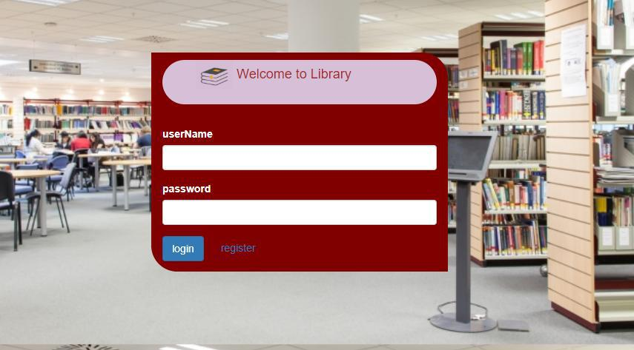

Figure 3-2 Log in page

<body>

<div class="container">

<h4> <img src="images/hiclipart.com.png" width="50px" height="40px" margin-right:"50px" > Welcome to Student Management System </h4> <br>

<form method="post" action="doUserServlet.do?type=login"> <div class="form-group">
<label for="userName">userName</label>

<input type="text" class="form-control" id="userName"

name="userName" >

</div>

<div class="form-group">

<label for="password">password</label>

12

<input type="password" class="form-control" id="password" name="password">

</div>

<button type="submit" class="btn btn-primary">login</button> &nbsp;&nbsp;&nbsp;&nbsp;

<a href="register.jsp">register</a>

</form>

</div>

</body>

3.3 User Manage

3.3.1 User list

The User List are administration pages in the User and User talk namespaces that are useful for organizing and aiding the work users do on Library Management System. as well as facilitating interaction and sharing between users. User pages are mainly for interpersonal discussion, notices, testing and drafts and, if desired, limited autobiographical and personal content. User pages are available to Library Management System users personally for purposes compatible with the Library Management System project and acceptable to the community.
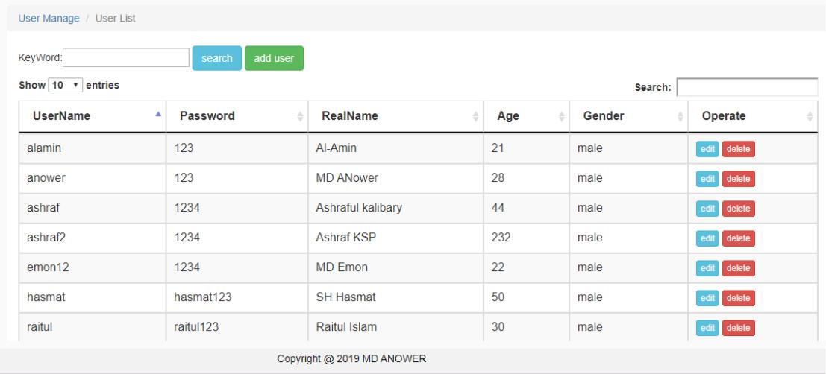

13

Figure 3-3-1 User List

<script>

$(function(){

$("#infoTable").dataTable({

"searching":true,

"autoWidth":true,

"scrollY": 330,

"paging":true,

//"pagingType":"full_numbers",

"processing" : true,

"ordering":true,

"stateSave" : true,

"deferRender":true,

})

})

</script>

<body>

<nav aria-label="breadcrumb">

<ol class="breadcrumb">

<li class="breadcrumb-item"><a href="#">User Manage </a></li> <li class="breadcrumb-item active" aria-current="page">User List</li>

</ol>

</nav>

<%

ArrayList<model.User> userList = (ArrayList<model.User>)request.getAttribute("userList");%>

<div class="container">

KeyWord:<input type="text" id="keyword" name="keyword" /> <button class="btn btn-info" onclick="search();">search</button>

<button class="btn btn-success" id="add_hw" onclick="add();">add user</button>

</div>

<div class="container">

<table id="infoTable" class="table table-striped table-bordered table-condensed table-hover datatable">

<thead>

<tr>

<th scope="col">UserName</th>

<th scope="col">Password</th>

<th scope="col">RealName</th>

<th scope="col">Age</th>

<th scope="col">Gender</th>

<th scope="col">Operate</th>

14

</tr>

</thead>

<tbody>

<%

for(int i=0; i<userList.size(); i++){

model.User user = userList.get(i);

%>

<tr>

<td><%=user.getUserName() %></td>

<td><%=user.getPassword() %></td>

<td><%=user.getRealName() %></td>

<td><%=user.getAge() %></td>

<td><%=user.getGender() %></td>

<td>

<button class="btn btn-xs btn-info" onclick="edit('<%=user.getUserName() %>')">edit</button>

<button class="btn btn-xs btn-danger" onclick="del('<%=user.getUserName() %>');">delete</button>

</td>

</tr>

<%

}

%>

</tbody>

</table>

</div>

<script type="text/javascript">

function search(){

var keyWord = $('#keyword').val();

window.location.href = "doUserServlet.do?type=search&keyWord=" +

keyWord;

}

function del(userName){

if(confirm("Are you sure to delete the user?")){

window.location.href = "doUserServlet.do?type=delete&userName=" + userName;

}

}

function add(){

window.location.href = "userAdd.jsp";

}

function edit(userName){

window.location.href = "userEdit.jsp?userName=" + userName;

}

15

</script>

</body>

3.3.2 Change Password

A password, sometimes called a pass code is a memorized secret used to confirm the identity of a user.^{[2]} Using the terminology of the NIST Digital Identity Guidelines, the secret is memorized by a party called the claimant while the party verifying the identity of the claimant is called the verifier. When the claimant successfully demonstrates knowledge of the password to the verifier through an established authentication protocol, the verifier is able to infer the

claimant’s identity.In general, a password is an arbitrary string of characters including letters, digits, or other symbols. If the permissible characters are constrained to be numeric, the corresponding secret is sometimes called a personal identification number (PIN).Despite its name, a password need not be an actual word; indeed a non-word (in the dictionary sense) may be harder to guess, which is a desirable property of passwords. A memorized secret consisting of a sequence of words or other text separated by spaces is sometimes called a passphrase. A passphrase is similar to a password in usage but the former is generally longer for added security.

16

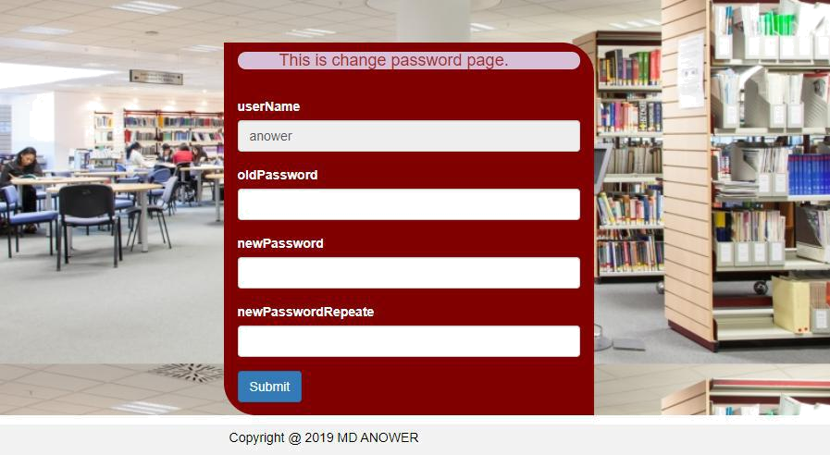

Figure 3-3-1 Change Password

<body>

<%

String userName = (String)session.getAttribute("userName"); %>

<nav aria-label="breadcrumb">

<ol class="breadcrumb">

<li class="breadcrumb-item"><a href="#">User Manage </a></li>

<li class="breadcrumb-item active" aria-current="page">ChangePsw</li> </ol>

</nav>

<div class="container">

<h4>This is change password page.</h4> <br>

<form method="post" action="doUserServlet.do?type=changePswPost"> <div class="form-group">

<label for="userName">userName</label>

<input type="text" class="form-control" id="userName"

name="userName" value="<%=userName %>" readonly="readonly"

</div>

<div class="form-group">

<label for="oldPassword">oldPassword</label>

<input type="password" class="form-control" id="oldPassword" name="oldPassword">

</div>

<div class="form-group">

<label for="newPassword">newPassword</label>

<input type="password" class="form-control" id="newPassword" name="newPassword">

</div>

<div class="form-group">

17

<label for="newPasswordRepeate">newPasswordRepeate</label>

<input type="password" class="form-control" id="newPasswordRepeate" name="newPasswordRepeate">

</div>

<button type="submit" class="btn btn-primary">Submit</button>

</form>

</div>

</body>

3.4 Student Manage

3.4.1 Student List

A student is primarily a person enrolled in a school or other educational institution who attends classes in a course to attain the appropriate level of mastery of a subject under the guidance of an instructor and who devotes time outside class to do whatever activities the instructor assigns that are necessary either for class preparation or to submit evidence of progress towards that mastery. In the broader sense, a student is anyone who applies themselves to the intensive intellectual engagement with some matter necessary to master it as part of some practical affair in which such mastery is basic or decisive.
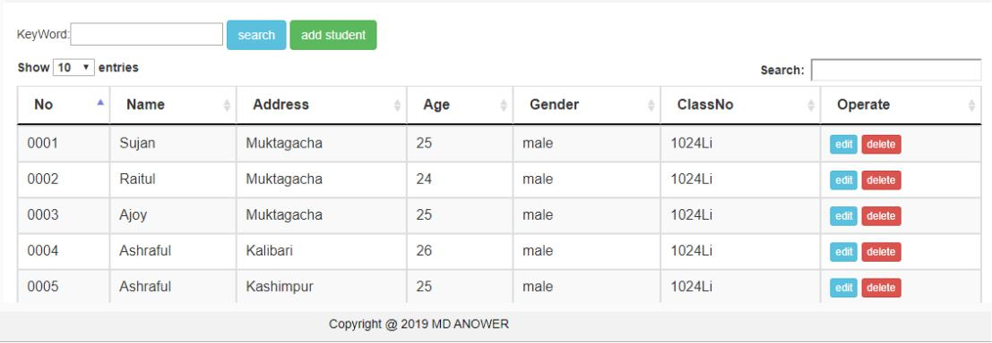

Figure 4-1 Student List

18

<script>

$(function(){

$("#infoTable").dataTable({

"searching":true,

"autoWidth":true,

"scrollY": 330,

"paging":true,

//"pagingType":"full_numbers",

"processing" : true,

"ordering":true,

"stateSave" : true,

"deferRender":true,

})

})

</script>

<body>

<h2> This is my JSP page.</h2><br>

<nav aria-label="breadcrumb">

<ol class="breadcrumb">

<li class="breadcrumb-item"><a href="#">User Manage </a></li> <li class="breadcrumb-item active" aria-current="page">User List</li>

</ol>

</nav>

<%

ArrayList<model.Student> studentList = (ArrayList<model.Student>)request.getAttribute("studentList");

%>

<div class="container">

KeyWord:<input type="text" id="keyword" name="keyword" /> <button class="btn btn-info" onclick="search();">search</button>

<button class="btn btn-success" id="add_hw" onclick="add();">add student</button>

</div>

<div class="container">

<table id="infoTable" class="table table-striped table-bordered table-condensed table-hover datatable">

<thead>

<tr>

<th scope="col">No</th>

<th scope="col">Name</th>

19

<th scope="col">Address</th>

<th scope="col">Age</th>

<th scope="col">Gender</th>

<th scope="col">ClassNo</th>

<th scope="col">Operate</th>

</tr>

</thead>

<tbody>

<%

for(int i=0; i<studentList.size(); i++){ model.Student student = studentList.get(i);

%>

<tr>

<td><%=student.getNo() %></td>

<td><%=student.getName() %></td>

<td><%=student.getAddress() %></td>

<td><%=student.getAge() %></td>

<td><%=student.getGender() %></td>

<td><%=student.getClassNo() %></td>

<td>

<button class="btn btn-xs btn-info" onclick="edit('<%=student.getNo() %>')">edit</button>

<button class="btn btn-xs btn-danger" onclick="del('<%=student.getNo() %>');">delete</button>

</td>

</tr>

<%

}

%>

</tbody>

</table>

</div>
</ | body | >
<script type="text/javascript">
 | function search(){
 |  | var keyWord = $('#keyword').val();
 |  | window.location.href = "doUserServlet.do?type=search&keyWord=" | +
keyWord;
}
 | function del(userName){
 |  | if(confirm("Are you sure to delete the user?")){
 |  | window.location.href | =

20

"doUserServlet.do?type=delete&userName=" + userName;

}

}

function add(){

window.location.href = "studentAdd.jsp";

}

function edit(No){

//window.location.href = "studentEdit.jsp?no=" + No;window.location.href = "doStudentServlet.do?type=edit&no=" + No;}

</script>

3.4.2 Add Student

The database management system (DBMS) is the software that interacts with end users, applications, and the database itself to capture and analyze the data. The DBMS software additionally encompasses the core facilities provided to administer the database. The sum total of the database, the DBMS and the associated applications can be referred to as a "database system". Often the term "database" is also used to loosely refer to any of the DBMS, the database system or an application associated with the database. In the add student function the user can add student manually

21

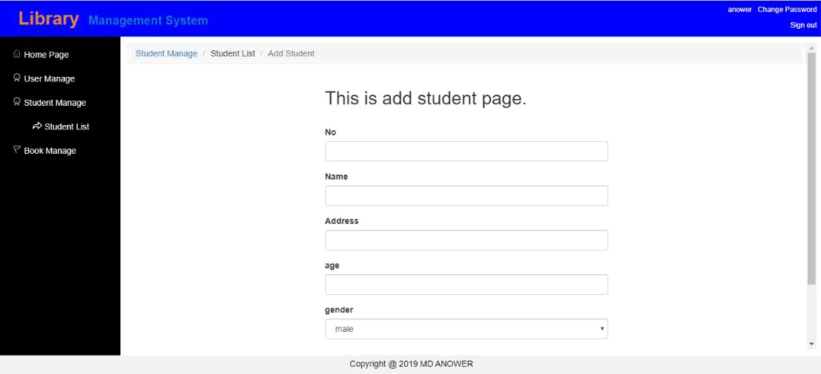

page 4-2 Student Add

<body>

<nav aria-label="breadcrumb">

<ol class="breadcrumb">

<li class="breadcrumb-item"><a href="#">Student Manage </a></li> <li class="breadcrumb-item" aria-current="page">Student List</li>

<li class="breadcrumb-item active" aria-current="page">Add Student</li> </ol>

</nav>

<div class="container">

<h2>This is add student page.</h2> <br>

<form method="post" action="doStudentServlet.do?type=add"> <div class="form-group">

<label for="No">No</label>

<input type="text" class="form-control" id="No" name="No" > </div>

<div class="form-group">

<label for="Name">Name</label>

<input type="text" class="form-control" id="Name" name="Name">

</div>

<div class="form-group">

<label for="Address">Address</label>

<input type="text" class="form-control" id="Address"

name="Address">

</div>

<div class="form-group">

<label for="age">age</label>

22

<input type="text" class="form-control" id="age" name="age">

</div>

<div class="form-group">

<label for="gender">gender</label>

<select class="form-control" id="gender" name="gender"> <option selected value="male">male</option> <option value="female">female</option>

</select>

</div>

<div class="form-group">

<label for="ClassNo">ClassNo</label>

<input type="text" class="form-control" id="ClassNo"

name="ClassNo">

</div>

<button type="submit" class="btn btn-primary">Submit</button>

</form>

</div>

</body>

3.4.3 Edit Student Information

When students edit in the Library, they show the world what they know, and they show themselves that they know. They’re making a statement. they’ve learned and they tell the world: “I know this.” That’s the difference between writing for an assignment and writing for an audience. Students make the leap from passive learning to an active expression of knowledge. They rephrase and revise their understanding as they work. They put knowledge into their own words, they make it theirs, and pass it on. In the end, they’ve shared real knowledge with the world. But they’ve also made that knowledge distinctly their own.

23

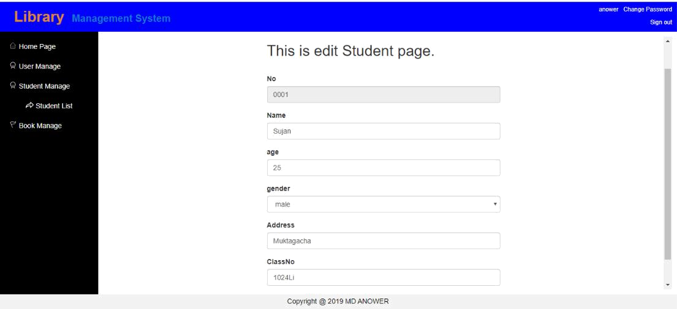

Figure 4-3 Student Edit Information

<body>

<nav aria-label="breadcrumb">

<ol class="breadcrumb">

<li class="breadcrumb-item"><a href="#">Student Manage </a></li> <li class="breadcrumb-item" aria-current="page">Student List</li>

<li class="breadcrumb-item active" aria-current="page">Edit Student</li> </ol>

</nav>

<div class="container">

<h2>This is edit Student page.</h2> <br>

<form method="post" action="doStudentServlet.do?type=editPost"> <div class="form-group">

<label for="No">No</label>

<input type="text" class="form-control" id="No" name="No"

value="<%=student.getNo() %>" readonly="readonly" >

</div>

<div class="form-group">

<label for="Name">Name</label>

<input type="text" class="form-control" id="Name" name="Name" value="<%=student.getName() %>" >

</div>

<div class="form-group">

<label for="age">age</label>

<input type="text" class="form-control" id="age" name="age" value="<%=student.getAge() %>" >

</div>

<div class="form-group">

<label for="gender">gender</label>

24

<select class="form-control" id="gender" name="gender" %>" ><% if (student.getGender().equals("male"))

{

%>

<option selected value="male">male</option> <option value="female">female</option>

<%

}else

{

%>

<option value="male">male</option>

<option selected value="female">female</option> <%

}

%>

</select>

</div>

<div class="form-group">

<label for="Address">Address</label>

<input type="text" class="form-control" id="Address" name="Address" value="<%=student.getAddress() %>" >

</div>

<div class="form-group">

<label for="ClassNo">ClassNo</label>

<input type="text" class="form-control" id="ClassNo"

name="ClassNo" value="<%=student.getClassNo() %>" >

</div>

<button type="submit" class="btn btn-primary">Submit</button>

</form>

</div>

<script>

<%-- $(function(){

var gender = <%=student.getGender()%>;

console.log(gender);

if (gender == "male"){

$('#gender').val("male");

}else{

$('#gender').val("female");

}

}); --%>

</script>

</body>

25

4 Summary

A Library Management System (LMS) is a tool to help any libraries which are still using the old way to manage their library. The old way like searching for a book using manual work is hassle, fast report generation is not possible, information about issue/return of the books are not properly maintained, no central database can be created as information is not available in database. But by using the LMS, user can overcome all the problems mentioned above. This system can manage all the happenings of the library. Book transactions including book searching, availability of the book, details and appearance of the book, personal book borrowing history and etc. can be very easily handled by this system. This system is suitable for small to big libraries including medical and legal libraries, colleges, schools, universities, corporate houses and other academic resource centers. However, I would like to focus on LMS for colleges or universities.

