

Chongqing University of Technology

Course Design

Course: Advance Java

Topic: Hospital Management System

College: Computer Science and Engineering

Class: 6201703L1

Student ID: 62017010084

Name: Md Anower(an hao ming)

Teacher: Liu Yahui

Score:

Time： 2020.06.22 - 2020.07.03

Contents

**1 System Overview** 4

1.1 Background 5

1.2 System Targets and Implementation Technology 5

**2 Database Design** 6

2.1 Database Name 7

2.2 Database Table 7

2.2.1 Admin Database 8

2.2.2 Branch Database 8

2.2.3 Doctor Database 8

2.2.4 Doctor Category Database 9

2.2.5 Appointment Database 9

2.2.6 Contact Database 10

3 Specific Function Description 10

3.1 Public Activity 10

3.1.1 Home Page 11

3.1.2 Make Appointment 13

3.1.3 Doctor List 17

3.1.4 Contact Us 19

3.2 Authority Activity/management Activity 21

3.2.1 Login Page 21

3.2.2 Authority Home Page 23

3.2.3 Admin Manage 26

3.2.3.1 Admin List 26

3.2.3.1.1 Add Admin 28

3.2.3.1.2 Edit Admin 29

3.2.3.1.3 Delete Admin 31

3.2.3.2 Change Password 32

3.3.4 Branch Manage 33

3.3.4.1 Branch List 34

3.3.4.2 Add Branch 35

3.3.4.3 Edit Branch 36

3.3.5 Doctor Manage 38

3.3.5.1 Doctor Category List 38

3.3.5.1.1 Add Doctor Category 40

3.3.5.1.2 Edit Doctor Category 41

3.3.5.2 Doctor List 42

3.3.5.2.1 Add Doctor 43

3.3.5.2.2 Edit Doctor 45

3.3.5.2.3 Delete Doctor 46

3.3.5.3 Doctor Search 46

4 Summary 48

5. Reference 49

# **1 System Overview**

My main focus is design a unique Hospital Management System that will improve hospital experience for both patients and the hospital authorities. The whole system will run on internet. The system is written in jsp, servlet, java script, jQuery,boatstrap, HTML and CSS. Users will have the felicity to log in from any place with internet connection. After that they will be able to various tasks that are designed for them. The primary target is to focus on every user who can get our service and get benefitted. It can be turned into a paid system only for doctors. A doctor can have different types of patient and the number of patients also vary from doctor to doctor. A doctor can have various number of patients. We can assume that doctors will need different amount of cloud storage. We can allocate a fixed cloud storage for each doctors. They can ask for extra storage according their demand and they will be charged for their demand. We can make various package and assign various cost. The patients will have some allocated space which they can use to keep their information. As the patient only needs storage for only themselves they can use this as a free user. This will make the system useful and more convenient for everyone. Keeping the goal in mind the system we developed works as a social network where information’s are more close and relevant for every user. This report contains the full details of the system and its functionality in details. To execute the project, you will need the following Steps unzip the Project, open the eclipse and import the project. This is the main module in the proposed project. The administrator can read and write information about any member. The administrator can also update, create and delete the record of membership as per requirement and implementation plans. Now, for this particular project, I have considered six tables, which are:

* Appointment Table
* Doctor Table
* Doctor Category Table
* Contact Table
* Branch Table
* Admin Table

## Background

Various management program for management are present out there but there any not too many which provides the patients any functionality. The hospital system has been automated but the benefit is not for all. In such a situation I have figured out that there should be something for the patients. Some simple features for appointment, asking for appointment, Contact and Doctor List can reduce the hassle up to 70-80%. Because those are the sector where we face a lot of trouble and can find a way out. So this will allow us something that we were waiting for so long. The world is moving to internet so this is the right time to think about this. I have checked some hospital management system on internet and some local programs that the hospital stuffs are using near me. They are also very well designed and have rich features too but nothing for the patients to be happy about is there. If we compare the benefits and the satisfaction form every point of view then we cannot conclude things beneficial for all.

## System Targets and Implementation Technology

HospitalDCH is implemented in the organizations for enhancing the efficiency of the organizations. The implementation of HospitalDCH is considered as interesting topic for the practitioners as well as researchers since last two weeks. HospitalDCH is a socio-technical system, it requires the parallel implementation of IT and human activity. Implementation of HospitalDCH involves both social and technical implementation. Social system implementation involves that proper users are selected, trained and supported in use of technology. Technical system implementation involves the hardware, software and data.

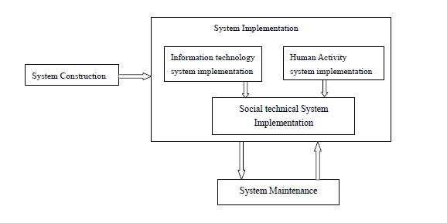

Figure 1: System Implementation

# **2 Database Design**

Database is an organized collection of data, generally stored and accessed electronically from a computer system. Where databases are more complex they are often developed using formal design and modeling techniques. The database management system (DBMS) is the software that interacts with end users, applications, and the database itself to capture and analyze the data. The DBMS software additionally encompasses the core facilities provided to administer the database. The sum total of the database, the DBMS and the associated applications can be referred to as a "database system". Often the term "database" is also used to loosely refer to any of the DBMS, the database system or an application associated with the database.

2.1 Database Name

In the every database have a name. For the small scale project of Hospital Management System has also a database, this is a local server database no need to use internet the name of the database is: **FramworkHospital.**

## 2.2 Database Table

A table is a collection of related data held in a table format within a database. It consists of columns, and rows. In relational databases, and flat file databases, a *table* is a set of data elements (values) using a model of vertical columns (identifiable by name) and horizontal rows, the cell being the unit where a row and column intersect. A table has a specified number of columns, but can have any number of rows. Each row is identified by one or more values appearing in a particular column subset. A specific choice of columns which uniquely identify rows is called the primary key. "Table" is another term for "relation"; although there is the difference in that a table is usually a multi set (bag) of rows where a relation is a set and does not allow duplicates. Besides the actual data rows, tables generally have associated with them some metadata, such as constraints on the table or on the values within particular columns. The data in a table does not have to be physically stored in the database. Views also function as relational tables, but their data are calculated at query time. External tables can also be thought of as views. List of the table below

### 2.2.1 Admin Database

Table 2.2-1 Users

|  |  |  |  |  |
| --- | --- | --- | --- | --- |
| Table Name | Admin | | | |
| Column | Data Type | Allowable null Value | Constant Condition | Introduce |
| Id | int |  | Pk | Login Account |
| User Name | Nvarchar(20) |  |  | Admin User Name |
| Password | Nvarchar(20) |  |  | Admin Password |

### 2.2.2 Branch Database

Table 2.2-2 Student

|  |  |  |  |  |
| --- | --- | --- | --- | --- |
| Table Name | **Branch** | | | |
| Column | Data Type | Allowable null Value | Constant condition | Introduce |
| Id | Int |  | Pk | Branch ID |
| No | Nvarchar(20) |  |  | Branch No |
| Name | Nvarchar(20) |  |  | Branch Name |
| Age | Int | ✓ |  | Year |

### 2.2.3 Doctor Database

Table 2.2-3 Book

|  |  |  |  |  |
| --- | --- | --- | --- | --- |
| Table Name | **Doctor** | | | |
| Column | Data Type | Allowable null  value | Constant  Condition | Introduce |
| Id | Int |  | Pk | Doctor ID |
| Doctor Name | Nvarchar(20) |  |  | Name Of Doctor |
| Picture | Nvarchar(200) | ✓ |  | Image Of Doctor |
| Category ID | int | ✓ | FK | Id of Category |
| Remark | Nvarchar(20) | ✓ |  | Remark |

### 2.2.4 Doctor Category Database

Table 2.2-4 Book Category

|  |  |  |  |  |
| --- | --- | --- | --- | --- |
| Table Name | **Doctor Category** | | | |
| Column | Data Type | Allowable null  Value | Constraint  condition | Introduce |
| Id | int |  | Pk | Category ID |
| Category Name | Nvarchar(20) |  |  | Name Of Category |
| Remark | Nvarchar(20) | ✓ |  | Remark |

### 2.2.5 Appointment Database

Table 2.2-5 Appointment

|  |  |  |  |  |
| --- | --- | --- | --- | --- |
| Table Name | **Appointment** | | | |
| Column | Data Type | Allowable null  Value | Constraint  condition | Introduce |
| FirstName | nvarchar(50) | ✓ |  | First Name of Patient |
| LastName | nvarchar(50) | ✓ |  | Last Name of Patient |
| FullAddress | nvarchar(100) | ✓ |  | Full Address of Patient |
| CityName | nvarchar(50) | ✓ |  | City Name of Patient |
| PhnNumber | nvarchar(50) | ✓ |  | Phone number of Patient |
| Email | nvarchar(50) | ✓ |  | Email of Patient |
| DateOfBirth | nvarchar(20) | ✓ |  | Date Of Birth of Patient |
| AppointmentTime | nvarchar(20) | ✓ |  | Time of Appointment when the patient want |
| ContactPerson | nvarchar(50) | ✓ |  | Contact of Patient |
| BloodGroup | nvarchar(10) | ✓ |  | Blood Group of Patient |
| Age | nvarchar(20) | ✓ |  | Age of Patient |
| Gender | nvarchar(20) | ✓ |  | Gender of Patient |
| SpecialMessage | text | ✓ |  | Describe the problem |
| Id | int |  |  | Id |

### 2.2.6 Contact Database

Table 2.2-6 Contact

|  |  |  |  |  |
| --- | --- | --- | --- | --- |
| Table Name | **Contact** | | | |
| Column | Data Type | Allowable null  Value | Constraint  condition | Introduce |
| FullName | nvarchar(50) | ✓ |  | Full Name of Contact person |
| Email | nvarchar(50) | ✓ |  | Email of Contact person |
| Phone | nvarchar(50) |  |  | Phone number of Contact person |
| Message | nvarchar(500) |  |  | Message |
| Id | nvarchar(50) | ✓ |  | Id |

# 3 Specific Function Description

## 3.1 Public Activity

Every Web site has two things one is public activity another is Admin Activity. The public activity is for everyone anyone can see it access it visit it anything to do the public want. But there is another things that the public can’t access it that’s called Admin Activity. Every web site has this things the authority or the admin can access data they can access full web site. An Admin can add another Admin etc.

### 3.1.1 Home Page

Home page when any one will entry in the web page the public can see the following view. Here the public can see some feature Home page, log in, Appointment, Contact, about etc. Home page is the common a page in web page where all of the information’s have shortly. The visitor can easily understand the system of the management system. In this hospital management system the same thing has occurred. Hospital are the essential part of our lives, providing appointments medical facilities to people suffering from various ailments, which may 1k due to change in climatic conditions, increased work-load, emotional trauma stress etc. It is necessary for the hospitals to keep track of its day-to-day. Activities & records of its patients, doctors, nurses, ward boys and other staff personals that keep the hospital running smoothly & successfully. But keeping track of all the instruments and their records on paper is very and error prone. It also is very inefficient and a time-consuming pixies Observing the continuous increase in population and number of people visiting the hospital. Recycling and maintaining all these records is highly unreliable, inefficient and error-prone. It is also not economically & technically feasible to maintain these on paler. In the Home of the web page are all thing can get the patients?

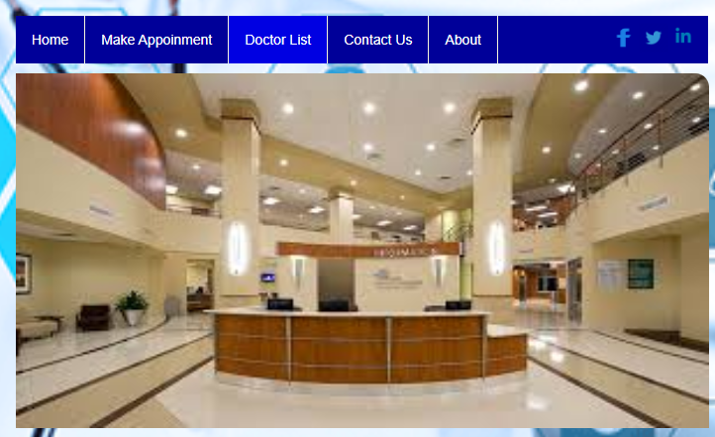Figure 3-1: Home Page

<div class=*"containertop"*>

<h1> <img src=*"images/logo-hospitalmake.png"* width=*"250px"* height=*70px*" margin-right:"50px" > DAILY CARE HOSPITAL </h1> <br>

</form>

</div>

<nav id=*"tips"*>

<div id=*"header"*>

<div id=*"header-ul-li"*>

<ul id=*"headerul"*>

<li ><a href=*"#"*>Home</a></li>

<li ><a href=*"BookAppointment.jsp"*>Make Appoinment</a></li>

<li ><a href=*"PublicDoctorList.jsp"*>Doctor List</a></li>

<li ><a href=*"Contact.jsp"*>Contact Us</a></li>

<li ><a href=*"#"*>About</a>

</li>

<a href=*"www.linkeding.com/in/anower33"*> <img class=*"linkdin-icon"* src=*"img_social_icon/linkdin.png"* height=*"30px"* width=*"30px"*> </a>

<a href=*"www.twitter.com/MDAnower9"*><img class=*"twitter-icon"* src=*"img_social_icon/Twitter-512.png"* height=*"30px"* width=*"30px"*></a>

<a href=*"www.facebook.com/anower33"*> <img class=*"facebook-icon"* src=*"img_social_icon/facebook.png"* height=*"20px"* width=*"30px"*></a>

</ul>

</div>

<nav id=*"slide-image"*>

<script>

**var** i = 0; // Start point

**var** images = [];

**var** time = 2000;

// Image List

images[0] = 'images/slide-2.jpg';

images[1] = 'images/slide-3.jpg';

images[2] = 'images/slide-4.jpg';

images[3] = 'images/slide-5.jpg';

// Change Image

**function** changeImg(){

document.slide.src = images[i];

**if** (i < images.length - 1) {

i++;

} **else** {

i = 0;

}

setTimeout("changeImg()", time);

}

window.onload = changeImg;

</script>

<img id=*"slide-img-border"* name=*"slide"* width=*"700"* height=*"358"*>

</nav>

</nav>

### 3.1.2 Make Appointment

A basic plan can help you make the most of your appointment whether you are starting with a new doctor or continuing with the doctor you’ve seen for years. The following tips will make it easier for you and your doctor to cover everything you need to talk about. Make a list of what you want to discuss. For example, do you have a new symptom you want to ask the doctor about? Do you want to get a flu shot? Are you concerned about how a treatment is affecting your daily life? If you have more than a few items to discuss, put them in order and ask about the most important ones first. Don’t put off the things that are really on your mind until the end of your appointment—bring them up right away! Some doctors suggest you put all your prescription drugs, over-the-counter medicines, vitamins, and herbal remedies or supplements in a bag and bring them with you. Others recommend you

Figure 3-2: Book Appointment Demo

Bring a list of everything you take and the dose. You should also take your insurance cards, names and phone numbers of other doctors you see, and your medical records if the doctor doesn’t already have them. Sometimes it is helpful to bring a family member or close friend with you. Let your family member or friend know in advance what you want from your visit. Your companion can remind you what you planned to discuss with the doctor if you forget. She or he can take notes for you and can help you remember what the doctor said. Tell the doctor about your illnesses, operations, medical conditions, and other doctors you see. You may want to ask the doctor to send you a copy of the medical history form before your visit so you can fill it out at home, where you have the time and information you need to complete it. If you have problems understanding how to fill out any of the forms, ask for help. Some community organizations provide this kind of help.

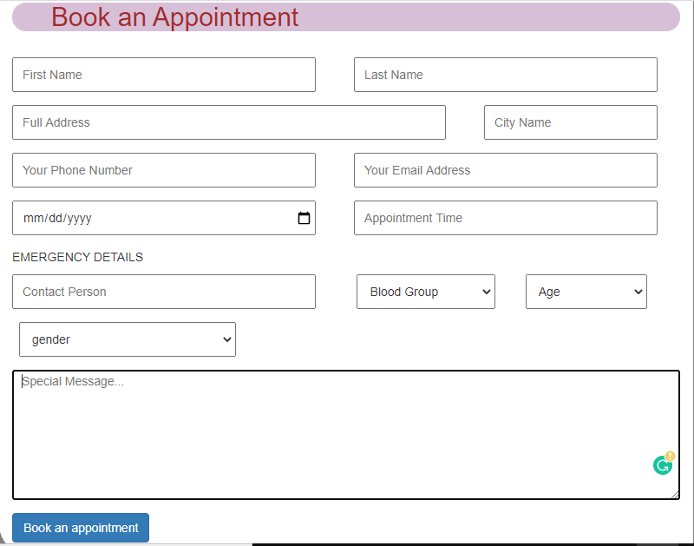

Figure 3-3: Book Appointment

<form action=*"appointmentAction_add"* method=*"post"* enctype=*"multipart/form-data"*>

<div class=*"form-group"*>

<input type=*"text"* placeholder=*"First Name"* class=*"form-controlFN"* id=*"firstname"* name=*"firstname"* >

<input type=*"text"* placeholder=*"Last Name"* class=*"form-controlLN"* id=*"lastname"* name=*"lastname"*>

</div>

<div class=*"form-group"*>

<input type=*"text"* placeholder=*"Full Address"* class=*"form-controlFA"* id=*"fulladdress"* name=*"fulladdress"*>

<input type=*"text"* placeholder=*"City Name"* class=*"form-controlCN"* id=*"cityname"* name=*"cityname"*>

</div>

<div class=*"form-group"*>

<input type=*"text"* placeholder=*"Your Phone Number"* class=*"form-controlPHN"* id=*"phnnumber"* name=*"phnnumber"*>

<input type=*"email"* placeholder=*"Your Email Address"* class=*"form-controEMAIL"* id=*"email"* name=*"email"*>

</div>

<div class=*"form-group"*>

<input type=*"Date"* value=*"Birth year-month-day"* class=*"form-controlPHN"* id=*"dateofbirth"* name=*"dateofbirth"*>

<input type=*"slot"* placeholder=*"Appointment Time"* class=*"form-controEMAIL"* id=*"appointmenttime"* name=*"appointmenttime"*>

</div>

<div class=*"form-group"*>

<p>EMERGENCY DETAILS</p>

<input type=*"text"* placeholder=*"Contact Person"* class=*"form-controlFN"* id=*"firstname"* name=*"contactperson"* >

<label for=*"blood"*>Blood</label>

<select class=*"blood"* placeholder=*"blood"* id=*"blood"* name=*"bloodgroup"*>

<option >Blood Group</option>

<option >A+</option>

<option >B+</option>

<option >AB+</option>

<option >AB-</option>

<option >A-</option>

<option >B-</option>

</select>

<label for=*"age"*>Age</label>

<select class=*"age"* placeholder=*"age"* id=*"age"* name=*"age"*>

<option >Age</option>

<option >-18</option>

<option >18-40</option>

<option >41-60</option>

<option >61+</option>

</select>

</div>

<div class=*"form-group"*>

<label for=*"gender"*>Gender</label>

<select class=*"gender"* placeholder=*"Gender"* id=*"gender"* name=*"gender"*>

<option >gender</option>

<option >male</option>

<option >female</option>

<option >common</option>

</select>

</div>

<div class=*"form-group"*>

<textarea class=*"input100"* name=*"specialmessage"* placeholder=*"Special Message..."*></textarea>

<span class=*"focus-input100"*></span>

</div>

<button type=*"submit"* class=*"btn btn-primary"*>Book an appointment</button>

</form>

### 3.1.3 Doctor List

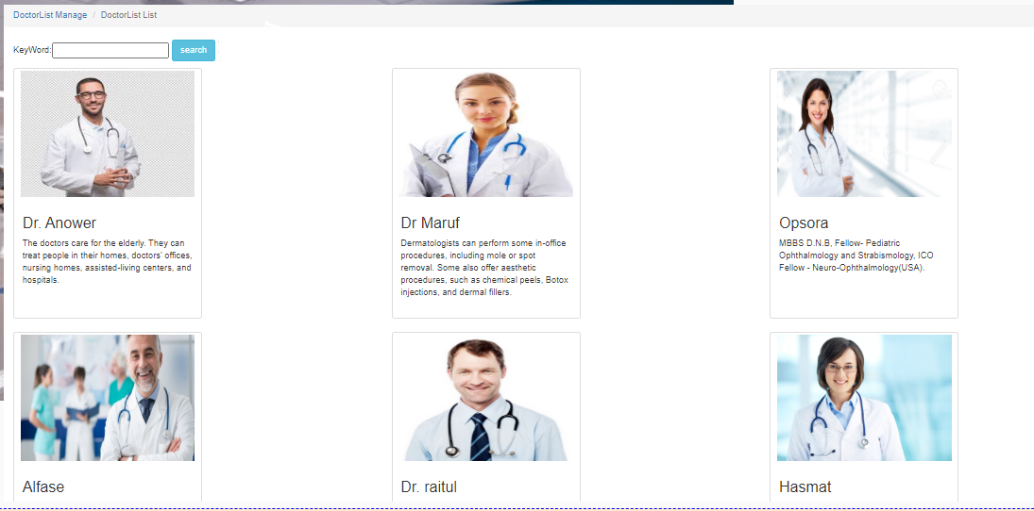DCH Health provides a wide range of primary care services for patients of all ages, from infants to seniors. Our doctors, nurses and other health professionals work to keep you healthy with preventive medicine, screenings and education. We treat acute medical problems and also manage ongoing conditions. If you need a specialist, we coordinate your care with our medical center's world-renowned experts. At DCH, we want your primary care clinic to feel like your health care home. We welcome patients from all walks of life and backgrounds, and we ensure that every patient receives innovative, conscientious and high-quality care. May be the patients need to know the about the doctor before booking appointment, because the patients should know about the doctor from where the is graduated.

Figure 3-4: Public Doctor List

<!DOCTYPE HTML PUBLIC "-//W3C//DTD HTML 4.01 Transitional//EN">

<html>

<head>

<base href=*"*<%=basePath%>*"*>

<title>My JSP 'PublicDoctorList.jsp' starting page</title>

<meta http-equiv=*"pragma"* content=*"no-cache"*>

<meta http-equiv=*"cache-control"* content=*"no-cache"*>

<meta http-equiv=*"expires"* content=*"0"*>

<meta http-equiv=*"keywords"* content=*"keyword1,keyword2,keyword3"*>

<meta http-equiv=*"description"* content=*"This is my page"*>

<link rel=*"stylesheet"* type=*"text/css"* href=*"css/bootstrap.min.css"*>

<link rel=*"stylesheet"* type=*"text/css"* href=*"css/jquery.dataTables.min.css"*>

<script src=*"js/jquery-3.4.1.min.js"*></script>

<script src=*"js/bootstrap.min.js"*></script>

<script src=*"js/dataTables.bootstrap.js"*></script>

<script src=*"js/jquery.dataTables.min.js"*></script>

<style>

*.container* {

width:*100%*;

margin:*10px 0px*;

}

*.thumbnail*{

width:*300px*;

height:*400px*;

}

</style>

</head>

<body>

<nav aria-label=*"breadcrumb"*>

<ol class=*"breadcrumb"*>

<li class=*"breadcrumb-item"*><a href=*"#"*>DoctorList Manage </a></li>

<li class=*"breadcrumb-item active"* aria-current=*"page"*>DoctorList List</li>

</ol>

</nav>

<div class=*"container"*>

KeyWord:<input type=*"text"* id=*"keyword"* name=*"keyword"* />

<button class=*"btn btn-info"* onclick="search();">search</button>

<!-- <button class="btn btn-success" id="add_hw" onclick="add();">add Doctor</button> -->

</div>

<div class=*"container"*>

<div class=*"row"*>

<s:iterator var=*"item"* status=*"st"* value=*"#list"*>

<div class=*"col-sm-6 col-sm-4"*>

<div class=*"thumbnail"*>

<img style="height: *200px*; width:*96%* "src=*"*<s:property value=*"#item.Picture"*/>*"*/>

<div class=*"caption"*>

<h3><s:property value=*"#item.BookName"*/></h3>

<p><s:property value=*"#item.Description"*/></p>

</div>

</div>

</div>

</s:iterator>

</div>

</div>

</body>

### 3.1.4 Contact Us

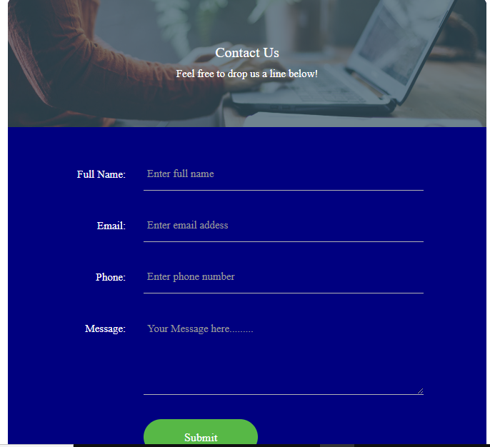What a fun example! This contact us page from Marvel allows for user to fill out a simple, general form or segment themselves to find the specific help they need (i.e. sales, press, or support).Next, the real photography used in the location section helps put a face to a brand and provides insight into the company’s office culture (employees appearing to be enjoying their job is a plus).There's a lot going well for Tune's contact page: the beautiful design, the calls-to-action, the clearly displayed contact information, and the form below the fold for visitors who want to get in touch with specific inquiries.

Figure 3-5: Contact Us

<body>

<div class=*"wrap-contact100"*>

<div class=*"contact100-form-title"* style="background-image: *url(images/bg-01.jpg)*;">

<span class=*"contact100-form-title-1"*>

Contact Us

</span>

<span class=*"contact100-form-title-2"*>

Feel free to drop us a line below!

</span>

</div>

<form class=*"contact100-form validate-form"* method=*"post"* action=*"contactAction_add"* >

<div class=*"wrap-input100 validate-input"* data-validate=*"Name is required"*>

<span class=*"label-input100"*>Full Name:</span>

<input class=*"input100"* type=*"text"* name=*"name"* placeholder=*"Enter full name"*>

<span class=*"focus-input100"*></span>

</div>

<div class=*"wrap-input100 validate-input"* data-validate = *"Valid email is required: ex@abc.xyz"*>

<span class=*"label-input100"*>Email:</span>

<input class=*"input100"* type=*"text"* name=*"email"* placeholder=*"Enter email addess"*>

<span class=*"focus-input100"*></span>

</div>

<div class=*"wrap-input100 validate-input"* data-validate=*"Phone is required"*>

<span class=*"label-input100"*>Phone:</span>

<input class=*"input100"* type=*"text"* name=*"phone"* placeholder=*"Enter phone number"*>

<span class=*"focus-input100"*></span>

</div>

<div class=*"wrap-input100 validate-input"* data-validate = *"Message is required"*>

<span class=*"label-input100"*>Message:</span>

<textarea class=*"input100"* name=*"message"* placeholder=*"Your Message here........."*></textarea>

<span class=*"focus-input100"*></span>

</div>

<div class=*"container-contact100-form-btn"*>

<button class=*"contact100-form-btn"*>

<span>

Submit

<i class=*"fa fa-long-arrow-right m-l-7"* aria-hidden=*"true"*></i>

</span>

</button>

</div>

</form>

</div>

</body>

## 3.2 Authority Activity/management Activity

Every Web site has two things one is public activity another is Admin Activity. The public activity is for everyone anyone can see it access it visit it anything to do the public want. But there is another things that the public can’t access it that’s called Admin Activity. Every web site has this things the authority or the admin can access data they can access full web site. An Admin can add another Admin etc.

### 3.2.1 Login Page

Logging in is usually used to enter a specific page, website or application, which trespassers cannot see. Once the user is logged in, the login token may be used to track what actions the user has taken while connected to the site. Logging out may be performed explicitly by the user taking some actions, such as entering the appropriate command or clicking a website link labeled as such. It can also be done implicitly, such as by the user powering off his or her workstation, closing a web browser window, leaving a website, or not refreshing a webpage within a defined period. In the case of websites that use cookies to track sessions, when the user logs out, session-only cookies from that site will usually be deleted from the user's computer. In addition, the server invalidates any associations with the session, thereby making any session-handle in the user's cookie store useless. This feature comes in handy if the user is using a public computer or a computer that is using a public wireless connection. As a security precaution, one should not rely on implicit means of logging out of a system, especially not on a public computer; instead, one should explicitly log out and wait for the confirmation that this request has taken place. In the log in page the students has already registered by giving there information in registration page. Here just input the unique name which is username and the password. After the login all thing can 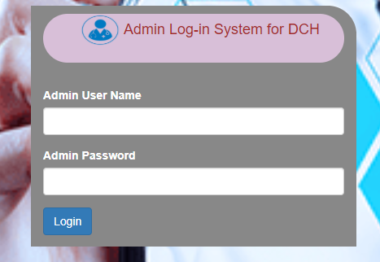access the logged in student.

Figure 3-6 Log in page

<div class=*"container"*>

<!-- <h2>The Library login page.</h2> <br> -->

<h4> <img src=*"images/logo-hospital.png"* width=*"50px"* height=*"40px"* margin-right:"50px" > Admin Log-in System for DCH </h4> <br>

<form method=*"post"* action=*"userAction_login"*>

<div class=*"form-group"*>

<label for=*"userName"*>Admin User Name</label>

<input type=*"text"* class=*"form-control"* id=*"userName"* name=*"userName"* >

</div>

<div class=*"form-group"*>

<label for=*"password"*>Admin Password</label>

<input type=*"password"* class=*"form-control"* id=*"password"* name=*"password"*>

</div>

<button type=*"submit"* class=*"btn btn-primary"*>Login</button>

&nbsp;&nbsp;&nbsp;&nbsp;

<!-- <a href="register.jsp">Register</a> -->

</form>

${msg }

</div>

<div class=*"containertop"*>

<h1> <img src=*"images/logo-hospitalmake.png"* width=*"250px"* height=*70px*" margin-right:"50px" > DAILY CARE HOSPITAL </h1> <br>

</form>

</div>

### 3.2.2 Authority Home Page

A home page is generally the main web page a visitor navigating to a website from a search engine will see, and it may also serve as a landing page to attract visitors. The home page is used to facilitate navigation to other pages on the site by providing links to prioritized and recent articles and pages, and possibly a search box. For example, a news website may present headlines and first paragraphs of top stories, with links to full articles. Meanwhile, other websites use the home page to attract users to create an account. Once they are logged in, the home page may be redirected to their profile page. Authority is the legitimate power which one person or group possesses and practices over another. A civil state usually makes this formal by way of a judicial branch and an executive branch of government. In the exercise of governance, the terms authority and power sometimes are inaccurately used as synonyms. The term authority identifies political legitimacy, which grants and justifies the right to exercise power of government; and the term power identifies the ability to accomplish an authorized goal, by way either of compliance or of obedience hence, authority is the power to make decisions and the legitimacy to make such legal decisions and order their execution.

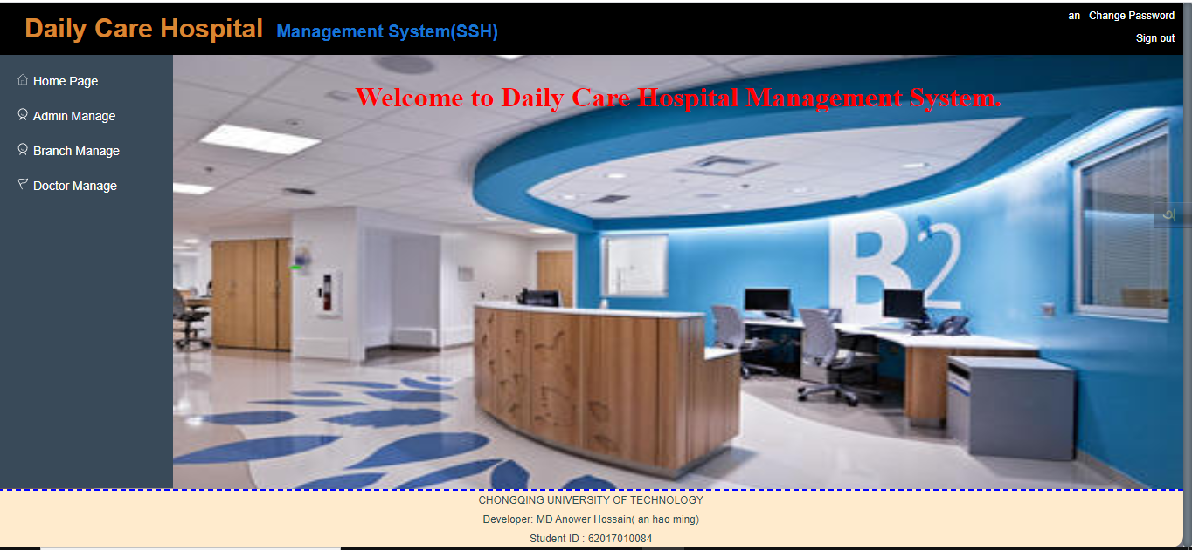Figure 3-7: Admin Home Page

<body>

<div id=*"header"*>

<div class=*"left"*>

<label class=*"logo1"*> Daily Care Hospital</label> &nbsp;

<label class=*"logo2"*>Management System(SSH)</label>

</div>

<div class=*"hright"*>

<div class=*"top"*>

<p>${user.userName }</p>

<a href=*"changePsw.jsp"*>Change Password</a>

</div>

<div class=*"bottom"*>

<a href=*"userAction_signOut"*>Sign out</a>

</div>

</div>

</div>

<div id=*"box"*>

<div id=*"menu"*>

<ul>

<li class=*"home"*>

<a href=*"javascript:clickMenu('*<%=basePath%>*welcome.jsp');"*>Home Page</a>

</li>

<li class=*"user"*><a class=*"menuBar"* href=*"javascript:void(0)"*>Admin Manage</a>

<ul class=*"none"*>

<li class=*"right"*><a href=*"javascript:clickMenu('*<%=basePath%>*userAction_list');"*>Admin List</a></li>

<%-- <li class="right"><a href="javascript:clickMenu('<%=basePath%>userAction_changePsw');">Change Psw</a></li> --%>

<li class=*"right"*><a href=*"changePsw.jsp"*>Change Psw</a></li>

</ul>

</li>

<li class=*"student"*><a class=*"menuBar"* href=*"javascript:void(0)"*>Branch Manage</a>

<ul class=*"none"*>

<li class=*"right"*><a href=*"javascript:clickMenu('*<%=basePath%>*studentAction_list');"*>Branch List</a></li>

</ul>

</li>

<li class=*"book"*><a class=*"menuBar"* href=*"javascript:void(0)"*>Doctor Manage</a>

<ul class=*"none"*>

<li class=*"right"*><a href=*"javascript:clickMenu('*<%=basePath%>*bookCategoryAction_list');"*>DoctorCategory List</a></li>

<li class=*"right"*><a href=*"javascript:clickMenu('*<%=basePath%>*bookAction_list');"*>Doctors</a></li>

<li class=*"right"*><a href=*"javascript:clickMenu('*<%=basePath%>*bookAction_search');"*>Doctor Search</a></li>

<%-- <li class="right"><a href="javascript:clickMenu('<%=basePath%>#');">Borrow</a></li>

<li class="right"><a href="javascript:clickMenu('<%=basePath%>#');">Return</a></li> --%>

</ul>

</li>

</ul>

</div>

<div id=*"content"*>

<iframe id=*"iframe"* width=*"100%"* style="border: *0px*;" height=*"100%;"*

frameborder=*"0"* scrolling=*"auto"* src=*"*<%=basePath%>*welcome.jsp"*></iframe>

<div id=*"loadingDialog"*>

<div class=*"double-bounce1"*></div>

<div class=*"double-bounce2"*></div>

</div>

</div>

</div>

<div id=*"footer"*>

<!-- <div style="text-align: center;">

Copyright @ 2019 CQUT-LYH

</div> -->

<p>

<a href=*"https://www.cqut.edu.cn/"*>CHONGQING UNIVERSITY OF TECHNOLOGY</a>

</p>

<p>Developer: <a href=*"www.facebook.com/anower33"*>MD Anower Hossain( an hao ming)</a>

</p>

<p> Student ID : 62017010084

</p>

</div>

<script type=*"text/javascript"*>

**function** clickMenu(url) {

$("#loadingDialog").css("display", "block");

$('#iframe').attr('src', url);

}

$(document).ready(**function**(e){

**var** iframe =document.getElementById("iframe");

**if** (iframe.attachEvent) {

//

iframe.attachEvent("onload", **function**() {

$("#loadingDialog").css("display", "none");

});

} **else** {

iframe.onload = **function**() {

$("#loadingDialog").css("display", "none");

};

}

});

</script>

</body>

### 3.2.3 Admin Manage

Management (or managing) is the administration of an organization, whether it is a business, a not-for-profit organization, or government body. Management includes the activities of setting the strategy of an organization and coordinating the efforts of its employees (or of volunteers) to accomplish its objectives through the application of available resources, such as financial, natural, technological, and human resources. The term "management" may also refer to those people who manage an organization – individually managers.

#### 3.2.3.1 Admin List

Administrators, commonly known as Admins or sysops .are Hospital Managements editors who have been granted the technical ability to perform certain special actions on the Daily Care Hospital management system .These include the ability to block and unblock user accounts edit fully protected pages, protect and unprotect pages from editing, delete and undelete pages, rename pages without restriction, and use certain other tools. Administrators assume these responsibilities as volunteers after undergoing a community review process. They do not act as employees of the Daily Care Hospital management system Foundation. They are never required to use their tools, and must never use them to gain an advantage in a dispute in which they were involved. Administrators should not be confused with 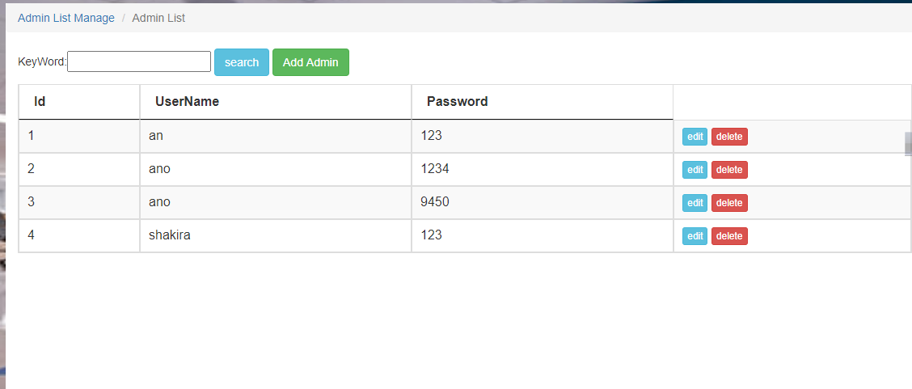the Daily Care Hospital management system.

Figure 3-8: Admin list

<nav aria-label=*"breadcrumb"*>

<ol class=*"breadcrumb"*>

<li class=*"breadcrumb-item"*><a href=*"#"*>Admin List Manage </a></li>

<li class=*"breadcrumb-item active"* aria-current=*"page"*>Admin List</li>

</ol>

</nav>

<div class=*"container"*>

KeyWord:<input type=*"text"* id=*"keyword"* name=*"keyword"* />

<button class=*"btn btn-info"* onclick="search();">search</button>

<button class=*"btn btn-success"* id=*"add_hw"* onclick="add();">Add Admin</button>

</div>

<div class=*"container"*>

<table id=*"infoTable"* class=*"table table-striped table-bordered table-condensed table-hover datatable"*>

<thead>

<tr>

<th scope=*"col"*>Id</th>

<th scope=*"col"*>UserName</th>

<th scope=*"col"*>Password</th>

</thead>

<tbody>

<s:iterator var=*"item"* status=*"st"* value=*"#list"*>

<tr>

<td><s:property value=*"#item.Id"*/></td>

<td><s:property value=*"#item.UserName"*/></td>

<td><s:property value=*"#item.Password"*/></td>

<td>

<button class=*"btn btn-xs btn-info"* onclick=*"edit('*<s:property value=*"#item.Id"*/>*')"*>edit</button>

<button class=*"btn btn-xs btn-danger"* onclick=*"del('*<s:property value=*"#item.Id"*/>*');"*>delete</button>

</td>

</tr>

</s:iterator>

</tbody>

</table>

</div>

<script type=*"text/javascript"*>

**function** search(){

**var** keyWord = $('#keyword').val();

window.location.href = "userAction_query?keyWord=" + keyWord;

}

**function** del(id){

**if**(confirm("Are you sure to delete the record?")){

window.location.href = "userAction_delete?id=" + id;

}

}

**function** add(){

window.location.href = "userAction_showAdd";

}

**function** edit(id){

window.location.href = "userEdit.jsp?id=" + id;

}

</script>

##### 3.2.3.1.1 Add Admin

Add admin maybe the hospital management system may have some branch in different area that’s why the administrators need one more admin. For opening a new branch the administrator will add a new Admin for the new branch.

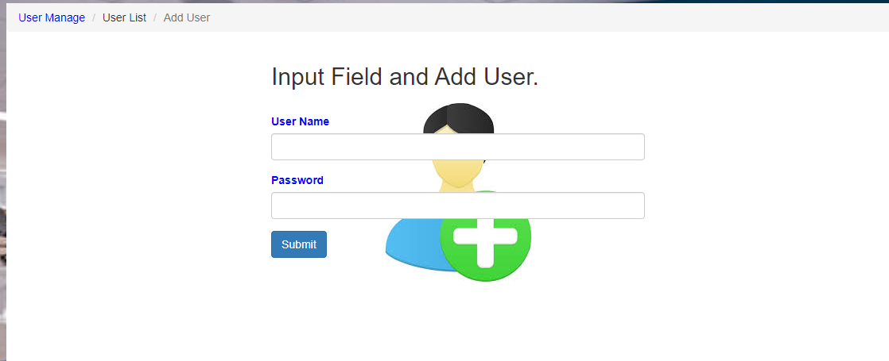

Figure 3-9: Add admin

<nav aria-label=*"breadcrumb"*>

<ol class=*"breadcrumb"*>

<li class=*"breadcrumb-item"*><a href=*"#"*>User Manage </a></li>

<li class=*"breadcrumb-item"* aria-current=*"page"*>User List</li>

<li class=*"breadcrumb-item active"* aria-current=*"page"*>Add User</li>

</ol>

</nav>

<div class=*"container"*>

<h2>Input Field and Add User.</h2> <br>

<form method=*"post"* action=*"userAction_add"* enctype=*"multipart/form-data"*>

<div class=*"form-group"*>

<label for=*"UserName"*>User Name</label>

<input type=*"text"* class=*"form-control"* id=*"userName"* name=*"userName"* >

</div>

<div class=*"form-group"*>

<label for=*"Password"*>Password</label>

<input type=*"password"* class=*"form-control"* id=*"password"* name=*"password"*>

</div>

<button type=*"submit"* class=*"btn btn-primary"*>Submit</button>

</form>

</div>

</body>

##### 3.2.3.1.2 Edit Admin

Admin, maybe the hospital management system may have some branch in different area that’s why the administrators need one more admin. For opening a new branch the administrator will add a new Admin for the new branch .so already added new admin as an administrators. Now for adding an admin should include some basic information’s mistakenly the information’s may have wrong. So solve this problem 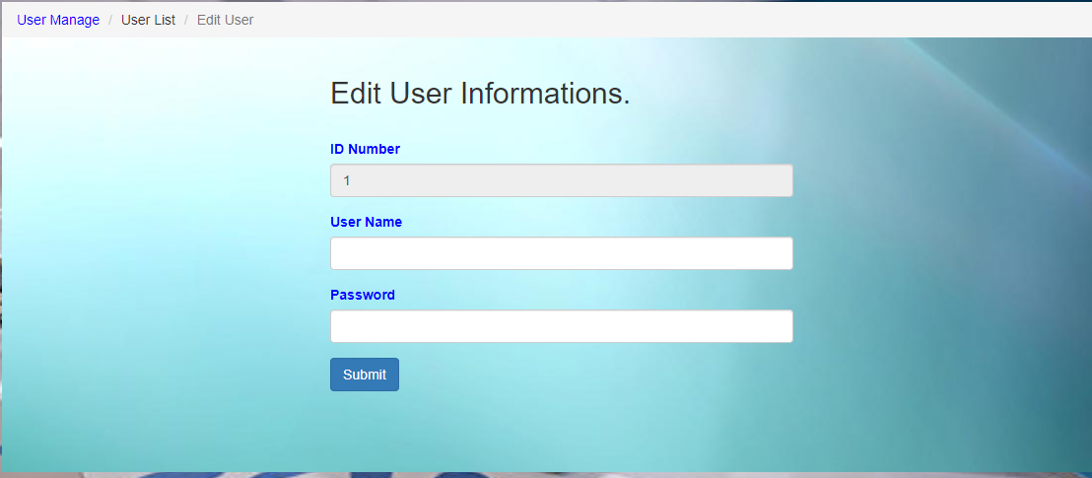the admin need modify the information’s.

Figure 3-10: Edit admin

<body>

<%

String id = request.getParameter("id");

%>

<nav aria-label=*"breadcrumb"*>

<ol class=*"breadcrumb"*>

<li class=*"breadcrumb-item"*><a href=*"#"*>User Manage </a></li>

<li class=*"breadcrumb-item"* aria-current=*"page"*>User List</li>

<li class=*"breadcrumb-item active"* aria-current=*"page"*>Edit User</li>

</ol>

</nav>

<div class=*"container"*>

<h2>Edit User Informations.</h2> <br>

<form method=*"post"* action=*"userAction_edit"*>

<div class=*"form-group"*>

<label for=*"Id"*>ID Number</label>

<input type=*"text"* class=*"form-control"* id=*"Id"* name=*"id"* value=*"*<%=id %>*"* readonly=*"readonly"*>

</div>

<div class=*"form-group"*>

<label for=*"UserName"*>User Name</label>

<input type=*"text"* class=*"form-control"* id=*"UserName"* name=*"userName"* >

</div>

<div class=*"form-group"*>

<label for=*"Password"*>Password</label>

<input type=*"Password"* class=*"form-control"* id=*"Password"* name=*"password"*>

</div>

<button type=*"submit"* class=*"btn btn-primary"*>Submit</button>

</form>

</div>

</body>

##### 3.2.3.1.3 Delete Admin

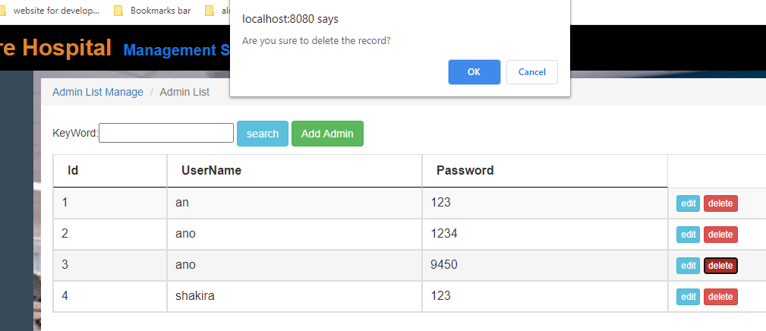Unfortunately any administrators may have broken or don’t need any more keep one admin as a administrators, may be the branch is not active anymore so the admin should remove. For the remove admin the admin use delete option of the admin manage. Prompting delete the admin or user the system will notify you to that you are sure or not, if you really sure delete the admin then pressing enter the admin will be deleted.

Figure 3-11: Delete Admin

**function** del(id){

**if**(confirm("Are you sure to delete the record?")){

window.location.href = "userAction_delete?id=" + id;

}

}

#### 3.2.3.2 Change Password

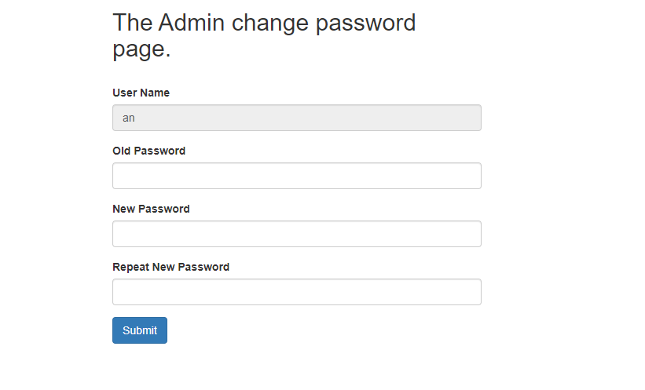A password, sometimes called a pass code, is a memorized secret used to confirm the identity of a user, using the terminology of the NIST Digital Identity Guidelines, the secret is memorized by a party called the *claimant* while the party verifying the identity of the claimant is called the verifier. When the claimant successfully demonstrates knowledge of the password to the verifier through an established authentication protocol the verifier is able to infer the claimant’s identity. In general, a password is an arbitrary string of characters including letters, digits, or other symbols. If the permissible characters are constrained to be numeric, the corresponding secret is sometimes called a personal identification number (PIN).so for the security of the maintenance of the hospital may have to do change the password.

Figure 3-12: Change Password

<%

entity.User user = (entity.User)session.getAttribute("user");

String userName = user.getUserName();

%>

<nav aria-label=*"breadcrumb"*>

<ol class=*"breadcrumb"*>

<li class=*"breadcrumb-item"*><a href=*"#"*>Admin Manage </a></li>

<li class=*"breadcrumb-item active"* aria-current=*"page"*>Change Psw</li>

</ol>

</nav>

<div class=*"container"*>

<h2>The Admin change password page.</h2> <br>

<form method=*"post"* action=*"userAction_changePsw"*>

<div class=*"form-group"*>

<label for=*"userName"*>User Name</label>

<input type=*"text"* class=*"form-control"* id=*"userName"* name=*"userName"* value=*"*<%=userName %>*"* readonly=*"readonly"* >

</div>

<div class=*"form-group"*>

<label for=*"oldPassword"*>Old Password</label>

<input type=*"password"* class=*"form-control"* id=*"oldPassword"* name=*"oldPassword"*>

</div>

<div class=*"form-group"*>

<label for=*"newPassword"*>New Password</label>

<input type=*"password"* class=*"form-control"* id=*"newPassword"* name=*"newPassword"*>

</div>

<div class=*"form-group"*>

<label for=*"newPasswordRepeate"*>Repeat New Password</label>

<input type=*"password"* class=*"form-control"* id=*"newPasswordRepeate"* name=*"newPasswordRepeate"*>

</div>

<button type=*"submit"* class=*"btn btn-primary"*>Submit</button>

</form>

${msg }

</div>

### 3.3.4 Branch Manage

A branch manager is an executive who oversees a division or office of a large business or organization, operating locally or with a particular function. Their responsibility is to ensure that payments to employees are correct, their vacation pay arrives on time and they receive proper care if they are injured while working. In banking, a branch manager is responsible for all functions and staff within the branch office.

#### 3.3.4.1 Branch List

When a big company spread in a whole country then there are may have so much branch. For now any information about doctor, patients etc can easily find the branch and can see the details.

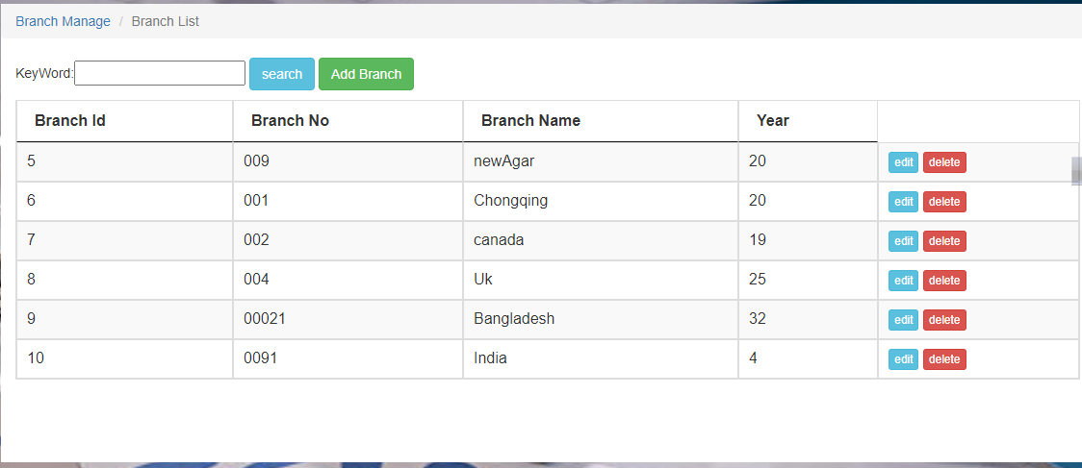

Figure 3-13: Branch List

<body>

<nav aria-label=*"breadcrumb"*>

<ol class=*"breadcrumb"*>

<li class=*"breadcrumb-item"*><a href=*"#"*>Branch Manage </a></li>

<li class=*"breadcrumb-item active"* aria-current=*"page"*>Branch List</li>

</ol>

</nav>

<div class=*"container"*>

KeyWord:<input type=*"text"* id=*"keyword"* name=*"keyword"* />

<button class=*"btn btn-info"* onclick="search();">search</button>

<button class=*"btn btn-success"* id=*"add_hw"* onclick="add();">Add Branch</button>

</div>

<div class=*"container"*>

<table id=*"infoTable"* class=*"table table-striped table-bordered table-condensed table-hover datatable"*>

<thead>

<tr>

<th scope=*"col"*>Branch Id</th>

<th scope=*"col"*>Branch No</th>

<th scope=*"col"*>Branch Name</th>

<th scope=*"col"*>Year</th>

<!-- <th scope="col">Gender</th> -->

</thead>

<tbody>

<s:iterator var=*"item"* status=*"st"* value=*"#list"*>

<tr>

<td><s:property value=*"#item.Id"*/></td>

<td><s:property value=*"#item.No"*/></td>

<td><s:property value=*"#item.Name"*/></td>

<td><s:property value=*"#item.Age"*/></td>

<%-- <td><s:property value="#item.Gender"/></td> --%>

<td>

<button class=*"btn btn-xs btn-info"* onclick=*"edit('*<s:property value=*"#item.Id"*/>*');"*>edit</button>

<button class=*"btn btn-xs btn-danger"* onclick=*"del('*<s:property value=*"#item.Id"*/>*');"*>delete</button>

</td>

</tr>

</s:iterator>

</tbody>

</table>

</div>

#### 3.3.4.2 Add Branch

May be the hospital authority wants to open a new branch. Every year a company open a new branch for spreading there business. So the Hospital Management system also can have open a new branch. This features can easily add a new branch.

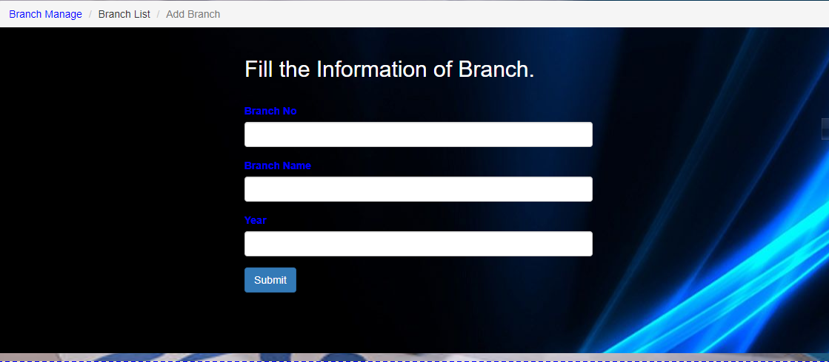Figure 3-14: Add Branch

<nav aria-label=*"breadcrumb"*>

<ol class=*"breadcrumb"*>

<li class=*"breadcrumb-item"*><a href=*"#"*>Branch Manage </a></li>

<li class=*"breadcrumb-item"* aria-current=*"page"*>Branch List</li>

<li class=*"breadcrumb-item active"* aria-current=*"page"*>Add Branch</li>

</ol>

</nav>

<div class=*"container"*>

<h2>Fill the Information of Branch.</h2> <br>

<form method=*"post"* action=*"studentAction_add"* enctype=*"multipart/form-data"*>

<div class=*"form-group"*>

<label for=*"No"*>Branch No</label>

<input type=*"text"* class=*"form-control"* id=*"No"* name=*"no"*>

</div>

<div class=*"form-group"*>

<label for=*"Name"*>Branch Name</label>

<input type=*"text"* class=*"form-control"* id=*"Name"* name=*"name"*>

</div>

<div class=*"form-group"*>

<label for=*"Age"*>Year</label>

<input type=*"text"* class=*"form-control"* id=*"Age"* name=*"age"*>

</div>

<%-- <div class="form-group">

<label for="Gender">Gender</label>

<select class="form-control" id="Gender" name="gender">

<option value="Male">Male</option>

<option value="Female">Female</option>

</select>

</div> --%>

<button type=*"submit"* class=*"btn btn-primary"*>Submit</button>

</form>

</div>

#### 3.3.4.3 Edit Branch

Editing is the process of selecting and preparing writing, photography, visual, audible, and film media used to convey information. Everywhere need editing or modifying. If some information inputted is wrong that time it need to modify the information. May be the hospital authority has inputted wrong information. So the Hospital Management system can have to edit the branch information. This feature easily can edit the information’s.

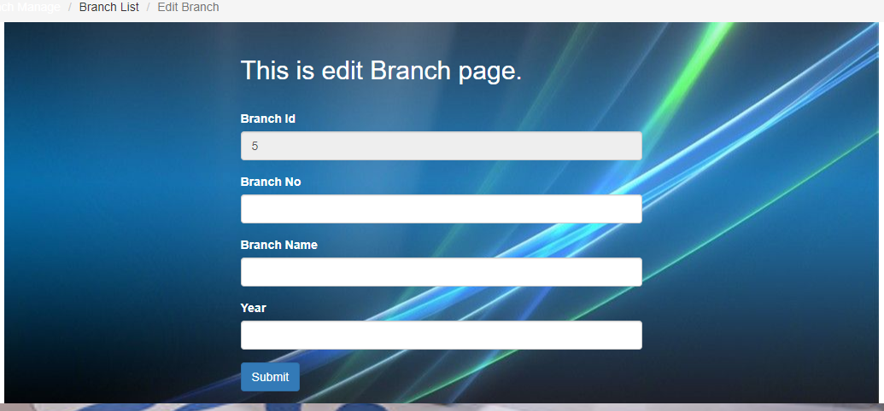

Figure 3-14: Edit Branch

<body>

<%

String id = request.getParameter("id");

%>

<nav aria-label=*"breadcrumb"*>

<ol class=*"breadcrumb"*>

<li class=*"breadcrumb-item"*><a href=*"#"*>Branch Manage </a></li>

<li class=*"breadcrumb-item"* aria-current=*"page"*>Branch List</li>

<li class=*"breadcrumb-item active"* aria-current=*"page"*>Edit Branch</li>

</ol>

</nav>

<div class=*"container"*>

<h2>This is edit Branch page.</h2> <br>

<form method=*"post"* action=*"studentAction_edit"* enctype=*"multipart/form-data"*>

<div class=*"form-group"*>

<label for=*"id"*>Branch Id</label>

<input type=*"text"* class=*"form-control"* id=*"id"* name=*"id"* value=*"*<%=id %>*"* readonly=*"readonly"*>

</div>

<div class=*"form-group"*>

<label for=*"No"*>Branch No</label>

<input type=*"text"* class=*"form-control"* id=*"No"* name=*"no"*>

</div>

<div class=*"form-group"*>

<label for=*"Name"*>Branch Name</label>

<input type=*"text"* class=*"form-control"* id=*"Name"* name=*"name"*>

</div>

<div class=*"form-group"*>

<label for=*"Age"*>Year</label>

<input type=*"text"* class=*"form-control"* id=*"Age"* name=*"age"*>

</div>

<%-- <div class="form-group">

<label for="Gender">Gender</label>

<select class="form-control" id="Gender" name="gender">

<option value="Male">Male</option>

<option value="Female">Female</option>

</select>

</div> --%>

<button type=*"submit"* class=*"btn btn-primary"*>Submit</button>

</form>

</div>

</body>

### 3.3.5 Doctor Manage

A doctor's communication and interpersonal skills encompass the ability to gather information in order to facilitate accurate diagnosis, counsel appropriately, give therapeutic instructions, and establish caring relationships with patients.2-4 These are the core clinical skills in the practice of medicine, with the ultimate goal of achieving the best outcome and patient satisfaction, which are essential for the effective delivery of health care.

#### 3.3.5.1 Doctor Category List

When a person has a medical concern, they may turn to a doctor for help. There are many types of doctor, and a person’s specific concern will usually determine the type of doctor they choose. There are many types of doctors, but there are two main categories: primary care or specialty care. Within these two groups, doctors vary widely in their specialty area and level of training. This article looks at the different types of doctor, their roles, the conditions they treat, and the procedures they can perform. This called Doctor Category some doctor categories below:

* Allergist
* Andrologist
* Cardiologist
* Cardiac
* Electrophysiologist
* Dermatologist
* Emergency Room (ER) Doctors
* Endocrinologist
* Epidemiologist
* Family Medicine Physician
* Gastroenterologist
* Geriatrician
* Hyperbaric Physician
* Hematologist
* Immunologist
* Infectious Disease Specialist
* Intensivist

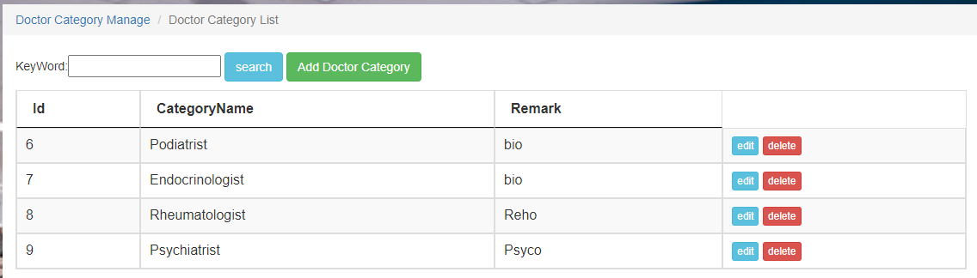

Figure 3-15: Doctor Category List

<body>

<nav aria-label=*"breadcrumb"*>

<ol class=*"breadcrumb"*>

<li class=*"breadcrumb-item"*><a href=*"#"*>Doctor Category Manage </a></li>

<li class=*"breadcrumb-item active"* aria-current=*"page"*>Doctor Category List</li>

</ol>

</nav>

<div class=*"container"*>

KeyWord:<input type=*"text"* id=*"keyword"* name=*"keyword"* />

<button class=*"btn btn-info"* onclick="search();">search</button>

<button class=*"btn btn-success"* id=*"add_hw"* onclick="add();">Add Doctor Category</button>

</div>

<div class=*"container"*>

<table id=*"infoTable"* class=*"table table-striped table-bordered table-condensed table-hover datatable"*>

<thead>

<tr>

<th scope=*"col"*>Id</th>

<th scope=*"col"*>CategoryName</th>

<th scope=*"col"*>Remark</th>

</thead>

<tbody>

<s:iterator var=*"item"* status=*"st"* value=*"#list"*>

<tr>

<td><s:property value=*"#item.Id"*/></td>

<td><s:property value=*"#item.CategoryName"*/></td>

<td><s:property value=*"#item.Remark"*/></td>

<td>

<button class=*"btn btn-xs btn-info"* onclick=*"edit('*<s:property value=*"#item.Id"*/>*')"*>edit</button>

<button class=*"btn btn-xs btn-danger"* onclick=*"del('*<s:property value=*"#item.Id"*/>*');"*>delete</button>

</td>

</tr>

</s:iterator>

</tbody>

</table>

</div>

##### 3.3.5.1.1 Add Doctor Category

The Doctor don’t work in a specific hospital for whole life. Sometime some doctors are can be removed, can be added so when a will join to the hospital obviously the doctor is a specific specialist or a specific category doctor. For added time the doctor will be added in a specific category this feature will help you to add to a category.

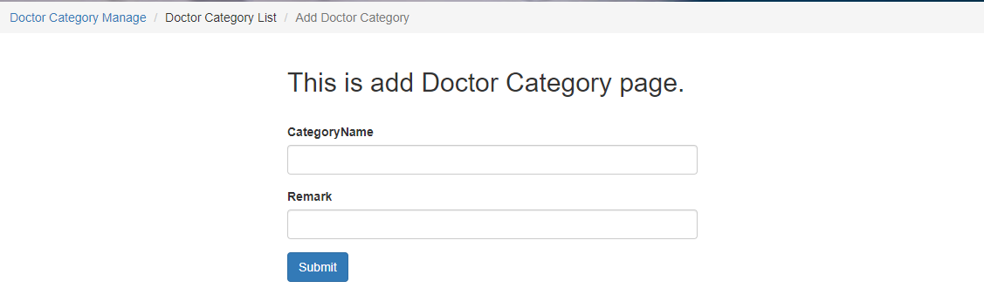

Figure 3-16: Add Doctor Category

<nav aria-label=*"breadcrumb"*>

<ol class=*"breadcrumb"*>

<li class=*"breadcrumb-item"*><a href=*"#"*>Doctor Category Manage </a></li>

<li class=*"breadcrumb-item"* aria-current=*"page"*>Doctor Category List</li>

<li class=*"breadcrumb-item active"* aria-current=*"page"*>Add Doctor Category</li>

</ol>

</nav>

<div class=*"container"*>

<h2>This is add Doctor Category page.</h2> <br>

<form method=*"post"* action=*"bookCategoryAction_add"*>

<div class=*"form-group"*>

<label for=*"CategoryName"*>CategoryName</label>

<input type=*"text"* class=*"form-control"* id=*"CategoryName"* name=*"categoryName"* >

</div>

<div class=*"form-group"*>

<label for=*"Remark"*>Remark</label>

<input type=*"text"* class=*"form-control"* id=*"Remark"* name=*"remark"*>

</div>

<button type=*"submit"* class=*"btn btn-primary"*>Submit</button>

</form>

</div>

##### 3.3.5.1.2 Edit Doctor Category

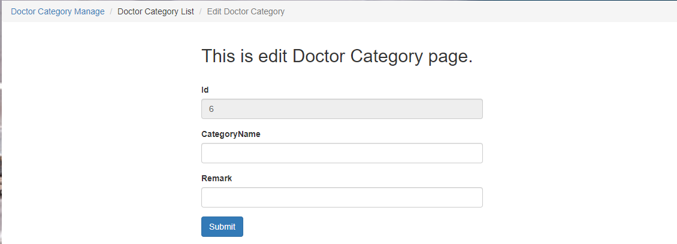For the wrong inputted the information of doctor category that time need to edit the category. This feature is very friendly to edit doctor category.

Figure 3-17: Edit Doctor Category

<body>

<%

String id = request.getParameter("id");

%>

<nav aria-label=*"breadcrumb"*>

<ol class=*"breadcrumb"*>

<li class=*"breadcrumb-item"*><a href=*"#"*>Doctor Category Manage </a></li>

<li class=*"breadcrumb-item"* aria-current=*"page"*>Doctor Category List</li>

<li class=*"breadcrumb-item active"* aria-current=*"page"*>Edit Doctor Category</li>

</ol>

</nav>

<div class=*"container"*>

<h2>This is edit Doctor Category page.</h2> <br>

<form method=*"post"* action=*"bookCategoryAction_edit"*>

<div class=*"form-group"*>

<label for=*"Id"*>Id</label>

<input type=*"text"* class=*"form-control"* id=*"Id"* name=*"id"* value=*"*<%=id %>*"* readonly=*"readonly"*>

</div>

<div class=*"form-group"*>

<label for=*"CategoryName"*>CategoryName</label>

<input type=*"text"* class=*"form-control"* id=*"CategoryName"* name=*"categoryName"* >

</div>

<div class=*"form-group"*>

<label for=*"Remark"*>Remark</label>

<input type=*"text"* class=*"form-control"* id=*"Remark"* name=*"remark"*>

</div>

<button type=*"submit"* class=*"btn btn-primary"*>Submit</button>

</form>

</div>

</body>

#### 3.3.5.2 Doctor List

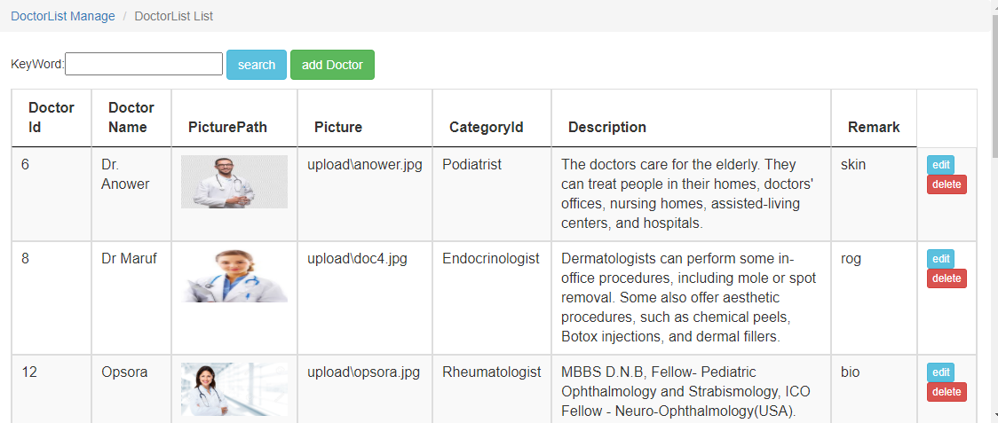Doctor list is a common activity in this project, the admin may have need to see the doctor who is active or not, who are available or not the admin can see everything in this list. And also with the list has editing and deleting the doctor. All of the activity for admin.

Figure 3-18: Doctor List

<nav aria-label=*"breadcrumb"*>

<ol class=*"breadcrumb"*>

<li class=*"breadcrumb-item"*><a href=*"#"*>Branch Manage </a></li>

<li class=*"breadcrumb-item active"* aria-current=*"page"*>Branch List</li>

</ol>

</nav>

<div class=*"container"*>

KeyWord:<input type=*"text"* id=*"keyword"* name=*"keyword"* />

<button class=*"btn btn-info"* onclick="search();">search</button>

<button class=*"btn btn-success"* id=*"add_hw"* onclick="add();">Add Branch</button>

</div>

<div class=*"container"*>

<table id=*"infoTable"* class=*"table table-striped table-bordered table-condensed table-hover datatable"*>

<thead>

<tr>

<th scope=*"col"*>Branch Id</th>

<th scope=*"col"*>Branch No</th>

<th scope=*"col"*>Branch Name</th>

<th scope=*"col"*>Year</th>

<!-- <th scope="col">Gender</th> -->

</thead>

<tbody>

<s:iterator var=*"item"* status=*"st"* value=*"#list"*>

<tr>

<td><s:property value=*"#item.Id"*/></td>

<td><s:property value=*"#item.No"*/></td>

<td><s:property value=*"#item.Name"*/></td>

<td><s:property value=*"#item.Age"*/></td>

<%-- <td><s:property value="#item.Gender"/></td> --%>

<td>

<button class=*"btn btn-xs btn-info"* onclick=*"edit('*<s:property value=*"#item.Id"*/>*');"*>edit</button>

<button class=*"btn btn-xs btn-danger"* onclick=*"del('*<s:property value=*"#item.Id"*/>*');"*>delete</button>

</td>

</tr>

</s:iterator>

</tbody>

</table>

</div>

##### 3.3.5.2.1 Add Doctor

This is the adding doctor in the Daily care hospital, this feature is a new doctor adding system, maybe the doctor not enough currently, have only some doctor but the small amount of doctor can’t serve all the patients perfectly , so the authority should expand the doctor list .Add doctor is the feature of adding doctor .

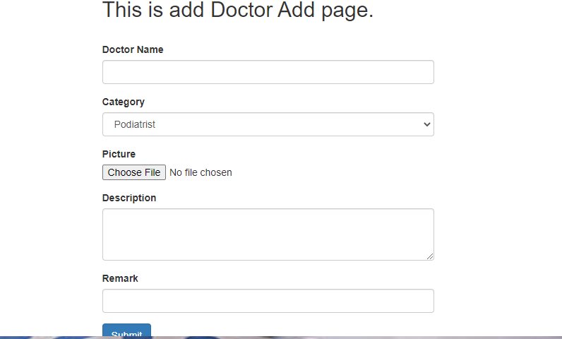Figure 3-19: Add Doctor

<body>

<nav aria-label=*"breadcrumb"*>

<ol class=*"breadcrumb"*>

<li class=*"breadcrumb-item"*><a href=*"#"*>Branch Manage </a></li>

<li class=*"breadcrumb-item"* aria-current=*"page"*>Branch List</li>

<li class=*"breadcrumb-item active"* aria-current=*"page"*>Add Branch</li>

</ol>

</nav>

<div class=*"container"*>

<h2>Fill the Information of Branch.</h2> <br>

<form method=*"post"* action=*"studentAction_add"* enctype=*"multipart/form-data"*>

<div class=*"form-group"*>

<label for=*"No"*>Branch No</label>

<input type=*"text"* class=*"form-control"* id=*"No"* name=*"no"*>

</div>

<div class=*"form-group"*>

<label for=*"Name"*>Branch Name</label>

<input type=*"text"* class=*"form-control"* id=*"Name"* name=*"name"*>

</div>

<div class=*"form-group"*>

<label for=*"Age"*>Year</label>

<input type=*"text"* class=*"form-control"* id=*"Age"* name=*"age"*>

</div>

<%-- <div class="form-group">

<label for="Gender">Gender</label>

<select class="form-control" id="Gender" name="gender">

<option value="Male">Male</option>

<option value="Female">Female</option>

</select>

</div> --%>

<button type=*"submit"* class=*"btn btn-primary"*>Submit</button>

</form>

</div>

</body>

##### 3.3.5.2.2 Edit Doctor

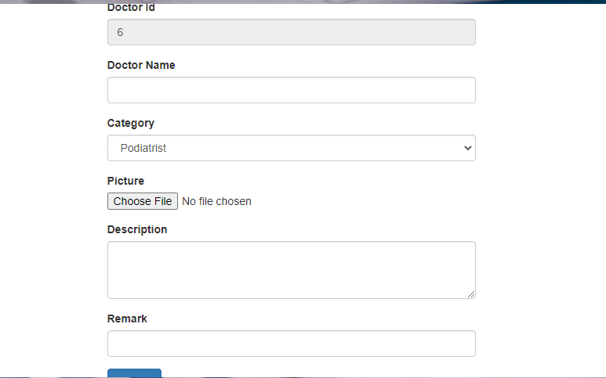Doctor list , adding doctor all of the including in the doctor manage for the wrong inputted information’s about the doctor then the administrators should modify the doctor information’s , may be the information’s have some wrong like name , id , age etc. everything can possible for this editing page .

Figure 3-20: Edit Doctor

##### 3.3.5.2.3 Delete Doctor

Unfortunately any Doctor may have broken or don’t need any more keep one Doctor as a doctor service, may be the Doctor is not active anymore so the Doctor should remove. For the remove Doctor the admin use delete option of the Doctor manage. Prompting delete the admin or user the system will notify you to that you are sure or not, if you really sure delete the admin then pressing enter the Doctor will be deleted.

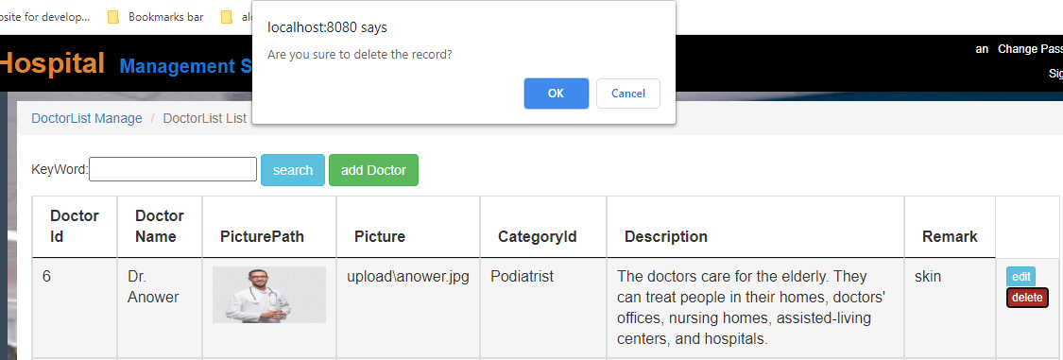

Figure 3-21: Delete Doctor

**function** del(id){

**if**(confirm("Are you sure to delete the record?")){

window.location.href = "studentAction_delete?id=" + id;

}

}

#### 3.3.5.3 Doctor Search

Provide any information’s about doctor any one can want the information’s about a specific doctor that time the authority search a doctor and provide the information.

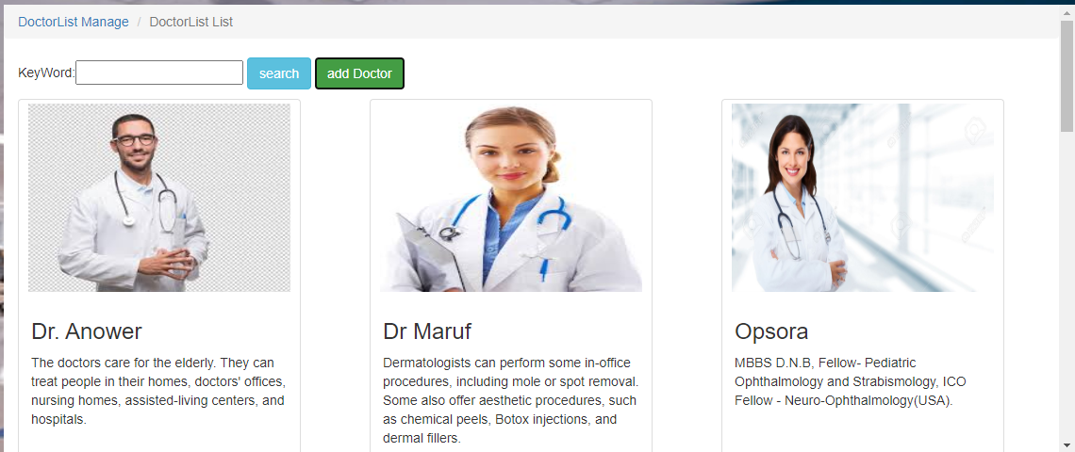

Figure 3-22: search Doctor

<body>

<nav aria-label=*"breadcrumb"*>

<ol class=*"breadcrumb"*>

<li class=*"breadcrumb-item"*><a href=*"#"*>DoctorList Manage </a></li>

<li class=*"breadcrumb-item active"* aria-current=*"page"*>DoctorList List</li>

</ol>

</nav>

<div class=*"container"*>

KeyWord:<input type=*"text"* id=*"keyword"* name=*"keyword"* />

<button class=*"btn btn-info"* onclick="search();">search</button>

<button class=*"btn btn-success"* id=*"add_hw"* onclick="add();">add Doctor</button>

</div>

<div class=*"container"*>

<div class=*"row"*>

<s:iterator var=*"item"* status=*"st"* value=*"#list"*>

<div class=*"col-sm-6 col-sm-4"*>

<div class=*"thumbnail"*>

<img style="height: *200px*; width:*96%* "src=*"*<s:property value=*"#item.Picture"*/>*"*/>

<div class=*"caption"*>

<h3><s:property value=*"#item.BookName"*/></h3>

<p><s:property value=*"#item.Description"*/></p>

</div>

</div>

</div>

</s:iterator>

</div>

</div>

</body>

# 4 Summary

This was an excellent project to work on and I have learned a lot of things to complete this project. A lot of new idea and several problems that may happen to a system like this is quite clear for me now. I am not going to claim that this program offers you 100% functionality. It has mind blowing features but while working I have figured out how we can make this more beneficial for us. I have enjoyed this project and I want to keep working on it to give it a better shape. I believe that I can do make this different in a way that people will love the final output. my creativity makes me different from every other species on this planet. I build tools and machines to make my lives easy and more comfortable. This has begun at a very early age and since then I have never stopped to build or design new things. Due to this creativity my planet has become very something totally different than our ancestors experienced. AI – artificial intelligence is an old concept but My current approach has taken it to a different height. I have been able to build things that has changed the entire thinking process of human civilization. Medical technology has also improved along with other sectors of science. Once people used to die of different diseases but we have overcome those by our advancement in various sectors. We are now able to perform surgery that people could not even think about a decade ago. Automation in medical sector is still quite new but the question is for how long this will remain new. Researches are advancing to perform diagnosis and prescribe medicine for people without a doctor. Of course there are doctors for supervisions. We are building intelligent tools to take things at a new height. This project is a tiny step towards the vast possibilities that science and computers can make to the medical sector. We have different approaches towards new things. Some people jump towards new things while others just sit back. This has been the case for human and it will continue. But new tools are coming every now and then. Science will keep on its journey and so will our human society. I am very proud to be a part of this work and very hopeful that someday this will be the reality of your hospital experience.

# 5. Reference

[1]Bryan Basham, Kathy Sierra & Bert Bates. Head First Servlets and JSP[M]. O’Reilly, 2008.

[2] https://getbootstrap.com

[3] Spring Framwork, Struts, Hibernate.

[4] https://w3schools.com

[5] https://www.eclipse.org/downloads/

[6] https://www.geeksforgeeks.org/introduction-java-servlets/

[7] https://www.javatpoint.com/jsp-tutorial

[8] https://www.microsoft.com/en-us/sql-server/sql-server-downloads

[9] My Teacher Mr: 辉哥