Restaurant Management System

**1. Introduction**

1.1 Purpose

This document outlines the requirements for a Restaurant Management System (RMS) designed to streamline and automate various restaurant operations, improving efficiency and customer satisfaction.

1.2 Intended Audience

* System developers
* Restaurant owners and managers
* System administrators
* End users (waiters, cashiers, cooks)

1.3 Intended Use

* Customer Details
* Order processing
* Billing
* Print Bill
* Past Records
* Search Records

1.4 Scope

The RMS will encompass the core functionalities mentioned above. Additional features can be considered in future versions based on user feedback and evolving needs.

1.5 Definitions and Acronyms

* RMS: Restaurant Management System
* POS: Point of Sale
* UI: User Interface

**2. Overall Description**

The RMS will be a application accessible through a user-friendly interface. It will be designed to be scalable and adaptable to different restaurant sizes and operational needs. The system will integrate with existing hardware like POS terminals and printers for seamless operation.

**3. System Features and Requirements**

3.1 Functional Requirements

Customer Management:

Name and contact will be noted.

Order Management:

Facilitate order taking through a digital menu with options.

Allow splitting bills and applying discounts.

Integrate with kitchen display system (KDS) for real-time order communication.

Enable order tracking and status updates for both staff and customers.

Menu Management:

Allow creation and modification of menus with various categories and descriptions.

Set pricing and manage availability of menu items.

Facilitate seasonal menu updates and promotions.

Bill Management:

Generate details of customer, Item List , Total Price ,GST, Grand Total and Time.

Printing of bill.

Saving the bill.

3.2 Data Flow Diagram

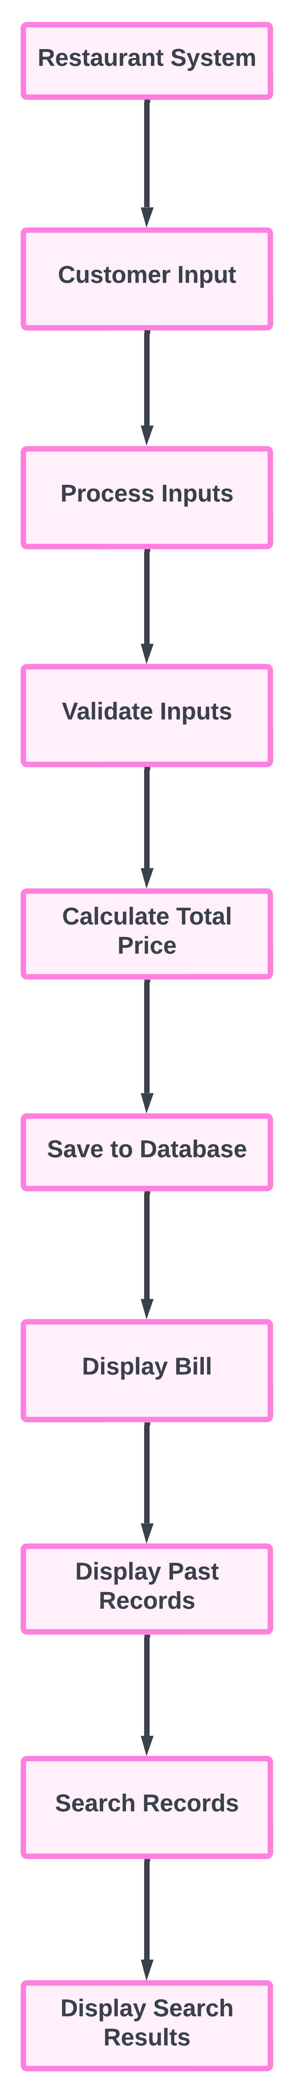

3.3 Non-Functional Requirements

Performance:

The system should be responsive and handle high order volumes efficiently.

Minimize loading times and maintain smooth operation during peak hours.

Scalability:

The system should be adaptable to accommodate the growth of the restaurant's business.

Allow for easy integration with additional features and functionalities in the future.

Usability:

The user interface should be intuitive and easy to navigate for users with varying technical-skills.

Provide clear instructions and user guides for different functionalities.

**4. Additional Information**

The specific technical requirements for hardware, software, and network infrastructure will be determined during the system design phase.

User interface mockups and wireframes will be developed to visually represent the system's functionalities.

A testing plan will be established to ensure the system meets all functional and non-functional requirements.