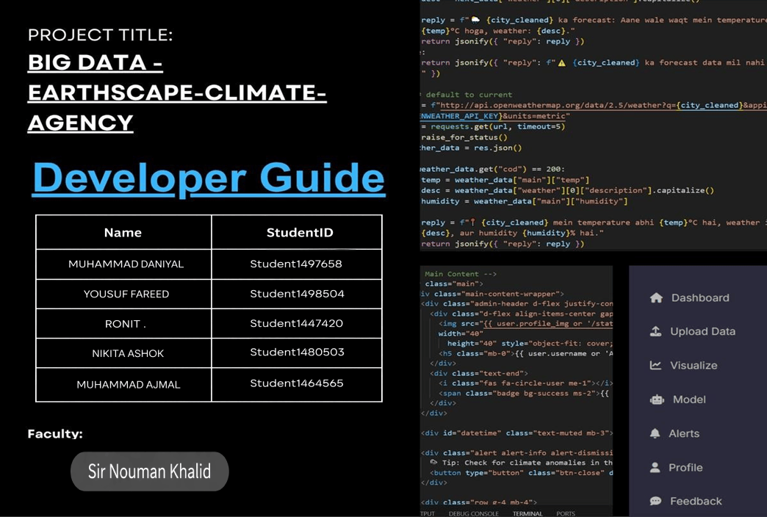

Table of Contents
- Project Overview 3
- Technology Stack 3
- Project Structure 4
- Dataset & Model Training 4
- AI Chatbot (EarthScape Bot) 5
- Weather API Integration 5
- System Setup & Installation 6
- ML Models & Joblib Files 7
- SMTP Email Alerts 7
- MongoDB Connection 7
- Role-Based Dashboards (Analyst & Admin) 9
- Code Snippets: 10
Final Summary 23

Project Overview
- EarthScape Climate Agency is a web-based application designed to allow users to upload, visualize, and predict climate data using machine learning models.
- It provides personalized climate predictions based on user data.
- The system integrates real-time weather information.
- Automatic alert notifications are sent to users when critical conditions arise.
- An AI-powered chatbot is available on every page to assist users with queries and support.

Technology Stack
  - Frontend: HTML, CSS, JavaScript
  - Backend: Python with Flask framework
  - Database: MongoDB (primary), SQLite (users.db) for lightweight user data storage
  - Machine Learning Libraries: scikit-learn, pandas, numpy
  - Visualization: matplotlib, seaborn

External APIs:
    - OpenWeatherMap API for live weather data
    - Gemini API for AI chatbot integration
  - Email Service: SMTP (using Flask-Mail with Gmail SMTP) for sending alerts

Project Structure
  - climate_dashboard/venv/ – Python virtual environment containing dependencies
  - static/js/ – JavaScript files
  - static/uploads/ – Temporary storage for uploaded CSV files
  - static/illustration.jpeg, illustration.jpg, logo.png – Image assets for UI
  - templates/admin/ – Admin-only HTML pages
  - templates/analyst/ – Analyst dashboard UI pages
  - templates/layout/ – Common layout templates (navbar, footer, etc.)
  - templates/login.html – User login page
  - templates/register.html – User registration form
  - app.py – Main Flask application file handling routing and logic
  - humidity_model.joblib, temperature_model.joblib – Pre-trained ML models
  - users.db – SQLite file for user data
  - requirements.txt – List of Python dependencies

Dataset & Model Training
  - The system uses structured CSV datasets containing temperature, humidity, rainfall, and windspeed data.

  - Models are trained using scikit-learn with algorithms including:
    - Linear Regression
    - Decision Tree
    - Random Forest
    - Support Vector Regression (SVR)
    - Polynomial Regression
  - Trained models are saved as .joblib files and dynamically loaded during predictions.

AI Chatbot (EarthScape Bot)
  - Built with Google Gemini API.
  - Accessible as a floating chatbot on every page.
  - Handles natural language queries related to weather, system usage, alerts, and predictions.
  - Trained on prompts related to the application’s functionality.

Weather API Integration
  - Uses OpenWeatherMap API to fetch live weather data based on user location and input.
  - Retrieves real-time values for temperature, humidity, rainfall, and windspeed.
  - Weather data is also integrated into chatbot responses.

System Setup & Installation

Prerequisites:
  - Python 3.10 or higher
  - MongoDB installed locally
  - Internet connection for API access

Setup Steps:
- Create a virtual environment: python -m venv venv
- Activate the virtual environment:
  - Windows: venv\Scripts\activate
  - macOS/Linux: source venv/bin/activate
- Install required packages: pip install -r requirements.txt
- Run the application: python app.py

ML Models & Joblib Files
  - Models are trained using scikit-learn and saved as .joblib files.
  - Models load dynamically depending on the user’s prediction choice (rainfall, temperature, or humidity).
  - Optional input like windspeed is supported to improve prediction accuracy.
  - Predictions are generated in real-time and logged into the database.

SMTP Email Alerts
  - Flask-Mail is configured with Gmail SMTP for sending real-time email alerts.
  - Alerts are triggered when predictions exceed safety thresholds or severe anomalies are detected.
  - SMTP settings (mail server, port, sender email, and app password) are configured in app.py.
  - Alerts appear both as on-screen notifications and email messages.
  - All alert events are logged in the database.

MongoDB Connection
  - Database name: climate_data
  - Collections include:

    - users: stores user credentials, roles, and profile images
    - predictions: stores user inputs, selected models, predicted results, and timestamps
    - alerts: records alert type, value, severity, user ID, and send status
    - feedback: stores user-submitted feedback messages

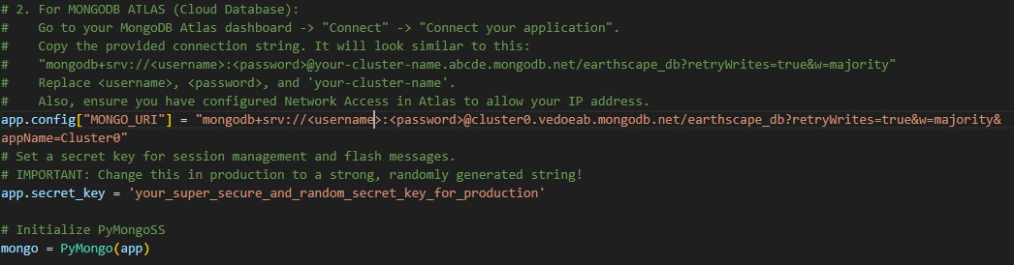

Role-Based Dashboards (Analyst & Admin)
  - The system includes two distinct dashboards designed for different user roles: Analyst and Admin.

Analyst Dashboard:
  - Provides a personalized interface for analysts to interact with climate data.
  - Allows uploading of CSV files for data input.
  - Enables making predictions using various machine learning models.
  - Displays prediction history and logs for user reference.
  - Offers dynamic visualizations to help analyze climate trends.
  - Focused on user-level forecasting and detailed data exploration.

Admin Dashboard:
  - Provides system-level controls and monitoring tools.
  - Displays metrics such as total users, total predictions made, and alerts triggered.
  - Allows admins to review feedback submitted by users.
  - Gives access to complete prediction histories across the platform.
  - Designed to manage overall platform health and ensure data integrity.

Code Snippets:

  - Imports and main configuration:
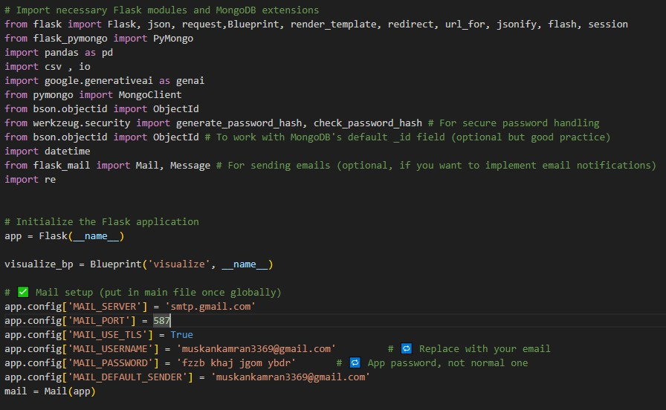

  - EarthScape Chatbot:
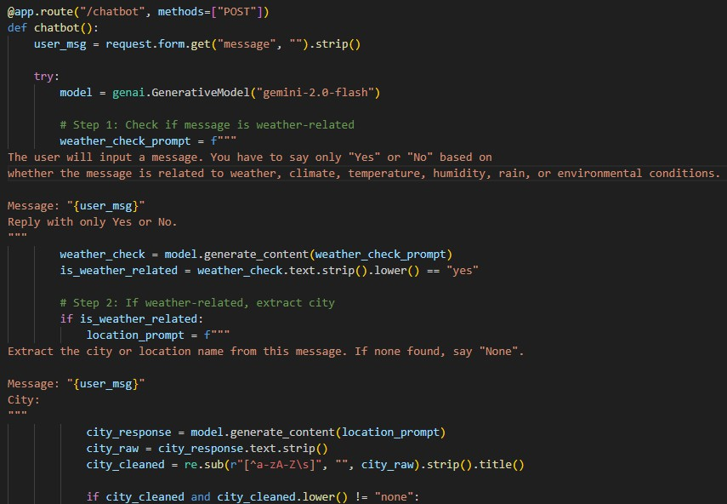

  - Registration:
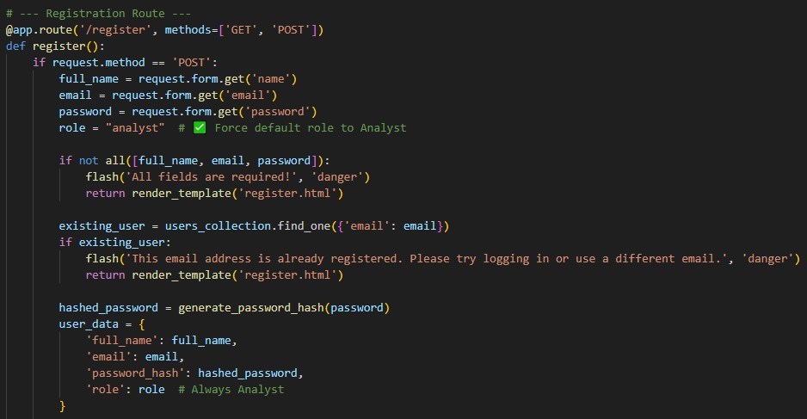

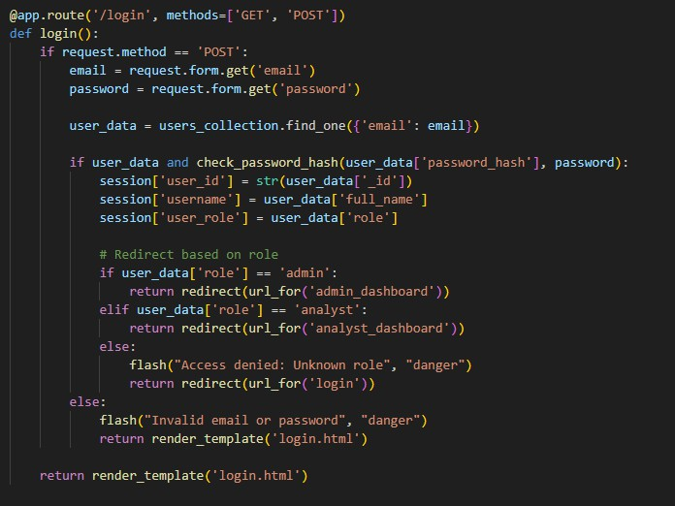
  - Login:

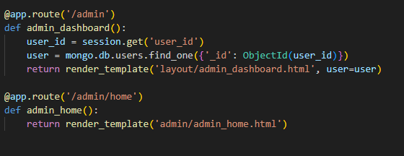
  - Admin dashboard:

  - Admin managing users:
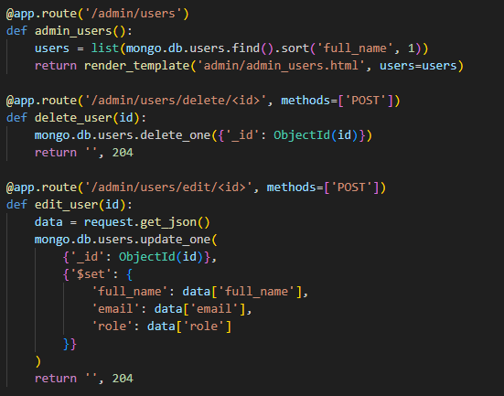

  - Admin models evaluation:
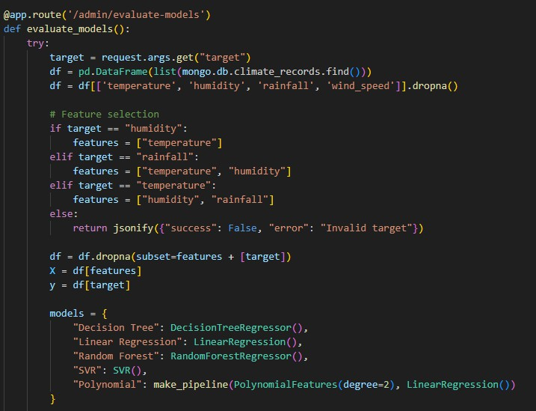

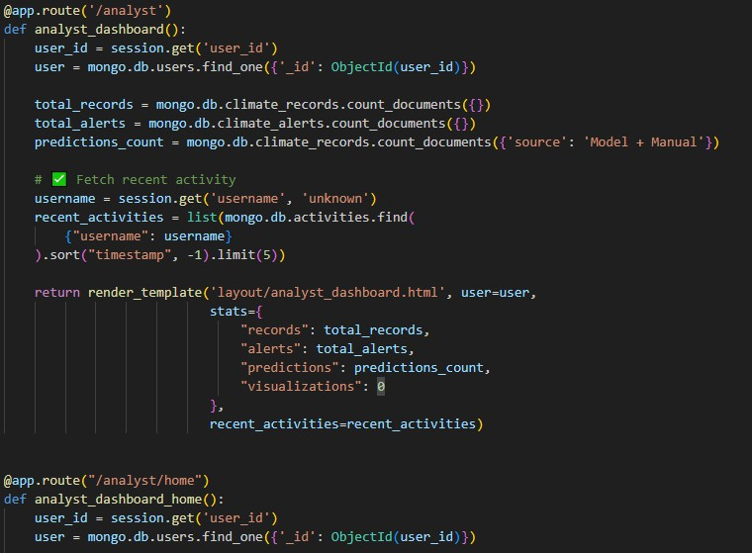
  - Analyst dashboard:

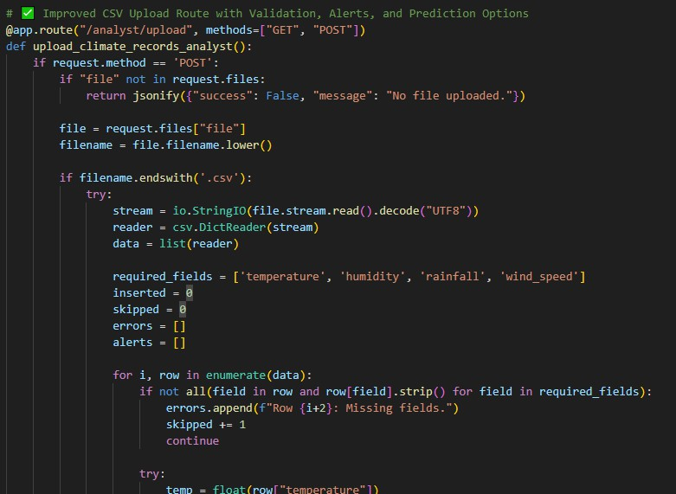
  - Analyst upload scv file:

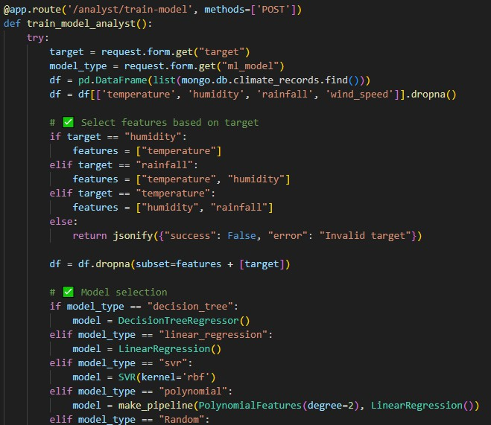
  - Model training:

  - Email alert via SMTP:
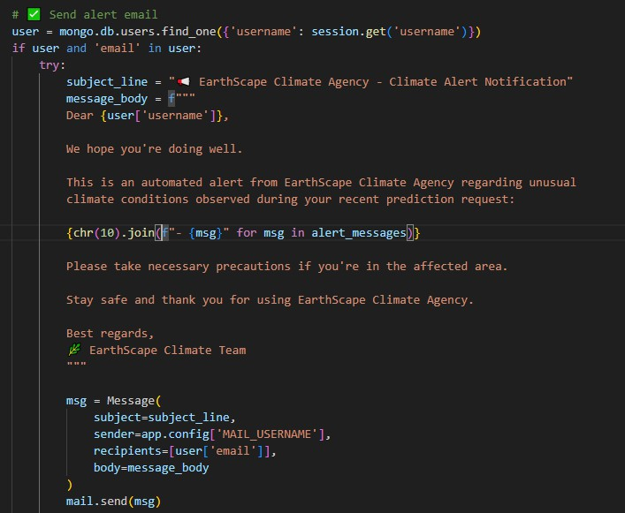

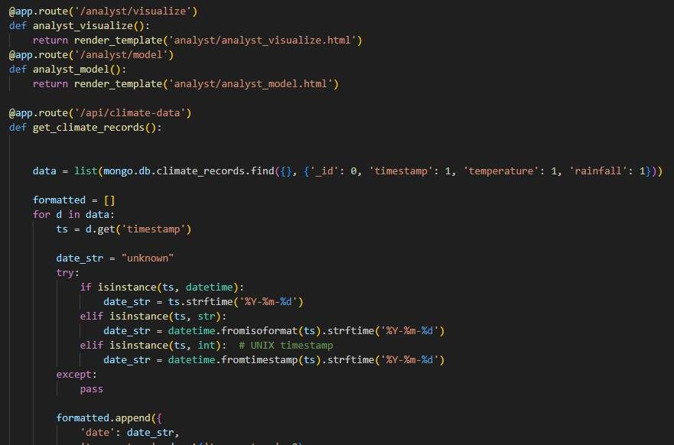
  - Visualizations:

\

  - Alerts & feedback:
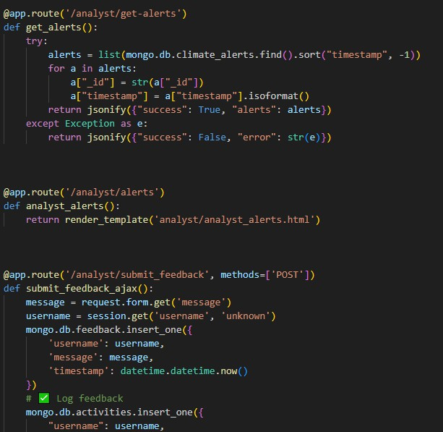

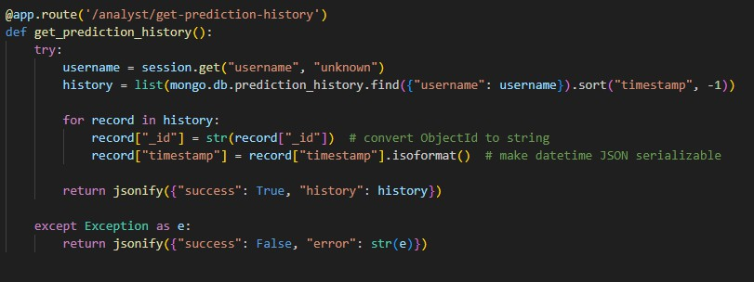
  - Prediction history:

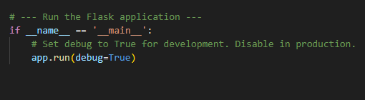
  - Main App run:

Final Summary
EarthScape Climate Agency is a comprehensive web-based platform that empowers users to upload, visualize, and predict climate data using advanced machine learning techniques. By integrating real-time weather information and offering personalized predictions, the system enables proactive climate monitoring and decision-making.
The application supports multiple user roles through dedicated Analyst and Admin dashboards, facilitating both detailed data analysis and system management. An AI-powered chatbot enhances user experience by providing instant support and guidance, while automated email alerts ensure timely notification of critical climate events.
Built with a robust technology stack—including Python Flask backend, MongoDB, and scikit-learn ML models—EarthScape Climate Agency exemplifies a scalable, user-centric solution for climate data analysis and forecasting.

