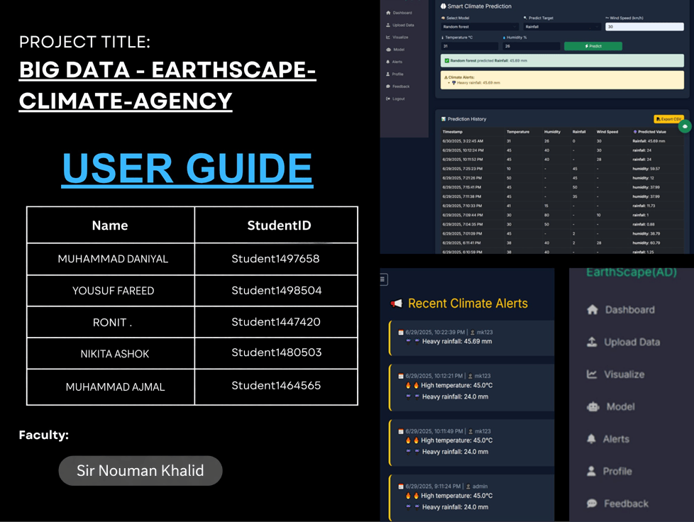

Table of Contents
Project Title: 1
Introduction: 3
Purpose of the System 3
General Features of EarthScape Climate Agency 4
EarthScape User Interface Guide: 5
- LOGIN / REGISTER 6
- MAIN DASHBOARD 7
- UPLOAD USER’S DATA(CSV FILE): 8
- VISUALIZATIONS 9
- MODEL PREDICTION 10
- ALERTS: 11
- PROFILE CREATION/UPDATE 12
- FEEDBACK 13
- EARTHSCAPE BOT – YOUR CLIMATE ASSISTANT 14

Introduction:

EarthScape Climate Agency is a web-based climate monitoring system designed to help users track and predict key climate indicators such as temperature, humidity, and rainfall. The system is built using pre-trained machine learning models and allows users to select which value they want to predict by entering the required climate conditions.

Purpose of the System:

This platform allows users to:

Enter climate data manually

Select one of the 3 key parameters to predict:

Rainfall

Temperature

Humidity
- Optionally enter Windspeed

Choose their preferred machine learning model

View the predicted result and graphs

This tool supports environmental researchers, students, and analysts in making data-driven forecasts.

General Features of EarthScape Climate Agency :

User Authentication System
  - Secure Login & Registration
  - Role-based redirection (e.g., Admin vs Analyst)
  - Password encryption for safety

Dashboard Overview
  - Displays user activity (uploads, visualizations, predictions)
  - Quick access to important tools and alerts

Custom Data Upload
  - Users can upload CSV files with climate data (Temp, Rainfall, Humidity, Wind Speed)
  - Uploaded data used for more personalized ML predictions

Interactive Visualizations
  - Line chart: Temperature over time
  - Scatter plot: Humidity vs Temperature
  - Bar charts: Wind Speed Distribution & Climate Comparison
  - Helps in trend analysis without manual processing

Machine Learning Predictions
  - Predict Rainfall, Humidity, or Temperature
  - Select from 5 pre-trained models:
    - Linear Regression
    - Decision Tree
    - Random Forest
    - SVR (Support Vector Regression)
    - Polynomial Regression
  - Real-time results + optional alert notifications

Climate Alerts System
  - Auto-generated alerts based on prediction thresholds

  - Includes parameter info, time, severity
  - Email notifications sent using SMTP

User Profile Management
  - Users can update their profile info and upload a picture
  - Data saved with update confirmations

Feedback & Suggestions
  - Users can submit bug reports, suggestions, or general feedback
  - Feedback sent to developers via email
  - Confirmation message displayed on submission

EarthScape Bot – AI Assistant
  - AI Chatbot powered by Gemini API
  - Integrated with live weather API
  - Answers climate queries and guides users through the system
  - Available on all pages for real-time support

EarthScape User Interface Guide:

This section provides a visual walkthrough of each page in the EarthScape system, along with brief descriptions to help users understand its features and usage.

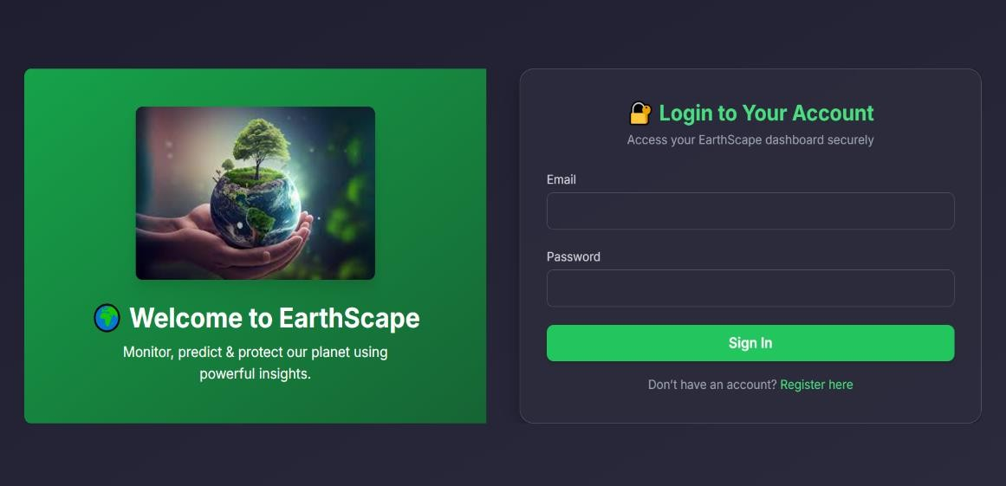
LOGIN / REGISTER:

Secure User Authentication
Users must log in using their registered credentials to access the system.

User Registration Option
If a user doesn't have an account, they can click on the “Register” button to create one instantly.

Registration Form Includes:
The registration form allows new users to create an account
by entering their username, email address, and a password with confirmation to ensure accuracy.


Redirect to Login
After successful registration, users are automatically redirected to the login page.

Password Encryption
User passwords are stored securely (handled in the backend, not visible to the user).

User Roles on Login
Based on the user role (e.g., Admin or Analyst), they are redirected to their respective dashboard after login.

MAIN DASHBOARD:

Recent Activity Log
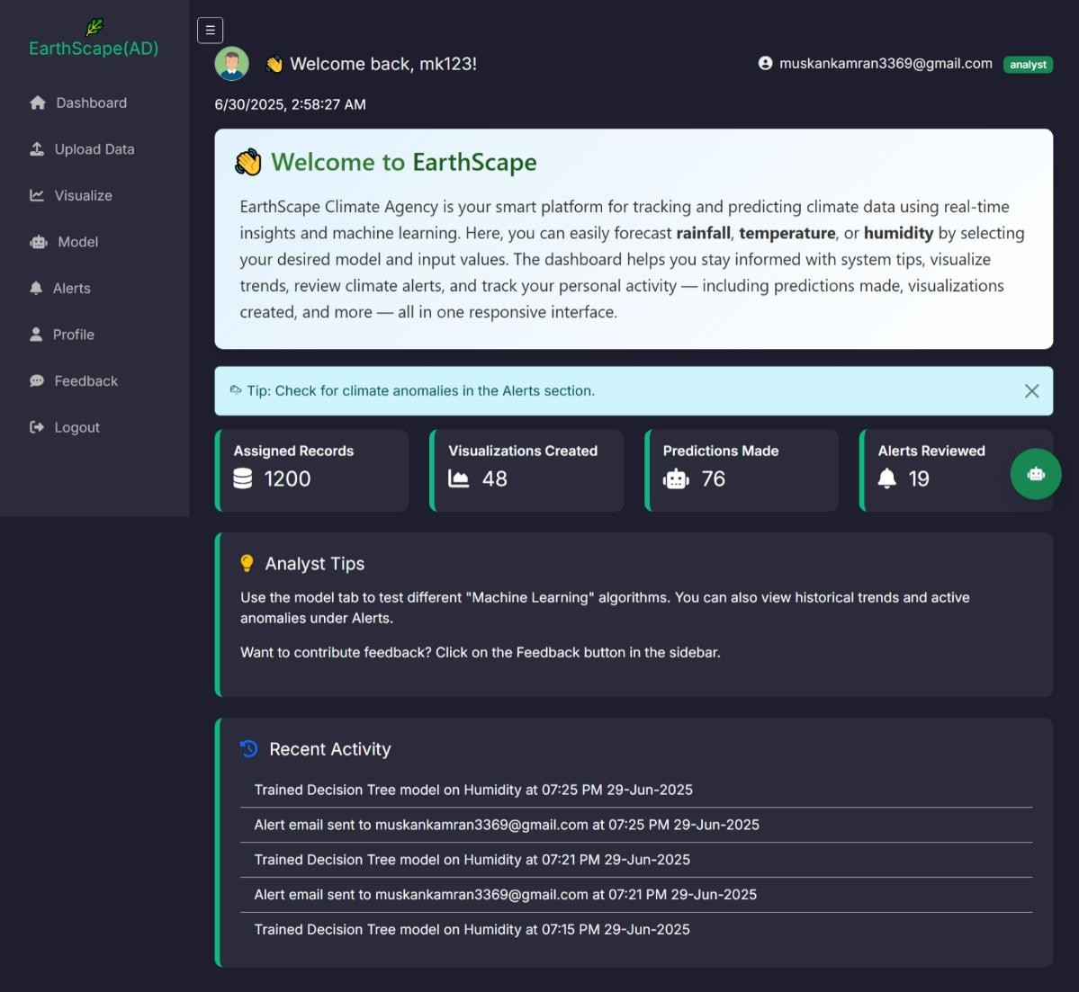
A dedicated section shows the user's latest activities.

Assigned Records
Displays how many climate records are assigned to the user.

Visualizations Created
Tracks the number of charts or graphical reports the user has built from the data.

Predictions Made
Shows how many times the user has run machine learning predictions (e.g., for rainfall or humidity).

Alerts Reviewed
Indicates how many system alerts have been generated

Quick Access to Prediction Module
Users can directly navigate to the prediction tool from the dashboard to enter values, select a model, and view results.

UPLOAD USER’S DATA(CSV FILE):

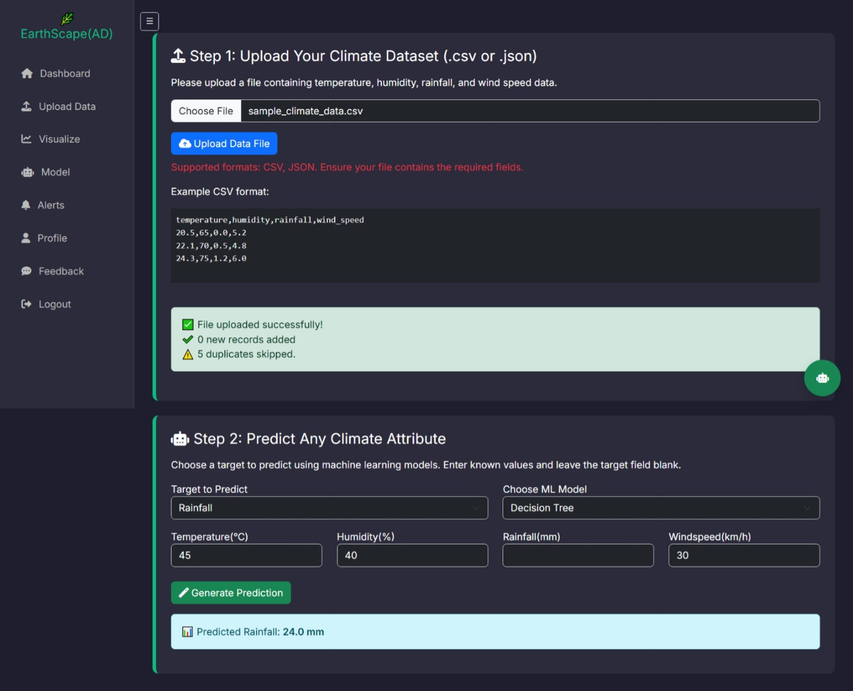
To make predictions more personalized and accurate, the system allows users to upload their own climate data in CSV format. This feature helps users work with real values from their own region or research. Once uploaded, the data is displayed in a table and
temporarily used alongside the trained dataset to generate predictions.
  - Upload your own climate data in CSV format, including temperature, humidity, rainfall, and optional windspeed.
  - The system temporarily combines your data with the trained dataset to generate more accurate personalized predictions.
  - Useful for users who want to test the system using their own environmental data or reports.

VISUALIZATIONS:

The Visualize tab allows users to explore climate trends through a set of ready-made, interactive charts. These visualizations help users quickly understand environmental changes, spot patterns, and analyze relationships between different climate factors — all without manual data processing.

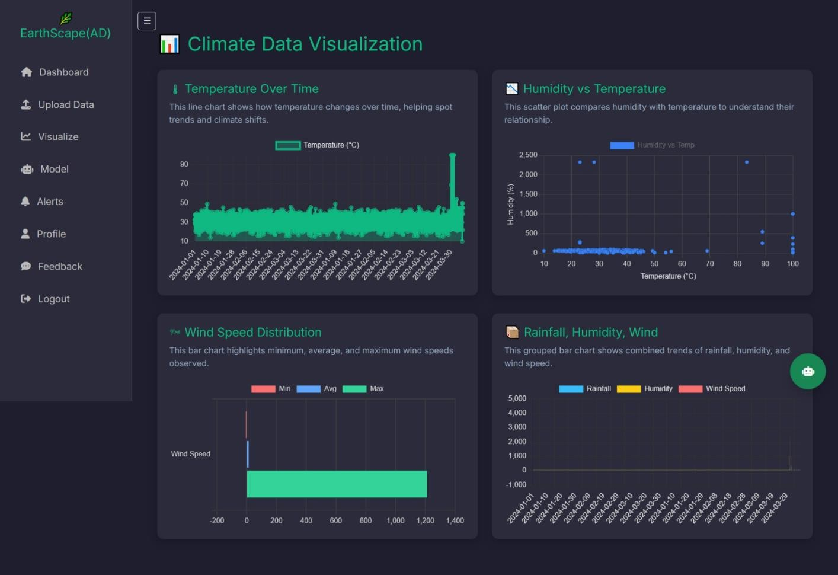
Key Highlights:
  - Temperature Over Time: Line chart showing how temperature changes over time.
  - Humidity vs Temperature: Scatter plot comparing humidity and temperature.

Wind Speed Distribution:
Bar chart showing min, avg, and max wind speeds.

Rainfall, Humidity, Wind Comparison:
Grouped bar chart to view combined climate trends.

MODEL PREDICTION:
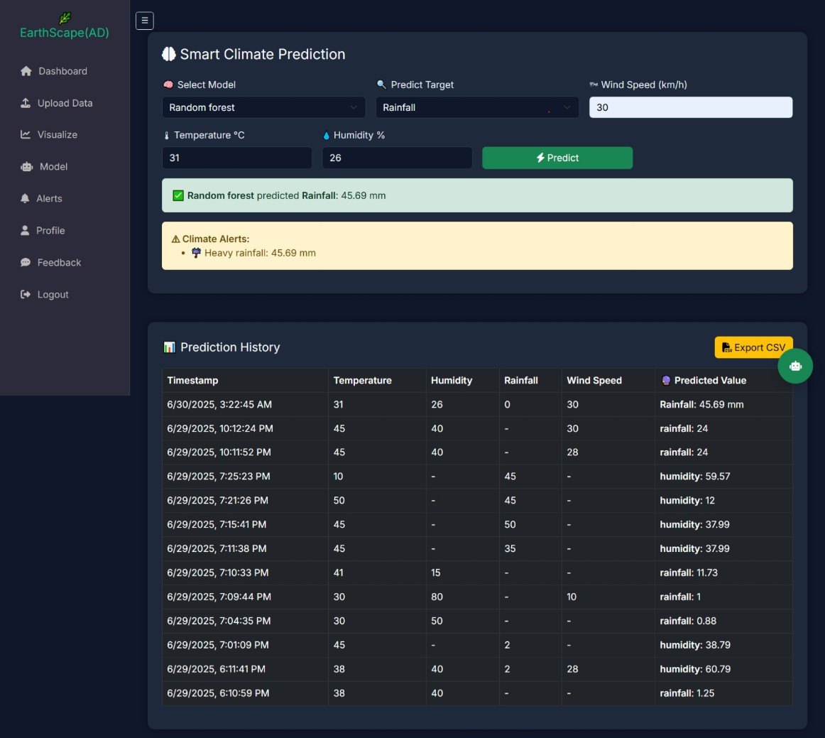
The Prediction page allows users to forecast climate values like rainfall, temperature, or humidity using one of five pre-trained machine learning models. Users enter relevant inputs, choose a model, and get real-time predictions along with alerts if critical values are detected.

Key Highlights:

Model Selection
Users can choose from five available machine learning models:
    - Linear Regression
    - Decision Tree
    - Random Forest
    - Support Vector Regression (SVR)
    - Polynomial Regression

Alerts:
If the result exceeds safe limits, an on- screen warning appears and an email alert is sent to the user’s email via SMTP.

Prediction History:
All predictions are saved with input values, result, date, and time for future reference.

ALERTS:
The Alerts page displays all system-generated climate alerts based on prediction results and live data thresholds. This section helps users stay informed about abnormal or potentially dangerous environmental conditions such as high temperature, excessive rainfall, or extreme humidity.

Key Highlights:

All Alerts:
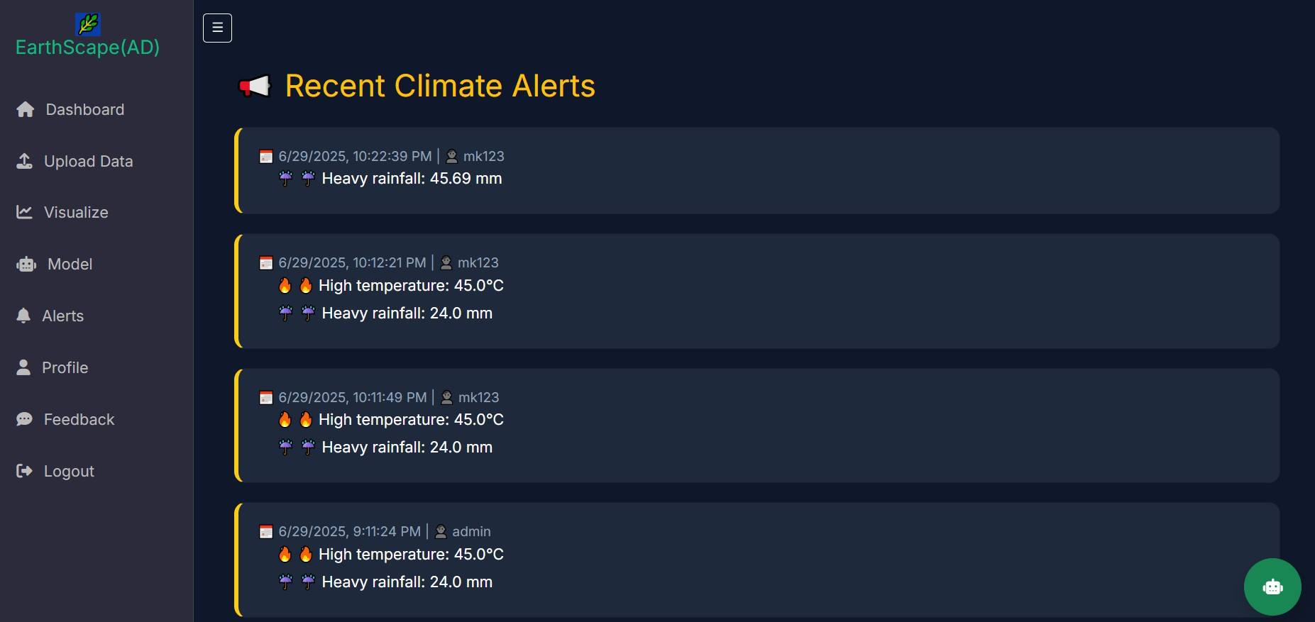
Shows a list of climate alerts triggered by predictions or uploads.
  - Alert Info: Includes parameter, value, date, time, and severity.
  - Email Notification: Alerts are also sent to the user’s email via SMTP.

PROFILE CREATION/UPDATE:
The Profile page allows users to create, view, and update their personal information for a more personalized experience. This includes essential details like username, email, and password, as well as the ability to upload a profile picture.

Key Highlights:

Create and Update Profile:
Users can add or edit their basic information including username, email, and bio at any time.

Profile Picture Upload:
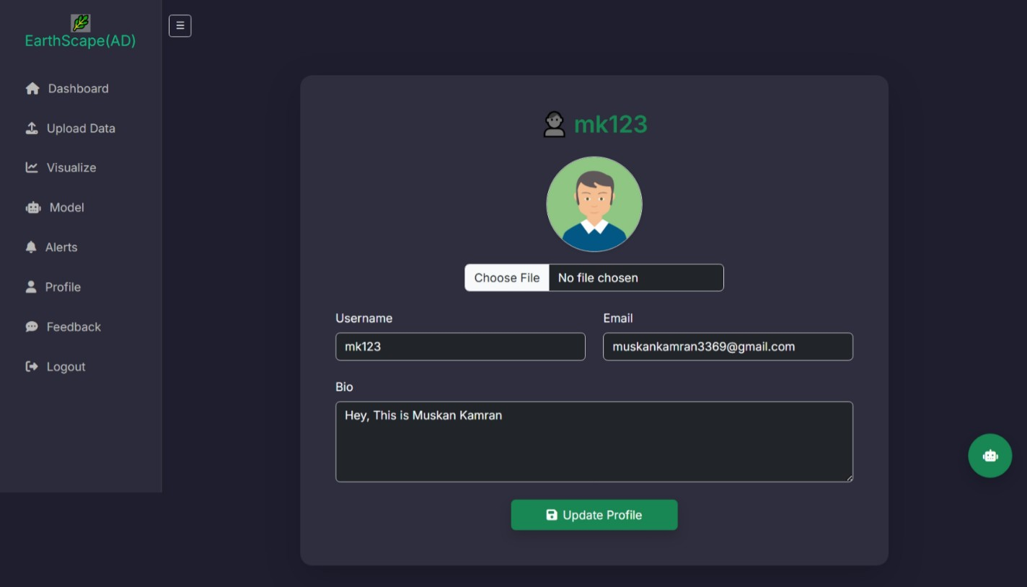
A “Choose File” option allows users to upload their profile photo. The image is displayed on their dashboard after saving.

Update Confirmation:
A success message is displayed after profile details or photo have been successfully updated.

FEEDBACK:
The Feedback page provides users with a simple way to share their experience, report issues, or suggest improvements directly to the development team. This helps ensure the system remains user-friendly and continues to evolve based on real user needs.

Key Highlights:

Multiple Purposes:
The form can be used to report bugs, request features, or provide general suggestions.

Email Integration:
Submitted feedback is sent directly to the admin or developer's registered email using SMTP.

Confirmation Message:
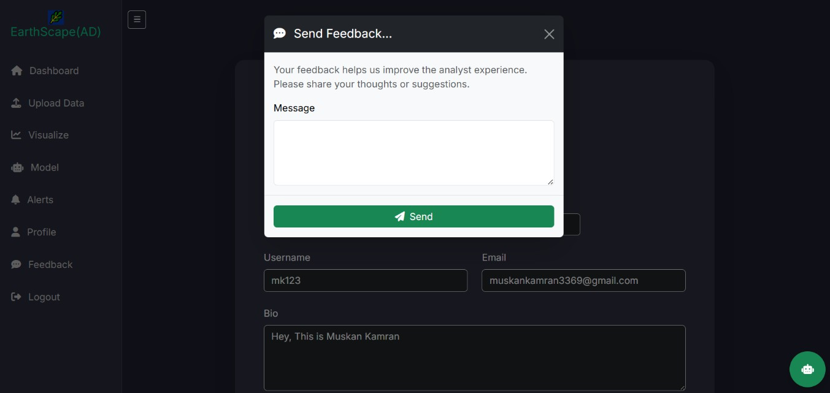
After successful submission, the user sees a confirmation that their feedback has been received.

EARTHSCAPE BOT – YOUR CLIMATE ASSISTANT
The EarthScape Bot is a built-in AI assistant developed using Gemini API and integrated with a live weather API. It helps users with climate-related questions and provides instant guidance across the platform, making navigation and data understanding easier.

Key Highlights:
  - Instantly answers climate-related queries using real-time weather data.
  - Assists users in understanding how to use dashboard features.
  - Responds in natural language for easy conversation.
  - Available on every page for quick help anytime.
  - Built using Gemini API for intelligent, accurate replies.
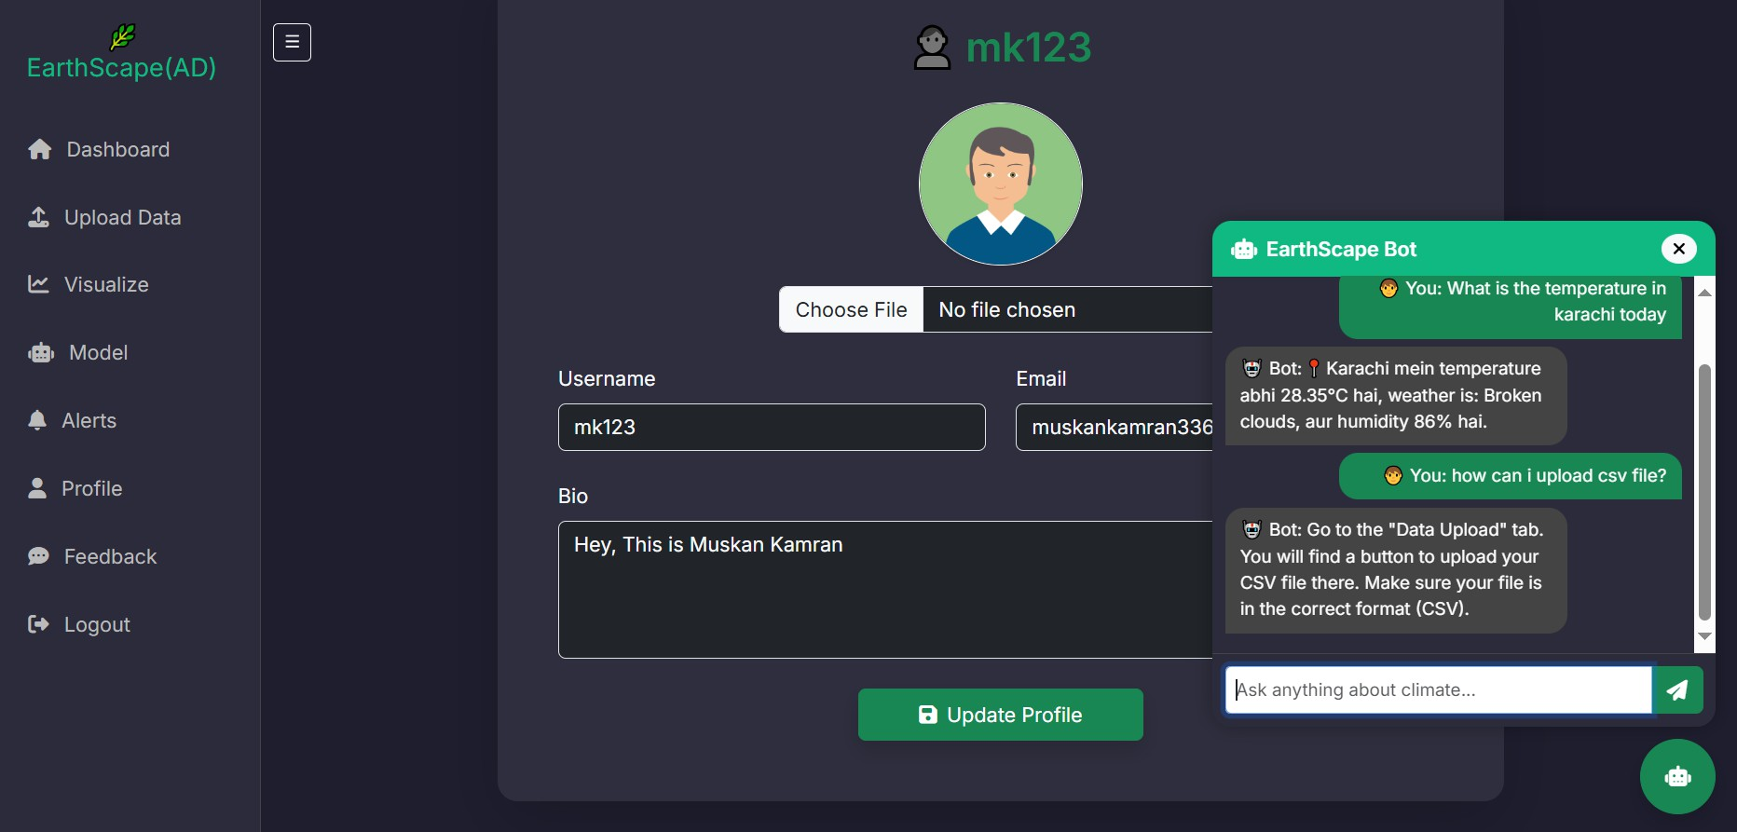

- FINAL SUMMARY
The EarthScape Climate Agency platform offers an all-in-one solution for climate monitoring, prediction, and analysis. With a user-friendly interface, powerful machine learning models, real-time visualizations, and smart alert systems, the platform empowers users to make data-driven climate decisions. From uploading personal data to interacting with the AI-powered EarthScape Bot, every feature is designed to support researchers, students, and analysts in understanding and forecasting environmental conditions. Whether you're exploring trends or predicting future outcomes, EarthScape ensures an intuitive and insightful experience for every user.

