

e-Project Documentation OnGreen Living Hub App

| Faculty | Miss Tazeen | |
| --- | --- | --- |
| Batch | 2307a | |
| Project Name | Green Living Hub App | |
| Serial No. | Student Id | Student Name |
| 1. | Student1497658 | MUHAMMAD DANIYAL |
| 2. | Student1443878 | UZAIR |
| 3. | Student1498504 | YOUSUF FAREED |
| 4. | Student1498511 | SUFIYAN |
| 5. | Student1498332 | ABDUL WAHEED |

**INDEX**

* **Project Overview**..................................................................................................................
* **Customer Requirements Specification**................................................................................

Home page..................................................................................................................

**Authentication Page** ...............................................................................................

Feature Pages....................................................................................…

* **Database and Firebase Integration**...........................................................................…
* **Navigation Flow..**......................................................................................................
* **Task Sheet**..............................................................................................................................
* **Future Enhancements**...........................................................................................................
* **Conclusion**.............................................................................................................................

1. **Project Overview**

The Green Living Hub App is a mobile application built to promote eco-conscious living. It enables users to join green communities, share tips and achievements, track their carbon footprint, discover green events, and access sustainable lifestyle guides. Developed using Flutter and Firebase, this project provides a scalable platform for sustainable living, with a focus on user engagement and environmental awareness.

# Customer Requirements Specification Homepage:Capture

# Describing the main entry point for authenticated users with an engaging layout:

# • **App Bar**: Displays the app name ”GreenLivingHub” and a Login/Sign-up button.

# • **Drawer Menu**: Includes navigation options: Home, About, Contact Us.

# • **Feature Cards:** Links to key pages: – Communities (Join Communities) – Quick Tips (Tips & Success Stories) – Visual Achievements (Achievements Page) – Discover Events – Track Carbon Footprint – Eco-Friendly Shopping Guide

# • **UI Design:** Features a hero image with a community illustration and a clean card-based layout using Flutter’s Material Design.

* + **Authentication Page**s:

Detailing secure user management pages:

### Login Page:

Displays ”Welcome Back!” with fields for Email and Password.

Includes a ”Login” button and a ”Sign Up” link for new users.

### Signup Page:

Allows account creation with Full Name, Email, and Password fields.

Features a ”Sign Up” button and a ”Login” link for existing users.

**Back end**:

Utilizes Firebase Authentication for secure user management.

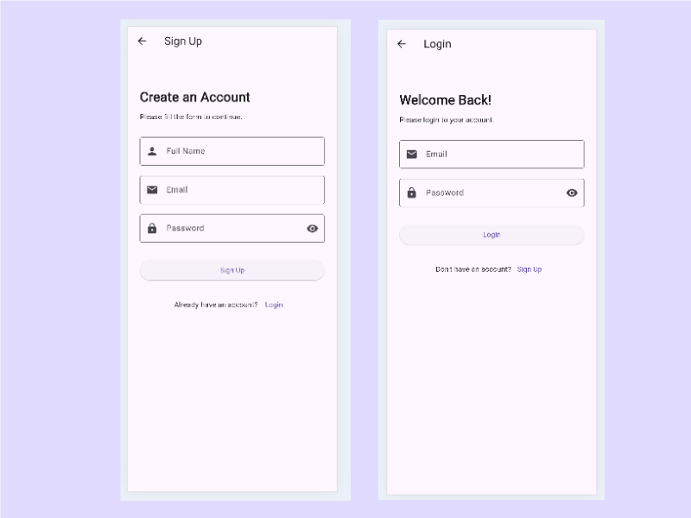

**Feature Pages**

Outlining specific functionalities accessible via Homepage cards:

### Join Communities:

Displays Community Updates (e.g., Tip of Day) and Popular Communities (e.g., Eco Warriors).

Allows users to explore and join groups.

### Tips & Success Stories:

Shows a list of user-shared tips (e.g., ”Saved Water by Installing Low-Flow Showerheads”).

Includes a form to share new tips or success stories with Title and Content fields.

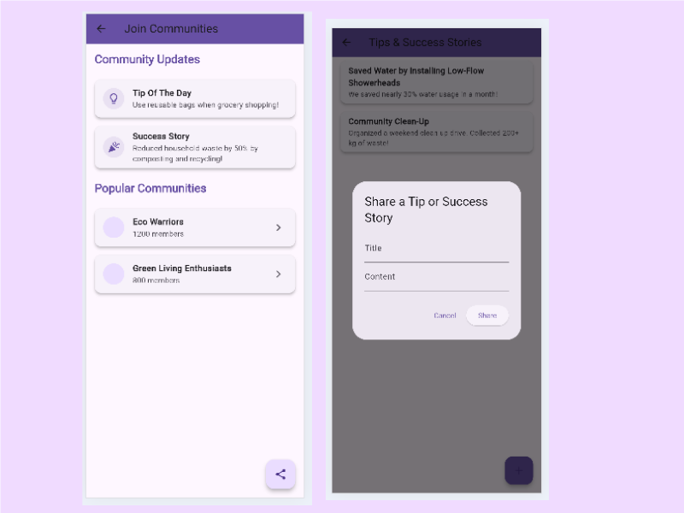

### Visual Achievements Page:

Displays user achievements with graphical elements (e.g., badges, progress bars).

### Discover Events:

Lists upcoming green events with details (placeholder UI implemented).

### Track Carbon Footprint:

Calculates carbon footprint (e.g., 0.20 kg/day) based on inputs for Auto, Means, House, Airplane, and Phone.

Offers ”Recalculate” and ”Remove your CO2 emissions” options.

### Eco-Friendly Shopping Guide:

Provides categories like Recyclability (e.g., Recycled Paper Towels), Sustain- ability Certifications (e.g., Fair Trade Coffee), and Ethical Sourcing (e.g., Cruelty-Free Cosmetics).

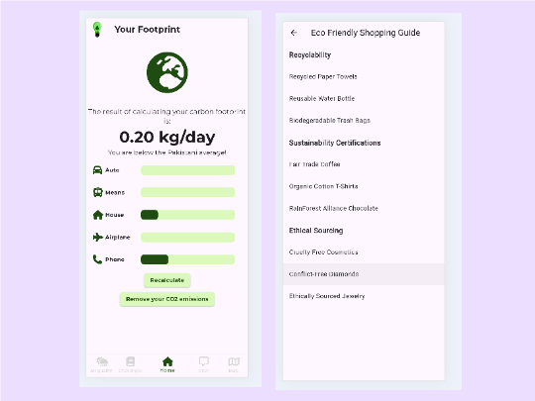

**About**: Offers a guide on sustainable living with key features and tips.

**Contact Us**:

Includes a form for Name, Email, and Message, plus direct contact details (email, phone, address).

### 2Capture

# Database and Firebase Integration

Explaining data management:

**Firebase Authentication**:

Manages secure user login and signup with email/password authentication.

**Firebase Firestore**:

Initialized for future storage of dynamic content such as tips, achievements, and events.

**Data Structure**:

Planned Firestore collections for user-generated content and event data.

# Task Sheet

Listing completed tasks:

Developed App Bar and Drawer with navigation options.

Implemented Firebase Authentication for user management.

Designed Homepage with feature cards and hero image.

Created Login and Signup pages with Firebase integration.

Built feature pages (Join Communities, Tips & Success Stories, etc.) with place- holder UI.

Configured Firebase Firestore for future content storage.

Documented project functionality in LaTeX format.

# Future Enhancements

Proposing next steps:

Add real-time posting and commenting for community interaction using Firestore.

Implement dynamic event listings and user profiles with eco-points.

Enhance carbon footprint tracking with detailed analytics.

Integrate social media sharing for tips and achievements.

Add dark mode and accessibility features for broader usability.

# Conclusion

Summarizing project success: The Green Living Hub App delivers a user-friendly platform for promoting sustainable living, featuring community engagement, carbon tracking, and shopping guides. Built with Flutter and Firebase, it provides a solid foundation for future growth. The project is tested, documented, and ready for additional features to enhance user experience.