**Artificial Intelligence Based ATM Booth System**

**Introduction:** In today’s technically modern world, all the automatic systems are gaining more popularity. Due to advances in technology, the ATM and credit card has been installed that simplifies financial and banking activity, however the crime related with financial systems has been increased equally. Among the crime for financial systems the cases of theft and robbery have very high proportion of over 90% and the crime related to ATM has been increased gradually.

Automated Teller Machine are a part of our daily life as they allow to easy access to get cash twenty-four hours a day. The Real Life Monitoring and security based system for ATM booth arise with the recent incidents happening around us in day to day life. This project deals with prevention of ATM theft from robbery.

**AI Features:**

1. Iris Scanner.
2. Face recognition Camera.
3. Fingerprint for Transaction.

**Iris Scanner:** There is an iris scanner system at the front gate of ATM booth. A person can get the entry of ATM booth if he/she can pass the iris scanning system. When a person comes to open an account to the bank at the time bank must take his/her iris and fingerprint and store it toh bank database. When a user wants to enter the ATM booth he/she put his/her eye at the iris scanner module. This module capture the digital picture of customer’s eyes and match it to the database, if it matches then the gate will automatically open and the valid customer gets the entry. If it doesn’t match the database then the gate will remain close.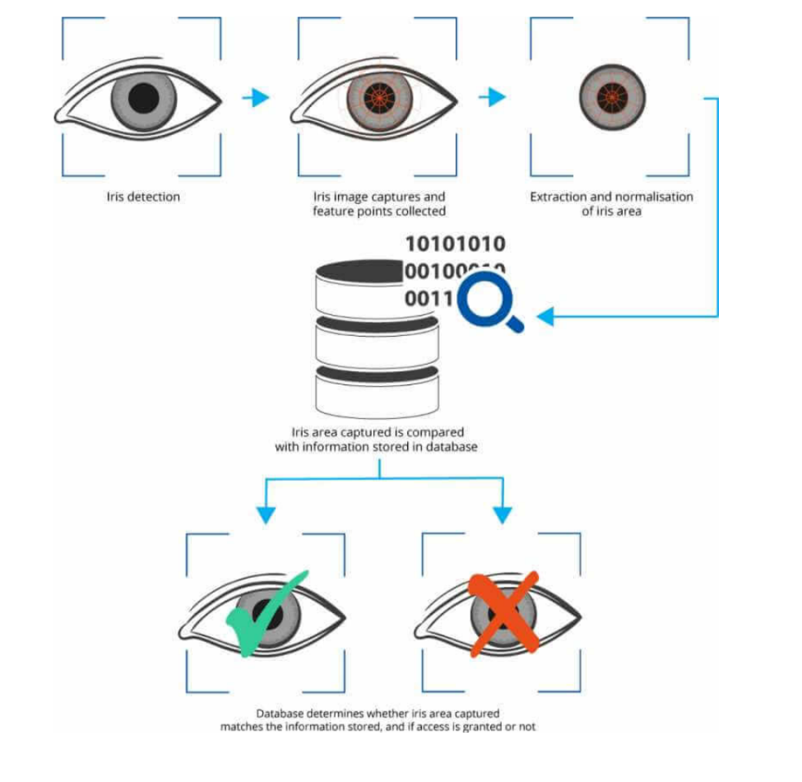

**Flowchart:**

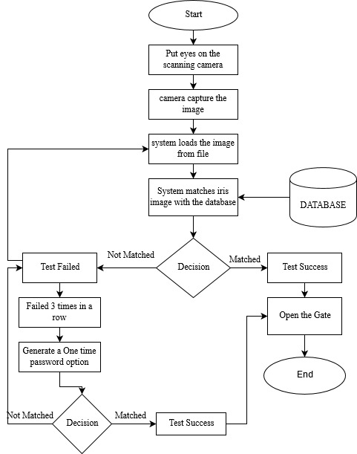

**Face Recognition Camera:** This camera is work on the basis of Deep Learning. We implement this camera inside the ATM booth. When a valid customer enters in the booth the camera capture his face image and matches the face algorithm it has previously stored. If a customer uses face mask or the face is covered with something then buzzer will beep and the door is automatically shutdown. If the face is fully visible and is readable through the face algorithm then the buzzer will remain silent.

**Flowchart:**

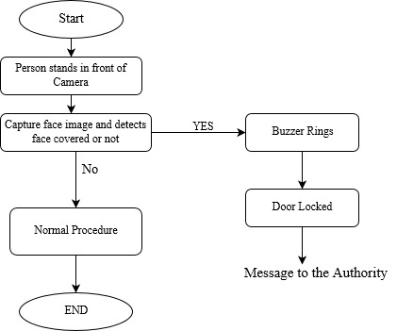

**Fingerprint For Transaction:**

Traditional ATM systems authenticate generally by using customers ATM card and password. The method has some defects. Using card and password cannot identify the user properly. Ones user’s card is lost or stolen or someone knows the password then the criminal will withdraw all the money in a short time.

The original password authentication method combine with the biometric identification technology verify the clients identity better and achieve the purpose of using ATM machines &improve the security.

**Fingerprint Recognition:**

The customer’s fingerprint information was used as the standard identification. It must certify the feature of the human fingerprint before using ATM system. Which was stored in the database.

System can compare current client’s fingerprint information with remote fingerprint server. If fingerprint doesn’t match with the server than it will not allow any further procedure to complete. In this system there is also some problem like sometimes the fingerprint module doesn’t work properly because of the server problem. So a valid customer cannot complete their transaction. So there is a solution for this problem, if fingerprint doesn’t match three times then it will generate a one time password to complete the transaction. If the password is wrong then the account will freeze at least one hour for security purpose.

Using this fingerprint customer can do many things :

1. Cash Withdraw.
2. Balance Check.
3. Transfer Money to the other account.
4. Deposit Money

**Flowchart:**

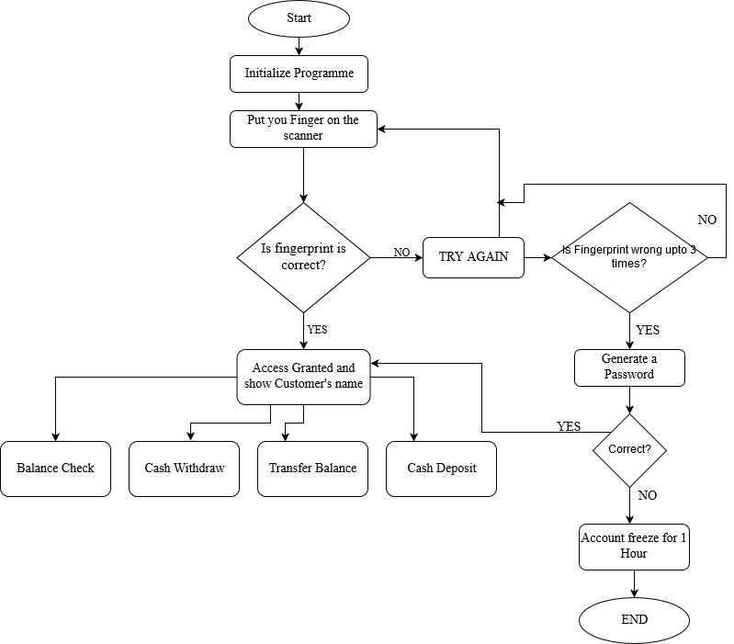

**Conclusion:**

Our main goal in this project is to give an idea to increase the ATM booth security using some Artificial Intelligence system. As we all know most of the ATM’s have been attacked by robbery which is leading to gradual increase in the theft of the ATM year by year. In this we show how an automation of ATM theft prevention from robbery or thief can be implemented using AI. By implementing this design we can avoid theft in ATM booths.