

SECV2223-06

**(WEB PROGRAMMING)**

**Group 03 [ Aventures ]**

Lecturer: Dr. Sarina Suliaman

Assignment 1

**5 hospital websites Performance Analysis Using**

**Google lighthouse matrix**

Ali Mohamed Fathy A22EC0009

Jahid A22EC9149

Omar Ibrahim A22EC0024 

**1.1 INTRODUCTION**

It has been decades since the strive of the Web, thus the development of web pages have gone so far, from providing essential life services to sharing information across millions of fields, these websites have been an essential tool for international and national businesses. They serve nearly hundreds of millions of customers on a daily basis. There have been a couple of principles to improve and develop these websites accordingly. A good website can significantly improve the customer's overall satisfaction, as it may be considered as part of the service quality. In this report we are going to test out 5 hospital websites. We will be using a Google lighthouse matrix to provide us with the statistics.

**1.2 Matrix Comparison**

**1.2.1 NMC hospital** [**[2]**](https://nmc.ae/en/hospitals/abu-dhabi/nmc-specialty-hospital-1)

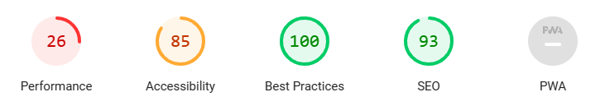

**1.2.2 Suliman Alhabibe** [**[3]**](https://drsulaimanalhabib.ae/)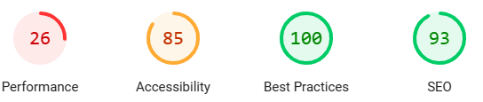

**1.2.3 Mayo Clinic [**[**mayoclinic.org**](https://www.mayoclinic.org/)**]**

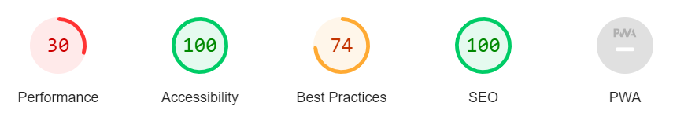

**1.2.4**  **PANTAI HOSPITAL** [**04**](https://www.pantai.com.my/)

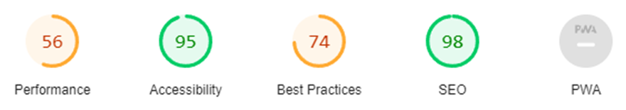

**1.2.5**  **KPJ HEALTHCARE BERHAD**  [05](https://www.kpjhealth.com.my/)

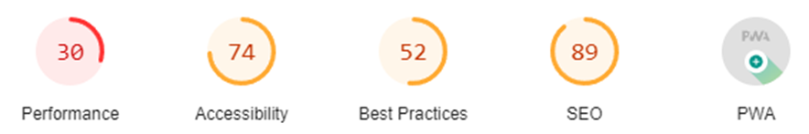

**1.3 LITERATURE REVIEW**

**1.3.1 NMC hospital**

The performance of this website came very low at 26, The website is bombarded with a lot of delays while moving from different pages to another. While accessibility came relatively low as there is not much design contrast nor having much visual labels in the website. Then they have a very high SEO as they don't have many crawlable links.

**1.3.2 Sulaiman Al habib hospital**

This website has a little bit higher performance than the NMC, there is a light difference between NMB and SA websites, there is no contrast between the background and the front elements. This will affect the accessibility. While we have a little lower SEO than NMC the best practices are full, coming similar to the NMC which is proven effective against cyber attacks. This means a strong protected data.

**1.3.3** **Mayo Clinic**

The Mayo Clinic website excels in performance, accessibility, and SEO. With fast loading times, strong adherence to accessibility standards, and strategic keyword optimization, it ensures a seamless user experience and high visibility in search engine rankings. Continued focus on these areas will further enhance its reputation as a top-tier healthcare resource

**1.3.4 Pantai Hospitals:**

Performance (Score: 56):

The website exhibits average performance, with improvements needed in various areas.Issues include long main-thread work, high Largest Contentful Paint (LCP), and render-blocking resources.

Recommendations include reducing unused CSS and JavaScript, optimizing image sizes, and addressing third-party code impact.

Accessibility (Score: 95):

This website excels in accessibility, scoring significantly higher than other aspects.

Proper HTML markup and adherence to accessibility standards contribute to the high score.

No major issues were identified, indicating good accessibility practices.

Best Practices (Score: 74):

Although not as high as accessibility, it still maintains a respectable score in best practices. Recommendations include eliminating unused JavaScript and CSS, serving images in next-gen formats, and optimizing cache policies.

SEO (Score: 98):

The website performs exceptionally well in terms of SEO, with a near-perfect score. Proper meta tags, structured data, and content optimization contribute to high search engine visibility significant issues were identified in this aspect. Progressive Web App (PWA) (Installable: 0/1, Optimized: 2/5):

The website lacks PWA installability but shows moderate optimization efforts. Recommendations include improving installability and enhancing PWA features for a more app-like experience.KPJ Healthcare Berhad :

Performance (Score: 30):

This website exhibits below-average performance, with several critical issues affecting load times and interactivity. Major issues include high JavaScript execution time, render-blocking resources, and inefficient image loading. Recommendations include reducing JavaScript and CSS sizes, optimizing image delivery, and addressing network payloads.

Accessibility (Score: 74):

While still acceptable, the website's accessibility score indicates room for improvement.

Issues may include inadequate keyboard navigation, color contrast issues, or missing ARIA attributes.

Further evaluation and adjustments are needed to ensure compliance with accessibility standards.

Best Practices (Score: 52):

KPJ Healthcare Berhad website scored relatively low in best practices, indicating potential violations of web development standards. Issues include unused JavaScript and CSS, inefficient resource delivery, and lack of text compression. Recommendations focus on code optimization, cache policies, and enabling text compression for better performance.

SEO (Score: 89):

The website performs well in SEO but not as strongly as Pantai Hospitals website. Proper meta tags, structured data, and mobile-friendliness contribute to good search engine visibility. Minor optimizations may be needed to improve ranking and visibility further. Progressive Web App (PWA) (Installable: 1/1, Optimized: 4/5):

KPJ Healthcare Berhad website demonstrates better progress in PWA optimization compared to the Pantai Hospitals website. It achieves PWA installability and shows significant optimization efforts, indicating a more app-like experience for users. However, some issues still need addressing, such as errors in content loading and layout shifts.

**Comparison:**

Performance: Pantai Hospitals website outperforms KPJ Healthcare Berhad website in terms of performance score, with fewer critical issues affecting load times and interactivity.

Accessibility and SEO: Pantai Hospitals' website excels in accessibility and SEO, scoring higher than KPJ Healthcare Berhad's website in both aspects.

Best Practices: Both websites have room for improvement in adhering to best practices, but the Pantai Hospital website scores slightly higher.

PWA Optimization: The KPJ Healthcare Berhad website shows better progress in PWA optimization, achieving installability and higher optimization scores compared to the Pantai Hospitals website.

Overall, while Pantai Hospitals' website demonstrates strengths in accessibility and SEO, KPJ Healthcare Berhad's website shows potential in PWA optimization. Both websites have areas for improvement, particularly in performance optimization and adherence to best practices.

**Resources**

[1] Microsoft AI bing generated (cover picture )

[2] [**NMC Specialty Hospital, Best Hospital in Abu Dhabi | NMC Healthcare**](https://nmc.ae/en/hospitals/abu-dhabi/nmc-specialty-hospital-1)