DevOpS
Introduction:
DevOps is a set of practices, tools, culture that automate and integrate the processes between software development and IT teams combining Development and Operations.
The DevOps lifecycle:
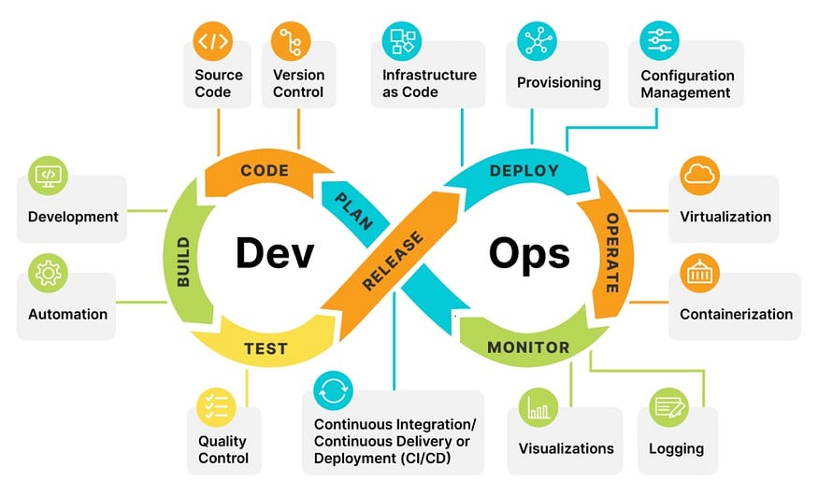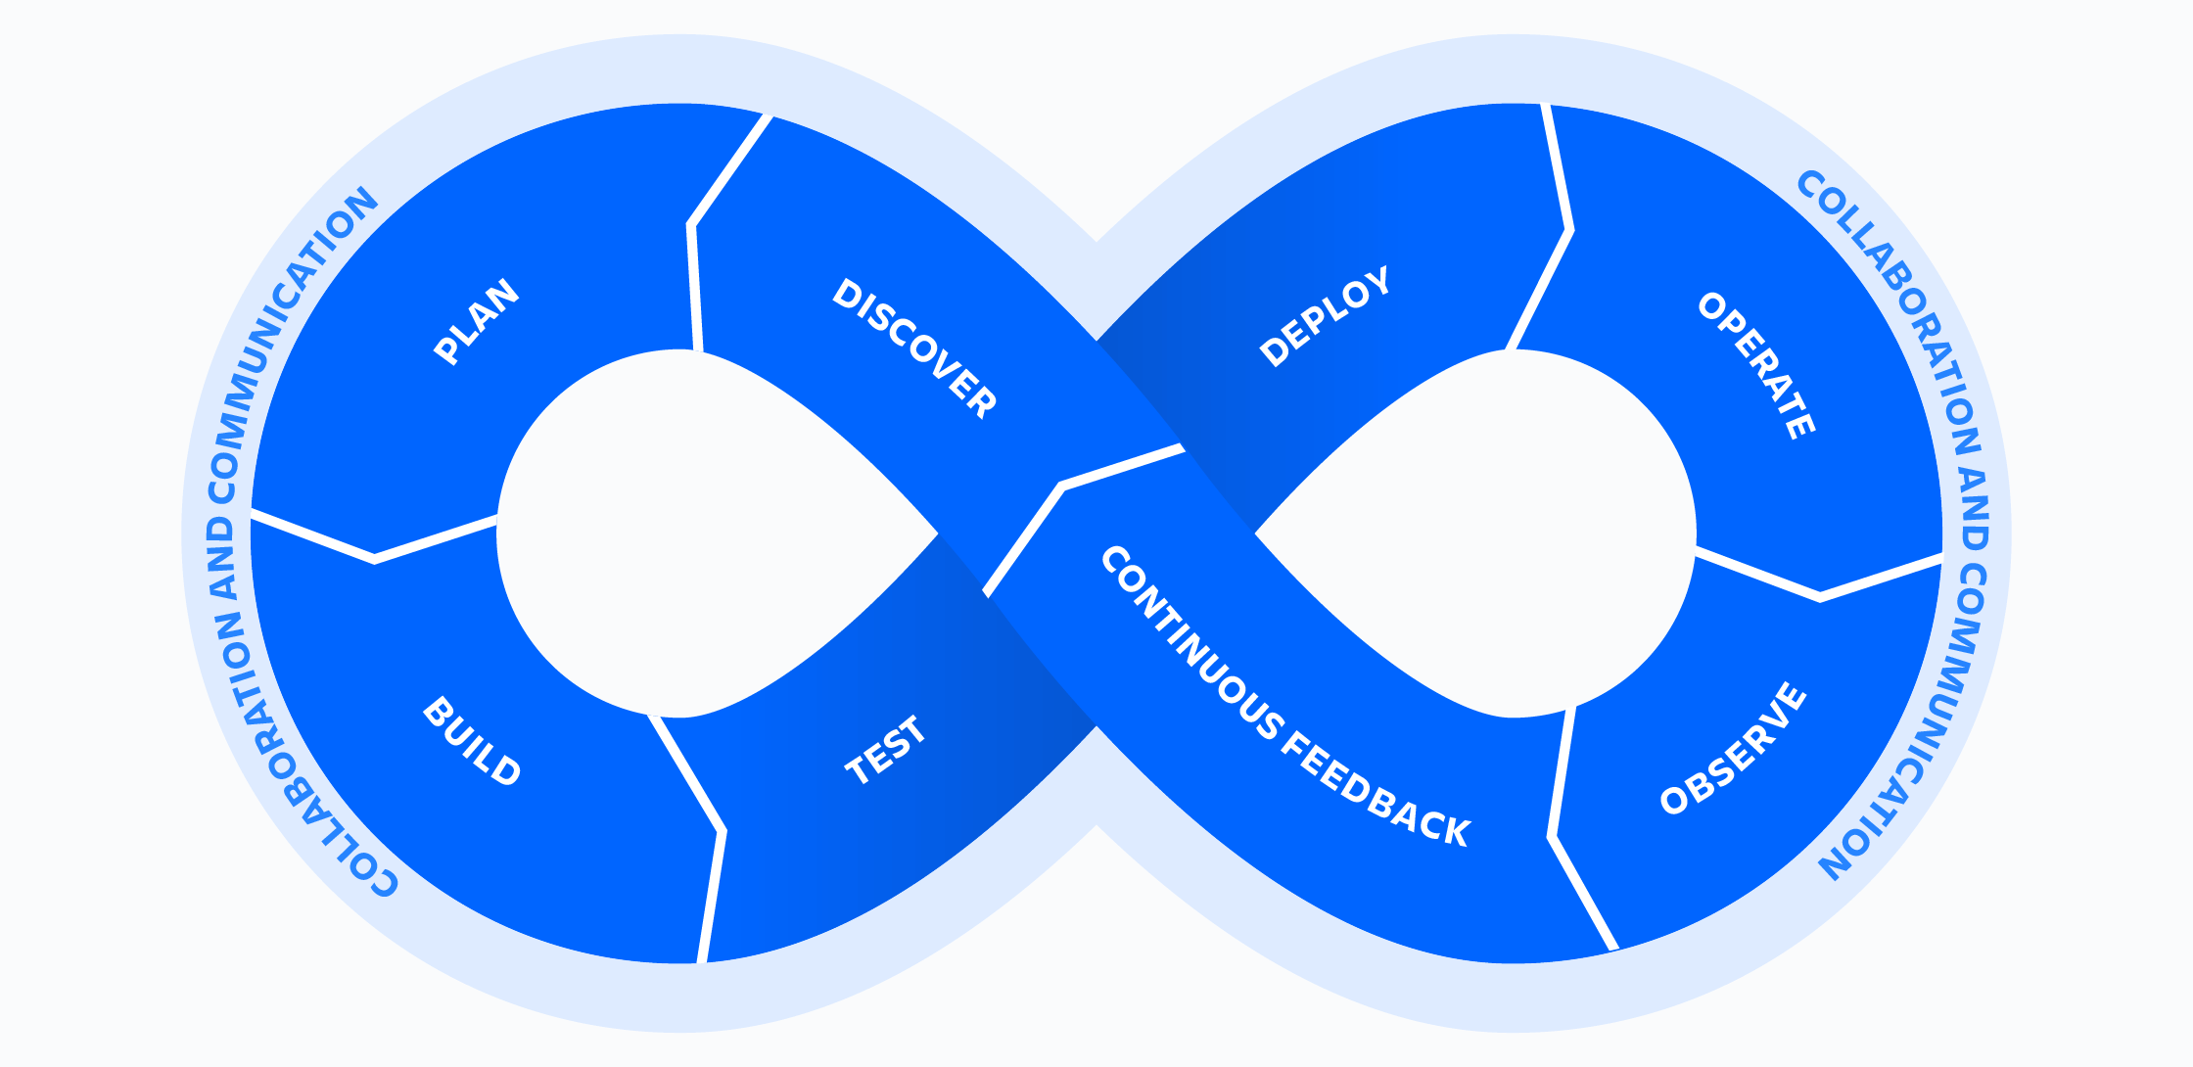
Discover → Plan → Build → Test → Deploy → Operate → Observe → Feedback → (loop)
CALMS Framework
CALMS is a model used to check if a company is ready for DevOps and to track progress in adopting DevOps. It involves:
- Culture:
- DevOps is not just tools or processes. It is about how teams work together.
• Teams must collaborate across roles: devs, ops, QA, product managers, etc.
• It’s better to have product-based teams (working on one goal) than role-based
teams (just dev or just ops).
2. Automation:
- CI/CD (Continuous Integration/Delivery):
- Code is tested and deployed automatically after changes.
- Configuration as Code:
- Infrastructure setup is written as code (e.g., Terraform, Ansible).
3. Lean:
- Release small, working features instead of waiting for months.
- Use A/B testing, small experiments to see what works better.
4. Measurement:
- Time from code to deployment
- Number of bugs or failures
- Recovery time after crashes
5. Sharing:
- Make knowledge, responsibility, and success shared between teams.

