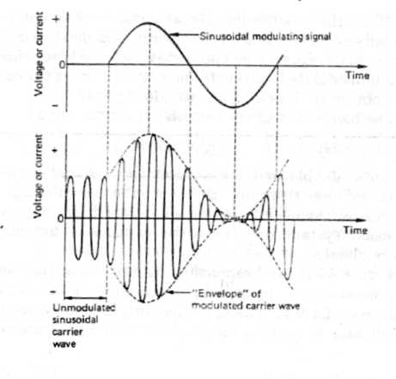

**Amplitude Modulation**

Amplitude Modulation (AM) plus frequency division multiplexing (FDM) is one

way of solving above problem. Each conversation is shifted to a different part of

the frequency spectrum by using a high-frequency waveform to "carry" each

individual speech signal. These high frequencies are called carrier frequencies .

Amplitude modulation is the process of varying the amplitude of the sinusoidal

carrier wave by the amplitude of the modulating signal, and is illustrated in Fig. 5

**Amplitude-mudulated carrier wave**

The unmodulated carrier wave has a constant peak value and a higher

frequency than the modulating signal , but, when the modulating signal is applied,

the peak value of the carrier varies in accordance with the instantaneous value

of the modulating signal, and the outline wave shape or "envelope" of the

modulated wave's peak values is the same as the original modulating signal wave

shape. The modulating signal waveform has been superimposed on the carrier

wave.

When a sinusoidal carrier wave of frequency fc Hz is amplitude - modulated

by a sinusoidal modulating signal of frequency fm Hz , then the modulated

carrier wave contains three frequencies .

1) fc Hz : Original carrier frequency

2) ( fc + fm ) Hz : The sum of carrier and modulating signal frequencies

3) ( fc - fm ) Hz : The difference between carrier and modulating signal

Principle of amplitude modulation

It should be noted that two of these frequencies are new, being produced by

the amplitude-modulation process, and are called side-frequencies.

The sum of carrier and modulating signal frequencies is called the upper

side-frequency. The difference between carrier and modulating signal frequency is

called the lower side-frequency. The bandwidth of the modulated carrier wave is

( fc + fm ) - ( fc - fm ) = 2 fm i.e. double the modulating signal frequency