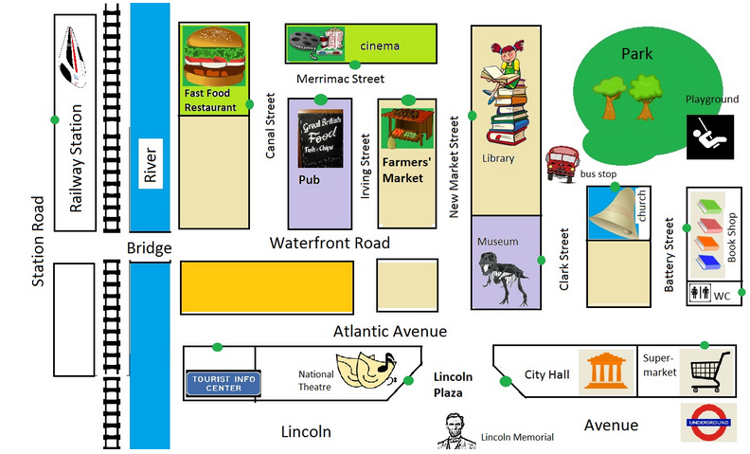

**Task 1 – Record a dialogue**

Look at the map and make dialogues.

The starting point is always the railway station.

The entrance to the buildings is marked with a green dot.

Follow the instructions below on how to record your dialogue either with Microsoft Surface or your iPad. You can use any other mobile device (smartphone, notebook ...) you want.

[Dialogues - Microsoft Surface Textseite](http://aufgabensammlung8.digikomp.at/mod/page/view.php?id=1654)

[Dialogues - iPad](http://aufgabensammlung8.digikomp.at/mod/page/view.php?id=1655)

**Task 2 – Make a Video**

Choose any place you want to go to on the map.

Start from the station.

Make your own dialogue (and write it down, if you want to).

Follow the instructions below on how to record a video either with Microsoft Surface or your iPad. You can use any other mobile device you want.

[Video - Microsoft Surface Textseite](http://aufgabensammlung8.digikomp.at/mod/page/view.php?id=1657)

[Video - iPad - "ShowMe" Tutorial Video Link/URL](http://aufgabensammlung8.digikomp.at/mod/url/view.php?id=1661)

[Video - iPad Textseite](http://aufgabensammlung8.digikomp.at/mod/page/view.php?id=1658)

[Video - iPad - Watch an example!](http://aufgabensammlung8.digikomp.at/mod/url/view.php?id=1662)