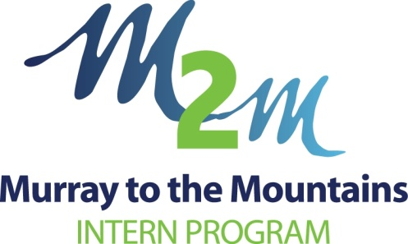**M2M Recruitment Process**

|  |  |
| --- | --- |
| **IMPORTANT DATES** |  |
| Medical Expo | 28 April 2018 |
| Intern Registration opens | 1 May 2018 |
| Intern Applications close | 1 June 2018 |
| Computer Match | 3-6 July 2018 |

|  |
| --- |
| **WEBSITE:** [**www.m2m.asn.au**](http://www.m2m.asn.au) |

|  |
| --- |
| **Interviews** |
| Shortlisted candidates only |
| Phone interviews will be available. |
| Interviews will be conducted on Tuesday 19th June in Wangaratta. |
| Interview panel includes M2M, Northeast Health Wangaratta & Albury Wodonga Health. |

|  |
| --- |
| **M2M Application Requirements** |
| **For a copy of the Position Description** |
| Shane Boyer, M2M Manager |
| email: [shane.boyer@unimelb.edu.au](mailto:shane.boyer@unimelb.edu.au) |
| **A cover letter addressing selection criteria is essential** |